Supplementary Table 1: Endpoint Definition

Overall Survival | Time from randomization to death from any cause
Radiographic Progression-free survival | ﻿  Radiographic progression  Progression in CT or bone scans as defined by PCWG2 criteria  Radiographic PFS:  Time from randomization to the first objective evidence of radiographic disease progression or death due to any cause
PSA PFS | ﻿  PSA Progression  Patients with a PSA decline: ≥25% increase and an absolute increase of ≥2 ng/mL above the nadir, confirmed by a second value at least 3 weeks later.  Patients without a PSA decline: ≥25% increase and an absolute increase of ≥2 ng/mL above baseline confirmed by a second value at least 3 weeks later.  PSA Progression-Free Survival:  Time from ﻿ randomization to first confirmed PSA progression.
PSA Response | ﻿  Confirmed PSA responses, defined as a ≥50% reduction in PSA from baseline to the lowest post-baseline PSA result. A consecutive assessment conducted at least 3 weeks later was required to confirm the PSA response.
Time to FACT-P progresion | ﻿  Time from randomization to first assessment with at least a 10-point decrease from baseline in the total FACT-P score

Supplementary Table 2: Risk Score Calculation

- ﻿Continuous Risk Score

Risk score = −0.344*𝐴𝑙𝑏𝑢𝑚𝑖𝑛 + 0.235*𝐴𝐿𝑃 – 0.166*𝐻𝑒𝑚𝑜𝑔𝑙𝑜𝑏𝑖𝑛 + 0.408*𝐿𝐷𝐻 + 0.378*𝑁𝐿𝑅 + 0.381*𝑁𝐵𝑀 + 0.262*𝑃𝑎𝑖𝑛 + 0.707*𝑃𝑜𝑆 + 0.204*𝑙𝑜𝑔G 𝑃𝑆𝐴 – 0.003*𝑇𝐷𝑅 + 0.389*𝑇𝑟𝑒𝑎𝑡𝑚𝑒𝑛𝑡

Values used for each of the variables:
﻿Albumin: baseline g/dL
ALP: 0 if ALP <ULN; 1 if ALP ≥ULN
Hemoglobin: baseline levels (g/dL)
LDH: 0 if LDH < ULN; 1 if LDH ≥ ULN
NBM (number of bone metastases): 0 if < 10 bone metastases, 1 if ≥ 10 bone metastases
NLR (neutrophil to lymphocyte ratio): 0 if NLR < 2.5, 1 if NLR ≥ 2.5
Pain (BPI SF Question #3): 0 if BPI score 0-1; 1 if BPI score ≥ 2
PoS (Pattern of spread): 1 if liver metastases present, 0 if liver metastases absent
PSA: log_{e} of baseline PSA (ng/mL)
TDR (Time from diagnosis to randomization): number of months from diagnosis
Treatment arm: 0 if placebo + prednisone, 1 if abiraterone + prednisone

- Categorical Risk Score

Risk factors

Albumin: 0 if Albumin ≥ 4 g/dL; 1 if Albumin < 4 g/dL
ALP: 0 if ALP <ULN; 1 if ALP ≥ULN
Hemoglobin: 0 if Hb ≥ 12.5 g/dL; 1 if Hb < 12.5 g/dL
LDH: 0 if LDH < ULN; 1 if LDH ≥ ULN
NBM: 0 if < 10 bone metastases, 1 if ≥ 10 bone metastases
NLR: 0 if NLR < 2.5, 1 if NLR ≥ 2.5
Pain: 0 if BPI score 0-1; 1 if BPI score ≥ 2
PoS: 0 if liver metastases absent, 1 if liver metastases present
PSA: 0 if baseline PSA < 50 ng/mL; 1 if PSA ≥ 50 ng/mL
TDR: 0 if TDR ≥ 60 months; 1 if TDR < 60 months
Treatment arm: 0 if placebo + prednisone, 1 if abiraterone + prednisone

Risk group:

Low risk: if < 4 risk factors present
Intermediate risk: if 4-6 risk factors present
High risk: if 7-10 risk factors present

Supplementary Table 3. Multivariable Cox-Regression Models

 | OS |  | rPFS |  | PSA-PFS
Variable* | HR (95%CI) | p-value | HR (95%CI) | p-value | HR (95%CI) | p-value
Albumin | 0.69 (0.54-0.89) | 0.003 | 0.78 (0.62-0.97) | 0.03 | 0.86 (0.68-1.09) | 0.2
ALP | 1.38 (1.16-1.64) | <0.001 | 1.13 (0.96-1.33) | 0.14 | 1.09 (0.91-1.3) | 0.4
Hb | 0.93 (0.88-0.99) | 0.03 | 0.98 (0.93-1.04) | 0.5 | 0.99 (0.93-1.05) | 0.6
LDH | 1.51 (1.23-1.84) | <0.001 | 1.23 (1.02-1.48) | 0.031 | 1.24 (1.01-1.54) | 0.044
NLR | 1.18 (1.02-1.37) | 0.03 | 1.12 (0.98-1.28) | 0.11 | 1.11 (0.96-1.28) | 0.16
Bone Mets | 1.39 (1.17-1.65) | <0.001 | 1.29 (1.1-1.51) | 0.002 | 1.3 (1.09-1.55) | 0.003
Pain | 1.26 (1.09-1.47) | 0.003 | 1.20 (1.05-1.38) | 0.008 | 1.29 (1.10-1.51) | 0.001
PSA | 1.14 (1.08-1.2) | <0.001 | 1.13 (1.08-1.19) | < 0.001 | 1.14 (1.08-1.19) | < 0.001
TDR | 0.99 (0.99-1) | <0.001 | 0.99 (0.99-1) | 0.11 | 0.99 (0.99-0.99) | < 0.001
Treatment arm | 1.14 (0.99-1.32) | 0.07 | 1.51 (1.32-1.72) | < 0.001 | 1.67 (1.45-1.92) | < 0.001

*Variables are defined as used in the continuous risk score calculation:
Albumin (continuous): baseline g/dL
ALP (categorical): 0 if ALP <ULN; 1 if ALP ≥ULN
Hemoglobin (continuous): baseline levels (g/dL)
LDH (categorical): 0 if LDH < ULN; 1 if LDH ≥ ULN
NBM (number of bone metastases - categorical): 0 if < 10 bone metastases, 1 if ≥ 10 bone metastases
NLR (neutrophil to lymphocyte rati - categorical): 0 if NLR < 2.5, 1 if NLR ≥ 2.5
Pain (categorical): 0 if BPI score 0-1; 1 if BPI score ≥ 2
PSA (continuous): log_{e} of baseline PSA (ng/mL)
TDR (Time from diagnosis to randomization - continuous): number of months from diagnosis
Treatment arm (categorical): 0 if placebo + prednisone, 1 if abiraterone + prednisone

Supplementary Table 4. Reason for Treatment Discontinuation and Risk Group

Reason for Discontinuation | Low-Risk | Intermediate-Risk | High-Risk | OR (95%CI)* | p-value**
Radiographic Progression | 228 (67%) | 191 (59%) | 51 (56%) | 0.67 (0.49-0.92) | 0.01
Unequivocal Clinical Progression | 164 (48%) | 183 (56%) | 64 (70%) | 1.55 (1.15-2.09) | 0.003
Opiate Analgesia | 35 (10%) | 46 (14%) | 15 (17%) | 1.49 (0.94-2.39) | 0.08
ECOG ≥ 3 | 4 (1.2%) | 11 (3.4%) | 3 (3.3%) | 2.91 (0.9-12.2) | 0.057
Cytotoxic chemotherapy | 85 (25%) | 94 (29%) | 32 (35%) | 1.29 (0.93-1.81) | 0.12
Radiotherapy | 57 (17%) | 55 (17%) | 19 (21%) | 1.07 (0.72-1.59) | 0.8
Surgical Intervention | 6 (1.8%) | 7 (2.1%) | 5 (5.5%) | 1.64 (0.56-5.39) | 0.3

N=756 patients who discontinued treatment and performed a discontinuation visit
*OR: Odds ratio (low vs intermediate or high)
**p-value: Fisher’s exact test for the comparison of low vs intermediate or high risk.

Supplementary Table 5. PSA and Radiographic Response Rates

 | Risk Category |  |  |  |  |  | p-value***
 | Low |  | Intermediate |  | High |  | p-value***
 | N | % | N | % | N | % | p-value***
30% PSA Response* | 354 | 66% | 212 | 48% | 38 | 35% | <0.001
50% PSA Response* | 316 | 59% | 174 | 39% | 34 | 31% | <0.001
90% PSA Response* | 151 | 28% | 74 | 17% | 15 | 14% | <0.001
Radiographic Response** | 98 | 45% | 44 | 25% | 13 | 31% | <0.001

*PSA response rates were confirmed by a second value
**Radiographic response rates reported on the total of patients with measurable disease (Total N=434; Low risk N = 262; Intermediate risk N=148; High risk N=56)
***Fisher’s exact test
Supplementary Figure 1: Missing value imputation
170 patients (15.6%) had missing data in at least one variable. Missing values were imputed by predictive mean matching (PMM). Five datasets were created and pooled for analysis.
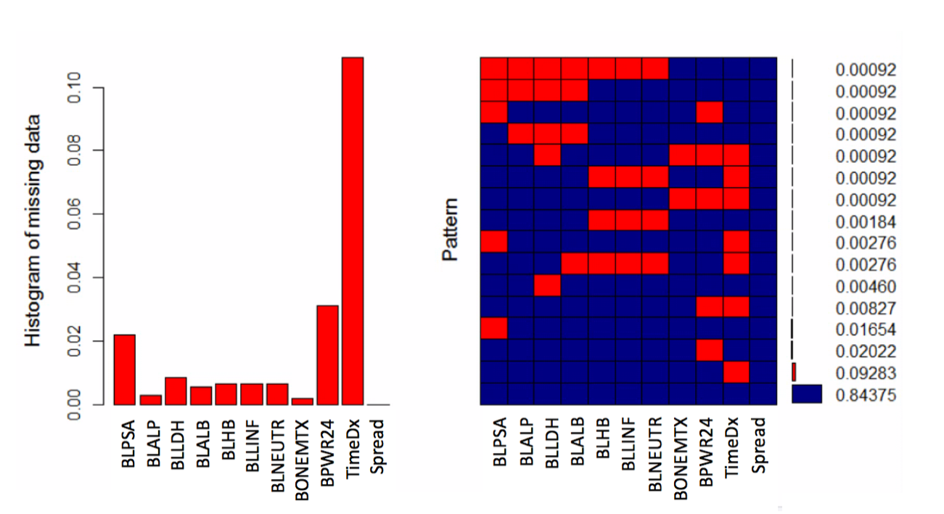
- Missing Data Patterns

- Densitiy plots: non-missing (blue) and imputed (red) data
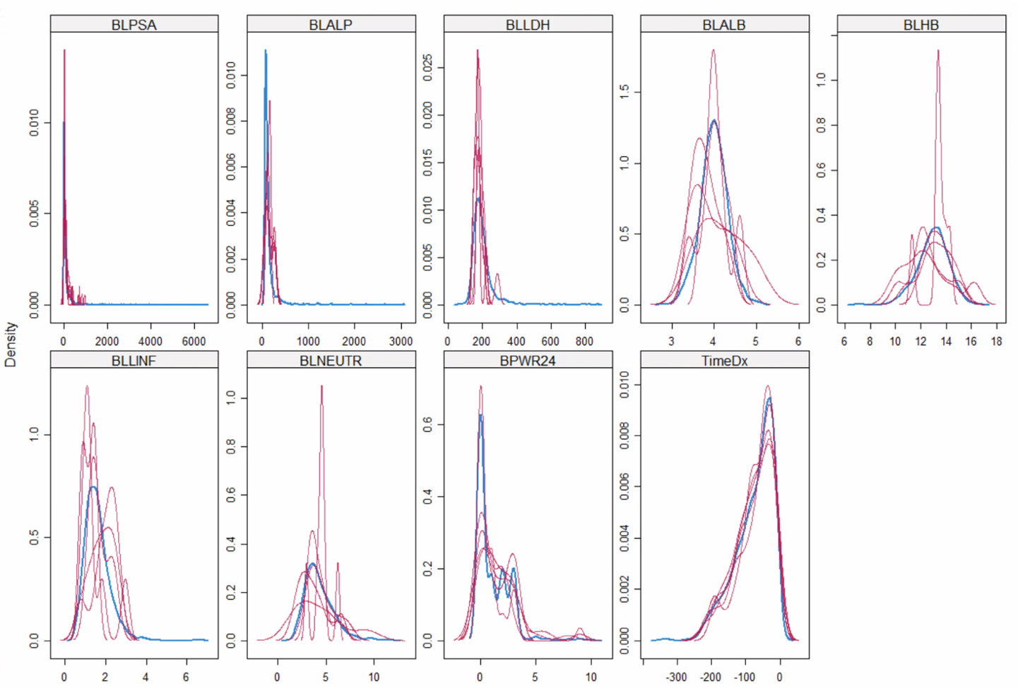

Supplementary Figure 2. Distribution of the prognostic index

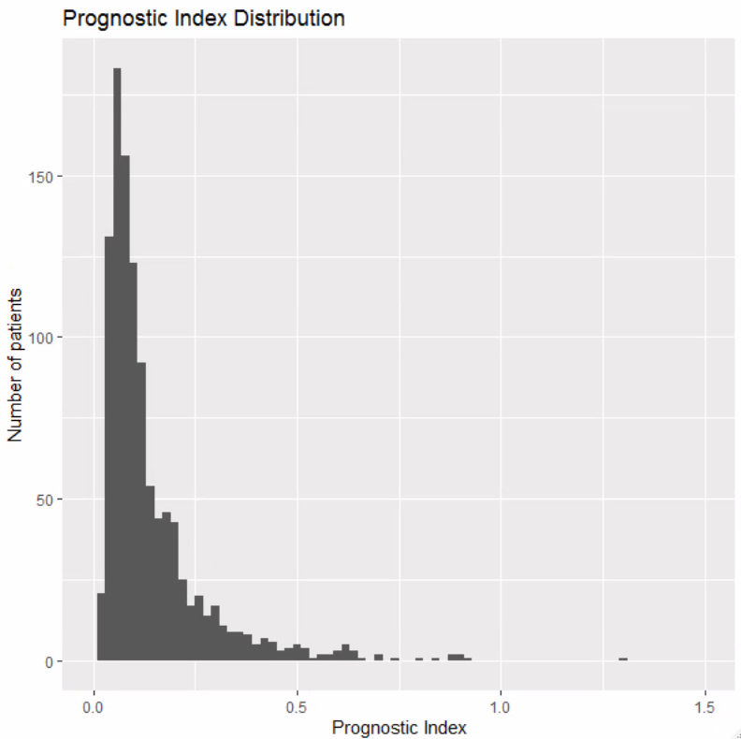

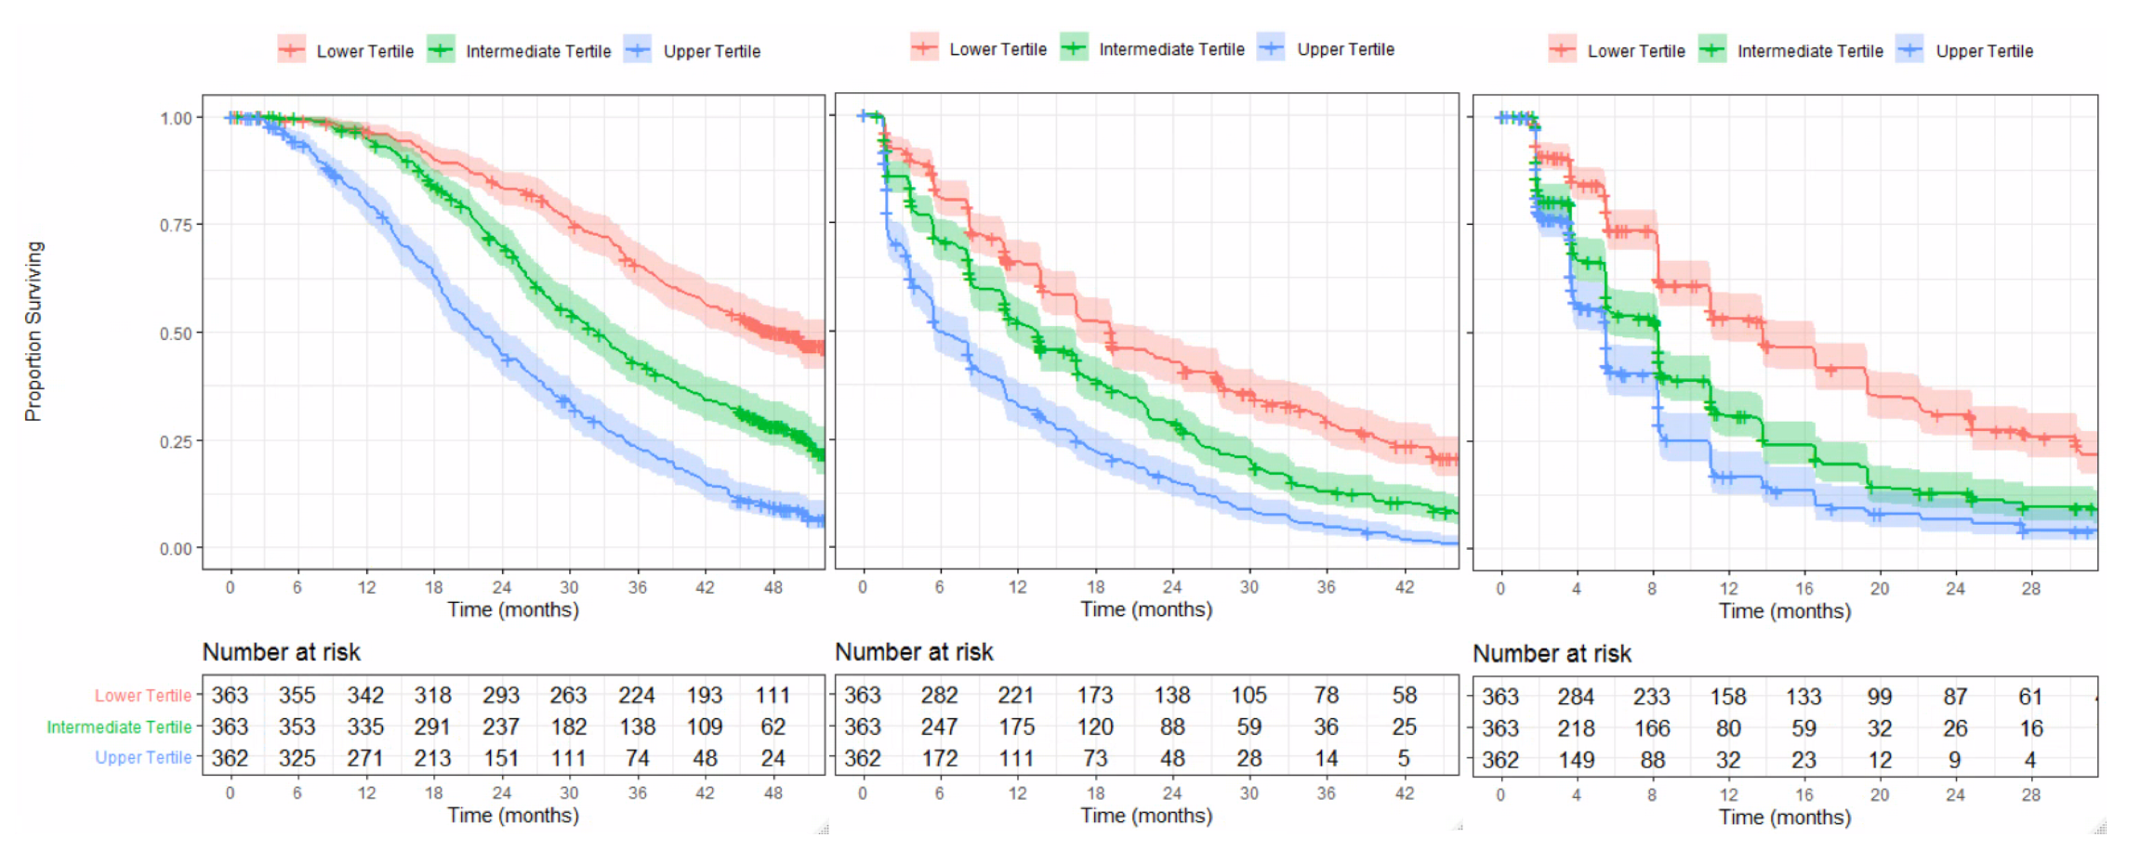
Supplementary Figure 3. Survival based on Prognostic Index Tertiles
Overall survival
Radiographic Progression-Free Survival
PSA Progression-Free Survival
Supplementary Figure 4. Distribution (number) of risk factors
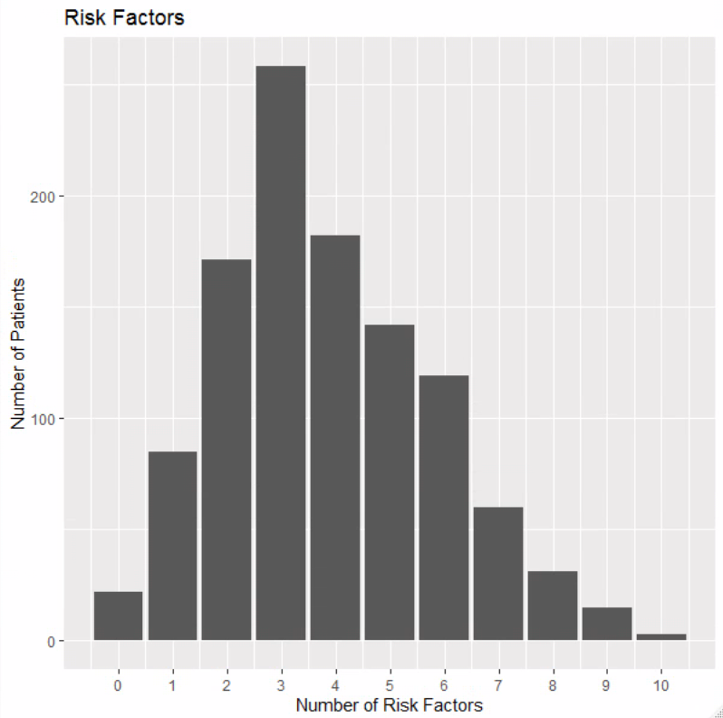

Supplementary Figure 5. Radiographic Progression-free survival benefit of abiraterone in low-, intermediate- and high-risk patients

Supplementary Figure 6. Time to FACT-P deterioration by Risk Group

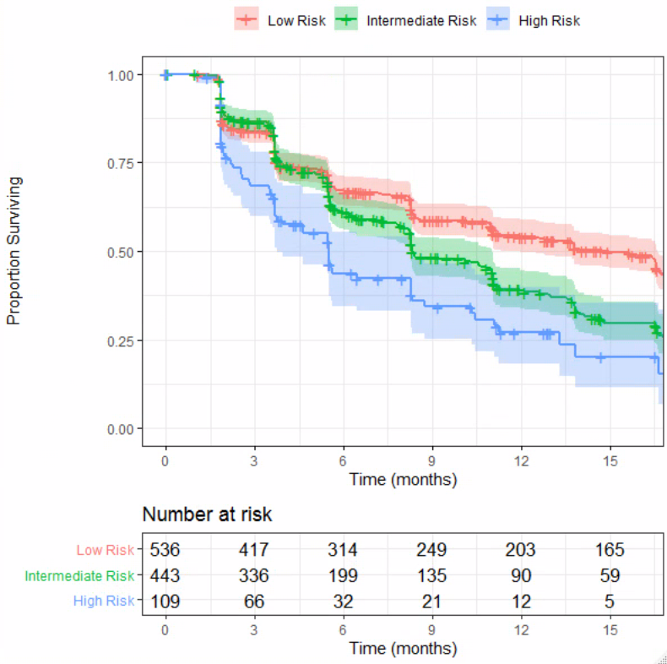

Supplementary Figure 7. Time to FACT-P deterioration in Abiraterone vs Placebo-treated patients by Risk Group
