Remote Ischemic Preconditioning Ameliorates Anthracycline-induced Cardiotoxicity and Preserves Mitochondrial Integrity
SUPPLEMENTARY MATERIAL

Supplementary Figure 1. LV mass and volumes from experiment 1.
Data by group, over time and at 16 weeks for (A) LV mass indexed, (B) LVEDV indexed and (C) LVESV indexed.

Supplementary Figure 2. Cardiac contractility (wall thickening) at the end of the study for both groups in the remote area.

Supplementary Table 1. CMR in-vivo data of the whole study 1 for all the time points and all the groups.

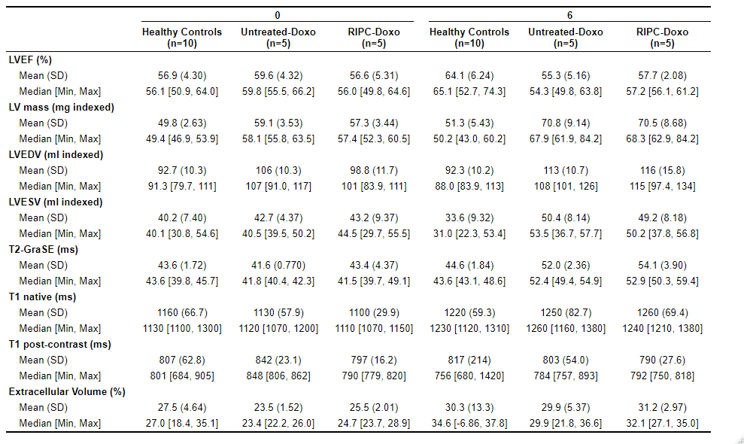
Supplementary Table 2. CMR in-vivo data of the whole study 2 for all the time points and all the groups (healthy controls at 0 and 6 weeks from study 1 are also included for comparison).

Supplementary Figure 3. Unedited WB gels.

