SUPPLEMENTARY INFORMATION

Sara Verdura, Elisabet Cuyàs, Laura Llorach-Parés, Almudena Pérez-Sánchez, Vicente Micol,

Alfons Nonell Canals, Jorge Joven, Manuel Valiente, Melchor Sánchez-Martínez,

Joaquim Bosch-Barrera, Javier A. Menendez

SUPPLEMENTARY TABLES

Table S1. Docking binding energies of silibinin and STAT3i against the SH2 domain of monomeric STAT3. Each entry contains the inhibitor employed, the PDB ID against which the docking calculations were realized, and the binding energies of classical docking calculations. Each calculation was performed twice (R0, R1) to avoid false positives. The more negative the binding energy, the more plausible the interaction.

Molecule | 1BG1  R0 /R1  Chain A | 3CWG  R0/R1  Chain A | 4E68  R0/R1  Chain A | Model 1  R0/R1  Chain A | Model 2  R0/R1  Chain A
Silibinin | -6.0/-5.9 | -6.1/-6.2 | -6.6/-6.6 | -5.6/-5.9 | -6.7/-6.7
Stattic | -4.8/-5.0 | -5.0/-4.9 | -4.6/-4.8 | -5.4/-5.4 | -5.1/-5.2
S31-M2001 | -6.1/-6.1 | -6.3/-6.8 | -6.1/-5.8 | -5.5/-5.6 | -6.1/-5.9
TPCA-1 | -5.1/-4.8 | -5.6/-5.3 | -4.6/-5.0 | -4.9/-4.9 | -4.8/-4.5
OPB-31121 | -4.7/-5.3 | -4.5/-4.9 | -5.2/-5.1 | -3.9/-4.0 | -4.8/-4.9
LLL-12 | -5.9/-5.9 | -6.2/-6.2 | -6.1/-6.1 | -5.7/-5.7 | -6.2/-6.2
InS3-54A18 | -5.6/-5.6 | -6.0/-6.0 | -6.4/-6.5 | -5.7/-5.7 | -5.4/-5.5
HO-3687 | -7.0/-6.9 | -6.7/-6.7 | -6.8/-6.8 | -7.5/-7.5 | -6.7/-6.7
BP5-087 | -6.7/-5.7 | -6.4/-6.3 | -6.9/-6.6 | -7.0/-6.1 | -6.2/-6.7
STX-0119 | -6.7/-6.7 | -7.6/-7.6 | -7.8/-7.8 | -6.6/-6.6 | -6.9/-6.7
ISS610 | -5.9/-6.2 | -5.0/-4.2 | -5.3/-4.9 | -5.5/-5.5 | -5.6 -4.7
SH-4-054 | -5.8/-7.3 | -6.5/-6.3 | -6.5/-6.5 | -7.1/-6.9 | -6.3/-6.2
S31-1757 | -5.7/-5.8 | -6.4/-6.4 | -5.8/-6.4 | -5.6/-6.0 | -6.0/-6.3
Compound 50 | -5.4/-5.5 | -5.8/-5.1 | -5.2/-5.0 | -4.9/-5.0 | -5.6/-5.6
Compound 24 | -6.4/-6.8 | -6.4/-5.4 | -6.5/-6.3 | -6.1/-6.7 | -6.1/-6.0

Table S2. Docking binding energies of silibinin and STAT3i against the SH2 domain of dimeric STAT3. Each entry contains the inhibitor employed, the PDB ID against which the docking calculations were realized, and the binding energies of classical docking calculations. Each calculation was performed twice (R0, R1) to avoid false positives. The more negative the binding energy, the more plausible the interaction.

Molecule | 1BG1  R0 /R1 | 3CWG  R0/R1 | 4E68  R0/R1 | Model 1  R0/R1 | Model 2  R0/R1
 | Chain A  Chain B | Chain A  Chain B | Chain A Chain B | Chain A  Chain B | Chain A  Chain B
Silibinin | -7.2/-7.9  -7.2/-7.9 | -6.8/-6.9  -6.5/-6.6 | -7.2/-6.5  -6.9/-7.1 | -8.0/-7.2  -7.7/-8.0 | -9.0/-9.0  -8.9/-8.6
Stattic | -5.2/-4.8  -5.2/-4.8 | -5.0/-5.0  -5.0/-5.0 | -5.0/-4.9  -5.0/-4.9 | -5.3/-5.0  -5.3/-5.0 | -6.7/-6.7  -6.7/-6.7
S31-M2001 | -7.1/-7.1  -7.1/-7.1 | -6.5/-5.9  -6.5/-5.9 | -6.5/-7.0  -6.5/-7.0 | -6.7/-6.9  -6.7/-6.9 | -8.2/-8.2  -8.2/-8.2
TPCA-1 | -4.6/-6.2  -4.6/-6.2 | -5.7/-5.5  -5.7/-5.5 | -5.1/-4.3  -5.1/-4.3 | -4.9/-4.9  -4.9/-4.9 | -6.4/-6.5  -6.4/-6.5
OPB-31121 | -5.7/-6.2  -5.7/-6.2 | -4.6/-4.7  -4.6/-4.7 | -4.4/-4.3  -4.4/-4.3 | -6.5/-5.9  -6.5/-5.9 | -7.0/-6.6  -7.0/-6.6
LLL-12 | -6.8/-6.8  -6.8/-6.8 | -5.8/-6.0  -5.8/-6.0 | -6.1/-6.1  -6.1/-6.1 | -6.8/-6.8  -6.8/-6.8 | -7.7/-7.7  -7.7/-7.7
InS3-54A18 | -7.7/-7.7  -7.7/-7.7 | -6.0/-6.0  -6.0/-6.0 | -7.3/-7.3  -7.3/-7.3 | -7.6/-7.6  -7.6/-7.6 | -8.4/-8.4  -8.4/-8.4
HO-3687 | -8.1/-8.2  -8.1/-8.2 | -6.2/-6.2  -6.2/-6.2 | -7.1/-7.1  -7.1/-7.1 | -7.8/-7.8  -7.8/-7.8 | -8.8/-8.6  -8.8/-8.6
BP5-087 | -8.1/-8.2  -8.1/-8.2 | -5.4/-6.2  -5.4/-6.2 | -7.0/-7.1  -7.0/-7.1 | -8.6/-8.5  -8.6/-8.5 | -7.8/-7.7  -7.8/-7.7
STX-0119 | -7.6/-7.6  -7.6/-7.6 | -7.7/-7.7  -7.7/-7.7 | -7.7/-7.7  -7.7/-7.7 | -8.1/-8.2  -8.1/-8.2 | -8.7/-8.9  -8.7/-8.9
ISS610 | -6.2/-5.8  -6.2/-5.8 | -4.2/-5.2  -4.2/-5.2 | -6.1/-5.7  -6.1/-5.7 | -5.7/-6.2  -5.7/-6.2 | -8.0/-8.1  -8.0/-8.1
SH-4-054 | -7.0/-8.1  -7.0/-8.1 | -6.2/-6.3  -6.2/-6.3 | -8.3/-8.2  -8.3/-8.2 | -6.4/-6.7  -6.6/-6.7 | -8.5/-7.8  -8.5/-7.8
S31-1757 | -8.1/-8.2  -8.1/-8.2 | -6.0/-5.8  -6.0/-5.8 | -7.7/-7.9  -7.7/-7.9 | -8.3/-8.3  -8.3/-8.3 | -8.6/-8.7  -8.6/-8.7
Compound 50 | -6.3/-6.5  -6.3/-6.5 | -5.7/-5.8  -5.7/-5.8 | -6.0/-6.1  -6.0/-6.1 | -6.2/-6.0  -6.2/-6.0 | -7.1/-7.6  -7.1/-7.6
Compound 24 | -7.1/-7.3  -7.1/-7.3 | -5.9/-6.0  -5.9/-6.0 | -7.4/-7.3  -7.4/-7.3 | -8.0/-8.0  -8.0/-8.0 | -8.0/-7.9  -8.0/-7.9
Table S3. Docking binding energies of silibinin and STAT3i against the DBD of dimeric STAT3. Each entry contains the inhibitor employed, the PDB ID against which the docking calculations were realized, and the binding energies of classical docking calculations. Each calculation was performed twice (R0, R1) to avoid false positives. The more negative the binding energy, the more plausible the interaction.

Molecule | 1BG1  R0/R1± | 3CWG  R0/R1± | 4E68  R0/R1± | Model 1  R0/R1± | Model 2  R0/R1±
 | Chain A  Chain B | Chain A  Chain B | Chain A Chain B | Chain A Chain B | Chain A  Chain B
Silibinin | -8.2/-8.5  -7.6/-7.6 | -5.9/-6.9  -6.4/-5.5 | -7.5/-7.5  7.5/-7.5 | -8.4/-8.4  -8.3/-8.4 | -7.3/-7.5  -7.4/-7.4
Stattic | -6.3/-6.3  -5.3/-6.3 | -5.5/-5.5  -5.5/-5.5 | -6.0/-5.9  -5.9/-5.9 | -6.0/-5.9  -5.9/-5.9 | -6.8/-7.2  -6.5/-6.5
S31-M2001 | -7.0/-7.6  -7.1/-6.9 | -6.6/-6.1  -6.3/-7.6 | -6.2/-7.0  -7.4/-6.7 | -6.2/-7.0  -7.4/-6.7 | -6.8/-7.2  -6.5/-6.5
TPCA-1 | -6.4/-6.6  -6.4/-6.4 | -5.3/-4.9  -5.6/-5.4 | -6.3/-6.1  -5.4/-6.1 | -6.3/-6.1  -5.4/-6.1 | -6.8/-7.2  -6.5/-6.5
OPB-31121 | -6.0/-6.0  -6.0/-5.9 | -6.3/-5.2  -5.3/-5.1 | -5.8/-5.6  -5.6/-5.5 | -5.8/-5.6  -5.6/-5.5 | -6.8/-7.2  -6.5/-6.5
LLL-12 | -7.0/-7.0  -6.5/-7.0 | -6.3/-6.2  -6.7/-6.7 | -7.1/-7.1  -7.1/-7.1 | -7.1/-7.1  -7.1/-7.1 | -6.8/-7.2  -6.5/-6.5
InS3-54A18 | -6.8/-7.5  -7.5/-6.6 | -6.5/-6.6  -6.4/-6.1 | -6.5/-6.5  -6.5/-6.4 | -6.5/-6.5  -6.5/-6.4 | -6.8/-7.2  -6.5/-6.5
HO-3687 | -7.7/-6.8  -6.8/-6.8 | -7.0/-7.3  -7.6/-7.7 | -7.2/-7.1  -6.5/-7.3 | -7.2/-7.1  -6.5/-7.3 | -6.8/-7.2  -6.5/-6.5
BP5-087 | -6.9/-6.3  -6.4/-6.4 | -6.2/-6.1  -6.9/-6.4 | -5.9/-6.2  -6.8/-6.0 | -5.9/-6.2  -6.8/-6.0 | -6.8/-7.2  -6.5/-6.5
STX-0119 | -8.1/-7.9  -8.2/-8.2 | -8.3/-8.4  -7.8/-8.5 | -8.5/-8.5  -8.5/-8.5 | -8.5/-8.5  -8.5/-8.5 | -6.8/-7.2  -6.5/-6.5
ISS610 | -6.1/-5.4  -5.8/-5.0 | -6.1/-5.9  -5.7/-5.9 | -5.4/-6.6  -6.0/-5.3 | -5.4/-6.6  -6.0/-5.3 | -6.8/-7.2  -6.5/-6.5
SH-4-054 | -8.8/-8.6  -7.0/-8.7 | -5.8/-6.4  -7.4/-7.1 | -7.2/-7.4  -7.3/-7.4 | -7.2/-7.4  -7.3/-7.4 | -6.8/-7.2  -6.5/-6.5
S31-1757 | -6.8/-7.1  -8.7/-8.3 | -7.2/-7.4  -6.9/-7.4 | -6.7/-6.0  -6.9/-6.9 | -6.7/-6.0  -6.9/-6.9 | -6.8/-7.2  -6.5/-6.5
Compound 50 | -6.6/-6.5  -6.6/-6.6 | -6.5/-5.4  -5.6/-5.9 | -6.3/-6.3  -6.3/-5.9 | -6.3/-6.3  -6.3/-5.9 | -6.8/-7.2  -6.5/-6.5
Compound 24 | -7.0/-7.0  -7.1/-6.9 | -6.9/-6.6  -6.6/-6.8 | -6.8/-7.2  -6.5/-6.5 | -6.8/-7.2  -6.5/-6.5 | -6.8/-7.2  -6.5/-6.5

Table S4. MM/GBSA calculations of the energy binding of silibinin and STAT3i against the SH2 domain of monomeric STAT3. Each entry contains the inhibitor employed, the PDB ID against which the docking calculations were realized, and the binding energies of the MM/GBSA calculations. Each calculation was performed twice (R0, R1) to avoid false positives. The more negative the binding energy, the more plausible the interaction.
Molecule | 4E68  MM/GBSA Energy  (kcal/mol) | Model 1  MM/GBSA Energy  (kcal/mol)
Silibinin | -24.5797 | -20.0086
Stattic | -3.4448 | -6.2290
S31-M2001 | -10.9319 | -36.6796
TPCA-1 | -11.2728 | -18.3658
OPB-31121 | -17.8542 | -22.2703
LLL-12 | -22.4032 | -23.6978
InS3-54A18 | -30.5783 | -15.1343
HO-3687 | -33.9801 | -19.6155
BP5-087 | -42.9657 | -14.6283
STX-0119 | -30.4366 | -22.3299
ISS610 | -37.8494 | -42.4216
SH-4-054 | -30.6180 | -50.6282
S31-1757 | -42.0304 | -44.0258
Compound 50 | -17.3237 | -15.5636
Compound 24 | -36.1047 | -33.7591

Table S5. MM/GBSA calculations of the energy binding of silibinin and STAT3i against the SH2 domain of dimeric STAT3. Each entry contains the inhibitor employed, the PDB ID against which the docking calculations were realized, and the binding energies of the MM/GBSA calculations. Each calculation was performed twice (R0, R1) to avoid false positives. The more negative the binding energy, the more plausible the interaction.
Molecule | 4E68  MM/GBSA Energy  (kcal/mol) | Model 1  MM/GBSA Energy  (kcal/mol)
Silibinin | -35.8444 | -36.4145
Stattic | -11.7022 | -25.1263
S31-M2001 | -23.1913 | -23.4159
TPCA-1 | -20.0759 | -22.0484
OPB-31121 | -18.5804 | -20.2228
LLL-12 | -27.4378 | -17.7976
InS3-54A18 | -24.8615 | -30.5578
HO-3687 | -16.8437 | -22.0220
BP5-087 | -26.2231 | -43.2597
STX-0119 | -26.0846 | -26.9465
ISS610 | -14.8876 | -27.6832
SH-4-054 | -23.9733 | -27.5046
S31-1757 | -34.4451 | -36.3568
Compound 50 | -20.7817 | -16.5988
Compound 24 | -31.8987 | -38.1313

Table S6. MM/GBSA calculations of the energy binding of silibinin and STAT3i against the DBD of dimeric STAT3. Each entry contains the inhibitor employed, the PDB ID against which the docking calculations were realized, and the binding energies of the MM/GBSA calculations. Each calculation was performed twice (R0, R1) to avoid false positives. The more negative the binding energy, the more plausible the interaction.
Molecule | 1BG1  MM/GBSA Energy  (kcal/mol) | Model 1  MM/GBSA Energy  (kcal/mol)
Silibinin | -40.5752 | -31.6419
Stattic | -17.4627 | -16.6930
S31-M2001 | -12.8820 | -24.5465
TPCA-1 | -27.2303 | -23.2817
OPB-31121 | -18.8595 | -22.8524
LLL-12 | -27.4595 | -15.7280
InS3-54A18 | -26.9986 | -23.9096
HO-3687 | -24.5368 | -23.7166
BP5-087 | -27.7039 | -29.9400
STX-0119 | -38.2513 | -26.2576
ISS610 | -30.4898 | -45.5128
SH-4-054 | -38.3646 | -49.5412
S31-1757 | -25.0957 | -37.8486
Compound 50 | -19.8341 | -21.0036
Compound 24 | -30.7418 | -42.3498

Table S7. Summary of the residues shared between silibinin and STAT3i on their binding mode to the SH2 domain of monomeric STAT3. The coloured residues correspond to the residues shared between silibinin and STAT3 inhibitors. Each colour denotes a different residue. The numbering corresponds to the employed PDB structures.

Molecule | 4E68 | Model 1
Silibinin | M660,E638,K626,T620,  P639,V637,Y657,W623,  T714 | S613,K626,P639,Q635,  W623,E638
Stattic | E638
S31-M2001 | T714,K626,I634,E638,  P639,T622,Q635,K591,  R595,E594 | S611,S613,E612,S636,  K591,V637,E638,Y657,  T620,P639,Q635,K626,  I659,W623,I634
TPCA-1 | S611,E638,T641,E616 | S636,E638,E612,P639,  T620
OPB-31121 | P715,Q635,E638,T714,  I659,W623,V637 | A662,E638,Y657,I659,  N664,M660,P715
LLL-12 | S613,E612,S636,S611,  Q635,T620,E638,K591 | S636,E612,T620,K591,  I634
InS3-54A18 | S636,E638,I634,E612,  E594,Q635,K591,R595,  T620,T622,R609,P639 | S636,P639,W623,K591,  I634,T620
HO-3687 | Q635,S636,P639,V637,  I634,K591,E594,Q633,  W623,F716,T714,E612,  T620 | E638,W623,Q635,I659,  D661
BP5-087 | E612,S611,S636,R609,  E616,P639,T641,F716,  E638 | S613,E612,R609,T620,  P639
STX-0119 | R609,S636,R595,E594,  Q635,I634,T622,P639 | S611,S613,E612,S636,  K591,R609,K626,I659,  W623,E638,V637,P639
ISS610 | Q633,K591,R609,K626,  E612,I634,T622,E594,  T620,P639,Q635 | E612,S611,S613,K591,  R609,I634,T620,P639,  Q635
SH-4-054 | Q635,K626,E594,K591,  I634,R595,T622 | S613,E612,S611,R609,  Q635,P639,E638,T641
S31-1757 | K591,E612,S611,R609,  E638,E616,P639,T641,  Q635 | Q633,R595,E594,I634,  T622
Compound 50 | S636,E638,P639 | S611,S613,E612,S636,  K591,V637,E638,Y657,  T620,P639,Q635,K626,  I659,W623,I634
Compound 24 | S613,E612,S611,T620,  F716,I659,E638,Q635,  W623 | S636,E638,E612,P639,  T620

Table S8. Summary of the residues shared between silibinin and STAT3i on their binding mode to the SH2 domain of dimeric STAT3. The coloured residues correspond to the residues shared between silibinin and STAT3 inhibitors. Each colour denotes a different residue. The numbering corresponds to the employed PDB structures.

Molecule | 4E68 | MODEL1
Silibinin | K707,F710,Q4644,T4641,  N647,E4638,S4614,M648 | K1658,M655,I1711,P1715,  K709,V713,E652,V1713,  L1666,I711,L666
Stattic | K4658,M660,K658,V4713,  P4715,I711,P715,V713,  L666,I4711,L4666 | F1710,F710,M648,L1645,  Q1644,M1648,I1653,  Y1640
S31-M2001 | K658,I711,I4711,V713 | N647,N1647,R1688,Q644,  E1652,F1710,M1648,Q643
TPCA-1 | S4668,K4658,I711,I4711,  N664,K658,L666,P4669,  L4666,V713,V4713 | E690,K709,F710,Q1643,  Y1640,Q1644
OPB-31121 | K4658,M4655,V4713,L4666,  I711,I4711,L666,V713 | K658,I711,V713,I1711,  M660,K1658
LLL-12 | L4666,N4664,I4711,V713,  V4713,L666,I711 | L1666,N1664,I1711,K658,  I711,V1713,V667
InS3-54A18 | K658,N4664,I711,P4715,  V4713,L4666,L666 | I1711,V1713,L666,L1666,  I711,K658,I1665,N664,  K1658
HO-3687 | K658,N4664,V4713,L666,  L4666,K4658,I711,M4660,  K709,P704 | N1664,K709,P1715,K1658,  L1666,M1660,V1713
BP5-087 | K4658,K4709,V713,L4666,  I4711,L666,P715,N664,  I711 | K658,I1711,I711,L1666,  P1715,K709,V1713,P689,  V713
STX-0119 | K658,K709,K4658,V4713,  I711,V4667,N4664,M4660,  L4666,P4715 | E1690,P1689,T641,T1708,  F1710,Y640,E638,Q644,  P639
ISS610 | K658,I4711,I711,P4715,  L4666,K4658,V4713,M4660,  V713,L706,L666,K709 | K1658,K658,V1713,I711,  P1715,L1666,L666,V713,  I1665,I1711
SH-4-054 | K4658,L4666,V713,L666,  I711,V4713,I4711 | F710,T1641,S649,E1638,  P1639,M648,Y1640,T708  E690,
S31-1757 | K4709,L4666,L666,K4658,  F4716,V4713,N664,V713,  I4711 | N664,K1658,P715,K1709,  I1711,V713,
Compound 50 | K4658,M660,K658,V4713,  P4715,I711,P715,V713,  L666,I4711,L4666 | K658,K1709,I1711,E652,  V713,I711,P1715,M655,  P715
Compound 24 | K658,I711,I4711,V713 | K1658,I1711,L1666,P715,  V713,K1709

The residues with four numbers correspond to chain B and those with three numbers to chain A; i.e., for 4E68, K4658 and K658 represent the same residue but for chain B and A, respectively; for Model1, K1658 and K658 represent the same residue but for chain B and A, respectively.

Table S9. Summary of the residues shared between silibinin and STAT3i on their binding mode to the DBD of dimeric STAT3. The coloured residues correspond to the residues shared between silibinin and STAT3 inhibitors. Each colour denotes a different residue. The numbering corresponds to the employed PDB structures.

Molecule | 1BG1 | MODEL1
Silibinin | R423, K383, G419, DT1005,  R382, V432, E415 | G419, G422, K383, G380,  Q416, R423
Stattic | K244, V322, P487, L459 | K383, N420
S31-M2001 | H457, K318, E455, V323,  P487, K244, V322, L459 | K318, P487, R245, K244,  N486, Q247, L459, N485,  Q248, V322, A241
TPCA-1 | S381,K383,N420,R379,  H437,A377,D369,A376 | N420,A377,H437,V490,  R379
OPB-31121 | R379,K383,Q416,L378,  D369 | G380,S381,K383,R379,  N420,A424
LLL-12 | R423,K383,R379,E415,  R382,N420 | G422,S381,K383,D374,
InS3-54A18 | Q248,P487,V323,E455,  K244,L459,H457 | N485,R245,P487,T236,  K233,D237,K244,A241
HO-3687 | G421,R382,L378,Q416,  K383,A377 | G422,E415,Q416,K383,  R417,V432,R382,R423
BP5-087 | K383,E415,A377,R417,  R382,N420,Q416,V375 | N420,R423,K383,R382,  Q416
STX-0119 | G380,K383,Q416,R382,  V432,R417,R423,N420,  E435 | T456,N315,K244,L459,  Q247,E455,K318,V323
ISS610 | S381,G422,L438,R417,  N420,G380,C418,R382,  R423,R379,D369,K383,  A377,L378 | C418,R382,S465,R417,  R423,E435,I431,E415
SH-4-054 | G380,R379,K383,V490,  H437,A376,D369,A377,  R423 | N420,R379,L378,V490,  A377,K383,A376,C418
S31-1757 | K488,V490,D369,K318,  L438,K370,H457,A377,  T440 | R423,G380,R379,K383,  R382
Compound50 | K383,D369,D374 | V323,L240,W243,L459,  Q247,K244
Compound24 | V323,K488,T456,H457,  K370,L438,E455,T440,P487 | V323,S372,Q326,H457,  W243,L438,L240,V322,  P487,E455

SUPPLEMENTARY FIGURES

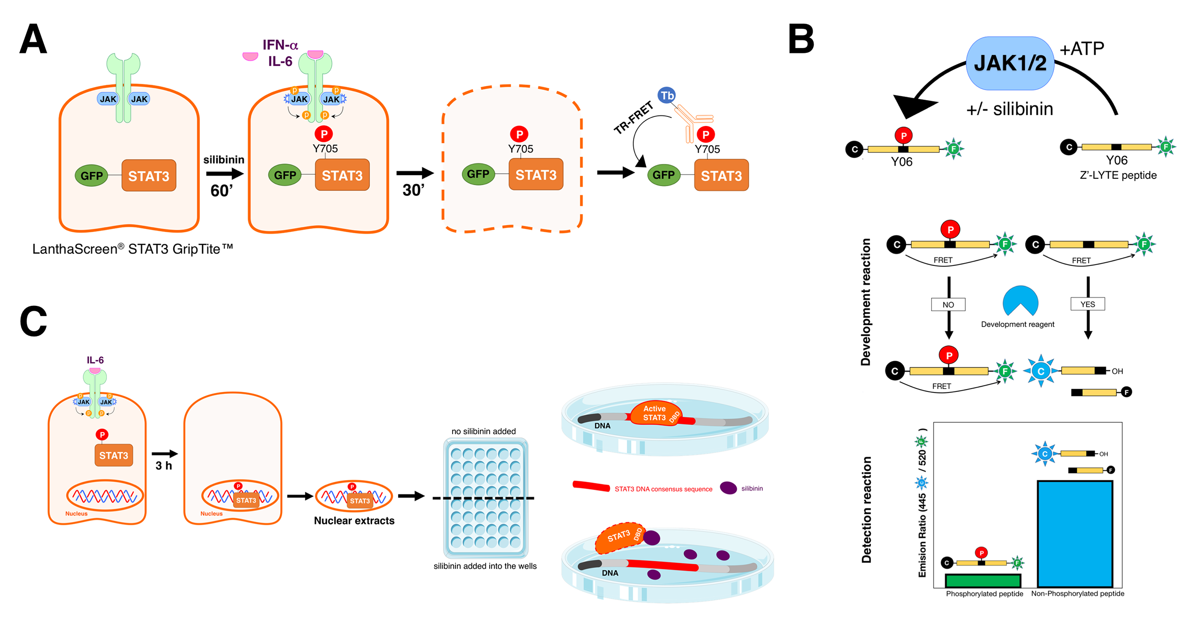

Figure S1. A. LanthaScreen® STAT3 GripTite™ cells were plated the day prior to the assay. On the day of the assay, cells were pre-treated with graded concentrations of silibinin for 1 h before being stimulated with IL-6 for 30 min. Cells were lysed and incubated with Tb-anti-pSTAT3 (pTyr705) antibody for 60 min at room temperature. Fluorescence emission values at 520 nm and 490 nm were obtained using a BMG Pherastar plate reader set to TR-FRET mode. B. Schematic of the Z’-LYTE assay method employed to characterize the JAK1/JAK2 kinase inhibitory activity of silibinin. C. Schematic of the TransAM assay method employed to characterize an inhibitory effect of silibinin on STAT3 DNA binding activity.
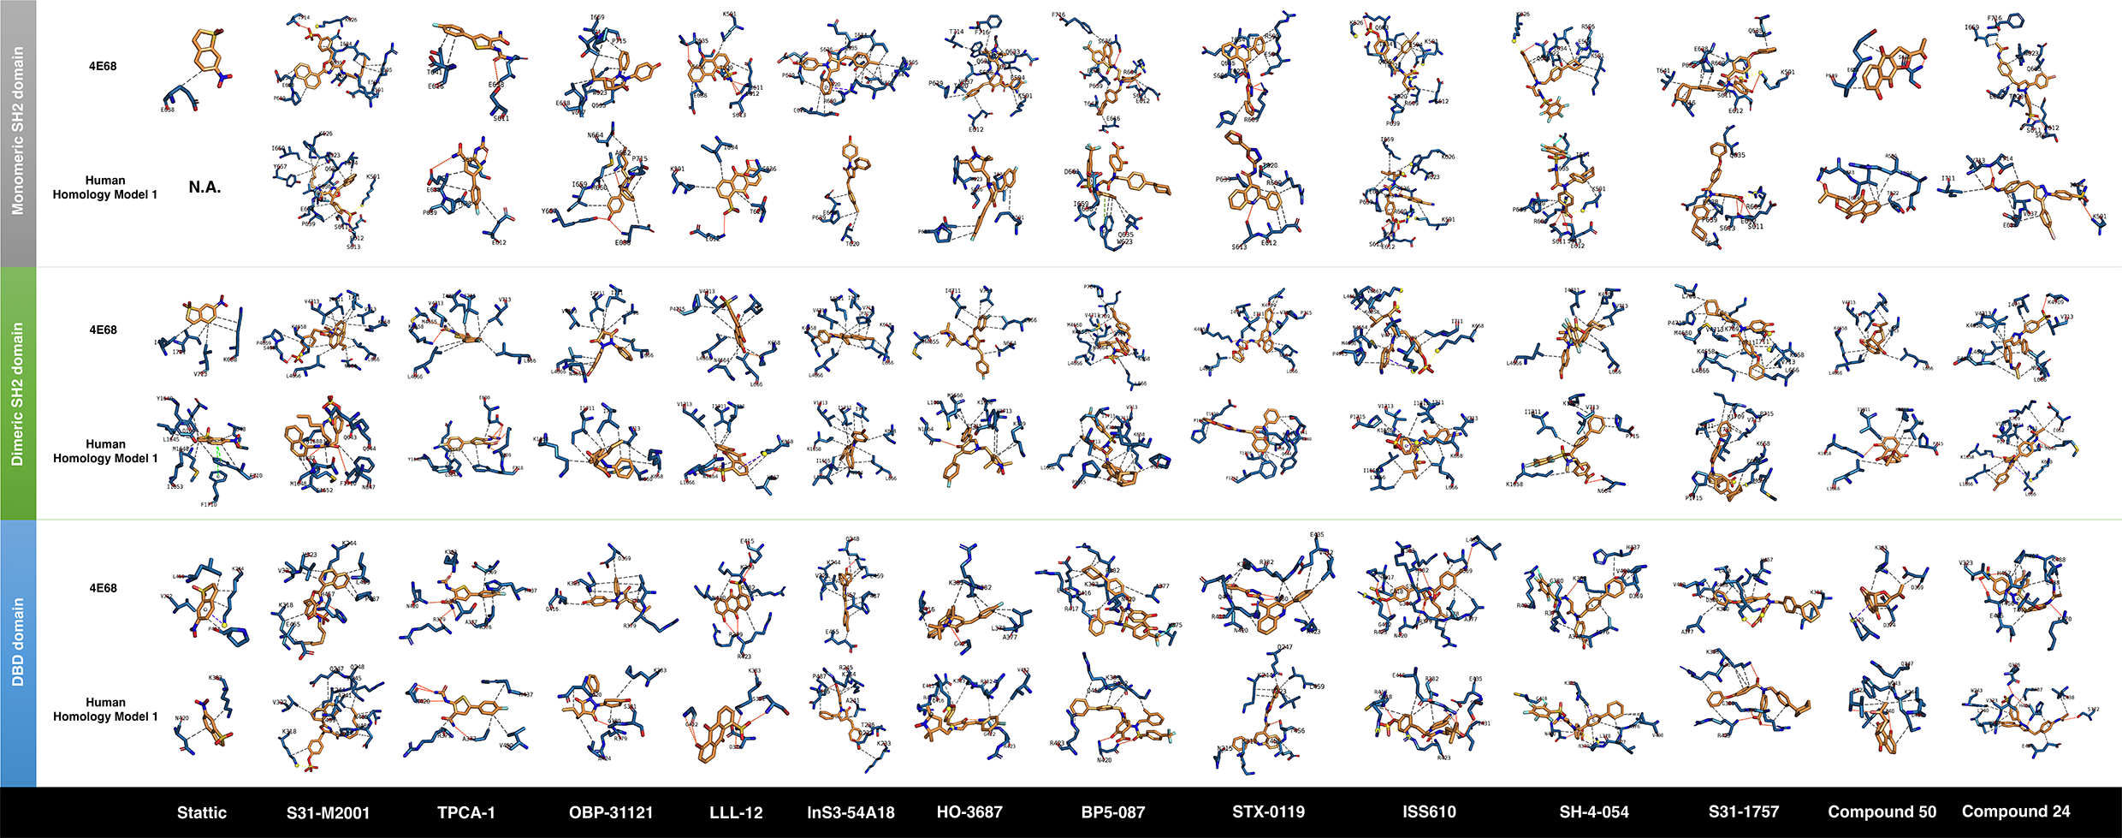

Figure S2. Mode of binding of STAT3i to SH2 activation/dimerization and DNA binding (DBD) domains of STAT3. Figure shows in sticks all the pharmacophoric interaction residues involved in the in silico binding of STAT3i to the SH2 and DBD domains of STAT3 using PLIP. Orange dashed lines represent hydrogen bond interactions; grey dashed lines represent hydrophobic interactions. The main residues involved in silibinin interaction with the protein backbone are shown in black; the residues numbers shown correspond to the original PDB file numbering. Figure displays self-docking poses under molecular dynamics (MD) simulations modeling the backbone and ligand (STAT3i) flexibility.

