Supplementary Tables
Supplementary Table 1: Basic set of accessory variables required for each study participant
Basic accessory information required for each study participant
Analytical information | Biomarker concentrations, Limit of detection, Limit of quantification, analytical method used
Sampling information | Sampling matrix, spot/repeated sampling, sampling year and month, sampling season, sampling time during the day, creatinine for urinary samples, specific gravity for urinary samples from teenagers, lipid content (in case of BFRs)
Participant information | Age, sex, SES (ISCED), weight, height, Body mass index, degree of urbanization, country, Nomenclature of territorial units for statistics (NUTS)*, smoking behavior of subject or smoking behavior of parents for children/teenagers
* NUTS classification is not available for Norway and Switzerland. They provide information on subdivision according to ISO 3166-2 (Codes for the representation of names of countries and their subdivisions – Part 2: Country subdivision code).

Supplementary Figures

● Northern Europe
● Western Europe
● Eastern Europe
● Southern Europe
Supplementary Figure 1: Countries contributing to the joint HBM4EU survey clustered by EU region
Adapted from United Nations geoscheme subregions of Europe i.e. Northern Europe, Western Europe, Eastern Europe, Southern Europe. According to United Nations geoscheme Cyprus is attributed to Asia, in HBM4EU Cyprus is included in Southern Europe.

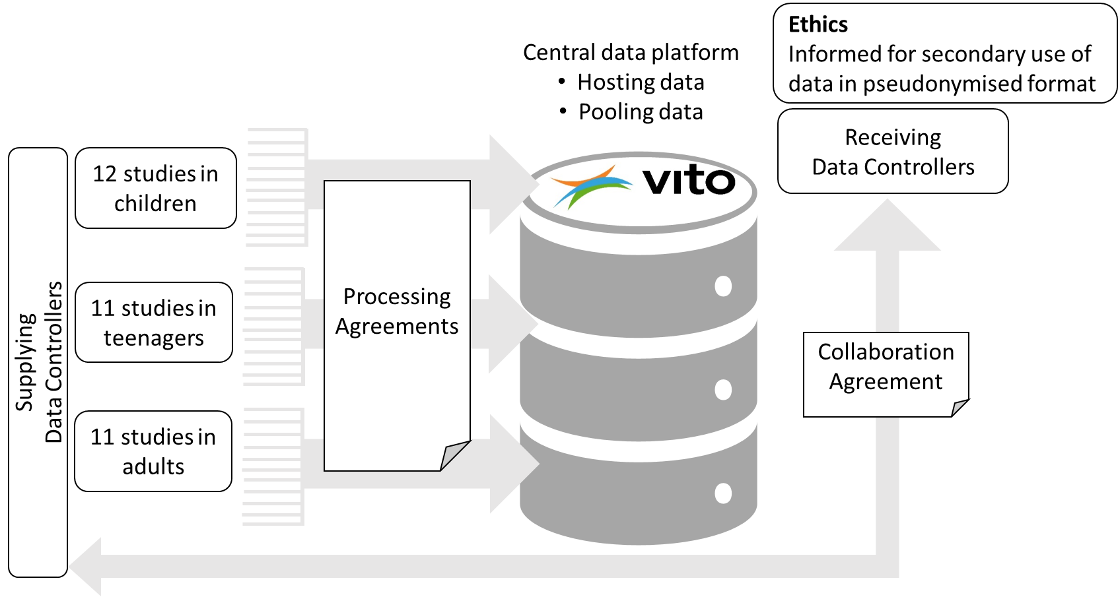
Supplementary Figure 2: Schematic presentation of data exchange agreements for the exchange and use of pseudonymised individual personal data.

