The influence of extracellular vesicles on tumor evolution and resistance to therapy

Enrique Bastón*¹, Juan García-Agulló*¹ and Héctor Peinado^{1#}

¹Microenvironment and Metastasis Laboratory, Molecular Oncology Programme, Spanish National Cancer Research Center (CNIO), Madrid, Spain.

* Equal contribution
# Correspondence: Héctor Peinado; e-mail: hpeinado@cnio.es

Running title: EVs and tumor evolution and resistance to therapy

Keywords: Extracellular Vesicles, Metastasis, Pre-metastatic niche, Therapy Resistance, Tumor evolution

Abstract
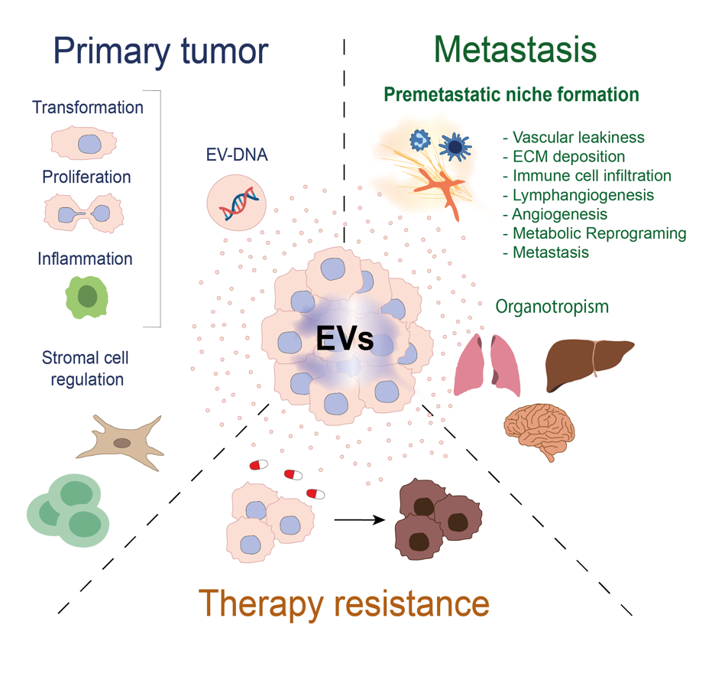
Disruption of cellular communication that regulates normal physiology is often key factor in the development of disease, including cancer. Extracellular vesicles (EVs) are mediators of cell-cell communication, modulating local and distant microenvironments and playing an important role influencing tumor progression at both early and late stages. Indeed, EV-mediated communication participate in the initial steps of primary tumor transformation and proliferation, as well as the preparation of the pre-metastatic niche and subsequent metastasis. In this context, the presence of DNA in EVs (EV-DNA) is particularly intriguing, with important biological implications and significant potential as a biomarker in liquid biopsies. In this review we will discuss the mechanisms involved in EV-shed DNA and the potential impact in tumor evolution. In addition, it has become apparent in recent years that the secretion of EVs also influences the behavior of the surrounding microenvironment. An important unresolved challenge in oncology is the resistance of tumors to treatment, one of the primary causes of high cancer mortality. The role of EVs in therapy resistance has garnered considerable interest. In the later part of this review, we will also examine the potential involvement of EVs in resistance to therapy.

Clinical Highlights
EVs are important mediators of cell-cell communication in both health and disease. Unraveling the complexities of how EVs reprogram cells and affect cancer progression holds immense potential for the development of novel therapeutic approaches. Moreover, understanding the diverse nature of EVs, and their contributions to tumor growth and spreading will offer valuable insights into cancer biology. EVs emerge as key players from the earliest stages of tumor formation to the later stages of metastasis, reshaping our understanding of cancer development and offering new possibilities for treatment. By deciphering the cargo in EVs and harnessing its therapeutic potential, we could move closer to realizing the goals of personalized cancer care and precision medicine. EVs can contain DNA, derived from the cells that produce them and in clinical terms, extracting these EVs from body fluids holds promise as a tool to track disease, although the superiority of this tool over cfDNA in liquid biopsies remains unclear. Nevertheless, the multifaceted cargo in EVs and their potential to outperform other biomarkers in liquid biopsies represents an intriguing avenue for further exploration.

Table of Contents
Abstract 2
Clinical Highlights 3
1. A Brief History of Extracellular Vesicles 5
1.1. EV nomenclature and biogenesis 6
1.2. EVs in immune cell regulation and development 11
13
2. Fertilizing the Metastatic Soil: The Role of Extracellular Vesicles in Tumor Growth and Metastasis 14
2.1. Understanding metastasis 14
2.2. The role of EVs in the primary tumor niche, and in promoting tumor growth and survival 17
2.3. Role of EVs in pre-metastatic niche formation and metastatic dissemination 22
2.4. Role of EVs in immune cell regulation during tumor progression 25
3. Exploring the Role of Extracellular Vesicles in Primary Tumor Evolution 27
3.1. The presence of genetic material in extracellular vesicles 27
3.2. The impact of extracellular vesicle-mediated horizontal transfer of DNA on primary tumor evolution 31
3.3. Examining extracellular vesicle DNA and its potential as a surrogate marker for mutations 35
4. The Influence of Extracellular Vesicles in Resistance to Therapy 38
4.1 The influence of EVs on resistance to therapy 38
4.2. The role of CSC-derived EVs in resistance to therapy 43
6. Conclusions 49
7. Funding 50
8. Author contributions 50
9. Acknowledgments 50
10. References 51

1. A Brief History of Extracellular Vesicles
Intercellular communication influences cell homeostasis and physiological processes. In addition to the secretion of soluble molecules, communication via extracellular vesicles (EVs) has emerged as an important element within this framework. Accordingly, the past decade has seen a notable increase in the study of EVs, enhancing our understanding of their functions (1).
The initial observations of material that could potentially be secreted via multivesicular bodies (MVBs) date back to the 1950s. One of the first descriptions of MVBs was in rat oocytes, as “vesicular structure, containing a large number of small vesicles” providing early indications that these structures could potentially liberate their content to the surrounding environment (2). Later, a biological role for secreted extracellular material was recognized when platelet-secreted vesicles were shown to be implicated in platelet activation during blood coagulation (Figure 1: (3)). Some years later, the term “exosome” was coined to define the microvesicles produced by both normal and neoplastic cells, and the 5'-nucleosidase activity they possessed suggested they fulfil a physiological role (4).
By 1983, a more comprehensive picture of the EV secretion pathway had been stablished. Studies into reticulocyte to erythrocyte maturation defined an active mechanism of secretion within a recycling system that involved transferrin and its receptor, a process characterized by MVB fusion to the plasma membrane (5, 6) (Figure 1). The term “exosome” was then specifically adopted to describe vesicles ranging from 40 to 100 nm in diameter that are actively secreted into the extracellular milieu. Subsequently, it was proposed that exosome secretion appears to release material that is superfluous to the cell (7). However, a seminal study in the 1990s was the first to ascribe EVs an active role in cell-cell communication, demonstrating that B lymphocytes infected with Epstein-Barr virus secreted exosomes enriched in major histocompatibility complex (MHC) class II (8). These exosomes could stimulate CD4⁺ lymphocytes and thus, a role for immune cell-secreted exosomes in antigen presentation was proposed. Another landmark study then revealed that exosomes derived from dendritic cells (DCs) contain both MHC class I and II, along with T lymphocyte co-stimulatory molecules, and that they were able to eradicate or suppress the growth of established murine tumors in a T cell-dependent manner (9)(Figure 1). Thanks to these pioneering studies, we have since been able to gain significant insights into the biogenesis of EVs and their activity.

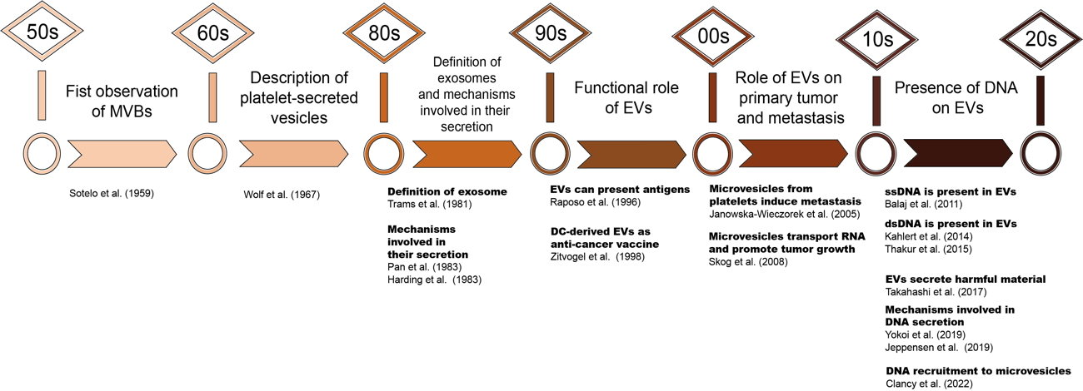
Figure 1. Timeline of the main milestones in extracellular vesicle (EV) research. The first observations date back to the 1950s and 1960s when multivesicular structures were observed in different prokaryotic and eukaryotic organisms, as was a role for platelet-derived EVs in coagulation. In the last 20 years, an important role for EVs in primary tumor development it has also been demonstrated, as well as in the formation of pre-metastatic niches and in advanced metastasis. The discovery of nucleic acids in EVs (especially DNA) opens up a wide range of possibilities to study the relevance of this material throughout tumor development.

1.1. EV nomenclature and biogenesis
Since the discovery of EVs, the different nomenclatures employed have generated some confusion over the years. In an effort to standardize this issue, biomarkers and other characteristics of these vesicles have been defined. Thanks to the International Society of Extracellular Vesicles (ISEV), leaders in the field have established guidelines for EVs (10, 11) and as a result, EVs are currently defined as a heterogeneous group of lipid membrane-based particles secreted by various cell types that can be found in any biological fluid, yet they lack a functional nucleus which makes them unable to replicate (12, 13). Based on their size, EVs can be categorized as large (lEVs) or small EVs (sEVs) (14). LEVs include microvesicles (150 nm - 1 µm), apoptotic bodies (1 µm - 5 µm) and large oncosomes (1 µm - 10 µm), whereas sEVs include exosomes that range from 50-100 nm in diameter (15). As cargo, EVs may be loaded with proteins, lipids and notably, nucleic acids (NAs). EV-associated NAs include RNA as well as DNA, which will be discussed in greater detail later in this review. In recent years, a population of non-vesicular extracellular particles (NVEPs) has also been defined, which include exomeres (16, 17) and supermeres (18, 19).
Historically, sEVs have been more extensively studied and the mechanisms driving their biogenesis have been thoroughly characterized. As such, sEV biogenesis primarily involves the endosomal pathway, a cellular process that centers on the internalization of receptors or cellular components that are then directed for secretion or lysosomal degradation (20, 21). The sequence within the endosomal pathway commences with the formation of early endosomes (EEs) through to the internalization of specific plasma membrane components. As these early endosomes mature into late endosomes (LEs), intraluminal vesicles (ILVs) are generated through intra-endosomal budding, forming MVBs. While the primary fate of MVBs is in the degradative pathway through their fusion with lysosomes, they may also fuse with the plasma membrane to release ILV-containing exosomes into the extracellular microenvironment.

Along the pathways involved in ILVs by the inward budding of MVEs, the role of the Endosomal Sorting Complex Required for Transport (the ESCRT) has been studied intensely in the formation of MVBs and ILVs (22, 23)(Figure 2-1). The ESCRT machinery was originally discovered in the late 1990s from studies of yeast mutants with defective transport of molecules to the vacuole (the equivalent of mammalian lysosomes (24-27). The ESCRT is made up of approximately thirty evolutionarily conserved proteins organized into four multi-protein sub-complexes (ESCRT-0, I, II and III), along with accessory proteins like Syndecans, ALIX or Syntenin-1 that are recruited sequentially to induce ILV excision (28)(Table 1).
Table 1. Description of ESCRT Complex

Complex | Main function | Protein members | References
ESCRT-0 | Binds and recruits ubiquitinated proteins into MVB | HRS, STAM (1 & 2) | (250-254)
ESCRT-I | Connects ESCRT-0 and ESCRT-II complexes to form ILVs by clustering ubiquitinated proteins | VPS23 (TSG101), VPS28, VPS37 (A-D), MVB12 (A, B) | (26, 255-258)
ESCRT-II | Initiates the budding process of the endosomal pathway and interacts with ESCRT-III | EAP20, EAP30, EAP45 | (259-262)
ESCRT-III | Triggers membrane scission to form ILVs | CHMP2 (A, B), CHMP6, CHMP3, CHMP4 (A, B, C) | (24, 263, 264)
VPS4-VTA1 Complex | Involved in ESCRT-III disassembly | VPS4, VTA1 | (25, 265, 266)
Accessory proteins | Recruit deubiquitinases to the ESCRT-III complex | ALIX | (267, 268)
Accessory proteins | Favors the formation of ILVs | Syntenin-1, Syndecans | (269, 270)

ILV formation in MVBs is not strictly dependent on the presence of ESCRT complexes since ESCRT-independent pathways that govern MVB formation exist in higher organisms (29). Along with other tetraspanins, CD63, CD9 and CD81 form clusters that facilitate the budding of protein rich microdomains (30)(Figure 2-1). Therefore, both ESCRT-dependent and ESCRT-independent pathways play crucial roles in the formation of sEVs and the incorporation of their cargo (Figure 2-1). The use of these distinct mechanisms appears to depend significantly on the specific cargo to be incorporated. For instance, ceramide produced by Neutral Sphingomyelinase 2 (nSMase2) is essential for the targeted sorting of proteolipid protein (PLP) into sEVs (31). Moreover, recent findings indicate that tetraspanin CD63 plays a crucial role in cholesterol sorting into ILVs (32). Hence, the involvement of each sorting mechanism sees to vary depending on the biological context, further highlighting the extensive heterogeneity among sEVs. Once formed, MVBs face two possible fates: degradation in the lysosomal pathway or secretion of their content in the form of sEVs (Figure 2). The quantity of sEVs released by a cell is inversely correlated to MVB degradation in lysosomes. Although the precise mechanisms governing the equilibrium between lysosomal degradation and sEV secretion are not fully understood, the significance of the Rab GTPase protein family in orchestrating these processes has been highlighted.
Regarding other proteins involved in small extracellular vesicle (sEV) secretion, among the more than 60 members of the Rab GTPase family associated with various intracellular compartments and functions, only a subset has been implicated (33). The main RAB GTPases that have been shown to be involved in the production and secretion of exosomes are RAB7, RAB11, RAB27, and RAB35 (34)(Table 2). Rab27 in particular plays a crucial role in generating sEVs and it has been studied extensively with respect to sEV trafficking to the cell membrane (Figure 2-2). Pioneering studies showed that inhibiting either Rab27A or Rab27B significantly dampens sEV secretion, for the first time suggesting that these proteins were crucial for sEV secretion from tumor cells (35). This role of Rab27 has been observed consistently in various tumor types, including bladder carcinoma (36) and melanoma (37). These proteins differ in their subcellular localization, with Rab27A primarily associated with CD63⁺ MVBs where it is involved in the intracellular mobilization of the actin cytoskeleton (38), while Rab27B localizes to the trans-Golgi region near the nucleus. Importantly, the coordinated action of Rab27a and the small GTPase Arl8 at membrane contact sites between pre-lysosomal endosomes and the endoplasmic reticulum is important for the efficient secretion of exosomes, highlighting the critical role of these small GTPases in exosome biology (39). Nevertheless, the extracellular vesicle (EV) secretion machinery varies depending on the cell type and tissue, involving different members of the Rab GTPase family(40). Specifically, Rab5, Rab7, Rab11, Rab27, and Rab35 are implicated in vesicle secretion, playing crucial roles in processes such as cancer progression (Table 2) .

Table 2. Description of Main Rab Proteins Involved in sEV Secretion

Protein | Localization | Function | Cell/Tumor type | References
Rab7 | Late endosomes and lysosomes | MVB transport to lysosomal pathway | Epithelial, HEK, Cervical cancer, Breast cancer, Melanoma | (271-274)
Rab11 | ER, Golgi and early endosome | Recycling from endosomal compartment to plasma membrane | Epithelial, Colon cancer, Cervical cancer, Chronic Myelogenous Leukemia, Neuronal | (275-278)
Rab27 | Late endosomes, secretory vesicles and melanosomes | Exocytosis events / Translocation of melanosomes to the plasma membrane | Cervical cancer, Bladder cancer, Melanoma, Head and neck squamous cell carcinoma, Breast cancer | (34-36, 136, 279)
Rab35 | Plasma membrane, recycling endosome | Protein recycling to the plasma membrane | Neuronal/glioma, Cervical cancer | (280-283)

The final stage in the release of ILVs into the extracellular domain as sEVs requires MVB fusion with the plasma membrane. The SNARE complex plays an important role in this process (Figure 2-3), a complex of receptors situated within the MVB (vesicle-SNARE or v-SNARE) or as membrane receptors (target-SNARE or t-SNARE). Interactions among these elements facilitate sEV release, along with recycling of the constituent elements through an ATP-dependent mechanism (41). Among the v-SNARE proteins are Vesicle-associated membrane proteins (VAMPs), whose exact functions remain unclear. Consequently, significant challenges and controversies persist in understanding the specific machinery involved in small extracellular vesicle (sEV) shedding, particularly in the context of tumor cell biology.
Despite the historic relevance of sEVs, in recent years lEVs have been seen to be important players in the cellular communication driven by EVs despite being the focus of fewer studies. As described above, lEV are generated by direct blebbing of the plasma membrane, driven through the direct interaction of the actin and myosin cytoskeleton with small GTP and ARF proteins (42)(Figure 2-4). In healthy cells, lEV formation involves rearranging lipid components of the plasma membrane and notably, maintaining lipid asymmetry in the plasma membrane is crucial to mobilize the cytoskeleton and facilitate lEV formation. The enzymatic activity of acid sphingomyelinase, responsible for hydrolyzing sphingomyelin to ceramide, promotes plasma membrane lipid modifications, thereby triggering lEV formation in glial cells (43). Furthermore, the presence of cholesterol in the membrane promotes the formation of lEVs in activated platelets (44), while external factors like elevated Ca²⁺ concentrations favor lEV secretion (45).
In 2009, the first evidence linking the ARF6 protein to cytoskeletal remodeling highlighted how ARF6 activation promotes lEV production in melanoma cells through downstream signals that act through its effectors, phospholipase D, ERK and myosin light-chain kinase (MLCK: (46). However, ARF6 overexpression in HeLa cells does not affect lEV secretion, although RhoA and its effectors do play a critical role in lEV biogenesis in these cells (47). Likewise, the small GTPase ARF1 was found to regulate matrix metalloproteinase (MMP)-9 activity, thereby favoring lEV shedding (48). Some proteins of the ESCRT machinery have been also implicated in membrane budding (49), such that these studies underline the heterogeneity in lEV formation (Figure 2-4), highlighting the need to further explore and unravel the mechanisms underlying lEV biogenesis.
The presence of bioactive molecules within EVs enables them to participate in cell-cell communication over short and long distances. The information encapsulated in EVs is transmitted to recipient cells through membrane fusion or via interactions with molecules on the surface of the recipient cell. A crucial breakthrough was the discovery of NAs (RNAs) in EVs that had the capacity to actively influence host cells following the translation of the information they encode (50). This breakthrough raised many new possibilities and amplified the communication potentially of EVs, which was thereafter explored extensively. Different mechanisms of EV uptake have now been described, depending on the origin of the EVs and the type of recipient cell. The interaction between EVs and recipient cells involves specific membrane receptors, endocytotic processes (pinocytosis or phagocytosis), intracellular proteins (clathrin), lipid rafts (caveolae) or direct membrane fusion (51).

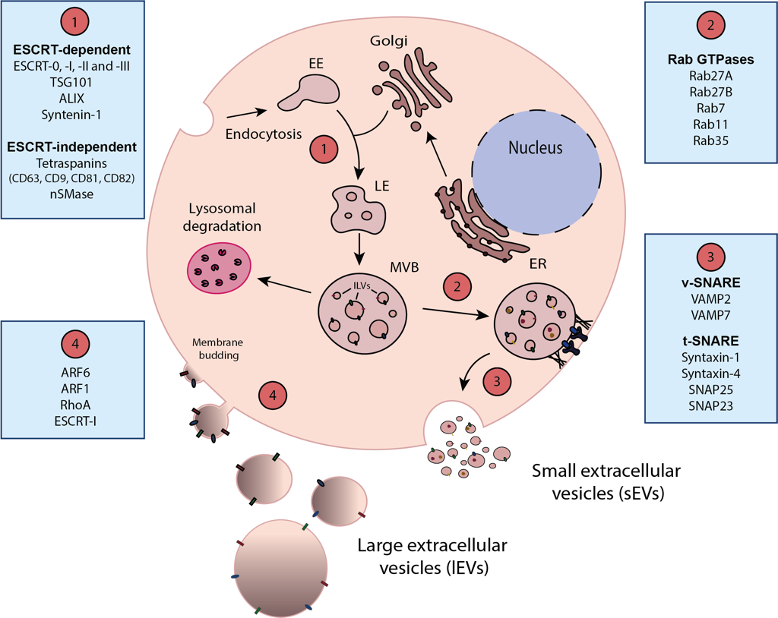
Figure 2. Mechanisms involved in EV biogenesis. Scheme representing the mechanisms underlying the biogenesis and the release of small (sEVs) and large extracellular vesicles (lEVs). (1) Initiation of sEV generation involves various endocytotic processes that lead to the formation of early endosomes (EEs). Subsequent maturation of EEs into late endosomes (LEs) can occur via pathways dependent on or independent of ESCRT (Endosomal Sorting Complex Required for Transport). In the ESCRT-dependent pathway, successive incorporation of ESCRT (0, I, II, III) and accessory proteins (e.g., TSG101, ALIX, Syntenin-1) results in the formation of intraluminal vesicles (ILVs). Alternatively, this process may be driven through the tetraspanin family (CD63, CD9, CD81 and CD82) of proteins along with other proteins (nSMase) in an ESCRT-independent manner. The incorporation of proteins from the Golgi apparatus, together with the aforementioned mechanisms, culminates in the LE maturing into the multivesicular body (MVB). (2) The MVB may then either degrade in lysosomes or be secreted into the extracellular milieu. Proteins of the RabGTPase family (such as Rab27A and Rab27B) are involved in the movement of the MVBs to the membrane for secretion. (3) The final step of MVB fusion with the plasma membrane for sEV secretion depends on the interaction between vesicular proteins (v-SNARE) and plasma membrane proteins (t-SNARE). This interaction forms a protein complex necessary for the release of sEVs into the extracellular milieu. (4) Secretion of lEVs involves direct membrane blebbing facilitated by the interaction of the cell cytoskeleton with proteins of the ARF family (ARF6, ARF1) and small GTPases (RhoA). Some proteins of the ESCRT machinery are also involved in membrane budding. ER: Endoplasmic Reticulum.

1.2. EVs in immune cell regulation and development
While our primary emphasis in this review is on the impact of EVs within the context of tumor progression and metastasis, it is crucial to acknowledge that EVs also play an important role in physiological processes like development (52), or in regulating the cells responsible for immune responses (53)(Figure 3A). The innate immune system is the primary line of defense in an organism, in which inflammation is a key mechanism. EVs have been attributed a dual role in inflammation as they may have both pro-inflammatory and anti-inflammatory effects. For example, the uptake of EVs derived from necrotic cells by macrophages induces the production of pro-inflammatory cytokines like TNF-α and CCL2, as is also the case for apoptotic cell-derived EVs (54). By contrast, EVs secreted by neutrophils (named ectosomes) contain TGF-β and certain membrane lipids that favor an anti-inflammatory response (55). Moreover, Natural killer (NK) cells have the capacity to generate EVs irrespective of their activation status, and these vesicles express typical protein markers of NK cells that produce cytotoxic activity against several tumor cell lines (i.e. Fas ligand and perforin), and against activated but not resting immune cells (56). This pro-inflammatory activity of EVs due to specific mediators or damage patterns, as well as their anti-inflammatory role in certain contexts, is highly context-dependent and influenced by the EVs secreted by cells of the innate immune system.
Antigen-presenting cells (APCs), represent a crucial link between the innate and adaptive immune systems and their maturation is associated with an enhanced capacity to secrete more EVs enriched with MHC-antigens. EVs from DCs can activate the adaptive immune system by inducing antigen-specific naïve CD4⁺ T cell activation or by priming naïve T cells (57, 58). Following activation by the T cell receptor (TCR), T lymphocytes bearing the TCR/CD3/zeta complex enhance their ability to secrete EVs compared to basal conditions (59). Notably, T cell derived EVs can activate mast cells by triggering the degranulation induced by IL-24 production (60). Furthermore EVs fulfil diverse roles in both the initiation and effector phases of immune responses ((61), and they influence the effectiveness of immune cell responses. Indeed, EVs have also been implicated in autoimmune diseases (62, 63).
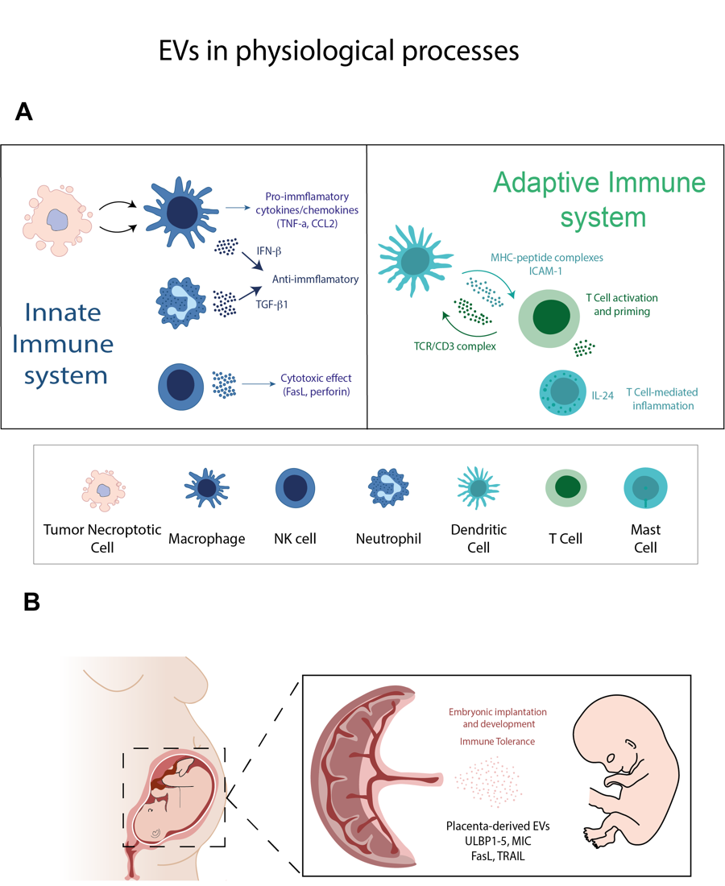
EVs may also be involved in the bidirectional regulation of the immune system during pregnancy (Figure 3B), when immunosuppression is necessary to establish the immune tolerance in women necessary for the ‘semi-allograft’ fetus to develop (64). The involvement of EVs in immune cell regulation has also been described during gestational development, when immunosuppression is necessary in pregnant women to establish the immune tolerance required to allow the ‘semi-allograft’ fetus to develop (64). Pregnant women have more plasma EVs than normal (65), and EVs from placental trophoblasts and maternal thrombocytes can trigger immune tolerance through STAT3 phosphorylation in T cells (66). Moreover, EVs derived from the human placenta can dampen T cell and NK cell cytotoxicity (67), as well as inducing apoptosis of activated immune cells (PBMCs)((68). Hence, circulating EVs represent a novel form of communication between the placenta and the maternal immune system to ensure embryonic development. In addition, maternal EVs promote embryo implantation, with maternal endometrial miRNAs potentially modifying the transcriptomic of the pre-implantation embryo (69). Although there are limited studies, EVs derived from porcine embryos in vitro were found to contain miRNAs associated with pluripotent genes, including Oct4, Sox2, Klf4, c-Myc and Nanog. Embryos produced in vitro can secrete EVs that possibly enable them to communicate with their microenvironment (70), which suggests a potential contribution of miRNAs secreted from embryonic cells to the processes of implantation and development.
In summary, over recent years our understanding of the importance of EVs in various physiological processes has advanced significantly, shedding light on the regulation of immune cell responses, particularly during pregnancy. From here onwards, we will focus on the role of EVs secreted by tumor cells on the establishment of primary tumors, their growth and the process of metastasis.
Figure 3. EVs in physiological processes. (A) EVs play an important role in regulating and mediating communication within the innate and adaptive immune systems, thereby promoting anti-tumor responses. The interaction between tumor necroptotic cells and innate immune cells stimulates the secretion of EVs that carry pro-inflammatory factors (e.g. TNF-α, CCL2) and anti-inflammatory factors (e.g. IFN-β, TGF-β1), eliciting context-dependent responses. Furthermore, EVs derived from innate immune cells (e.g. NK cells) harbor cytotoxic proteins (FasL, perforin), which contribute to anti-tumor effects. Crosstalk between the innate and adaptive immune systems via EVs facilitates T cell activation through MHC-antigen-enriched EVs. In turn, activated T cells enhance their activity by secreting TCR/CD3-enriched EVs into the innate immune system and EVs capable of activating mast cell-mediated degranulation via IL-24. (B) During gestational development, EVs contribute to the establishment of an immunosuppressive environment crucial for fetal implantation and development. This immunosuppression is facilitated by EVs enriched with proteins that dampen immune activity (e.g. ULBP1-5, MIC, FASL, TRAIL).

2. Fertilizing the Metastatic Soil: The Role of Extracellular Vesicles in Tumor Growth and Metastasis

2.1. Understanding metastasis
In 1889, the pathologist Stephen Paget proposed the concept of ‘seed and soil’ (71). This concept emerged from necropsy studies on 735 women with breast cancer, noting that the metastatic behavior of their tumors could not be explained by mechanical factors alone. Tumor cells in the breast had a much greater predisposition to metastasize to the liver than to other organs with a similar vascular supply, like the spleen. A predisposition to settle in specific bones like the femur was also noted. According to Paget, this phenomenon can be attributed to a specific and selective interaction between the tumor cells ("seed") and the distant organs ("soil"), and as a given seed type thrives best in a specific soil, so do tumor cells find it easier to metastasize to certain organs (71). This concept, initially based on empirical observations of probability, marked a significant breakthrough in the understanding of metastasis. Although James Ewing later argued that metastatic spread was exclusively due to mechanical factors (namely the anatomy of the vascular system), considering metastasis to be a purely passive process (72), it is now clear that metastasis is an active process that cannot be fully explained by vascular considerations alone.
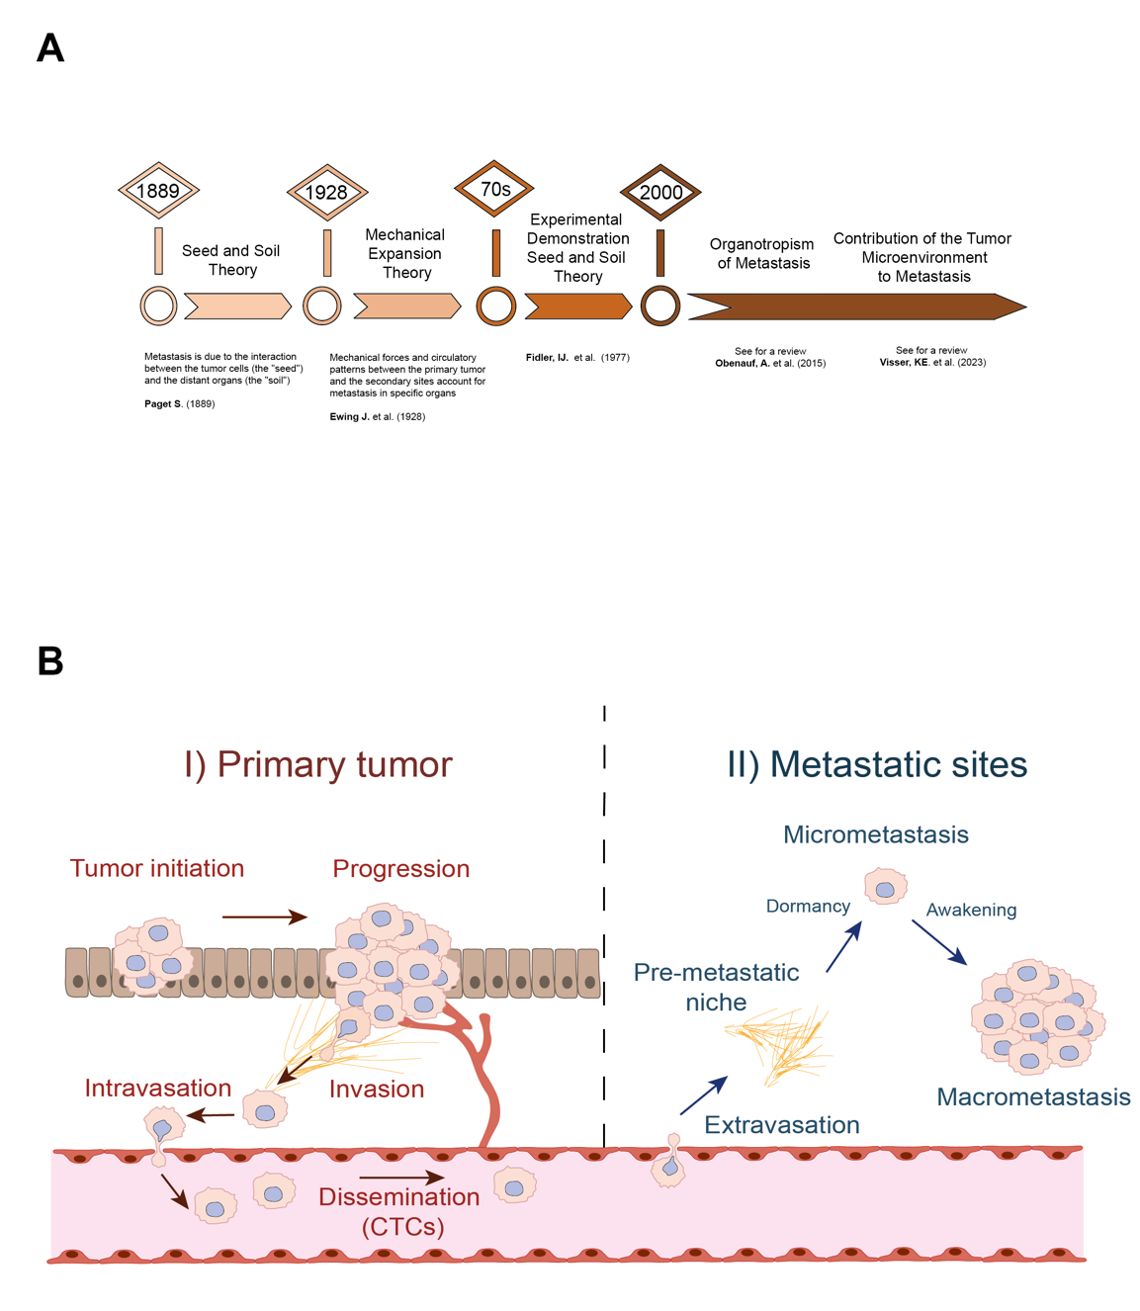
The ‘seed and soil’ theory was consolidated throughout the 70s and 80s, gaining acceptance within the scientific community. Indeed, Isaiah J. Fidler carried out important studies that marked the first steps towards demonstrating what Paget had proposed almost a century earlier (Figure 4A). Many of these advances regarding the requirements of tumor cells to metastasize to specific organs were revisited by Fidler in two important reviews (73, 74). In early studies, on syngeneic models of melanoma metastasis using the B16 cell line, only a small proportion of tumor cells were seen to be capable of metastasizing (75). Moreover, Fidler was the first to demonstrate that metastatic cells were derived from a small subset of cells within the primary tumor (76). These findings represented a significant advance in understanding metastasis and led to new hypotheses based on the special traits of metastatic tumor cells, helping to define the concept of site-specific metastasis. He then went on to describe some relevant mechanisms of site-specific metastasis in different organs like the brain (77, 78), liver (79) or bone (80). Today, metastatic dissemination is much better understood, and the significance of the interactions between disseminated tumor cells and specific organs is widely acknowledged. Genomics and systems approaches have provided important insights into the cancer cell traits that drive the interactions with stromal niches and that facilitate organ-specific metastasis, and the relevance of the microenvironment in metastatic dissemination is also well established, as compiled in a recent review (81)(Figure 4A).

Figure 4. Tumor evolution and metastasis. A. Timeline of the main studies and ideas in the field of metastasis. B. The progression of cancer involves multiple steps, culminating in metastasis. Following the initiation and growth of the primary tumor locally, tumor cells must attain the capacity to invade surrounding tissues and enter the bloodstream, where they disperse as circulating tumor cells (CTCs). This marks the initial crucial phase in tumor expansion and metastatic spread, characterized by the physical translocation of tumor cells from the primary tumor (I). However, effective metastasis entails several further steps. The subsequent critical phase, termed distal organ colonization (II), requires the tumor cells to exit the bloodstream, survive in a novel milieu to form micrometastases and then adapt to the new environmental cues to ensure the growth of macrometastases. This progression is influenced by the formation of a pre-metastatic niche (PMN) within the distant organs, which facilitates the metastatic process.

Simplistically, metastatic dissemination can be divided into two fundamental processes: physical translocation from the primary tumor to the site of dissemination; and colonization/adaptation of disseminated cells to the microenvironment of the distant organ (82, 83). Each of these processes can be further divided into several stages that tumor cells must navigate to metastasize. After tumor initiation and progression, tumor cells must acquire an invasive phenotype to be able to migrate through the stroma of the organ of origin and intravasate into the bloodstream. Subsequently, circulating tumor cells (CTCs) within the bloodstream must learn how to survive and successfully extravasate into the appropriate tissue. Concomitant with tumor cell dissemination, pre-metastatic niches (PMNs) form in the metastatic organs to which tumor cells are able to successfully home and form micro-metastatic foci (82, 83). Subsequently, tumor cells in the metastatic organs must adapt to the new microenvironment and develop macrometastatic foci (Figure 4B).
This process of dissemination is highly inefficient, requiring tumor cells to acquire a range of traits that enable them to progress through each metastatic stage (84). A quintessential hallmark of malignancy is the capacity for self-renewal, an attribute are often associated with specific subpopulations within tumors recognized as cancer stem cells (CSCs) (85), cells that normally constitute only a small fraction of the overall tumor mass. Remarkably, there is data supporting the existence of a minor population of tumor cells in continuous evolution along the metastatic pathway that have the ability to successfully invade distal organs, referred to as metastasis initiating cells (MICs)(86). During tumor progression, clonal expansion akin to the principles of Darwinian evolution drives malignant tumor development and metastasis. Comparing the genetic features of primary tumors and metastases has revealed important disparities between the metastatic lesions and their primary counterparts, primarily due to sub-clonal selection. These studies also revealed different modes of metastatic progression driven by underlying genetic variations. Indeed, competitive or co-operative interactions appear to be established among distinct sub-clones during metastasis that play a pivotal role in shaping the genetic diversity observed in metastatic lesions (87).
Organ-specific metastasis is currently understood as a very intricate process influenced by a myriad of factors (88)(Figure 4A). One intriguing insight is that the initial arrival of tumor cells to distant organs does not seem to be the primary rate-limiting factor of metastasis but rather, cancer cells can enter secondary organs and persist in a dormant state for extended periods (89). Consequently, the transition from cell infiltration to successful colonization represents a pivotal step in the metastatic cascade. Completing this transition means cancer cells have evaded detrimental signals to then capitalize on the supportive and survival cues provided by the host organ.
EVs have emerged as pivotal players in the context of metastasis, participating actively in various stages of this process (90). By exploring the significance of EVs in metastasis, it becomes clear that they are instrumental in shaping the microenvironment of both the primary tumor and the distant organ, influencing the fate of disseminated cancer cells (91). Revisiting the classic "seed" and "soil" analogy of metastasis, EVs assume an important role as their cargo, consisting of growth factors, signaling molecules and genetic material, conditions or “fertilizes” the “soil”, interacting with resident cells to ensure a supportive niche is established for incoming cancer cells at potential metastatic sites (92). Furthermore, EVs also contribute to the molding of primary tumors, influencing tumor development and the acquisition of malignant traits from the very earliest stages of cancer progression. This multifaceted role of EVs highlights their critical importance in the complex landscape of metastasis.

2.2. The role of EVs in the primary tumor niche, and in promoting tumor growth and survival
EVs released by tumor cells have a significant influence on the primary tumor microenvironment, playing a pivotal role in the early stages of tumor development. These vesicles carry a cargo rich in proteins crucial for the survival and proliferation of the primary tumor. Thus, the intricate relationship between tumor-derived EVs and their microenvironment highlights their key role in shaping the conditions that favor tumor progression (93). The wide relevance and increasing knowledge of the nature and characteristics of EVs has led to their use at the translational level in different clinical trials. This table gathers the information of relevant clinical trials selected based on our criteria (Table 3). In addition a systematic review of the different clinical trials available in the field of EVs together with different applications has been recently published by other authors(94). The effect of EVs on primary tumor development is manifested in different dimensions. Firstly, EVs influence the communication between tumor cells and the tumor niche to aid the development of the former. Consequently, the significance of their communication with cancer associated fibroblasts (CAFs) in tumor development has been studied extensively. Melanoma-derived EVs were proposed to play an important role in the formation of the primary tumor niche by supporting fibroblast proliferation, migration and the initiation of the proinflammatory transcriptional programs characteristic of CAFs. Notably, the miRNA-211 within these vesicles targets IGF2R and activates the MAPK pathway, fostering reciprocal growth in melanoma (95)(Figure 5-1).
Table 3. Selection of active clinical trials with known status, involving ispecific EV biomarkers across different tumor types.

NCT Number | Use | Target | Year | Disease Stage | Tumor Type
NCT03985696 | Response to therapy | Protein - CD20, PDL-1 | 2019 | Advanced - Inmunotherapy | Lymphoma
NCT04852653 | Response to therapy | Protein, DNA | 2021 | T2, T3, T4 - Neoadjuvant treatment | Rectal Cancer
NCT05575622 | Response to therapy | Protein - PD-L1, LAG3 | 2022 | Stage IV - Immunotherapy | Hepatocellular Carcinoma
NCT05705583 | Response to therapy | RNA | 2023 | Advanced - Inmunotherapy | Renal Cell Carcinoma
NCT05854030 | Response to therapy | miRNA | 2023 | Stage IV - Immunotherapy | Lung Cancer
NCT06104930 | Response to therapy | DNA methylation | 2023 | Indication for radiotherapy | Meningioma
NCT05218759 | Response to therapy | miRNA | 2022 | Advanced - Anlotinib | Lung Cancer
NCT04499794 | Prognosis | EML4-ALK fusion | 2020 | IIIB-IV unresectable | Lung Cancer
NCT04948437 | Prognosis | Thyroglobulin and Galectin-3 | 2021 | Any | Thyroid Cancer
NCT05463107 | Prognosis | Proteins (see details in trial) | 2022 | Any | Thyroid Cancer
NCT05798338 | Diagnosis/Prognosis | Protein - EV - SIMOA/ELISA | 2023 | Stage I-III | Breast Cancer
NCT05831397 | Diagnosis/Prognosis | Protein - EV - SIMOA/ELISA | 2023 | Any | Breast Cancer
NCT02147418 | Diagnosis | Protein | 2014 | Any | Oral Squamous Cell Carcinoma
NCT05417048 | Diagnosis | miRNA - glycosylated EVs | 2022 | Any | Breast Cancer
NCT05587114 | Diagnosis | ctDNA, CTCs and EV | 2022 | Any | Lung Cancer
NCT06278064 | Diagnosis | Protein - Proteomics | 2024 | Stage I-II | Gastric Cancer
NCT03791073 | Diagnosis | Interstitial tissue fluid, Proteomics | 2018 | Any | Pancreatic Cancer
NCT06702891 | Diagnosis | Protein, RNA, DNA | 2024 | Any | Gastric Cancer

Moreover, studies on different tumor types have highlighted the intricate EV-mediated communication between cancer cells and CAFs. The EVs derived from prostate cancer and mesothelioma are particularly noteworthy, with the membrane-bound TGF-β along with the betaglycan carried by these EVs activating SMAD-dependent signaling in primary lung fibroblasts, promoting their differentiation into CAFs (96). This interplay was examined in other contexts and for instance, the presence of miRNA-494 and miRNA-542-3p in EVs from the BSp73ASML rat adenocarcinoma metastatic model enhances MMP expression and downregulates cadherin 17 in reticular fibroblasts, forming a pro-invasive niche (97). Importantly, the interaction between tumor cells and CAFs within the niche mediated by EVs is bidirectional (98). A pivotal study showcased the significant impact of CAF-derived EVs on breast cancer cells, revealing that by transferring Cd81 and activating an autocrine Wnt-PCP pathway these EVs are critical to enhance tumor cell motility (99).
In addition to its role in the primary tumor microenvironment, communication through EVs appears to play an intrinsic role in conferring malignant traits to tumor cells (Figure 5-2). Notably, oncoproteins like PDGFR, Met, β-catenin, Ras and Akt have been identified as cargo within EVs, and when cells take up these EVs these proteins produce profound biological alterations, potentially inducing genetic instability and enhanced aggressiveness (90). Pioneering studies revealed that EVs derived from glioblastoma contained mRNAs, miRNAs and angiogenic proteins that were internalized by tumor cells, promoting proliferation (100). Notably, tumor-specific EGFRvIII was discovered in EVs from glioblastoma patients, suggesting potential diagnostic applications when analyzing liquid biopsies. Subsequently, this groundbreaking work was followed by numerous studies confirming that EVs facilitate the horizontal transfer of miRNAs to cells throughout tumor progression (Figure 1). Hence, the involvement of EVs in reprogramming the transcriptome of the recipient cells became relevant, particularly in breast cancer where proliferation is promoted and non-tumorigenic cells are converted to a tumorigenic phenotype (95).
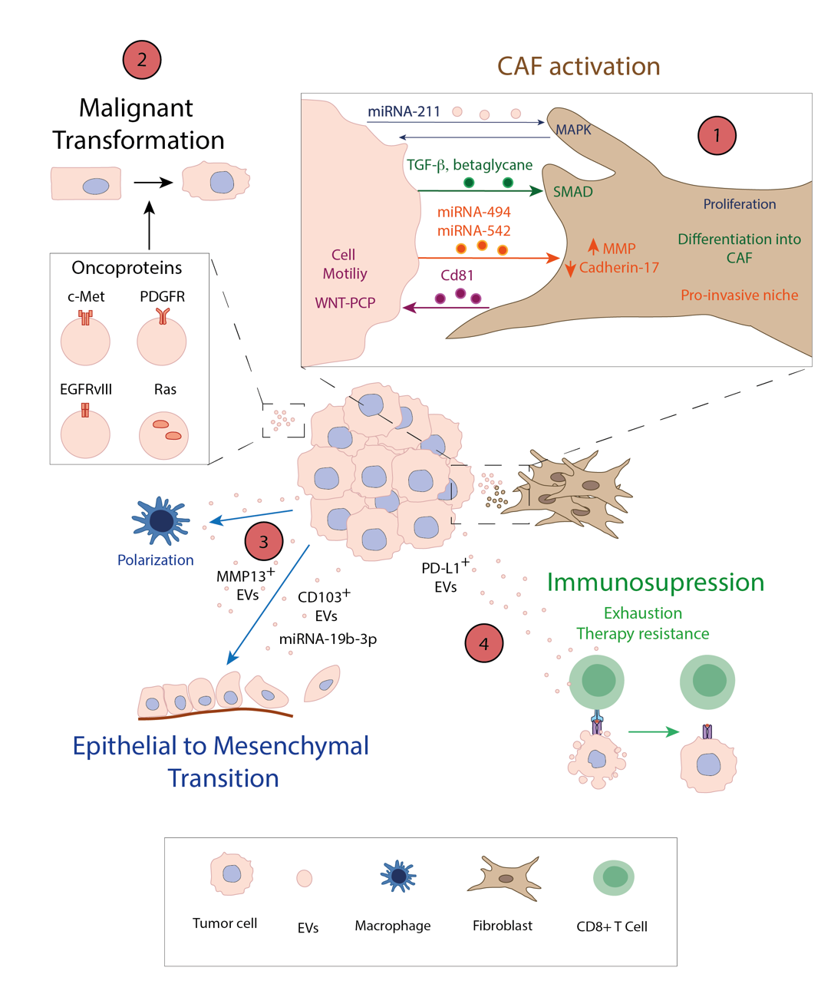
Interestingly, EVs are involved in multiple aspects of tumor cell motility, including targeting, cell adhesion and extracellular matrix (ECM) degradation (101). Indeed, it was originally proposed that EVs are involved in establishing cell and tissue polarity (102), and accordingly, much effort has focused on the role of EVs in cell plasticity and dissemination, such as the epithelial-to-mesenchymal transition (EMT). The EMT is a complex process whereby epithelial cells lose their epithelial properties and acquire a mesenchymal-like phenotype. This transformation is characterized by the downregulation of E-cadherin and other typical epithelial markers, along with the disruption of apical–basal cell polarity (103). EMT was initially identified in early embryogenesis as a crucial event to facilitate cell motility. However, the last two decades have seen that EMT plays a crucial role in tumor progression (as does the inverse mesenchymal-to-epithelial transition -MET), not only in tumor invasion but also, at various stages of the metastatic cascade and in terms of resistance to therapy.

Figure 5. The influence of EVs on primary tumor growth. EVs are crucial in stromal activation and to modulate primary tumor growth through different mechanisms. (1) They contribute to CAF activation through multiple pathways: promoting proliferation by the horizontal transfer of miRNA-211, enhancing differentiation through TGF-β1, and contributing to a pro-invasive niche via miRNA-494 and miRNA-542. In addition, CAFs secrete Cd81 in EVs that contribute to tumor cell motility and the activation of the WNT-PCP pathway. (2) EVs also contribute to the malignant transformation of neighboring cells by carrying oncoproteins such as c-Met, PDGFR, EGFRvIII and Ras. (3) Tumor-secreted EVs are able to mediate EMT by promoting macrophage polarization and secreting different proteins like MMP13, or miRNAs such as miRNA 19b-3p. (4) EVs derived from tumor cells are also involved in immunosuppression by secreting PD-L1, and inducing T cell exhaustion and resistance to immunotherapy.

How the invasive phenotype of cancer cells affects EV release and malignancy is an important question. It is well-established that cancer cells release higher amounts of EVs compared to non-malignant cells (104). Interestingly, the enhanced release of EVs in cancer cells is influenced by both cell-intrinsic factors, such as oncogenic transformation, and environmental signals, including hypoxia and cellular stress, which activate multiple signaling pathways (104). Beyond increasing EV secretion, malignant cells also enhance their capacity to pack cargo—such as proteins and DNA—into EVs (37, 105). Therefore, malignant transformation not only affects the number of EVs released but also the volume and content of cargo loaded into these vesicles. Given the biological effects of EVs described in this review, considerable efforts are underway to target specific pathways involved in EV secretion or cargo packaging as potential anti-tumor therapies(106).
In addition, EVs are known to contain proteases (e.g. MT1-MMP) that are involved in proteolytic degradation and remodelling of the ECM facilitating the tumor cell invasion, EMT and metastasis(107). Considering this evidence, attention has increasingly turned to the impact of EVs on EMT in recent years. The initial evidence of this association came from a proteomics study on bladder carcinoma, which revealed an enrichment of EMT-related proteins in the lumen of EVs derived from metastatic tumors (108). This connection was confirmed in oral squamous carcinomas, where horizontal transfer of MMP13 by EVs between tumor cells promotes metastasis and enhances the expression of mesenchymal markers typically associated with EMT (109) (Figure 5-3). More recently, EVs were seen to enhance EMT in oral squamous tumors, inducing macrophage polarization (110, 111). As well as these advances, CD103 CSCs⁺-derived EVs induce EMT in clear cell renal cell carcinoma through PTEN inhibition and via the horizontal transfer of miRNA-19b-3p (112). Nevertheless, our current understanding of this relationship remains incomplete and there is still insufficient evidence to conclusively support this link in vivo. Thus, further research using in vivo models and different tumor types will be necessary to elucidate whether EV-mediated regulation of EMT is relevant in cancer. The ability of EVs to influence tumor cell proliferation has also been studied in metastatic niches. In the context of brain metastasis, tumor cells selectively downregulate the expression of the PTEN tumor suppressor gene in a brain niche-specific manner, promoting tumor proliferation. The underlying mechanism appears to rely on the horizontal transfer of miRNAs via EVs released by brain astrocytes. Indeed, inhibiting EV secretion by astrocytes rescues PTEN expression and suppresses brain metastasis (113).

2.3. Role of EVs in pre-metastatic niche formation and metastatic dissemination
As tumors progress they secrete soluble factors and shed EVs that influence primary tumor growth, as well as the formation of PMNs. Indeed, tumors have an effect on the microenvironments in distant organs, establishing a milieu favoring the survival and outgrowth of tumor cells upon their arrival (114). The contribution of tumor-derived factors to PMN formation has opened a new era in metastasis research, particularly in relation to tumor-secreted EVs (90). The influence of EVs on metastatic dissemination and PMN formation has been shown in several tumor types. Pioneering studies showed that EVs from platelets promote tumor progression, metastasis and angiogenesis by stimulating the expression of angiogenic factors like MMP‐9, vascular endothelial growth factor (VEGF), interleukin‐8 (IL-8) and hepatocyte growth factor (HGF), as well as adhesion to fibrinogen and endothelial cells (115). Subsequently, CSC-derived EVs expressing CD105 were implicated in the angiogenic switch of endothelial cells that favors metastatic dissemination of renal cancer in the lungs (Figure 6-1) (116). Similarly, EVs favor the assembly of a soluble matrix in models of pancreatic cancer, enhancing metastatic dissemination in cooperation with soluble factors and dependent on CD44v6 (Figure 6-1). Moreover, melanoma-derived sEVs somehow increase sentinel lymph node metastasis, suggesting an involvement of EVs in local metastatic dissemination (117). Hence, the main idea was that EVs secreted by primary tumor cells appear to influence local and distal metastasis by provoking changes in PMNs.
Building upon these insights, we extended our understanding of the effects of melanoma-derived sEVs (37), proposing that tumor-derived sEVs promote: 1) the formation of PMNs in distal organs by increasing vascular leakiness and bone marrow cell recruitment; and 2) the reprograming of bone marrow progenitors toward a pro-vasculogenic and pro-metastatic phenotype through a mechanism dependent on the c-Met oncoprotein carried in sEVs (Figure 6-1). This highlights the influence of EVs on distant organs and how they can affect both PMNs in organs and immune cell niches, facilitating metastatic dissemination. Moreover, sEVs were further demonstrated to drive organotropic metastatic tropism of different tumor cells to distinct organs (e.g. breast and pancreatic cancer). As such, sEVs derived from tumor cells with tropism to the lung, liver and brain preferably fused with stromal cells in these specific organs, promoting organ-specific metastasis (118). This process was dependent on specific integrins in the EVs, with integrins α6β4 and α6β1 implicated in lung metastasis, while exosomal integrin αvβ5 was associated with liver metastasis (Figure 6-2). Targeting these integrins, decreased sEV uptake, and reduced metastasis to the lungs and liver. Importantly, this data also suggests that exosomal integrins may serve as predictive markers for organ-specific metastasis (118). In addition, sEVs derived from pancreatic ductal adenocarcinoma (PDAC) were shown to be involved in liver PMN formation by attracting bone marrow-derived macrophages, enhancing fibronectin deposition in the liver and establishing an environment favorable for the initiation of metastatic seeding in a process involving the macrophage migration inhibitory factor (MIF) (119)(Figure 6-3)
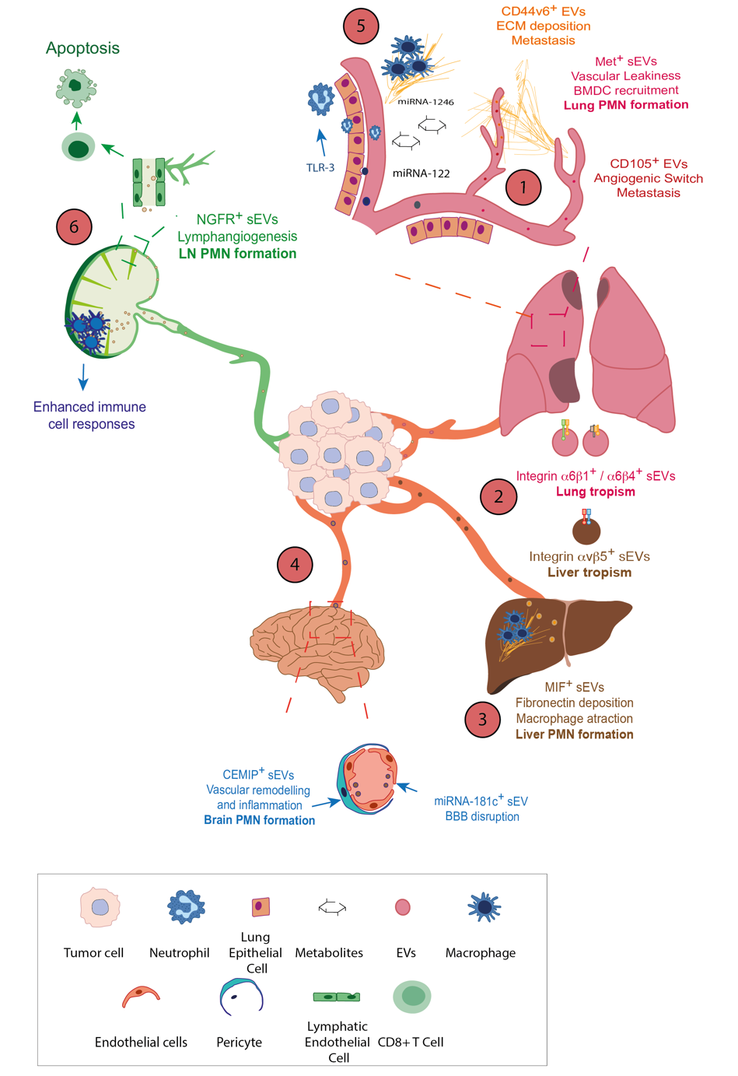
Tumor-derived EVs have also been implicated in disrupting the endothelial barrier in several organs (120), as well as by provoking a loss of integrity at the blood-brain barrier (BBB) when forming a brain PMN (121, 122)(Figure 6-4). Breast cancer-derived EVs were proposed to induce BBB breakdown in a mechanism dependent on the miRNA-181c downregulation of its target gene, PDPK1 (121). Moreover, secretion of Cell Migration Inducing Protein, Hyaluronan Binding (CEMIP) in tumor-derived sEVs was identified as a key driver of brain PMN formation, inducing endothelial cell branching and inflammation, suggesting it may be a potential target to prevent and treat brain metastasis (122). Besides the protein cargoes of secreted EVs, miRNAs have been also implicated in the generation of PMNs (123). Vesicles containing miRNA-122 reprogram glucose metabolism in PMNs (Figure 6-5), thereby facilitating metastasis, while inhibiting miRNA-122 in vivo restores glucose uptake and limits the formation of metastases. This was the first indication of the influence of EVs on the metabolic state of distant organs, thereby influencing PMN formation and opening a novel area for study. Nevertheless, our understanding of how primary tumor-secreted factors facilitate PMN formation, particularly by influencing nutrient availability, remains limited. It was recently proposed that tumor-secreted factors might provoke an increase in palmitate availability in pre-metastatic lungs (124). While the contribution of EVs to this process was not specifically studied, the available evidence is compatible with soluble factors and EVs regulating metabolism within PMNs, thereby influencing early metastatic dissemination.
Figure 6. Influence of EVs in PMN formation. EVs contribute to the formation of pre-metastatic niches (PMNs) through different mechanisms. (1) Tumor secreted EVs carry different proteins (e.g. Met+, CD105, CD44v6) that are involved in the formation of lung PMNs (defined by greater vascular leakiness and BMDC recruitment), promoting an angiogenic switch and ECM deposition, and favoring metastasis to the lung. (2) The expression of integrins drives EV tropism to distal organs, which contributes to organ-specific metastasis: integrins α6β1 and α6β4 are involved in lung tropism, and α_{v}β5 integrin in liver tropism. (3) Tumor-secreted EVs also contribute to liver PMN formation and metastasis through the MIF contained in sEVs that favors the deposition of fibronectin, resulting in macrophage recruitment. (4) Similarly, secretion of CEMIP in tumor-derived sEVs favors PMN formation in the brain, promoting vascular remodeling and inflammation. EVs can also disrupt the BBB via miRNA-181. (5) Other mechanisms relevant to PMN formation in the lung mediated by EVs are neutrophil recruitment via TLR-3 and metabolic reprograming via miRNA-122, as well as horizontal transfer of miRNA-1246 to macrophages from endogenously-secreted sEVs. (6) EVs contribute to Lymph Node (LN) PMN formation by inducing lymphangiogenesis via NGFR and inducing apoptosis in CD8 T cells within the LNs, thereby enhancing metastatic spread. On the other hand, macrophages in the LNs represent one of the main barriers to proximal metastasis, enhancing immune cell responses.

Intriguingly, EVs are also involved in the formation of lymph node (LN) PMNs as they efficiently spread through the lymphatic system. Melanoma-derived EVs are known to distribute through the lymphatic system (125), with the potential to be detected by lymphatic drainage, and they interact with lymphatic endothelial cells (LECs) (Figure 6-6). Indeed, melanoma-derived secreted EVs become distributed throughout the mouse lymphatic system, facilitating tumor cell homing and binding to CD169⁺ macrophages in the sub-capsular sinus of tumor-draining LNs, and eliciting enhanced immune responses against cancer cells that tumors usually overcome (126). In addition, we found that melanoma-derived EVs can be taken up by LECs, enhancing lymphangiogenesis, PMN formation and the ensuing adhesion of tumor cells. This process was dependent on the nerve growth factor receptor (NGFR) p75^{NTR} in the EVs (127). In addition to their implication in PMN formation, melanoma-derived EVs taken up by LECs promote the apoptosis of CD8 T cells, thereby contributing to immunosuppression and tumor progression (128)(Figure 6-6).

2.4. Role of EVs in immune cell regulation during tumor progression
In addition to their direct influence on tumor malignancy and proliferation, EVs also have an immunosuppressive effect that contributes to tumor development (Figure 5-4) (129). The overexpression of PD-L1 by tumor cells is a fundamental mechanism to evade immune attack, this ligand interacting with its PD-1 receptor on CD8 T cells to induce an immune checkpoint response. Thus, checkpoint inhibitors represent a potentially groundbreaking advance in the treatment of many tumor types, particularly in metastatic disease (130). Interestingly, the presence of PD-L1 in EVs secreted by tumors contributes directly to resistance to immunotherapy. This effect is attributed to the decoy role of PD-L1 in EVs, which diminishes the functional immunostimulatory activity of blocking antibodies (131). PD-L1 is also expressed in the membrane of tumor-secreted EVs, suppressing immune responses. Indeed, the PD-L1 in tumor-derived EVs is essential to promote T cell exhaustion, and blocking this PD-L1 in EVs has an independent and additive antitumor effect to the PD-1/PD-L1 blocking antibodies utilized in the clinic (132). In addition to vesicular PD-L1 levels being regulated by IFN-ɣ, which in turn functionally regulates the response of CD8 T cells, altered levels of circulating PD-L1 were evident in EVs from patients during treatment. Significantly, these changes allowed patients to be reliably classified as responders or non-responders to immune checkpoint blockade (133). Given the lack of predictive markers of response to immunotherapy, the possibility of using circulating PD-L1 bound to EVs to assess this issue is very promising. This phenomenon has also been expanded to head and neck squamous cell carcinoma (HNSCC), with the levels of PD-L1 in circulating EVs again correlated with disease progression. Notably, this correlation was observed exclusively for PD-L1 in circulating EVs, as opposed to soluble PD-L1 or PD-1 (134), underlining the pivotal role of PD-L1 within EVs. Studying the mechanisms involved in the immune checkpoint response will be crucial to gain a more comprehensive understanding of the relevance of EVs in immunoregulation, an issue that remains relatively underexplored. Moreover, this data represents a significant milestone in defining the immunoregulatory effects of EVs and their potential therapeutic implications.
Tumor-secreted sEVs may also favor PMN formation by promoting neutrophil recruitment and by inducing chemokine secretion from lung epithelial cells. In this model, epithelial cells in the lung can sense tumor exosomal RNAs through the Toll-like receptor 3 (TLR3) (135). Importantly, recent work showed that endogenously secreted EVs from tumors can transfer miRNA-1246 to macrophages inducing local inflammation at PMNs (136)(Figure 6-5). Furthermore, tumor-derived EVs might participate in the suppression of immune responses by mobilizing myeloid-derived suppressor cells (137) and neutrophils (138). Cancer-derived EVs also play a crucial role in inhibiting NK cell cytotoxicity, promoting expression of the NKG2D activating ligand and serving as a decoy for NK cell activation (139). In addition, other immune regulators have been found in tumor-derived EVs, helping suppress the cytotoxic response of T cells. For example, ovarian cancer tumor cells release EVs containing arginase-1, which disrupts antigen presentation by DCs and consequently, alters the cytotoxicity of CD8 T cells (140). Similarly, the LGALS9 ligand is secreted in EVs derived from glioblastoma and it interacts with the TIM3 receptor on DCs, thereby inhibiting antigen processing and presentation, and ultimately affecting antitumor immunity (141). Notably, this marker may also be studied in cerebrospinal fluid (CSF) from patients, highlighting its potential as a marker in liquid biopsies. Interestingly, tumor-derived EVs may also be anti-tumoral under certain conditions and EVs from a non-metastatic melanoma model were able to protect against lung metastasis due to their immunomodulatory effects. Education by these EVs helped activate the innate immune system, expanding bone marrow-derived monocytes and aiding the immune elimination of metastasis (142). In addition, triple-negative breast cancer (TNBC)-released EVs containing CSF-1 foster a tumor immune microenvironment linked to a favorable prognosis in these patients (143).

3. Exploring the Role of Extracellular Vesicles in Primary Tumor Evolution

3.1. The presence of genetic material in extracellular vesicles
The discovery of the presence of RNA in EVs and its functional relevance in recipient cells represented a major breakthrough in cancer research (50, 100). Besides RNA and miRNAs, EVs derived from cancer cells carry retrotransposon elements that include LINE-1 (L1), ALU and human endogenous retroviruses (HERVs:(144). Subsequent studies identified the presence of transfer RNA (tRNA), ribosomal RNA (rRNA), long non-coding RNA (lncRNA), piwi-interacting RNAs (piRNAs), Y RNAs, mitochondrial RNAs and vault RNAs (vtRNAs) in EVs, further stimulating interest in the specific regulation of EV packaging and release (145).
The mechanisms by which RNA is incorporated into extracellular vesicles (EVs) are becoming clearer, with most RNA transiting the cytoplasm in association with RNA-binding proteins (RBPs). However, the specific processes involved are only just beginning to be understood. For instance, the Argonaute 2 RBP that is involved in miRNA biogenesis controls miRNA secretion in EVs (146). HNRNPK and SAFB are also RBPs that control the secretion of non-coding RNA (ncRNA) through a process involving secretory autophagy (147). In addition, post-translational modifications of RBPs (e.g., sumoylation, ubiquitylation, phosphorylation) and post-transcriptional modifications of RNA sequences (e.g., uridylation), are also involved (148). For example, following sumoylation, the heterogeneous nuclear ribonucleoprotein A2B1, (hnRNPA2B1) can identify specific sequence motifs that are enriched in exosomal miRNAs, promoting the preferential secretion of particular miRNA subsets in EVs derived from human primary T lymphocytes (149). Once released, these exosomal miRNAs can influence a variety of physiological processes. For instance, the polarization of MVBs on T lymphocytes in the context of immune synapses, facilitating the transfer of sEVs and exosomal miRNAs to APCs in an antigen-specific manner (150).
Moreover, specific sequence motifs are also determinants of miRNA secretion via EVs or their permanence within the cell. Sequence analysis identified 4 to 7 nucleotide motifs with a high GC content that promote miRNA secretion into sEVs, such as CNGGNG or UGUG[U/C], whereas shorter 4 or 5 nucleotide motifs with a low GC content favor intracellular retention. However, the presence and role of these motifs appears to be cell type-specific, establishing a complex system that governs miRNA sorting into sEVs (151). Other mechanisms related to the sub-cellular localization of miRNA packaging have recently been described. Specifically, the interaction of a specific miR-223 sequence with two proteins was described as a novel miRNA release mechanism in EVs (152), with release dependent on the interaction with a region of the YBX1 protein and an interaction with YBAP1 in the mitochondria where miR-223 originally resides serving as a negative regulator of packaging in EVs. Another relevant study shows the relevance of the contact zones between the endoplasmic reticulum (ER) and plasma membrane through the linker protein VAP-A, which regulates the specific secretion of miRNA-100 via EVs (153). Notably, this study highlights the relevance of this process in mediating tumor progression. Despite these advances, the precise mechanisms governing RNA packaging into extracellular vesicles are still largely unknown and await further discovery.
DNA can also be incorporated into EVs, as first demonstrated by the detection of mitochondrial DNA (mtDNA) in EVs derived from astrocytes and glioblastoma cells (154). Notably, only approximately 10% of the mtDNA remained protected within EVs following DNase treatment, suggesting that most of the DNA is on the outside of the EVs (154). Subsequent studies into EV associated DNA (EV-DNA) showed that single-stranded DNA (ssDNA) was the main DNA population in EVs from brain tumor cells and it was more prevalent than in the EVs from normal brain cells (144). One of the potential explanation by the authors was that ssDNA may be packaged into EVs in tumor cells following replication failure and the accumulation of Okazaki fragments in the cytoplasm (144).
EVs from tumor cells may also contain double-stranded DNA (dsDNA), representing the entire genome of the cell of origin (Figure 1) (105, 155). Notably, current experimental data suggest that EV-DNA is predominantly located outside of small extracellular vesicles (sEVs), with only a small proportion (1–20%) protected within them (156). Moreover, an examination of DNA in lEVs derived from prostate cancer plasma and cell culture media revealed the presence of both ssDNA and dsDNA. Notably, these DNA species were predominantly located inside the lEVs, exhibiting lengths of more than 2 million base pairs (bps) and suggesting that higher-order DNA structures are adopted to protect this DNA against degradation (157). These findings were recently confirmed by analyzing EV-DNA at the single-vesicle level using nano-flow cytometry (nFCM). The populations of DNA-containing EVs varied from 30 to 80% depending on the cell line (158) and furthermore, the secretion of other extracellular particles (EPs) lacking the characteristics of typical EVs but that share potential functional and structural similarities with them also contained DNA (159).
How DNA is loaded into different EV populations is not fully understood. It has been proposed that DNA in sEVs stems from micronuclear structures, small buddings of the nucleus that are generated in response to DNA damage and that are indicative of genomic instability in the cell (160, 161)(Figure 7-1). Indeed, classic markers of sEVs (CD63, CD9) were seen to co-localize with markers of micronuclei (Laminin A/C) in ovarian cancer cells. Intriguingly, only a minority of EVs (10% of the cell line-derived EVs and 1% of plasma-derived EVs) contained DNA, indicating that the incorporation of DNA into EVs might not be predominant. However, exposure to cytotoxic agents that induce genomic instability enhances the appearance of micronuclei and EV-DNA (162)(Figure 1). Another hypothesis was proposed in a model dependent on autophagy and MVBs but independent of sEV secretion (Figure 7-2), suggesting that dsDNA and histones do not associated with sEVs derived from human colon cancer, glioblastoma and breast cancer cell lines. Moreover, it also appears that in the DKO-1 human colon cancer cell line, nuclear structures may bleb into the cytoplasm in a process dependent on the LC3B marker of autophagy and the nuclear Laminin B protein. This blebbing leads to the formation of an autophagosome, for which LC3B-PE is essential, and their subsequent fusion with MVBs creates a hybrid single-membrane structure or “amphisome”. This amphisome will ultimately undergo lysosomal degradation or it is secreted into the extracellular space by mechanisms independent of sEV secretion (163)(Figure 1). Regarding lEVs, in melanoma cell lines, dsDNA can be recruited to lEVs via ARF6 GTP/GDP cycling in a process that also involves the cytosolic DNA sensor cGAS (Figure 7-3). Notably, this process is independent of the elements associated with amphisomes or micronuclei, suggesting it might serve as a means for DNA transfer to neighboring cells (164)(Figure 1). Thus, distinct mechanisms for DNA incorporation into both sEVs and lEVs have been proposed and the mechanisms involved may not be universally applicable but rather, they may depend on the specific biological context.
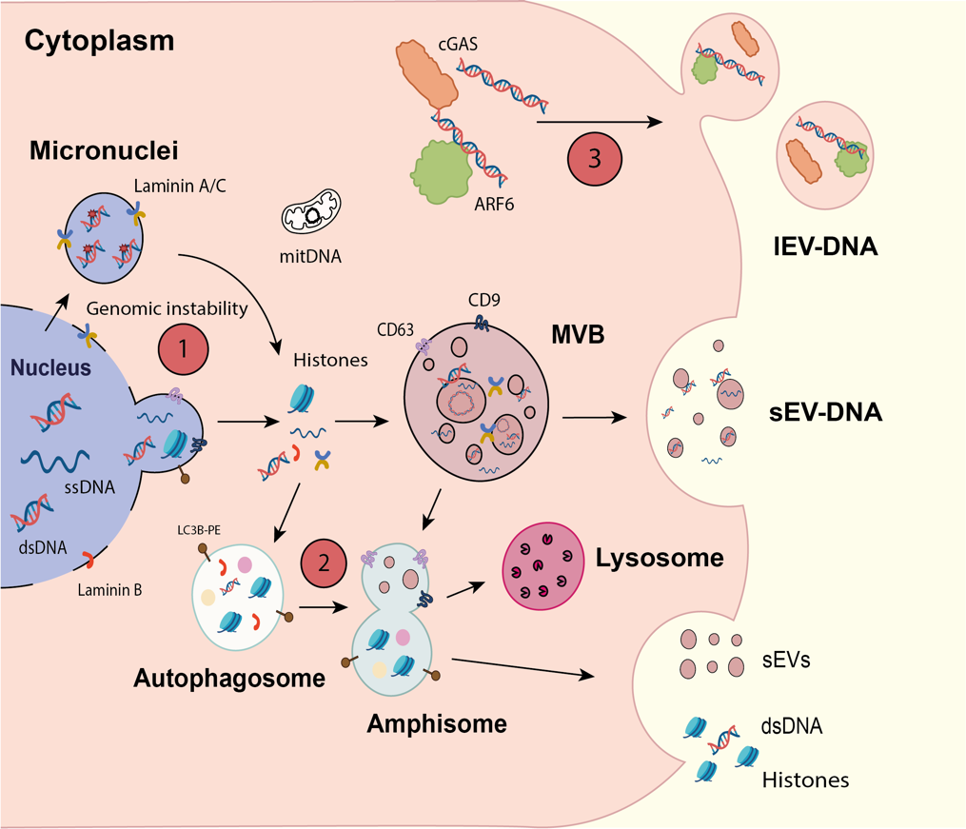
Regarding its biological relevance, the secretion of DNA in EVs may be a mechanism to control cell homeostasis. Inhibiting the production of sEVs by non-tumor cells caused DNA Damage Responses (DDRs) in the cell itself due to the accumulation of DNA in the cytoplasm. These findings, coupled with the fragments of chromosomal DNA found in some sEVs, provide evidence that they may serve to maintain cell homeostasis by secreting potentially harmful DNA, particularly in normal cell lines (165)(Figure 1). There is evidence that EV-DNA may increase in response to DNA damage and for example, more mtDNA was detected in sEVs derived from the conditioned medium of human and mouse fibroblast cells following X-ray irradiation (166). Moreover, the external surface of sEVs from human leukemia Jurkat cells treated with ciprofloxacin, an antibiotic used to treat bacterial diseases in humans, has more mtDNA and chromosomal DNA associated to it (167). Hence, the secretion of DNA via EVs could contribute to protective strategies against harmful materials, such that EV secretion could be considered a cellular defense mechanism that alleviates the intrinsic burden of damaging material. The possible implications of this strategy for tumor progression are significant, as EVs could carry hazardous material that might affect the microenvironment, with unforeseen consequences. Understanding the biological significance of DNA shedding through EVs and its extrinsic effect could also help define new anti-tumor therapies, and the development of novel approaches to target tumor cell growth.
Figure 7. Mechanisms of DNA secretion into the extracellular medium. (1) Nuclear DNA can be translocated into the cytoplasm either directly from the nucleus via direct nuclear membrane blebs or through micronuclear structures formed in response to DNA damage or genomic instability. Subsequently, this cytoplasmic DNA may be incorporated into MVBs within the endosomal pathway, ultimately leading to its incorporation and secretion in association with sEVs. (2) Cytoplasmic DNA and histones have the capacity to associate with autophagic proteins (e.g. LC3B), facilitating the assembly of autophagosome structures. Fusion of these autophagosomes with MVBs results in the formation of hybrid structures known as amphisomes, which can undergo either degradation or secretion of their nuclear components independently of sEVs. (3) The interaction between cytoplasmic DNA, ARF family proteins (e.g. ARF6) and the DNA sensor protein cGAS promotes the incorporation of DNA into the lEV biogenesis pathway. This process culminates in membrane blebbing and the subsequent encapsulation of genetic material into this vesicular fraction.

3.2. The impact of extracellular vesicle-mediated horizontal transfer of DNA on primary tumor evolution
A unique aspect of tumor-derived EVs is the inclusion of structurally abnormal (oncogenic) proteins and/or NAs that possess an inherent transformative potential. There is data supporting that cancer-shed EVs contain a repertoire of oncoproteins and their corresponding transcripts, including EGFRvIII, MET, KIT, RAS, EGFR, HER2, AKT, AXL, LMP1 or IDH1 (Figure 8-1). Moreover, several studies suggest that cancer-associated EVs could carry oncogenic DNA sequences corresponding to MYC, KRAS, HRAS and other genes (168). Thus, whether cancer-derived EVs possess the capacity to deliver oncogenic cargo to normal cells is an interesting debate (169-172).
There is evidence that EVs contain oncogenic DNA (172, 173), RNA (174, 175) or proteins (171, 176) that can induce tumorigenic conversion in different cell types, however the mechanisms involved are far from being understood. Pioneering studies showed that the uptake of mutant HRAS by immortalized rodent fibroblasts (177) or the delivery of oncogenic EGFR/EGFRvIII to dormant glioma cells via EVs promotes changes that are classic indicators of oncogenic transformation (171), such as altered cell morphology, accelerated proliferation, enhanced colony formation in soft agar, or growth into what resemble cancerous foci in vitro. In addition, the oncogenic transformation and intercellular trafficking of cancer-derived EVs could potentially contribute to pathological transformation of stromal cells (e.g. endothelial cells), facilitating the intercellular transmission of genomic instability (178)(Figure 8-2). However, these effects may frequently be constrained in time and they may not independently lead to tumor formation in vivo (179). Nevertheless, pancreatic cancer cell-derived sEVs have been proposed to act as initiators that induce random mutations in recipient cells, such as NIH-3T3 fibroblasts (180, 181). These findings suggest EVs influence the "horizontal transformation" of the surrounding microenvironment, a hypothesis also proposed from studies into the influence of plasma cfDNA. Hence, intercellular transfer of oncogenic cargo could theoretically induce a tumorigenic phenotype in normal cells, thereby establishing a new mechanism that drives malignant growth and the hypothesis of “genometastasis” (182). Distinguishing whether these effects are caused by the molecular transfer of oncogenic material or if they are due to the intrinsic evolution of the primary tumor is not always easy. As such, the extent to which these interactions may involve horizontal transfer of oncogenic molecules via EVs or cfDNA, as well as when this may occur, remains unclear.
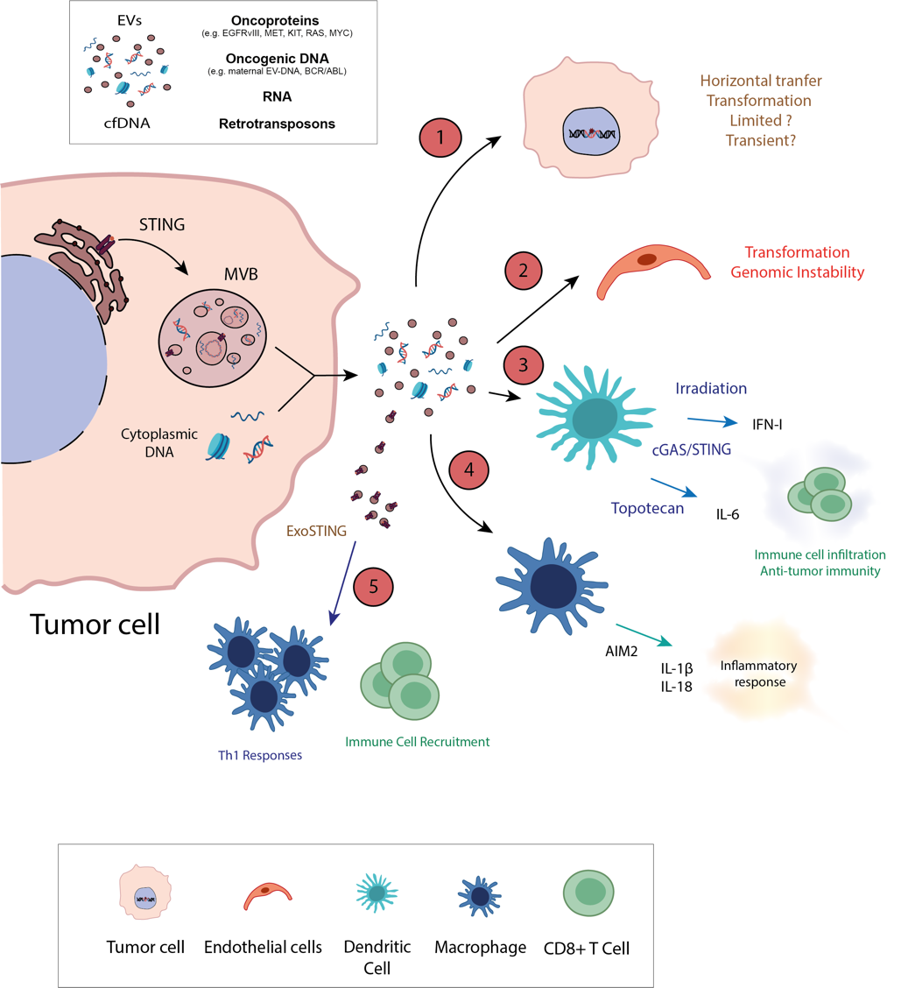
The discovery of retrotransposons in EVs also hints that these elements may fulfil a potential role in recipient cells. Retrotransposons are “jumping elements” that can insert into the host genome and be transcribed (183), although their ability to influence the behavior of recipient cells remains unclear. The protection of retrotransposon sequences afforded by EVs suggests they are potentially involved in the horizontal transfer of these sequences that are protected from degradation (184), as reflected by the horizontal transfer of retrotransposons to recipient cells and their ensuing activity-dependent translation (185, 186). While the replication and integration of retrotransposons into the host genome is well understood, their ability to be transferred between cells via EVs in vivo has yet to be fully confirmed (184).
Figure 8. Horizontal transfer of DNA. Extracellular secretion of genetic material can occur in the form of cfDNA or in association with EVs, potentially involving oncoprotein transcripts, oncogenic DNA, RNA or retrotransposon elements. Horizontal transfer of this genetic material has the capacity to induce replication and translation of oncogenes, thereby potentially leading to malignant transformation and genomic instability in (1) tumor cells (although it remains uncertain whether this may be a transient transformation) or (2) endothelial cells. The transfer of EV-DNA or cfDNA plays a significant role in immune cell activation. DNA recognition by elements in the cGAS/STING signaling pathway of dendritic cells activates the secretion of cytokines that promote anti-tumor immunity (3). Moreover, the detection of cytoplasmic DNA by macrophages triggers an inflammasome response, leading to hyper-inflammation (4). The anti-tumor response stimulated by the recognition of EV-DNA/cfDNA by immune cells suggests the potential therapeutic application of modified EVs (ExoSTING) to enhance immune recruitment and inflammatory responses (5).

Cells employ mechanisms to recognize external NAs, typically in response to bacterial or viral infection (187). These mechanisms involve Pattern Recognition Receptors (PRRs) like TLRs or Rig-I Like Receptors (RLRs), which can detect exogenous RNAs and DNAs, thereafter initiating the induction of specific inflammatory events that provoke cell death (187). In the case of the cGAS-STING pathway, this appears to be altered in tumor contexts such that effector responses are not elicited, leading to the accumulation of Chromosomal Instability (CIN) and consequently, enhancing metastatic potential (188). Interestingly, the transfer to DCs of dsDNA in tumor-derived EVs generated by irradiated mouse breast cancer cells (RT-TEX) upregulated co-stimulatory molecules and the activation of IFN-I through the STING pathway, which could prime protective anti-tumor T-cell responses (189)(Figure 8-3). Similarly, conditioned media derived from topotecan-treated tumor cells elevated the IL-6 produced by DCs. In this scenario, ExoDNA served as a potent inducer of anti-tumor immunity by activating DCs and facilitating the infiltration of CD8+ T cell populations into tumor sites (190)(Figure 8-3). Besides activating anti-tumor responses and T cells, EV-shed DNA after chemotherapy treatment with irinotecan can also activate innate immune cells, stimulating the AIM2 (absent in melanoma 2) inflammasome response that leads to IL-1β and IL-18 secretion, and provoking intestinal cell toxicity (191)(Figure 8-4). Hence, EVs could be involved in both anti-tumor effects and in the associated adverse inflammatory responses. Thus, understanding the effects of EVs in these scenarios could help modulate anti-tumor cell responses and reduce their collateral effects.
Most research into the interplay between components of the cGAS/STING pathway and EVs has concentrated on dsDNA transfer by EVs under physiological conditions. For example, inhibiting EV secretion promotes cell senescence by activating the cyclic cGAS/STING inflammatory pathway in fibroblasts (165). The mechanisms involved in the release of STING within EVs are now being studied, with several reports indicating that STING is transported into EVs following cell infection with herpes simplex virus (192, 193). A more recent study showed that when the cGAS/STING signaling pathway was activated, EVs carry STING oligomers as an alternative degradation pathway, thereby modulating the innate immune response. These data support a role for EVs in cGAS/STING signaling, both in physiological and pathological scenarios (Figure 8-5). Since this pathway is being explored to modulate anti-tumor cell responses (194, 195), it would be intriguing to assess the significance of EV secretory pathways on treatment efficacy. Indeed, EVs were utilized as a therapeutic modality to manipulate this pathway and ExoSTING, an engineered EV loaded with cyclic dinucleotides, selectively activates APCs within the tumor, promoting local Th1 responses and CD8+ T cell recruitment while eliciting systemic anti-tumor immunity (196).
In addition to their impact on DNA-sensing pathways, EVs also have the ability to horizontally transfer genomic DNA (gDNA). The horizontal transmission of EV-DNA has been suggested as a novel mechanism to transfer genetic material, influencing genome evolution (184, 197). The transfer of EV-DNA to recipient cells is a rare event, although the potential integration of specific DNA sequences into the recipient cell's genome is a phenomenon that could be plausible (198), but still a matter of debate. Increased levels of SRY (sex-determining region Y) DNA in plasma EVs from patients with coronary artery disease offers additional support for DNA transfer. It was proposed that this EV-associated gDNA could be transferred to recipient cells and expressed by them, thereby influencing recipient cell behavior by elevating DNA-coding mRNA and protein levels (199), consequently increasing the expression of ICAM1 in endothelial cells and CD11a in macrophages (Figure 8-3). In addition, the transmission of maternal EV-DNA is linked to altered embryo bioenergetics during the periconception period (200). These data, suggest that horizontal DNA transfer by EVs appears to be a rare but physiological phenomenon.
In the context of cancer, the potential for EVs to transfer mutated DNA was demonstrated by analyzing BCR/ABL hybrid sequences transferred to HEK293K cells exposed to EVs from K562 cells (173). In addition, sEVs derived from tumor patients can induce malignant transformation of fibroblasts, altering their cell fate and leading to tumor formation when they are injected into mice, thereby conferring a similar phenotype (170). However, not all cells exhibit the same susceptibility to EV-DNA incorporation nor the mechanisms involved have been demonstrated. The transformation induced by EVs in non-transfected cells may be limited or absent due to defense mechanisms, such that while uptake occurs it may be transient in both primary and immortalized fibroblasts (179).
In summary, there is a significant interest not only in understanding the mechanisms involved in EV-DNA secretion but also in elucidating the associated biological implications. Intrinsically, the secretion of EV-DNA by tumor cells is thought to be a means to eliminate harmful material from the cell and to dampen anti-tumor cell responses, thereby promoting tumor progression. Externally, the secretion and transfer of EV-DNA to recipient cells may provoke oncogenic transformation, yet it may also activate anti-tumor cell immunity, but how these mechanisms may affect tumor evolution in vivo is still not clear. Overall, it appears that modulating EV secretion and the impact of EV cargo represents a delicate balance that could have a significant influence on tumor cell evolution. It is crucial to acknowledge that EVs transport a huge variety of molecules. Hence, the evolution of tumor cells during metastatic transformation would entail a combination of intrinsic and extrinsic factors, including the transfer of EV-DNA, as well as that of other regulatory molecules conveyed by EVs like RNA and proteins.
Nevertheless, the current literature lacks clear evidence of direct integration of EV-DNA into recipient cells, nor does it clarify the mechanisms involved in processing this material. Since the expression of oncogenes typically induces senescence rather than transformation (201), understanding how EV-mediated horizontal transfer could drive transformation in recipient cells suggests that additional mechanisms may be involved. For example, it is plausible to speculate that EV-mediated horizontal transfer could promote transformation by activating pathways that accelerate intrinsic processes or tumor progression, such as DDR or chromosomal instability (CIN). Potential mechanisms could include STING activation, DDR signaling, or retrotransposon transfer. Given the typical composition of EV-DNA (generally small fragments), it is likely that transformation may not involve genetic changes. Instead, it could influence signaling or epigenetic regulation in recipient cells, thereby enhancing the intrinsic evolution of tumorigenesis.
The absence of conclusive evidence in this area should not discourage further investigation; rather, it should stimulate it. Given these uncertainties, it is evident that additional research is required to fully understand the biological implications of EV-DNA secretion and its potential extrinsic effects on tumor evolution.

3.3. Examining extracellular vesicle DNA and its potential as a surrogate marker for mutations
Liquid biopsies are minimally invasive tests that may enable the molecular profile of patients to be defined in real-time. In addition to being non-invasive, these biopsies may also be less expensive than conventional biopsies to capture tumor heterogeneity and facilitate a sequential analysis of samples (202). Historically, liquid biopsies predominantly analyze circulating tumor cells (CTCs) and circulating free DNA (cfDNA: (203, 204), yet the means to obtain biopsies face specific technical limitations, as well as challenges regarding stability and sensitivity. Interest in studying EV-DNA in liquid biopsies has increased in recent years since this DNA is representative of the tumor cell of origin, offering the potential to monitor tumor mutations (105)(Table 4).

Table 4. DNA Mutations and Liquid Biopsy – Main References and Relevance/Use

Gene | Tumor type | Mutations | Clinical utility | Body fluid | Analyte | References
BRAF | Melanoma | V600E | Detection of patients at high risk of relapse | Exudative seroma | EV DNA/RNA + cfDNA | (211)
 |  |  |  | Plasma | EV DNA/RNA + cfDNA + DNA tissue | (212)
BRAF | Melanoma | V600E | Improve detection of mutation, Patient Monitoring | Plasma | EV DNA + cfDNA | (213)
BRAF, KRAS, EGFR | Multiple advanced cancers | BRAF^{V600},  KRAS^{G12/G13}, EGFR^{exon19del/L858R} | Comparison with cfDNA, Patient Monitoring | Plasma | EV DNA/RNA + cfDNA | (206)
EGFR | NSCLC | T790M | Detection of mutation | Plasma | EV DNA/RNA + cfDNA | (209)
 |  |  |  | Plasma | EV DNA/RNA + cfDNA | (210)
KRAS | PDAC | Codon 22, 12, 273 | Detection of mutation | Serum | EV DNA | (153)
KRAS | PDAC | G12D | Detection of mutation | Serum | EV DNA | (203)
KRAS | PDAC | Multiplex KRAS mutations | Comparison with cfDNA, Patient Monitoring | Plasma | EV DNA | (204)
KRAS | PDAC | G12V, G12D | Diagnosis and monitoring early and late stage PDAC | Blood | EV DNA | (208)
TP53 | PDAC | Codon 273 GΔA | Proof of concept | Serum | EV DNA | (153)
TP53 | PDAC | R273H | Proof of concept | Serum | EV DNA | (203)
IDH1 | Glioma | G395A | Diagnosis and monitoring | Blood | EV DNA | (207)

Pioneering studies revealed that most sEV-derived DNA larger than 2.5 kb is linked to the outer membrane, whereas internal sEV-dsDNA is typically between 100 bp and 2.5 kb in size. This DNA was tested for cancer-specific mutations, such as the BRAFV600E mutation in melanoma-derived sEVs and epidermal growth factor receptor (EGFR) in non-small cell lung cancer (NSCLC)-derived sEVs (105). It was also demonstrated that sEVs derived from pancreatic cancer patients contained fragments of dsDNA >10 kb inside EVs that spanned all chromosomes. Moreover, since the KRAS mutation was successfully identified in this EV-DNA, the bottleneck appears to reside in the sensitivity of the techniques available to detect the valuable information contained in EVs (155). Indeed, it was subsequently seen that KRAS mutations in PDAC patients could be more accurately detected from sEV-DNA than cfDNA (205, 206). Similar results were obtained when analyzing different mutations in EV-DNA and cfDNA for a variety of tumor types (207). Furthermore, less EV-DNA in plasma appears to correlate with longer survival, implying that EV-DNA may offer insight into the clinical outcomes of patients undergoing treatment (208). Analyzing EV-DNA in glioma patients indicated that several types of EVs contain genomic DNA sequences. Interestingly, the G395A mutation in IDH1, a significant mutation to diagnose human glioma, was detected in EVs in the peripheral blood of glioma patients. As patients with mutated IDH1 have a better prognosis than patients with wild-type IDH, EV-DNA may serve as an alternative to liquid biopsies obtained from CSF (209).
Although many studies have focused on the study of sEV-DNA, lEV-DNA may harbor even more valuable information for certain cancers. In the context of prostate cancer, the majority of DNA in the patient’s plasma was enclosed within lEVs, representing a potential source for mutation detection (157). The contribution of each EV fraction may hinge on factors like tumor type and disease stage. For instance, in the context of pancreatic cancer, lEV-DNA is prominent in the detection of KRAS mutations in early disease stages, shifting in favor of sEV-DNA at advanced stages (210). Hence, while the fraction of lEVs has traditionally been ignored, it may be of value to obtain information from liquid biopsies. It was recently proposed that integrating different fractions may enhance the sensitivity of such techniques, rather than focusing on a single fraction. Indeed, combining EV-DNA/RNA together with cfDNA has a sensitivity and specificity of detection close to 90% for the EGFRT790M mutation in NSCLC patients. Diagnosing this mutation is crucial to the optimal treatment of these patients, although obtaining a conventional biopsy for analysis is challenging (211, 212).
As an alternative to plasma-derived EVs, liquid biopsies can extend to other biological fluids. Notably, lymphatic drainage obtained from stage III melanoma patients after lymphadenectomy was rich in EVs and detecting the BRAFV600E mutation in EV-NAs from this fluid correlated with the risk of relapse (213). Therefore, further developments to improve the sensitivity and specificity of the different detection methods, as well as combining fractions and identifying the most appropriate biological material, will help advance the diagnostic value of EV-NAs from liquid biopsies. Indeed, we recently found that the systematic evaluation of BRAF mutations in both tissue and plasma enhances the rate of mutant BRAF detection, improving the prognostic efficiency in high-risk melanoma patients, particularly in the short term. Thus, the combined analysis of mutations in tissue, circulating cfDNA and EV-NAs could be more effective to monitor patients than relying on one component alone (214).
Nevertheless, the clinical translation of EV analysis faces significant challenges, primarily due to the need to identify suitable and reproducible protocols compatible with clinical settings, and also standardization of the procedures for isolation and analysis. However, a practical clinical protocol to isolate EV-DNA and evaluate the BRAF gene in plasma samples has been proposed, and it was seen to enhance the detection of BRAFV600E gene copies when compared to cfDNA isolation, highlighting the potential of EVs in next-generation liquid biopsy approaches (215). Interestingly, there are already platforms currently being tested in clinical settings, such as the ExoDx Prostate IntelliScore® test for prostate cancer patients (178) and the QuantideX® qPCR ESR1 test for breast cancer patients (216). Nevertheless, there are still no standardized protocols or approaches to analyze plasma-circulating EVs, which hinders their application in clinical settings.

4. The Influence of Extracellular Vesicles in Resistance to Therapy

4.1 The influence of EVs on resistance to therapy
When considering the significance of EVs in tumor development, the question has been raised regarding their potential involvement in one of the principal challenges in cancer research: resistance to therapy. While various studies have sought to demonstrate the role of EVs in the propagation of resistance, this issue still remains unclear. Key mechanisms that drive resistance to therapy have been outlined previously (217), a review in which the connections between specific mechanisms and types of resistance, as well as the potential to target EVs to overcome resistance, are discussed in depth. In this part of the review we will discuss the role of EVs in therapy resistance and the main works that contributed to this idea, we have summarized all of them in Table 5.
Table 5. Main studies contributing to the role of EVs in therapy resistance

Therapy | Tumor Type | Mechanism of Action | Reference Number
Chemotherapy and Radiation | Breast Cancer | Fibroblast-derived EVs promote therapy resistance | (216)
Chemotherapy | Breast Cancer | Fibroblast-derived EVs promote therapy resistance | (217)
Oxaliplatin | Gastric cancer | Fibroblast-derived EVs promote therapy resistance | (227)
Bortezomib | Multiple Myeloma | Bone marrow-derived EVs mediate therapy resistance | (219)
Doxorubicin | Osteosarcoma | Resistant tumor cell-derived EVs promote therapy resistance | (223)
Sunitinib | Renal cancer | Resistant tumor cell-derived EVs promote therapy resistance | (224)
Sorafenib | Hepatocellular carcinoma | Resistant tumor cell-derived EVs promote therapy resistance | (225)
Docetaxel | Lung Cancer | Tumor-derived EVs inhibit therapy resistance | (228)
Temozolomide | Glioblastoma | EVs from CSCs confer therapy resistance | (241)
Radiation | Glioma | EVs from CSCs confer therapy resistance | (242)
Erlotinib | Lung Cancer | EVs from CSCs confer therapy resistance | (243)
Enzalutamide | Prostate cancer | EVs from CSCs confer therapy resistance | (244)
Bortezomib, GW4869 | Mixed-lineage leukemia | EV inhibition enhances therapy effect | (247)
GW4869, Rab27KO, PD-L1 | Breast cancer | EV inhibition enhances therapy effect | (248)
GW4869, Ferropoptosis inhibitors, PD-L1 | Melanoma | EV inhibition enhances therapy effect | (249)

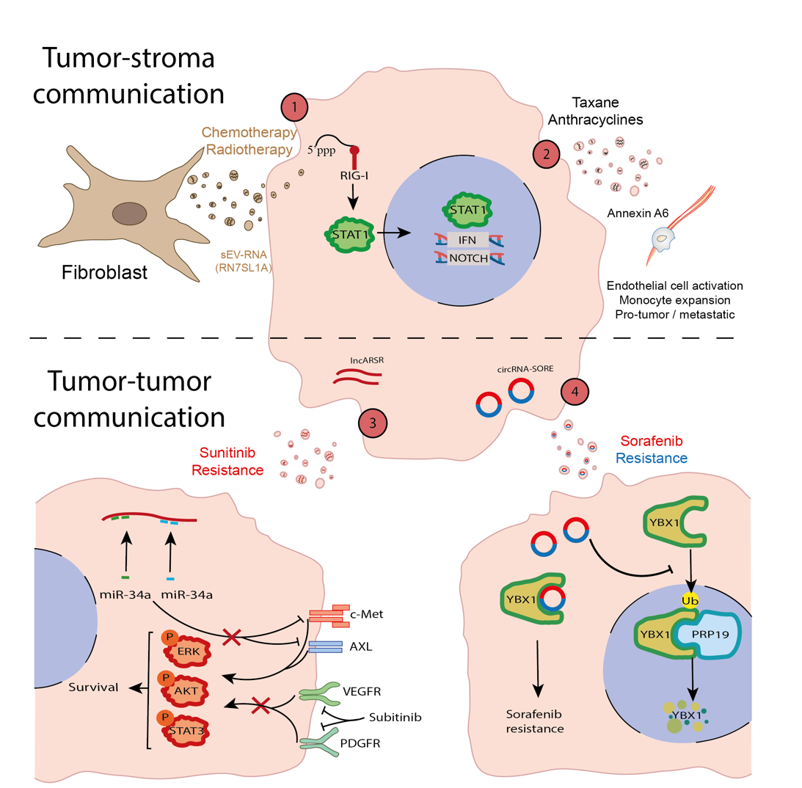
Significant advances in understanding this phenomenon have been made in breast cancer, with relevant studies elucidating mechanisms underlying the association between EVs and resistance to treatment. In particular, two relevant studies showed EVs mediate communication between stromal and tumor cells that contributes to resistance to therapy in breast tumors (Figure 9-1). A pivotal study revealed that stromal cells release EVs containing RNA that is capable of stimulating RIG-I to activate STAT1-dependent anti-viral signaling. In addition, stromal cells activate NOTCH3 on breast cancer cells. Both paracrine EV-driven anti-viral responses and juxtacrine NOTCH3 pathways converge to expand resistance to therapy (218). Another noteworthy study revealed that tumor cells can corrupt and convert fibroblasts into CAFs through the NOTCH1 and MYC pathways. These transformed CAFs subsequently release EVs that promote resistance to therapy and enhance metastatic potential. The underlying mechanisms involve the release of RN7SL1A RNA within EVs, which acts as a damage-associated molecular pattern (DAMP) recognized by tumor cells, thereby inducing a state of resistance in recipient cells (219). Another significant link between EVs and resistance to therapy was also made in breast cancer, such that EVs not only modulate resistance but also, therapy itself can trigger the release of EVs with pro-tumor and metastatic effects (220). Indeed, taxanes and anthracyclines were seen to activate EV secretion pathways enriched in annexin A6, leading to endothelial cell activation and monocyte expansion in the lung PMN, facilitating metastasis (Figure 9-2).
Figure 9. Influence of EVs on resistance to therapy. Resistance to therapy may be influenced by EVs through different mechanisms. (1) In breast cancer, CAFs release EVs carrying RN7SL1A that activates RIG-I in tumor cells, thereby inducing resistance to chemotherapy and radiotherapy via the STAT1-NOTCH3 and MYC-NOTCH1 pathways. (2) The release of annexin A6 by tumor cells contributes to resistance to taxane and anthracyclines, mediating endothelial cell activation and monocyte expansion. (3) The secretion of lncARSR in EVs transmits resistance to sunitinib by indirect activation of the MET/AXL pathways. (4). Tumor cells are also able to propagate sorafenib resistance by releasing EVs carrying circRNA-SORE, which activates oncogenic signaling in tumor recipient cells.

Beyond breast cancer, some progress has been achieved in elucidating the mechanisms underlying resistance to therapy associated with EVs in other tumor types, although they have been far from fully defined. For instance, a decade ago it was reported that, bone marrow-derived cells (BMDCs) promote multiple myeloma resistance to bortezomib through EVs, as well as other malignant features like proliferation and migration (221). These experiments were performed on patient-derived BMDCs, enhancing their translational relevance, and certain survival pathways were seen to be activated by EV treatment in vitro. Despite representing a significant advance in the field, the specific mechanisms underlying this resistant phenotype were not defined, and this resistance-promoting effect was not demonstrated in vivo.
Similarly, therapeutic resistance has long been associated with the role of ABC transporters. Notably, recent studies have also highlighted the significance of EVs in contributing to resistance by releasing ATP Binding Cassette (ABC) transporters. For a more comprehensive discussion on these mechanisms, several insightful reviews are available (222, 223). Another example is the P-gp glycoprotein, one of the most extensively studied transporters due to its implication in cancer. This protein was detected in EVs from prostate cancer patients resistant to docetaxel (224) and the secretion of P-gp via EVs was shown to contribute to doxorubicin resistance in osteosarcoma (225). These findings highlight the potential for future research along these lines.
A promising area in cancer research involves exploring the role of ncRNA in mediating the resistance to therapy through horizontal transfer, with various ncRNAs implicated in conferring a resistant phenotype to different tumor types over recent years. Intriguingly, the most studies focus on a specific ncRNA within a particular tumor context, and perhaps the two most relevant were conducted on renal cell carcinoma (226) and hepatocellular carcinoma (227). In the former, the ncRNA known as lncARSR induced resistance to sunitinib via EVs, facilitating the expression of AXL and c-MET oncoproteins (226)(Figure 9-3). The second study, published four years later, described how circRNA-SORE propagated hepatocellular carcinoma resistance to sorafenib through EVs (227) (Figure 9-4). Importantly, both studies demonstrated resistance to therapy in vivo, supporting the findings with clinical data from patients. Interestingly, the circRNA-SORE present in EVs from patient plasma was proposed as a potential biomarker for treatment response, possibly applicable to liquid biopsies. Indeed, an independent study identified AR-V7 lncRNA in EVs as a marker of resistance to hormone therapy in prostate cancer, further evidence of the promise of this approach (228). However, it is essential to acknowledge the limitations of these studies in predicting treatment response, as none of them demonstrated these ncRNAs to be independent and better markers than those used for other liquid biopsies, such as CTCs. Building on the success of these studies, other recent publications delved into the roles of specific ncRNAs in gastric cancer resistance to oxaliplatin (229) and lung adenocarcinoma resistance to docetaxel (230). Notably, the use of in vivo models of tumor growth and resistance in these studies adds to the relevance of their findings. While the transfer of specific ncRNAs seems to play an important role in EV-mediated resistance in diverse tumor types, further studies are needed. Known resistance mechanisms beyond ncRNAs must be explored given the limited number of articles addressing resistance to therapy mediated by EVs that involve other biomolecules. Moreover, the clinical relevance and utility of these findings in liquid biopsies awaits further validation. Finally. while the role of EVs in cell-to-cell communication supports their implication in resistance to therapy, extensive research is underway to engineer EVs as therapeutic agents for drug delivery and related applications. These advances have been explored in a review (231). In addition, the literature supports the use of specific markers identified in EVs as therapeutic targets. Based on the information provided in the original studies used in this review, we have summarized these findings in Table 6.
Table 6. Selection of EV studies suggesting specific therapeutic approaches to reduce tumor progression

Cancer Type | Therapy/Approach | Target | Effect | Reference
Breast Cancer, Melanoma | shRNA | Rab27a | Preventing PTEN loss in tumor cells | (111)
Melanoma | shRNA | c-Met, Rab27a | Reduction of lung metastasis | (36)
Breast Cancer, Pancreatic Cancer | shRNA, Integrin blocking peptides | Integrins (β4, β5) | Reduction of lung and liver organ-specific metastasis | (116)
Pancreatic Cancer | shRNA | MIF | Reduction of liver metastasis | (117)
Breast Cancer | KO | CEMIP | Reduction of brain metastasis | (120)
Breast Cancer | Overexpression | miRNA-122 | Reduction of metastasis | (121)
Melanoma | shRNA | THX-B, NGFR | Reduction of lymph node metastasis | (125)
Prostate Cancer, Colon Cancer | Antibodies, KO | PD-L1, Rab27a, nSMase | Reactivation of anti-tumor immunity | (129), (130)
Melanoma | Antibodies | CD63, PD-L1 | Reactivation of anti-tumor immunity | (131)
Colon Cancer, Breast Cancer, Lymphoma | DMA, amiloride | Reduction of exosome secretion | Improve chemotherapy response | (135)
Breast Cancer | shRNA | Rab27a | Reduction of primary tumor and metastases | (136)
Glioma | KO | LGALS9, Rab27a, nSMase2 | Reduction of primary tumor growth | (139)
Melanoma, Lymphoma, Colon Cancer, Hepatoma | Overexpression | STING, Cyclic dinucleotides | Enhance anti-tumoral immune response | (194)

4.2. The role of CSC-derived EVs in resistance to therapy
When discussing known resistance mechanisms that have received limited attention in the context of EVs, CSCs are of particular interest. The identification of CSCs represented a groundbreaking paradigm shift in cancer research, challenging the conventional understanding of tumor initiation and maintenance (85). Beyond their role in initiating and sustaining tumors in vivo, CSCs have emerged as a resilient subpopulation capable of evading therapeutic interventions (232). The phenomenon of resistance to therapy underscores the notion of intratumoral heterogeneity, such that certain cell clones within tumors exhibit resistance and their survival is favored following therapy. The concept of CSCs inherently embodies this intratumoral heterogeneity, with a significant implication in resistance to therapy, with the evidence that CSCs are important mediators contributing to resistant phenotypes having been examined comprehensively (233). The recognition that EVs also contribute to such resistance shifted attention towards the mechanisms possibly driven by CSCs, although this issue remains relatively unexplored.
The transformative concept of CSCs evolved towards the end of the last century, starting with critical discoveries in acute myeloid leukemia (AML) (234, 235). In these studies tumor cells were injected into immunosuppressed NOD/SCID mice, and their ability to engraft and maintain tumor growth was assessed. These cells were identified and characterized through their CD34⁺/CD38⁻ membrane markers, revealing their hierarchical role in tumor formation. As a result of these findings further exploration of CSCs was undertaken in various cancer types and through analogous experiments on NOD/SCID mice, similar cell populations were identified in breast cancer (236), brain tumors (237) and colon cancer (238, 239). While these cells expressed different markers to those observed in AML (CD44⁺/CD24⁻ in breast cancer, CD133⁺ in brain tumors and colon cancer), they shared the pivotal capacity to initiate and maintain tumors in vivo.
The mechanisms governing CSC initiation and maintenance resemble the normal regenerative processes of epithelial stem cells. In analogy to basal stem cells that drive efficient regeneration and maintenance of the epithelium (240, 241), CSCs can initiate and sustain clonal expansion, and tumor growth. Indeed, the plasticity of these cells is gaining prominence as a fundamental concept underlying resistance to therapy. The capacity to swiftly adapt and respond to stress, exemplified by therapeutic interventions in the context of tumors, aligns with the characteristic behavior of stem cells. It is increasingly evident that CSC populations are often synonymous with the cell subsets resistant to anti-neoplastic treatments. Whether this phenomenon signifies a passive Darwinian selection in the context of cancer or active reprogramming toward a stem-like phenotype remains unclear (232). Nevertheless, significant advances have been made in defining the characteristics of this therapeutically refractory stem-like phenotype.
In this context, a question arises regarding the potential role of EVs in establishing the CSC phenotype and more specifically, in the CSC-associated resistance phenotype. A critical issue is whether CSC-derived EVs exert an influence on the transformation of other tumor cells into more aggressive and resistant phenotypes. Currently, there is limited data available favoring this connection, although CSC-derived EVs have been linked to tumor progression in mouse models of PDAC. Preferential communication via EVs was apparently orchestrated from CSCs to non-CSCs, which ultimately promoted tumor growth. In addition, mechanistic insights suggested that the observed effect on tumor growth is dependent on the activation of YAP in the recipient cells through the horizontal transfer of agrin (242)(Figure 10-1). Beyond the specific mechanisms, these studies provide fundamental indications that CSC-derived EVs play an important role in promoting tumor development, although future research will need to establish this connection.
While there is limited data establishing a link between CSC-derived EVs and tumor progression, the relationship between these EVs and CSC-related mechanisms of therapeutic resistance is even less well understood. However, the CSC of gliomas, named glioma stem cells (GSCs), are known as the cells that contribute preferentially to the therapeutic resistance of brain tumors and thus, the role of GSC-derived EVs in therapeutic resistance has been assessed. Patient-derived GSCs cultured under hypoxic conditions secrete EVs that contribute to the survival and proliferation of cancer cells. It was proposed that under hypoxic conditions the GSCs secrete miRNA-30b-3p in EVs which affect recipient cells by targeting RHOB (243)(Figure 10-2). This mechanism was described in vitro but the effect of miRNA-30b-3p on tumor growth was also shown in vivo, with an association between higher levels of miRNA-30b-3p in the CSF of temozolomide resistant patients also found (243). Interestingly, this study suggests that in the context of brain tumors, CSCs could release EVs that influence tumor progression and treatment failure under specific hypoxic conditions. In an independent study using a similar model of CSCs, GSC-derived EVs contributed to radiotherapy resistance in vitro (244), although the underlying mechanisms were not defined and the effect in vivo was not assessed.
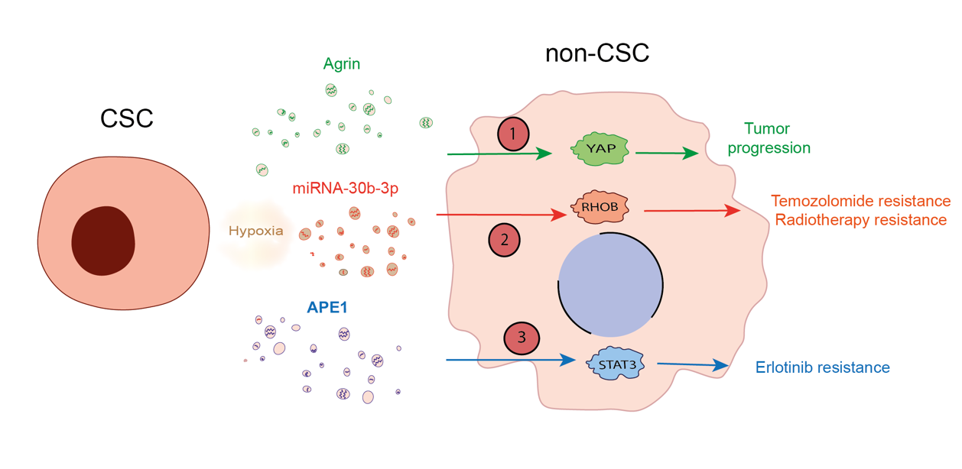
Figure 10. Influence of EVs on CSC-mediated resistance. EVs play a crucial role in tumor development through CSCs. (1) EVs derived from CSCs preferentially communicate with non-CSCs, and promote tumor progression carrying agrin and activating YAP in recipient cells. (2) Hypoxia promotes the release of miRNA-30B-3P in EVs, which contributes to resistance against temozolomide and radiotherapy by targeting the RHOB factor. (3) Another mechanism involves the activation of STAT3, which mediates resistance to erlotinib via APE1 secreted in CSC-derived EVs.

Besides these data from brain tumors, a few other relevant studies have assessed the effect of CSC-derived EVs on the resistance to therapy of other tumors. In erlotinib-resistant NSCLC lines, the APE1 protein was upregulated in resistant cells and implicated in malignancy through IL6/STAT3 signaling (Figure 10-3). The presence of this protein in CSC-derived EVs contributed to resistance to erlotinib in vitro, results that were partially confirmed in vivo with a mild effect of the genetic modulation of APE1 in EVs. However, the implications of this novel mechanisms in patients are yet to be assessed (245). Moreover, a potential novel effect of CSC-derived EVs was proposed in a study performed on metastatic castration-resistant prostate cancer. In this case, the YAP1 protein was seen to be overexpressed by cells resistant to enzalutamide and as a transcription factor, this protein can contribute to resistance by regulating the expression of genes associated to ‘stemness’. The pharmacological inhibition of YAP1 had a therapeutic effect in vivo and indeed, YAP1 is secreted in EVs derived from the resistant cells and these EVs enhance resistance in vitro. While CSCs were not explicitly identified or isolated in this publication nor was the effect of EVs on resistance conclusively shown to depend on YAP1, this may be a potentially novel means for EVs to regulate a resistant stem-like phenotype (246). In conclusion, further research on CSC-derived EVs is urgently needed and will be pivotal to advance our understanding of EV biology, both in tumor development and resistance to therapy.
Thus, CSC-derived EVs may play a significant role in resistance to therapy and as EV-mediated communication relies heavily on stromal interactions and paracrine signaling, they may be crucial in regulating the CSC phenotype. Notably, studies have highlighted the influence of endothelial cells in this context and for example, endothelial cells were shown to promote the CSC phenotype in colorectal cancer through the secretion of soluble Jagged-1 (247). Although this study did not focus on EV-based communication, it provided a foundational understanding of how the CSC phenotype may be regulated directly from the stroma. Expanding on this, a recent glioblastoma study demonstrated that endothelial cells could regulate the mesenchymal phenotype of the stem cell compartment via EV secretion (248). This study also found that this mode of communication could influence both responsiveness to chemotherapy and tumor progression. These studies support the idea that the CSC phenotype can be regulated by EV-mediated communication through bidirectional crosstalk with stromal and endothelial cells, highlighting their potential as targets for overcoming therapy resistance.
Indeed, a several studies have explored how targeting EVs might provide novel therapeutic strategies to overcome this resistance. For example, inhibiting EV secretion by combining bortezomib with the nSMase2 inhibitor GW4869 resulted in a stronger anti-tumor effect than either agent alone (249). This suggests the potential of using EV inhibitors to overcome therapy resistance and improve the efficacy of anti-tumor treatments. Similarly, genetic knockdown of Rab27a or treatment with the EV inhibitor GW4869 enhanced the therapeutic impact of anti-PD-L1 antibodies, suggesting that resistance to immunotherapy could be mitigated by reducing EV secretion (250). In addition, treatment with GW4869, combined with ferroptosis inducers, can restore T cell activity, enhance ferroptosis, and potentiate antitumor immunity, offering a promising strategy to overcome therapeutic resistance (251). While the development of agents targeting EV secretion is emerging, it is important to consider the potential collateral effects of systemic administration of general inhibitors of EV secretion. EV secretion plays a key role in normal cellular communication, so inhibiting it broadly could have serious long-term consequences, particularly in humans. Instead, the focus should be on designing specific approaches to understand the pathways and cargo associated with tumor-derived EV secretion. Although this is a challenging task, targeting the secretion of oncogenic material within EVs could significantly improve therapeutic outcomes while minimizing adverse effects.

5. Future perspectives
In this review, we provide an overview of the various activities attributed to EVs, from the initial hypotheses that they release the cell’s unwanted material to that of targeted cell-cell communication. The significant advances in the past two decades indicate that EVs constitute a heterogeneous population of vesicles that carry specific messages which must now be decoded and understood.
EVs have a complex and varied origin, a diversity that poses challenges to the study of their biology, and to understand their physiological and pathological significance. Indeed, the role of EVs in specific biological processes seems to be highly context-dependent. Comprehending the heterogeneity of EVs and their unique contributions to biological processes would facilitate a deeper understanding of the complexity underlying EV secretion and the extrinsic effects of EVs. Indeed, one of the main limitations in the field is the significant heterogeneity of EVs in terms of both size and content. Their cargo is diverse, including proteins, lipids, RNAs and DNA. This variability in size and content presents challenges for the isolation and analysis of EVs. Establishing standardized protocols for EV isolation, characterization, and quantification is crucial for advancing our understanding of their role in cancer, their potential as biomarkers, and their contribution to therapy resistance
The relevance of EVs has been studied at different stages of tumor development, ranging from the initiation and proliferation of primary tumors to metastatic progression. The extrinsic effect of EVs on the primary tumor niche, through the regulation of CAFs, and on immunity through PD-L1 or other mechanisms have been validated more intensely, adding to our understanding of the initial interactions of EVs in the tumor microenvironment. However, our current understanding of EV involvement in primary tumor development is still limited and thus, the intrinsic effects they may have on the formation and evolution of the primary tumor niche, and on recipient tumor cells is intriguing. Investigating whether EVs exert extrinsic selective pressures during primary tumor formation and elucidating the mechanisms involved clearly warrant further study. In particular, their effects on EMT, and on the communication between CSCs and non-CSCs remain largely unexplored. The intriguing concept that CSCs may orchestrate tumor progression by communicating with other tumor cells via EVs could represent a valuable insight into tumor biology, as well as perhaps offering an insight into the mechanisms underlying resistance to therapy. The evidence currently available is encouraging since promising effects on tumor transformation and proliferation have been observed.
EVs secreted by the primary tumor redefine our understanding of the tumor's invasive front, extending this beyond mere physical contact. While the boundaries of tumors are conventionally delineated by the primary tumor mass, our insights now reveal a new level of interaction with their microenvironment and beyond. Notably, the secretion of EVs represents a sophisticated tactic of counterintelligence, disrupting physiological communication between immune cells, influencing local invasion and promoting the transformation of tumor and stromal cells. We have some understanding of how EVs mediate organ-specific metastasis as a result of PMN preparation. As a prelude to metastatic colonization, EV homing to metastatic organs anticipates the imminent establishment of metastases. Consequently, unraveling the underlying mechanisms and devising strategies to counteract this phenomenon will be promising to develop novel therapies. By targeting EV shedding and homing to metastatic organs, interventions could mitigate PMN formation and thereby decelerate the progression of metastasis. Combining therapies that inhibit EV shedding and PMN formation with conventional anti-tumor strategies would represent a more holistic approach to effectively combat metastasis.
Apart from the potential CSC-associated mechanisms of resistance to therapy, other pathways have also been implicated, especially in breast cancer. However, more research is needed in other tumor types and models, not least as our current understanding of EV driven resistance and its relevance in the clinic is still limited. Although CSCs constitute a relatively small population within the tumor, the cargo carried by their EVs could potentially reprogram the surrounding microenvironment. Understanding the spatial and temporal dynamics of EV-mediated reprogramming, whether local or distal, could provide crucial insights into the co-evolution of tumor cells with their microenvironment and the potential involvement of EVs in this process.
Clarifying the pathways responsible for the management and regulation of the cargo within EVs would enhance our understanding of these structures. The discovery of EV-DNA raised the possibility of a number of new implications and therapeutic opportunities. The secretion of EV-DNA may facilitate the release of unwanted material from cells, potentially triggering anti-tumor responses by the immune system, while also potentially inducing oncogenic transformation in neighboring cells through the horizontal transfer of EV-DNA. The detection of EV-DNA in biological fluids, protected from degradation, holds significant promise for disease monitoring in patients and in specific tumors, potentially serving as a biomarker for mutations in different tumor types. However, the advantage of utilizing EVs in liquid biopsies compared to cfDNA is yet to be demonstrated, not least as most standardized clinical procedures focus on the analysis of cfDNA and the superiority of studying EVs is yet to be established. In terms of biological relevance, the mechanisms and stimuli that control EV-DNA secretion are still poorly defined, and further studies will be needed to determine the relevance of this cargo to cell survival and tumor progression. Indeed, there is a need to better understand the potential extrinsic effects of this EV-DNA on recipient cells. Thus, the hypothesis of horizontal transfer and subsequent oncogenic transformation of neighboring cells as a result of EV-DNA uptake requires more thorough investigation.

6. Conclusions
The results obtained over the last two decades show that EVs play a pivotal role in mediating cell-cell communication in both physiological and pathological processes, notably in cancer. We have seen the pivotal role EVs play in cancer and how their cargo, such as NAs, can horizontally influence the tumor and metastatic microenvironment. However, our comprehension of the biological significance and the mechanisms that define the nature of their cargo requires further elucidation. There are many key questions that remain to be answered regarding the participation of EVs in cancer, however we can anticipate that in the forthcoming years much light will be shed on how EVs influence the development and propagation of primary tumors, how they contribute to metastasis, as well as to resistance to therapy. Perhaps more importantly, we hope that in this time the diagnostic, prognostic and therapeutic potential of these vehicles will begin to be realized.

7. Funding
Dr Peinado´s laboratory is supported by grants from the Agencia Estatal de Investigación, Ministerio de Ciencia e Innovación / State Research Agencia Financiadora (AEI - Ministry of Science and Innovation: PID2020-118558RB-I00), Fundación Científica AECC (PRYCO223002PEIN) and the Mission Cancer within HORIZON EU Programme (PANCAID-101096309). E.B. is suported by a predoctoral fellowship from the Ministerio de Ciencia, Innovación y Universidades and Agencia Estatal de Investigación (AEI, PRE2021-098062). J.G-A is supported by a predoctoral fellowship from the Fundación Cientifica AECC (PRDMA21602GARC).

8. Author contributions
E.B., J.G-A. prepared the figures, drafted the manuscript, edited and revised the manuscript and approved final version of manuscript. H.P. supervised the work, revised the manuscript and approved the final version of the manuscript.

9. Acknowledgments
We express our gratitude to all members of Dr Peinado's laboratory for their dedication and contributions to the ideas discussed in this work. Dr Peinado extends special thanks to all his former lab-mates and supervisors for their insightful discussions and the time spent together in the pursuit of scientific knowledge in relation to all the ideas discussed in this review. We extend our apologies in advance to any authors whose contributions could not be incorporated into this review.

10. References
1. Couch Y, Buzas EI, Di Vizio D, Gho YS, Harrison P, Hill AF, Lotvall J, Raposo G, Stahl PD, Thery C, Witwer KW, and Carter DRF. A brief history of nearly EV-erything - The rise and rise of extracellular vesicles. J Extracell Vesicles 10: e12144, 2021.
2. Sotelo JR, and Porter KR. An electron microscope study of the rat ovum. J Biophys Biochem Cytol 5: 327-342, 1959.
3. Wolf P. The nature and significance of platelet products in human plasma. Br J Haematol 13: 269-288, 1967.
4. Trams EG, Lauter CJ, Salem N, Jr., and Heine U. Exfoliation of membrane ecto-enzymes in the form of micro-vesicles. Biochim Biophys Acta 645: 63-70, 1981.
5. Pan BT, and Johnstone RM. Fate of the transferrin receptor during maturation of sheep reticulocytes in vitro: selective externalization of the receptor. Cell 33: 967-978, 1983.
6. Harding C, Heuser J, and Stahl P. Receptor-mediated endocytosis of transferrin and recycling of the transferrin receptor in rat reticulocytes. J Cell Biol 97: 329-339, 1983.
7. Johnstone RM, Adam M, Hammond JR, Orr L, and Turbide C. Vesicle formation during reticulocyte maturation. Association of plasma membrane activities with released vesicles (exosomes). J Biol Chem 262: 9412-9420, 1987.
8. Raposo G, Nijman HW, Stoorvogel W, Liejendekker R, Harding CV, Melief CJ, and Geuze HJ. B lymphocytes secrete antigen-presenting vesicles. J Exp Med 183: 1161-1172, 1996.
9. Zitvogel L, Regnault A, Lozier A, Wolfers J, Flament C, Tenza D, Ricciardi-Castagnoli P, Raposo G, and Amigorena S. Eradication of established murine tumors using a novel cell-free vaccine: dendritic cell-derived exosomes. Nat Med 4: 594-600, 1998.
10. Thery C, Witwer KW, Aikawa E, Alcaraz MJ, Anderson JD, Andriantsitohaina R, Antoniou A, Arab T, Archer F, Atkin-Smith GK, Ayre DC, Bach JM, Bachurski D, Baharvand H, Balaj L, Baldacchino S, Bauer NN, Baxter AA, Bebawy M, Beckham C, Bedina Zavec A, Benmoussa A, Berardi AC, Bergese P, Bielska E, Blenkiron C, Bobis-Wozowicz S, Boilard E, Boireau W, Bongiovanni A, Borras FE, Bosch S, Boulanger CM, Breakefield X, Breglio AM, Brennan MA, Brigstock DR, Brisson A, Broekman ML, Bromberg JF, Bryl-Gorecka P, Buch S, Buck AH, Burger D, Busatto S, Buschmann D, Bussolati B, Buzas EI, Byrd JB, Camussi G, Carter DR, Caruso S, Chamley LW, Chang YT, Chen C, Chen S, Cheng L, Chin AR, Clayton A, Clerici SP, Cocks A, Cocucci E, Coffey RJ, Cordeiro-da-Silva A, Couch Y, Coumans FA, Coyle B, Crescitelli R, Criado MF, D'Souza-Schorey C, Das S, Datta Chaudhuri A, de Candia P, De Santana EF, De Wever O, Del Portillo HA, Demaret T, Deville S, Devitt A, Dhondt B, Di Vizio D, Dieterich LC, Dolo V, Dominguez Rubio AP, Dominici M, Dourado MR, Driedonks TA, Duarte FV, Duncan HM, Eichenberger RM, Ekstrom K, El Andaloussi S, Elie-Caille C, Erdbrugger U, Falcon-Perez JM, Fatima F, Fish JE, Flores-Bellver M, Forsonits A, Frelet-Barrand A, Fricke F, Fuhrmann G, Gabrielsson S, Gamez-Valero A, Gardiner C, Gartner K, Gaudin R, Gho YS, Giebel B, Gilbert C, Gimona M, Giusti I, Goberdhan DC, Gorgens A, Gorski SM, Greening DW, Gross JC, Gualerzi A, Gupta GN, Gustafson D, Handberg A, Haraszti RA, Harrison P, Hegyesi H, Hendrix A, Hill AF, Hochberg FH, Hoffmann KF, Holder B, Holthofer H, Hosseinkhani B, Hu G, Huang Y, Huber V, Hunt S, Ibrahim AG, Ikezu T, Inal JM, Isin M, Ivanova A, Jackson HK, Jacobsen S, Jay SM, Jayachandran M, Jenster G, Jiang L, Johnson SM, Jones JC, Jong A, Jovanovic-Talisman T, Jung S, Kalluri R, Kano SI, Kaur S, Kawamura Y, Keller ET, Khamari D, Khomyakova E, Khvorova A, Kierulf P, Kim KP, Kislinger T, Klingeborn M, Klinke DJ, 2nd, Kornek M, Kosanovic MM, Kovacs AF, Kramer-Albers EM, Krasemann S, Krause M, Kurochkin IV, Kusuma GD, Kuypers S, Laitinen S, Langevin SM, Languino LR, Lannigan J, Lasser C, Laurent LC, Lavieu G, Lazaro-Ibanez E, Le Lay S, Lee MS, Lee YXF, Lemos DS, Lenassi M, Leszczynska A, Li IT, Liao K, Libregts SF, Ligeti E, Lim R, Lim SK, Line A, Linnemannstons K, Llorente A, Lombard CA, Lorenowicz MJ, Lorincz AM, Lotvall J, Lovett J, Lowry MC, Loyer X, Lu Q, Lukomska B, Lunavat TR, Maas SL, Malhi H, Marcilla A, Mariani J, Mariscal J, Martens-Uzunova ES, Martin-Jaular L, Martinez MC, Martins VR, Mathieu M, Mathivanan S, Maugeri M, McGinnis LK, McVey MJ, Meckes DG, Jr., Meehan KL, Mertens I, Minciacchi VR, Moller A, Moller Jorgensen M, Morales-Kastresana A, Morhayim J, Mullier F, Muraca M, Musante L, Mussack V, Muth DC, Myburgh KH, Najrana T, Nawaz M, Nazarenko I, Nejsum P, Neri C, Neri T, Nieuwland R, Nimrichter L, Nolan JP, Nolte-'t Hoen EN, Noren Hooten N, O'Driscoll L, O'Grady T, O'Loghlen A, Ochiya T, Olivier M, Ortiz A, Ortiz LA, Osteikoetxea X, Ostergaard O, Ostrowski M, Park J, Pegtel DM, Peinado H, Perut F, Pfaffl MW, Phinney DG, Pieters BC, Pink RC, Pisetsky DS, Pogge von Strandmann E, Polakovicova I, Poon IK, Powell BH, Prada I, Pulliam L, Quesenberry P, Radeghieri A, Raffai RL, Raimondo S, Rak J, Ramirez MI, Raposo G, Rayyan MS, Regev-Rudzki N, Ricklefs FL, Robbins PD, Roberts DD, Rodrigues SC, Rohde E, Rome S, Rouschop KM, Rughetti A, Russell AE, Saa P, Sahoo S, Salas-Huenuleo E, Sanchez C, Saugstad JA, Saul MJ, Schiffelers RM, Schneider R, Schoyen TH, Scott A, Shahaj E, Sharma S, Shatnyeva O, Shekari F, Shelke GV, Shetty AK, Shiba K, Siljander PR, Silva AM, Skowronek A, Snyder OL, 2nd, Soares RP, Sodar BW, Soekmadji C, Sotillo J, Stahl PD, Stoorvogel W, Stott SL, Strasser EF, Swift S, Tahara H, Tewari M, Timms K, Tiwari S, Tixeira R, Tkach M, Toh WS, Tomasini R, Torrecilhas AC, Tosar JP, Toxavidis V, Urbanelli L, Vader P, van Balkom BW, van der Grein SG, Van Deun J, van Herwijnen MJ, Van Keuren-Jensen K, van Niel G, van Royen ME, van Wijnen AJ, Vasconcelos MH, Vechetti IJ, Jr., Veit TD, Vella LJ, Velot E, Verweij FJ, Vestad B, Vinas JL, Visnovitz T, Vukman KV, Wahlgren J, Watson DC, Wauben MH, Weaver A, Webber JP, Weber V, Wehman AM, Weiss DJ, Welsh JA, Wendt S, Wheelock AM, Wiener Z, Witte L, Wolfram J, Xagorari A, Xander P, Xu J, Yan X, Yanez-Mo M, Yin H, Yuana Y, Zappulli V, Zarubova J, Zekas V, Zhang JY, Zhao Z, Zheng L, Zheutlin AR, Zickler AM, Zimmermann P, Zivkovic AM, Zocco D, and Zuba-Surma EK. Minimal information for studies of extracellular vesicles 2018 (MISEV2018): a position statement of the International Society for Extracellular Vesicles and update of the MISEV2014 guidelines. J Extracell Vesicles 7: 1535750, 2018.
11. Welsh JA, Goberdhan DCI, O'Driscoll L, Buzas EI, Blenkiron C, Bussolati B, Cai H, Di Vizio D, Driedonks TAP, Erdbrugger U, Falcon-Perez JM, Fu QL, Hill AF, Lenassi M, Lim SK, Mahoney MG, Mohanty S, Moller A, Nieuwland R, Ochiya T, Sahoo S, Torrecilhas AC, Zheng L, Zijlstra A, Abuelreich S, Bagabas R, Bergese P, Bridges EM, Brucale M, Burger D, Carney RP, Cocucci E, Crescitelli R, Hanser E, Harris AL, Haughey NJ, Hendrix A, Ivanov AR, Jovanovic-Talisman T, Kruh-Garcia NA, Ku'ulei-Lyn Faustino V, Kyburz D, Lasser C, Lennon KM, Lotvall J, Maddox AL, Martens-Uzunova ES, Mizenko RR, Newman LA, Ridolfi A, Rohde E, Rojalin T, Rowland A, Saftics A, Sandau US, Saugstad JA, Shekari F, Swift S, Ter-Ovanesyan D, Tosar JP, Useckaite Z, Valle F, Varga Z, van der Pol E, van Herwijnen MJC, Wauben MHM, Wehman AM, Williams S, Zendrini A, Zimmerman AJ, Consortium M, Thery C, and Witwer KW. Minimal information for studies of extracellular vesicles (MISEV2023): From basic to advanced approaches. J Extracell Vesicles 13: e12404, 2024.
12. Raposo G, and Stoorvogel W. Extracellular vesicles: exosomes, microvesicles, and friends. J Cell Biol 200: 373-383, 2013.
13. Mathieu M, Martin-Jaular L, Lavieu G, and Thery C. Specificities of secretion and uptake of exosomes and other extracellular vesicles for cell-to-cell communication. Nat Cell Biol 21: 9-17, 2019.
14. Witwer KW, and Thery C. Extracellular vesicles or exosomes? On primacy, precision, and popularity influencing a choice of nomenclature. J Extracell Vesicles 8: 1648167, 2019.
15. Jeppesen DK, Zhang Q, Franklin JL, and Coffey RJ. Extracellular vesicles and nanoparticles: emerging complexities. Trends Cell Biol 33: 667-681, 2023.
16. Zhang Q, Higginbotham JN, Jeppesen DK, Yang YP, Li W, McKinley ET, Graves-Deal R, Ping J, Britain CM, Dorsett KA, Hartman CL, Ford DA, Allen RM, Vickers KC, Liu Q, Franklin JL, Bellis SL, and Coffey RJ. Transfer of Functional Cargo in Exomeres. Cell Rep 27: 940-954 e946, 2019.
17. Zhang H, Freitas D, Kim HS, Fabijanic K, Li Z, Chen H, Mark MT, Molina H, Martin AB, Bojmar L, Fang J, Rampersaud S, Hoshino A, Matei I, Kenific CM, Nakajima M, Mutvei AP, Sansone P, Buehring W, Wang H, Jimenez JP, Cohen-Gould L, Paknejad N, Brendel M, Manova-Todorova K, Magalhaes A, Ferreira JA, Osorio H, Silva AM, Massey A, Cubillos-Ruiz JR, Galletti G, Giannakakou P, Cuervo AM, Blenis J, Schwartz R, Brady MS, Peinado H, Bromberg J, Matsui H, Reis CA, and Lyden D. Identification of distinct nanoparticles and subsets of extracellular vesicles by asymmetric flow field-flow fractionation. Nat Cell Biol 20: 332-343, 2018.
18. Clancy JW, Boomgarden AC, and D'Souza-Schorey C. Profiling and promise of supermeres. Nat Cell Biol 23: 1217-1219, 2021.
19. Zhang Q, Jeppesen DK, Higginbotham JN, Graves-Deal R, Trinh VQ, Ramirez MA, Sohn Y, Neininger AC, Taneja N, McKinley ET, Niitsu H, Cao Z, Evans R, Glass SE, Ray KC, Fissell WH, Hill S, Rose KL, Huh WJ, Washington MK, Ayers GD, Burnette DT, Sharma S, Rome LH, Franklin JL, Lee YA, Liu Q, and Coffey RJ. Supermeres are functional extracellular nanoparticles replete with disease biomarkers and therapeutic targets. Nat Cell Biol 23: 1240-1254, 2021.
20. Klumperman J, and Raposo G. The complex ultrastructure of the endolysosomal system. Cold Spring Harb Perspect Biol 6: a016857, 2014.
21. Gould GW, and Lippincott-Schwartz J. New roles for endosomes: from vesicular carriers to multi-purpose platforms. Nat Rev Mol Cell Biol 10: 287-292, 2009.
22. Colombo M, Moita C, van Niel G, Kowal J, Vigneron J, Benaroch P, Manel N, Moita LF, Thery C, and Raposo G. Analysis of ESCRT functions in exosome biogenesis, composition and secretion highlights the heterogeneity of extracellular vesicles. J Cell Sci 126: 5553-5565, 2013.
23. Colombo M, Raposo G, and Thery C. Biogenesis, secretion, and intercellular interactions of exosomes and other extracellular vesicles. Annu Rev Cell Dev Biol 30: 255-289, 2014.
24. Babst M, Katzmann DJ, Snyder WB, Wendland B, and Emr SD. Endosome-associated complex, ESCRT-II, recruits transport machinery for protein sorting at the multivesicular body. Dev Cell 3: 283-289, 2002.
25. Babst M, Katzmann DJ, Estepa-Sabal EJ, Meerloo T, and Emr SD. Escrt-III: an endosome-associated heterooligomeric protein complex required for mvb sorting. Dev Cell 3: 271-282, 2002.
26. Babst M, Sato TK, Banta LM, and Emr SD. Endosomal transport function in yeast requires a novel AAA-type ATPase, Vps4p. EMBO J 16: 1820-1831, 1997.
27. Katzmann DJ, Babst M, and Emr SD. Ubiquitin-dependent sorting into the multivesicular body pathway requires the function of a conserved endosomal protein sorting complex, ESCRT-I. Cell 106: 145-155, 2001.
28. Williams RL, and Urbe S. The emerging shape of the ESCRT machinery. Nat Rev Mol Cell Biol 8: 355-368, 2007.
29. Stuffers S, Sem Wegner C, Stenmark H, and Brech A. Multivesicular endosome biogenesis in the absence of ESCRTs. Traffic 10: 925-937, 2009.
30. Charrin S, Jouannet S, Boucheix C, and Rubinstein E. Tetraspanins at a glance. J Cell Sci 127: 3641-3648, 2014.
31. Trajkovic K, Hsu C, Chiantia S, Rajendran L, Wenzel D, Wieland F, Schwille P, Brugger B, and Simons M. Ceramide triggers budding of exosome vesicles into multivesicular endosomes. Science 319: 1244-1247, 2008.
32. Palmulli R, Couty M, Piontek MC, Ponnaiah M, Dingli F, Verweij FJ, Charrin S, Tantucci M, Sasidharan S, Rubinstein E, Kontush A, Loew D, Lhomme M, Roos WH, Raposo G, and van Niel G. CD63 sorts cholesterol into endosomes for storage and distribution via exosomes. Nat Cell Biol 26: 1093-1109, 2024.
33. Stenmark H. Rab GTPases as coordinators of vesicle traffic. Nat Rev Mol Cell Biol 10: 513-525, 2009.
34. Xu M, Ji J, Jin D, Wu Y, Wu T, Lin R, Zhu S, Jiang F, Ji Y, Bao B, Li M, Xu W, and Xiao M. The biogenesis and secretion of exosomes and multivesicular bodies (MVBs): Intercellular shuttles and implications in human diseases. Genes Dis 10: 1894-1907, 2023.
35. Ostrowski M, Carmo NB, Krumeich S, Fanget I, Raposo G, Savina A, Moita CF, Schauer K, Hume AN, Freitas RP, Goud B, Benaroch P, Hacohen N, Fukuda M, Desnos C, Seabra MC, Darchen F, Amigorena S, Moita LF, and Thery C. Rab27a and Rab27b control different steps of the exosome secretion pathway. Nat Cell Biol 12: 19-30; sup pp 11-13, 2010.
36. Ostenfeld MS, Jeppesen DK, Laurberg JR, Boysen AT, Bramsen JB, Primdal-Bengtson B, Hendrix A, Lamy P, Dagnaes-Hansen F, Rasmussen MH, Bui KH, Fristrup N, Christensen EI, Nordentoft I, Morth JP, Jensen JB, Pedersen JS, Beck M, Theodorescu D, Borre M, Howard KA, Dyrskjot L, and Orntoft TF. Cellular disposal of miR23b by RAB27-dependent exosome release is linked to acquisition of metastatic properties. Cancer Res 74: 5758-5771, 2014.
37. Peinado H, Aleckovic M, Lavotshkin S, Matei I, Costa-Silva B, Moreno-Bueno G, Hergueta-Redondo M, Williams C, Garcia-Santos G, Ghajar C, Nitadori-Hoshino A, Hoffman C, Badal K, Garcia BA, Callahan MK, Yuan J, Martins VR, Skog J, Kaplan RN, Brady MS, Wolchok JD, Chapman PB, Kang Y, Bromberg J, and Lyden D. Melanoma exosomes educate bone marrow progenitor cells toward a pro-metastatic phenotype through MET. Nat Med 18: 883-891, 2012.
38. Sinha S, Hoshino D, Hong NH, Kirkbride KC, Grega-Larson NE, Seiki M, Tyska MJ, and Weaver AM. Cortactin promotes exosome secretion by controlling branched actin dynamics. J Cell Biol 214: 197-213, 2016.
39. Verweij FJ, Bebelman MP, George AE, Couty M, Becot A, Palmulli R, Heiligenstein X, Sires-Campos J, Raposo G, Pegtel DM, and van Niel G. ER membrane contact sites support endosomal small GTPase conversion for exosome secretion. J Cell Biol 221: 2022.
40. Hutagalung AH, and Novick PJ. Role of Rab GTPases in membrane traffic and cell physiology. Physiol Rev 91: 119-149, 2011.
41. Jahn R, and Fasshauer D. Molecular machines governing exocytosis of synaptic vesicles. Nature 490: 201-207, 2012.
42. Tricarico C, Clancy J, and D'Souza-Schorey C. Biology and biogenesis of shed microvesicles. Small GTPases 8: 220-232, 2017.
43. Bianco F, Perrotta C, Novellino L, Francolini M, Riganti L, Menna E, Saglietti L, Schuchman EH, Furlan R, Clementi E, Matteoli M, and Verderio C. Acid sphingomyelinase activity triggers microparticle release from glial cells. EMBO J 28: 1043-1054, 2009.
44. Del Conde I, Shrimpton CN, Thiagarajan P, and Lopez JA. Tissue-factor-bearing microvesicles arise from lipid rafts and fuse with activated platelets to initiate coagulation. Blood 106: 1604-1611, 2005.
45. Cocucci E, Racchetti G, and Meldolesi J. Shedding microvesicles: artefacts no more. Trends Cell Biol 19: 43-51, 2009.
46. Muralidharan-Chari V, Clancy J, Plou C, Romao M, Chavrier P, Raposo G, and D'Souza-Schorey C. ARF6-regulated shedding of tumor cell-derived plasma membrane microvesicles. Curr Biol 19: 1875-1885, 2009.
47. Li B, Antonyak MA, Zhang J, and Cerione RA. RhoA triggers a specific signaling pathway that generates transforming microvesicles in cancer cells. Oncogene 31: 4740-4749, 2012.
48. Schlienger S, Campbell S, and Claing A. ARF1 regulates the Rho/MLC pathway to control EGF-dependent breast cancer cell invasion. Mol Biol Cell 25: 17-29, 2014.
49. Hurley JH, and Hanson PI. Membrane budding and scission by the ESCRT machinery: it's all in the neck. Nat Rev Mol Cell Biol 11: 556-566, 2010.
50. Valadi H, Ekstrom K, Bossios A, Sjostrand M, Lee JJ, and Lotvall JO. Exosome-mediated transfer of mRNAs and microRNAs is a novel mechanism of genetic exchange between cells. Nat Cell Biol 9: 654-659, 2007.
51. van Niel G, D'Angelo G, and Raposo G. Shedding light on the cell biology of extracellular vesicles. Nat Rev Mol Cell Biol 19: 213-228, 2018.
52. Yanez-Mo M, Siljander PR, Andreu Z, Zavec AB, Borras FE, Buzas EI, Buzas K, Casal E, Cappello F, Carvalho J, Colas E, Cordeiro-da Silva A, Fais S, Falcon-Perez JM, Ghobrial IM, Giebel B, Gimona M, Graner M, Gursel I, Gursel M, Heegaard NH, Hendrix A, Kierulf P, Kokubun K, Kosanovic M, Kralj-Iglic V, Kramer-Albers EM, Laitinen S, Lasser C, Lener T, Ligeti E, Line A, Lipps G, Llorente A, Lotvall J, Mancek-Keber M, Marcilla A, Mittelbrunn M, Nazarenko I, Nolte-'t Hoen EN, Nyman TA, O'Driscoll L, Olivan M, Oliveira C, Pallinger E, Del Portillo HA, Reventos J, Rigau M, Rohde E, Sammar M, Sanchez-Madrid F, Santarem N, Schallmoser K, Ostenfeld MS, Stoorvogel W, Stukelj R, Van der Grein SG, Vasconcelos MH, Wauben MH, and De Wever O. Biological properties of extracellular vesicles and their physiological functions. J Extracell Vesicles 4: 27066, 2015.
53. Robbins PD, and Morelli AE. Regulation of immune responses by extracellular vesicles. Nat Rev Immunol 14: 195-208, 2014.
54. Shlomovitz I, Erlich Z, Arad G, Edry-Botzer L, Zargarian S, Cohen H, Manko T, Ofir-Birin Y, Cooks T, Regev-Rudzki N, and Gerlic M. Proteomic analysis of necroptotic extracellular vesicles. Cell Death Dis 12: 1059, 2021.
55. Gasser O, and Schifferli JA. Activated polymorphonuclear neutrophils disseminate anti-inflammatory microparticles by ectocytosis. Blood 104: 2543-2548, 2004.
56. Lugini L, Cecchetti S, Huber V, Luciani F, Macchia G, Spadaro F, Paris L, Abalsamo L, Colone M, Molinari A, Podo F, Rivoltini L, Ramoni C, and Fais S. Immune surveillance properties of human NK cell-derived exosomes. J Immunol 189: 2833-2842, 2012.
57. Thery C, Duban L, Segura E, Veron P, Lantz O, and Amigorena S. Indirect activation of naive CD4+ T cells by dendritic cell-derived exosomes. Nat Immunol 3: 1156-1162, 2002.
58. Segura E, Nicco C, Lombard B, Veron P, Raposo G, Batteux F, Amigorena S, and Thery C. ICAM-1 on exosomes from mature dendritic cells is critical for efficient naive T-cell priming. Blood 106: 216-223, 2005.
59. Blanchard N, Lankar D, Faure F, Regnault A, Dumont C, Raposo G, and Hivroz C. TCR activation of human T cells induces the production of exosomes bearing the TCR/CD3/zeta complex. J Immunol 168: 3235-3241, 2002.
60. Shefler I, Pasmanik-Chor M, Kidron D, Mekori YA, and Hershko AY. T cell-derived microvesicles induce mast cell production of IL-24: relevance to inflammatory skin diseases. J Allergy Clin Immunol 133: 217-224 e211-213, 2014.
61. Thery C, Ostrowski M, and Segura E. Membrane vesicles as conveyors of immune responses. Nat Rev Immunol 9: 581-593, 2009.
62. Jonoush ZA, Mahdavi R, Farahani M, Zeinali F, Shayan E, and Amari A. The implications of exosomes in psoriasis: disease: emerging as new diagnostic markers and therapeutic targets. Mol Biol Rep 51: 465, 2024.
63. Anel A, Gallego-Lleyda A, de Miguel D, Naval J, and Martinez-Lostao L. Role of Exosomes in the Regulation of T-cell Mediated Immune Responses and in Autoimmune Disease. Cells 8: 2019.
64. Mor G, and Cardenas I. The immune system in pregnancy: a unique complexity. Am J Reprod Immunol 63: 425-433, 2010.
65. Sarker S, Scholz-Romero K, Perez A, Illanes SE, Mitchell MD, Rice GE, and Salomon C. Placenta-derived exosomes continuously increase in maternal circulation over the first trimester of pregnancy. J Transl Med 12: 204, 2014.
66. Pap E, Pallinger E, Falus A, Kiss AA, Kittel A, Kovacs P, and Buzas EI. T lymphocytes are targets for platelet- and trophoblast-derived microvesicles during pregnancy. Placenta 29: 826-832, 2008.
67. Hedlund M, Stenqvist AC, Nagaeva O, Kjellberg L, Wulff M, Baranov V, and Mincheva-Nilsson L. Human placenta expresses and secretes NKG2D ligands via exosomes that down-modulate the cognate receptor expression: evidence for immunosuppressive function. J Immunol 183: 340-351, 2009.
68. Stenqvist AC, Nagaeva O, Baranov V, and Mincheva-Nilsson L. Exosomes secreted by human placenta carry functional Fas ligand and TRAIL molecules and convey apoptosis in activated immune cells, suggesting exosome-mediated immune privilege of the fetus. J Immunol 191: 5515-5523, 2013.
69. Vilella F, Moreno-Moya JM, Balaguer N, Grasso A, Herrero M, Martinez S, Marcilla A, and Simon C. Hsa-miR-30d, secreted by the human endometrium, is taken up by the pre-implantation embryo and might modify its transcriptome. Development 142: 3210-3221, 2015.
70. Saadeldin IM, Kim SJ, Choi YB, and Lee BC. Improvement of cloned embryos development by co-culturing with parthenotes: a possible role of exosomes/microvesicles for embryos paracrine communication. Cell Reprogram 16: 223-234, 2014.
71. Paget S. The distribution of secondary growths in cancer of the breast. 1889. Cancer Metastasis Rev 8: 98-101, 1989.
72. James Ewing A.M. MD, Sc.D., Professor of Pathology at Cornell University Medical College, N.Y.; Pathologist to the Memorial Hospital. Neoplastic Diseases: A Treatise on Tumours. Third edition Royal 8vo: 8vo., 1928.
73. Fidler IJ. The pathogenesis of cancer metastasis: the 'seed and soil' hypothesis revisited. Nat Rev Cancer 3: 453-458, 2003.
74. Langley RR, and Fidler IJ. The seed and soil hypothesis revisited--the role of tumor-stroma interactions in metastasis to different organs. Int J Cancer 128: 2527-2535, 2011.
75. Fidler IJ. Metastasis: quantitative analysis of distribution and fate of tumor emboli labeled with 125 I-5-iodo-2'-deoxyuridine. J Natl Cancer Inst 45: 773-782, 1970.
76. Fidler IJ, and Kripke ML. Metastasis results from preexisting variant cells within a malignant tumor. Science 197: 893-895, 1977.
77. Schackert G, and Fidler IJ. Site-specific metastasis of mouse melanomas and a fibrosarcoma in the brain or meninges of syngeneic animals. Cancer Res 48: 3478-3484, 1988.
78. Fidler IJ, Yano S, Zhang RD, Fujimaki T, and Bucana CD. The seed and soil hypothesis: vascularisation and brain metastases. Lancet Oncol 3: 53-57, 2002.
79. Radinsky R, Risin S, Fan D, Dong Z, Bielenberg D, Bucana CD, and Fidler IJ. Level and function of epidermal growth factor receptor predict the metastatic potential of human colon carcinoma cells. Clin Cancer Res 1: 19-31, 1995.
80. Uehara H, Kim SJ, Karashima T, Shepherd DL, Fan D, Tsan R, Killion JJ, Logothetis C, Mathew P, and Fidler IJ. Effects of blocking platelet-derived growth factor-receptor signaling in a mouse model of experimental prostate cancer bone metastases. J Natl Cancer Inst 95: 458-470, 2003.
81. de Visser KE, and Joyce JA. The evolving tumor microenvironment: From cancer initiation to metastatic outgrowth. Cancer Cell 41: 374-403, 2023.
82. Chaffer CL, and Weinberg RA. A perspective on cancer cell metastasis. Science 331: 1559-1564, 2011.
83. Lambert AW, Pattabiraman DR, and Weinberg RA. Emerging Biological Principles of Metastasis. Cell 168: 670-691, 2017.
84. Fidler IJ. Critical determinants of metastasis. Semin Cancer Biol 12: 89-96, 2002.
85. Batlle E, and Clevers H. Cancer stem cells revisited. Nat Med 23: 1124-1134, 2017.
86. Celia-Terrassa T, and Kang Y. Distinctive properties of metastasis-initiating cells. Genes Dev 30: 892-908, 2016.
87. Turajlic S, and Swanton C. Metastasis as an evolutionary process. Science 352: 169-175, 2016.
88. Obenauf AC, and Massague J. Surviving at a Distance: Organ-Specific Metastasis. Trends Cancer 1: 76-91, 2015.
89. Risson E, Nobre AR, Maguer-Satta V, and Aguirre-Ghiso JA. The current paradigm and challenges ahead for the dormancy of disseminated tumor cells. Nat Cancer 1: 672-680, 2020.
90. Becker A, Thakur BK, Weiss JM, Kim HS, Peinado H, and Lyden D. Extracellular Vesicles in Cancer: Cell-to-Cell Mediators of Metastasis. Cancer Cell 30: 836-848, 2016.
91. Kalluri R, and McAndrews KM. The role of extracellular vesicles in cancer. Cell 186: 1610-1626, 2023.
92. Wortzel I, Dror S, Kenific CM, and Lyden D. Exosome-Mediated Metastasis: Communication from a Distance. Dev Cell 49: 347-360, 2019.
93. Rak J, and Guha A. Extracellular vesicles--vehicles that spread cancer genes. Bioessays 34: 489-497, 2012.
94. Mizenko RR, Feaver M, Bozkurt BT, Lowe N, Nguyen B, Huang KW, Wang A, and Carney RP. A critical systematic review of extracellular vesicle clinical trials. J Extracell Vesicles 13: e12510, 2024.
95. Dror S, Sander L, Schwartz H, Sheinboim D, Barzilai A, Dishon Y, Apcher S, Golan T, Greenberger S, Barshack I, Malcov H, Zilberberg A, Levin L, Nessling M, Friedmann Y, Igras V, Barzilay O, Vaknine H, Brenner R, Zinger A, Schroeder A, Gonen P, Khaled M, Erez N, Hoheisel JD, and Levy C. Melanoma miRNA trafficking controls tumour primary niche formation. Nat Cell Biol 18: 1006-1017, 2016.
96. Webber J, Steadman R, Mason MD, Tabi Z, and Clayton A. Cancer exosomes trigger fibroblast to myofibroblast differentiation. Cancer Res 70: 9621-9630, 2010.
97. Rana S, Malinowska K, and Zoller M. Exosomal tumor microRNA modulates premetastatic organ cells. Neoplasia 15: 281-295, 2013.
98. De Wever O, Van Bockstal M, Mareel M, Hendrix A, and Bracke M. Carcinoma-associated fibroblasts provide operational flexibility in metastasis. Semin Cancer Biol 25: 33-46, 2014.
99. Luga V, Zhang L, Viloria-Petit AM, Ogunjimi AA, Inanlou MR, Chiu E, Buchanan M, Hosein AN, Basik M, and Wrana JL. Exosomes mediate stromal mobilization of autocrine Wnt-PCP signaling in breast cancer cell migration. Cell 151: 1542-1556, 2012.
100. Skog J, Wurdinger T, van Rijn S, Meijer DH, Gainche L, Sena-Esteves M, Curry WT, Jr., Carter BS, Krichevsky AM, and Breakefield XO. Glioblastoma microvesicles transport RNA and proteins that promote tumour growth and provide diagnostic biomarkers. Nat Cell Biol 10: 1470-1476, 2008.
101. Sung BH, Parent CA, and Weaver AM. Extracellular vesicles: Critical players during cell migration. Dev Cell 56: 1861-1874, 2021.
102. Lakkaraju A, and Rodriguez-Boulan E. Itinerant exosomes: emerging roles in cell and tissue polarity. Trends Cell Biol 18: 199-209, 2008.
103. Lambert AW, and Weinberg RA. Linking EMT programmes to normal and neoplastic epithelial stem cells. Nat Rev Cancer 21: 325-338, 2021.
104. Bebelman MP, Janssen E, Pegtel DM, and Crudden C. The forces driving cancer extracellular vesicle secretion. Neoplasia 23: 149-157, 2021.
105. Thakur BK, Zhang H, Becker A, Matei I, Huang Y, Costa-Silva B, Zheng Y, Hoshino A, Brazier H, Xiang J, Williams C, Rodriguez-Barrueco R, Silva JM, Zhang W, Hearn S, Elemento O, Paknejad N, Manova-Todorova K, Welte K, Bromberg J, Peinado H, and Lyden D. Double-stranded DNA in exosomes: a novel biomarker in cancer detection. Cell Res 24: 766-769, 2014.
106. Lee YJ, Shin KJ, and Chae YC. Regulation of cargo selection in exosome biogenesis and its biomedical applications in cancer. Exp Mol Med 56: 877-889, 2024.
107. Schmidtmann M, and D'Souza-Schorey C. Extracellular Vesicles: Biological Packages That Modulate Tumor Cell Invasion. Cancers (Basel) 15: 2023.
108. Jeppesen DK, Nawrocki A, Jensen SG, Thorsen K, Whitehead B, Howard KA, Dyrskjot L, Orntoft TF, Larsen MR, and Ostenfeld MS. Quantitative proteomics of fractionated membrane and lumen exosome proteins from isogenic metastatic and nonmetastatic bladder cancer cells reveal differential expression of EMT factors. Proteomics 14: 699-712, 2014.
109. You Y, Shan Y, Chen J, Yue H, You B, Shi S, Li X, and Cao X. Matrix metalloproteinase 13-containing exosomes promote nasopharyngeal carcinoma metastasis. Cancer Sci 106: 1669-1677, 2015.
110. Ono K, Sogawa C, Kawai H, Tran MT, Taha EA, Lu Y, Oo MW, Okusha Y, Okamura H, Ibaragi S, Takigawa M, Kozaki KI, Nagatsuka H, Sasaki A, Okamoto K, Calderwood SK, and Eguchi T. Triple knockdown of CDC37, HSP90-alpha and HSP90-beta diminishes extracellular vesicles-driven malignancy events and macrophage M2 polarization in oral cancer. J Extracell Vesicles 9: 1769373, 2020.
111. Song J, Yang P, Li X, Zhu X, Liu M, Duan X, and Liu R. Esophageal Cancer-Derived Extracellular Vesicle miR-21-5p Contributes to EMT of ESCC Cells by Disorganizing Macrophage Polarization. Cancers (Basel) 13: 2021.
112. Wang L, Yang G, Zhao D, Wang J, Bai Y, Peng Q, Wang H, Fang R, Chen G, Wang Z, Wang K, Li G, Yang Y, Wang Z, Guo P, Peng L, Hou D, and Xu W. CD103-positive CSC exosome promotes EMT of clear cell renal cell carcinoma: role of remote MiR-19b-3p. Mol Cancer 18: 86, 2019.
113. Zhang L, Zhang S, Yao J, Lowery FJ, Zhang Q, Huang WC, Li P, Li M, Wang X, Zhang C, Wang H, Ellis K, Cheerathodi M, McCarty JH, Palmieri D, Saunus J, Lakhani S, Huang S, Sahin AA, Aldape KD, Steeg PS, and Yu D. Microenvironment-induced PTEN loss by exosomal microRNA primes brain metastasis outgrowth. Nature 527: 100-104, 2015.
114. Peinado H, Zhang H, Matei IR, Costa-Silva B, Hoshino A, Rodrigues G, Psaila B, Kaplan RN, Bromberg JF, Kang Y, Bissell MJ, Cox TR, Giaccia AJ, Erler JT, Hiratsuka S, Ghajar CM, and Lyden D. Pre-metastatic niches: organ-specific homes for metastases. Nat Rev Cancer 17: 302-317, 2017.
115. Janowska-Wieczorek A, Wysoczynski M, Kijowski J, Marquez-Curtis L, Machalinski B, Ratajczak J, and Ratajczak MZ. Microvesicles derived from activated platelets induce metastasis and angiogenesis in lung cancer. Int J Cancer 113: 752-760, 2005.
116. Grange C, Tapparo M, Collino F, Vitillo L, Damasco C, Deregibus MC, Tetta C, Bussolati B, and Camussi G. Microvesicles released from human renal cancer stem cells stimulate angiogenesis and formation of lung premetastatic niche. Cancer Res 71: 5346-5356, 2011.
117. Hood JL, San RS, and Wickline SA. Exosomes released by melanoma cells prepare sentinel lymph nodes for tumor metastasis. Cancer Res 71: 3792-3801, 2011.
118. Hoshino A, Costa-Silva B, Shen TL, Rodrigues G, Hashimoto A, Tesic Mark M, Molina H, Kohsaka S, Di Giannatale A, Ceder S, Singh S, Williams C, Soplop N, Uryu K, Pharmer L, King T, Bojmar L, Davies AE, Ararso Y, Zhang T, Zhang H, Hernandez J, Weiss JM, Dumont-Cole VD, Kramer K, Wexler LH, Narendran A, Schwartz GK, Healey JH, Sandstrom P, Labori KJ, Kure EH, Grandgenett PM, Hollingsworth MA, de Sousa M, Kaur S, Jain M, Mallya K, Batra SK, Jarnagin WR, Brady MS, Fodstad O, Muller V, Pantel K, Minn AJ, Bissell MJ, Garcia BA, Kang Y, Rajasekhar VK, Ghajar CM, Matei I, Peinado H, Bromberg J, and Lyden D. Tumour exosome integrins determine organotropic metastasis. Nature 527: 329-335, 2015.
119. Costa-Silva B, Aiello NM, Ocean AJ, Singh S, Zhang H, Thakur BK, Becker A, Hoshino A, Mark MT, Molina H, Xiang J, Zhang T, Theilen TM, Garcia-Santos G, Williams C, Ararso Y, Huang Y, Rodrigues G, Shen TL, Labori KJ, Lothe IM, Kure EH, Hernandez J, Doussot A, Ebbesen SH, Grandgenett PM, Hollingsworth MA, Jain M, Mallya K, Batra SK, Jarnagin WR, Schwartz RE, Matei I, Peinado H, Stanger BZ, Bromberg J, and Lyden D. Pancreatic cancer exosomes initiate pre-metastatic niche formation in the liver. Nat Cell Biol 17: 816-826, 2015.
120. Zhou W, Fong MY, Min Y, Somlo G, Liu L, Palomares MR, Yu Y, Chow A, O'Connor ST, Chin AR, Yen Y, Wang Y, Marcusson EG, Chu P, Wu J, Wu X, Li AX, Li Z, Gao H, Ren X, Boldin MP, Lin PC, and Wang SE. Cancer-secreted miR-105 destroys vascular endothelial barriers to promote metastasis. Cancer Cell 25: 501-515, 2014.
121. Tominaga N, Kosaka N, Ono M, Katsuda T, Yoshioka Y, Tamura K, Lotvall J, Nakagama H, and Ochiya T. Brain metastatic cancer cells release microRNA-181c-containing extracellular vesicles capable of destructing blood-brain barrier. Nat Commun 6: 6716, 2015.
122. Rodrigues G, Hoshino A, Kenific CM, Matei IR, Steiner L, Freitas D, Kim HS, Oxley PR, Scandariato I, Casanova-Salas I, Dai J, Badwe CR, Gril B, Tesic Mark M, Dill BD, Molina H, Zhang H, Benito-Martin A, Bojmar L, Ararso Y, Offer K, LaPlant Q, Buehring W, Wang H, Jiang X, Lu TM, Liu Y, Sabari JK, Shin SJ, Narula N, Ginter PS, Rajasekhar VK, Healey JH, Meylan E, Costa-Silva B, Wang SE, Rafii S, Altorki NK, Rudin CM, Jones DR, Steeg PS, Peinado H, Ghajar CM, Bromberg J, de Sousa M, Pisapia D, and Lyden D. Tumour exosomal CEMIP protein promotes cancer cell colonization in brain metastasis. Nat Cell Biol 21: 1403-1412, 2019.
123. Fong MY, Zhou W, Liu L, Alontaga AY, Chandra M, Ashby J, Chow A, O'Connor ST, Li S, Chin AR, Somlo G, Palomares M, Li Z, Tremblay JR, Tsuyada A, Sun G, Reid MA, Wu X, Swiderski P, Ren X, Shi Y, Kong M, Zhong W, Chen Y, and Wang SE. Breast-cancer-secreted miR-122 reprograms glucose metabolism in premetastatic niche to promote metastasis. Nat Cell Biol 17: 183-194, 2015.
124. Altea-Manzano P, Doglioni G, Liu Y, Cuadros AM, Nolan E, Fernandez-Garcia J, Wu Q, Planque M, Laue KJ, Cidre-Aranaz F, Liu XZ, Marin-Bejar O, Van Elsen J, Vermeire I, Broekaert D, Demeyer S, Spotbeen X, Idkowiak J, Montagne A, Demicco M, Alkan HF, Rabas N, Riera-Domingo C, Richard F, Geukens T, De Schepper M, Leduc S, Hatse S, Lambrechts Y, Kay EJ, Lilla S, Alekseenko A, Geldhof V, Boeckx B, de la Calle Arregui C, Floris G, Swinnen JV, Marine JC, Lambrechts D, Pelechano V, Mazzone M, Zanivan S, Cools J, Wildiers H, Baud V, Grunewald TGP, Ben-David U, Desmedt C, Malanchi I, and Fendt SM. A palmitate-rich metastatic niche enables metastasis growth via p65 acetylation resulting in pro-metastatic NF-kappaB signaling. Nat Cancer 4: 344-364, 2023.
125. Srinivasan S, Vannberg FO, and Dixon JB. Lymphatic transport of exosomes as a rapid route of information dissemination to the lymph node. Sci Rep 6: 24436, 2016.
126. Pucci F, Garris C, Lai CP, Newton A, Pfirschke C, Engblom C, Alvarez D, Sprachman M, Evavold C, Magnuson A, von Andrian UH, Glatz K, Breakefield XO, Mempel TR, Weissleder R, and Pittet MJ. SCS macrophages suppress melanoma by restricting tumor-derived vesicle-B cell interactions. Science 352: 242-246, 2016.
127. Garcia-Silva S, Benito-Martin A, Nogues L, Hernandez-Barranco A, Mazariegos MS, Santos V, Hergueta-Redondo M, Ximenez-Embun P, Kataru RP, Lopez AA, Merino C, Sanchez-Redondo S, Grana-Castro O, Matei I, Nicolas-Avila JA, Torres-Ruiz R, Rodriguez-Perales S, Martinez L, Perez-Martinez M, Mata G, Szumera-Cieckiewicz A, Kalinowska I, Saltari A, Martinez-Gomez JM, Hogan SA, Saragovi HU, Ortega S, Garcia-Martin C, Boskovic J, Levesque MP, Rutkowski P, Hidalgo A, Munoz J, Megias D, Mehrara BJ, Lyden D, and Peinado H. Melanoma-derived small extracellular vesicles induce lymphangiogenesis and metastasis through an NGFR-dependent mechanism. Nat Cancer 2: 1387-1405, 2021.
128. Leary N, Walser S, He Y, Cousin N, Pereira P, Gallo A, Collado-Diaz V, Halin C, Garcia-Silva S, Peinado H, and Dieterich LC. Melanoma-derived extracellular vesicles mediate lymphatic remodelling and impair tumour immunity in draining lymph nodes. J Extracell Vesicles 11: e12197, 2022.
129. Whiteside TL. Exosomes and tumor-mediated immune suppression. J Clin Invest 126: 1216-1223, 2016.
130. Kraehenbuehl L, Weng CH, Eghbali S, Wolchok JD, and Merghoub T. Enhancing immunotherapy in cancer by targeting emerging immunomodulatory pathways. Nat Rev Clin Oncol 19: 37-50, 2022.
131. Chen J, Yang J, Wang W, Guo D, Zhang C, Wang S, Lu X, Huang X, Wang P, Zhang G, Zhang J, Wang J, and Cai Z. Tumor extracellular vesicles mediate anti-PD-L1 therapy resistance by decoying anti-PD-L1. Cell Mol Immunol 19: 1290-1301, 2022.
132. Poggio M, Hu T, Pai CC, Chu B, Belair CD, Chang A, Montabana E, Lang UE, Fu Q, Fong L, and Blelloch R. Suppression of Exosomal PD-L1 Induces Systemic Anti-tumor Immunity and Memory. Cell 177: 414-427 e413, 2019.
133. Chen G, Huang AC, Zhang W, Zhang G, Wu M, Xu W, Yu Z, Yang J, Wang B, Sun H, Xia H, Man Q, Zhong W, Antelo LF, Wu B, Xiong X, Liu X, Guan L, Li T, Liu S, Yang R, Lu Y, Dong L, McGettigan S, Somasundaram R, Radhakrishnan R, Mills G, Lu Y, Kim J, Chen YH, Dong H, Zhao Y, Karakousis GC, Mitchell TC, Schuchter LM, Herlyn M, Wherry EJ, Xu X, and Guo W. Exosomal PD-L1 contributes to immunosuppression and is associated with anti-PD-1 response. Nature 560: 382-386, 2018.
134. Theodoraki MN, Yerneni SS, Hoffmann TK, Gooding WE, and Whiteside TL. Clinical Significance of PD-L1(+) Exosomes in Plasma of Head and Neck Cancer Patients. Clin Cancer Res 24: 896-905, 2018.
135. Liu Y, Gu Y, Han Y, Zhang Q, Jiang Z, Zhang X, Huang B, Xu X, Zheng J, and Cao X. Tumor Exosomal RNAs Promote Lung Pre-metastatic Niche Formation by Activating Alveolar Epithelial TLR3 to Recruit Neutrophils. Cancer Cell 30: 243-256, 2016.
136. Blavier L, Nakata R, Neviani P, Sharma K, Shimada H, Benedicto A, Matei I, Lyden D, and DeClerck YA. The capture of extracellular vesicles endogenously released by xenotransplanted tumours induces an inflammatory reaction in the premetastatic niche. J Extracell Vesicles 12: e12326, 2023.
137. Chalmin F, Ladoire S, Mignot G, Vincent J, Bruchard M, Remy-Martin JP, Boireau W, Rouleau A, Simon B, Lanneau D, De Thonel A, Multhoff G, Hamman A, Martin F, Chauffert B, Solary E, Zitvogel L, Garrido C, Ryffel B, Borg C, Apetoh L, Rebe C, and Ghiringhelli F. Membrane-associated Hsp72 from tumor-derived exosomes mediates STAT3-dependent immunosuppressive function of mouse and human myeloid-derived suppressor cells. J Clin Invest 120: 457-471, 2010.
138. Bobrie A, Krumeich S, Reyal F, Recchi C, Moita LF, Seabra MC, Ostrowski M, and Thery C. Rab27a supports exosome-dependent and -independent mechanisms that modify the tumor microenvironment and can promote tumor progression. Cancer Res 72: 4920-4930, 2012.
139. Mincheva-Nilsson L, and Baranov V. Cancer exosomes and NKG2D receptor-ligand interactions: impairing NKG2D-mediated cytotoxicity and anti-tumour immune surveillance. Semin Cancer Biol 28: 24-30, 2014.
140. Czystowska-Kuzmicz M, Sosnowska A, Nowis D, Ramji K, Szajnik M, Chlebowska-Tuz J, Wolinska E, Gaj P, Grazul M, Pilch Z, Zerrouqi A, Graczyk-Jarzynka A, Soroczynska K, Cierniak S, Koktysz R, Elishaev E, Gruca S, Stefanowicz A, Blaszczyk R, Borek B, Gzik A, Whiteside T, and Golab J. Small extracellular vesicles containing arginase-1 suppress T-cell responses and promote tumor growth in ovarian carcinoma. Nat Commun 10: 3000, 2019.
141. Wang M, Cai Y, Peng Y, Xu B, Hui W, and Jiang Y. Exosomal LGALS9 in the cerebrospinal fluid of glioblastoma patients suppressed dendritic cell antigen presentation and cytotoxic T-cell immunity. Cell Death Dis 11: 896, 2020.
142. Plebanek MP, Angeloni NL, Vinokour E, Li J, Henkin A, Martinez-Marin D, Filleur S, Bhowmick R, Henkin J, Miller SD, Ifergan I, Lee Y, Osman I, Thaxton CS, and Volpert OV. Pre-metastatic cancer exosomes induce immune surveillance by patrolling monocytes at the metastatic niche. Nat Commun 8: 1319, 2017.
143. Tkach M, Thalmensi J, Timperi E, Gueguen P, Nevo N, Grisard E, Sirven P, Cocozza F, Gouronnec A, Martin-Jaular L, Jouve M, Delisle F, Manel N, Rookhuizen DC, Guerin CL, Soumelis V, Romano E, Segura E, and Thery C. Extracellular vesicles from triple negative breast cancer promote pro-inflammatory macrophages associated with better clinical outcome. Proc Natl Acad Sci U S A 119: e2107394119, 2022.
144. Balaj L, Lessard R, Dai L, Cho YJ, Pomeroy SL, Breakefield XO, and Skog J. Tumour microvesicles contain retrotransposon elements and amplified oncogene sequences. Nat Commun 2: 180, 2011.
145. Raposo G, and Stahl PD. Extracellular vesicles, genetic programmers. Nat Cell Biol 26: 22-23, 2024.
146. McKenzie AJ, Hoshino D, Hong NH, Cha DJ, Franklin JL, Coffey RJ, Patton JG, and Weaver AM. KRAS-MEK Signaling Controls Ago2 Sorting into Exosomes. Cell Rep 15: 978-987, 2016.
147. Leidal AM, Huang HH, Marsh T, Solvik T, Zhang D, Ye J, Kai F, Goldsmith J, Liu JY, Huang YH, Monkkonen T, Vlahakis A, Huang EJ, Goodarzi H, Yu L, Wiita AP, and Debnath J. The LC3-conjugation machinery specifies the loading of RNA-binding proteins into extracellular vesicles. Nat Cell Biol 22: 187-199, 2020.
148. Abels ER, and Breakefield XO. Introduction to Extracellular Vesicles: Biogenesis, RNA Cargo Selection, Content, Release, and Uptake. Cell Mol Neurobiol 36: 301-312, 2016.
149. Villarroya-Beltri C, Gutierrez-Vazquez C, Sanchez-Cabo F, Perez-Hernandez D, Vazquez J, Martin-Cofreces N, Martinez-Herrera DJ, Pascual-Montano A, Mittelbrunn M, and Sanchez-Madrid F. Sumoylated hnRNPA2B1 controls the sorting of miRNAs into exosomes through binding to specific motifs. Nat Commun 4: 2980, 2013.
150. Mittelbrunn M, Gutierrez-Vazquez C, Villarroya-Beltri C, Gonzalez S, Sanchez-Cabo F, Gonzalez MA, Bernad A, and Sanchez-Madrid F. Unidirectional transfer of microRNA-loaded exosomes from T cells to antigen-presenting cells. Nat Commun 2: 282, 2011.
151. Garcia-Martin R, Wang G, Brandao BB, Zanotto TM, Shah S, Kumar Patel S, Schilling B, and Kahn CR. MicroRNA sequence codes for small extracellular vesicle release and cellular retention. Nature 601: 446-451, 2022.
152. Ma L, Singh J, and Schekman R. Two RNA-binding proteins mediate the sorting of miR223 from mitochondria into exosomes. Elife 12: 2023.
153. Barman B, Sung BH, Krystofiak E, Ping J, Ramirez M, Millis B, Allen R, Prasad N, Chetyrkin S, Calcutt MW, Vickers K, Patton JG, Liu Q, and Weaver AM. VAP-A and its binding partner CERT drive biogenesis of RNA-containing extracellular vesicles at ER membrane contact sites. Dev Cell 57: 974-994 e978, 2022.
154. Guescini M, Genedani S, Stocchi V, and Agnati LF. Astrocytes and Glioblastoma cells release exosomes carrying mtDNA. J Neural Transm (Vienna) 117: 1-4, 2010.
155. Kahlert C, Melo SA, Protopopov A, Tang J, Seth S, Koch M, Zhang J, Weitz J, Chin L, Futreal A, and Kalluri R. Identification of double-stranded genomic DNA spanning all chromosomes with mutated KRAS and p53 DNA in the serum exosomes of patients with pancreatic cancer. J Biol Chem 289: 3869-3875, 2014.
156. Lazaro-Ibanez E, Lasser C, Shelke GV, Crescitelli R, Jang SC, Cvjetkovic A, Garcia-Rodriguez A, and Lotvall J. DNA analysis of low- and high-density fractions defines heterogeneous subpopulations of small extracellular vesicles based on their DNA cargo and topology. J Extracell Vesicles 8: 1656993, 2019.
157. Vagner T, Spinelli C, Minciacchi VR, Balaj L, Zandian M, Conley A, Zijlstra A, Freeman MR, Demichelis F, De S, Posadas EM, Tanaka H, and Di Vizio D. Large extracellular vesicles carry most of the tumour DNA circulating in prostate cancer patient plasma. J Extracell Vesicles 7: 1505403, 2018.
158. Liu H, Tian Y, Xue C, Niu Q, Chen C, and Yan X. Analysis of extracellular vesicle DNA at the single-vesicle level by nano-flow cytometry. J Extracell Vesicles 11: e12206, 2022.
159. Malkin EZ, and Bratman SV. Bioactive DNA from extracellular vesicles and particles. Cell Death Dis 11: 584, 2020.
160. Crasta K, Ganem NJ, Dagher R, Lantermann AB, Ivanova EV, Pan Y, Nezi L, Protopopov A, Chowdhury D, and Pellman D. DNA breaks and chromosome pulverization from errors in mitosis. Nature 482: 53-58, 2012.
161. Harding SM, Benci JL, Irianto J, Discher DE, Minn AJ, and Greenberg RA. Mitotic progression following DNA damage enables pattern recognition within micronuclei. Nature 548: 466-470, 2017.
162. Yokoi A, Villar-Prados A, Oliphint PA, Zhang J, Song X, De Hoff P, Morey R, Liu J, Roszik J, Clise-Dwyer K, Burks JK, O'Halloran TJ, Laurent LC, and Sood AK. Mechanisms of nuclear content loading to exosomes. Sci Adv 5: eaax8849, 2019.
163. Jeppesen DK, Fenix AM, Franklin JL, Higginbotham JN, Zhang Q, Zimmerman LJ, Liebler DC, Ping J, Liu Q, Evans R, Fissell WH, Patton JG, Rome LH, Burnette DT, and Coffey RJ. Reassessment of Exosome Composition. Cell 177: 428-445 e418, 2019.
164. Clancy JW, Sheehan CS, Boomgarden AC, and D'Souza-Schorey C. Recruitment of DNA to tumor-derived microvesicles. Cell Rep 38: 110443, 2022.
165. Takahashi A, Okada R, Nagao K, Kawamata Y, Hanyu A, Yoshimoto S, Takasugi M, Watanabe S, Kanemaki MT, Obuse C, and Hara E. Exosomes maintain cellular homeostasis by excreting harmful DNA from cells. Nat Commun 8: 15287, 2017.
166. Ariyoshi K, Miura T, Kasai K, Fujishima Y, Nakata A, and Yoshida M. Radiation-Induced Bystander Effect is Mediated by Mitochondrial DNA in Exosome-Like Vesicles. Sci Rep 9: 9103, 2019.
167. Nemeth A, Orgovan N, Sodar BW, Osteikoetxea X, Paloczi K, Szabo-Taylor KE, Vukman KV, Kittel A, Turiak L, Wiener Z, Toth S, Drahos L, Vekey K, Horvath R, and Buzas EI. Antibiotic-induced release of small extracellular vesicles (exosomes) with surface-associated DNA. Sci Rep 7: 8202, 2017.
168. Choi D, Lee TH, Spinelli C, Chennakrishnaiah S, D'Asti E, and Rak J. Extracellular vesicle communication pathways as regulatory targets of oncogenic transformation. Semin Cell Dev Biol 67: 11-22, 2017.
169. Abdouh M, Floris M, Gao ZH, Arena V, Arena M, and Arena GO. Colorectal cancer-derived extracellular vesicles induce transformation of fibroblasts into colon carcinoma cells. J Exp Clin Cancer Res 38: 257, 2019.
170. Abdouh M, Hamam D, Gao ZH, Arena V, Arena M, and Arena GO. Exosomes isolated from cancer patients' sera transfer malignant traits and confer the same phenotype of primary tumors to oncosuppressor-mutated cells. J Exp Clin Cancer Res 36: 113, 2017.
171. Al-Nedawi K, Meehan B, Micallef J, Lhotak V, May L, Guha A, and Rak J. Intercellular transfer of the oncogenic receptor EGFRvIII by microvesicles derived from tumour cells. Nat Cell Biol 10: 619-624, 2008.
172. Bergsmedh A, Szeles A, Henriksson M, Bratt A, Folkman MJ, Spetz AL, and Holmgren L. Horizontal transfer of oncogenes by uptake of apoptotic bodies. Proc Natl Acad Sci U S A 98: 6407-6411, 2001.
173. Cai J, Han Y, Ren H, Chen C, He D, Zhou L, Eisner GM, Asico LD, Jose PA, and Zeng C. Extracellular vesicle-mediated transfer of donor genomic DNA to recipient cells is a novel mechanism for genetic influence between cells. J Mol Cell Biol 5: 227-238, 2013.
174. Dai X, Chen C, Yang Q, Xue J, Chen X, Sun B, Luo F, Liu X, Xiao T, Xu H, Sun Q, Zhang A, and Liu Q. Exosomal circRNA_100284 from arsenite-transformed cells, via microRNA-217 regulation of EZH2, is involved in the malignant transformation of human hepatic cells by accelerating the cell cycle and promoting cell proliferation. Cell Death Dis 9: 454, 2018.
175. Melo SA, Sugimoto H, O'Connell JT, Kato N, Villanueva A, Vidal A, Qiu L, Vitkin E, Perelman LT, Melo CA, Lucci A, Ivan C, Calin GA, and Kalluri R. Cancer exosomes perform cell-independent microRNA biogenesis and promote tumorigenesis. Cancer Cell 26: 707-721, 2014.
176. Antonyak MA, Li B, Boroughs LK, Johnson JL, Druso JE, Bryant KL, Holowka DA, and Cerione RA. Cancer cell-derived microvesicles induce transformation by transferring tissue transglutaminase and fibronectin to recipient cells. Proc Natl Acad Sci U S A 108: 4852-4857, 2011.
177. Lee TH, Chennakrishnaiah S, Audemard E, Montermini L, Meehan B, and Rak J. Oncogenic ras-driven cancer cell vesiculation leads to emission of double-stranded DNA capable of interacting with target cells. Biochem Biophys Res Commun 451: 295-301, 2014.
178. Chennakrishnaiah S, Tsering T, Gregory C, Tawil N, Spinelli C, Montermini L, Karatzas N, Aprikian S, Choi D, Klewes L, Mai S, and Rak J. Extracellular vesicles from genetically unstable, oncogene-driven cancer cells trigger micronuclei formation in endothelial cells. Sci Rep 10: 8532, 2020.
179. Lee TH, Chennakrishnaiah S, Meehan B, Montermini L, Garnier D, D'Asti E, Hou W, Magnus N, Gayden T, Jabado N, Eppert K, Majewska L, and Rak J. Barriers to horizontal cell transformation by extracellular vesicles containing oncogenic H-ras. Oncotarget 7: 51991-52002, 2016.
180. Servage KA, Stefanius K, Gray HF, and Orth K. Proteomic Profiling of Small Extracellular Vesicles Secreted by Human Pancreatic Cancer Cells Implicated in Cellular Transformation. Sci Rep 10: 7713, 2020.
181. Stefanius K, Servage K, de Souza Santos M, Gray HF, Toombs JE, Chimalapati S, Kim MS, Malladi VS, Brekken R, and Orth K. Human pancreatic cancer cell exosomes, but not human normal cell exosomes, act as an initiator in cell transformation. Elife 8: 2019.
182. Garcia-Olmo DC, Dominguez C, Garcia-Arranz M, Anker P, Stroun M, Garcia-Verdugo JM, and Garcia-Olmo D. Cell-free nucleic acids circulating in the plasma of colorectal cancer patients induce the oncogenic transformation of susceptible cultured cells. Cancer Res 70: 560-567, 2010.
183. Cordaux R, and Batzer MA. The impact of retrotransposons on human genome evolution. Nat Rev Genet 10: 691-703, 2009.
184. Kawamura Y, Yamamoto Y, Sato TA, and Ochiya T. Extracellular vesicles as trans-genomic agents: Emerging roles in disease and evolution. Cancer Sci 108: 824-830, 2017.
185. Pastuzyn ED, Day CE, Kearns RB, Kyrke-Smith M, Taibi AV, McCormick J, Yoder N, Belnap DM, Erlendsson S, Morado DR, Briggs JAG, Feschotte C, and Shepherd JD. The Neuronal Gene Arc Encodes a Repurposed Retrotransposon Gag Protein that Mediates Intercellular RNA Transfer. Cell 172: 275-288 e218, 2018.
186. Kawamura Y, Sanchez Calle A, Yamamoto Y, Sato TA, and Ochiya T. Extracellular vesicles mediate the horizontal transfer of an active LINE-1 retrotransposon. J Extracell Vesicles 8: 1643214, 2019.
187. Hu MM, and Shu HB. Cytoplasmic Mechanisms of Recognition and Defense of Microbial Nucleic Acids. Annu Rev Cell Dev Biol 34: 357-379, 2018.
188. Bakhoum SF, and Cantley LC. The Multifaceted Role of Chromosomal Instability in Cancer and Its Microenvironment. Cell 174: 1347-1360, 2018.
189. Diamond JM, Vanpouille-Box C, Spada S, Rudqvist NP, Chapman JR, Ueberheide BM, Pilones KA, Sarfraz Y, Formenti SC, and Demaria S. Exosomes Shuttle TREX1-Sensitive IFN-Stimulatory dsDNA from Irradiated Cancer Cells to DCs. Cancer Immunol Res 6: 910-920, 2018.
190. Kitai Y, Kawasaki T, Sueyoshi T, Kobiyama K, Ishii KJ, Zou J, Akira S, Matsuda T, and Kawai T. DNA-Containing Exosomes Derived from Cancer Cells Treated with Topotecan Activate a STING-Dependent Pathway and Reinforce Antitumor Immunity. J Immunol 198: 1649-1659, 2017.
191. Lian Q, Xu J, Yan S, Huang M, Ding H, Sun X, Bi A, Ding J, Sun B, and Geng M. Chemotherapy-induced intestinal inflammatory responses are mediated by exosome secretion of double-strand DNA via AIM2 inflammasome activation. Cell Res 27: 784-800, 2017.
192. Deschamps T, and Kalamvoki M. Extracellular Vesicles Released by Herpes Simplex Virus 1-Infected Cells Block Virus Replication in Recipient Cells in a STING-Dependent Manner. J Virol 92: 2018.
193. Kalamvoki M, and Deschamps T. Extracellular vesicles during Herpes Simplex Virus type 1 infection: an inquire. Virol J 13: 63, 2016.
194. Tian Z, Zeng Y, Peng Y, Liu J, and Wu F. Cancer immunotherapy strategies that target the cGAS-STING pathway. Front Immunol 13: 996663, 2022.
195. Kwon J, and Bakhoum SF. The Cytosolic DNA-Sensing cGAS-STING Pathway in Cancer. Cancer Discov 10: 26-39, 2020.
196. Jang SC, Economides KD, Moniz RJ, Sia CL, Lewis N, McCoy C, Zi T, Zhang K, Harrison RA, Lim J, Dey J, Grenley M, Kirwin K, Ross NL, Bourdeau R, Villiger-Oberbek A, Estes S, Xu K, Sanchez-Salazar J, Dooley K, Dahlberg WK, Williams DE, and Sathyanarayanan S. ExoSTING, an extracellular vesicle loaded with STING agonists, promotes tumor immune surveillance. Commun Biol 4: 497, 2021.
197. Valcz G, Ujvari B, Buzas EI, Krenacs T, Spisak S, Kittel A, Tulassay Z, Igaz P, Takacs I, and Molnar B. Small extracellular vesicle DNA-mediated horizontal gene transfer as a driving force for tumor evolution: Facts and riddles. Front Oncol 12: 945376, 2022.
198. Fischer S, Cornils K, Speiseder T, Badbaran A, Reimer R, Indenbirken D, Grundhoff A, Brunswig-Spickenheier B, Alawi M, and Lange C. Indication of Horizontal DNA Gene Transfer by Extracellular Vesicles. PLoS One 11: e0163665, 2016.
199. Cai J, Guan W, Tan X, Chen C, Li L, Wang N, Zou X, Zhou F, Wang J, Pei F, Chen X, Luo H, Wang X, He D, Zhou L, Jose PA, and Zeng C. SRY gene transferred by extracellular vesicles accelerates atherosclerosis by promotion of leucocyte adherence to endothelial cells. Clin Sci (Lond) 129: 259-269, 2015.
200. Bolumar D, Moncayo-Arlandi J, Gonzalez-Fernandez J, Ochando A, Moreno I, Monteagudo-Sanchez A, Marin C, Diez A, Fabra P, Checa MA, Espinos JJ, Gardner DK, Simon C, and Vilella F. Vertical transmission of maternal DNA through extracellular vesicles associates with altered embryo bioenergetics during the periconception period. Elife 12: 2023.
201. Serrano M, Lin AW, McCurrach ME, Beach D, and Lowe SW. Oncogenic ras provokes premature cell senescence associated with accumulation of p53 and p16INK4a. Cell 88: 593-602, 1997.
202. Batool SM, Yekula A, Khanna P, Hsia T, Gamblin AS, Ekanayake E, Escobedo AK, You DG, Castro CM, Im H, Kilic T, Garlin MA, Skog J, Dinulescu DM, Dudley J, Agrawal N, Cheng J, Abtin F, Aberle DR, Chia D, Elashoff D, Grognan T, Krysan K, Oh SS, Strom C, Tu M, Wei F, Xian RR, Skates SJ, Zhang DY, Trinh T, Watson M, Aft R, Rawal S, Agarwal A, Kesmodel SB, Yang C, Shen C, Hochberg FH, Wong DTW, Patel AA, Papadopoulos N, Bettegowda C, Cote RJ, Srivastava S, Lee H, Carter BS, and Balaj L. The Liquid Biopsy Consortium: Challenges and opportunities for early cancer detection and monitoring. Cell Rep Med 4: 101198, 2023.
203. Alix-Panabieres C, and Pantel K. Clinical Applications of Circulating Tumor Cells and Circulating Tumor DNA as Liquid Biopsy. Cancer Discov 6: 479-491, 2016.
204. Lianidou E, and Pantel K. Liquid biopsies. Genes Chromosomes Cancer 58: 219-232, 2019.
205. Yang S, Che SP, Kurywchak P, Tavormina JL, Gansmo LB, Correa de Sampaio P, Tachezy M, Bockhorn M, Gebauer F, Haltom AR, Melo SA, LeBleu VS, and Kalluri R. Detection of mutant KRAS and TP53 DNA in circulating exosomes from healthy individuals and patients with pancreatic cancer. Cancer Biol Ther 18: 158-165, 2017.
206. Allenson K, Castillo J, San Lucas FA, Scelo G, Kim DU, Bernard V, Davis G, Kumar T, Katz M, Overman MJ, Foretova L, Fabianova E, Holcatova I, Janout V, Meric-Bernstam F, Gascoyne P, Wistuba I, Varadhachary G, Brennan P, Hanash S, Li D, Maitra A, and Alvarez H. High prevalence of mutant KRAS in circulating exosome-derived DNA from early-stage pancreatic cancer patients. Ann Oncol 28: 741-747, 2017.
207. Garcia-Silva S, Gallardo M, and Peinado H. DNA-Loaded Extracellular Vesicles in Liquid Biopsy: Tiny Players With Big Potential? Front Cell Dev Biol 8: 622579, 2020.
208. Mohrmann L, Huang HJ, Hong DS, Tsimberidou AM, Fu S, Piha-Paul SA, Subbiah V, Karp DD, Naing A, Krug A, Enderle D, Priewasser T, Noerholm M, Eitan E, Coticchia C, Stoll G, Jordan LM, Eng C, Kopetz ES, Skog J, Meric-Bernstam F, and Janku F. Liquid Biopsies Using Plasma Exosomal Nucleic Acids and Plasma Cell-Free DNA Compared with Clinical Outcomes of Patients with Advanced Cancers. Clin Cancer Res 24: 181-188, 2018.
209. Garcia-Romero N, Carrion-Navarro J, Esteban-Rubio S, Lazaro-Ibanez E, Peris-Celda M, Alonso MM, Guzman-De-Villoria J, Fernandez-Carballal C, de Mendivil AO, Garcia-Duque S, Escobedo-Lucea C, Prat-Acin R, Belda-Iniesta C, and Ayuso-Sacido A. DNA sequences within glioma-derived extracellular vesicles can cross the intact blood-brain barrier and be detected in peripheral blood of patients. Oncotarget 8: 1416-1428, 2017.
210. Hagey DW, Kordes M, Gorgens A, Mowoe MO, Nordin JZ, Moro CF, Lohr JM, and El Andaloussi S. Extracellular vesicles are the primary source of blood-borne tumour-derived mutant KRAS DNA early in pancreatic cancer. J Extracell Vesicles 10: e12142, 2021.
211. Krug AK, Enderle D, Karlovich C, Priewasser T, Bentink S, Spiel A, Brinkmann K, Emenegger J, Grimm DG, Castellanos-Rizaldos E, Goldman JW, Sequist LV, Soria JC, Camidge DR, Gadgeel SM, Wakelee HA, Raponi M, Noerholm M, and Skog J. Improved EGFR mutation detection using combined exosomal RNA and circulating tumor DNA in NSCLC patient plasma. Ann Oncol 29: 700-706, 2018.
212. Castellanos-Rizaldos E, Grimm DG, Tadigotla V, Hurley J, Healy J, Neal PL, Sher M, Venkatesan R, Karlovich C, Raponi M, Krug A, Noerholm M, Tannous J, Tannous BA, Raez LE, and Skog JK. Exosome-Based Detection of EGFR T790M in Plasma from Non-Small Cell Lung Cancer Patients. Clin Cancer Res 24: 2944-2950, 2018.
213. Garcia-Silva S, Benito-Martin A, Sanchez-Redondo S, Hernandez-Barranco A, Ximenez-Embun P, Nogues L, Mazariegos MS, Brinkmann K, Amor Lopez A, Meyer L, Rodriguez C, Garcia-Martin C, Boskovic J, Leton R, Montero C, Robledo M, Santambrogio L, Sue Brady M, Szumera-Cieckiewicz A, Kalinowska I, Skog J, Noerholm M, Munoz J, Ortiz-Romero PL, Ruano Y, Rodriguez-Peralto JL, Rutkowski P, and Peinado H. Use of extracellular vesicles from lymphatic drainage as surrogate markers of melanoma progression and BRAF (V600E) mutation. J Exp Med 216: 1061-1070, 2019.
214. Garcia-Silva S, Vico-Alonso C, Meyer L, Enderle D, Sanchez JA, Onteniente MDM, Noerholm M, Skog J, Rodriguez-Peralto JL, Ortiz-Romero PL, and Peinado H. Improved Sensitivity in BRAFV600E Detection in Combined Tissue and Extracellular Vesicle-Based Liquid Biopsy in Melanoma. J Invest Dermatol 143: 1606-1610, 2023.
215. Zocco D, Bernardi S, Novelli M, Astrua C, Fava P, Zarovni N, Carpi FM, Bianciardi L, Malavenda O, Quaglino P, Foroni C, Russo D, Chiesi A, and Fierro MT. Isolation of extracellular vesicles improves the detection of mutant DNA from plasma of metastatic melanoma patients. Sci Rep 10: 15745, 2020.
216. Statt S, Thibert J, Church M, Myers J, Dale H, Caughron B, Kelnar K, and Haynes B. An exosome-based ESR1 monitoring RT-qPCR kit that rapidly and accurately detects acquired resistance variants at ≤ 0.1% frequency in liquid biopsy samples. Annals of Oncology 35: S396, 2024.
217. Yang Q, Xu J, Gu J, Shi H, Zhang J, Zhang J, Chen ZS, Fang X, Zhu T, and Zhang X. Extracellular Vesicles in Cancer Drug Resistance: Roles, Mechanisms, and Implications. Adv Sci (Weinh) 9: e2201609, 2022.
218. Boelens MC, Wu TJ, Nabet BY, Xu B, Qiu Y, Yoon T, Azzam DJ, Twyman-Saint Victor C, Wiemann BZ, Ishwaran H, Ter Brugge PJ, Jonkers J, Slingerland J, and Minn AJ. Exosome transfer from stromal to breast cancer cells regulates therapy resistance pathways. Cell 159: 499-513, 2014.
219. Nabet BY, Qiu Y, Shabason JE, Wu TJ, Yoon T, Kim BC, Benci JL, DeMichele AM, Tchou J, Marcotrigiano J, and Minn AJ. Exosome RNA Unshielding Couples Stromal Activation to Pattern Recognition Receptor Signaling in Cancer. Cell 170: 352-366 e313, 2017.
220. Keklikoglou I, Cianciaruso C, Guc E, Squadrito ML, Spring LM, Tazzyman S, Lambein L, Poissonnier A, Ferraro GB, Baer C, Cassara A, Guichard A, Iruela-Arispe ML, Lewis CE, Coussens LM, Bardia A, Jain RK, Pollard JW, and De Palma M. Chemotherapy elicits pro-metastatic extracellular vesicles in breast cancer models. Nat Cell Biol 21: 190-202, 2019.
221. Wang J, Hendrix A, Hernot S, Lemaire M, De Bruyne E, Van Valckenborgh E, Lahoutte T, De Wever O, Vanderkerken K, and Menu E. Bone marrow stromal cell-derived exosomes as communicators in drug resistance in multiple myeloma cells. Blood 124: 555-566, 2014.
222. De Rubis G, and Bebawy M. Extracellular Vesicles in Chemoresistance. Subcell Biochem 97: 211-245, 2021.
223. Console L, and Scalise M. Extracellular Vesicles and Cell Pathways Involved in Cancer Chemoresistance. Life (Basel) 12: 2022.
224. Kato T, Mizutani K, Kameyama K, Kawakami K, Fujita Y, Nakane K, Kanimoto Y, Ehara H, Ito H, Seishima M, Deguchi T, and Ito M. Serum exosomal P-glycoprotein is a potential marker to diagnose docetaxel resistance and select a taxoid for patients with prostate cancer. Urol Oncol 33: 385 e315-320, 2015.
225. Torreggiani E, Roncuzzi L, Perut F, Zini N, and Baldini N. Multimodal transfer of MDR by exosomes in human osteosarcoma. Int J Oncol 49: 189-196, 2016.
226. Qu L, Ding J, Chen C, Wu ZJ, Liu B, Gao Y, Chen W, Liu F, Sun W, Li XF, Wang X, Wang Y, Xu ZY, Gao L, Yang Q, Xu B, Li YM, Fang ZY, Xu ZP, Bao Y, Wu DS, Miao X, Sun HY, Sun YH, Wang HY, and Wang LH. Exosome-Transmitted lncARSR Promotes Sunitinib Resistance in Renal Cancer by Acting as a Competing Endogenous RNA. Cancer Cell 29: 653-668, 2016.
227. Xu J, Ji L, Liang Y, Wan Z, Zheng W, Song X, Gorshkov K, Sun Q, Lin H, Zheng X, Chen J, Jin RA, Liang X, and Cai X. CircRNA-SORE mediates sorafenib resistance in hepatocellular carcinoma by stabilizing YBX1. Signal Transduct Target Ther 5: 298, 2020.
228. Del Re M, Biasco E, Crucitta S, Derosa L, Rofi E, Orlandini C, Miccoli M, Galli L, Falcone A, Jenster GW, van Schaik RH, and Danesi R. The Detection of Androgen Receptor Splice Variant 7 in Plasma-derived Exosomal RNA Strongly Predicts Resistance to Hormonal Therapy in Metastatic Prostate Cancer Patients. Eur Urol 71: 680-687, 2017.
229. Qu X, Liu B, Wang L, Liu L, Zhao W, Liu C, Ding J, Zhao S, Xu B, Yu H, Zhang X, and Chai J. Loss of cancer-associated fibroblast-derived exosomal DACT3-AS1 promotes malignant transformation and ferroptosis-mediated oxaliplatin resistance in gastric cancer. Drug Resist Updat 68: 100936, 2023.
230. Yu Z, Tang H, Chen S, Xie Y, Shi L, Xia S, Jiang M, Li J, and Chen D. Exosomal LOC85009 inhibits docetaxel resistance in lung adenocarcinoma through regulating ATG5-induced autophagy. Drug Resist Updat 67: 100915, 2023.
231. Zhang X, Zhang H, Gu J, Zhang J, Shi H, Qian H, Wang D, Xu W, Pan J, and Santos HA. Engineered Extracellular Vesicles for Cancer Therapy. Adv Mater 33: e2005709, 2021.
232. Marine JC, Dawson SJ, and Dawson MA. Non-genetic mechanisms of therapeutic resistance in cancer. Nat Rev Cancer 20: 743-756, 2020.
233. Shibue T, and Weinberg RA. EMT, CSCs, and drug resistance: the mechanistic link and clinical implications. Nat Rev Clin Oncol 14: 611-629, 2017.
234. Lapidot T, Sirard C, Vormoor J, Murdoch B, Hoang T, Caceres-Cortes J, Minden M, Paterson B, Caligiuri MA, and Dick JE. A cell initiating human acute myeloid leukaemia after transplantation into SCID mice. Nature 367: 645-648, 1994.
235. Bonnet D, and Dick JE. Human acute myeloid leukemia is organized as a hierarchy that originates from a primitive hematopoietic cell. Nat Med 3: 730-737, 1997.
236. Al-Hajj M, Wicha MS, Benito-Hernandez A, Morrison SJ, and Clarke MF. Prospective identification of tumorigenic breast cancer cells. Proc Natl Acad Sci U S A 100: 3983-3988, 2003.
237. Singh SK, Hawkins C, Clarke ID, Squire JA, Bayani J, Hide T, Henkelman RM, Cusimano MD, and Dirks PB. Identification of human brain tumour initiating cells. Nature 432: 396-401, 2004.
238. Ricci-Vitiani L, Lombardi DG, Pilozzi E, Biffoni M, Todaro M, Peschle C, and De Maria R. Identification and expansion of human colon-cancer-initiating cells. Nature 445: 111-115, 2007.
239. O'Brien CA, Pollett A, Gallinger S, and Dick JE. A human colon cancer cell capable of initiating tumour growth in immunodeficient mice. Nature 445: 106-110, 2007.
240. Clayton E, Doupe DP, Klein AM, Winton DJ, Simons BD, and Jones PH. A single type of progenitor cell maintains normal epidermis. Nature 446: 185-189, 2007.
241. Mascre G, Dekoninck S, Drogat B, Youssef KK, Brohee S, Sotiropoulou PA, Simons BD, and Blanpain C. Distinct contribution of stem and progenitor cells to epidermal maintenance. Nature 489: 257-262, 2012.
242. Ruivo CF, Bastos N, Adem B, Batista I, Duraes C, Melo CA, Castaldo SA, Campos-Laborie F, Moutinho-Ribeiro P, Morao B, Costa-Pinto A, Silva S, Osorio H, Ciordia S, Costa JL, Goodrich D, Cavadas B, Pereira L, Kouzarides T, Macedo G, Maio R, Carneiro F, Cravo M, Kalluri R, Machado JC, and Melo SA. Extracellular Vesicles from Pancreatic Cancer Stem Cells Lead an Intratumor Communication Network (EVNet) to fuel tumour progression. Gut 71: 2043-2068, 2022.
243. Yin J, Ge X, Shi Z, Yu C, Lu C, Wei Y, Zeng A, Wang X, Yan W, Zhang J, and You Y. Extracellular vesicles derived from hypoxic glioma stem-like cells confer temozolomide resistance on glioblastoma by delivering miR-30b-3p. Theranostics 11: 1763-1779, 2021.
244. Ma C, Nguyen HPT, Jones JJ, Stylli SS, Whitehead CA, Paradiso L, Luwor RB, Areeb Z, Hanssen E, Cho E, Putz U, Kaye AH, and Morokoff AP. Extracellular Vesicles Secreted by Glioma Stem Cells Are Involved in Radiation Resistance and Glioma Progression. Int J Mol Sci 23: 2022.
245. Tang CH, Qin L, Gao YC, Chen TY, Xu K, Liu T, and Ren T. APE1 shRNA-loaded cancer stem cell-derived extracellular vesicles reverse Erlotinib resistance in non-small cell lung cancer via the IL-6/STAT3 signalling. Clin Transl Med 12: e876, 2022.
246. Lee HC, Ou CH, Huang YC, Hou PC, Creighton CJ, Lin YS, Hu CY, and Lin SC. YAP1 overexpression contributes to the development of enzalutamide resistance by induction of cancer stemness and lipid metabolism in prostate cancer. Oncogene 40: 2407-2421, 2021.
247. Lu J, Ye X, Fan F, Xia L, Bhattacharya R, Bellister S, Tozzi F, Sceusi E, Zhou Y, Tachibana I, Maru DM, Hawke DH, Rak J, Mani SA, Zweidler-McKay P, and Ellis LM. Endothelial cells promote the colorectal cancer stem cell phenotype through a soluble form of Jagged-1. Cancer Cell 23: 171-185, 2013.
248. Adnani L, Kassouf J, Meehan B, Spinelli C, Tawil N, Nakano I, and Rak J. Angiocrine extracellular vesicles impose mesenchymal reprogramming upon proneural glioma stem cells. Nat Commun 13: 5494, 2022.
249. Ge M, Qiao Z, Kong Y, Lu H, and Liu H. Exosomes mediate intercellular transfer of non-autonomous tolerance to proteasome inhibitors in mixed-lineage leukemia. Cancer Sci 111: 1279-1290, 2020.
250. Yang Y, Li CW, Chan LC, Wei Y, Hsu JM, Xia W, Cha JH, Hou J, Hsu JL, Sun L, and Hung MC. Exosomal PD-L1 harbors active defense function to suppress T cell killing of breast cancer cells and promote tumor growth. Cell Res 28: 862-864, 2018.
251. Xie L, Li J, Wang G, Sang W, Xu M, Li W, Yan J, Li B, Zhang Z, Zhao Q, Yuan Z, Fan Q, and Dai Y. Phototheranostic Metal-Phenolic Networks with Antiexosomal PD-L1 Enhanced Ferroptosis for Synergistic Immunotherapy. J Am Chem Soc 144: 787-797, 2022.

