SUPPLEMENTARY DATA
NLRP3-inflammasome suppression improves longevity and prevents cardiac aging in male mice
Fabiola Marín-Aguilar¹, Ana V. Lechuga-Vieco^{2,3}, Diego Cañadas-Lozano¹, Elísabet Alcocer-Gómez⁴, Beatriz Castejón-Vega¹, Javier Lucas², Carlos Garrido², Alejandro Peralta-Garcia⁵, Antonio J. Pérez-Pulido⁵, Alfonso Varela-López⁶, José L. Quiles⁶, Bernhard Ryffel⁷, Ignacio Flores², Pedro Bullón¹, Jesús Ruiz-Cabello^{3,8,9,10}, Mario D. Cordero⁶
¹ Research Laboratory, Oral Medicine Department, University of Sevilla, Sevilla, Spain
² Centro Nacional de Investigaciones Cardiovasculares Carlos III (CNIC), 28049 Madrid, Spain; CIBERES: C/ Melchor Fernández-Almagro 3, 28029 Madrid, Spain.
³ CIBER de Enfermedades Respiratorias (CIBERES), Madrid, Spain
⁴ Departamento de Psicología Experimental, Facultad de Psicología, Universidad de Sevilla, Seville Spain
⁵ Centro Andaluz de Biología del Desarrollo (CABD), Universidad Pablo de Olavide-CSIC-Junta de Andalucía, Sevilla, Spain.
⁶ Institute of Nutrition and Food Technology "José Mataix Verdú", Department of Physiology, Biomedical Research Center, University of Granada, 18100 Granada, Spain
⁷ Laboratory of Experimental and Molecular Immunology and Neurogenetics (INEM), UMR 7355 CNRS-University of Orleans, Orléans, France; IDM, University of Cape Town, South Africa
⁸ CIC biomaGUNE, San Sebastian-Donostia, Spain
⁹ IKERBASQUE, Basque Foundation for Science, Spain.
¹⁰ Universidad Complutense Madrid, Spain.
Running Title: NLRP3 inflammasome and cardiac aging
Corresponding Authors:
Dr. Mario D. Cordero
Institute of Nutrition and Food Technology "José Mataix Verdú", Department of Physiology, Biomedical Research Center, University of Granada, 18100 Granada, Spain. +34-958-241-000 (ext. 20316), Email: mdcormor@ugr.es

Keywords: NLRP3-inflammasome, cardiac aging, autophagy, longevity

SUPPLEMENTARY INFORMATION
Table S1: Biochemical parameters in plasma of NLRP3 -/- and wild-type mice during aging.
 | WT |  | NLRP3 -/-
Parameters | Young | Old |  | Young | Old
Cholesterol (mg/dL) | 300.1±15.4 | 351.3±12.4** |  | 308.1±11.6 | 273.1±18.7 ^{aaa}
Triglycerides (mg/dL) | 35.4±6.9 | 25.9±7.1 |  | 44.2±8.3 | 31.5±12.4
Glucose (mg/dL) | 125.8±5.5 | 216.4±10.8*** |  | 144.5±8.6 | 116.1±18.8 ^{aaa}
IGF-1 (ng/mL) | 52.1±3.3 | 61.4±3.11 |  | 34.1±4.6^{aaa} | 37.8±6.4^{aaa}
Albumin (mg/dL) | 2.39±0.24 | 2.23±0.15 |  | 2.64±0.11 | 2.82±0.12
Bilirubin (mg/dL) | 0.17±0.03 | 0.15±0.02 |  | 0.14±0.03 | 0.12±0.02
Lactate dehydrogenase (UL) | 1398 (155) | 2210 (325)*** |  | 1173 (197) | 1411 (351) ^{aaa}
Ala aminotransferase (UL) | 321.5±88 | 551.83±95*** |  | 339.21±89 | 352.1±112 ^{aaa}
Asp aminotransferase (UL) | 328.7±79 | 478.3±85*** |  | 341.55± 112 | 369.1±89 ^{aaa}
Creatine phosphokinase (UL) | 3759±956 | 6115±750*** |  | 3271±742 | 3412±539 ^{aaa}
Uric Acid (µMol/dL) | 25.24±2.2 | 31.29±1.7** |  | 29.05±2.1 | 28.11±1.7
Creatinine (mg/dL) | 0.59±0.03 | 1.53±0.41*** |  | 0.90±0.15 | 1.04±0.13 ª
TNF-α (pg/mL) | 7.9±1.3 | 35.8±3.6*** |  | 6.8±1.9 | 30.9±4.2***
IL-6 (pg/mL) | 21.3±4.1 | 89.5±6.8*** |  | 16.9±2.3 | 78.2±5.6***
IL-8 (pg/mL) | 15.8±5.7 | 71.5±7.3*** |  | 10.1±1.9 | 66.8±6.3***
Values are presented as mean ± SEM. UL, units per litre. * P˂0.05, **P˂0.005, ***P˂0.001 young versus old; ^{aaa}P˂0.001 versus WT. (n=10).
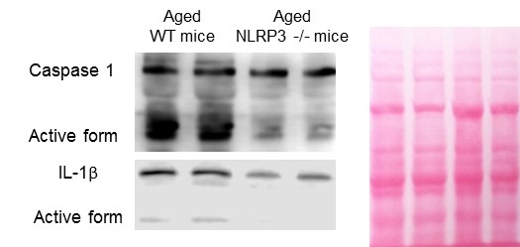

Supplementary Figure 1. (A) Western blot analysis showing reduced levels in the Active forms of Caspase 1 and IL-1β in the heart of aged NLRP3 -/- mice compared with aged WT.

Table S2. Individual values of heart weight to body weight ratios of 15 representative mice per condition.
 | WT Young | WT Old | NLRP3 -/- Young | NLRP3 -/- Old
1 | 0,00544656 | 0,00595654 | 0,0053586 | 0,00547115
2 | 0,00532842 | 0,00590824 | 0,00559116 | 0,0056549
3 | 0,00553299 | 0,00622328 | 0,00531664 | 0,00600908
4 | 0,00539219 | 0,00617978 | 0,00584407 | 0,0056636
5 | 0,00540007 | 0,00625723 | 0,00555598 | 0,00589816
6 | 0,00554221 | 0,00646595 | 0,00542785 | 0,00612802
7 | 0,00536042 | 0,0061719 | 0,0057432 | 0,00599136
8 | 0,0053317 | 0,00637173 | 0,00568227 | 0,00590793
9 | 0,00513985 | 0,00604161 | 0,00573671 | 0,00593507
10 | 0,00534063 | 0,00657189 | 0,00545153 | 0,00595156
11 | 0,00530032 | 0,00634751 | 0,00513968 | 0,00586804
12 | 0,00529866 | 0,00616351 | 0,00536951 | 0,00586247
13 | 0,0052454 | 0,00625067 | 0,00545286 | 0,00586289
14 | 0,00536887 | 0,00624866 | 0,0054883 | 0,00592428
15 | 0,0053125 | 0,00658995 | 0,00535364 | 0,0058491

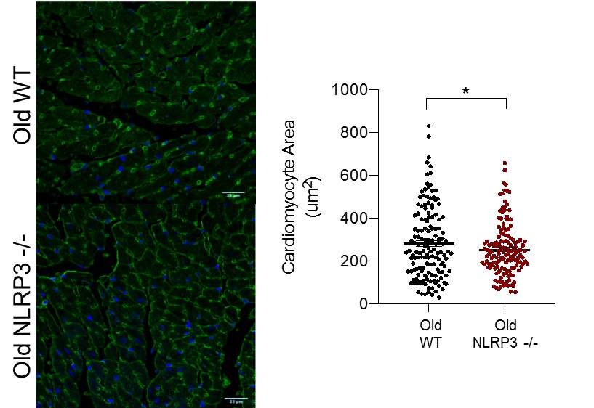

Supplementary Figure 2. Wheat Germ Agglutinin Staining in the heart of aged WT and NLRP3 -/- mice and quantification (4 animals per genotype). All data are presented as means ± SEM; *P < 0.05.

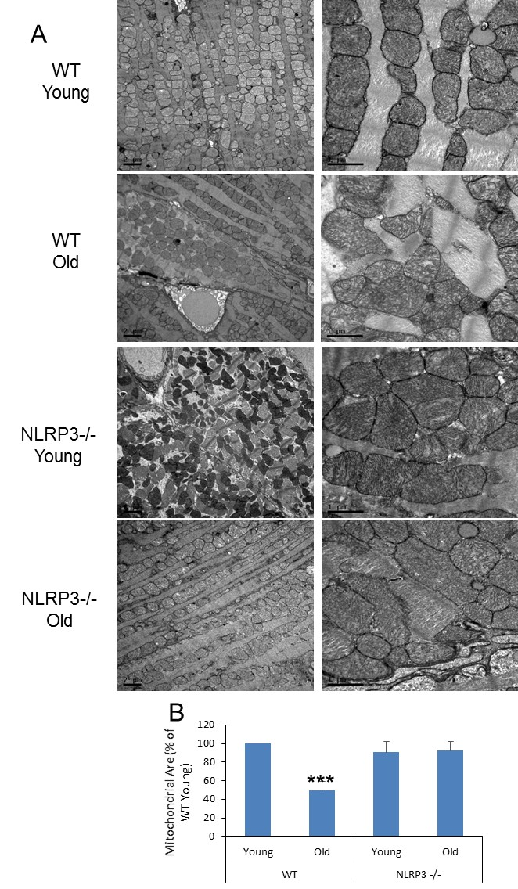

Supplementary Figure 3. (A) Representative TEM images of mouse left ventricle from Young and old WT and NLRP3 -/- mice (3 animals per genotype). (B) Morphometric analysis of mitochondrial area. All data are presented as means ± SEM, n = 10 mice; ***P < 0.001.

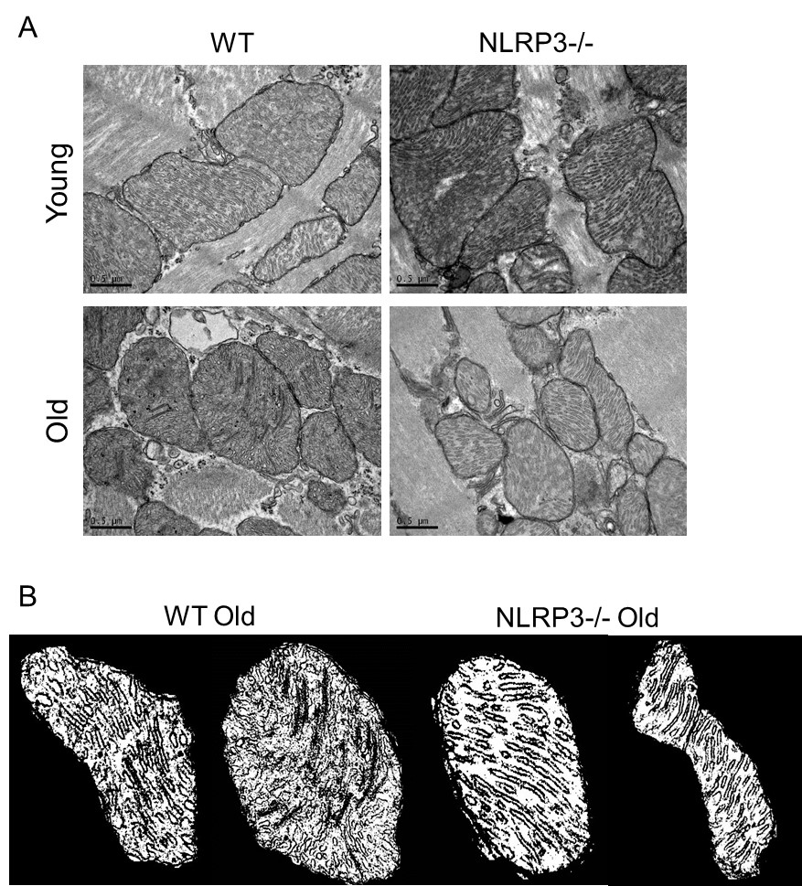

Supplementary Figure 4. (A) Representative TEM images of mitochondria from Young and old WT and NLRP3 -/- mice (3 animals per genotype). (B) Representative masks of individual heart mitochondria from old WT and NLRP3 -/- mice.
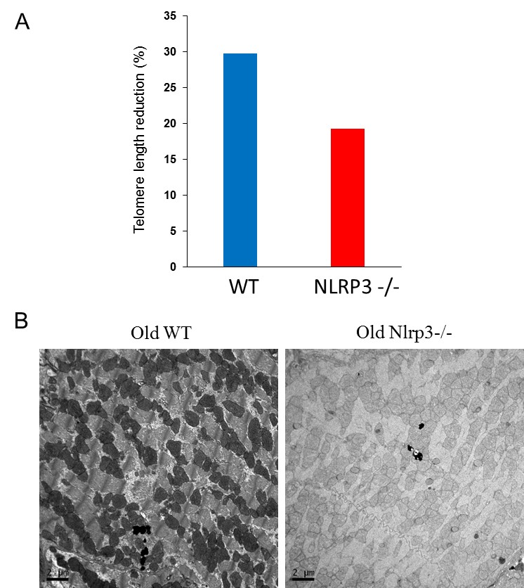

Supplementary Figure 5. (A) Telomere length reduction in old mice during the second year of life in WT mice. (B) Representative heart TEM images illustrating differences in lipofuscin.

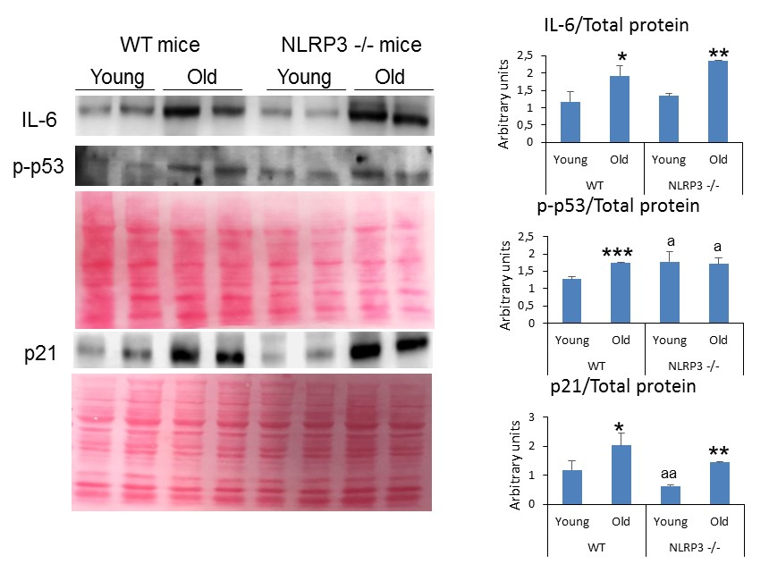

Supplementary Figure 6. Western blot analysis showing the protein expression of senescence markers IL-6, p21 ad p-p53 in the heart of Young and aged NLRP3 -/- mice compared with aged WT. All data are presented as means ± SEM, n = 4 mice; *P < 0.05, **P < 0.005, ***P < 0.001 young vs old mice. ªP < 0.05, ^{aa}P < 0.005, WT vs NLRP3 -/- mice.

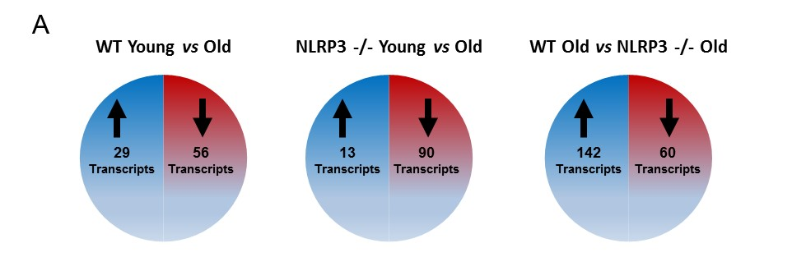

Supplementary Figure 7. A Diagram showing the number of genes up-and down-regulated in young and old WT and NLRP3 -/-.

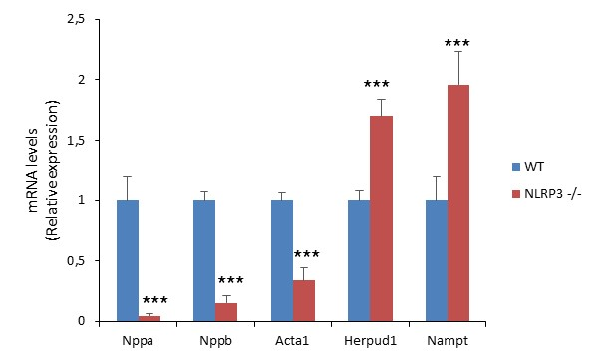
Supplementary Figure 8. mRNA expression analysis in heart by quantitative real-time PCR. Relative expression values were normalized to those of vehicle mice. All data are presented as means ± SEM, n =3 mice per group.

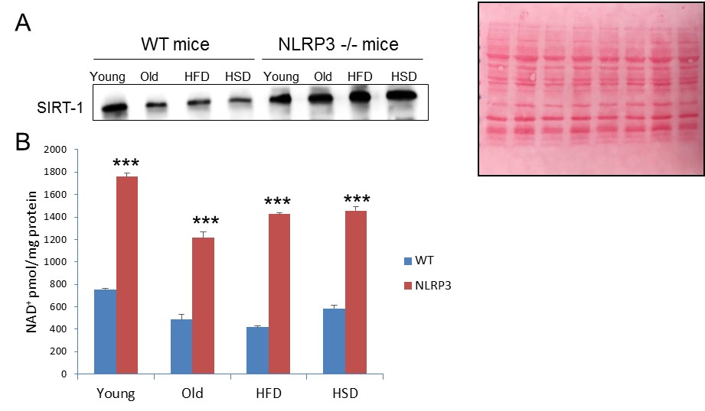
Supplementary Figure 9. SIRT1 protein expression (A) and NAD+ content (B) in cardiac tissues from Young and old WT and NLRP3 -/- mice and fed with high fat diet (HFD) and high sugar diet (HSD). All data are presented as means ± SEM, n = 10 mice; ***P < 0.001.

Table S3. Microarray data. Genes significantly down-regulated with aging (FDR<0.05, more than 2 fold).
Gene Symbol | Fold Change (linear) (wt Old vs. NLRP3-/- Old) | ANOVA p-value (wt Old vs. NLRP3-/- Old) | FDR p-value (wt Old vs. NLRP3-/- Old) | Gene Accession
Nampt | -3,23 | 0,000104 | 0,725489 | NM_021524
Gpr22 | -3,16 | 0,004631 | 0,775506 | NM_175191
Dbp | -3,03 | 0,042778 | 0,775506 | NM_016974
Herpud1 | -2,85 | 0,003404 | 0,775506 | NM_022331
Mlf1 | -2,4 | 0,068472 | 0,775506 | NM_001039543
Dhrs4 | -2,39 | 0,055669 | 0,775506 | NM_001037938
Kiz | -2,17 | 0,050594 | 0,775506 | NM_001033298
Wee1 | -2,11 | 0,005452 | 0,775506 | NM_009516

Table S4. Microarray data. Genes significantly up-regulated with aging (FDR<0.05, more than 2 fold).
Gene Symbol | Fold Change (linear) (wt Old vs. NLRP3-/- Old) | ANOVA p-value (wt Old vs. NLRP3-/- Old) | FDR p-value (wt Old vs. NLRP3-/- Old) | Gene Accession
Nppa | 418,26 | 0,038899 | 0,775506 | NM_008725
Acta1 | 35,69 | 0,03478 | 0,775506 | NM_001272041
Kdr | 9,35 | 0,056718 | 0,775506 | NM_010612
Rrad | 8,34 | 0,028376 | 0,775506 | NM_019662
Rcan1 | 8,05 | 0,000741 | 0,725489 | NM_001081549
Thbs1 | 7,63 | 0,013941 | 0,775506 | NM_011580
Serpina3n | 7,59 | 0,031951 | 0,775506 | NM_009252
Nppb | 6,58 | 0,031957 | 0,775506 | NM_001287348
Rnu6 | 5,91 | 0,041046 | 0,775506 | NR_003027
Cdkn1a | 5,7 | 0,00024 | 0,725489 | NM_001111099
Mt2 | 5,49 | 0,005336 | 0,775506 | NM_008630
Clic5 | 5,43 | 0,029888 | 0,775506 | NM_172621
Slc41a3 | 5,4 | 0,000379 | 0,725489 | NM_001037493
Pgam1-ps2 | 5,22 | 0,026011 | 0,775506 | ENSMUST00000091336
Tnfrsf12a | 5,17 | 0,010429 | 0,775506 | NM_001161746
Adgrg1 | 4,98 | 0,052936 | 0,775506 | NM_00119889
Trim72 | 4,93 | 0,033887 | 0,775506 | NM_001079932
Eif3a | 4,79 | 0,068421 | 0,775506 | NM_010123
Tbx20 | 4,77 | 0,045391 | 0,775506 | NM_001205085
Ppp1r3c | 4,69 | 0,00285 | 0,775506 | NM_016854
Jph2 | 4,66 | 0,060337 | 0,775506 | NM_001205076
Ktn1 | 4,63 | 0,06524 | 0,775506 | NM_008477
Clock | 4,57 | 0,011749 | 0,775506 | NM_001289826
Mir467c | 4,54 | 0,002001 | 0,775506 | NR_030571
Ankrd23 | 4,46 | 0,014217 | 0,775506 | NM_153502
Ptpn11 | 4,11 | 0,054054 | 0,775506 | NM_001109992
Epha4 | 4,03 | 0,061651 | 0,775506 | NM_007936
Cltc | 3,99 | 0,03151 | 0,775506 | NM_001003908
Parm1 | 3,95 | 0,037135 | 0,775506 | NM_145562
Fuca2 | 3,76 | 0,00424 | 0,775506 | NM_025799BC094449
2810474O19Rik | 3,76 | 0,006324 | 0,775506 | NM_001289661
Lpin1 | 3,68 | 0,028853 | 0,775506 | NM_001130412
Fbn1 | 3,67 | 0,021784 | 0,775506 | NM_007993
Slc38a2 | 3,66 | 0,05876 | 0,775506 | NM_175121
Plxna2 | 3,64 | 0,046632 | 0,775506 | NM_008882
Uck2 | 3,55 | 0,007241 | 0,775506 | ENSMUST00000053686
Acta2 | 3,53 | 0,030275 | 0,775506 | NM_007392
Ednra | 3,42 | 0,067714 | 0,775506 | NM_010332
Hspa5 | 3,38 | 0,027612 | 0,775506 | NM_001163434
Plxnd1 | 3,36 | 0,012069 | 0,775506 | NM_026376
Vegfa | 3,36 | 0,063511 | 0,775506 | NM_001025250
Larp1 | 3,29 | 0,06288 | 0,775506 | NM_028451
Prob1 | 3,2 | 0,049 | 0,775506 | NM_001270646
Nr1d1 | 3,15 | 0,031812 | 0,775506 | NM_145434
Hsp90aa1 | 3,07 | 0,002804 | 0,775506 | NM_010480
Ctsl | 3 | 0,016962 | 0,775506 | NM_009984
Hsph1 | 2,99 | 0,005889 | 0,775506 | NM_013559
Cd93 | 2,99 | 0,042868 | 0,775506 | NM_010740
Cyp1b1 | 2,93 | 0,041465 | 0,775506 | NM_009994
Plin3 | 2,91 | 0,00168 | 0,775506 | NM_025836
Akap1 | 2,88 | 0,052964 | 0,775506 | NM_001042541
Rel | 2,87 | 0,044881 | 0,775506 | NM_009044
Kremen1 | 2,87 | 0,056047 | 0,775506 | NM_032396
P4ha1 | 2,81 | 0,002965 | 0,775506 | NM_011030
Tgm2 | 2,78 | 0,005924 | 0,775506 | NM_009373
Lrrc8c | 2,75 | 0,008367 | 0,775506 | NM_133897
Plod1 | 2,75 | 0,028084 | 0,775506 | NM_011122
Arntl | 2,73 | 0,000075 | 0,725489 | NM_001243048
Plpp3 | 2,69 | 0,027728 | 0,775506 | NM_080555
Ide | 2,69 | 0,037083 | 0,775506 | NM_031156
Col4a2 | 2,69 | 0,038395 | 0,775506 | NM_009932
Zfp568 | 2,69 | 0,042048 | 0,775506 | NM_001033355
Ntn1 | 2,67 | 0,061582 | 0,775506 | NM_008744
Ttc17 | 2,66 | 0,069429 | 0,775506 | NM_183106
Myot | 2,63 | 0,024762 | 0,775506 | NM_001033621
Pam | 2,62 | 0,027936 | 0,775506 | NM_013626
Osmr | 2,61 | 0,011959 | 0,775506 | NM_011019
Gns | 2,61 | 0,045234 | 0,775506 | NM_029364
Enah | 2,61 | 0,048235 | 0,775506 | NM_001083120
Dmxl2 | 2,6 | 0,042827 | 0,775506 | NM_172771
Sparc | 2,58 | 0,012543 | 0,775506 | NM_009242
Irs1 | 2,57 | 0,029511 | 0,775506 | NM_010570
Srl | 2,57 | 0,044193 | 0,775506 | NM_175347
Adprhl1 | 2,56 | 0,035527 | 0,775506 | NM_172750
Itga5 | 2,54 | 0,069865 | 0,775506 | NM_010577
Zdhhc5 | 2,53 | 0,022932 | 0,775506 | NM_144887
Trak2 | 2,53 | 0,06193 | 0,775506 | NM_172406
Sacm1l | 2,5 | 0,010196 | 0,775506 | NM_030692
Mical2 | 2,5 | 0,012148 | 0,775506 | NM_001193305
Optn | 2,49 | 0,01166 | 0,775506 | NM_181848
Adipor2 | 2,48 | 0,039892 | 0,775506 | NM_197985
Gda | 2,46 | 0,042532 | 0,775506 | NM_010266
Gbp10; Gbp6 | 2,45 | 0,002531 | 0,775506 | NM_001039646
Itga1; Pelo | 2,45 | 0,055169 | 0,775506 | NM_001033228
Prkar1a | 2,42 | 0,000971 | 0,775506 | NM_021880
Mlec | 2,4 | 0,053743 | 0,775506 | NM_175403
Hsp90b1 | 2,35 | 0,05891 | 0,775506 | NM_011631
Alas1 | 2,34 | 0,013525 | 0,775506 | NM_020559
Hif1an | 2,33 | 0,055884 | 0,775506 | NM_176958
Nr4a3 | 2,32 | 0,011718 | 0,775506 | NM_015743
Twf2 | 2,3 | 0,001343 | 0,775506 | NM_011876
Stat3 | 2,3 | 0,003969 | 0,775506 | NM_011486
Murc | 2,3 | 0,016755 | 0,775506 | NM_026509
Itga6 | 2,27 | 0,068226 | 0,775506 | NM_001277970
Clu | 2,26 | 0,033104 | 0,775506 | NM_013492
Rab11fip5; Mir705 | 2,24 | 0,009407 | 0,775506 | NM_001003955
B4galt6 | 2,24 | 0,015324 | 0,775506 | NM_019737
Mcam | 2,23 | 0,015353 | 0,775506 | NM_023061
Dcaf7 | 2,23 | 0,066398 | 0,775506 | NM_027946
Prps2 | 2,23 | 0,068735 | 0,775506 | NM_026662
Uck2 | 2,22 | 0,043249 | 0,775506 | NM_030724
Nacc1 | 2,21 | 0,017817 | 0,775506 | NM_025788
Ap1b1 | 2,21 | 0,02155 | 0,775506 | NM_001243043
Col4a1 | 2,21 | 0,023836 | 0,775506 | NM_009931
Rbpms2 | 2,19 | 0,046395 | 0,775506 | NM_028030
Elovl5 | 2,19 | 0,049429 | 0,775506 | NM_134255
Arfgef2 | 2,19 | 0,053697 | 0,775506 | NM_001085495
Csf1 | 2,18 | 0,030025 | 0,775506 | NM_001113529
Hspa4 | 2,15 | 0,026764 | 0,775506 | NM_008300
Sulf2 | 2,15 | 0,064398 | 0,775506 | NM_001252578
Rrp12 | 2,14 | 0,028827 | 0,775506 | NM_199447
Perm1 | 2,14 | 0,03265 | 0,775506 | NM_172417
Tigar | 2,12 | 0,009492 | 0,775506 | NM_177003
Tubb2a | 2,12 | 0,014865 | 0,775506 | NM_009450
sep-11 | 2,12 | 0,056453 | 0,775506 | NM_001009818
Flnb | 2,12 | 0,061557 | 0,775506 | NM_134080
Slc35f6; Mir5625 | 2,12 | 0,062831 | 0,775506 | NM_175675
Wdr1 | 2,11 | 0,004702 | 0,775506 | NM_011715
Trp53i11 | 2,11 | 0,008959 | 0,775506 | NM_001025246
Pds5a | 2,11 | 0,031806 | 0,775506 | NM_001081321
Hif1a | 2,11 | 0,057054 | 0,775506 | NM_010431
Ganab | 2,11 | 0,057258 | 0,775506 | NM_008060
Pfkp | 2,1 | 0,001333 | 0,775506 | NM_019703
Chordc1 | 2,1 | 0,004947 | 0,775506 | NM_025844
Sox18 | 2,1 | 0,00755 | 0,775506 | NM_009236
Atp6v0a2 | 2,1 | 0,012376 | 0,775506 | NM_011596
Cpxm2 | 2,1 | 0,02969 | 0,775506 | NM_018867
Azin1 | 2,09 | 0,005213 | 0,775506 | NM_001102458
Pfkfb2; C4bp-ps1 | 2,09 | 0,019886 | 0,775506 | NM_001162415
Lrp5 | 2,09 | 0,029533 | 0,775506 | NM_008513
Sec31a | 2,09 | 0,04515 | 0,775506 | NM_026969
Tnks2 | 2,09 | 0,055745 | 0,775506 | NM_001163635
Spast | 2,08 | 0,05102 | 0,775506 | NM_001162870
Myh9 | 2,08 | 0,06249 | 0,775506 | NM_022410
Tmlhe | 2,07 | 0,035497 | 0,775506 | NM_138758
Sf3b3 | 2,05 | 0,016504 | 0,775506 | NM_133953
Rapgef1 | 2,04 | 0,028561 | 0,775506 | NM_001039086
Srf | 2,04 | 0,033731 | 0,775506 | NM_020493
Baiap2l1 | 2,03 | 0,01153 | 0,775506 | NM_025833
Sema7a | 2,03 | 0,023908 | 0,775506 | NM_011352
Ap3d1 | 2,02 | 0,022434 | 0,775506 | NM_007460
Cyp2u1 | 2,01 | 0,038943 | 0,775506 | NM_027816
Parvb | 2,01 | 0,060061 | 0,775506 | NM_133167
Art3 | 2,01 | 0,066082 | 0,775506 | NM_181728
Il4ra | 2 | 0,000499 | 0,725489 | NM_001008700
Tspan9 | 2 | 0,007208 | 0,775506 | NM_175414
Dctn4 | 2 | 0,047573 | 0,775506 | NM_026302

Table S4: Primers of the gene expression study.
Gen amplificado | Secuencia
Nppa | Primer forward: CCTAAGCCCTTGTGGTGTGT  Primer reverse: CAGAGTGGGAGAGGCAAGAC
Nppb | Primer forward: CAGCTCTTGAAGGACCAAGG  Primer reverse: AGACCCAGGCAGAGTCAGAA
Acta1 | Primer forward: GCATGCAGAAGGAGATCACA  Primer reverse: TTGTCGATTGTCGTCCTGAG
Thbs1 | Primer forward: CCAAAGCCTGCAAGAAAGAC  Primer reverse: CCTGCTTGTTGCAAACTTGA
Nampt | Primer forward: AGGGGTTAGCAGGTGATCCT  Primer reverse: TAGTGCGGGCTAGCCTAAAA
Herpud1 | Primer forward: ACAAAGGGTGCTGAATCCAC  Primer reverse: CCTTGGAAAGTCTGCTGGAC
β-actin | Primer forward: TGTTACCAACTGGGACGACA  Primer reverse: GGGGTGTTGAAGGTCTCAAA

Original Western blots
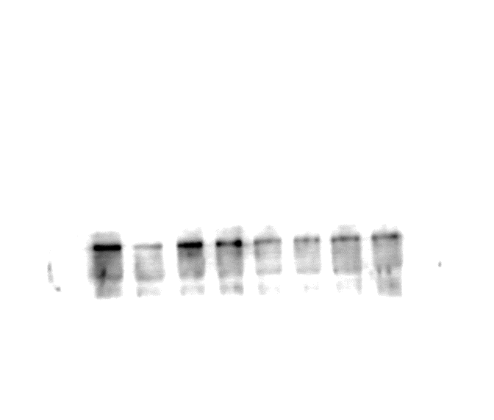
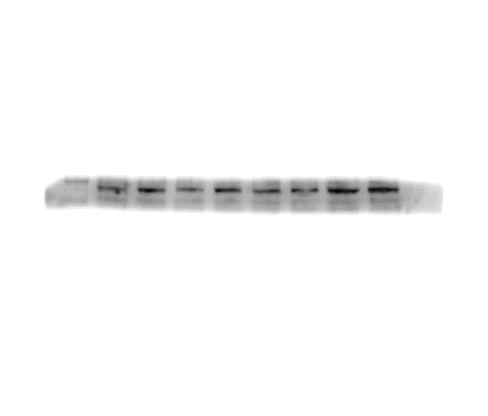
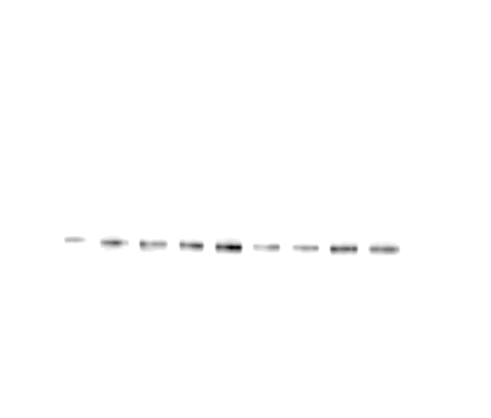
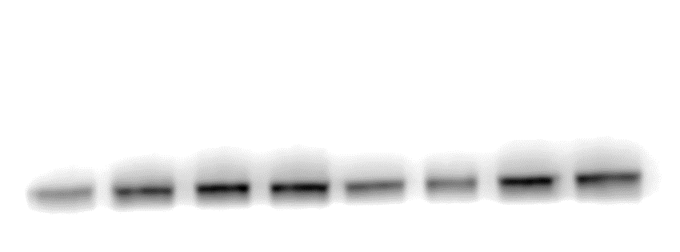
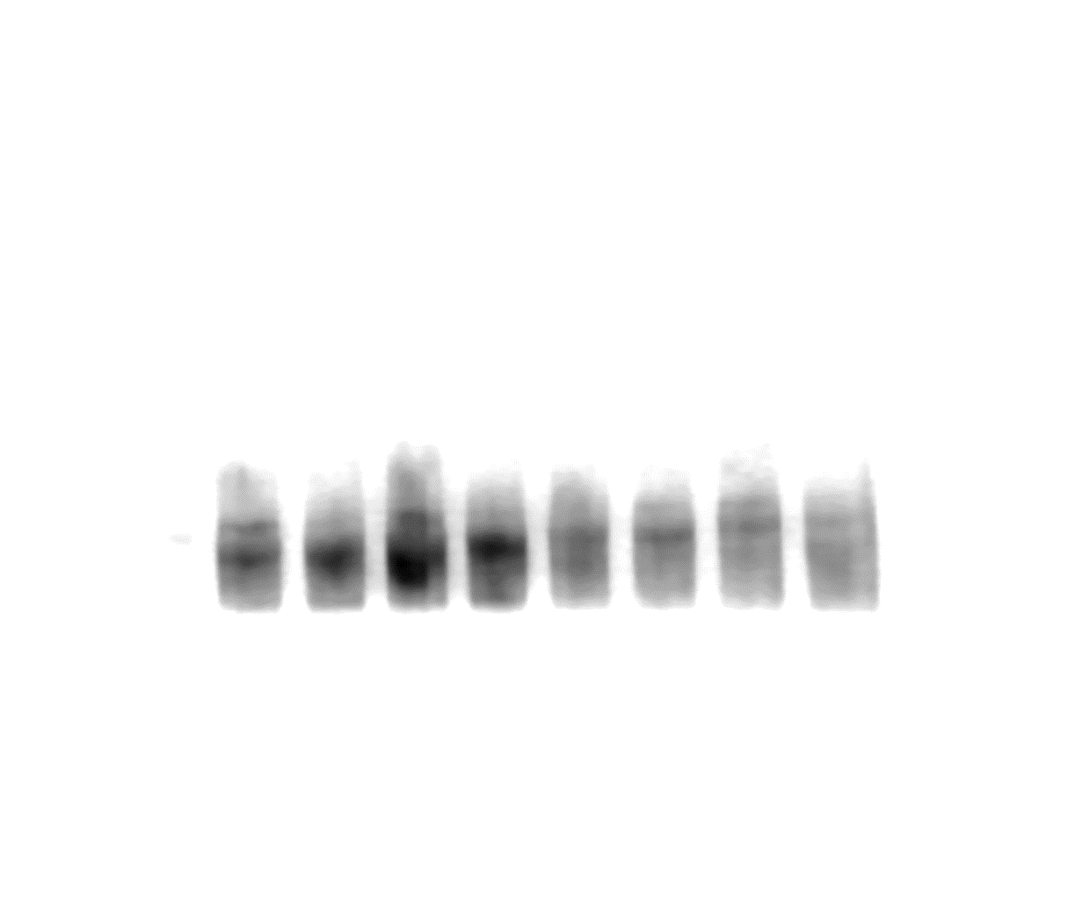
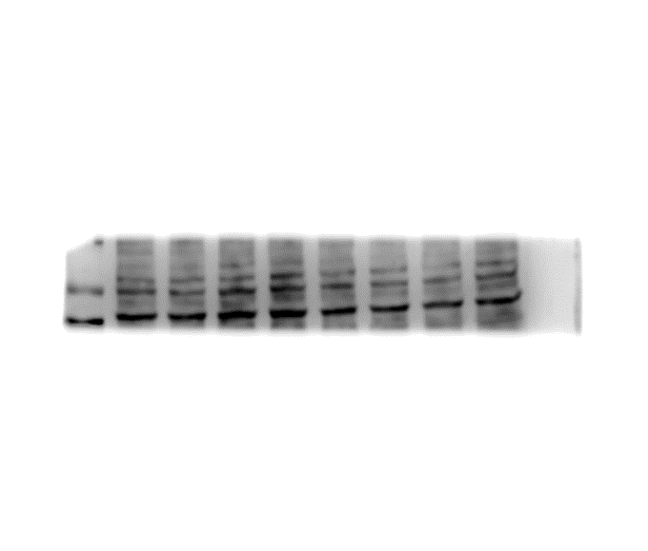
P62
ATG12
p-PI3K
PI3K
p-mTOR
mTOR

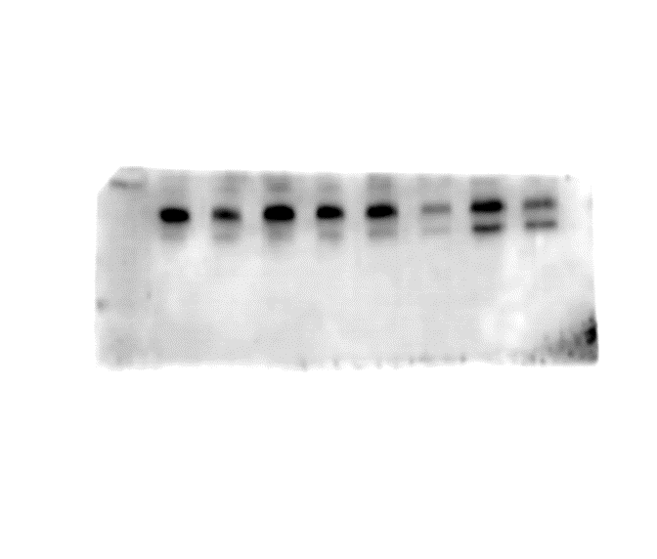
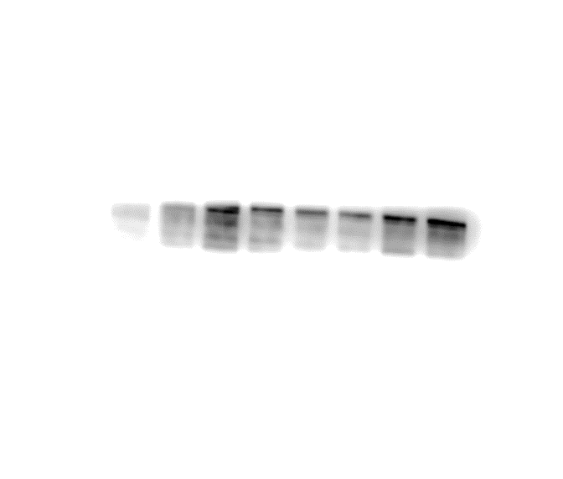
LC3
Beclin1

