Supplementary file 1. Preferred Reporting Items for Systematic reviews and Meta-Analyses extension for Scoping Reviews (PRISMA-ScR) Checklist
SECTION | ITEM | PRISMA-ScR CHECKLIST ITEM | REPORTED ON PAGE #
TITLE
Title | 1 | Identify the report as a scoping review. | #1
ABSTRACT
Structured summary | 2 | Provide a structured summary that includes (as applicable): background, objectives, eligibility criteria, sources of evidence, charting methods, results, and conclusions that relate to the review questions and objectives. | #2
INTRODUCTION
Rationale | 3 | Describe the rationale for the review in the context of what is already known. Explain why the review questions/objectives lend themselves to a scoping review approach. | #3
Objectives | 4 | Provide an explicit statement of the questions and objectives being addressed with reference to their key elements (e.g., population or participants, concepts, and context) or other relevant key elements used to conceptualize the review questions and/or objectives. | #4
METHODS
Protocol and registration | 5 | Indicate whether a review protocol exists; state if and where it can be accessed (e.g., a Web address); and if available, provide registration information, including the registration number. | #4
Eligibility criteria | 6 | Specify characteristics of the sources of evidence used as eligibility criteria (e.g., years considered, language, and publication status), and provide a rationale. | #4
Information sources* | 7 | Describe all information sources in the search (e.g., databases with dates of coverage and contact with authors to identify additional sources), as well as the date the most recent search was executed. | #7
Search | 8 | Present the full electronic search strategy for at least 1 database, including any limits used, such that it could be repeated. | #7
Selection of sources of evidence† | 9 | State the process for selecting sources of evidence (i.e., screening and eligibility) included in the scoping review. | #7
Data charting process‡ | 10 | Describe the methods of charting data from the included sources of evidence (e.g., calibrated forms or forms that have been tested by the team before their use, and whether data charting was done independently or in duplicate) and any processes for obtaining and confirming data from investigators. | #7
Data items | 11 | List and define all variables for which data were sought and any assumptions and simplifications made. | #7
Critical appraisal of individual sources of evidence§ | 12 | If done, provide a rationale for conducting a critical appraisal of included sources of evidence; describe the methods used and how this information was used in any data synthesis (if appropriate). | NA
Synthesis of results | 13 | Describe the methods of handling and summarizing the data that were charted. | #7
RESULTS
Selection of sources of evidence | 14 | Give numbers of sources of evidence screened, assessed for eligibility, and included in the review, with reasons for exclusions at each stage, ideally using a flow diagram. | #9
Characteristics of sources of evidence | 15 | For each source of evidence, present characteristics for which data were charted and provide the citations. | #9
Critical appraisal within sources of evidence | 16 | If done, present data on critical appraisal of included sources of evidence. | NA
Results of individual sources of evidence | 17 | For each included source of evidence, present the relevant data that were charted that relate to the review questions and objectives. | #9
Synthesis of results | 18 | Summarize and/or present the charting results as they relate to the review questions and objectives. | #9
DISCUSSION
Summary of evidence | 19 | Summarize the main results (including an overview of concepts, themes, and types of evidence available), link to the review questions and objectives, and consider the relevance to key groups. | #12
Limitations | 20 | Discuss the limitations of the scoping review process. | #15
Conclusions | 21 | Provide a general interpretation of the results with respect to the review questions and objectives, as well as potential implications and/or next steps. | #16
FUNDING
Funding | 22 | Describe sources of funding for the included sources of evidence, as well as sources of funding for the scoping review. Describe the role of the funders of the scoping review. | #22
JBI = Joanna Briggs Institute; PRISMA-ScR = Preferred Reporting Items for Systematic reviews and Meta-Analyses extension for Scoping Reviews.
* Where sources of evidence (see second footnote) are compiled from, such as bibliographic databases, social media platforms, and Web sites.
† A more inclusive/heterogeneous term used to account for the different types of evidence or data sources (e.g., quantitative and/or qualitative research, expert opinion, and policy documents) that may be eligible in a scoping review as opposed to only studies. This is not to be confused with information sources (see first footnote).
‡ The frameworks by Arksey and O’Malley (6) and Levac and colleagues (7) and the JBI guidance (4, 5) refer to the process of data extraction in a scoping review as data charting.
§ The process of systematically examining research evidence to assess its validity, results, and relevance before using it to inform a decision. This term is used for items 12 and 19 instead of "risk of bias" (which is more applicable to systematic reviews of interventions) to include and acknowledge the various sources of evidence that may be used in a scoping review (e.g., quantitative and/or qualitative research, expert opinion, and policy document).

From: Tricco AC, Lillie E, Zarin W, O'Brien KK, Colquhoun H, Levac D, et al. PRISMA Extension for Scoping Reviews (PRISMAScR): Checklist and Explanation. Ann Intern Med. 2018;169:467–473. doi: 10.7326/M18-0850.
Supplementary file 2. Definitions.

Prevention: reduction of the likelihood of developing a disease, sustaining an injury, or experiencing an unfavourable outcome. This study includes both collective (e.g., population screening) and individual (e.g., individual risk stratification) preventive measures.
Primary prevention is targeted at individuals that have not developed clinical manifestations of the diseases but are considered at risk of developing them, thus efforts are focused on preventing the onset of the disease.
Secondary prevention involves the time in which an intervention might be made to avoid disease progression. Screening programmes also play a role in secondary prevention. Screening is actively offered to defined population groups who do not have symptoms and have not sought medical help but are defined as being at risk of the disease.
Biomarkers were classified in the following categories:
- Molecular Biomarkers: These biomarkers involve the analysis of specific molecules such as DNA, RNA, proteins, metabolites, or genetic variations. This category encompasses both studies using specific, more targeted molecules and those using high-throughput, hypothesis-free approaches such as arrays. They are subclassified into the following groups: genetic/ genomics; epigenetic/ epigenomics; transcriptomics; metabolites/ metabolomics; proteins/ proteomics; microbiological/ microbiomics; biochemistry, and others. Within genetic/genomics, we have also extracted specifically information on the use of mendelian randomization.
- Cellular Biomarkers: In this category, we have included both cytological and histological biomarkers. These include the analysis of cells or cell components to provide information about cellular processes, dysfunction, or disease states, or examination of tissue samples through techniques such as staining or immunohistochemistry to identify specific cellular or tissue characteristics associated with a disease.
- Physiological Biomarkers: Physiological biomarkers reflect functional changes in the body and can include measurements such as blood pressure or heart rate. This group also includes patterns of movement (i.e. derived from accelerometery).
- Imaging Biomarkers: Imaging biomarkers utilize medical imaging techniques, such as X-rays, MRI (magnetic resonance imaging), PET (positron emission tomography), or CT (computed tomography), to visualize and measure structural, functional, or molecular changes in organs or tissues.
- Anthropometric Biomarkers: Anthropometric biomarkers involve the measurement of physical characteristics of the body, such as body mass index (BMI), waist circumference, or body fat percentage. In almost all the cases, they are covariables in multivariate models that include other biomarkers and/or personal characteristics of the individuals.
Lifestyles and subpopulations explored: the strategy we have used to incorporate existing information and knowledge on prevention into the review is as follows:
In primary prevention, there are lifestyle-related factors that, similar to family history, clearly influence the likelihood of developing the disease. Biomarkers should add additional value to what it is already known. In addition, we have explored, both in primary and secondary prevention, whether scientific papers examined differences or provided specific risk estimators for subgroups defined by certain risk factors and/or clinical conditions or diseases associated with clear increases in the risk of our target diseases. These studies are likely to be particularly valuable as they could help refine or personalised prevention strategies.
Wearable technology, the use of personal sensors or computing devices incorporated into accessories to provide healthcare information about people bearing them.
Artificial intelligence, when referring to the medical field, includes mainly image processing, computer vision, artificial neural network (ANN), machine learning, convolutional neural network (CNN) and Deep learning (DL).
Supplementary file 3. Eligibility criteria.

Inclusion | Exclusion
Population  ✔ Adult general population (> 18 years)  ✔ Apart from the general population, we have included relevant specific subgroups of high-risk adults depending on the group of diseases to which they belong: Smoking, alcohol consumption, diabetes, obesity, family history, hypertension, hypercholesterolemia or dyslipidaemia, APOE genotype, hearing impairment.  ✔ People who have already had the disease of interest, have it or in whom there is a proxy for the disease.  ✔ Any country of origin  Concept  ✔ Studies with a focus on molecular, cellular, physiological, and imaging biomarkers used for individualised primary or secondary  prevention of amyotrophic lateral sclerosis, Parkinson’s disease, Alzheimer’s disease, frontotemporal dementia,  vascular dementia, Lewy body disease and multiple sclerosis  ✔ In primary prevention:  Biomarkers should stratify individuals into groups  ✔ In secondary prevention:  Biomarkers should improve the screening or early detection:  ◦ stratifying different risk groups  ◦ improving the sensitivity, specificity, and time of diagnosis  for new subgroups of individuals  ✔ Studies with some risk stratification related to the early detection  (not to the evolution of the disease)  Context  ✔ Clinical or public health settings  ✔ English language only  ✔ Any geographical setting  Type of evidence  ✔ Reviews:  Umbrella review, systematic review, meta-analysis, scoping  review  ✔ Experimental and quasi-experimental study designs:  Randomised controlled trials, non-randomised controlled trials,  before and after studies, interrupted time-series studies  ✔ Analytical observational study designs:  Prospective and retrospective cohort studies, case–control studies,  and analytical cross-sectional studies  ✔ Descriptive observational study designs:  Descriptive cross-sectional studies  Sources  ✔ MEDLINE via Ovid  ✔ Embase via Ovid  ✔ Embase preprints via Ovid | Population  Pregnancy  Context  × Studies published before 2020  Type of evidence  × Editorials and opinion pieces  × Narrative reviews  × Protocols  × Qualitative study designs. Delphi studies  × Conference abstracts, conference reports  × Clinical practice guidelines  × Basic research (i.e. laboratory research in animals, human tissues, and cell lines)  × Data simulation or modelling studies  × Case reports and case series

Supplementary file 4. Search strategies for the different databases and repositories.
The PCC framework was considered to develop the search strategy, and the following topics were obtained for the search: biomarkers, neurodegenerative diseases, prevention and personalised. For each of them, the corresponding indexed and free terms were included. “Block” of terms was combined following this general strategy:
#1 biomarkers
#2 neurodegenerative diseases
#3 prevention
#4 personalised, precision, prediction or predictive
#5 #1 AND #2 AND #3 AND #4
#6 #5 Filters: from 2020-2023

Neurodegenerative diseases
OVID MEDLINE
BIOMARKERS
(exp Biological factors/ or ("biological factor*" or biomarker* or "bio* marker*").ti,ab,kw,kf.)
(exp *carbohydrates/ or exp *lipids/ or exp *amino acids/ or exp *proteins/ or exp *vitamins/ or exp *steroids/ or exp *Hormones/ or exp *Enzymes/)
(exp genetic markers/ or exp genotype/ or exp genetics/ or exp genomics or ("genetic marker*" or "genotype" or "germline biomarker*" or "genetic*" or "genomic*" or "epigen*" or "epigenetic mark*").ti,ab,kw,kf.)
(exp Microchip Analytical Procedures/ or (Microarray*).ti,ab,kw,kf.)
(exp Metabolomics/ or exp Proteomics/ or ("metabolomic*" or "proteomic*" or "lipidomic*" or "immunomic*" or "nutriomic*" or "transcriptomic*" or "radiomic*").ti,ab,kw,kf.)
((exp neuroglia/ or exp microbiota/) or ("neuroglia" or "microbiota" or "microbiome" or "gut microbiota").ti,ab,kw,kf.)
(exp *"Diagnostic Imaging"/ or (imag*).ti,ab,kw,kf.)
DISEASES
(exp amyotrophic lateral sclerosis/ or ("amyotrophic lateral sclerosis" or "gehrig disease" or "lou gehrig disease").ti,ab,kw,kf.)
(exp parkinson disease/ or ("parkinson" or "secondary parkinson disease" or "secondary parkinsonism").ti,ab,kw,kf.)
(exp alzheimer disease/ or ("Alzheimer disease" or "Alzheimer´s disease" or "alzheimer" or "alzheimer dementia").ti,ab,kw,kf.)
(exp Frontotemporal dementia/ or ("Frontotemporal dementia" or "Wilhelmsen-Lynch disease" or "Frontotemporal Lobe Dementia").ti,ab,kw,kf.)
(exp Lewy body disease/ or ("Dementia with lewy body" or "Diffuse Lewy Body Disease" or "Lewy Body Dementia").ti,ab,kw,kf.)
((exp Multiple sclerosis/) or ("Multiple sclerosis").ti,ab,kw,kf.)
((exp Vascular dementia/) or ("Vascular dementia").ti,ab,kw,kf.)
PREVENTION
(exp Primary Health Care/ or ("public health service*" or "primary health care" or "primary care").ti,ab,kw,kf.)
(exp Primary prevention/ or ("primary disease prevent*" or "preventable disease*").ti,ab,kw,kf.)
(exp Preventive Medicine/ or ("preventive medicine*" or "medical prevent*").ti,ab,kw,kf.)
(("protective factor*").ti,ab,kw,kf.)
(susceptibil*.ti,ab,kw,kf.)
(exp *smoking/)
(exp *exercise/ or exp *sedentary behavior/)
(exp *Diet, food, and nutrition/ or exp *Overweight/)
(exp *Alcohol Drinking/)
((exp *blood pressure/ or exp *hypertension/) or ("blood pressure" or "hypertension" or "high blood pressure").ti,ab,kw,kf.)
(exp *hypercholesterolemia/)
(exp *Type 2 Diabetes Mellitus/)
(exp Early Diagnosis/ or ("early diagnos*").ti,ab,kw,kf.)
(exp Mass Screening/ or exp Secondary Prevention/ or ("secondary prevent*" or "screening*").ti,ab,kw,kf.)
(exp Population Surveillance/ or ("population surveillance*" or "population screening*").ti,ab,kw,kf.)
(exp *Community Health Planning / or ("community setting*" or "health care plan*" or "community health plan*").ti,ab,kw,kf.)
(exp *Preventive health service/ or ("Preventive health service*").ti,ab,kw,kf.)
(exp *Community Health Center/ or ("community health center*" or "community health centre*" or "community care").ti,ab,kw,kf.)
(exp *Health Education / or ("health educat*" or "health promot*").ti,ab,kw,kf.)
PERSONALISED
(exp Precision medicine/ or ("personalised medicine*" or "precision medicine*" or "predict*" or "individualized medicine*" or "personalised medicine*" or "individualised medicine*").ti,ab,kw,kf.)
(exp Risk assessment / or exp Risk adjustment / or ("risk stratif" or "risk scor*" or "risk assess*" or "risk adjust*").ti,ab,kw,kf.)
(exp Machine learning/)

Neurodegenerative diseases
OVID EMBASE EMTREE
BIOMARKERS
(exp marker/ or ('biological factor*' or 'bio* marker*').ti,ab.)
(exp *'carbohydrate'/ or exp *'lipid'/ or exp *'amino acid'/ or exp *'protein'/ or exp *'vitamin'/ or exp *'steroid'/ or exp *'hormone'/ or exp *'enzyme'/)
(exp 'genetic marker'/ or exp 'genotype'/ or exp 'genetics'/ or exp 'genomics'/ or ('genotype' or 'genetic*' or 'genomic*' or 'epigenetic mark*' or 'germline biomarker*' or 'epigen*' or 'genetic marker*').ti,ab.)
(exp 'microchip analysis'/ or exp 'microarray analysis'/ or ('microarray*').ti,ab.)
(exp metabolomics/ or exp proteomics/ or exp lipidomics/ or exp nutriomics/ or exp transcriptomics/ or exp immunomics/ or exp radiomics/ or (proteomic* or lipidomic* or nutriomic* or metabolomic* or transcriptomic* or immunomic* or radiomic*).ti,ab.)
(exp 'glia'/ or exp 'microflora'/ or exp 'immunomics'/ or exp *'neurotransmitter'/ or ('microbiota' or 'microglia' or 'microbiome').ti,ab.)
(exp *'Diagnostic Imaging'/ or (imag*).ti,ab.)

DISEASES
(exp 'Amyotrophic lateral sclerosis'/ or ('amyotrophic lateral sclerosis' or 'Gehrig Disease' or 'Lou Gehrig Disease').ti,ab.)
(exp 'Parkinson disease'/ or ('Parkinson' or 'Secondary Parkinson Disease' or 'Secondary Parkinsonism').ti,ab.)
(exp 'Alzheimer disease'/ or ('Alzheimer' or 'Alzheimer disease' or 'Alzheimer's disease' or 'Alzheimer Dementia').ti,ab.)
(exp 'Frontotemporal dementia'/ or ('Wilhelmsen-Lynch disease' or 'Frontotemporal Lobe Dementia').ti,ab.)
(exp 'Lewy body disease'/ or ('Dementia with Lewy body' or 'Diffuse Lewy body disease' or 'Lewy body dementia').ti,ab.)
(exp 'Multiple sclerosis'/ or 'Multiple sclerosis'.ti,ab.)
(exp 'multiinfarct dementia'/ or ('multiinfarct dementia' or 'vascular dementia').ti,ab.)

PREVENTION
(exp 'primary health care'/ or exp 'public health service'/ or ('primary health care' or 'primary care' or "public health service*" ).ti,ab)
(exp 'primary prevention'/ or ('primary disease prevent*' or 'preventable disease*').ti,ab.)
(exp 'preventive medicine'/ or ('medical prevent*' or 'preventive medicine*').ti,ab.)
('protective factor*'.ti,ab.)
(susceptibil*.ti,ab.)
(exp *smoking/)
(exp *exercise/ or exp *'sedentary lifestyle'/)
(exp *nutrition/ or exp *obesity/)
(exp *'drinking behavior'/ or exp *'alcohol consumption'/)
(exp *'non insulin dependent diabetes mellitus'/)
(exp *hypercholesterolemia/ OR exp dyslipidemia/ or "dyslipidemia*".ti,ab. OR "dyslipidaemia*".ti,ab. OR "high cholesterol".ti,ab.)
(exp *'blood pressure'/ or exp *'hypertension'/ or ('blood pressure' or 'high blood pressure' or 'hypertension').ti,ab.)
('health care plan*' or 'community setting*' or 'community health plan*').ti,ab.
(exp *'preventive health service'/ or ("preventive health service*").ti,ab.)
(exp community care/ or ('community health center*' or 'community health centre*' or 'community care').ti,ab.)
(exp *'health education'/ or exp *'health promotion'/ or ('health educat*' or 'health promot*').ti,ab.)
(exp 'mass screening'/ or exp 'secondary prevention'/ or ('screening*' or 'secondary prevent*').ti,ab.)
(exp 'population surveillance'/ or ('population surveillance*' or 'population screening*').ti,ab.)
(exp Early Diagnosis/ or ("early diagnos*").ti,ab.)

PERSONALISED
(exp 'personalized medicine'/ or ('precision medicine*' or 'predict*' or 'personalized medicine*' or 'individualized medicine*' or 'personalised medicine*' or 'individualised medicine*').ti,ab.)
(exp 'risk assessment'/ or ('risk stratif*' or 'risk scor*' or 'risk adjust*' or 'risk assess*').ti,ab.)
(exp 'Machine learning'/)

Supplementary file 5. Data extraction.
CODE
Methods | Study design | Umbrella reviews
Methods | Study design | Systematic review (With metaanalysis)
Methods | Study design | Systematic review (Without metaanalysis)
Methods | Study design | RCT
Methods | Study design | Cohort study
Methods | Study design | Case-control study
Methods | Study design | Other design
Methods | Study design | N/P (Not Provided)
Methods | Mendelian Randomization | Has Mendelian randomization been used in the study?
Biomarker(s) | Name | Name of the biomarker(s) in text format
Biomarker(s) | Molecular | Genetics/Genomics
Biomarker(s) | Molecular | Epigenetics/Epigenomics
Biomarker(s) | Molecular | Transcription/Transcriptomics
Biomarker(s) | Molecular | Metabolites/Metabolomics
Biomarker(s) | Molecular | Proteins/Proteomics
Biomarker(s) | Molecular | Microbiomics/Microbiology
Biomarker(s) | Molecular | Biochemistry
Biomarker(s) | Molecular | Other molecular biomarker
Biomarker(s) | Molecular | N/P
Biomarker(s) | Cellular | Histology (tissue abnormalities)
Biomarker(s) | Cellular | Cytology (cell types)
Biomarker(s) | Cellular | Other cellular biomarker
Biomarker(s) | Cellular | N/P
Biomarker(s) | Imaging | X-Rays
Biomarker(s) | Imaging | Ultrasound (echography, etc)
Biomarker(s) | Imaging | CT Scan
Biomarker(s) | Imaging | PET/SPECT
Biomarker(s) | Imaging | Spectrometry
Biomarker(s) | Imaging | MRI
Biomarker(s) | Imaging | Scintigraphy (Gamma)
Biomarker(s) | Imaging | Other image biomarker
Biomarker(s) | Imaging | N/P
Biomarker(s) | Physiological | Blood Pressure
Biomarker(s) | Physiological | Ankle-brachial Index
Biomarker(s) | Physiological | Electrocardiogram
Biomarker(s) | Physiological | Electromiography
Biomarker(s) | Physiological | Other physiological biomarker
Biomarker(s) | Physiological | N/P
Biomarker(s) | Anthropometric measures | Body mass index
Biomarker(s) | Anthropometric measures | Body perimeters
Biomarker(s) | Anthropometric measures | Other anthropometric biomarker
Biomarker(s) | Anthropometric measures | N/P

CODE
Clinical Utility | Does the paper mention the clinical utility of the biomarker? (explicitly)
AI | Did they use AI technology or methods related to AI? (Deep learning, machine learning, clinical trial simulation, etc.)
Radiomics | Does the paper mention radiomics?
Technology | If they used a new technology/wearable to measure the biomarker, specify which one | Smart watch
Technology |  | Pulse oximetry
Technology |  | Infrared cameras
Technology |  | Other
Diseases
Diseases | Neurodegenerative diseases | ALS
Diseases | Neurodegenerative diseases | Parkinson
Diseases | Neurodegenerative diseases | Alzheimer
Diseases | Neurodegenerative diseases | Frontotemporal dementia
Diseases | Neurodegenerative diseases | Vascular dementia
Diseases | Neurodegenerative diseases | Lewy body disease
Diseases | Neurodegenerative diseases | Multiple sclerosis
Prevention | Type | Primary
Prevention | Type | Secondary: Screening, early diagnosis, and early detection
Prevention | Type | N/P
Prevention | If Primary: Lifestyle | Smoking
Prevention | If Primary: Lifestyle | Exercise
Prevention | If Primary: Lifestyle | Diet
Prevention | If Primary: Lifestyle | Alcohol
Prevention | If Primary: Lifestyle | Air pollution
Prevention | If Primary: Lifestyle | Immunization
Prevention | If Primary: Lifestyle | Obesity
Prevention | If Primary: Lifestyle | Preventive drugs
Prevention | If Primary: Lifestyle | Other: Specify which one
Prevention | If Primary: Lifestyle | N/P
Population | Population type | General: without any other condition or healthy participants. (Included in all disease groups)
Population | Population type | Smoking
Population | Population type | Alcohol consumption  Family history
Population | Population type | Diabetes
Population | Population type | Hypertension
Population | Population type | Dyslipidaemia
Population | Population type | Obesity
Population | Population type | Sleep
Population | Population type | Apoe genotype
Population | Population type | Hearing impairment
Population | Population type | N/P
Observations

Supplementary file 6. Bubble plot representing the number of studies identified for primary prevention of neurodegenerative diseases where lifestyle factors were considered, where the size of the bubble represents the number of studies, and the colour represents a type of biomarker.
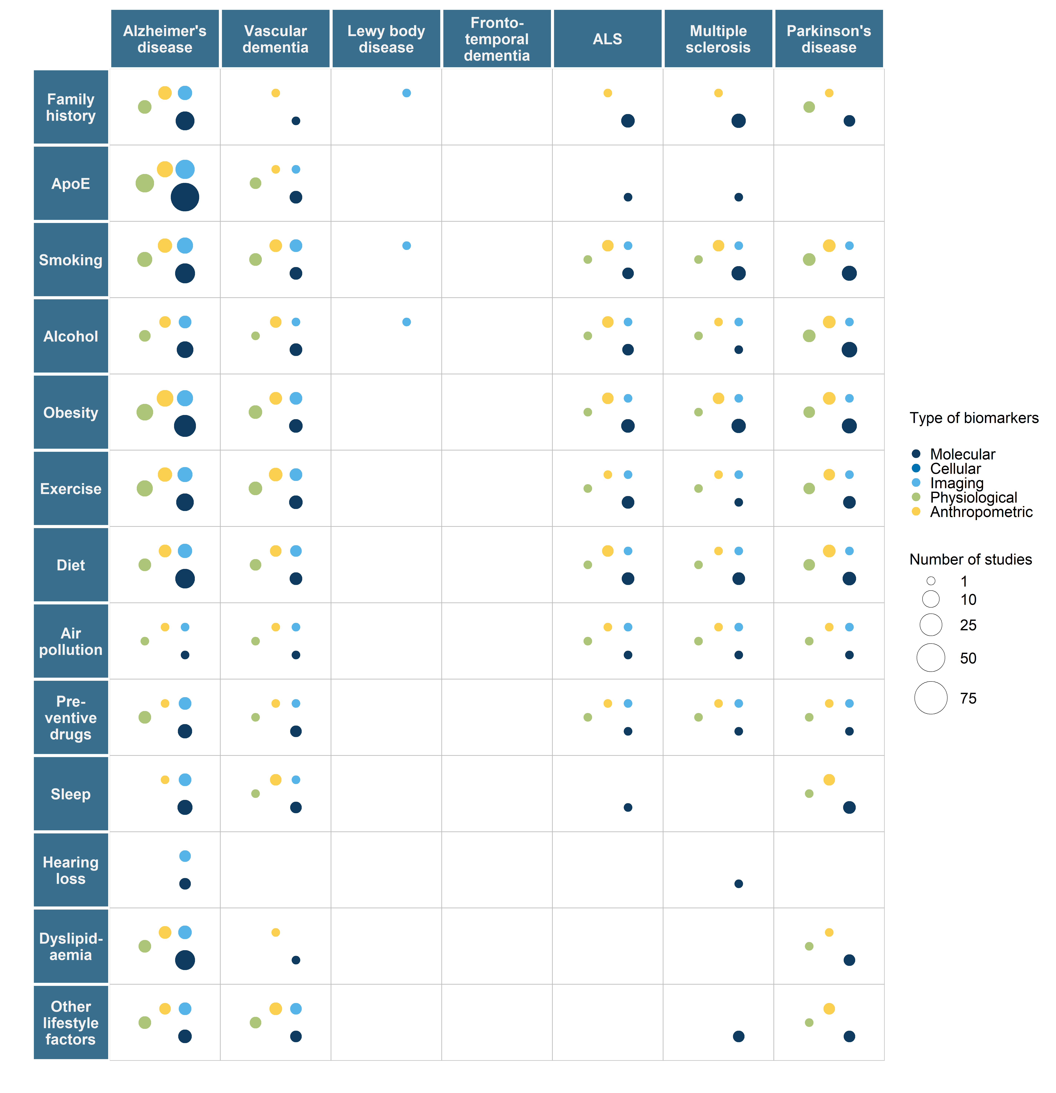

Supplementary file 7. Bubble plot. Number of studies identified for primary prevention of neurodegenerative diseases for each population type, where the size of the bubble represents the number of studies, and the colour represents a type of biomarker.

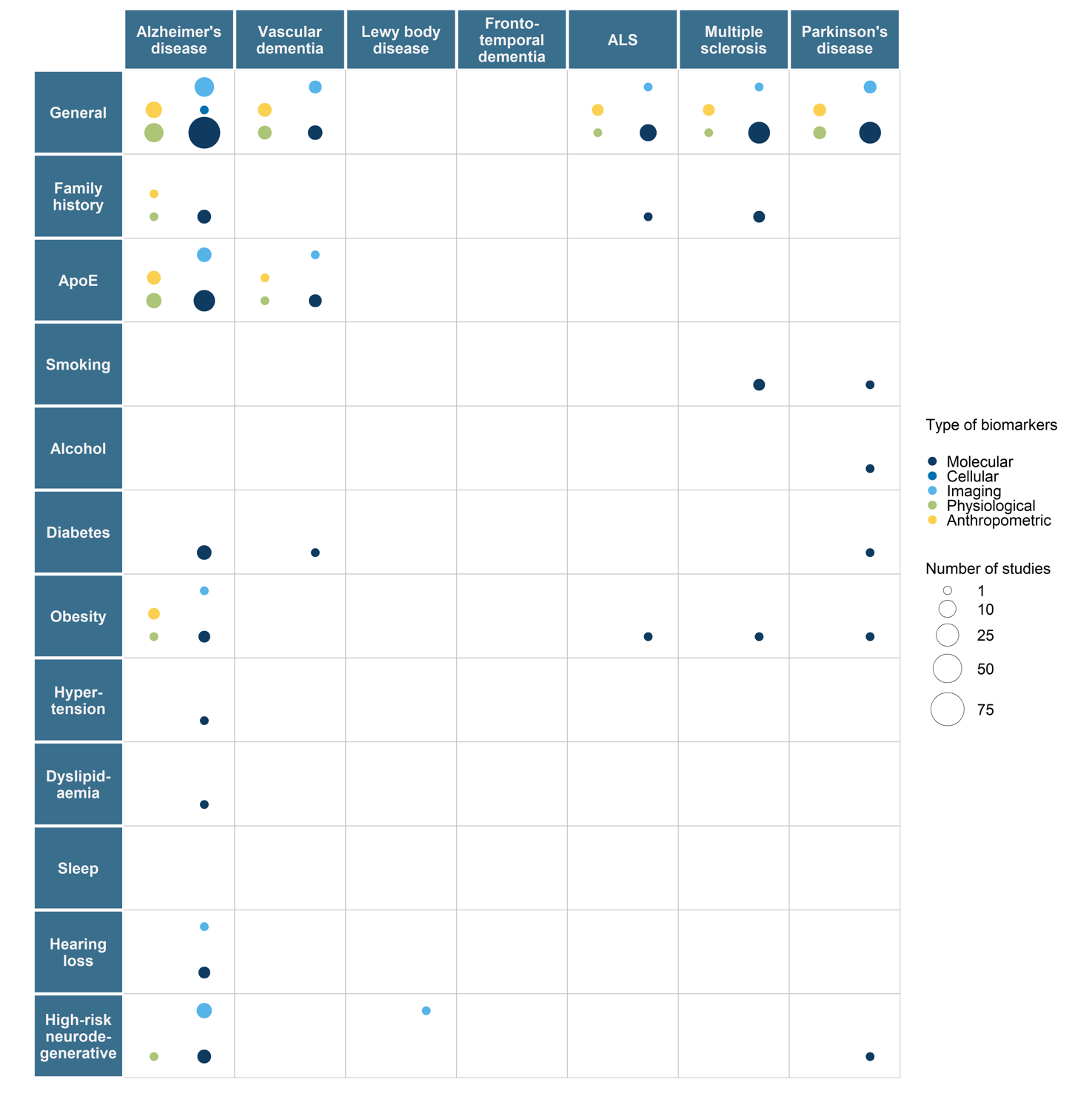

Supplementary file 8. Bubble plot. Number of studies identified for secondary prevention for each population type, where the size of the bubble represents the number of studies, and the colour represents a type of biomarker.
