SUPPLEMENTARY MATERIAL
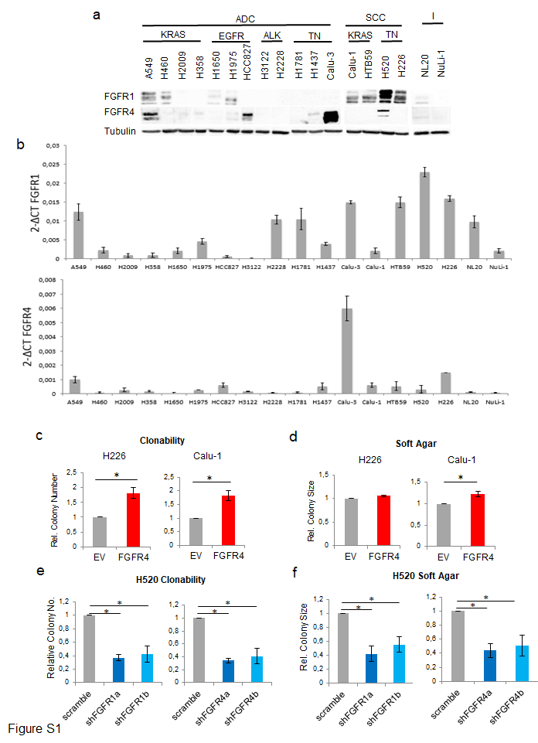
150
100
100
50

Supplementary Figure S1. Effect of FGFR1 and FGFR4 on lung squamous cell carcinoma lines. See also Figure 1. (a) Western blot determination of FGFR1 and FGFR4 protein expression in lung cell lines. To assess the expression of these proteins in the 18 cell lines, different blots were performed in parallel with an internal reference sample and the assembled images are shown. (b) mRNA expression determination for FGFR1 and FGFR4 in these cell lines. Clonability assays (c) and soft agar assay colony relative size representation (d) of FGFR4-overexpressing lung squamous cell carcinoma lines. Clonability (e) and soft agar assay colony relative size representation (f) of FGFR1- and FGFR4-silenced H520 cells. Colony number and size are shown for soft agar assays, and colony number is shown for clonability assays. All values were normalised to the empty vector control, and the mean of all normalised replicates is presented. Silencing of either gene was performed using two different shRNAs, referred as “a” and “b”. p-values are indicated by asterisks (* p<0.05; ** p<0.01; *** p<0.001). EV=Empty vector control, FGFR1=FGFR1-overexpressing, FGFR4=FGFR4 overexpressing, scramble=scramble shRNA control, shFGFR1=FGFR1 shRNA, shFGFR4=FGFR4 shRNA.

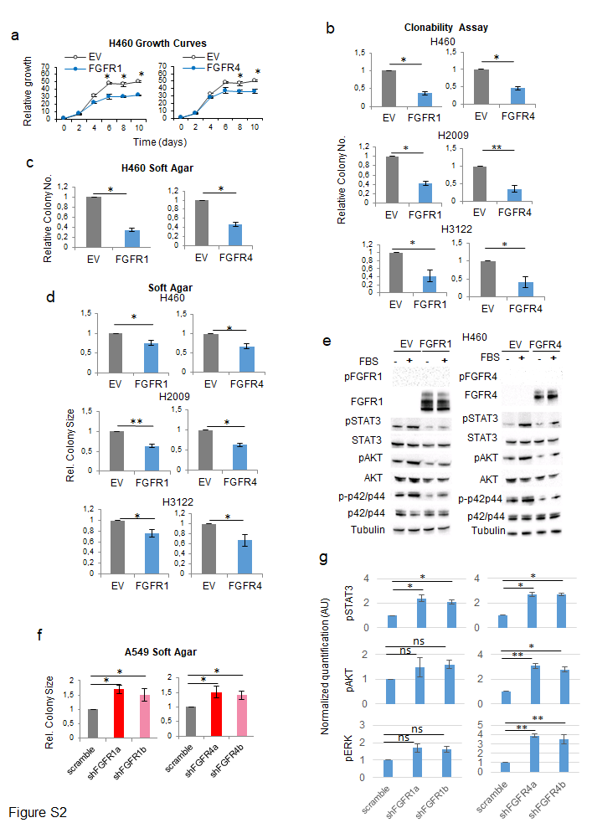
100
75
75
50
37
75
50
50
37
100

Supplementary Figure S2. Effect of FGFR1 and FGFR4 on lung adenocarcinoma cell lines. See also Figure 2. (a) 0.5% FBS growth curves for FGFR1- and FGFR4-overexpressing H460 cell line. (b) Clonability of FGFR1- and FGFR4-overexpressing H2009, H3122 and H460 cell lines. (c) Soft agar colony number of FGFR1- and FGFR4-overexpressing H460 cell line. (d) Soft agar assays of relative colony size for FGFR1- and FGFR4-overexpressing H2009, H3122 and H460 cell lines. (e) Western blot determination of the activation of FGFR-related signalling pathways in FGFR1– and FGFR4-overexpressing H460 cell line compared to the empty vector-containing cell line, after stimulation with FBS. (f) Soft agar assays of relative colony size for FGFR1- and FGFR4-silenced A549 cells. Silencing of either gene was performed using two different shRNAs, referred as “a” and “b”. (g) Quantification of western blots from Figure 2f. Band volume was quantified and normalised to tubulin, which was used as a loading control. Three independent replicates were quantified and normalised; median +/- SEM are shown. p-values are indicated by asterisks (* p<0.05; ** p<0.01; *** p<0.001). EV=Empty vector control, FGFR1=FGFR1-overexpressing, FGFR4=FGFR4 overexpressing, scramble=scramble shRNA control, shFGFR1=FGFR1 shRNA, shFGFR4=FGFR4 shRNA, FBS=Foetal Bovine Serum.
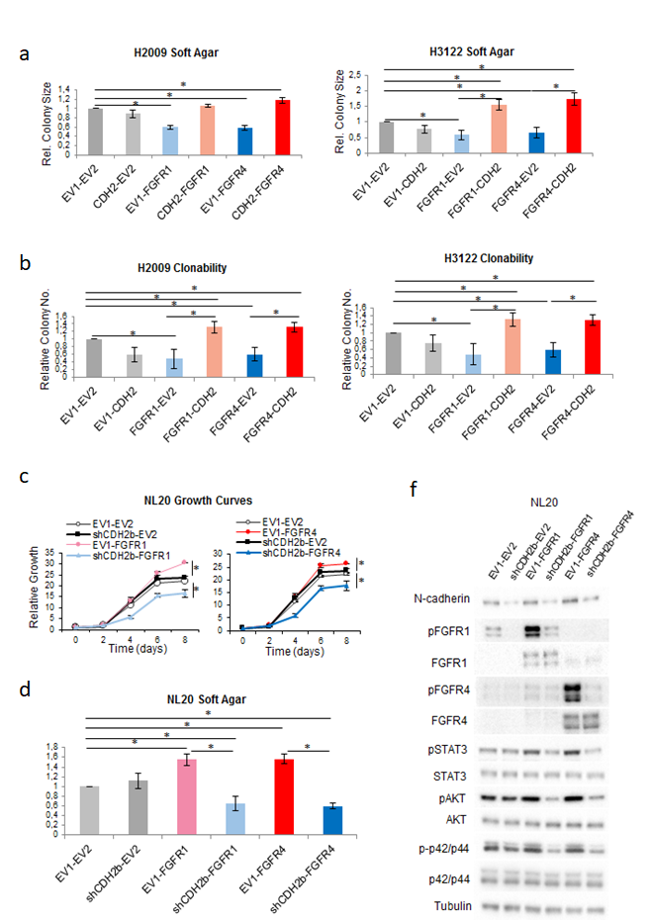
150
100
150
100
75
75
50
37
75
50
50
37
100
100
150

Supplementary Figure S3 Related to Figures 3 and 4. Soft agar relative colony size representation (a) and clonability assay (b) of the combination of N-cadherin overexpression and FGFR1 or FGFR4 overexpression in the lung adenocarcinoma cell lines H2009 and H3122. 0.5% FBS growth curves (c), soft agar assay (d) and western blot oncogenic signalling assessment (e) of the combination of N-cadherin silencing and FGFR1 or FGFR4 overexpression in the lung immortalised cell line NL20 with an alternative shRNA. All values in clonability and soft agar assays were normalised to the double empty vector control for each replicate of the experiment. The mean of each normalised replicate is represented. p-values are represented as asterisks (*, p<0.05; **, p<0.01; ***, p<0.001). FGFR1=FGFR1 overexpressing, FGFR4=FGFR4 overexpressing, EV1=Empty Vector 1, EV2=Empty Vector 2, CDH2=N-cadherin overexpressing, shCDH2 = N-cadherin shRNA silencing.

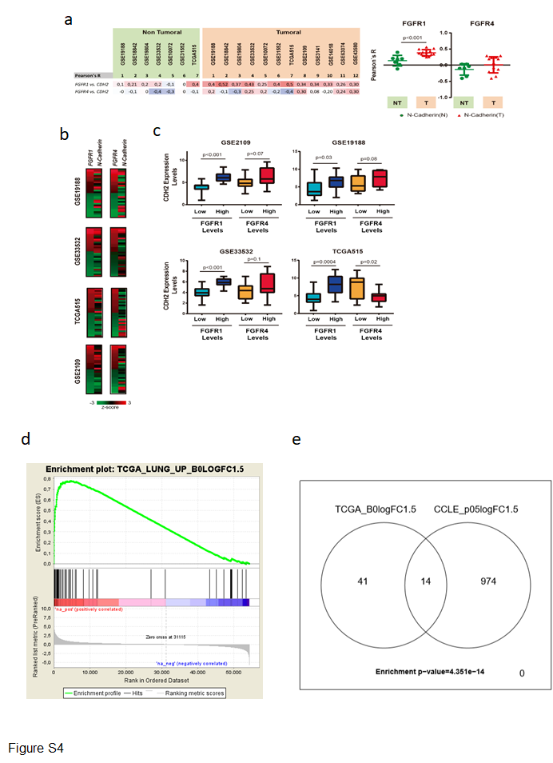
Supplementary Figure S4. (a) Right, Correlation of expression levels of FGFR1 or FGFR4 and N-cadherin genes in GSE19188, GSE18842, GSE19804, GSE33532, GSE10072, GSE31552, TCGA, GSE2109, GSE3141, GSE14018, GSE63074 and GSE43580 lung patient databases. Data were analysed using Pearson’s r correlation. Left, Average of Pearson’s r correlation of non-tumoral (NT) or tumoral (T) GSE19188, GSE18842, GSE19804, GSE33532, GSE10072, GSE31552, TCGA, GSE2109, GSE3141, GSE14018, GSE63074 and GSE43580 lung patient databases. (b) Heatmap showing the expression levels (z-score) of FGFR1, FGFR4 and N-cadherin genes from 15 patients with the highest and 15 patients with the lowest FGFR1 or FGFR4 expression levels in four representative lung cancer patient databases. (c) Blot plots showing the N-cadherin expression levels from 15 patients with the highest and 15 patients with the lowest FGFR1 or FGFR4 expression levels in four representative lung cancer patient databases. Statistical significances (p-value) for Mann Whitney U-tests are plotted in each graph. (d) Gene set enrichment analysis (GSEA) of the FGFR1/4high-N-CDH2high transcriptional signature obtained from the TCGA lung cancer patients projected in cell lines of the CCLE grouped by FGFR1/4 and N-cadherin expression levels (FGFR1/4high-CDH2high vs FGFR1/4high-CDH2low).

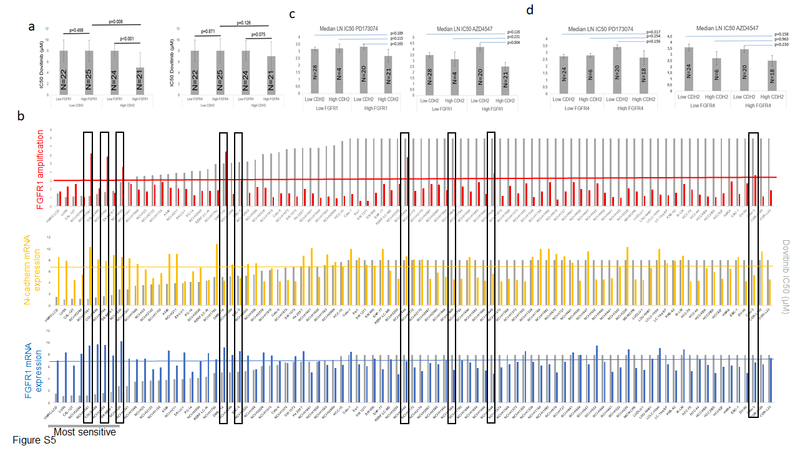

Supplementary Figure S5. Related to Figure 6. Data from the Cancer Cell Line Encyclopedia (CCLE) and Genomics of Drug Sensitivity in Cancer (GDSC) were analysed for an extensive panel of lung cancer cell lines treated with the FGFR1 inhibitor dovitinib (N=92, and N=63, respectively). (a) Analysis of sensitivity to the FGFR inhibitor dovitinib in lung cancer cell lines according to N-cadherin and FGFR1 or FGFR4 mRNA expression in CCLE data. Cell lines were divided according N-cadherin (CDH2) and FGFR1 or FGFR4 mRNA expression, where expression was considered to be high for values above the median expression for each gene. We found that sensitivity to dovitinib was only increased in those cell lines with high expression of both FGFR1 and N-cadherin genes. Means and standard deviations for dovitinib IC50 for each group is shown. p-values were obtained with the two-sided Mann-Whitney U test. Analysis of sensitivity to AZD4547 and PD173074 in relation to FGFR1 and CDH2 (b) or FGFR4 and CDH2 (c) expression in GDSC data. The mean expression of all probes per gene was used. Cell lines were divided according N-cadherin (CDH2) and FGFR1 or FGFR4 mRNA expression, here expression was considered to be high for values above the median expression for either FGFR, and third quartile expression for CDH2. (d) Analysis of FGFR1 amplification and MYC overexpression in the sensitivity of lung cancer cell lines in CCLE data to the FGFR inhibitor dovitinib. This figure is divided into graphs, all of which show dovitinib IC50 values, and each showing FGFR1 amplification, N-cadherin mRNA expression, FGFR1 mRNA expression and MYC mRNA expression. For the FGFR1 amplification graph, a cut-off value of > 3 was set to consider a cell line as FGFR1-amplified, with FGFR1-amplified cell lines are marked within the black boxes. In each mRNA expression graph, a coloured line indicates the median value of expression for each gene, which was set as the cut-off value to define low or high expression. Cell lines with the lowest 25% dovitinib IC50 values were considered to be sensitive. Of note, among nine cell lines with FGFR1 amplification, the most comprehensive eligibility criterion for clinical trials with FGFR inhibitors, three out of three with high N-cadherin and FGFR1 levels showed significant sensitivity to dovitinib, while five out of six cell lines with limited dovitinib sensitivity showed low N-cadherin and/or FGFR1 expression levels. In line with these results, we found FGFR inhibition sensitivity in FGFR-amplified H520 cells and in non-FGFR1-amplified H226 cells (Figure 5A). The remaining cell lines tested did not harbour FGFR1 amplification. These data were obtained from the Cancer Cell Line Encyclopedia (CCLE) database (https://portals.broadinstitute.org/ccle/home).

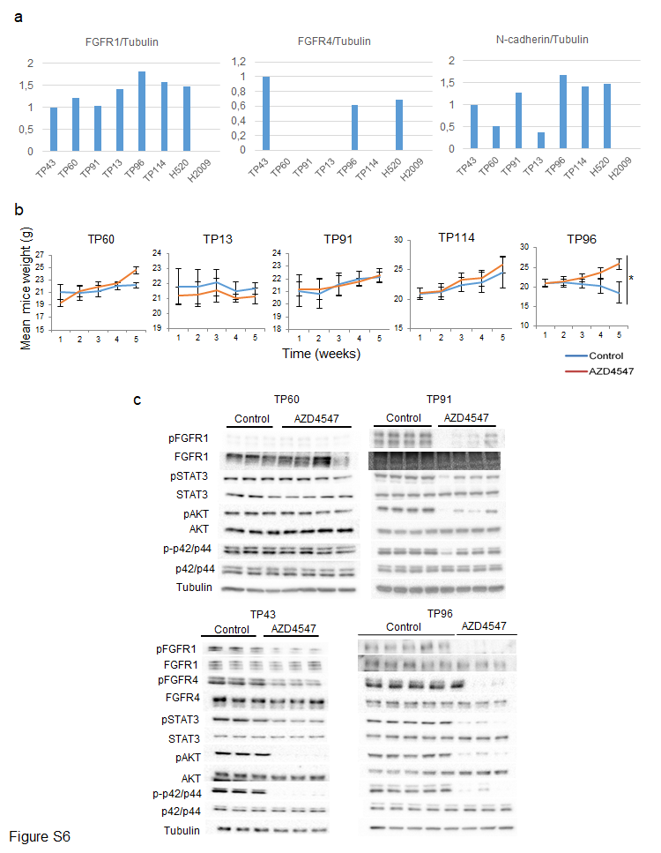
150
100
150
100
75
75
50
37
75
50
50
37
150
100
150
100
75
75
50
37
75
50
50
37
100
100

Figure S6. Related to Figure 7. (a) Western blot quantification of FGFR1, FGFR4 and N-cadherin expression in the PDX models under study. Band volume for these proteins was quantified and normalised to tubulin, which was used as a loading control. (b) Weight determination of AZD4547-treated mice for the treated PDX models, as indicative of AZD4547 treatment toxicity. (c) Western blot determination of the effect of AZD4547 treatment on oncogenic signalling pathways in the TP60, TP43, TP91 and TP96 PDXs models. p-values were obtained with the two-sided Mann-Whitney U test and are represented as asterisks (*, p<0.05; **, p<0.01; ***, p<0.001).

SUPPLEMENTARY TABLES
Supplementary Table S1. Description of the driver molecular alterations and FGFR1 amplification of our lung cell line panel Figure S1. Related to Figure 1. ADC=Adenocarcinoma, SCC=Squamous Cell Carcinoma, LCC=Large cell carcinoma, TN=“Triple Negative” (referring to the absence of alterations in KRAS, EGFR or ALK), I=Immortalised
Cell line | Histology | Driver mutation | Reference for driver mutation | FGFR1 amplification (FGFR1/CEP8)
A549 | ADC | KRAS p.G12S | (Helfrich, Raben et al. 2006) | 1.06
H460 | LCC | KRAS p.Q61H | (Helfrich, Raben et al. 2006) | 1.09
H2009 | ADC | KRAS p.G12A | COSMIC | 0.55
H358 | ADC | KRAS p.G12C | (Helfrich, Raben et al. 2006) | 1.38
H1650 | ADC | EGFR E746-E750 del | (Blanco, Iwakawa et al. 2009) | 0.6
H1975 | ADC | EGFR L858R/T790M | COSMIC | 0.92
HCC827 | ADC | EGFR E746-E750 del | (Helfrich, Raben et al. 2006) | 1.11
H3122 | ADC | EML4-ALK v1 translocation | COSMIC | 0.93
H2228 | ADC | EML4-ALK v3 translocation | COSMIC | 1.10
H1781 | ADC | TN | (Helfrich, Raben et al. 2006) | 0.73
H1437 | ADC | TN | (Helfrich, Raben et al. 2006) | 1.04
Calu-3 | ADC | TN | (Helfrich, Raben et al. 2006) | 2.45 (FGFR1 amplified)
Calu-1 | SSC | KRAS p.G12C | COSMIC | 1.11
HTB59 | SSC | KRAS p-G12V | COSMIC | 1.13
H520 | SSC | TN | COSMIC, (Helfrich, Raben et al. 2006) | 4.04 (FGFR1 amplified)
H226 | SSC | TN | COSMIC, (Helfrich, Raben et al. 2006) | 1.31
NL20 | I | TN | COSMIC | 1.55
NuLi-1 | I | TN | COSMIC | 1.07

Supplementary Table S2. Characteristics of the NSCLC cancer patient cohort

Patients (n)  Gender  Male  Female  Age (years)  Smoking habits  Smoker  Former smoker  Non-smoker  Squamous cell carcinoma Stage I-II Stage III  Adenocarcinoma Stage I-II Stage III  Other histologies | 109  100 (92%)  9 (8%)  65.0 [54.0-78.0]  56 (51.3%)  48 (44.1%)  5 (4.6%)  58 (53.2%)  43 (74.1%)  15 (25.9%)  36 (33%)  30 (83.3%)  6 (16.6%)  15 (13.7%)

Supplementary Table S3. Differentially expressed genes in our filtered gene expression signature for NSCLC tumours expressing high levels of FGFR1 and/or FGFR4, and high levels of N-cadherin in the TCGA RNAseq database for lung adenocarcinoma and squamous lung carcinoma. F14hhvsChl=comparison of tumours with high and low N-cadherin, considering only those tumours with high FGFR1 and/or FGFR4 expression. F14hhvsClh= comparison of tumours with high and low N-cadherin, considering only those tumours with high FGFR1 and/or FGFR4 expression. The results shown here are based in whole or in part upon data generated by the TCGA Research Network: http://cancergenome.nih.gov/.

Gene | F14hhvsChl.logFC | F14hhvsChl.P.Value | F14hhvsChl.B | F14hhvsClh.logFC | F14hhvsClh.P.Value | F14hhvsClh.B
PROX1 | 2,316472296 | 5,22E-17 | 28,03644776 | 0,520633695 | 0,252601838 | -5,599728495
REEP2 | 1,645627476 | 2,88E-14 | 21,87973126 | 0,44583087 | 0,216762707 | -5,494830316
RNF150 | 1,589519552 | 1,25E-13 | 20,44652754 | 0,395724466 | 0,269848058 | -5,643918909
MLLT11 | 1,826922773 | 1,02E-12 | 18,40765996 | 0,628897241 | 0,14426504 | -5,201569568
TUBB2B | 2,669018848 | 1,09E-12 | 18,33766149 | 0,951149294 | 0,131297957 | -5,131317223
AVPR1A | 1,53448157 | 3,00E-12 | 17,35849631 | 0,130159179 | 0,724732396 | -6,173026852
EYA2 | 2,254591255 | 1,28E-11 | 15,94684125 | 0,197813038 | 0,724520817 | -6,172930656
TMEM74 | 1,646818423 | 1,89E-11 | 15,56770788 | 0,145775008 | 0,724603074 | -6,172968066
SV2A | 1,543591123 | 7,09E-11 | 14,28616172 | 0,460833169 | 0,250410007 | -5,593846038
STRA6 | 2,011150741 | 2,45E-10 | 13,08375862 | 0,862147094 | 0,110310607 | -4,999415032
SLITRK4 | 1,867411577 | 2,55E-10 | 13,04745991 | 0,202157373 | 0,686377377 | -6,154139504
MMP12 | 2,113516801 | 3,22E-10 | 12,81960076 | 0,928987521 | 0,104092083 | -4,95494437
KCNB2 | 1,913303023 | 3,55E-10 | 12,72643168 | 0,460038686 | 0,374319878 | -5,851119389
NRXN1 | 2,102284226 | 2,06E-09 | 11,02386284 | 0,657621511 | 0,271322077 | -5,647532318
ZFHX4 | 1,718168313 | 3,21E-09 | 10,59612972 | 0,712940197 | 0,150121963 | -5,231008505
ZMAT4 | 2,181705774 | 4,25E-09 | 10,32634909 | -0,375824368 | 0,552877799 | -6,062611046
GRM4 | 1,934099017 | 5,95E-09 | 10,00107227 | 0,64744775 | 0,254100471 | -5,603714555
KLHL14 | 1,51477529 | 7,06E-09 | 9,836437455 | 0,567475796 | 0,204365283 | -5,453598729
TNC | 1,588160968 | 7,51E-09 | 9,776634796 | 0,594733005 | 0,205411078 | -5,457189803
POU3F2 | 2,104076853 | 8,01E-09 | 9,714497443 | 0,995455829 | 0,110682111 | -5,001984088
IP6K3 | 1,819096141 | 1,03E-08 | 9,473358516 | -0,355617537 | 0,51226409 | -6,025230066
CHRNA1 | 1,581176882 | 1,09E-08 | 9,414120289 | 0,548552414 | 0,246186387 | -5,582330592
GNG4 | 2,060855231 | 1,11E-08 | 9,400964709 | -0,239418325 | 0,697561252 | -6,159952944
FGF5 | 1,559057183 | 1,18E-08 | 9,343495609 | 0,278545025 | 0,550911051 | -6,060917113
TMSB15A | 1,569826229 | 1,76E-08 | 8,953017633 | 0,715637931 | 0,133798066 | -5,145450412
INSM1 | 2,316325437 | 1,99E-08 | 8,838947063 | 0,036477767 | 0,958762896 | -6,231738745
SOX11 | 2,153635026 | 2,00E-08 | 8,831062531 | 0,714118916 | 0,276961188 | -5,661132382
ISL1 | 1,718207381 | 4,00E-08 | 8,164447527 | -0,258863744 | 0,629016089 | -6,120091686
NXPH4 | 1,856746244 | 4,03E-08 | 8,158527583 | -0,122262824 | 0,832773419 | -6,211458699
ST6GAL2 | 1,603487652 | 8,42E-08 | 7,44971104 | 0,822670378 | 0,109712589 | -4,995259529
KIF5A | 1,55334967 | 1,01E-07 | 7,278084709 | 0,538686043 | 0,282055201 | -5,673121788
PCSK1 | 2,223351137 | 1,83E-07 | 6,703745948 | -0,990032348 | 0,176904948 | -5,35077785
NOL4 | 1,713726405 | 1,84E-07 | 6,696412703 | 0,326755534 | 0,56267026 | -6,070878191
RET | 1,775099002 | 2,86E-07 | 6,27575141 | 0,665106601 | 0,263670206 | -5,628502228
NRCAM | 1,586167227 | 6,91E-07 | 5,431822583 | 0,434837997 | 0,429450995 | -5,930939232
B4GALNT4 | 1,577318202 | 1,11E-06 | 4,981900743 | -0,347251757 | 0,533728293 | -6,045626177
DPYSL5 | 1,882815979 | 1,36E-06 | 4,784498325 | 0,670578391 | 0,318606165 | -5,751744625
CHRNA9 | 1,736372553 | 1,50E-06 | 4,693645236 | -0,649339048 | 0,297045926 | -5,706869291
IGF2 | 1,688476119 | 1,75E-06 | 4,544865525 | 0,52117931 | 0,392457527 | -5,879163182
GALNT13 | 1,506639186 | 1,85E-06 | 4,49167229 | 0,629953826 | 0,248137711 | -5,587680578
CDK5R2 | 1,560242913 | 2,14E-06 | 4,352684397 | 0,771139113 | 0,175201105 | -5,343795774
ASCL1 | 2,607198158 | 2,84E-06 | 4,082523682 | -1,080052348 | 0,261665578 | -5,623402939
TAGLN3 | 1,559656288 | 3,04E-06 | 4,019066049 | -0,290641281 | 0,614344265 | -6,110172062
SCG3 | 1,673851438 | 8,18E-06 | 3,076533344 | 0,211389787 | 0,744648916 | -6,181698725
FBN2 | 1,946066508 | 9,60E-06 | 2,924708996 | 0,820416913 | 0,281284694 | -5,671325914
MMP3 | 1,768453999 | 1,13E-05 | 2,770626661 | 1,092096552 | 0,117983769 | -5,050633016
CTNND2 | 1,89553686 | 1,23E-05 | 2,692866979 | -1,100361215 | 0,143264361 | -5,196405177
TBX18 | 1,602993727 | 1,88E-05 | 2,288805856 | 0,055896716 | 0,931352323 | -6,229441547
PTHLH | 1,823736376 | 1,94E-05 | 2,256595463 | 0,665085616 | 0,368886216 | -5,84234263
SPOCK3 | 1,572158525 | 2,80E-05 | 1,912696381 | 0,163750673 | 0,801251785 | -6,202369012
PCP4 | 1,748334483 | 6,04E-05 | 1,18760244 | -0,358732184 | 0,635459188 | -6,124285685
SLC6A15 | 1,999190858 | 6,31E-05 | 1,146328274 | 0,341849622 | 0,693555335 | -6,157900199
KIF1A | 2,105352509 | 0,000109643 | 0,628194341 | -0,025153924 | 0,978782054 | -6,232690193
COL2A1 | 1,530461482 | 0,000109759 | 0,627201243 | -0,470902956 | 0,493617643 | -6,006266275
UGT3A1 | 1,56859785 | 0,000211738 | 0,013045483 | -0,045497438 | 0,950753486 | -6,231186679

Supplementary Table S4. Potential upstream regulatory kinases and transcription factors of our gene signature identified by IPA using a conservative approach (p value < 0.01). The results shown here are based in whole or in part upon data generated by the TCGA Research Network: http://cancergenome.nih.gov/.
Upstream Regulator | Expr Log Ratio | Molecule Type | Activation z-score | p-value of overlap
ERBB3 |  | kinase |  | 1,45E-03
FGFR1 |  | kinase |  | 1,45E-03
TGFBR2 |  | kinase |  | 1,57E-03
NTRK1 |  | kinase |  | 1,68E-03
RET | 1.775 | kinase |  | 3,04E-03
FGFR2 |  | kinase |  | 4,21E-03
MAP3K8 |  | kinase |  | 6,78E-03
PIK3C3 |  | kinase |  | 7,59E-03
MAP3K1 |  | kinase |  | 8,30E-03
CTNNB1 |  | transcription regulator | 2.425 | 6,16E-08
ASCL1 | 2.607 | transcription regulator | 1.982 | 3,62E-06
RBPJ |  | transcription regulator | -1.980 | 3,31E-05
MTF1 |  | transcription regulator |  | 3,42E-04
PTF1A |  | transcription regulator |  | 5,00E-04
NHLH2 |  | transcription regulator |  | 5,63E-04
REST |  | transcription regulator |  | 6,29E-04
EGR2 |  | transcription regulator | 1.964 | 7,09E-04
JUN |  | transcription regulator | 1.982 | 1,04E-03
TLX3 |  | transcription regulator |  | 1,05E-03
SCX |  | transcription regulator |  | 1,29E-03
EHF |  | transcription regulator |  | 1,50E-03
PAX3 |  | transcription regulator |  | 1,60E-03
GLI1 |  | transcription regulator | 1.067 | 1,75E-03
TAF4B |  | transcription regulator |  | 1,97E-03
HMGB2 |  | transcription regulator |  | 1,97E-03
PAX6 |  | transcription regulator |  | 2,01E-03
ELF3 |  | transcription regulator |  | 2,80E-03
MYOG |  | transcription regulator |  | 2,80E-03
SMAD3 |  | transcription regulator | 0,870 | 3,02E-03
DACH1 |  | transcription regulator |  | 4,19E-03
POU4F2 |  | transcription regulator |  | 4,19E-03
NEUROD1 |  | transcription regulator |  | 4,40E-03
DDX20 |  | transcription regulator |  | 5,06E-03
MRTFA |  | transcription regulator |  | 5,09E-03
PAX1 |  | transcription regulator |  | 6,08E-03
SMAD7 |  | transcription regulator |  | 6,42E-03
FOXA1 |  | transcription regulator |  | 7,03E-03
KLF2 |  | transcription regulator |  | 7,28E-03
ZNF219 |  | transcription regulator |  | 7,59E-03
LHX8 |  | transcription regulator |  | 7,59E-03
SOX2 |  | transcription regulator |  | 9,76E-03

