Supplementary Table S1. Primers used in the mutation analysis of the samples. Examples of identified mutations are also shown.
Gene/exon | Primer | Primer sequence | Genomic location of the amplicon | Example of identified mutation
RET exon 8 | RET exon 8 Forward | GTGCTCCTGGCACTGTCTTT | chr10: 43111939-43112376 | No mutation identified
RET exon 8 | RET exon 8 Reverse | GCTATGCTGGCATCGAGAG | chr10: 43111939-43112376 | No mutation identified
RET exon 10 | RET exon 10 Forward | TATGCTTGCGACACCAGTTG | chr10: 43113443-43113768 | DS#8: RET p.C618S  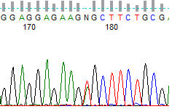
RET exon 10 | RET exon 10 Reverse | CAGCAATTTCCTCCCTTGTT | chr10: 43113443-43113768
RET exon 11 | RET exon 11 Forward | CAGAGCATACGCAGCCTGTA | chr10: 43114405-43114907 | DS#14: RET p.C634R  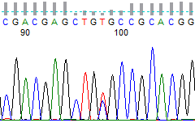
RET exon 11 | RET exon 11 Reverse | CACAGACTGTCCCCACACAG | chr10: 43114405-43114907
RET exon 13 | RET exon 13 Forward | TGACCTGGTATGGTCATGGA | chr10: 43118303-43118552 | No mutation identified
RET exon 13 | RET exon 13 Reverse | GGAGAACAGGGCTGTATGGA | chr10: 43118303-43118552 | No mutation identified
RET exon 14 | RET exon 14 Forward | AAGACCCAAGCTGCCTGAC | chr10: 43119478-43119772 | No mutation identified
RET exon 14 | RET exon 14 Reverse | GCTGGGTGCAGAGCCATA | chr10: 43119478-43119772 | No mutation identified
RET exon 15 | RET exon 15 Forward | GTCTCACCAGGCCGCTAC | chr10: 43119964-43120292 | DS#3: RET p.A883F  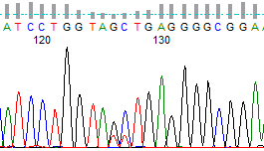
RET exon 15 | RET exon 15 Reverse | TATCTTTCCTAGGCTTCCCAA | chr10: 43119964-43120292
RET exon 16 | RET exon 16 Forward | GCCTGGCCTTCTCCTTTAC | chr10: 43121870-43122052 | DS#11: RET p.M918T  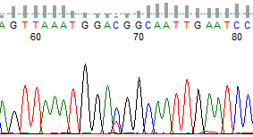
RET exon 16 | RET exon 16 Reverse | TAACCTCCACCCCAAGAGAG | chr10: 43121870-43122052
HRAS exon 2 | HRAS exon 2 Forward | CAGGAGACCCTGTAGGAGGA | chr11: 534143-534369 | DS#45: HRAS p.G13R  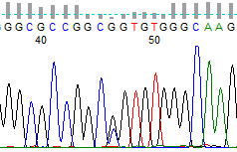
HRAS exon 2 | HRAS exon 2 Reverse | CCTATCCTGGCTGTGTCCTG | chr11: 534143-534369
HRAS exon 3 | HRAS exon 3 Forward | GATTCCTACCGGAAGCAGGT | chr11: 533804-533944 | DS#23: HRAS p.Q61R  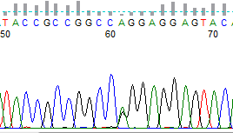
HRAS exon 3 | HRAS exon 3 Reverse | GATGGCAAACACACACAGGA | chr11: 533804-533944
NRAS exon 2 | NRAS exon 2 Forward | GTCACACTAGGGTTTTCATT | chr1: 114716063-114716272 | No mutation identified
NRAS exon 2 | NRAS exon 2 Reverse | TCATATTCATCTACAAAGTGGT | chr1: 114716063-114716272 | No mutation identified
NRAS exon 3 | NRAS exon 3 Forward | AGAAATGGGCTTGAATAGTT | chr1: 114713816-114714099 | No mutation identified
NRAS exon 3 | NRAS exon 3 Reverse | CCGCAAATGACTTGCTAT | chr1: 114713816-114714099 | No mutation identified
KRAS exon 2 | KRAS exon 2 Forward | GCCTGCTGAAAATGACTGAA | chr12: 25245282-25245395 | DS#24: p.G12V  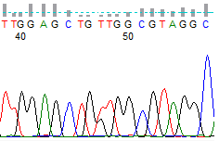
KRAS exon 2 | KRAS exon 2 Reverse | TTGGATCATATTCGTCCACA | chr12: 25245282-25245395
KRAS exon 3 | KRAS exon 3 Forward | TAGTAATTGATGGAGAAACCTG | chr12: 25227217-25227393 | No mutation identified
KRAS exon 3 | KRAS exon 3 Reverse | ATTCAATTTAAACCCACCTATA | chr12: 25227217-25227393 | No mutation identified

