Supplementary data for

Multiplexed Biosensing Diagnostic Platforms Detecting Autoantibodies to Tumor-Associated Antigens from Exosomes Released by CRC Cells and Tissue Samples Showed High Diagnostic Ability for Colorectal Cancer
Ana Montero-Calle ª, Itziar Aranguren-Abeigon ª, María Garranzo-Asensio ^{a,b}, Carmen Poves ^{c}, María Jesús Fernández-Aceñero ^{d}, Javier Martínez-Useros ^{e}, Rodrigo Sanz ^{c}, Jana Dziaková ^{c}, Javier Rodriguez-Cobos ^{f}, Guillermo Solís-Fernández ª, Eloy Povedano ^{g}, Maria Gamella ^{g}, Rebeca Magnolia Torrente-Rodríguez ^{g}, Miren Alonso-Navarro ª, Vivian de los Ríos ^{h}, J. Ignacio Casal ^{h}, Gemma Domínguez-Muñoz ^{f}, Ana Guzmán-Aránguez ^{b}, Alberto Peláez-García ^{i}, José Manuel Pingarrón ^{g}, Susana Campuzano ^{g}, Rodrigo Barderas ^{a,}*
ª Chronic Disease Program (UFIEC), Carlos III Health Institute, Madrid E-28220, Spain
^{b} Department of Biochemistry and Molecular Biology, Complutense University of Madrid, Madrid, E-28040, Spain
^{c} Gastroenterology Unit, San Carlos Clinical Hospital, Madrid E-28040, Spain
^{d} Surgical Pathology Department, San Carlos Clinical Hospital, Madrid E-28040, Spain
^{e} Translational Oncology Division, OncoHealth Institute, Jimenez Diaz Foundation University Hospital, Madrid E-28040, Spain
^{f} Department of Medicine, Faculty of Medicine, Alberto Sols Institute of Biomedical Research, CSIC-UAM, Madrid E-28029, Spain
^{g} Department of Analytical Chemistry, Faculty of Chemical Sciences, Complutense University of Madrid, Madrid 28040, Spain
^{h} Center for Biological Research, CSIC, E-28040 Madrid, Spain
^{i} Molecular Pathology and Therapeutic Targets Group, La Paz University Hospital (IdiPAZ), Madrid E-28046, Spain

* Corresponding author.
E-mail address: r.barderasm@isciii.es (R. Barderas)

Table S1
Information of the serum samples from CRC patients, individuals with premalignant lessions and heallthy individuals used in the study.

Samples | Sex | Age | Stage | Application
CT1 | F | 82 | Healthy | IP
CT2 | F | 40 | Healthy | IP
CT3 | F | 83 | Healthy | IP, Luminescence
CT4 | F | 80 | Healthy | IP, Luminescence
CT5 | M | 73 | Healthy | IP, Luminescence
CT6 | M | 75 | Healthy | IP, Luminescence
CT7 | M | 35 | Healthy | IP, Luminescence
CT8 | F | 48 | Healthy | IP, Luminescence
CT9 | F | 36 | Healthy | IP, Luminescence
CT10 | F | 41 | Healthy | IP, Luminescence
CT11 | M | 82 | Healthy | IP, Luminescence, Biosensor
CT12 | F | 82 | Healthy | IP, Luminescence, Biosensor
CT13 | F | 38 | Healthy | Luminescence
CT14 | F | 82 | Healthy | Luminescence
CT15 | M | 41 | Healthy | Luminescence
CT16 | F | 88 | Healthy | Luminescence
CT17 | F | 23 | Healthy | Luminescence
CT18 | F | 62 | Healthy | Luminescence
CT19 | F | 58 | Healthy | Luminescence
CT20 | F | 67 | Healthy | Luminescence
CT21 | M | 61 | Healthy | Luminescence
CT22 | F | 74 | Healthy | Luminescence
CT23 | M | 71 | Healthy | Luminescence
CT24 | M | 70 | Healthy | Luminescence
CT25 | F | 63 | Healthy | Luminescence
CT26 | M | 59 | Healthy | Luminescence
CT27 | M | 50 | Healthy | Luminescence
CT28 | F | 55 | Healthy | Luminescence
CT29 | M | 64 | Healthy | Luminescence
CT30 | F | 63 | Healthy | Luminescence
CT31 | F | 53 | Healthy | Luminescence
CT32 | F | 42 | Healthy | Luminescence
CT33 | M | 57 | Healthy | Luminescence
CT34 | F | 56 | Healthy | Luminescence
CT35 | F | 52 | Healthy | Luminescence, WB
CT36 | M | 64 | Healthy | Luminescence
CT37 | F | 55 | Healthy | Luminescence
CT38 | F | 64 | Healthy | Luminescence
CT39 | F | 59 | Healthy | Luminescence
CT40 | M | 58 | Healthy | Luminescence, WB
CT41 | M | 70 | Healthy | WB
CT42 | M | 67 | Healthy | WB
PRE1 | F | 60 | Low-grade adenoma | Luminescence
PRE2 | F | 67 | Low-grade adenoma | Luminescence
PRE3 | F | 58 | Low-grade adenoma | Luminescence
PRE4 | M | 49 | Low-grade adenoma | Luminescence
PRE5 | F | 79 | Low-grade adenoma | Luminescence
PRE6 | M | 76 | Low-grade adenoma | Luminescence
PRE7 | M | 55 | Low-grade adenoma | Luminescence
PRE8 | F | 54 | High-grade adenoma | Luminescence
PRE9 | F | 65 | High-grade adenoma | Luminescence
PRE10 | M | 59 | High-grade adenoma | Luminescence
PRE11 | M | 57 | Low-grade adenoma | Luminescence
PRE12 | M | 40 | High-grade adenoma | Luminescence
PRE13 | M | 67 | Low-grade adenoma | Luminescence, WB
PRE14 | F | 63 | High-grade adenoma | Luminescence
PRE15 | M | 67 | High-grade adenoma | Luminescence
PRE16 | F | 65 | High-grade adenoma | Luminescence
PRE17 | M | 64 | High-grade adenoma | Luminescence
PRE18 | M | 64 | High-grade adenoma | Luminescence
PRE19 | F | 73 | High-grade adenoma | Luminescence
PRE20 | M | 64 | High-grade adenoma | Luminescence
PRE21 | M | 57 | High-grade adenoma | Luminescence
PRE22 | M | 65 | High-grade adenoma | Luminescence
PRE23 | M | 50 | High-grade adenoma | Luminescence
PRE24 | F | 68 | High-grade adenoma | Luminescence
PRE25 | M | 65 | High-grade adenoma | Luminescence
PRE26 | M | 60 | Low-grade adenoma | Luminescence
PRE27 | M | 60 | Low-grade adenoma | Luminescence
PRE28 | M | 59 | Low-grade adenoma | Luminescence
PRE29 | M | 57 | Low-grade adenoma | Luminescence
PRE30 | F | 64 | Low-grade adenoma | Luminescence, WB
PRE31 | M | 60 | Low-grade adenoma | Luminescence
PRE32 | M | 59 | Low-grade adenoma | Luminescence
PRE33 | M | 50 | High-grade adenoma | Luminescence
PRE34 | M | 57 | Low-grade adenoma | Luminescence
PRE35 | F | 61 | Low-grade adenoma | Luminescence, Biosensor
PRE36 | M | 70 | Low-grade adenoma | Luminescence, Biosensor, WB
PRE37 | F | 38 | Low-grade adenoma | WB
CRC1 | M | 64 | III | IP
CRC2 | M | - | III | IP, Luminescence
CRC3 | M | - | III | IP, Luminescence
CRC4 | M | 85 | III | IP, Luminescence, WB
CRC5 | M | 71 | III | IP, Luminescence
CRC6 | F | 66 | III | IP, Luminescence
CRC7 | F | 60 | III | IP, Luminescence
CRC8 | M | 56 | III | IP, Luminescence
CRC9 | F | 74 | IV | IP, Luminescence
CRC10 | F | 76 | IV | IP, Luminescence
CRC11 | F | 64 | IV | IP, Luminescence
CRC12 | M | 75 | III | IP, Luminescence, Biosensor
CRC13 | F | 51 | IV | Luminescence
CRC14 | M | 77 | III | Luminescence
CRC15 | M | 77 | IV | Luminescence
CRC16 | M | 78 | III | Luminescence
CRC17 | M | 83 | I | Luminescence
CRC18 | M | 86 | I | Luminescence
CRC19 | F | ´81 | I | Luminescence
CRC20 | F | 65 | III | Luminescence
CRC21 | M | 83 | II | Luminescence
CRC22 | M | 55 | II | Luminescence
CRC23 | M | 73 | II | Luminescence
CRC24 | F | 85 | III | Luminescence
CRC25 | M | 63 | III | Luminescence
CRC26 | M | 78 | III | Luminescence
CRC27 | F | 39 | II | Luminescence
CRC28 | F | 66 | IV | Luminescence
CRC29 | F | 51 | IV | Luminescence
CRC30 | F | 66 | IV | Luminescence
CRC31 | M | 54 | IV | Luminescence
CRC32 | F | 58 | IV | Luminescence
CRC33 | F | 74 | IV | Luminescence
CRC34 | M | 82 | IV | Luminescence
CRC35 | M | 85 | IV | Luminescence
CRC36 | F | 69 | IV | Luminescence
CRC37 | M | 55 | IV | Luminescence
CRC38 | M | 85 | III | Luminescence, Biosensor
CRC39 | M | 84 | IV | Luminescence
CRC40 | M | 67 | I | WB
CRC41 | F | 65 | I | WB
CRC42 | M | 61 | III | WB
CRC43 | M | 68 | II | WB
CRC44 | F | 62 | IV | WB
CRC45 | M | 64 | IV | WB
CRC46 | F | 73 | I | WB
CRC47 | M | 70 | I | WB

Table S2
Information of the OCT embedded tissue samples from CRC patients and healthy individuals used in the study.
Sample | Age | Sex | Stage | Application
Patient 1 | 78 | M | I | IP, WB
Patient 2 | 81 | F | II | IP, WB
Patient 3 | 86 | M | II | IP, WB
Patient 4 | 60 | F | II | IP, WB
Patient 5 | 81 | F | II | IP, WB
Patient 6 | 76 | F | II | IP, WB
Patient 7 | 83 | M | III | IP, WB
Patient 8 | 69 | F | III | IP, WB
Patient 9 | 87 | M | III | IP
Patient 10 | 55 | M | III | IP, WB
Patient 11 | 82 | F | IV | IP, WB
Patient 12 | 79 | M | IV | IP, WB
Patient 13 | 84 | M | IV | IP, WB
Patient 14 | 88 | M | II | WB
Patient 15 | 65 | F | III | WB
Patient 16 | 83 | M | III | WB
Patient 17 | 83 | M | IV | WB
Patient 18 | 39 | F | IV | WB

Table S3
List of antibodies used for WB and IHC analysis.
Target | Source | Clonality | Application |  | Provider | Reference
Target | Source | Clonality | WB | IHC | Provider | Reference
HMGCS2 | Rabbit | Polyclonal | 1:500 | - | Elabscience | E-AB-16483
MT-CO2 | Rabbit | Polyclonal | 1:500 | - | Elabscience | E-AB-53240
TGM3 | Rabbit | Polyclonal | 1:1000 | - | Elabscience | E-AB-18250
SPDL1 | Rabbit | Polyclonal | 1:1000 | 1:50 | Elabscience | E-AB-10614
CYB5R1 | Rabbit | Polyclonal | 1:1000 | - | Biorbyt | orb226725
SDF2L1 | Rabbit | Polyclonal | 1:500 | 1:300 | Fitzgerald | 70R-20132
RAB25 | Mouse | Monoclonal | 1:500 | - | SCBT* | sc-65978
ACTR3 | Mouse | Monoclonal | 1:500 | 1:300 | SCBT* | sc-48344
PSPH | Mouse | Monoclonal | 1:500 | - | SCBT* | sc-271421
DEFA1 | Rabbit | Polyclonal | 1:500 | - | Elabscience | E-AB-12365
FABP5 | Mouse | Monoclonal | 1:500 | - | SCBT* | sc-365236
SERPINB12 | Mouse | Monoclonal | 1:500 | - | SCBT* | sc-32234
SERPINB3 | Mouse | Monoclonal | 1:500 | - | SCBT* | sc-21767
Alix | Mouse | Monoclonal | 1:500 | - | SCBT* | sc-53540
β-Actin | Rabbit | Polyclonal | 1:2000 | - | Rockland | 800-656-7625
GAPDH | Rabbit | Polyclonal | 1:2000 | - | Rockland | 800-656-7625
Halotag | Mouse | Monoclonal | 1:2000 | - | Promega | G921A
HRP-labeled secondary antibodies
Name | Source | Clonality | Dilution |  | Provider | Refernce
HRP-anti mouse IgG | Goat | Polyclonal | 1:2500 |  | Sigma Aldrich | A4416
HRP-anti rabbit IgG | Goat | Polyclonal | 1:3000 |  | Sigma Aldrich | A6154
HRP-anti human IgG | Goat | Polyclonal | 1:3000 |  | Dako | P0212
* SCBT, Santa Cruz Biotechnology

Table S4
Information of 72 the paraffin-embedded tissue samples from CRC patients printed onto the microarrays for immunohistochemistry staining.
Supplementary Table 4. Information of 72 the paraffin-embedded tissue samples from CRC patients printed onto the microarrays for immunohistochemistry staining.
Sample |  | Sex |  | Age |  | Lymphatic nodes metastasis |  | Liver metastasis |  | Lung metastasis |  | Survival |  | Recurrence
Patient 1 |  | M |  | 41 |  | No |  | Yes |  | No |  | Dead |  | -
Patient 10 |  | F |  | 59 |  | No |  | No |  | Yes |  | Dead |  | -
Patient 11 |  | M |  | 59 |  | No |  | Yes |  | No |  | Dead |  | -
Patient 12 |  | M |  | 74 |  | No |  | Yes |  | No |  | Dead |  | -
Patient 13 |  | M |  | 73 |  | No |  | Yes |  | No |  | Dead |  | -
Patient 14 |  | M |  | 64 |  | No |  | Yes |  | Yes |  | Dead |  | -
Patient 15 |  | M |  | 72 |  | No |  | No |  | Yes |  | Alive |  | Yes
Patient 16 |  | M |  | 68 |  | No |  | Yes |  | No |  | Dead |  | -
Patient 17 |  | F |  | 68 |  | No |  | Yes |  | Yes |  | Dead |  | -
Patient 18 |  | F |  | 49 |  | Yes |  | No |  | No |  | Dead |  | -
Patient 19 |  | M |  | 69 |  | No |  | Yes |  | No |  | Alive |  | Yes
Patient 2 |  | M |  | 68 |  | Yes |  | Yes |  | No |  | Dead |  | -
Patient 20 |  | M |  | 79 |  | No |  | No |  | Yes |  | Alive |  | Yes
Patient 21 |  | F |  | 59 |  | No |  | Yes |  | No |  | Alive |  | Yes
Patient 22 |  | F |  | 75 |  | No |  | No |  | No |  | Alive |  | No
Patient 23 |  | M |  | 68 |  | Yes |  | No |  | Yes |  | Dead |  | -
Patient 24 |  | M |  | 69 |  | No |  | Yes |  | No |  | Dead |  | -
Patient 25 |  | M |  | 55 |  | No |  | No |  | Yes |  | Dead |  | -
Patient 26 |  | M |  | 64 |  | No |  | Yes |  | No |  | Dead |  | -
Patient 27 |  | M |  | 68 |  | No |  | Yes |  | No |  | Alive |  | Yes
Patient 28 |  | F |  | 72 |  | No |  | Yes |  | No |  | Alive |  | Yes
Patient 29 |  | M |  | 66 |  | No |  | Yes |  | No |  | Dead |  | -
Patient 3 |  | M |  | 67 |  | No |  | Yes |  | Yes |  | Alive |  | Yes
Patient 30 |  | M |  | 70 |  | No |  | Yes |  | No |  | Alive |  | Yes
Patient 31 |  | M |  | 54 |  | No |  | Yes |  | No |  | Alive |  | Yes
Patient 32 |  | F |  | 70 |  | No |  | Yes |  | No |  | Alive |  | Yes
Patient 33 |  | M |  | 66 |  | No |  | Yes |  | Yes |  | Dead |  | -
Patient 34 |  | M |  | 69 |  | No |  | Yes |  | Yes |  | Dead |  | -
Patient 35 |  | M |  | 76 |  | No |  | Yes |  | Yes |  | Dead |  | -
Patient 36 |  | M |  | 57 |  | Yes |  | Yes |  | No |  | Dead |  | -
Patient 37 |  | F |  | 63 |  | Yes |  | Yes |  | No |  | Dead |  | -
Patient 38 |  | M |  | 70 |  | Yes |  | No |  | No |  | Dead |  | -
Patient 39 |  | F |  | 68 |  | No |  | Yes |  | Yes |  | Dead |  | -
Patient 4 |  | M |  | 63 |  | Yes |  | Yes |  | No |  | Dead |  | -
Patient 40 |  | M |  | 71 |  | No |  | Yes |  | No |  | Dead |  | -
Patient 41 |  | M |  | 68 |  | No |  | Yes |  | No |  | Alive |  | Yes
Patient 42 |  | M |  | 70 |  | Yes |  | Yes |  | No |  | Dead |  | -
Patient 43 |  | F |  | 66 |  | Yes |  | Yes |  | Yes |  | Alive |  | Yes
Patient 44 |  | F |  | 64 |  | No |  | No |  | Yes |  | Alive |  | Yes
Patient 45 |  | M |  | 74 |  | Yes |  | No |  | Yes |  | Alive |  | No
Patient 46 |  | F |  | 74 |  | No |  | Yes |  | Yes |  | Dead |  | -
Patient 47 |  | M |  | 68 |  | No |  | No |  | Yes |  | Alive |  | Yes
Patient 48 |  | F |  | 63 |  | Yes |  | No |  | Yes |  | Dead |  | -
Patient 49 |  | F |  | 55 |  | No |  | No |  | Yes |  | Alive |  | Yes
Patient 5 |  | M |  | 63 |  | No |  | Yes |  | Yes |  | Dead |  | -
Patient 50 |  | F |  | 56 |  | No |  | No |  | No |  | Dead |  | -
Patient 51 |  | M |  | 61 |  | No |  | Yes |  | Yes |  | Alive |  | Yes
Patient 52 |  | M |  | 57 |  | No |  | Yes |  | No |  | Alive |  | Yes
Patient 53 |  | F |  | 67 |  | No |  | No |  | No |  | Alive |  | Yes
Patient 54 |  | M |  | 80 |  | No |  | Yes |  | Yes |  | Dead |  | -
Patient 55 |  | F |  | 80 |  | Yes |  | Yes |  | No |  | Dead |  | -
Patient 56 |  | F |  | 53 |  | No |  | Yes |  | No |  | Dead |  | -
Patient 57 |  | M |  | 79 |  | No |  | No |  | Yes |  | Alive |  | Yes
Patient 58 |  | M |  | 54 |  | Yes |  | No |  | No |  | Alive |  | Yes
Patient 59 |  | F |  | 70 |  | Yes |  | No |  | Yes |  | Alive |  | Yes
Patient 6 |  | F |  | 56 |  | No |  | Yes |  | No |  | Dead |  | -
Patient 60 |  | M |  | 72 |  | Yes |  | No |  | Yes |  | Dead |  | -
Patient 61 |  | F |  | 57 |  | No |  | Yes |  | Yes |  | Dead |  | -
Patient 62 |  | M |  | 81 |  | No |  | Yes |  | No |  | Dead |  | -
Patient 63 |  | M |  | 43 |  | No |  | Yes |  | No |  | Alive |  | Yes
Patient 64 |  | M |  | 78 |  | No |  | Yes |  | No |  | Alive |  | No
Patient 65 |  | F |  | 74 |  | Yes |  | Yes |  | No |  | Dead |  | -
Patient 66 |  | M |  | 75 |  | No |  | Yes |  | No |  | Dead |  | -
Patient 67 |  | M |  | 78 |  | No |  | Yes |  | Yes |  | Dead |  | -
Patient 68 |  | F |  | 82 |  | No |  | Yes |  | No |  | Dead |  | -
Patient 69 |  | M |  | 55 |  | No |  | No |  | No |  | Alive |  | Yes
Patient 7 |  | M |  | 57 |  | Yes |  | Yes |  | No |  | Dead |  | -
Patient 70 |  | F |  | 64 |  | No |  | Yes |  | No |  | Dead |  | -
Patient 71 |  | F |  | 58 |  | No |  | Yes |  | No |  | Dead |  | -
Patient 72 |  | M |  | 63 |  | No |  | Yes |  | No |  | Alive |  | Yes
 | Patient 8 | M | 55 |  | No |  | Yes |  | No |  | Alive |  | No
 | Patient 9 | M | 60 |  | No |  | Yes |  | No |  | Alive |  | Yes

Table S5
Proteins (404) identified as seroreactive to control and CRC IgGs in the tissue samples from CRC patients at stages I-II by immunoprecipitation.

Accesion number | Description | Gene | Σcoverage (%) | Σ Peptides | Σ PSMs | Score Control | Score CRC
P78330 | Phosphoserine phosphatase OS=Homo sapiens GN=PSPH PE=1 SV=2 - [SERB_HUMAN] | SERB | 64 | 11 | 18 | - | 521.49
P60660 | Myosin light polypeptide 6 OS=Homo sapiens GN=MYL6 PE=1 SV=2 - [MYL6_HUMAN] | MYL6 | 31.79 | 4 | 7 | - | 203.34
P19105 | Myosin regulatory light chain 12A OS=Homo sapiens GN=MYL12A PE=1 SV=2 - [ML12A_HUMAN] | ML12A | 34.5 | 5 | 5 | - | 186.91
O94832 | Myosin-Id OS=Homo sapiens GN=MYO1D PE=1 SV=2 - [MYO1D_HUMAN] | MYO1D | 5.86 | 7 | 7 | - | 135.83
P31947 | 14-3-3 protein sigma OS=Homo sapiens GN=SFN PE=1 SV=1 - [1433S_HUMAN] | 1433S | 8.87 | 2 | 2 | - | 124.07
O15143 | Actin-related protein 2/3 complex subunit 1B OS=Homo sapiens GN=ARPC1B PE=1 SV=3 - [ARC1B_HUMAN] | ARC1B | 8.33 | 2 | 3 | - | 117.45
P54868 | Hydroxymethylglutaryl-CoA synthase, mitochondrial OS=Homo sapiens GN=HMGCS2 PE=1 SV=1 - [HMCS2_HUMAN] | HMCS2 | 8.07 | 4 | 4 | - | 95.64
P14625 | Endoplasmin OS=Homo sapiens GN=HSP90B1 PE=1 SV=1 - [ENPL_HUMAN] | ENPL | 2.99 | 2 | 2 | - | 93.15
Q13835 | Plakophilin-1 OS=Homo sapiens GN=PKP1 PE=1 SV=2 - [PKP1_HUMAN] | PKP1 | 3.08 | 2 | 2 | - | 87.37
O15145 | Actin-related protein 2/3 complex subunit 3 OS=Homo sapiens GN=ARPC3 PE=1 SV=3 - [ARPC3_HUMAN] | ARPC3 | 19.66 | 3 | 3 | - | 84.84
P04843 | Dolichyl-diphosphooligosaccharide--protein glycosyltransferase subunit 1 OS=Homo sapiens GN=RPN1 PE=1 SV=1 - [RPN1_HUMAN] | RPN1 | 5.6 | 3 | 3 | - | 84.43
Q9UGM3 | Deleted in malignant brain tumors 1 protein OS=Homo sapiens GN=DMBT1 PE=1 SV=2 - [DMBT1_HUMAN] | DMBT1 | 6.96 | 1 | 1 | - | 81.20
Q9NYL9 | Tropomodulin-3 OS=Homo sapiens GN=TMOD3 PE=1 SV=1 - [TMOD3_HUMAN] | TMOD3 | 5.68 | 2 | 2 | - | 77.73
P20700 | Lamin-B1 OS=Homo sapiens GN=LMNB1 PE=1 SV=2 - [LMNB1_HUMAN] | LMNB1 | 1.37 | 1 | 1 | - | 66.16
O15144 | Actin-related protein 2/3 complex subunit 2 OS=Homo sapiens GN=ARPC2 PE=1 SV=1 - [ARPC2_HUMAN] | ARPC2 | 13.33 | 4 | 4 | - | 65.72
P01040 | Cystatin-A OS=Homo sapiens GN=CSTA PE=1 SV=1 - [CYTA_HUMAN] | CYTA | 19.39 | 2 | 2 | - | 62.75
P30044 | Peroxiredoxin-5, mitochondrial OS=Homo sapiens GN=PRDX5 PE=1 SV=4 - [PRDX5_HUMAN] | PRDX5 | 8.88 | 2 | 2 | - | 61.36
Q14103 | Heterogeneous nuclear ribonucleoprotein D0 OS=Homo sapiens GN=HNRNPD PE=1 SV=1 - [HNRPD_HUMAN] | HNRPD | 3.94 | 1 | 1 | - | 60.24
P10599 | Thioredoxin OS=Homo sapiens GN=TXN PE=1 SV=3 - [THIO_HUMAN] | THIO | 12.38 | 1 | 1 | - | 56.32
P16403 | Histone H1.2 OS=Homo sapiens GN=HIST1H1C PE=1 SV=2 - [H12_HUMAN] | H12 | 9.39 | 2 | 2 | - | 54.17
P61160 | Actin-related protein 2 OS=Homo sapiens GN=ACTR2 PE=1 SV=1 - [ARP2_HUMAN] | ARP2 | 3.55 | 1 | 2 | - | 51.46
P34897 | Serine hydroxymethyltransferase, mitochondrial OS=Homo sapiens GN=SHMT2 PE=1 SV=3 - [GLYM_HUMAN] | GLYM | 4.37 | 2 | 2 | - | 50.49
P08134 | Rho-related GTP-binding protein RhoC OS=Homo sapiens GN=RHOC PE=1 SV=1 - [RHOC_HUMAN] | RHOC | 5.7 | 1 | 1 | - | 48.70
P28331 | NADH-ubiquinone oxidoreductase 75 kDa subunit, mitochondrial OS=Homo sapiens GN=NDUFS1 PE=1 SV=3 - [NDUS1_HUMAN] | NDUS1 | 4.13 | 2 | 2 | - | 48.69
Q86SJ6 | Desmoglein-4 OS=Homo sapiens GN=DSG4 PE=1 SV=1 - [DSG4_HUMAN] | DSG4 | 0.77 | 1 | 1 | - | 45.73
P00403 | Cytochrome c oxidase subunit 2 OS=Homo sapiens GN=MT-CO2 PE=1 SV=1 - [COX2_HUMAN] | COX2 | 4.41 | 1 | 1 | - | 43.61
P42766 | 60S ribosomal protein L35 OS=Homo sapiens GN=RPL35 PE=1 SV=2 - [RL35_HUMAN] | RL35 | 8.13 | 1 | 2 | - | 43.48
P51659 | Peroxisomal multifunctional enzyme type 2 OS=Homo sapiens GN=HSD17B4 PE=1 SV=3 - [DHB4_HUMAN] | DHB4 | 3.4 | 2 | 2 | - | 41.24
P56134 | ATP synthase subunit f, mitochondrial OS=Homo sapiens GN=ATP5J2 PE=1 SV=3 - [ATPK_HUMAN] | ATPK | 13.83 | 1 | 1 | - | 40.15
P59998 | Actin-related protein 2/3 complex subunit 4 OS=Homo sapiens GN=ARPC4 PE=1 SV=3 - [ARPC4_HUMAN] | ARPC4 | 6.55 | 1 | 1 | - | 39.97
P23284 | Peptidyl-prolyl cis-trans isomerase B OS=Homo sapiens GN=PPIB PE=1 SV=2 - [PPIB_HUMAN] | PPIB | 6.02 | 1 | 1 | - | 39.61
P01023 | Alpha-2-macroglobulin OS=Homo sapiens GN=A2M PE=1 SV=3 - [A2MG_HUMAN] | A2MG | 0.81 | 1 | 1 | - | 39.18
Q00610 | Clathrin heavy chain 1 OS=Homo sapiens GN=CLTC PE=1 SV=5 - [CLH1_HUMAN] | CLH1 | 1.07 | 1 | 2 | - | 38.79
O95994 | Anterior gradient protein 2 homolog OS=Homo sapiens GN=AGR2 PE=1 SV=1 - [AGR2_HUMAN] | AGR2 | 10.29 | 2 | 2 | - | 38.21
P61247 | 40S ribosomal protein S3a OS=Homo sapiens GN=RPS3A PE=1 SV=2 - [RS3A_HUMAN] | RS3A | 3.41 | 1 | 1 | - | 37.83
P08519 | Apolipoprotein(a) OS=Homo sapiens GN=LPA PE=1 SV=1 - [APOA_HUMAN] | APOA | 6.82 | 1 | 1 | - | 37.78
P61158 | Actin-related protein 3 OS=Homo sapiens GN=ACTR3 PE=1 SV=3 - [ARP3_HUMAN] | ARP3 | 2.15 | 1 | 1 | - | 37.14
Q96IU4 | Abhydrolase domain-containing protein 14B OS=Homo sapiens GN=ABHD14B PE=1 SV=1 - [ABHEB_HUMAN] | ABHEB | 3.33 | 1 | 1 | - | 35.21
Q14697 | Neutral alpha-glucosidase AB OS=Homo sapiens GN=GANAB PE=1 SV=3 - [GANAB_HUMAN] | GANAB | 1.59 | 1 | 1 | - | 35.08
Q9Y4L1 | Hypoxia up-regulated protein 1 OS=Homo sapiens GN=HYOU1 PE=1 SV=1 - [HYOU1_HUMAN] | HYOU1 | 1.2 | 1 | 1 | - | 34.95
Q96EA4 | Protein Spindly OS=Homo sapiens GN=SPDL1 PE=1 SV=2 - [SPDLY_HUMAN] | SPDLY | 1.16 | 1 | 1 | - | 34.57
P51991 | Heterogeneous nuclear ribonucleoprotein A3 OS=Homo sapiens GN=HNRNPA3 PE=1 SV=2 - [ROA3_HUMAN] | ROA3 | 4.23 | 1 | 1 | - | 34.28
Q9BPW8 | Protein NipSnap homolog 1 OS=Homo sapiens GN=NIPSNAP1 PE=1 SV=1 - [NIPS1_HUMAN] | NIPS1 | 3.17 | 1 | 1 | - | 34.09
Q96CW1 | AP-2 complex subunit mu OS=Homo sapiens GN=AP2M1 PE=1 SV=2 - [AP2M1_HUMAN] | AP2M1 | 1.61 | 1 | 1 | - | 33.94
P06703 | Protein S100-A6 OS=Homo sapiens GN=S100A6 PE=1 SV=1 - [S10A6_HUMAN] | S10A6 | 8.89 | 1 | 1 | - | 32.96
P40227 | T-complex protein 1 subunit zeta OS=Homo sapiens GN=CCT6A PE=1 SV=3 - [TCPZ_HUMAN] | TCPZ | 2.26 | 1 | 1 | - | 32.45
Q9BPX5 | Actin-related protein 2/3 complex subunit 5-like protein OS=Homo sapiens GN=ARPC5L PE=1 SV=1 - [ARP5L_HUMAN] | ARP5L | 7.84 | 1 | 1 | - | 30.05
Q12792 | Twinfilin-1 OS=Homo sapiens GN=TWF1 PE=1 SV=3 - [TWF1_HUMAN] | TWF1 | 2 | 1 | 1 | - | 28.77
P67936 | Tropomyosin alpha-4 chain OS=Homo sapiens GN=TPM4 PE=1 SV=3 - [TPM4_HUMAN] | TPM4 | 4.03 | 1 | 1 | - | 28.17
Q13243 | Splicing factor, arginine/serine-rich 5 OS=Homo sapiens GN=SFRS5 PE=1 SV=1 - [SFRS5_HUMAN] | SFRS5 | 3.31 | 1 | 1 | - | 27.96
O15511 | Actin-related protein 2/3 complex subunit 5 OS=Homo sapiens GN=ARPC5 PE=1 SV=3 - [ARPC5_HUMAN] | ARPC5 | 7.95 | 1 | 1 | - | 27.35
Q969V3 | Nicalin OS=Homo sapiens GN=NCLN PE=1 SV=2 - [NCLN_HUMAN] | NCLN | 2.49 | 1 | 1 | - | 26.60
Q5VU13 | V-set and immunoglobulin domain-containing protein 8 OS=Homo sapiens GN=VSIG8 PE=2 SV=1 - [VSIG8_HUMAN] | VSIG8 | 2.42 | 1 | 1 | - | 26.60
Q15181 | Inorganic pyrophosphatase OS=Homo sapiens GN=PPA1 PE=1 SV=2 - [IPYR_HUMAN] | IPYR | 3.11 | 1 | 1 | - | 25.07
P10620 | Microsomal glutathione S-transferase 1 OS=Homo sapiens GN=MGST1 PE=1 SV=1 - [MGST1_HUMAN] | MGST1 | 10.32 | 1 | 1 | - | 23.25
P38919 | Eukaryotic initiation factor 4A-III OS=Homo sapiens GN=EIF4A3 PE=1 SV=4 - [IF4A3_HUMAN] | IF4A3 | 1.95 | 1 | 1 | - | 0.00
Q7Z406 | Myosin-14 OS=Homo sapiens GN=MYH14 PE=1 SV=2 - [MYH14_HUMAN] | MYH14 | 23.86 | 40 | 51 | 131.73 | 1474.44
P05141 | ADP/ATP translocase 2 OS=Homo sapiens GN=SLC25A5 PE=1 SV=7 - [ADT2_HUMAN] | ADT2 | 17.11 | 5 | 10 | 28.20 | 297.94
P09327 | Villin-1 OS=Homo sapiens GN=VIL1 PE=1 SV=4 - [VILI_HUMAN] | VILI | 23.82 | 17 | 28 | 91.87 | 644.85
P08238 | Heat shock protein HSP 90-beta OS=Homo sapiens GN=HSP90AB1 PE=1 SV=4 - [HS90B_HUMAN] | HS90B | 10.08 | 7 | 12 | 44.12 | 295.65
P35749 | Myosin-11 OS=Homo sapiens GN=MYH11 PE=1 SV=3 - [MYH11_HUMAN] | MYH11 | 15.67 | 26 | 34 | 148.08 | 932.85
P06396 | Gelsolin OS=Homo sapiens GN=GSN PE=1 SV=1 - [GELS_HUMAN] | GELS | 6.01 | 4 | 7 | 29.46 | 135.17
P62736 | Actin, aortic smooth muscle OS=Homo sapiens GN=ACTA2 PE=1 SV=1 - [ACTA_HUMAN] | ACTA | 37.4 | 11 | 51 | 297.52 | 1285.16
P38646 | Stress-70 protein, mitochondrial OS=Homo sapiens GN=HSPA9 PE=1 SV=2 - [GRP75_HUMAN] | GRP75 | 21.21 | 12 | 21 | 144.86 | 578.13
P14923 | Junction plakoglobin OS=Homo sapiens GN=JUP PE=1 SV=3 - [PLAK_HUMAN] | PLAK | 13.42 | 8 | 9 | 65.27 | 259.63
P47755 | F-actin-capping protein subunit alpha-2 OS=Homo sapiens GN=CAPZA2 PE=1 SV=3 - [CAZA2_HUMAN] | CAZA2 | 8.74 | 2 | 3 | 25.24 | 98.49
P04844 | Dolichyl-diphosphooligosaccharide--protein glycosyltransferase subunit 2 OS=Homo sapiens GN=RPN2 PE=1 SV=3 - [RPN2_HUMAN] | RPN2 | 11.09 | 4 | 5 | 30.72 | 119.01
P18124 | 60S ribosomal protein L7 OS=Homo sapiens GN=RPL7 PE=1 SV=1 - [RL7_HUMAN] | RL7 | 23.79 | 6 | 9 | 36.32 | 134.43
P62424 | 60S ribosomal protein L7a OS=Homo sapiens GN=RPL7A PE=1 SV=2 - [RL7A_HUMAN] | RL7A | 16.54 | 5 | 7 | 49.06 | 179.07
P35579 | Myosin-9 OS=Homo sapiens GN=MYH9 PE=1 SV=4 - [MYH9_HUMAN] | MYH9 | 44.44 | 80 | 145 | 975.27 | 3489.94
P45880 | Voltage-dependent anion-selective channel protein 2 OS=Homo sapiens GN=VDAC2 PE=1 SV=2 - [VDAC2_HUMAN] | VDAC2 | 17.69 | 4 | 5 | 36.16 | 113.31
P12236 | ADP/ATP translocase 3 OS=Homo sapiens GN=SLC25A6 PE=1 SV=4 - [ADT3_HUMAN] | ADT3 | 26.85 | 6 | 10 | 66.51 | 203.03
P60709 | Actin, cytoplasmic 1 OS=Homo sapiens GN=ACTB PE=1 SV=1 - [ACTB_HUMAN] | ACTB | 59.2 | 15 | 92 | 738.00 | 2131.83
Q14240 | Eukaryotic initiation factor 4A-II OS=Homo sapiens GN=EIF4A2 PE=1 SV=2 - [IF4A2_HUMAN] | IF4A2 | 13.27 | 5 | 8 | 61.76 | 177.33
Q00325 | Phosphate carrier protein, mitochondrial OS=Homo sapiens GN=SLC25A3 PE=1 SV=2 - [MPCP_HUMAN] | MPCP | 7.73 | 3 | 5 | 33.66 | 95.34
P32119 | Peroxiredoxin-2 OS=Homo sapiens GN=PRDX2 PE=1 SV=5 - [PRDX2_HUMAN] | PRDX2 | 14.65 | 3 | 3 | 25.91 | 71.56
P40429 | 60S ribosomal protein L13a OS=Homo sapiens GN=RPL13A PE=1 SV=2 - [RL13A_HUMAN] | RL13A | 20.69 | 4 | 6 | 54.29 | 146.48
O95571 | Persulfide dioxygenase ETHE1, mitochondrial OS=Homo sapiens GN=ETHE1 PE=1 SV=2 - [ETHE1_HUMAN] | ETHE1 | 15.35 | 3 | 4 | 31.90 | 82.09
Q9HCN8 | Stromal cell-derived factor 2-like protein 1 OS=Homo sapiens GN=SDF2L1 PE=1 SV=2 - [SDF2L_HUMAN] | SDF2L | 19.46 | 3 | 4 | 48.29 | 121.44
P62888 | 60S ribosomal protein L30 OS=Homo sapiens GN=RPL30 PE=1 SV=2 - [RL30_HUMAN] | RL30 | 31.3 | 3 | 4 | 49.08 | 118.19
P15924 | Desmoplakin OS=Homo sapiens GN=DSP PE=1 SV=3 - [DESP_HUMAN] | DESP | 2.23 | 7 | 8 | 50.13 | 119.04
Q15233 | Non-POU domain-containing octamer-binding protein OS=Homo sapiens GN=NONO PE=1 SV=4 - [NONO_HUMAN] | NONO | 5.94 | 3 | 3 | 36.25 | 85.03
P23526 | Adenosylhomocysteinase OS=Homo sapiens GN=AHCY PE=1 SV=4 - [SAHH_HUMAN] | SAHH | 4.63 | 2 | 2 | 24.16 | 56.01
P05091 | Aldehyde dehydrogenase, mitochondrial OS=Homo sapiens GN=ALDH2 PE=1 SV=2 - [ALDH2_HUMAN] | ALDH2 | 6.19 | 3 | 5 | 47.23 | 107.70
P05388 | 60S acidic ribosomal protein P0 OS=Homo sapiens GN=RPLP0 PE=1 SV=1 - [RLA0_HUMAN] | RLA0 | 9.15 | 2 | 3 | 25.66 | 58.32
P11678 | Eosinophil peroxidase OS=Homo sapiens GN=EPX PE=1 SV=2 - [PERE_HUMAN] | PERE | 8.39 | 5 | 6 | 78.45 | 172.81
P13639 | Elongation factor 2 OS=Homo sapiens GN=EEF2 PE=1 SV=4 - [EF2_HUMAN] | EF2 | 3.38 | 3 | 3 | 31.72 | 67.71
P61626 | Lysozyme C OS=Homo sapiens GN=LYZ PE=1 SV=1 - [LYSC_HUMAN] | LYSC | 8.11 | 1 | 3 | 38.97 | 80.27
P07437 | Tubulin beta chain OS=Homo sapiens GN=TUBB PE=1 SV=2 - [TBB5_HUMAN] | TBB5 | 39.86 | 14 | 42 | 428.99 | 881.66
Q01469 | Fatty acid-binding protein, epidermal OS=Homo sapiens GN=FABP5 PE=1 SV=3 - [FABP5_HUMAN] | FABP5 | 28.15 | 4 | 7 | 71.73 | 147.03
P21397 | Amine oxidase [flavin-containing] A OS=Homo sapiens GN=MAOA PE=1 SV=1 - [AOFA_HUMAN] | AOFA | 7.78 | 3 | 7 | 74.70 | 150.91
P04406 | Glyceraldehyde-3-phosphate dehydrogenase OS=Homo sapiens GN=GAPDH PE=1 SV=3 - [G3P_HUMAN] | G3P | 34.93 | 8 | 18 | 242.83 | 477.11
P23396 | 40S ribosomal protein S3 OS=Homo sapiens GN=RPS3 PE=1 SV=2 - [RS3_HUMAN] | RS3 | 53.5 | 11 | 26 | 238.14 | 465.59
P23246 | Splicing factor, proline- and glutamine-rich OS=Homo sapiens GN=SFPQ PE=1 SV=2 - [SFPQ_HUMAN] | SFPQ | 6.22 | 4 | 6 | 63.38 | 123.35
P30837 | Aldehyde dehydrogenase X, mitochondrial OS=Homo sapiens GN=ALDH1B1 PE=1 SV=3 - [AL1B1_HUMAN] | AL1B1 | 9.09 | 5 | 9 | 78.77 | 151.14
P11142 | Heat shock cognate 71 kDa protein OS=Homo sapiens GN=HSPA8 PE=1 SV=1 - [HSP7C_HUMAN] | HSP7C | 14.4 | 7 | 18 | 243.10 | 458.66
P36578 | 60S ribosomal protein L4 OS=Homo sapiens GN=RPL4 PE=1 SV=5 - [RL4_HUMAN] | RL4 | 12.88 | 5 | 8 | 79.91 | 149.72
P62269 | 40S ribosomal protein S18 OS=Homo sapiens GN=RPS18 PE=1 SV=3 - [RS18_HUMAN] | RS18 | 25 | 5 | 9 | 103.66 | 189.93
P61254 | 60S ribosomal protein L26 OS=Homo sapiens GN=RPL26 PE=1 SV=1 - [RL26_HUMAN] | RL26 | 15.86 | 3 | 7 | 60.82 | 109.76
P62805 | Histone H4 OS=Homo sapiens GN=HIST1H4A PE=1 SV=2 - [H4_HUMAN] | H4 | 50.49 | 5 | 14 | 141.57 | 255.21
P49411 | Elongation factor Tu, mitochondrial OS=Homo sapiens GN=TUFM PE=1 SV=2 - [EFTU_HUMAN] | EFTU | 16.37 | 6 | 9 | 98.47 | 172.57
P62826 | GTP-binding nuclear protein Ran OS=Homo sapiens GN=RAN PE=1 SV=3 - [RAN_HUMAN] | RAN | 35.65 | 6 | 11 | 110.89 | 194.20
Q9Y277 | Voltage-dependent anion-selective channel protein 3 OS=Homo sapiens GN=VDAC3 PE=1 SV=1 - [VDAC3_HUMAN] | VDAC3 | 19.08 | 4 | 7 | 79.77 | 139.48
P30050 | 60S ribosomal protein L12 OS=Homo sapiens GN=RPL12 PE=1 SV=1 - [RL12_HUMAN] | RL12 | 43.03 | 5 | 9 | 85.28 | 148.09
P00966 | Argininosuccinate synthase OS=Homo sapiens GN=ASS1 PE=1 SV=2 - [ASSY_HUMAN] | ASSY | 6.8 | 3 | 4 | 33.96 | 57.81
P60842 | Eukaryotic initiation factor 4A-I OS=Homo sapiens GN=EIF4A1 PE=1 SV=1 - [IF4A1_HUMAN] | IF4A1 | 18.23 | 7 | 11 | 111.54 | 189.00
P09661 | U2 small nuclear ribonucleoprotein A' OS=Homo sapiens GN=SNRPA1 PE=1 SV=2 - [RU2A_HUMAN] | RU2A | 9.02 | 2 | 3 | 58.05 | 97.42
P68371 | Tubulin beta-2C chain OS=Homo sapiens GN=TUBB2C PE=1 SV=1 - [TBB2C_HUMAN] | TBB2C | 36.4 | 13 | 41 | 498.06 | 824.98
P51571 | Translocon-associated protein subunit delta OS=Homo sapiens GN=SSR4 PE=1 SV=1 - [SSRD_HUMAN] | SSRD | 6.36 | 1 | 2 | 40.94 | 66.33
P08107 | Heat shock 70 kDa protein 1A/1B OS=Homo sapiens GN=HSPA1A PE=1 SV=5 - [HSP71_HUMAN] | HSP71 | 8.89 | 5 | 10 | 159.26 | 257.91
B2RXH8 | Heterogeneous nuclear ribonucleoprotein C-like 2 OS=Homo sapiens GN=HNRNPCL2 PE=2 SV=1 - [HNRC2_HUMAN] | HNRC2 | 4.1 | 1 | 2 | 22.67 | 36.68
P14866 | Heterogeneous nuclear ribonucleoprotein L OS=Homo sapiens GN=HNRNPL PE=1 SV=2 - [HNRPL_HUMAN] | HNRPL | 5.77 | 3 | 5 | 61.52 | 98.94
P68431 | Histone H3.1 OS=Homo sapiens GN=HIST1H3A PE=1 SV=2 - [H31_HUMAN] | H31 | 10.29 | 2 | 4 | 35.30 | 55.66
O60547 | GDP-mannose 4,6 dehydratase OS=Homo sapiens GN=GMDS PE=1 SV=1 - [GMDS_HUMAN] | GMDS | 19.09 | 6 | 12 | 121.18 | 188.32
Q15717 | ELAV-like protein 1 OS=Homo sapiens GN=ELAVL1 PE=1 SV=2 - [ELAV1_HUMAN] | ELAV1 | 7.36 | 2 | 3 | 51.60 | 80.08
P46776 | 60S ribosomal protein L27a OS=Homo sapiens GN=RPL27A PE=1 SV=2 - [RL27A_HUMAN] | RL27A | 22.3 | 3 | 5 | 57.87 | 89.53
P62241 | 40S ribosomal protein S8 OS=Homo sapiens GN=RPS8 PE=1 SV=2 - [RS8_HUMAN] | RS8 | 28.85 | 5 | 9 | 132.83 | 203.65
P01876 | Ig alpha-1 chain C region OS=Homo sapiens GN=IGHA1 PE=1 SV=2 - [IGHA1_HUMAN] | IGHA1 | 65.16 | 14 | 37 | 470.25 | 716.18
P11216 | Glycogen phosphorylase, brain form OS=Homo sapiens GN=PYGB PE=1 SV=5 - [PYGB_HUMAN] | PYGB | 1.42 | 1 | 2 | 29.25 | 44.48
Q9UBS4 | DnaJ homolog subfamily B member 11 OS=Homo sapiens GN=DNAJB11 PE=1 SV=1 - [DJB11_HUMAN] | DJB11 | 34.92 | 10 | 21 | 275.22 | 413.53
P56556 | NADH dehydrogenase [ubiquinone] 1 alpha subcomplex subunit 6 OS=Homo sapiens OX=9606 GN=NDUFA6 PE=1 SV=4 - [NDUA6_HUMAN] | NDUA6 | 6.25 | 1 | 2 | 23.95 | 35.83
P15880 | 40S ribosomal protein S2 OS=Homo sapiens GN=RPS2 PE=1 SV=2 - [RS2_HUMAN] | RS2 | 10.24 | 3 | 4 | 39.27 | 58.25
P0CG48 | Polyubiquitin-C OS=Homo sapiens GN=UBC PE=1 SV=3 - [UBC_HUMAN] | UBC | 21.02 | 1 | 4 | 66.22 | 97.68
Q99623 | Prohibitin-2 OS=Homo sapiens GN=PHB2 PE=1 SV=2 - [PHB2_HUMAN] | PHB2 | 33.78 | 9 | 18 | 215.58 | 317.26
P00338 | L-lactate dehydrogenase A chain OS=Homo sapiens GN=LDHA PE=1 SV=2 - [LDHA_HUMAN] | LDHA | 22.59 | 7 | 16 | 236.63 | 346.92
P49207 | 60S ribosomal protein L34 OS=Homo sapiens GN=RPL34 PE=1 SV=3 - [RL34_HUMAN] | RL34 | 5.98 | 1 | 3 | 51.04 | 74.68
Q96EY1 | DnaJ homolog subfamily A member 3, mitochondrial OS=Homo sapiens GN=DNAJA3 PE=1 SV=2 - [DNJA3_HUMAN] | DNJA3 | 22.5 | 10 | 18 | 262.14 | 381.01
Q07020 | 60S ribosomal protein L18 OS=Homo sapiens GN=RPL18 PE=1 SV=2 - [RL18_HUMAN] | RL18 | 25.53 | 4 | 13 | 212.98 | 299.80
P23528 | Cofilin-1 OS=Homo sapiens GN=CFL1 PE=1 SV=3 - [COF1_HUMAN] | COF1 | 27.11 | 4 | 7 | 91.88 | 128.09
P01591 | Immunoglobulin J chain OS=Homo sapiens GN=JCHAIN PE=1 SV=4 - [IGJ_HUMAN] | IGJ | 12.58 | 2 | 3 | 58.80 | 81.95
Q86SE5 | RNA-binding Raly-like protein OS=Homo sapiens GN=RALYL PE=1 SV=2 - [RALYL_HUMAN] | RALYL | 4.12 | 1 | 2 | 24.93 | 33.73
P26373 | 60S ribosomal protein L13 OS=Homo sapiens GN=RPL13 PE=1 SV=4 - [RL13_HUMAN] | RL13 | 15.17 | 3 | 5 | 66.32 | 89.50
Q02543 | 60S ribosomal protein L18a OS=Homo sapiens GN=RPL18A PE=1 SV=2 - [RL18A_HUMAN] | RL18A | 7.39 | 1 | 4 | 67.63 | 90.79
P07195 | L-lactate dehydrogenase B chain OS=Homo sapiens GN=LDHB PE=1 SV=2 - [LDHB_HUMAN] | LDHB | 10.48 | 3 | 6 | 108.62 | 145.37
O60814 | Histone H2B type 1-K OS=Homo sapiens GN=HIST1H2BK PE=1 SV=3 - [H2B1K_HUMAN] | H2B1K | 26.19 | 3 | 6 | 93.73 | 125.40
Q9NZ08 | Endoplasmic reticulum aminopeptidase 1 OS=Homo sapiens GN=ERAP1 PE=1 SV=3 - [ERAP1_HUMAN] | ERAP1 | 1.38 | 1 | 2 | 46.30 | 60.31
P68104 | Elongation factor 1-alpha 1 OS=Homo sapiens GN=EEF1A1 PE=1 SV=1 - [EF1A1_HUMAN] | EF1A1 | 23.38 | 9 | 34 | 419.80 | 530.57
P50914 | 60S ribosomal protein L14 OS=Homo sapiens GN=RPL14 PE=1 SV=4 - [RL14_HUMAN] | RL14 | 10.7 | 2 | 7 | 145.52 | 182.45
Q8WWA0 | Intelectin-1 OS=Homo sapiens GN=ITLN1 PE=1 SV=1 - [ITLN1_HUMAN] | ITLN1 | 25.56 | 7 | 20 | 239.14 | 297.36
P01871 | Immunoglobulin heavy constant mu OS=Homo sapiens OX=9606 GN=IGHM PE=1 SV=4 - [IGHM_HUMAN] | IGHM | 31.35 | 12 | 24 | 316.05 | 383.05
P07355 | Annexin A2 OS=Homo sapiens GN=ANXA2 PE=1 SV=2 - [ANXA2_HUMAN] | ANXA2 | 24.19 | 7 | 16 | 242.50 | 292.12
Q06830 | Peroxiredoxin-1 OS=Homo sapiens GN=PRDX1 PE=1 SV=1 - [PRDX1_HUMAN] | PRDX1 | 18.59 | 4 | 6 | 58.54 | 70.45
P61106 | Ras-related protein Rab-14 OS=Homo sapiens GN=RAB14 PE=1 SV=4 - [RAB14_HUMAN] | RAB14 | 49.77 | 7 | 10 | 193.63 | 232.00
Q9UL25 | Ras-related protein Rab-21 OS=Homo sapiens GN=RAB21 PE=1 SV=3 - [RAB21_HUMAN] | RAB21 | 11.56 | 2 | 3 | 98.73 | 117.93
P01833 | Polymeric immunoglobulin receptor OS=Homo sapiens GN=PIGR PE=1 SV=4 - [PIGR_HUMAN] | PIGR | 24.48 | 15 | 29 | 352.55 | 416.90
P68871 | Hemoglobin subunit beta OS=Homo sapiens GN=HBB PE=1 SV=2 - [HBB_HUMAN] | HBB | 19.73 | 2 | 2 | 42.52 | 49.63
Q02338 | D-beta-hydroxybutyrate dehydrogenase, mitochondrial OS=Homo sapiens GN=BDH1 PE=1 SV=3 - [BDH_HUMAN] | BDH | 5.25 | 2 | 2 | 29.20 | 33.88
A8K7I4 | Calcium-activated chloride channel regulator 1 OS=Homo sapiens GN=CLCA1 PE=1 SV=3 - [CLCA1_HUMAN] | CLCA1 | 21.33 | 17 | 39 | 601.77 | 688.36
P51148 | Ras-related protein Rab-5C OS=Homo sapiens GN=RAB5C PE=1 SV=2 - [RAB5C_HUMAN] | RAB5C | 25.46 | 4 | 7 | 87.27 | 98.59
P04792 | Heat shock protein beta-1 OS=Homo sapiens GN=HSPB1 PE=1 SV=2 - [HSPB1_HUMAN] | HSPB1 | 9.76 | 2 | 4 | 81.08 | 90.85
P61019 | Ras-related protein Rab-2A OS=Homo sapiens GN=RAB2A PE=1 SV=1 - [RAB2A_HUMAN] | RAB2A | 12.74 | 2 | 4 | 116.75 | 130.49
P59665 | Neutrophil defensin 1 OS=Homo sapiens GN=DEFA1 PE=1 SV=1 - [DEF1_HUMAN] | DEF1 | 19.15 | 2 | 8 | 118.34 | 131.81
Q9Y3U8 | 60S ribosomal protein L36 OS=Homo sapiens GN=RPL36 PE=1 SV=3 - [RL36_HUMAN] | RL36 | 9.52 | 1 | 2 | 35.00 | 38.97
P62263 | 40S ribosomal protein S14 OS=Homo sapiens GN=RPS14 PE=1 SV=3 - [RS14_HUMAN] | RS14 | 36.42 | 4 | 9 | 140.02 | 153.85
P08670 | Vimentin OS=Homo sapiens GN=VIM PE=1 SV=4 - [VIME_HUMAN] | VIME | 22.32 | 12 | 18 | 229.19 | 251.15
P55084 | Trifunctional enzyme subunit beta, mitochondrial OS=Homo sapiens GN=HADHB PE=1 SV=3 - [ECHB_HUMAN] | ECHB | 18.57 | 7 | 14 | 155.50 | 168.25
P48735 | Isocitrate dehydrogenase [NADP], mitochondrial OS=Homo sapiens GN=IDH2 PE=1 SV=2 - [IDHP_HUMAN] | IDHP | 9.07 | 4 | 7 | 92.93 | 100.40
Q9Y6R7 | IgGFc-binding protein OS=Homo sapiens GN=FCGBP PE=1 SV=3 - [FCGBP_HUMAN] | FCGBP | 30.77 | 74 | 249 | 3874.08 | 4153.37
P62491 | Ras-related protein Rab-11A OS=Homo sapiens GN=RAB11A PE=1 SV=3 - [RB11A_HUMAN] | RB11A | 17.59 | 4 | 7 | 75.27 | 79.78
P62277 | 40S ribosomal protein S13 OS=Homo sapiens GN=RPS13 PE=1 SV=2 - [RS13_HUMAN] | RS13 | 27.81 | 5 | 8 | 81.02 | 85.80
P25311 | Zinc-alpha-2-glycoprotein OS=Homo sapiens GN=AZGP1 PE=1 SV=2 - [ZA2G_HUMAN] | ZA2G | 3.36 | 1 | 2 | 35.77 | 37.86
Q9Y3A5 | Ribosome maturation protein SBDS OS=Homo sapiens GN=SBDS PE=1 SV=4 - [SBDS_HUMAN] | SBDS | 10.4 | 2 | 2 | 51.36 | 53.96
P08559 | Pyruvate dehydrogenase E1 component subunit alpha, somatic form, mitochondrial OS=Homo sapiens GN=PDHA1 PE=1 SV=3 - [ODPA_HUMAN] | ODPA | 12.31 | 5 | 7 | 123.34 | 128.17
P14618 | Pyruvate kinase isozymes M1/M2 OS=Homo sapiens GN=PKM2 PE=1 SV=4 - [KPYM_HUMAN] | KPYM | 31.64 | 13 | 30 | 454.23 | 471.37
P47756 | F-actin-capping protein subunit beta OS=Homo sapiens GN=CAPZB PE=1 SV=4 - [CAPZB_HUMAN] | CAPZB | 19.13 | 4 | 7 | 107.70 | 111.04
P62266 | 40S ribosomal protein S23 OS=Homo sapiens GN=RPS23 PE=1 SV=3 - [RS23_HUMAN] | RS23 | 7.69 | 1 | 2 | 48.76 | 50.01
P83731 | 60S ribosomal protein L24 OS=Homo sapiens GN=RPL24 PE=1 SV=1 - [RL24_HUMAN] | RL24 | 30.57 | 5 | 8 | 108.66 | 111.43
P31943 | Heterogeneous nuclear ribonucleoprotein H OS=Homo sapiens GN=HNRNPH1 PE=1 SV=4 - [HNRH1_HUMAN] | HNRH1 | 3.79 | 1 | 2 | 72.42 | 74.19
P35232 | Prohibitin OS=Homo sapiens GN=PHB PE=1 SV=1 - [PHB_HUMAN] | PHB | 15.44 | 4 | 6 | 115.22 | 117.88
P62917 | 60S ribosomal protein L8 OS=Homo sapiens GN=RPL8 PE=1 SV=2 - [RL8_HUMAN] | RL8 | 13.23 | 3 | 6 | 74.10 | 75.52
P35268 | 60S ribosomal protein L22 OS=Homo sapiens GN=RPL22 PE=1 SV=2 - [RL22_HUMAN] | RL22 | 18.75 | 2 | 4 | 83.35 | 84.57
Q14019 | Coactosin-like protein OS=Homo sapiens GN=COTL1 PE=1 SV=3 - [COTL1_HUMAN] | COTL1 | 10.56 | 2 | 4 | 49.66 | 49.57
Q8IXJ6 | NAD-dependent protein deacetylase sirtuin-2 OS=Homo sapiens GN=SIRT2 PE=1 SV=2 - [SIR2_HUMAN] | SIR2 | 5.14 | 2 | 3 | 87.90 | 87.39
P50552 | Vasodilator-stimulated phosphoprotein OS=Homo sapiens GN=VASP PE=1 SV=3 - [VASP_HUMAN] | VASP | 2.89 | 1 | 2 | 48.90 | 48.23
P62937 | Peptidyl-prolyl cis-trans isomerase A OS=Homo sapiens GN=PPIA PE=1 SV=2 - [PPIA_HUMAN] | PPIA | 5.45 | 1 | 2 | 32.74 | 32.11
P60866 | 40S ribosomal protein S20 OS=Homo sapiens GN=RPS20 PE=1 SV=1 - [RS20_HUMAN] | RS20 | 15.13 | 2 | 6 | 96.65 | 94.24
P31930 | Cytochrome b-c1 complex subunit 1, mitochondrial OS=Homo sapiens GN=UQCRC1 PE=1 SV=3 - [QCR1_HUMAN] | QCR1 | 10 | 4 | 7 | 137.68 | 131.81
O14880 | Microsomal glutathione S-transferase 3 OS=Homo sapiens GN=MGST3 PE=1 SV=1 - [MGST3_HUMAN] | MGST3 | 18.42 | 3 | 5 | 106.71 | 101.99
P04279 | Semenogelin-1 OS=Homo sapiens GN=SEMG1 PE=1 SV=2 - [SEMG1_HUMAN] | SEMG1 | 2.6 | 1 | 2 | 78.90 | 74.63
P61353 | 60S ribosomal protein L27 OS=Homo sapiens GN=RPL27 PE=1 SV=2 - [RL27_HUMAN] | RL27 | 36.03 | 4 | 11 | 96.93 | 90.17
P25705 | ATP synthase subunit alpha, mitochondrial OS=Homo sapiens GN=ATP5A1 PE=1 SV=1 - [ATPA_HUMAN] | ATPA | 23.69 | 11 | 32 | 428.06 | 392.57
P62899 | 60S ribosomal protein L31 OS=Homo sapiens GN=RPL31 PE=1 SV=1 - [RL31_HUMAN] | RL31 | 18.4 | 2 | 4 | 64.21 | 58.75
P62244 | 40S ribosomal protein S15a OS=Homo sapiens GN=RPS15A PE=1 SV=2 - [RS15A_HUMAN] | RS15A | 36.15 | 5 | 9 | 109.03 | 97.77
O75964 | ATP synthase subunit g, mitochondrial OS=Homo sapiens GN=ATP5L PE=1 SV=3 - [ATP5L_HUMAN] | ATP5L | 10.68 | 1 | 2 | 69.72 | 61.36
P08311 | Cathepsin G OS=Homo sapiens GN=CTSG PE=1 SV=2 - [CATG_HUMAN] | CATG | 8.63 | 2 | 2 | 39.25 | 34.26
Q86YZ3 | Hornerin OS=Homo sapiens GN=HRNR PE=1 SV=2 - [HORN_HUMAN] | HORN | 13.75 | 10 | 19 | 325.38 | 282.53
P06576 | ATP synthase subunit beta, mitochondrial OS=Homo sapiens GN=ATP5B PE=1 SV=3 - [ATPB_HUMAN] | ATPB | 15.5 | 7 | 11 | 200.19 | 171.10
Q00839 | Heterogeneous nuclear ribonucleoprotein U OS=Homo sapiens GN=HNRNPU PE=1 SV=6 - [HNRPU_HUMAN] | HNRPU | 3.52 | 2 | 4 | 49.43 | 41.71
P36542 | ATP synthase subunit gamma, mitochondrial OS=Homo sapiens GN=ATP5C1 PE=1 SV=1 - [ATPG_HUMAN] | ATPG | 24.5 | 7 | 12 | 183.34 | 152.73
P46778 | 60S ribosomal protein L21 OS=Homo sapiens GN=RPL21 PE=1 SV=2 - [RL21_HUMAN] | RL21 | 9.38 | 1 | 4 | 46.75 | 38.71
P62701 | 40S ribosomal protein S4, X isoform OS=Homo sapiens GN=RPS4X PE=1 SV=2 - [RS4X_HUMAN] | RS4X | 38.78 | 10 | 20 | 301.42 | 249.36
P53007 | Tricarboxylate transport protein, mitochondrial OS=Homo sapiens GN=SLC25A1 PE=1 SV=2 - [TXTP_HUMAN] | TXTP | 3.86 | 1 | 2 | 44.27 | 36.30
P61020 | Ras-related protein Rab-5B OS=Homo sapiens GN=RAB5B PE=1 SV=1 - [RAB5B_HUMAN] | RAB5B | 19.07 | 3 | 6 | 104.25 | 84.36
P07339 | Cathepsin D OS=Homo sapiens GN=CTSD PE=1 SV=1 - [CATD_HUMAN] | CATD | 4.37 | 2 | 3 | 59.69 | 48.12
P62913 | 60S ribosomal protein L11 OS=Homo sapiens GN=RPL11 PE=1 SV=2 - [RL11_HUMAN] | RL11 | 16.85 | 3 | 8 | 158.96 | 126.04
P62829 | 60S ribosomal protein L23 OS=Homo sapiens GN=RPL23 PE=1 SV=1 - [RL23_HUMAN] | RL23 | 37.86 | 4 | 6 | 121.43 | 96.09
O75489 | NADH dehydrogenase [ubiquinone] iron-sulfur protein 3, mitochondrial OS=Homo sapiens GN=NDUFS3 PE=1 SV=1 - [NDUS3_HUMAN] | NDUS3 | 4.92 | 1 | 2 | 100.73 | 79.59
P05109 | Protein S100-A8 OS=Homo sapiens GN=S100A8 PE=1 SV=1 - [S10A8_HUMAN] | S10A8 | 23.66 | 2 | 3 | 59.72 | 46.62
Q02413 | Desmoglein-1 OS=Homo sapiens GN=DSG1 PE=1 SV=2 - [DSG1_HUMAN] | DSG1 | 3.62 | 2 | 3 | 41.57 | 32.15
P63244 | Guanine nucleotide-binding protein subunit beta-2-like 1 OS=Homo sapiens GN=GNB2L1 PE=1 SV=3 - [GBLP_HUMAN] | GBLP | 47.95 | 13 | 29 | 413.30 | 319.13
P01782 | Immunoglobulin heavy variable 3-9 OS=Homo sapiens GN=IGHV3-9 PE=1 SV=2 - [HV309_HUMAN] | HV309 | 34.75 | 3 | 13 | 208.00 | 158.01
P18621 | 60S ribosomal protein L17 OS=Homo sapiens GN=RPL17 PE=1 SV=3 - [RL17_HUMAN] | RL17 | 13.04 | 2 | 2 | 35.41 | 26.78
P68363 | Tubulin alpha-1B chain OS=Homo sapiens GN=TUBA1B PE=1 SV=1 - [TBA1B_HUMAN] | TBA1B | 35.92 | 11 | 19 | 310.51 | 234.56
P56470 | Galectin-4 OS=Homo sapiens GN=LGALS4 PE=1 SV=1 - [LEG4_HUMAN] | LEG4 | 18.89 | 6 | 19 | 299.04 | 225.82
P62995 | Transformer-2 protein homolog beta OS=Homo sapiens GN=TRA2B PE=1 SV=1 - [TRA2B_HUMAN] | TRA2B | 12.85 | 3 | 3 | 45.83 | 34.55
Q9Y6N5 | Sulfide:quinone oxidoreductase, mitochondrial OS=Homo sapiens GN=SQRDL PE=1 SV=1 - [SQRD_HUMAN] | SQRD | 17.78 | 8 | 11 | 199.40 | 149.58
P84103 | Splicing factor, arginine/serine-rich 3 OS=Homo sapiens GN=SFRS3 PE=1 SV=1 - [SFRS3_HUMAN] | SFRS3 | 10.37 | 2 | 2 | 29.54 | 21.68
Q16698 | 2,4-dienoyl-CoA reductase, mitochondrial OS=Homo sapiens GN=DECR1 PE=1 SV=1 - [DECR_HUMAN] | DECR | 15.52 | 4 | 7 | 104.67 | 76.45
P62318 | Small nuclear ribonucleoprotein Sm D3 OS=Homo sapiens GN=SNRPD3 PE=1 SV=1 - [SMD3_HUMAN] | SMD3 | 7.94 | 1 | 2 | 63.14 | 45.93
Q5D862 | Filaggrin-2 OS=Homo sapiens GN=FLG2 PE=1 SV=1 - [FILA2_HUMAN] | FILA2 | 3.89 | 3 | 4 | 116.88 | 84.32
P02511 | Alpha-crystallin B chain OS=Homo sapiens GN=CRYAB PE=1 SV=2 - [CRYAB_HUMAN] | CRYAB | 9.14 | 2 | 3 | 36.51 | 26.33
P46781 | 40S ribosomal protein S9 OS=Homo sapiens GN=RPS9 PE=1 SV=3 - [RS9_HUMAN] | RS9 | 16.49 | 4 | 11 | 153.48 | 110.30
P20339 | Ras-related protein Rab-5A OS=Homo sapiens GN=RAB5A PE=1 SV=2 - [RAB5A_HUMAN] | RAB5A | 19.07 | 3 | 5 | 68.67 | 48.56
P61026 | Ras-related protein Rab-10 OS=Homo sapiens GN=RAB10 PE=1 SV=1 - [RAB10_HUMAN] | RAB10 | 24 | 5 | 6 | 97.01 | 67.74
P46777 | 60S ribosomal protein L5 OS=Homo sapiens GN=RPL5 PE=1 SV=3 - [RL5_HUMAN] | RL5 | 29.97 | 7 | 13 | 195.00 | 135.67
P22695 | Cytochrome b-c1 complex subunit 2, mitochondrial OS=Homo sapiens GN=UQCRC2 PE=1 SV=3 - [QCR2_HUMAN] | QCR2 | 12.36 | 4 | 4 | 108.64 | 75.55
P39023 | 60S ribosomal protein L3 OS=Homo sapiens GN=RPL3 PE=1 SV=2 - [RL3_HUMAN] | RL3 | 4.71 | 2 | 4 | 125.45 | 87.08
P11021 | 78 kDa glucose-regulated protein OS=Homo sapiens GN=HSPA5 PE=1 SV=2 - [GRP78_HUMAN] | GRP78 | 31.96 | 16 | 33 | 725.80 | 498.75
P81605 | Dermcidin OS=Homo sapiens GN=DCD PE=1 SV=2 - [DCD_HUMAN] | DCD | 46.36 | 5 | 12 | 213.19 | 146.01
P18077 | 60S ribosomal protein L35a OS=Homo sapiens GN=RPL35A PE=1 SV=2 - [RL35A_HUMAN] | RL35A | 12.73 | 2 | 5 | 63.94 | 43.75
A0A0C4DH68 | Immunoglobulin kappa variable 2-24 OS=Homo sapiens OX=9606 GN=IGKV2-24 PE=3 SV=1 - [KV224_HUMAN] | KV224 | 35 | 3 | 7 | 164.14 | 107.62
P30041 | Peroxiredoxin-6 OS=Homo sapiens GN=PRDX6 PE=1 SV=3 - [PRDX6_HUMAN] | PRDX6 | 24.11 | 5 | 7 | 138.68 | 89.56
Q9UIJ7 | GTP:AMP phosphotransferase mitochondrial OS=Homo sapiens GN=AK3 PE=1 SV=4 - [KAD3_HUMAN] | KAD3 | 9.25 | 2 | 3 | 44.69 | 27.49
P53597 | Succinate--CoA ligase [ADP/GDP-forming] subunit alpha, mitochondrial OS=Homo sapiens GN=SUCLG1 PE=1 SV=4 - [SUCA_HUMAN] | SUCA | 11.56 | 3 | 5 | 91.08 | 53.00
Q02878 | 60S ribosomal protein L6 OS=Homo sapiens GN=RPL6 PE=1 SV=3 - [RL6_HUMAN] | RL6 | 34.72 | 11 | 28 | 582.95 | 338.69
P18085 | ADP-ribosylation factor 4 OS=Homo sapiens GN=ARF4 PE=1 SV=3 - [ARF4_HUMAN] | ARF4 | 43.33 | 6 | 13 | 227.51 | 131.91
P62280 | 40S ribosomal protein S11 OS=Homo sapiens GN=RPS11 PE=1 SV=3 - [RS11_HUMAN] | RS11 | 41.77 | 6 | 10 | 123.86 | 71.23
P42677 | 40S ribosomal protein S27 OS=Homo sapiens GN=RPS27 PE=1 SV=3 - [RS27_HUMAN] | RS27 | 9.52 | 1 | 3 | 76.54 | 42.77
P68366 | Tubulin alpha-4A chain OS=Homo sapiens GN=TUBA4A PE=1 SV=1 - [TBA4A_HUMAN] | TBA4A | 26.12 | 8 | 9 | 125.97 | 69.16
P84085 | ADP-ribosylation factor 5 OS=Homo sapiens GN=ARF5 PE=1 SV=2 - [ARF5_HUMAN] | ARF5 | 38.89 | 5 | 11 | 226.60 | 122.46
Q08554 | Desmocollin-1 OS=Homo sapiens GN=DSC1 PE=1 SV=2 - [DSC1_HUMAN] | DSC1 | 1.68 | 1 | 2 | 62.14 | 32.83
P32969 | 60S ribosomal protein L9 OS=Homo sapiens GN=RPL9 PE=1 SV=1 - [RL9_HUMAN] | RL9 | 22.4 | 3 | 4 | 62.17 | 32.65
Q9H0U4 | Ras-related protein Rab-1B OS=Homo sapiens GN=RAB1B PE=1 SV=1 - [RAB1B_HUMAN] | RAB1B | 29.35 | 4 | 6 | 108.04 | 55.17
Q15365 | Poly(rC)-binding protein 1 OS=Homo sapiens GN=PCBP1 PE=1 SV=2 - [PCBP1_HUMAN] | PCBP1 | 12.92 | 4 | 6 | 137.98 | 67.81
P46779 | 60S ribosomal protein L28 OS=Homo sapiens GN=RPL28 PE=1 SV=3 - [RL28_HUMAN] | RL28 | 21.9 | 3 | 6 | 91.28 | 44.75
P20340 | Ras-related protein Rab-6A OS=Homo sapiens GN=RAB6A PE=1 SV=3 - [RAB6A_HUMAN] | RAB6A | 10.58 | 2 | 2 | 51.15 | 25.07
P69905 | Hemoglobin subunit alpha OS=Homo sapiens GN=HBA1 PE=1 SV=2 - [HBA_HUMAN] | HBA | 26.76 | 3 | 4 | 72.12 | 34.96
P62847 | 40S ribosomal protein S24 OS=Homo sapiens GN=RPS24 PE=1 SV=1 - [RS24_HUMAN] | RS24 | 20.3 | 2 | 4 | 138.96 | 64.86
P56545 | C-terminal-binding protein 2 OS=Homo sapiens GN=CTBP2 PE=1 SV=1 - [CTBP2_HUMAN] | CTBP2 | 11.01 | 4 | 5 | 95.93 | 44.58
Q13838 | Spliceosome RNA helicase BAT1 OS=Homo sapiens GN=BAT1 PE=1 SV=1 - [UAP56_HUMAN] | UAP56 | 12.38 | 5 | 8 | 113.83 | 51.64
P01764 | Immunoglobulin heavy variable 3-23 OS=Homo sapiens GN=IGHV3-23 PE=1 SV=2 - [HV323_HUMAN] | HV323 | 37.61 | 3 | 19 | 421.76 | 187.86
Q13162 | Peroxiredoxin-4 OS=Homo sapiens GN=PRDX4 PE=1 SV=1 - [PRDX4_HUMAN] | PRDX4 | 7.75 | 2 | 5 | 87.73 | 38.85
P62820 | Ras-related protein Rab-1A OS=Homo sapiens GN=RAB1A PE=1 SV=3 - [RAB1A_HUMAN] | RAB1A | 28.78 | 4 | 6 | 108.04 | 47.50
P61978 | Heterogeneous nuclear ribonucleoprotein K OS=Homo sapiens GN=HNRNPK PE=1 SV=1 - [HNRPK_HUMAN] | HNRPK | 4.54 | 2 | 5 | 131.33 | 55.64
P01772 | Immunoglobulin heavy variable 3-33 OS=Homo sapiens GN=IGHV3-33 PE=1 SV=2 - [HV333_HUMAN] | HV333 | 41.03 | 4 | 28 | 597.98 | 248.98
P61204 | ADP-ribosylation factor 3 OS=Homo sapiens GN=ARF3 PE=1 SV=2 - [ARF3_HUMAN] | ARF3 | 49.17 | 6 | 13 | 335.82 | 138.40
Q15366 | Poly(rC)-binding protein 2 OS=Homo sapiens GN=PCBP2 PE=1 SV=1 - [PCBP2_HUMAN] | PCBP2 | 9.04 | 3 | 5 | 136.54 | 55.84
P01714 | Immunoglobulin lambda variable 3-19 OS=Homo sapiens GN=IGLV3-19 PE=1 SV=2 - [LV319_HUMAN] | LV319 | 34.82 | 2 | 6 | 146.36 | 59.84
P0DP02 | Immunoglobulin heavy variable 3-30-3 OS=Homo sapiens OX=9606 GN=IGHV3-30-3 PE=3 SV=1 - [HVC33_HUMAN] | HVC33 | 53.85 | 5 | 29 | 614.99 | 248.98
P01700 | Immunoglobulin lambda variable 1-47 OS=Homo sapiens OX=9606 GN=IGLV1-47 PE=1 SV=2 - [LV147_HUMAN] | LV147 | 11.11 | 1 | 7 | 181.40 | 73.22
P62081 | 40S ribosomal protein S7 OS=Homo sapiens GN=RPS7 PE=1 SV=1 - [RS7_HUMAN] | RS7 | 30.93 | 6 | 11 | 165.09 | 66.45
P0DOX2 | Immunoglobulin alpha-2 heavy chain OS=Homo sapiens OX=9606 PE=1 SV=2 - [IGA2_HUMAN] | IGA2 | 40 | 12 | 45 | 882.86 | 351.16
A0A0A0MRZ8 | Immunoglobulin kappa variable 3D-11 OS=Homo sapiens OX=9606 GN=IGKV3D-11 PE=3 SV=6 - [KVD11_HUMAN] | KVD11 | 26.09 | 2 | 13 | 302.16 | 118.81
P50454 | Serpin H1 OS=Homo sapiens GN=SERPINH1 PE=1 SV=2 - [SERPH_HUMAN] | SERPH | 20.81 | 7 | 9 | 153.06 | 58.96
A0A0C4DH42 | Immunoglobulin heavy variable 3-66 OS=Homo sapiens OX=9606 GN=IGHV3-66 PE=3 SV=1 - [HV366_HUMAN] | HV366 | 35.34 | 3 | 27 | 612.42 | 232.50
A0A0C4DH32 | Immunoglobulin heavy variable 3-20 OS=Homo sapiens OX=9606 GN=IGHV3-20 PE=3 SV=2 - [HV320_HUMAN] | HV320 | 18.8 | 2 | 9 | 145.04 | 52.33
P62910 | 60S ribosomal protein L32 OS=Homo sapiens GN=RPL32 PE=1 SV=2 - [RL32_HUMAN] | RL32 | 9.63 | 1 | 4 | 135.42 | 47.63
A0A075B6K5 | Immunoglobulin lambda variable 3-9 OS=Homo sapiens OX=9606 GN=IGLV3-9 PE=3 SV=1 - [LV39_HUMAN] | LV39 | 40 | 3 | 12 | 771.40 | 269.72
P01766 | Immunoglobulin heavy variable 3-13 OS=Homo sapiens GN=IGHV3-13 PE=1 SV=2 - [HV313_HUMAN] | HV313 | 18.97 | 2 | 8 | 154.72 | 52.33
P22087 | rRNA 2'-O-methyltransferase fibrillarin OS=Homo sapiens GN=FBL PE=1 SV=2 - [FBRL_HUMAN] | FBRL | 23.68 | 5 | 7 | 171.81 | 54.82
P01780 | Immunoglobulin heavy variable 3-7 OS=Homo sapiens GN=IGHV3-7 PE=1 SV=2 - [HV307_HUMAN] | HV307 | 32.48 | 4 | 30 | 602.02 | 190.92
P01602 | Immunoglobulin kappa variable 1-5 OS=Homo sapiens GN=IGKV1-5 PE=1 SV=2 - [KV105_HUMAN] | KV105 | 24.79 | 2 | 10 | 304.10 | 95.84
P62249 | 40S ribosomal protein S16 OS=Homo sapiens GN=RPS16 PE=1 SV=2 - [RS16_HUMAN] | RS16 | 6.85 | 1 | 4 | 77.18 | 22.34
P01614 | Immunoglobulin kappa variable 2D-40 OS=Homo sapiens GN=IGKV2D-40 PE=1 SV=2 - [KVD40_HUMAN] | KVD40 | 24.79 | 3 | 13 | 427.92 | 121.30
P01763 | Immunoglobulin heavy variable 3-48 OS=Homo sapiens GN=IGHV3-48 PE=1 SV=2 - [HV348_HUMAN] | HV348 | 35.04 | 3 | 24 | 609.38 | 170.79
P04211 | Immunoglobulin lambda variable 7-43 OS=Homo sapiens OX=9606 GN=IGLV7-43 PE=3 SV=2 - [LV743_HUMAN] | LV743 | 15.38 | 2 | 6 | 127.70 | 34.87
P19474 | 52 kDa Ro protein OS=Homo sapiens GN=TRIM21 PE=1 SV=1 - [RO52_HUMAN] | RO52 | 18.74 | 9 | 17 | 282.82 | 76.83
A0A0B4J1X8 | Immunoglobulin heavy variable 3-43 OS=Homo sapiens OX=9606 GN=IGHV3-43 PE=3 SV=1 - [HV343_HUMAN] | HV343 | 18.64 | 2 | 9 | 198.43 | 52.33
A0A0B4J1X5 | Immunoglobulin heavy variable 3-74 OS=Homo sapiens OX=9606 GN=IGHV3-74 PE=3 SV=1 - [HV374_HUMAN] | HV374 | 31.62 | 3 | 30 | 887.59 | 232.50
P06312 | Immunoglobulin kappa variable 4-1 OS=Homo sapiens GN=IGKV4-1 PE=1 SV=1 - [KV401_HUMAN] | KV401 | 29.75 | 3 | 21 | 512.92 | 131.07
P02768 | Serum albumin OS=Homo sapiens GN=ALB PE=1 SV=2 - [ALBU_HUMAN] | ALBU | 38.75 | 21 | 44 | 1278.57 | 318.37
P0DP01 | Immunoglobulin heavy variable 1-8 OS=Homo sapiens OX=9606 GN=IGHV1-8 PE=3 SV=1 - [HV108_HUMAN] | HV108 | 22.22 | 2 | 13 | 309.17 | 76.52
P01860 | Ig gamma-3 chain C region OS=Homo sapiens GN=IGHG3 PE=1 SV=2 - [IGHG3_HUMAN] | IGHG3 | 69.5 | 20 | 337 | 7409.58 | 1833.04
A0A0C4DH29 | Immunoglobulin heavy variable 1-3 OS=Homo sapiens OX=9606 GN=IGHV1-3 PE=3 SV=1 - [HV103_HUMAN] | HV103 | 22.22 | 2 | 14 | 322.66 | 76.52
P01859 | Ig gamma-2 chain C region OS=Homo sapiens GN=IGHG2 PE=1 SV=2 - [IGHG2_HUMAN] | IGHG2 | 58.9 | 17 | 324 | 6277.86 | 1472.63
P23083 | Immunoglobulin heavy variable 1-2 OS=Homo sapiens GN=IGHV1-2 PE=1 SV=2 - [HV102_HUMAN] | HV102 | 35.04 | 4 | 21 | 512.55 | 105.43
A0A0B4J1Y9 | Immunoglobulin heavy variable 3-72 OS=Homo sapiens OX=9606 GN=IGHV3-72 PE=3 SV=1 - [HV372_HUMAN] | HV372 | 42.86 | 5 | 13 | 337.50 | 67.01
P0CG05 | Ig lambda-2 chain C regions OS=Homo sapiens GN=IGLC2 PE=1 SV=1 - [LAC2_HUMAN] | LAC2 | 91.51 | 8 | 95 | 2478.61 | 490.81
P01834 | Immunoglobulin kappa constant OS=Homo sapiens OX=9606 GN=IGKC PE=1 SV=2 - [IGKC_HUMAN] | IGKC | 97.2 | 14 | 388 | 14382.61 | 2842.72
P01624 | Immunoglobulin kappa variable 3-15 OS=Homo sapiens GN=IGKV3-15 PE=1 SV=2 - [KV315_HUMAN] | KV315 | 26.09 | 2 | 12 | 282.11 | 53.67
P0DOX5 | Immunoglobulin gamma-1 heavy chain OS=Homo sapiens OX=9606 PE=1 SV=2 - [IGG1_HUMAN] | IGG1 | 60.36 | 26 | 473 | 11640.27 | 2164.73
A0A087WSY6 | Immunoglobulin kappa variable 3D-15 OS=Homo sapiens OX=9606 GN=IGKV3D-15 PE=3 SV=6 - [KVD15_HUMAN] | KVD15 | 26.09 | 2 | 6 | 184.15 | 34.09
P0DOX8 | Immunoglobulin lambda-1 light chain OS=Homo sapiens OX=9606 PE=1 SV=1 - [IGL1_HUMAN] | IGL1 | 52.31 | 9 | 89 | 2416.22 | 446.98
P06331 | Immunoglobulin heavy variable 4-34 OS=Homo sapiens GN=IGHV4-34 PE=1 SV=2 - [HV434_HUMAN] | HV434 | 37.4 | 3 | 22 | 739.00 | 136.21
A0A0J9YX35 | Immunoglobulin heavy variable 3-64D OS=Homo sapiens OX=9606 GN=IGHV3-64D PE=3 SV=1 - [HV64D_HUMAN] | HV64D | 18.8 | 2 | 7 | 169.07 | 30.52
A0A075B6I9 | Immunoglobulin lambda variable 7-46 OS=Homo sapiens OX=9606 GN=IGLV7-46 PE=3 SV=4 - [LV746_HUMAN] | LV746 | 15.38 | 2 | 6 | 193.31 | 34.87
P01742 | Immunoglobulin heavy variable 1-69 OS=Homo sapiens GN=IGHV1-69 PE=1 SV=2 - [HV169_HUMAN] | HV169 | 47.86 | 4 | 17 | 430.07 | 76.52
P01861 | Ig gamma-4 chain C region OS=Homo sapiens GN=IGHG4 PE=1 SV=1 - [IGHG4_HUMAN] | IGHG4 | 63 | 15 | 218 | 4470.97 | 772.19
A0A0B4J1V6 | Immunoglobulin heavy variable 3-73 OS=Homo sapiens OX=9606 GN=IGHV3-73 PE=3 SV=1 - [HV373_HUMAN] | HV373 | 47.9 | 5 | 13 | 311.02 | 52.45
P0DOX7 | Immunoglobulin kappa light chain OS=Homo sapiens OX=9606 PE=1 SV=1 - [IGK_HUMAN] | IGK | 62.15 | 16 | 363 | 14746.46 | 2459.51
A0A0B4J2H0 | Immunoglobulin heavy variable 1-69D OS=Homo sapiens OX=9606 GN=IGHV1-69D PE=1 SV=1 - [HV69D_HUMAN] | HV69D | 47.86 | 3 | 16 | 467.99 | 76.52
P0DP07 | Immunoglobulin heavy variable 4-31 OS=Homo sapiens OX=9606 GN=IGHV4-31 PE=3 SV=1 - [HV431_HUMAN] | HV431 | 22.88 | 2 | 8 | 492.62 | 72.80
P01619 | Immunoglobulin kappa variable 3-20 OS=Homo sapiens GN=IGKV3-20 PE=1 SV=2 - [KV320_HUMAN] | KV320 | 40.52 | 3 | 51 | 2465.80 | 288.70
P35222 | Catenin beta-1 OS=Homo sapiens GN=CTNNB1 PE=1 SV=1 - [CTNB1_HUMAN] | CTNB1 | 9.86 | 6 | 7 | 264.86 | 30.96
P01743 | Immunoglobulin heavy variable 1-46 OS=Homo sapiens GN=IGHV1-46 PE=1 SV=2 - [HV146_HUMAN] | HV146 | 43.59 | 3 | 23 | 692.22 | 76.52
A0A0C4DH31 | Immunoglobulin heavy variable 1-18 OS=Homo sapiens OX=9606 GN=IGHV1-18 PE=3 SV=1 - [HV118_HUMAN] | HV118 | 26.5 | 3 | 22 | 969.36 | 105.43
A0A0C4DH25 | Immunoglobulin kappa variable 3-20 OS=Homo sapiens GN=IGKV3D-20 PE=3 SV=1 - [KVD20_HUMAN] | KVD20 | 21.55 | 2 | 40 | 2353.38 | 249.79
A0A0C4DH38 | Immunoglobulin heavy variable 5-51 OS=Homo sapiens OX=9606 GN=IGHV5-51 PE=3 SV=1 - [HV551_HUMAN] | HV551 | 47.01 | 4 | 28 | 1062.62 | 102.18
A0A0B4J1V0 | Immunoglobulin heavy variable 3-15 OS=Homo sapiens OX=9606 GN=IGHV3-15 PE=3 SV=1 - [HV315_HUMAN] | HV315 | 35.29 | 5 | 16 | 412.44 | 34.53
A0A0J9YXX1 | Immunoglobulin heavy variable 5-10-1 OS=Homo sapiens OX=9606 GN=IGHV5-10-1 PE=3 SV=1 - [HV5X1_HUMAN] | HV5X1 | 26.5 | 3 | 18 | 562.81 | 42.60
P15814 | Immunoglobulin lambda-like polypeptide 1 OS=Homo sapiens GN=IGLL1 PE=1 SV=1 - [IGLL1_HUMAN] | IGLL1 | 14.08 | 2 | 11 | 351.23 | 20.33
P01597 | Immunoglobulin kappa variable 1-39 OS=Homo sapiens GN=IGKV1-39 PE=1 SV=2 - [KV139_HUMAN] | KV139 | 29.06 | 2 | 20 | 1025.91 | -
A0A0C4DH73 | Immunoglobulin kappa variable 1-12 OS=Homo sapiens GN=IGKV1-12 PE=3 SV=1 - [KV112_HUMAN] | KV112 | 29.06 | 2 | 19 | 977.83 | -
A0A0C4DH67 | Immunoglobulin kappa variable 1-8 OS=Homo sapiens OX=9606 GN=IGKV1-8 PE=3 SV=1 - [KV108_HUMAN] | KV108 | 42.61 | 3 | 17 | 891.83 | -
A0A075B6S5 | Immunoglobulin kappa variable 1-27 OS=Homo sapiens OX=9606 GN=IGKV1-27 PE=3 SV=1 - [KV127_HUMAN] | KV127 | 38.46 | 2 | 11 | 595.88 | -
P01594 | Immunoglobulin kappa variable 1-33 OS=Homo sapiens GN=IGKV1-33 PE=1 SV=2 - [KV133_HUMAN] | KV133 | 34.19 | 2 | 5 | 336.42 | -
A0A0A0MS15 | Immunoglobulin heavy variable 3-49 OS=Homo sapiens OX=9606 GN=IGHV3-49 PE=3 SV=1 - [HV349_HUMAN] | HV349 | 51.26 | 5 | 9 | 317.84 | -
A0A0C4DH43 | Immunoglobulin heavy variable 2-70D OS=Homo sapiens OX=9606 GN=IGHV2-70D PE=3 SV=1 - [HV70D_HUMAN] | HV70D | 36.13 | 3 | 8 | 313.09 | -
P01721 | Immunoglobulin lambda variable 6-57 OS=Homo sapiens OX=9606 GN=IGLV6-57 PE=1 SV=2 - [LV657_HUMAN] | LV657 | 17.09 | 1 | 4 | 297.09 | -
P0DP09 | Immunoglobulin kappa variable 1-13 OS=Homo sapiens OX=9606 GN=IGKV1-13 PE=3 SV=1 - [KV113_HUMAN] | KV113 | 29.06 | 2 | 5 | 293.61 | -
P01599 | Immunoglobulin kappa variable 1-17 OS=Homo sapiens OX=9606 GN=IGKV1-17 PE=1 SV=2 - [KV117_HUMAN] | KV117 | 23.93 | 3 | 6 | 282.62 | -
A0A0C4DH34 | Immunoglobulin heavy variable 4-28 OS=Homo sapiens OX=9606 GN=IGHV4-28 PE=3 SV=1 - [HV428_HUMAN] | HV428 | 7.69 | 1 | 8 | 251.34 | -
Q9Y6M1 | Insulin-like growth factor 2 mRNA-binding protein 2 OS=Homo sapiens GN=IGF2BP2 PE=1 SV=2 - [IF2B2_HUMAN] | IF2B2 | 10.68 | 5 | 5 | 247.48 | -
P01814 | Immunoglobulin heavy variable 2-70 OS=Homo sapiens GN=IGHV2-70 PE=1 SV=2 - [HV270_HUMAN] | HV270 | 24.37 | 2 | 5 | 220.67 | -
P0C0L4 | Complement C4-A OS=Homo sapiens GN=C4A PE=1 SV=2 - [CO4A_HUMAN] | CO4A | 3.1 | 4 | 5 | 216.49 | -
A0A075B6K4 | Immunoglobulin lambda variable 3-10 OS=Homo sapiens OX=9606 GN=IGLV3-10 PE=3 SV=2 - [LV310_HUMAN] | LV310 | 20.87 | 2 | 6 | 195.54 | -
A0A0C4DH33 | Immunoglobulin heavy variable 1-24 OS=Homo sapiens OX=9606 GN=IGHV1-24 PE=3 SV=1 - [HV124_HUMAN] | HV124 | 34.19 | 2 | 3 | 191.67 | -
Q9NZI8 | Insulin-like growth factor 2 mRNA-binding protein 1 OS=Homo sapiens GN=IGF2BP1 PE=1 SV=2 - [IF2B1_HUMAN] | IF2B1 | 13.17 | 6 | 6 | 175.79 | -
P12314 | High affinity immunoglobulin gamma Fc receptor I OS=Homo sapiens OX=9606 GN=FCGR1A PE=1 SV=2 - [FCGR1_HUMAN] | FCGR1 | 10.7 | 4 | 5 | 166.87 | -
Q13363 | C-terminal-binding protein 1 OS=Homo sapiens GN=CTBP1 PE=1 SV=2 - [CTBP1_HUMAN] | CTBP1 | 11.36 | 4 | 6 | 157.77 | -
A0A0A0MS14 | Immunoglobulin heavy variable 1-45 OS=Homo sapiens OX=9606 GN=IGHV1-45 PE=3 SV=1 - [HV145_HUMAN] | HV145 | 9.4 | 1 | 5 | 131.40 | -
A0A0B4J1Y8 | Immunoglobulin lambda variable 9-49 OS=Homo sapiens OX=9606 GN=IGLV9-49 PE=1 SV=1 - [LV949_HUMAN] | LV949 | 16.26 | 2 | 4 | 122.88 | -
A0A0C4DH24 | Immunoglobulin kappa variable 6-21 OS=Homo sapiens OX=9606 GN=IGKV6-21 PE=3 SV=1 - [KV621_HUMAN] | KV621 | 28.95 | 2 | 2 | 120.48 | -
O60884 | DnaJ homolog subfamily A member 2 OS=Homo sapiens GN=DNAJA2 PE=1 SV=1 - [DNJA2_HUMAN] | DNJA2 | 10.92 | 3 | 3 | 117.03 | -
P01701 | Immunoglobulin lambda variable 1-51 OS=Homo sapiens GN=IGLV1-51 PE=1 SV=2 - [LV151_HUMAN] | LV151 | 31.62 | 2 | 3 | 114.16 | -
P04430 | Immunoglobulin kappa variable 1-16 OS=Homo sapiens OX=9606 GN=IGKV1-16 PE=1 SV=2 - [KV116_HUMAN] | KV116 | 13.68 | 1 | 2 | 113.75 | -
P0DOX3 | Immunoglobulin delta heavy chain OS=Homo sapiens OX=9606 PE=1 SV=1 - [IGD_HUMAN] | IGD | 3.32 | 2 | 3 | 109.87 | -
P01817 | Immunoglobulin heavy variable 2-5 OS=Homo sapiens OX=9606 GN=IGHV2-5 PE=1 SV=2 - [HV205_HUMAN] | HV205 | 19.33 | 1 | 2 | 107.51 | -
A0A075B6K0 | Immunoglobulin lambda variable 3-16 OS=Homo sapiens OX=9606 GN=IGLV3-16 PE=3 SV=2 - [LV316_HUMAN] | LV316 | 18.26 | 2 | 4 | 106.34 | -
A0A0B4J1U7 | Immunoglobulin heavy variable 6-1 OS=Homo sapiens OX=9606 GN=IGHV6-1 PE=3 SV=1 - [HV601_HUMAN] | HV601 | 21.49 | 3 | 4 | 100.71 | -
P61313 | 60S ribosomal protein L15 OS=Homo sapiens GN=RPL15 PE=1 SV=2 - [RL15_HUMAN] | RL15 | 10.29 | 2 | 4 | 100.45 | -
O15344 | Midline-1 OS=Homo sapiens GN=MID1 PE=1 SV=1 - [TRI18_HUMAN] | TRI18 | 7.35 | 4 | 4 | 98.62 | -
Q13151 | Heterogeneous nuclear ribonucleoprotein A0 OS=Homo sapiens GN=HNRNPA0 PE=1 SV=1 - [ROA0_HUMAN] | ROA0 | 5.25 | 1 | 1 | 94.94 | -
A0A0A0MT36 | Immunoglobulin kappa variable 6D-21 OS=Homo sapiens OX=9606 GN=IGKV6D-21 PE=3 SV=1 - [KVD21_HUMAN] | KVD21 | 28.95 | 2 | 3 | 91.84 | -
Q6UWP8 | Suprabasin OS=Homo sapiens GN=SBSN PE=1 SV=2 - [SBSN_HUMAN] | SBSN | 15.25 | 2 | 2 | 74.21 | -
P01706 | Immunoglobulin lambda variable 2-11 OS=Homo sapiens GN=IGLV2-11 PE=1 SV=2 - [LV211_HUMAN] | LV211 | 6.72 | 1 | 3 | 73.30 | -
P01024 | Complement C3 OS=Homo sapiens GN=C3 PE=1 SV=2 - [CO3_HUMAN] | CO3 | 1.86 | 3 | 3 | 70.53 | -
P01709 | Immunoglobulin lambda variable 2-8 OS=Homo sapiens GN=IGLV2-8 PE=1 SV=2 - [LV208_HUMAN] | LV208 | 6.78 | 1 | 4 | 67.45 | -
Q99470 | Stromal cell-derived factor 2 OS=Homo sapiens GN=SDF2 PE=1 SV=2 - [SDF2_HUMAN] | SDF2 | 11.37 | 1 | 1 | 62.02 | -
P18754 | Regulator of chromosome condensation OS=Homo sapiens GN=RCC1 PE=1 SV=1 - [RCC1_HUMAN] | RCC1 | 4.28 | 2 | 2 | 60.00 | -
Q99424 | Peroxisomal acyl-coenzyme A oxidase 2 OS=Homo sapiens GN=ACOX2 PE=1 SV=1 - [ACOX2_HUMAN] | ACOX2 | 3.52 | 2 | 2 | 59.08 | -
P01718 | Immunoglobulin lambda variable 3-27 OS=Homo sapiens OX=9606 GN=IGLV3-27 PE=1 SV=2 - [LV327_HUMAN] | LV327 | 18.58 | 2 | 2 | 57.72 | -
P84098 | 60S ribosomal protein L19 OS=Homo sapiens GN=RPL19 PE=1 SV=1 - [RL19_HUMAN] | RL19 | 4.59 | 1 | 1 | 56.40 | -
A0A075B6I0 | Immunoglobulin lambda variable 8-61 OS=Homo sapiens OX=9606 GN=IGLV8-61 PE=3 SV=7 - [LV861_HUMAN] | LV861 | 14.75 | 2 | 2 | 55.35 | -
Q9UKY3 | Inactive carboxylesterase 4 OS=Homo sapiens GN=CES4 PE=2 SV=2 - [EST4_HUMAN] | EST4 | 5.23 | 1 | 1 | 52.90 | -
Q04837 | Single-stranded DNA-binding protein, mitochondrial OS=Homo sapiens GN=SSBP1 PE=1 SV=1 - [SSBP_HUMAN] | SSBP | 10.14 | 1 | 1 | 50.97 | -
O43837 | Isocitrate dehydrogenase [NAD] subunit beta, mitochondrial OS=Homo sapiens GN=IDH3B PE=1 SV=2 - [IDH3B_HUMAN] | IDH3B | 4.16 | 1 | 1 | 50.72 | -
P10809 | 60 kDa heat shock protein, mitochondrial OS=Homo sapiens GN=HSPD1 PE=1 SV=2 - [CH60_HUMAN] | CH60 | 4.71 | 2 | 2 | 49.46 | -
Q13287 | N-myc-interactor OS=Homo sapiens GN=NMI PE=1 SV=2 - [NMI_HUMAN] | NMI | 6.84 | 2 | 2 | 48.95 | -
P01699 | Immunoglobulin lambda variable 1-44 OS=Homo sapiens OX=9606 GN=IGLV1-44 PE=1 SV=2 - [LV144_HUMAN] | LV144 | 24.79 | 1 | 1 | 48.27 | -
P13637 | Sodium/potassium-transporting ATPase subunit alpha-3 OS=Homo sapiens GN=ATP1A3 PE=1 SV=3 - [AT1A3_HUMAN] | AT1A3 | 1.48 | 1 | 1 | 45.51 | -
P30740 | Leukocyte elastase inhibitor OS=Homo sapiens GN=SERPINB1 PE=1 SV=1 - [ILEU_HUMAN] | ILEU | 5.01 | 1 | 1 | 45.01 | -
P83881 | 60S ribosomal protein L36a OS=Homo sapiens GN=RPL36A PE=1 SV=2 - [RL36A_HUMAN] | RL36A | 8.49 | 1 | 1 | 44.82 | -
O75874 | Isocitrate dehydrogenase [NADP] cytoplasmic OS=Homo sapiens GN=IDH1 PE=1 SV=2 - [IDHC_HUMAN] | IDHC | 4.83 | 2 | 2 | 44.73 | -
A0A0B4J1V2 | Immunoglobulin heavy variable 2-26 OS=Homo sapiens OX=9606 GN=IGHV2-26 PE=3 SV=1 - [HV226_HUMAN] | HV226 | 5.88 | 1 | 2 | 44.65 | -
P62753 | 40S ribosomal protein S6 OS=Homo sapiens GN=RPS6 PE=1 SV=1 - [RS6_HUMAN] | RS6 | 3.21 | 1 | 1 | 43.72 | -
P31040 | Succinate dehydrogenase [ubiquinone] flavoprotein subunit, mitochondrial OS=Homo sapiens GN=SDHA PE=1 SV=2 - [DHSA_HUMAN] | DHSA | 1.66 | 1 | 1 | 43.09 | -
P11488 | Guanine nucleotide-binding protein G(t) subunit alpha-1 OS=Homo sapiens GN=GNAT1 PE=1 SV=5 - [GNAT1_HUMAN] | GNAT1 | 3.14 | 1 | 1 | 41.91 | -
O15523 | ATP-dependent RNA helicase DDX3Y OS=Homo sapiens GN=DDX3Y PE=1 SV=2 - [DDX3Y_HUMAN] | DDX3Y | 1.36 | 1 | 1 | 41.49 | -
P01705 | Immunoglobulin lambda variable 2-23 OS=Homo sapiens OX=9606 GN=IGLV2-23 PE=1 SV=2 - [LV223_HUMAN] | LV223 | 7.08 | 1 | 2 | 40.86 | -
P62495 | Eukaryotic peptide chain release factor subunit 1 OS=Homo sapiens GN=ETF1 PE=1 SV=3 - [ERF1_HUMAN] | ERF1 | 2.97 | 1 | 1 | 40.84 | -
A0A075B6Q5 | Immunoglobulin heavy variable 3-64 OS=Homo sapiens OX=9606 GN=IGHV3-64 PE=3 SV=1 - [HV364_HUMAN] | HV364 | 25.42 | 2 | 2 | 40.35 | -
Q9NVP1 | ATP-dependent RNA helicase DDX18 OS=Homo sapiens GN=DDX18 PE=1 SV=2 - [DDX18_HUMAN] | DDX18 | 1.49 | 1 | 1 | 40.02 | -
Q5T750 | Skin-specific protein 32 OS=Homo sapiens GN=XP32 PE=1 SV=1 - [XP32_HUMAN] | XP32 | 3.2 | 1 | 1 | 39.47 | -
Q9UI09 | NADH dehydrogenase [ubiquinone] 1 alpha subcomplex subunit 12 OS=Homo sapiens GN=NDUFA12 PE=1 SV=1 - [NDUAC_HUMAN] | NDUAC | 6.21 | 1 | 1 | 39.31 | -
O75795 | UDP-glucuronosyltransferase 2B17 OS=Homo sapiens GN=UGT2B17 PE=2 SV=1 - [UDB17_HUMAN] | UDB17 | 1.7 | 1 | 1 | 38.14 | -
Q13148 | TAR DNA-binding protein 43 OS=Homo sapiens GN=TARDBP PE=1 SV=1 - [TADBP_HUMAN] | TADBP | 2.17 | 1 | 1 | 37.86 | -
P62750 | 60S ribosomal protein L23a OS=Homo sapiens GN=RPL23A PE=1 SV=1 - [RL23A_HUMAN] | RL23A | 5.77 | 1 | 1 | 37.60 | -
P52272 | Heterogeneous nuclear ribonucleoprotein M OS=Homo sapiens GN=HNRNPM PE=1 SV=3 - [HNRPM_HUMAN] | HNRPM | 1.51 | 1 | 1 | 37.56 | -
O95477 | ATP-binding cassette sub-family A member 1 OS=Homo sapiens GN=ABCA1 PE=1 SV=3 - [ABCA1_HUMAN] | ABCA1 | 0.31 | 1 | 2 | 36.84 | -
Q08211 | ATP-dependent RNA helicase A OS=Homo sapiens GN=DHX9 PE=1 SV=4 - [DHX9_HUMAN] | DHX9 | 0.87 | 1 | 1 | 36.81 | -
O60701 | UDP-glucose 6-dehydrogenase OS=Homo sapiens GN=UGDH PE=1 SV=1 - [UGDH_HUMAN] | UGDH | 2.02 | 1 | 1 | 36.49 | -
P61513 | 60S ribosomal protein L37a OS=Homo sapiens GN=RPL37A PE=1 SV=2 - [RL37A_HUMAN] | RL37A | 8.7 | 1 | 1 | 36.46 | -
Q14667 | UPF0378 protein KIAA0100 OS=Homo sapiens GN=KIAA0100 PE=1 SV=3 - [K0100_HUMAN] | K0100 | 0.4 | 1 | 2 | 36.18 | -
Q9UBQ0 | Vacuolar protein sorting-associated protein 29 OS=Homo sapiens GN=VPS29 PE=1 SV=1 - [VPS29_HUMAN] | VPS29 | 8.79 | 2 | 2 | 36.11 | -
P26641 | Elongation factor 1-gamma OS=Homo sapiens GN=EEF1G PE=1 SV=3 - [EF1G_HUMAN] | EF1G | 2.97 | 1 | 1 | 35.99 | -
P07585 | Decorin OS=Homo sapiens GN=DCN PE=1 SV=1 - [PGS2_HUMAN] | PGS2 | 3.06 | 1 | 1 | 35.80 | -
P62330 | ADP-ribosylation factor 6 OS=Homo sapiens GN=ARF6 PE=1 SV=2 - [ARF6_HUMAN] | ARF6 | 16 | 2 | 2 | 34.78 | -
P46087 | Putative ribosomal RNA methyltransferase NOP2 OS=Homo sapiens GN=NOP2 PE=1 SV=2 - [NOP2_HUMAN] | NOP2 | 1.72 | 1 | 1 | 34.75 | -
P78363 | Retinal-specific ATP-binding cassette transporter OS=Homo sapiens GN=ABCA4 PE=1 SV=3 - [ABCA4_HUMAN] | ABCA4 | 0.31 | 1 | 1 | 34.56 | -
P06702 | Protein S100-A9 OS=Homo sapiens GN=S100A9 PE=1 SV=1 - [S10A9_HUMAN] | S10A9 | 13.16 | 1 | 1 | 32.76 | -
P84095 | Rho-related GTP-binding protein RhoG OS=Homo sapiens GN=RHOG PE=1 SV=1 - [RHOG_HUMAN] | RHOG | 4.19 | 1 | 1 | 32.13 | -
P08246 | Neutrophil elastase OS=Homo sapiens GN=ELANE PE=1 SV=1 - [ELNE_HUMAN] | ELNE | 3 | 1 | 1 | 30.94 | -
P10155 | 60 kDa SS-A/Ro ribonucleoprotein OS=Homo sapiens GN=TROVE2 PE=1 SV=2 - [RO60_HUMAN] | RO60 | 2.04 | 1 | 1 | 30.50 | -
Q92547 | DNA topoisomerase 2-binding protein 1 OS=Homo sapiens GN=TOPBP1 PE=1 SV=3 - [TOPB1_HUMAN] | TOPB1 | 0.46 | 1 | 1 | 30.48 | -
Q96DA0 | Zymogen granule protein 16 homolog B OS=Homo sapiens GN=ZG16B PE=1 SV=3 - [ZG16B_HUMAN] | ZG16B | 7.69 | 1 | 1 | 30.23 | -
Q8N8K9 | Uncharacterized protein KIAA1958 OS=Homo sapiens GN=KIAA1958 PE=1 SV=1 - [K1958_HUMAN] | K1958 | 0.98 | 1 | 1 | 30.05 | -
P01703 | Immunoglobulin lambda variable 1-40 OS=Homo sapiens OX=9606 GN=IGLV1-40 PE=1 SV=2 - [LV140_HUMAN] | LV140 | 13.56 | 1 | 1 | 29.59 | -
P29508 | Serpin B3 OS=Homo sapiens GN=SERPINB3 PE=1 SV=2 - [SPB3_HUMAN] | SPB3 | 1.79 | 1 | 1 | 29.21 | -
P01009 | Alpha-1-antitrypsin OS=Homo sapiens GN=SERPINA1 PE=1 SV=3 - [A1AT_HUMAN] | A1AT | 2.39 | 1 | 1 | 29.04 | -
Q9P2R7 | Succinyl-CoA ligase [ADP-forming] subunit beta, mitochondrial OS=Homo sapiens GN=SUCLA2 PE=1 SV=3 - [SUCB1_HUMAN] | SUCB1 | 2.59 | 1 | 1 | 28.81 | -
P46977 | Dolichyl-diphosphooligosaccharide--protein glycosyltransferase subunit STT3A OS=Homo sapiens GN=STT3A PE=1 SV=2 - [STT3A_HUMAN] | STT3A | 1.28 | 1 | 1 | 28.76 | -
P01704 | Immunoglobulin lambda variable 2-14 OS=Homo sapiens OX=9606 GN=IGLV2-14 PE=1 SV=2 - [LV214_HUMAN] | LV214 | 13.33 | 1 | 1 | 28.60 | -
P56192 | Methionyl-tRNA synthetase, cytoplasmic OS=Homo sapiens GN=MARS PE=1 SV=2 - [SYMC_HUMAN] | SYMC | 0.78 | 1 | 1 | 28.58 | -
Q9NR30 | Nucleolar RNA helicase 2 OS=Homo sapiens GN=DDX21 PE=1 SV=5 - [DDX21_HUMAN] | DDX21 | 1.15 | 1 | 1 | 28.37 | -
P16442 | Histo-blood group ABO system transferase OS=Homo sapiens OX=9606 GN=ABO PE=1 SV=2 - [BGAT_HUMAN] | BGAT | 1.98 | 1 | 1 | 27.51 | -
P08397 | Porphobilinogen deaminase OS=Homo sapiens GN=HMBS PE=1 SV=2 - [HEM3_HUMAN] | HEM3 | 2.22 | 1 | 1 | 27.26 | -
P15531 | Nucleoside diphosphate kinase A OS=Homo sapiens GN=NME1 PE=1 SV=1 - [NDKA_HUMAN] | NDKA | 7.89 | 1 | 1 | 26.91 | -
Q9Y566 | SH3 and multiple ankyrin repeat domains protein 1 OS=Homo sapiens GN=SHANK1 PE=1 SV=2 - [SHAN1_HUMAN] | SHAN1 | 0.42 | 1 | 1 | 26.76 | -
P17987 | T-complex protein 1 subunit alpha OS=Homo sapiens GN=TCP1 PE=1 SV=1 - [TCPA_HUMAN] | TCPA | 2.16 | 1 | 1 | 26.58 | -
Q9NR31 | GTP-binding protein SAR1a OS=Homo sapiens GN=SAR1A PE=1 SV=1 - [SAR1A_HUMAN] | SAR1A | 5.56 | 1 | 1 | 26.51 | -
Q9UJS0 | Calcium-binding mitochondrial carrier protein Aralar2 OS=Homo sapiens GN=SLC25A13 PE=1 SV=2 - [CMC2_HUMAN] | CMC2 | 1.93 | 1 | 1 | 23.94 | -
P51553 | Isocitrate dehydrogenase [NAD] subunit gamma, mitochondrial OS=Homo sapiens GN=IDH3G PE=1 SV=1 - [IDH3G_HUMAN] | IDH3G | 5.85 | 1 | 1 | 22.81 | -
Q8N7P1 | Inactive phospholipase D5 OS=Homo sapiens GN=PLD5 PE=2 SV=2 - [PLD5_HUMAN] | PLD5 | 1.31 | 1 | 1 | 18.68 | -

Table S6
Proteins (270) identified as seroreactive to control and CRC IgGs in the tissue samples from CRC patients at stages III-IV by immunoprecipitation
Accesion number | Description | Gene | Σcoverage (%) | Σ Peptides | Σ PSMs | Score Control | Score CRC
P78330 | Phosphoserine phosphatase OS=Homo sapiens GN=PSPH PE=1 SV=2 - [SERB_HUMAN] | SERB | 48.89 | 9 | 17 | - | 477.41
P30050 | 60S ribosomal protein L12 OS=Homo sapiens GN=RPL12 PE=1 SV=1 - [RL12_HUMAN] | RL12 | 23.64 | 3 | 3 | - | 83.21
Q9HCN8 | Stromal cell-derived factor 2-like protein 1 OS=Homo sapiens GN=SDF2L1 PE=1 SV=2 - [SDF2L_HUMAN] | SDF2L | 19.46 | 3 | 4 | - | 130.32
P62241 | 40S ribosomal protein S8 OS=Homo sapiens GN=RPS8 PE=1 SV=2 - [RS8_HUMAN] | RS8 | 18.27 | 3 | 3 | - | 106.84
P46779 | 60S ribosomal protein L28 OS=Homo sapiens GN=RPL28 PE=1 SV=3 - [RL28_HUMAN] | RL28 | 16.06 | 2 | 2 | - | 47.97
Q02543 | 60S ribosomal protein L18a OS=Homo sapiens GN=RPL18A PE=1 SV=2 - [RL18A_HUMAN] | RL18A | 15.34 | 2 | 2 | - | 101.61
P08246 | Neutrophil elastase OS=Homo sapiens GN=ELANE PE=1 SV=1 - [ELNE_HUMAN] | ELNE | 13.48 | 2 | 2 | - | 42.71
P02675 | Fibrinogen beta chain OS=Homo sapiens GN=FGB PE=1 SV=2 - [FIBB_HUMAN] | FIBB | 13.24 | 6 | 6 | - | 187.87
P09327 | Villin-1 OS=Homo sapiens GN=VIL1 PE=1 SV=4 - [VILI_HUMAN] | VILI | 13.18 | 9 | 11 | - | 285.49
P18077 | 60S ribosomal protein L35a OS=Homo sapiens GN=RPL35A PE=1 SV=2 - [RL35A_HUMAN] | RL35A | 11.82 | 2 | 2 | - | 52.57
P61019 | Ras-related protein Rab-2A OS=Homo sapiens GN=RAB2A PE=1 SV=1 - [RAB2A_HUMAN] | RAB2A | 11.32 | 2 | 2 | - | 104.40
P68431 | Histone H3.1 OS=Homo sapiens GN=HIST1H3A PE=1 SV=2 - [H31_HUMAN] | H31 | 10.29 | 2 | 2 | - | 44.68
P08559 | Pyruvate dehydrogenase E1 component subunit alpha, somatic form, mitochondrial OS=Homo sapiens GN=PDHA1 PE=1 SV=3 - [ODPA_HUMAN] | ODPA | 9.74 | 4 | 4 | - | 98.34
P45880 | Voltage-dependent anion-selective channel protein 2 OS=Homo sapiens GN=VDAC2 PE=1 SV=2 - [VDAC2_HUMAN] | VDAC2 | 9.52 | 2 | 2 | - | 40.47
Q9Y277 | Voltage-dependent anion-selective channel protein 3 OS=Homo sapiens GN=VDAC3 PE=1 SV=1 - [VDAC3_HUMAN] | VDAC3 | 8.48 | 2 | 2 | - | 77.81
P47755 | F-actin-capping protein subunit alpha-2 OS=Homo sapiens GN=CAPZA2 PE=1 SV=3 - [CAZA2_HUMAN] | CAZA2 | 8.04 | 2 | 2 | - | 52.64
P47756 | F-actin-capping protein subunit beta OS=Homo sapiens GN=CAPZB PE=1 SV=4 - [CAPZB_HUMAN] | CAPZB | 7.94 | 2 | 2 | - | 80.57
P32969 | 60S ribosomal protein L9 OS=Homo sapiens GN=RPL9 PE=1 SV=1 - [RL9_HUMAN] | RL9 | 7.29 | 1 | 1 | - | 29.23
P08238 | Heat shock protein HSP 90-beta OS=Homo sapiens GN=HSP90AB1 PE=1 SV=4 - [HS90B_HUMAN] | HS90B | 7.04 | 5 | 5 | - | 165.69
P52907 | F-actin-capping protein subunit alpha-1 OS=Homo sapiens GN=CAPZA1 PE=1 SV=3 - [CAZA1_HUMAN] | CAZA1 | 6.99 | 1 | 1 | - | 78.90
P08519 | Apolipoprotein(a) OS=Homo sapiens GN=LPA PE=1 SV=1 - [APOA_HUMAN] | APOA | 6.82 | 1 | 1 | - | 55.20
Q01469 | Fatty acid-binding protein, epidermal OS=Homo sapiens GN=FABP5 PE=1 SV=3 - [FABP5_HUMAN] | FABP5 | 6.67 | 1 | 2 | - | 83.96
P23528 | Cofilin-1 OS=Homo sapiens GN=CFL1 PE=1 SV=3 - [COF1_HUMAN] | COF1 | 6.63 | 1 | 1 | - | 33.31
P04406 | Glyceraldehyde-3-phosphate dehydrogenase OS=Homo sapiens GN=GAPDH PE=1 SV=3 - [G3P_HUMAN] | G3P | 6.57 | 2 | 2 | - | 65.82
P06396 | Gelsolin OS=Homo sapiens GN=GSN PE=1 SV=1 - [GELS_HUMAN] | GELS | 6.01 | 4 | 5 | - | 197.48
P19105 | Myosin regulatory light chain 12A OS=Homo sapiens GN=MYL12A PE=1 SV=2 - [ML12A_HUMAN] | ML12A | 5.26 | 1 | 1 | - | 32.37
P14868 | Aspartyl-tRNA synthetase, cytoplasmic OS=Homo sapiens GN=DARS PE=1 SV=2 - [SYDC_HUMAN] | SYDC | 5.19 | 2 | 2 | - | 69.81
P20339 | Ras-related protein Rab-5A OS=Homo sapiens GN=RAB5A PE=1 SV=2 - [RAB5A_HUMAN] | RAB5A | 5.12 | 1 | 1 | - | 32.03
O94832 | Myosin-Id OS=Homo sapiens GN=MYO1D PE=1 SV=2 - [MYO1D_HUMAN] | MYO1D | 4.97 | 6 | 6 | - | 111.63
P02008 | Hemoglobin subunit zeta OS=Homo sapiens GN=HBZ PE=1 SV=2 - [HBAZ_HUMAN] | HBAZ | 4.93 | 1 | 1 | - | 28.86
Q14019 | Coactosin-like protein OS=Homo sapiens GN=COTL1 PE=1 SV=3 - [COTL1_HUMAN] | COTL1 | 4.93 | 1 | 1 | - | 36.39
P63104 | 14-3-3 protein zeta/delta OS=Homo sapiens GN=YWHAZ PE=1 SV=1 - [1433Z_HUMAN] | 1433Z | 4.9 | 1 | 1 | - | 30.98
Q9Y2Y8 | Proteoglycan 3 OS=Homo sapiens GN=PRG3 PE=1 SV=2 - [PRG3_HUMAN] | PRG3 | 4.89 | 1 | 1 | - | 69.20
O15143 | Actin-related protein 2/3 complex subunit 1B OS=Homo sapiens GN=ARPC1B PE=1 SV=3 - [ARC1B_HUMAN] | ARC1B | 4.84 | 1 | 2 | - | 58.10
P61254 | 60S ribosomal protein L26 OS=Homo sapiens GN=RPL26 PE=1 SV=1 - [RL26_HUMAN] | RL26 | 4.83 | 1 | 1 | - | 29.49
P59998 | Actin-related protein 2/3 complex subunit 4 OS=Homo sapiens GN=ARPC4 PE=1 SV=3 - [ARPC4_HUMAN] | ARPC4 | 4.76 | 1 | 1 | - | 33.07
P61626 | Lysozyme C OS=Homo sapiens GN=LYZ PE=1 SV=1 - [LYSC_HUMAN] | LYSC | 4.73 | 1 | 1 | - | 22.30
P84098 | 60S ribosomal protein L19 OS=Homo sapiens GN=RPL19 PE=1 SV=1 - [RL19_HUMAN] | RL19 | 4.59 | 1 | 1 | - | 57.08
P02671 | Fibrinogen alpha chain OS=Homo sapiens GN=FGA PE=1 SV=2 - [FIBA_HUMAN] | FIBA | 4.27 | 3 | 3 | - | 126.36
Q15233 | Non-POU domain-containing octamer-binding protein OS=Homo sapiens GN=NONO PE=1 SV=4 - [NONO_HUMAN] | NONO | 4.25 | 2 | 2 | - | 52.13
P18124 | 60S ribosomal protein L7 OS=Homo sapiens GN=RPL7 PE=1 SV=1 - [RL7_HUMAN] | RL7 | 4.03 | 1 | 1 | - | 32.22
P57735 | Ras-related protein Rab-25 OS=Homo sapiens GN=RAB25 PE=1 SV=2 - [RAB25_HUMAN] | RAB25 | 3.76 | 1 | 1 | - | 30.19
P36542 | ATP synthase subunit gamma, mitochondrial OS=Homo sapiens GN=ATP5C1 PE=1 SV=1 - [ATPG_HUMAN] | ATPG | 3.69 | 1 | 1 | - | 43.21
P35232 | Prohibitin OS=Homo sapiens GN=PHB PE=1 SV=1 - [PHB_HUMAN] | PHB | 3.68 | 1 | 1 | - | 31.08
O15144 | Actin-related protein 2/3 complex subunit 2 OS=Homo sapiens GN=ARPC2 PE=1 SV=1 - [ARPC2_HUMAN] | ARPC2 | 3.67 | 1 | 1 | - | 35.64
P61160 | Actin-related protein 2 OS=Homo sapiens GN=ACTR2 PE=1 SV=1 - [ARP2_HUMAN] | ARP2 | 3.55 | 1 | 1 | - | 40.96
P51659 | Peroxisomal multifunctional enzyme type 2 OS=Homo sapiens GN=HSD17B4 PE=1 SV=3 - [DHB4_HUMAN] | DHB4 | 3.53 | 2 | 2 | - | 108.81
P50552 | Vasodilator-stimulated phosphoprotein OS=Homo sapiens GN=VASP PE=1 SV=3 - [VASP_HUMAN] | VASP | 3.42 | 1 | 1 | - | 42.02
P00488 | Coagulation factor XIII A chain OS=Homo sapiens GN=F13A1 PE=1 SV=4 - [F13A_HUMAN] | F13A | 3.28 | 3 | 4 | - | 95.87
P27348 | 14-3-3 protein theta OS=Homo sapiens GN=YWHAQ PE=1 SV=1 - [1433T_HUMAN] | 1433T | 3.27 | 1 | 1 | - | 36.34
P62753 | 40S ribosomal protein S6 OS=Homo sapiens GN=RPS6 PE=1 SV=1 - [RS6_HUMAN] | RS6 | 3.21 | 1 | 2 | - | 87.00
Q9Y3A5 | Ribosome maturation protein SBDS OS=Homo sapiens GN=SBDS PE=1 SV=4 - [SBDS_HUMAN] | SBDS | 3.2 | 1 | 1 | - | 48.61
Q99623 | Prohibitin-2 OS=Homo sapiens GN=PHB2 PE=1 SV=2 - [PHB2_HUMAN] | PHB2 | 3.01 | 1 | 1 | - | 39.43
P16520 | Guanine nucleotide-binding protein G(I)/G(S)/G(T) subunit beta-3 OS=Homo sapiens GN=GNB3 PE=1 SV=1 - [GBB3_HUMAN] | GBB3 | 2.94 | 1 | 1 | - | 54.92
P02545 | Lamin-A/C OS=Homo sapiens GN=LMNA PE=1 SV=1 - [LMNA_HUMAN] | LMNA | 2.86 | 2 | 2 | - | 90.15
P31040 | Succinate dehydrogenase [ubiquinone] flavoprotein subunit, mitochondrial OS=Homo sapiens GN=SDHA PE=1 SV=2 - [DHSA_HUMAN] | DHSA | 2.86 | 2 | 3 | - | 81.94
P14866 | Heterogeneous nuclear ribonucleoprotein L OS=Homo sapiens GN=HNRNPL PE=1 SV=2 - [HNRPL_HUMAN] | HNRPL | 2.72 | 2 | 2 | - | 69.34
Q9UHQ9 | NADH-cytochrome b5 reductase 1 OS=Homo sapiens GN=CYB5R1 PE=1 SV=1 - [NB5R1_HUMAN] | NB5R1 | 2.62 | 1 | 1 | - | 53.40
P31930 | Cytochrome b-c1 complex subunit 1, mitochondrial OS=Homo sapiens GN=UQCRC1 PE=1 SV=3 - [QCR1_HUMAN] | QCR1 | 2.5 | 1 | 1 | - | 63.77
P62995 | Transformer-2 protein homolog beta OS=Homo sapiens GN=TRA2B PE=1 SV=1 - [TRA2B_HUMAN] | TRA2B | 2.43 | 1 | 1 | - | 34.20
P23246 | Splicing factor, proline- and glutamine-rich OS=Homo sapiens GN=SFPQ PE=1 SV=2 - [SFPQ_HUMAN] | SFPQ | 2.4 | 2 | 2 | - | 54.42
Q9NWT1 | p21-activated protein kinase-interacting protein 1 OS=Homo sapiens GN=PAK1IP1 PE=1 SV=2 - [PK1IP_HUMAN] | PK1IP | 2.3 | 1 | 1 | - | 44.04
P49411 | Elongation factor Tu, mitochondrial OS=Homo sapiens GN=TUFM PE=1 SV=2 - [EFTU_HUMAN] | EFTU | 2.21 | 1 | 1 | - | 58.40
P61158 | Actin-related protein 3 OS=Homo sapiens GN=ACTR3 PE=1 SV=3 - [ARP3_HUMAN] | ARP3 | 2.15 | 1 | 1 | - | 46.97
P27338 | Amine oxidase [flavin-containing] B OS=Homo sapiens GN=MAOB PE=1 SV=3 - [AOFB_HUMAN] | AOFB | 2.12 | 1 | 1 | - | 57.56
Q8IXJ6 | NAD-dependent protein deacetylase sirtuin-2 OS=Homo sapiens GN=SIRT2 PE=1 SV=2 - [SIR2_HUMAN] | SIR2 | 2.06 | 1 | 1 | - | 27.60
Q00325 | Phosphate carrier protein, mitochondrial OS=Homo sapiens GN=SLC25A3 PE=1 SV=2 - [MPCP_HUMAN] | MPCP | 1.93 | 1 | 1 | - | 30.08
Q08188 | Protein-glutamine gamma-glutamyltransferase E OS=Homo sapiens GN=TGM3 PE=1 SV=4 - [TGM3_HUMAN] | TGM3 | 1.88 | 1 | 1 | - | 43.93
Q9Y6N5 | Sulfide:quinone oxidoreductase, mitochondrial OS=Homo sapiens GN=SQRDL PE=1 SV=1 - [SQRD_HUMAN] | SQRD | 1.78 | 1 | 1 | - | 30.62
Q16666 | Gamma-interferon-inducible protein 16 OS=Homo sapiens GN=IFI16 PE=1 SV=3 - [IF16_HUMAN] | IF16 | 1.66 | 1 | 1 | - | 35.24
Q96CW1 | AP-2 complex subunit mu OS=Homo sapiens GN=AP2M1 PE=1 SV=2 - [AP2M1_HUMAN] | AP2M1 | 1.61 | 1 | 1 | - | 32.75
P28331 | NADH-ubiquinone oxidoreductase 75 kDa subunit, mitochondrial OS=Homo sapiens GN=NDUFS1 PE=1 SV=3 - [NDUS1_HUMAN] | NDUS1 | 1.38 | 1 | 1 | - | 40.78
P14625 | Endoplasmin OS=Homo sapiens GN=HSP90B1 PE=1 SV=1 - [ENPL_HUMAN] | ENPL | 1.37 | 1 | 1 | - | 33.19
Q8N7P1 | Inactive phospholipase D5 OS=Homo sapiens GN=PLD5 PE=2 SV=2 - [PLD5_HUMAN] | PLD5 | 1.31 | 1 | 1 | - | 21.71
P13639 | Elongation factor 2 OS=Homo sapiens GN=EEF2 PE=1 SV=4 - [EF2_HUMAN] | EF2 | 1.28 | 1 | 1 | - | 33.34
P02751 | Fibronectin OS=Homo sapiens GN=FN1 PE=1 SV=4 - [FINC_HUMAN] | FINC | 0.88 | 2 | 2 | - | 57.78
Q14697 | Neutral alpha-glucosidase AB OS=Homo sapiens GN=GANAB PE=1 SV=3 - [GANAB_HUMAN] | GANAB | 0.85 | 1 | 1 | - | 23.27
Q99698 | Lysosomal-trafficking regulator OS=Homo sapiens GN=LYST PE=1 SV=3 - [LYST_HUMAN] | LYST | 0.21 | 1 | 1 | - | 29.75
Q7Z406 | Myosin-14 OS=Homo sapiens GN=MYH14 PE=1 SV=2 - [MYH14_HUMAN] | MYH14 | 22.66 | 39 | 51 | 115.72 | 1458.97
P35749 | Myosin-11 OS=Homo sapiens GN=MYH11 PE=1 SV=3 - [MYH11_HUMAN] | MYH11 | 31.9 | 52 | 64 | 174.67 | 1822.05
Q96EY1 | DnaJ homolog subfamily A member 3, mitochondrial OS=Homo sapiens GN=DNAJA3 PE=1 SV=2 - [DNJA3_HUMAN] | DNJA3 | 8.33 | 3 | 7 | 49.07 | 289.02
P62736 | Actin, aortic smooth muscle OS=Homo sapiens GN=ACTA2 PE=1 SV=1 - [ACTA_HUMAN] | ACTA | 31.83 | 11 | 40 | 191.82 | 1015.81
P60709 | Actin, cytoplasmic 1 OS=Homo sapiens GN=ACTB PE=1 SV=1 - [ACTB_HUMAN] | ACTB | 52 | 15 | 61 | 311.10 | 1541.57
P02679 | Fibrinogen gamma chain OS=Homo sapiens GN=FGG PE=1 SV=3 - [FIBG_HUMAN] | FIBG | 13.69 | 5 | 5 | 26.27 | 126.68
P35579 | Myosin-9 OS=Homo sapiens GN=MYH9 PE=1 SV=4 - [MYH9_HUMAN] | MYH9 | 40.66 | 77 | 149 | 918.18 | 3445.17
Q00610 | Clathrin heavy chain 1 OS=Homo sapiens GN=CLTC PE=1 SV=5 - [CLH1_HUMAN] | CLH1 | 1.61 | 2 | 4 | 28.14 | 88.76
P61026 | Ras-related protein Rab-10 OS=Homo sapiens GN=RAB10 PE=1 SV=1 - [RAB10_HUMAN] | RAB10 | 24 | 5 | 6 | 35.70 | 110.40
P53621 | Coatomer subunit alpha OS=Homo sapiens GN=COPA PE=1 SV=2 - [COPA_HUMAN] | COPA | 3.92 | 5 | 6 | 30.30 | 92.08
P62244 | 40S ribosomal protein S15a OS=Homo sapiens GN=RPS15A PE=1 SV=2 - [RS15A_HUMAN] | RS15A | 30.77 | 4 | 6 | 30.55 | 88.55
P83731 | 60S ribosomal protein L24 OS=Homo sapiens GN=RPL24 PE=1 SV=1 - [RL24_HUMAN] | RL24 | 16.56 | 3 | 4 | 28.19 | 72.18
P08670 | Vimentin OS=Homo sapiens GN=VIM PE=1 SV=4 - [VIME_HUMAN] | VIME | 7.94 | 4 | 6 | 42.18 | 100.32
Q9H0U4 | Ras-related protein Rab-1B OS=Homo sapiens GN=RAB1B PE=1 SV=1 - [RAB1B_HUMAN] | RAB1B | 14.93 | 3 | 4 | 35.70 | 84.40
Q9UL25 | Ras-related protein Rab-21 OS=Homo sapiens GN=RAB21 PE=1 SV=3 - [RAB21_HUMAN] | RAB21 | 6.67 | 1 | 2 | 59.88 | 124.70
A0A0C4DH68 | Immunoglobulin kappa variable 2-24 OS=Homo sapiens OX=9606 GN=IGKV2-24 PE=3 SV=1 - [KV224_HUMAN] | KV224 | 10.83 | 1 | 3 | 44.38 | 91.32
P60660 | Myosin light polypeptide 6 OS=Homo sapiens GN=MYL6 PE=1 SV=2 - [MYL6_HUMAN] | MYL6 | 19.87 | 3 | 5 | 49.37 | 98.01
P62829 | 60S ribosomal protein L23 OS=Homo sapiens GN=RPL23 PE=1 SV=1 - [RL23_HUMAN] | RL23 | 27.14 | 3 | 3 | 29.06 | 57.35
P08311 | Cathepsin G OS=Homo sapiens GN=CTSG PE=1 SV=2 - [CATG_HUMAN] | CATG | 11.76 | 2 | 4 | 39.55 | 76.02
P38646 | Stress-70 protein, mitochondrial OS=Homo sapiens GN=HSPA9 PE=1 SV=2 - [GRP75_HUMAN] | GRP75 | 7.66 | 5 | 5 | 57.52 | 109.75
P61106 | Ras-related protein Rab-14 OS=Homo sapiens GN=RAB14 PE=1 SV=4 - [RAB14_HUMAN] | RAB14 | 8.84 | 2 | 3 | 35.70 | 66.98
P42677 | 40S ribosomal protein S27 OS=Homo sapiens GN=RPS27 PE=1 SV=3 - [RS27_HUMAN] | RS27 | 9.52 | 1 | 2 | 28.51 | 52.57
P04279 | Semenogelin-1 OS=Homo sapiens GN=SEMG1 PE=1 SV=2 - [SEMG1_HUMAN] | SEMG1 | 7.36 | 2 | 2 | 34.98 | 62.66
O75882 | Attractin OS=Homo sapiens GN=ATRN PE=1 SV=2 - [ATRN_HUMAN] | ATRN | 1.4 | 2 | 2 | 30.71 | 52.92
P62913 | 60S ribosomal protein L11 OS=Homo sapiens GN=RPL11 PE=1 SV=2 - [RL11_HUMAN] | RL11 | 23.6 | 4 | 6 | 75.57 | 127.76
A8K7I4 | Calcium-activated chloride channel regulator 1 OS=Homo sapiens GN=CLCA1 PE=1 SV=3 - [CLCA1_HUMAN] | CLCA1 | 7.55 | 6 | 7 | 77.46 | 126.90
P62826 | GTP-binding nuclear protein Ran OS=Homo sapiens GN=RAN PE=1 SV=3 - [RAN_HUMAN] | RAN | 15.74 | 3 | 4 | 59.88 | 98.04
P39023 | 60S ribosomal protein L3 OS=Homo sapiens GN=RPL3 PE=1 SV=2 - [RL3_HUMAN] | RL3 | 2.98 | 1 | 2 | 55.48 | 86.34
P14618 | Pyruvate kinase isozymes M1/M2 OS=Homo sapiens GN=PKM2 PE=1 SV=4 - [KPYM_HUMAN] | KPYM | 5.27 | 3 | 3 | 43.83 | 67.65
P59665 | Neutrophil defensin 1 OS=Homo sapiens GN=DEFA1 PE=1 SV=1 - [DEF1_HUMAN] | DEF1 | 20.21 | 3 | 13 | 158.90 | 237.50
P40429 | 60S ribosomal protein L13a OS=Homo sapiens GN=RPL13A PE=1 SV=2 - [RL13A_HUMAN] | RL13A | 5.42 | 1 | 2 | 45.40 | 67.06
P23396 | 40S ribosomal protein S3 OS=Homo sapiens GN=RPS3 PE=1 SV=2 - [RS3_HUMAN] | RS3 | 30.45 | 7 | 14 | 172.67 | 253.34
P36578 | 60S ribosomal protein L4 OS=Homo sapiens GN=RPL4 PE=1 SV=5 - [RL4_HUMAN] | RL4 | 2.81 | 1 | 2 | 38.44 | 54.44
P00966 | Argininosuccinate synthase OS=Homo sapiens GN=ASS1 PE=1 SV=2 - [ASSY_HUMAN] | ASSY | 3.64 | 2 | 3 | 28.44 | 39.21
P62263 | 40S ribosomal protein S14 OS=Homo sapiens GN=RPS14 PE=1 SV=3 - [RS14_HUMAN] | RS14 | 15.89 | 2 | 3 | 50.40 | 66.94
P07437 | Tubulin beta chain OS=Homo sapiens GN=TUBB PE=1 SV=2 - [TBB5_HUMAN] | TBB5 | 20.05 | 8 | 17 | 210.67 | 274.78
P04637 | Cellular tumor antigen p53 OS=Homo sapiens GN=TP53 PE=1 SV=4 - [P53_HUMAN] | P53 | 27.48 | 9 | 14 | 205.17 | 257.16
Q13838 | Spliceosome RNA helicase BAT1 OS=Homo sapiens GN=BAT1 PE=1 SV=1 - [UAP56_HUMAN] | UAP56 | 7.01 | 3 | 3 | 31.03 | 38.63
P00338 | L-lactate dehydrogenase A chain OS=Homo sapiens GN=LDHA PE=1 SV=2 - [LDHA_HUMAN] | LDHA | 9.04 | 3 | 6 | 100.16 | 122.82
P01833 | Polymeric immunoglobulin receptor OS=Homo sapiens GN=PIGR PE=1 SV=4 - [PIGR_HUMAN] | PIGR | 16.62 | 10 | 11 | 164.53 | 200.54
P01591 | Immunoglobulin J chain OS=Homo sapiens GN=JCHAIN PE=1 SV=4 - [IGJ_HUMAN] | IGJ | 7.55 | 1 | 2 | 56.84 | 69.01
P81605 | Dermcidin OS=Homo sapiens GN=DCD PE=1 SV=2 - [DCD_HUMAN] | DCD | 10 | 1 | 4 | 59.34 | 71.38
P68104 | Elongation factor 1-alpha 1 OS=Homo sapiens GN=EEF1A1 PE=1 SV=1 - [EF1A1_HUMAN] | EF1A1 | 19.26 | 7 | 22 | 327.75 | 386.82
P01876 | Ig alpha-1 chain C region OS=Homo sapiens GN=IGHA1 PE=1 SV=2 - [IGHA1_HUMAN] | IGHA1 | 45.89 | 11 | 25 | 402.35 | 467.40
P12236 | ADP/ATP translocase 3 OS=Homo sapiens GN=SLC25A6 PE=1 SV=4 - [ADT3_HUMAN] | ADT3 | 26.85 | 6 | 10 | 145.98 | 167.94
P25705 | ATP synthase subunit alpha, mitochondrial OS=Homo sapiens GN=ATP5A1 PE=1 SV=1 - [ATPA_HUMAN] | ATPA | 12.66 | 7 | 9 | 113.58 | 129.66
P46781 | 40S ribosomal protein S9 OS=Homo sapiens GN=RPS9 PE=1 SV=3 - [RS9_HUMAN] | RS9 | 8.25 | 2 | 3 | 45.92 | 52.14
P05141 | ADP/ATP translocase 2 OS=Homo sapiens GN=SLC25A5 PE=1 SV=7 - [ADT2_HUMAN] | ADT2 | 21.48 | 6 | 9 | 110.45 | 123.02
Q9UBS4 | DnaJ homolog subfamily B member 11 OS=Homo sapiens GN=DNAJB11 PE=1 SV=1 - [DJB11_HUMAN] | DJB11 | 17.6 | 6 | 13 | 195.24 | 216.34
P46777 | 60S ribosomal protein L5 OS=Homo sapiens GN=RPL5 PE=1 SV=3 - [RL5_HUMAN] | RL5 | 3.37 | 1 | 2 | 32.54 | 35.78
P35268 | 60S ribosomal protein L22 OS=Homo sapiens GN=RPL22 PE=1 SV=2 - [RL22_HUMAN] | RL22 | 18.75 | 2 | 2 | 47.48 | 52.14
P63244 | Guanine nucleotide-binding protein subunit beta-2-like 1 OS=Homo sapiens GN=GNB2L1 PE=1 SV=3 - [GBLP_HUMAN] | GBLP | 14.83 | 5 | 9 | 120.03 | 128.55
O60884 | DnaJ homolog subfamily A member 2 OS=Homo sapiens GN=DNAJA2 PE=1 SV=1 - [DNJA2_HUMAN] | DNJA2 | 1.94 | 1 | 2 | 29.58 | 31.31
P46778 | 60S ribosomal protein L21 OS=Homo sapiens GN=RPL21 PE=1 SV=2 - [RL21_HUMAN] | RL21 | 9.38 | 1 | 3 | 48.94 | 51.08
P11678 | Eosinophil peroxidase OS=Homo sapiens GN=EPX PE=1 SV=2 - [PERE_HUMAN] | PERE | 3.08 | 2 | 4 | 80.91 | 82.20
P60842 | Eukaryotic initiation factor 4A-I OS=Homo sapiens GN=EIF4A1 PE=1 SV=1 - [IF4A1_HUMAN] | IF4A1 | 4.43 | 2 | 2 | 29.78 | 29.63
P62888 | 60S ribosomal protein L30 OS=Homo sapiens GN=RPL30 PE=1 SV=2 - [RL30_HUMAN] | RL30 | 10.43 | 1 | 2 | 50.35 | 49.73
P62280 | 40S ribosomal protein S11 OS=Homo sapiens GN=RPS11 PE=1 SV=3 - [RS11_HUMAN] | RS11 | 11.39 | 2 | 2 | 30.35 | 29.28
P62081 | 40S ribosomal protein S7 OS=Homo sapiens GN=RPS7 PE=1 SV=1 - [RS7_HUMAN] | RS7 | 10.31 | 2 | 2 | 30.71 | 28.47
P0CG48 | Polyubiquitin-C OS=Homo sapiens GN=UBC PE=1 SV=3 - [UBC_HUMAN] | UBC | 32.85 | 2 | 3 | 63.84 | 58.13
P60866 | 40S ribosomal protein S20 OS=Homo sapiens GN=RPS20 PE=1 SV=1 - [RS20_HUMAN] | RS20 | 15.13 | 2 | 5 | 84.27 | 75.81
P62805 | Histone H4 OS=Homo sapiens GN=HIST1H4A PE=1 SV=2 - [H4_HUMAN] | H4 | 7.77 | 1 | 2 | 27.24 | 24.47
P01871 | Immunoglobulin heavy constant mu OS=Homo sapiens OX=9606 GN=IGHM PE=1 SV=4 - [IGHM_HUMAN] | IGHM | 30.68 | 11 | 24 | 356.90 | 314.05
P18085 | ADP-ribosylation factor 4 OS=Homo sapiens GN=ARF4 PE=1 SV=3 - [ARF4_HUMAN] | ARF4 | 23.33 | 3 | 5 | 73.30 | 61.68
P50454 | Serpin H1 OS=Homo sapiens GN=SERPINH1 PE=1 SV=2 - [SERPH_HUMAN] | SERPH | 5.74 | 2 | 3 | 37.22 | 31.30
P84085 | ADP-ribosylation factor 5 OS=Homo sapiens GN=ARF5 PE=1 SV=2 - [ARF5_HUMAN] | ARF5 | 28.89 | 4 | 7 | 83.93 | 69.99
Q16531 | DNA damage-binding protein 1 OS=Homo sapiens GN=DDB1 PE=1 SV=1 - [DDB1_HUMAN] | DDB1 | 2.54 | 3 | 3 | 43.78 | 36.45
P04844 | Dolichyl-diphosphooligosaccharide--protein glycosyltransferase subunit 2 OS=Homo sapiens GN=RPN2 PE=1 SV=3 - [RPN2_HUMAN] | RPN2 | 3.33 | 2 | 2 | 53.93 | 41.47
Q8WWA0 | Intelectin-1 OS=Homo sapiens GN=ITLN1 PE=1 SV=1 - [ITLN1_HUMAN] | ITLN1 | 31.63 | 8 | 15 | 264.08 | 201.22
A0A075B6K0 | Immunoglobulin lambda variable 3-16 OS=Homo sapiens OX=9606 GN=IGLV3-16 PE=3 SV=2 - [LV316_HUMAN] | LV316 | 18.26 | 2 | 4 | 62.36 | 46.18
Q07020 | 60S ribosomal protein L18 OS=Homo sapiens GN=RPL18 PE=1 SV=2 - [RL18_HUMAN] | RL18 | 13.83 | 2 | 6 | 180.07 | 131.18
Q5D862 | Filaggrin-2 OS=Homo sapiens GN=FLG2 PE=1 SV=1 - [FILA2_HUMAN] | FILA2 | 3.55 | 3 | 3 | 96.44 | 68.57
Q02878 | 60S ribosomal protein L6 OS=Homo sapiens GN=RPL6 PE=1 SV=3 - [RL6_HUMAN] | RL6 | 30.21 | 8 | 12 | 239.97 | 169.56
P01718 | Immunoglobulin lambda variable 3-27 OS=Homo sapiens OX=9606 GN=IGLV3-27 PE=1 SV=2 - [LV327_HUMAN] | LV327 | 18.58 | 2 | 2 | 41.27 | 29.05
P01714 | Immunoglobulin lambda variable 3-19 OS=Homo sapiens GN=IGLV3-19 PE=1 SV=2 - [LV319_HUMAN] | LV319 | 8.04 | 1 | 5 | 83.73 | 56.43
P48741 | Putative heat shock 70 kDa protein 7 OS=Homo sapiens GN=HSPA7 PE=5 SV=2 - [HSP77_HUMAN] | HSP77 | 13.08 | 4 | 5 | 94.99 | 64.00
P0DOX3 | Immunoglobulin delta heavy chain OS=Homo sapiens OX=9606 PE=1 SV=1 - [IGD_HUMAN] | IGD | 3.32 | 2 | 7 | 162.31 | 106.71
Q13162 | Peroxiredoxin-4 OS=Homo sapiens GN=PRDX4 PE=1 SV=1 - [PRDX4_HUMAN] | PRDX4 | 7.38 | 2 | 2 | 46.23 | 30.38
P62701 | 40S ribosomal protein S4, X isoform OS=Homo sapiens GN=RPS4X PE=1 SV=2 - [RS4X_HUMAN] | RS4X | 7.22 | 2 | 2 | 49.75 | 29.16
P0C0L4 | Complement C4-A OS=Homo sapiens GN=C4A PE=1 SV=2 - [CO4A_HUMAN] | CO4A | 5.96 | 7 | 10 | 237.62 | 138.29
Q00839 | Heterogeneous nuclear ribonucleoprotein U OS=Homo sapiens GN=HNRNPU PE=1 SV=6 - [HNRPU_HUMAN] | HNRPU | 3.27 | 3 | 3 | 71.90 | 41.74
P56470 | Galectin-4 OS=Homo sapiens GN=LGALS4 PE=1 SV=1 - [LEG4_HUMAN] | LEG4 | 6.81 | 2 | 2 | 56.28 | 31.21
Q9Y6R7 | IgGFc-binding protein OS=Homo sapiens GN=FCGBP PE=1 SV=3 - [FCGBP_HUMAN] | FCGBP | 25.79 | 63 | 163 | 3805.16 | 1834.38
P01766 | Immunoglobulin heavy variable 3-13 OS=Homo sapiens GN=IGHV3-13 PE=1 SV=2 - [HV313_HUMAN] | HV313 | 18.97 | 2 | 13 | 191.56 | 89.83
P01780 | Immunoglobulin heavy variable 3-7 OS=Homo sapiens GN=IGHV3-7 PE=1 SV=2 - [HV307_HUMAN] | HV307 | 32.48 | 4 | 31 | 588.01 | 258.84
P01763 | Immunoglobulin heavy variable 3-48 OS=Homo sapiens GN=IGHV3-48 PE=1 SV=2 - [HV348_HUMAN] | HV348 | 35.04 | 3 | 25 | 503.68 | 214.25
P01614 | Immunoglobulin kappa variable 2D-40 OS=Homo sapiens GN=IGKV2D-40 PE=1 SV=2 - [KVD40_HUMAN] | KVD40 | 22.31 | 2 | 8 | 278.75 | 115.45
A0A0B4J1V6 | Immunoglobulin heavy variable 3-73 OS=Homo sapiens OX=9606 GN=IGHV3-73 PE=3 SV=1 - [HV373_HUMAN] | HV373 | 40.34 | 4 | 8 | 213.87 | 85.03
P11142 | Heat shock cognate 71 kDa protein OS=Homo sapiens GN=HSPA8 PE=1 SV=1 - [HSP7C_HUMAN] | HSP7C | 10.84 | 5 | 7 | 170.74 | 67.72
A0A075B6I0 | Immunoglobulin lambda variable 8-61 OS=Homo sapiens OX=9606 GN=IGLV8-61 PE=3 SV=7 - [LV861_HUMAN] | LV861 | 14.75 | 2 | 4 | 86.40 | 34.25
P04211 | Immunoglobulin lambda variable 7-43 OS=Homo sapiens OX=9606 GN=IGLV7-43 PE=3 SV=2 - [LV743_HUMAN] | LV743 | 15.38 | 2 | 4 | 97.59 | 37.17
A0A075B6I9 | Immunoglobulin lambda variable 7-46 OS=Homo sapiens OX=9606 GN=IGLV7-46 PE=3 SV=4 - [LV746_HUMAN] | LV746 | 15.38 | 2 | 4 | 101.69 | 37.17
A0A0C4DH32 | Immunoglobulin heavy variable 3-20 OS=Homo sapiens OX=9606 GN=IGHV3-20 PE=3 SV=2 - [HV320_HUMAN] | HV320 | 18.8 | 2 | 12 | 184.15 | 66.78
A0A0C4DH42 | Immunoglobulin heavy variable 3-66 OS=Homo sapiens OX=9606 GN=IGHV3-66 PE=3 SV=1 - [HV366_HUMAN] | HV366 | 38.79 | 4 | 24 | 596.87 | 216.25
A0A0A0MS15 | Immunoglobulin heavy variable 3-49 OS=Homo sapiens OX=9606 GN=IGHV3-49 PE=3 SV=1 - [HV349_HUMAN] | HV349 | 20.17 | 2 | 5 | 202.90 | 72.96
A0A0B4J1U7 | Immunoglobulin heavy variable 6-1 OS=Homo sapiens OX=9606 GN=IGHV6-1 PE=3 SV=1 - [HV601_HUMAN] | HV601 | 39.67 | 4 | 6 | 129.66 | 45.10
P01768 | Immunoglobulin heavy variable 3-30 OS=Homo sapiens GN=IGHV3-30 PE=1 SV=2 - [HV330_HUMAN] | HV330 | 57.26 | 6 | 25 | 576.86 | 195.92
P15924 | Desmoplakin OS=Homo sapiens GN=DSP PE=1 SV=3 - [DESP_HUMAN] | DESP | 1.46 | 4 | 5 | 121.03 | 40.72
P0DOX2 | Immunoglobulin alpha-2 heavy chain OS=Homo sapiens OX=9606 PE=1 SV=2 - [IGA2_HUMAN] | IGA2 | 29.89 | 10 | 38 | 800.84 | 268.54
A0A0B4J1X8 | Immunoglobulin heavy variable 3-43 OS=Homo sapiens OX=9606 GN=IGHV3-43 PE=3 SV=1 - [HV343_HUMAN] | HV343 | 34.75 | 3 | 13 | 200.81 | 66.78
P01782 | Immunoglobulin heavy variable 3-9 OS=Homo sapiens GN=IGHV3-9 PE=1 SV=2 - [HV309_HUMAN] | HV309 | 34.75 | 3 | 17 | 303.37 | 99.61
P01742 | Immunoglobulin heavy variable 1-69 OS=Homo sapiens GN=IGHV1-69 PE=1 SV=2 - [HV169_HUMAN] | HV169 | 39.32 | 4 | 17 | 382.02 | 121.65
Q86YZ3 | Hornerin OS=Homo sapiens GN=HRNR PE=1 SV=2 - [HORN_HUMAN] | HORN | 10.6 | 8 | 11 | 240.17 | 74.15
P06312 | Immunoglobulin kappa variable 4-1 OS=Homo sapiens GN=IGKV4-1 PE=1 SV=1 - [KV401_HUMAN] | KV401 | 29.75 | 3 | 20 | 480.71 | 145.07
P68363 | Tubulin alpha-1B chain OS=Homo sapiens GN=TUBA1B PE=1 SV=1 - [TBA1B_HUMAN] | TBA1B | 10.2 | 4 | 5 | 129.11 | 38.18
P11021 | 78 kDa glucose-regulated protein OS=Homo sapiens GN=HSPA5 PE=1 SV=2 - [GRP78_HUMAN] | GRP78 | 16.97 | 8 | 11 | 370.30 | 105.21
A0A0B4J1V0 | Immunoglobulin heavy variable 3-15 OS=Homo sapiens OX=9606 GN=IGHV3-15 PE=3 SV=1 - [HV315_HUMAN] | HV315 | 27.73 | 4 | 10 | 318.04 | 87.15
A0A0B4J1X5 | Immunoglobulin heavy variable 3-74 OS=Homo sapiens OX=9606 GN=IGHV3-74 PE=3 SV=1 - [HV374_HUMAN] | HV374 | 31.62 | 3 | 25 | 809.16 | 216.25
P01860 | Ig gamma-3 chain C region OS=Homo sapiens GN=IGHG3 PE=1 SV=2 - [IGHG3_HUMAN] | IGHG3 | 70.56 | 21 | 321 | 7146.33 | 1905.59
P01602 | Immunoglobulin kappa variable 1-5 OS=Homo sapiens GN=IGKV1-5 PE=1 SV=2 - [KV105_HUMAN] | KV105 | 29.06 | 3 | 8 | 308.92 | 79.12
P0CG05 | Ig lambda-2 chain C regions OS=Homo sapiens GN=IGLC2 PE=1 SV=1 - [LAC2_HUMAN] | LAC2 | 83.96 | 8 | 118 | 3089.38 | 788.88
A0A0B4J1Y9 | Immunoglobulin heavy variable 3-72 OS=Homo sapiens OX=9606 GN=IGHV3-72 PE=3 SV=1 - [HV372_HUMAN] | HV372 | 51.26 | 5 | 16 | 320.83 | 81.48
P01701 | Immunoglobulin lambda variable 1-51 OS=Homo sapiens GN=IGLV1-51 PE=1 SV=2 - [LV151_HUMAN] | LV151 | 31.62 | 2 | 5 | 121.67 | 30.47
P23083 | Immunoglobulin heavy variable 1-2 OS=Homo sapiens GN=IGHV1-2 PE=1 SV=2 - [HV102_HUMAN] | HV102 | 35.04 | 4 | 18 | 529.59 | 124.53
P01861 | Ig gamma-4 chain C region OS=Homo sapiens GN=IGHG4 PE=1 SV=1 - [IGHG4_HUMAN] | IGHG4 | 73.39 | 17 | 205 | 4231.64 | 971.60
P01859 | Ig gamma-2 chain C region OS=Homo sapiens GN=IGHG2 PE=1 SV=2 - [IGHG2_HUMAN] | IGHG2 | 60.43 | 17 | 409 | 8573.16 | 1951.34
P0DP01 | Immunoglobulin heavy variable 1-8 OS=Homo sapiens OX=9606 GN=IGHV1-8 PE=3 SV=1 - [HV108_HUMAN] | HV108 | 22.22 | 2 | 13 | 310.36 | 70.55
A0A0C4DH31 | Immunoglobulin heavy variable 1-18 OS=Homo sapiens OX=9606 GN=IGHV1-18 PE=3 SV=1 - [HV118_HUMAN] | HV118 | 39.32 | 4 | 16 | 556.90 | 124.53
P12314 | High affinity immunoglobulin gamma Fc receptor I OS=Homo sapiens OX=9606 GN=FCGR1A PE=1 SV=2 - [FCGR1_HUMAN] | FCGR1 | 10.7 | 4 | 7 | 158.15 | 34.89
A0A0J9YXX1 | Immunoglobulin heavy variable 5-10-1 OS=Homo sapiens OX=9606 GN=IGHV5-10-1 PE=3 SV=1 - [HV5X1_HUMAN] | HV5X1 | 26.5 | 3 | 17 | 468.26 | 91.25
P0DOX8 | Immunoglobulin lambda-1 light chain OS=Homo sapiens OX=9606 PE=1 SV=1 - [IGL1_HUMAN] | IGL1 | 48.61 | 10 | 101 | 2897.39 | 519.06
P01624 | Immunoglobulin kappa variable 3-15 OS=Homo sapiens GN=IGKV3-15 PE=1 SV=2 - [KV315_HUMAN] | KV315 | 26.09 | 2 | 15 | 339.91 | 59.01
P02768 | Serum albumin OS=Homo sapiens GN=ALB PE=1 SV=2 - [ALBU_HUMAN] | ALBU | 41.05 | 24 | 35 | 1005.39 | 171.74
P01743 | Immunoglobulin heavy variable 1-46 OS=Homo sapiens GN=IGHV1-46 PE=1 SV=2 - [HV146_HUMAN] | HV146 | 22.22 | 2 | 15 | 420.78 | 70.55
P06331 | Immunoglobulin heavy variable 4-34 OS=Homo sapiens GN=IGHV4-34 PE=1 SV=2 - [HV434_HUMAN] | HV434 | 37.4 | 3 | 33 | 1210.16 | 198.98
P01619 | Immunoglobulin kappa variable 3-20 OS=Homo sapiens GN=IGKV3-20 PE=1 SV=2 - [KV320_HUMAN] | KV320 | 21.55 | 2 | 46 | 2313.63 | 377.61
P01834 | Immunoglobulin kappa constant OS=Homo sapiens OX=9606 GN=IGKC PE=1 SV=2 - [IGKC_HUMAN] | IGKC | 97.2 | 14 | 429 | 17954.28 | 2873.47
A0A0B4J2H0 | Immunoglobulin heavy variable 1-69D OS=Homo sapiens OX=9606 GN=IGHV1-69D PE=1 SV=1 - [HV69D_HUMAN] | HV69D | 39.32 | 3 | 15 | 442.10 | 70.55
A0A0C4DH29 | Immunoglobulin heavy variable 1-3 OS=Homo sapiens OX=9606 GN=IGHV1-3 PE=3 SV=1 - [HV103_HUMAN] | HV103 | 22.22 | 2 | 16 | 467.07 | 70.55
A0A0C4DH25 | Immunoglobulin kappa variable 3-20 OS=Homo sapiens GN=IGKV3D-20 PE=3 SV=1 - [KVD20_HUMAN] | KVD20 | 27.59 | 3 | 39 | 2354.58 | 335.55
P0DOX7 | Immunoglobulin kappa light chain OS=Homo sapiens OX=9606 PE=1 SV=1 - [IGK_HUMAN] | IGK | 62.15 | 15 | 401 | 18304.00 | 2509.38
A0A0A0MRZ8 | Immunoglobulin kappa variable 3D-11 OS=Homo sapiens OX=9606 GN=IGKV3D-11 PE=3 SV=6 - [KVD11_HUMAN] | KVD11 | 26.09 | 2 | 13 | 391.27 | 53.16
P0DOX5 | Immunoglobulin gamma-1 heavy chain OS=Homo sapiens OX=9606 PE=1 SV=2 - [IGG1_HUMAN] | IGG1 | 55.9 | 27 | 677 | 17949.23 | 2431.31
A0A075B6K4 | Immunoglobulin lambda variable 3-10 OS=Homo sapiens OX=9606 GN=IGLV3-10 PE=3 SV=2 - [LV310_HUMAN] | LV310 | 27.83 | 3 | 8 | 264.81 | 34.22
P01700 | Immunoglobulin lambda variable 1-47 OS=Homo sapiens OX=9606 GN=IGLV1-47 PE=1 SV=2 - [LV147_HUMAN] | LV147 | 29.06 | 3 | 11 | 376.75 | 48.23
A0A0C4DH38 | Immunoglobulin heavy variable 5-51 OS=Homo sapiens OX=9606 GN=IGHV5-51 PE=3 SV=1 - [HV551_HUMAN] | HV551 | 47.01 | 4 | 28 | 886.11 | 91.25
A0A0C4DH73 | Immunoglobulin kappa variable 1-12 OS=Homo sapiens GN=IGKV1-12 PE=3 SV=1 - [KV112_HUMAN] | KV112 | 29.06 | 2 | 20 | 936.17 | 87.82
P01597 | Immunoglobulin kappa variable 1-39 OS=Homo sapiens GN=IGKV1-39 PE=1 SV=2 - [KV139_HUMAN] | KV139 | 29.06 | 2 | 22 | 987.95 | 87.82
P80748 | Immunoglobulin lambda variable 3-21 OS=Homo sapiens GN=IGLV3-21 PE=1 SV=2 - [LV321_HUMAN] | LV321 | 48.72 | 3 | 10 | 789.00 | 69.12
A0A075B6K5 | Immunoglobulin lambda variable 3-9 OS=Homo sapiens OX=9606 GN=IGLV3-9 PE=3 SV=1 - [LV39_HUMAN] | LV39 | 40 | 3 | 10 | 794.18 | 69.12
A0A087WSY6 | Immunoglobulin kappa variable 3D-15 OS=Homo sapiens OX=9606 GN=IGKV3D-15 PE=3 SV=6 - [KVD15_HUMAN] | KVD15 | 26.09 | 2 | 9 | 223.03 | 19.20
A0A075B6S5 | Immunoglobulin kappa variable 1-27 OS=Homo sapiens OX=9606 GN=IGKV1-27 PE=3 SV=1 - [KV127_HUMAN] | KV127 | 29.06 | 2 | 19 | 917.86 | 30.05
A0A0C4DH67 | Immunoglobulin kappa variable 1-8 OS=Homo sapiens OX=9606 GN=IGKV1-8 PE=3 SV=1 - [KV108_HUMAN] | KV108 | 42.61 | 3 | 20 | 938.05 | 30.05
A0A0A0MT89 | Immunoglobulin kappa joining 1 OS=Homo sapiens OX=9606 GN=IGKJ1 PE=4 SV=2 - [KJ01_HUMAN] | KJ01 | 66.67 | 1 | 1 | 26.00 | -
P01703 | Immunoglobulin lambda variable 1-40 OS=Homo sapiens OX=9606 GN=IGLV1-40 PE=1 SV=2 - [LV140_HUMAN] | LV140 | 38.98 | 2 | 2 | 57.06 | -
A0A0C4DH33 | Immunoglobulin heavy variable 1-24 OS=Homo sapiens OX=9606 GN=IGHV1-24 PE=3 SV=1 - [HV124_HUMAN] | HV124 | 34.19 | 2 | 5 | 205.14 | -
P04430 | Immunoglobulin kappa variable 1-16 OS=Homo sapiens OX=9606 GN=IGKV1-16 PE=1 SV=2 - [KV116_HUMAN] | KV116 | 29.06 | 2 | 3 | 80.10 | -
A0A075B6Q5 | Immunoglobulin heavy variable 3-64 OS=Homo sapiens OX=9606 GN=IGHV3-64 PE=3 SV=1 - [HV364_HUMAN] | HV364 | 25.42 | 2 | 2 | 43.99 | -
P01599 | Immunoglobulin kappa variable 1-17 OS=Homo sapiens OX=9606 GN=IGKV1-17 PE=1 SV=2 - [KV117_HUMAN] | KV117 | 23.93 | 3 | 4 | 199.29 | -
A0A0C4DH34 | Immunoglobulin heavy variable 4-28 OS=Homo sapiens OX=9606 GN=IGHV4-28 PE=3 SV=1 - [HV428_HUMAN] | HV428 | 21.37 | 2 | 12 | 421.23 | -
P61353 | 60S ribosomal protein L27 OS=Homo sapiens GN=RPL27 PE=1 SV=2 - [RL27_HUMAN] | RL27 | 21.32 | 2 | 2 | 42.15 | -
A0A0J9YX35 | Immunoglobulin heavy variable 3-64D OS=Homo sapiens OX=9606 GN=IGHV3-64D PE=3 SV=1 - [HV64D_HUMAN] | HV64D | 18.8 | 2 | 6 | 233.42 | -
A0A0C4DH43 | Immunoglobulin heavy variable 2-70D OS=Homo sapiens OX=9606 GN=IGHV2-70D PE=3 SV=1 - [HV70D_HUMAN] | HV70D | 17.65 | 2 | 4 | 107.41 | -
A0A0B4J1V2 | Immunoglobulin heavy variable 2-26 OS=Homo sapiens OX=9606 GN=IGHV2-26 PE=3 SV=1 - [HV226_HUMAN] | HV226 | 17.65 | 2 | 5 | 99.14 | -
A0A0A0MT36 | Immunoglobulin kappa variable 6D-21 OS=Homo sapiens OX=9606 GN=IGKV6D-21 PE=3 SV=1 - [KVD21_HUMAN] | KVD21 | 17.54 | 2 | 2 | 85.22 | -
A0A0A0MS14 | Immunoglobulin heavy variable 1-45 OS=Homo sapiens OX=9606 GN=IGHV1-45 PE=3 SV=1 - [HV145_HUMAN] | HV145 | 17.09 | 2 | 5 | 145.58 | -
P01721 | Immunoglobulin lambda variable 6-57 OS=Homo sapiens OX=9606 GN=IGLV6-57 PE=1 SV=2 - [LV657_HUMAN] | LV657 | 17.09 | 1 | 2 | 235.57 | -
A0A0B4J1Y8 | Immunoglobulin lambda variable 9-49 OS=Homo sapiens OX=9606 GN=IGLV9-49 PE=1 SV=1 - [LV949_HUMAN] | LV949 | 16.26 | 2 | 3 | 113.60 | -
P01601 | Immunoglobulin kappa variable 1D-16 OS=Homo sapiens OX=9606 GN=IGKV1D-16 PE=3 SV=2 - [KVD16_HUMAN] | KVD16 | 16.24 | 2 | 4 | 198.84 | -
P01594 | Immunoglobulin kappa variable 1-33 OS=Homo sapiens GN=IGKV1-33 PE=1 SV=2 - [KV133_HUMAN] | KV133 | 13.68 | 1 | 2 | 222.57 | -
P0DP09 | Immunoglobulin kappa variable 1-13 OS=Homo sapiens OX=9606 GN=IGKV1-13 PE=3 SV=1 - [KV113_HUMAN] | KV113 | 13.68 | 1 | 5 | 338.38 | -
P01709 | Immunoglobulin lambda variable 2-8 OS=Homo sapiens GN=IGLV2-8 PE=1 SV=2 - [LV208_HUMAN] | LV208 | 13.56 | 2 | 6 | 95.42 | -
P01706 | Immunoglobulin lambda variable 2-11 OS=Homo sapiens GN=IGLV2-11 PE=1 SV=2 - [LV211_HUMAN] | LV211 | 13.45 | 2 | 3 | 85.77 | -
P01817 | Immunoglobulin heavy variable 2-5 OS=Homo sapiens OX=9606 GN=IGHV2-5 PE=1 SV=2 - [HV205_HUMAN] | HV205 | 12.61 | 1 | 3 | 120.27 | -
P05109 | Protein S100-A8 OS=Homo sapiens GN=S100A8 PE=1 SV=1 - [S10A8_HUMAN] | S10A8 | 11.83 | 1 | 1 | 60.96 | -
P07355 | Annexin A2 OS=Homo sapiens GN=ANXA2 PE=1 SV=2 - [ANXA2_HUMAN] | ANXA2 | 11.8 | 3 | 4 | 137.83 | -
Q6UWP8 | Suprabasin OS=Homo sapiens GN=SBSN PE=1 SV=2 - [SBSN_HUMAN] | SBSN | 9.15 | 1 | 1 | 76.93 | -
P19474 | 52 kDa Ro protein OS=Homo sapiens GN=TRIM21 PE=1 SV=1 - [RO52_HUMAN] | RO52 | 8.63 | 3 | 3 | 55.54 | -
O60814 | Histone H2B type 1-K OS=Homo sapiens GN=HIST1H2BK PE=1 SV=3 - [H2B1K_HUMAN] | H2B1K | 7.14 | 1 | 2 | 26.10 | -
P15814 | Immunoglobulin lambda-like polypeptide 1 OS=Homo sapiens GN=IGLL1 PE=1 SV=1 - [IGLL1_HUMAN] | IGLL1 | 7.04 | 1 | 2 | 148.50 | -
P62249 | 40S ribosomal protein S16 OS=Homo sapiens GN=RPS16 PE=1 SV=2 - [RS16_HUMAN] | RS16 | 6.85 | 1 | 1 | 22.08 | -
Q4J6C6 | Prolyl endopeptidase-like OS=Homo sapiens GN=PREPL PE=1 SV=1 - [PPCEL_HUMAN] | PPCEL | 5.36 | 3 | 3 | 72.42 | -
P62277 | 40S ribosomal protein S13 OS=Homo sapiens GN=RPS13 PE=1 SV=2 - [RS13_HUMAN] | RS13 | 4.64 | 1 | 1 | 43.59 | -
P53618 | Coatomer subunit beta OS=Homo sapiens GN=COPB1 PE=1 SV=3 - [COPB_HUMAN] | COPB | 4.41 | 3 | 3 | 93.10 | -
P52789 | Hexokinase-2 OS=Homo sapiens GN=HK2 PE=1 SV=2 - [HXK2_HUMAN] | HXK2 | 4.14 | 3 | 3 | 65.41 | -
P14923 | Junction plakoglobin OS=Homo sapiens GN=JUP PE=1 SV=3 - [PLAK_HUMAN] | PLAK | 4.03 | 2 | 2 | 110.77 | -
P02787 | Serotransferrin OS=Homo sapiens GN=TF PE=1 SV=3 - [TRFE_HUMAN] | TRFE | 3.87 | 2 | 2 | 69.20 | -
Q92954 | Proteoglycan 4 OS=Homo sapiens OX=9606 GN=PRG4 PE=1 SV=3 - [PRG4_HUMAN] | PRG4 | 3.42 | 1 | 1 | 30.67 | -
P78346 | Ribonuclease P protein subunit p30 OS=Homo sapiens GN=RPP30 PE=1 SV=1 - [RPP30_HUMAN] | RPP30 | 3.36 | 1 | 1 | 38.76 | -
Q5JTZ9 | Probable alanyl-tRNA synthetase, mitochondrial OS=Homo sapiens GN=AARS2 PE=1 SV=1 - [SYAM_HUMAN] | SYAM | 3.35 | 2 | 2 | 93.40 | -
Q15365 | Poly(rC)-binding protein 1 OS=Homo sapiens GN=PCBP1 PE=1 SV=2 - [PCBP1_HUMAN] | PCBP1 | 3.09 | 1 | 1 | 48.12 | -
P61978 | Heterogeneous nuclear ribonucleoprotein K OS=Homo sapiens GN=HNRNPK PE=1 SV=1 - [HNRPK_HUMAN] | HNRPK | 2.59 | 1 | 1 | 33.19 | -
Q9P2S5 | WD repeat-containing protein WRAP73 OS=Homo sapiens OX=9606 GN=WRAP73 PE=1 SV=1 - [WRP73_HUMAN] | WRP73 | 1.96 | 1 | 1 | 23.78 | -
P17858 | 6-phosphofructokinase, liver type OS=Homo sapiens GN=PFKL PE=1 SV=6 - [K6PL_HUMAN] | K6PL | 1.92 | 1 | 1 | 27.47 | -
P01024 | Complement C3 OS=Homo sapiens GN=C3 PE=1 SV=2 - [CO3_HUMAN] | CO3 | 1.92 | 2 | 3 | 85.51 | -
Q9GZR7 | ATP-dependent RNA helicase DDX24 OS=Homo sapiens GN=DDX24 PE=1 SV=1 - [DDX24_HUMAN] | DDX24 | 1.4 | 1 | 1 | 47.73 | -
P01023 | Alpha-2-macroglobulin OS=Homo sapiens GN=A2M PE=1 SV=3 - [A2MG_HUMAN] | A2MG | 1.29 | 1 | 1 | 34.11 | -
Q9NP78 | ATP-binding cassette sub-family B member 9 OS=Homo sapiens GN=ABCB9 PE=1 SV=1 - [ABCB9_HUMAN] | ABCB9 | 1.04 | 1 | 3 | 55.33 | -
Q8N8K9 | Uncharacterized protein KIAA1958 OS=Homo sapiens GN=KIAA1958 PE=1 SV=1 - [K1958_HUMAN] | K1958 | 0.98 | 1 | 1 | 30.51 | -
P21333 | Filamin-A OS=Homo sapiens GN=FLNA PE=1 SV=4 - [FLNA_HUMAN] | FLNA | 0.72 | 1 | 1 | 47.26 | -
Q9Y566 | SH3 and multiple ankyrin repeat domains protein 1 OS=Homo sapiens GN=SHANK1 PE=1 SV=2 - [SHAN1_HUMAN] | SHAN1 | 0.42 | 1 | 1 | 29.77 | -
O95477 | ATP-binding cassette sub-family A member 1 OS=Homo sapiens GN=ABCA1 PE=1 SV=3 - [ABCA1_HUMAN] | ABCA1 | 0.31 | 1 | 1 | 24.96 | -

Table S7
245 proteins identified as seroreactive to control and CRC IgGs in the exosomes secreted by CRC cell lines by immunoprecipitation.
Accesion number | Description | Gene | Σcoverage (%) | Σ Peptides | Σ PSMs | Score Control | Score CRC
P01859 | Ig gamma-2 chain C region OS=Homo sapiens GN=IGHG2 PE=1 SV=2 - [IGHG2_HUMAN] | IGHG2 | 9.82 | 3 | 8 | - | 263.60
P01857 | Ig gamma-1 chain C region OS=Homo sapiens GN=IGHG1 PE=1 SV=1 - [IGHG1_HUMAN] | IGHG1 | 7.88 | 3 | 7 | - | 188.93
P62826 | GTP-binding nuclear protein Ran OS=Homo sapiens GN=RAN PE=1 SV=3 - [RAN_HUMAN] | RAN | 14.81 | 3 | 4 | - | 129.89
Q08188 | Protein-glutamine gamma-glutamyltransferase E OS=Homo sapiens GN=TGM3 PE=1 SV=4 - [TGM3_HUMAN] | TGM3 | 2.89 | 2 | 3 | - | 119.58
P20930 | Filaggrin OS=Homo sapiens GN=FLG PE=1 SV=3 - [FILA_HUMAN] | FILA | 1.77 | 3 | 4 | - | 118.46
P38646 | Stress-70 protein, mitochondrial OS=Homo sapiens GN=HSPA9 PE=1 SV=2 - [GRP75_HUMAN] | GRP75 | 4.86 | 3 | 3 | - | 109.40
Q5T750 | Skin-specific protein 32 OS=Homo sapiens GN=XP32 PE=1 SV=1 - [XP32_HUMAN] | XP32 | 3.20 | 1 | 3 | - | 85.97
P15880 | 40S ribosomal protein S2 OS=Homo sapiens GN=RPS2 PE=1 SV=2 - [RS2_HUMAN] | RS2 | 6.48 | 2 | 2 | - | 79.66
Q13835 | Plakophilin-1 OS=Homo sapiens GN=PKP1 PE=1 SV=2 - [PKP1_HUMAN] | PKP1 | 3.08 | 2 | 2 | - | 79.21
P04040 | Catalase OS=Homo sapiens GN=CAT PE=1 SV=3 - [CATA_HUMAN] | CATA | 4.55 | 2 | 3 | - | 79.04
P23083 | Immunoglobulin heavy variable 1-2 OS=Homo sapiens GN=IGHV1-2 PE=1 SV=2 - [HV102_HUMAN] | HV102 | 9.40 | 1 | 2 | - | 77.40
Q8WVV4 | Protein POF1B OS=Homo sapiens GN=POF1B PE=1 SV=3 - [POF1B_HUMAN] | POF1B | 4.41 | 2 | 2 | - | 75.50
P62195 | 26S protease regulatory subunit 8 OS=Homo sapiens GN=PSMC5 PE=1 SV=1 - [PRS8_HUMAN] | PRS8 | 5.42 | 2 | 2 | - | 73.95
P22090 | 40S ribosomal protein S4, Y isoform 1 OS=Homo sapiens GN=RPS4Y1 PE=2 SV=2 - [RS4Y1_HUMAN] | RS4Y1 | 3.80 | 1 | 1 | - | 71.87
Q92522 | Histone H1x OS=Homo sapiens GN=H1FX PE=1 SV=1 - [H1X_HUMAN] | H1X | 5.16 | 1 | 1 | - | 71.01
P04433 | Ig kappa chain V-III region VG (Fragment) OS=Homo sapiens PE=1 SV=1 - [KV309_HUMAN] | KV309 | 7.83 | 1 | 3 | - | 70.90
P51148 | Ras-related protein Rab-5C OS=Homo sapiens GN=RAB5C PE=1 SV=2 - [RAB5C_HUMAN] | RAB5C | 5.56 | 1 | 1 | - | 68.46
P59665 | Neutrophil defensin 1 OS=Homo sapiens GN=DEFA1 PE=1 SV=1 - [DEF1_HUMAN] | DEF1 | 19.15 | 2 | 2 | - | 67.77
Q08380 | Galectin-3-binding protein OS=Homo sapiens GN=LGALS3BP PE=1 SV=1 - [LG3BP_HUMAN] | LG3BP | 1.88 | 1 | 1 | - | 64.63
P07741 | Adenine phosphoribosyltransferase OS=Homo sapiens GN=APRT PE=1 SV=2 - [APT_HUMAN] | APT | 6.11 | 1 | 1 | - | 63.47
P48643 | T-complex protein 1 subunit epsilon OS=Homo sapiens GN=CCT5 PE=1 SV=1 - [TCPE_HUMAN] | TCPE | 1.85 | 1 | 1 | - | 62.47
P05198 | Eukaryotic translation initiation factor 2 subunit 1 OS=Homo sapiens GN=EIF2S1 PE=1 SV=3 - [IF2A_HUMAN] | IF2A | 3.81 | 1 | 1 | - | 61.89
P06576 | ATP synthase subunit beta, mitochondrial OS=Homo sapiens GN=ATP5B PE=1 SV=3 - [ATPB_HUMAN] | ATPB | 3.97 | 2 | 2 | - | 61.74
Q06830 | Peroxiredoxin-1 OS=Homo sapiens GN=PRDX1 PE=1 SV=1 - [PRDX1_HUMAN] | PRDX1 | 9.55 | 2 | 2 | - | 60.00
Q09666 | Neuroblast differentiation-associated protein AHNAK OS=Homo sapiens GN=AHNAK PE=1 SV=2 - [AHNK_HUMAN] | AHNK | 1.68 | 1 | 2 | - | 57.57
Q13347 | Eukaryotic translation initiation factor 3 subunit I OS=Homo sapiens GN=EIF3I PE=1 SV=1 - [EIF3I_HUMAN] | EIF3I | 6.46 | 2 | 3 | - | 57.40
Q08554 | Desmocollin-1 OS=Homo sapiens GN=DSC1 PE=1 SV=2 - [DSC1_HUMAN] | DSC1 | 2.57 | 2 | 2 | - | 57.02
P49327 | Fatty acid synthase OS=Homo sapiens GN=FASN PE=1 SV=3 - [FAS_HUMAN] | FAS | 0.68 | 2 | 2 | - | 55.66
Q99729 | Heterogeneous nuclear ribonucleoprotein A/B OS=Homo sapiens GN=HNRNPAB PE=1 SV=2 - [ROAA_HUMAN] | ROAA | 3.92 | 1 | 1 | - | 55.65
P00403 | Cytochrome c oxidase subunit 2 OS=Homo sapiens GN=MT-CO2 PE=1 SV=1 - [COX2_HUMAN] | COX2 | 3.08 | 1 | 1 | - | 54.52
P26373 | 60S ribosomal protein L13 OS=Homo sapiens GN=RPL13 PE=1 SV=4 - [RL13_HUMAN] | RL13 | 5.21 | 1 | 1 | - | 53.78
O00571 | ATP-dependent RNA helicase DDX3X OS=Homo sapiens GN=DDX3X PE=1 SV=3 - [DDX3X_HUMAN] | DDX3X | 2.11 | 1 | 1 | - | 53.33
O75223 | Gamma-glutamylcyclotransferase OS=Homo sapiens GN=GGCT PE=1 SV=1 - [GGCT_HUMAN] | GGCT | 11.70 | 2 | 2 | - | 52.21
P18754 | Regulator of chromosome condensation OS=Homo sapiens GN=RCC1 PE=1 SV=1 - [RCC1_HUMAN] | RCC1 | 2.38 | 1 | 1 | - | 51.60
P02545 | Lamin-A/C OS=Homo sapiens GN=LMNA PE=1 SV=1 - [LMNA_HUMAN] | LMNA | 2.86 | 2 | 2 | - | 51.18
Q13200 | 26S proteasome non-ATPase regulatory subunit 2 OS=Homo sapiens GN=PSMD2 PE=1 SV=3 - [PSMD2_HUMAN] | PSMD2 | 1.32 | 1 | 1 | - | 48.93
O95831 | Apoptosis-inducing factor 1, mitochondrial OS=Homo sapiens GN=AIFM1 PE=1 SV=1 - [AIFM1_HUMAN] | AIFM1 | 1.79 | 1 | 1 | - | 48.20
Q00610 | Clathrin heavy chain 1 OS=Homo sapiens GN=CLTC PE=1 SV=5 - [CLH1_HUMAN] | CLH1 | 0.66 | 1 | 1 | - | 47.17
Q96QA5 | Gasdermin-A OS=Homo sapiens GN=GSDMA PE=1 SV=4 - [GSDMA_HUMAN] | GSDMA | 1.80 | 1 | 1 | - | 46.44
P52272 | Heterogeneous nuclear ribonucleoprotein M OS=Homo sapiens GN=HNRNPM PE=1 SV=3 - [HNRPM_HUMAN] | HNRPM | 2.05 | 1 | 1 | - | 45.86
P35232 | Prohibitin OS=Homo sapiens GN=PHB PE=1 SV=1 - [PHB_HUMAN] | PHB | 4.04 | 1 | 1 | - | 45.64
P02788 | Lactotransferrin OS=Homo sapiens GN=LTF PE=1 SV=6 - [TRFL_HUMAN] | TRFL | 1.41 | 1 | 1 | - | 45.43
P23396 | 40S ribosomal protein S3 OS=Homo sapiens GN=RPS3 PE=1 SV=2 - [RS3_HUMAN] | RS3 | 3.70 | 1 | 1 | - | 45.40
P62280 | 40S ribosomal protein S11 OS=Homo sapiens GN=RPS11 PE=1 SV=3 - [RS11_HUMAN] | RS11 | 9.49 | 2 | 2 | - | 44.79
P62829 | 60S ribosomal protein L23 OS=Homo sapiens GN=RPL23 PE=1 SV=1 - [RL23_HUMAN] | RL23 | 7.14 | 1 | 1 | - | 44.53
P49773 | Histidine triad nucleotide-binding protein 1 OS=Homo sapiens GN=HINT1 PE=1 SV=2 - [HINT1_HUMAN] | HINT1 | 7.14 | 1 | 1 | - | 44.34
P53396 | ATP-citrate synthase OS=Homo sapiens GN=ACLY PE=1 SV=3 - [ACLY_HUMAN] | ACLY | 1.54 | 2 | 2 | - | 44.28
P62917 | 60S ribosomal protein L8 OS=Homo sapiens GN=RPL8 PE=1 SV=2 - [RL8_HUMAN] | RL8 | 4.28 | 1 | 1 | - | 43.85
Q15005 | Signal peptidase complex subunit 2 OS=Homo sapiens GN=SPCS2 PE=1 SV=3 - [SPCS2_HUMAN] | SPCS2 | 3.98 | 1 | 1 | - | 43.70
O43390 | Heterogeneous nuclear ribonucleoprotein R OS=Homo sapiens GN=HNRNPR PE=1 SV=1 - [HNRPR_HUMAN] | HNRPR | 1.90 | 1 | 1 | - | 42.43
P18077 | 60S ribosomal protein L35a OS=Homo sapiens GN=RPL35A PE=1 SV=2 - [RL35A_HUMAN] | RL35A | 10.91 | 1 | 1 | - | 42.08
P37837 | Transaldolase OS=Homo sapiens GN=TALDO1 PE=1 SV=2 - [TALDO_HUMAN] | TALDO | 2.37 | 1 | 1 | - | 41.83
P29508 | Serpin B3 OS=Homo sapiens GN=SERPINB3 PE=1 SV=2 - [SPB3_HUMAN] | SPB3 | 3.08 | 1 | 1 | - | 40.70
P28072 | Proteasome subunit beta type-6 OS=Homo sapiens GN=PSMB6 PE=1 SV=4 - [PSB6_HUMAN] | PSB6 | 4.18 | 1 | 1 | - | 40.64
P25705 | ATP synthase subunit alpha, mitochondrial OS=Homo sapiens GN=ATP5A1 PE=1 SV=1 - [ATPA_HUMAN] | ATPA | 1.81 | 1 | 1 | - | 40.62
P38919 | Eukaryotic initiation factor 4A-III OS=Homo sapiens GN=EIF4A3 PE=1 SV=4 - [IF4A3_HUMAN] | IF4A3 | 3.16 | 1 | 1 | - | 40.02
A4D1P6 | WD repeat-containing protein 91 OS=Homo sapiens GN=WDR91 PE=1 SV=2 - [WDR91_HUMAN] | WDR91 | 0.94 | 1 | 2 | - | 39.87
Q99832 | T-complex protein 1 subunit eta OS=Homo sapiens GN=CCT7 PE=1 SV=2 - [TCPH_HUMAN] | TCPH | 1.66 | 1 | 1 | - | 39.61
O75083 | WD repeat-containing protein 1 OS=Homo sapiens GN=WDR1 PE=1 SV=4 - [WDR1_HUMAN] | WDR1 | 1.32 | 1 | 1 | - | 39.10
P14625 | Endoplasmin OS=Homo sapiens GN=HSP90B1 PE=1 SV=1 - [ENPL_HUMAN] | ENPL | 1.25 | 1 | 1 | - | 38.95
P22531 | Small proline-rich protein 2E OS=Homo sapiens GN=SPRR2E PE=2 SV=2 - [SPR2E_HUMAN] | SPR2E | 25.00 | 1 | 1 | - | 38.82
P16949 | Stathmin OS=Homo sapiens GN=STMN1 PE=1 SV=3 - [STMN1_HUMAN] | STMN1 | 6.71 | 1 | 1 | - | 38.46
P61088 | Ubiquitin-conjugating enzyme E2 N OS=Homo sapiens GN=UBE2N PE=1 SV=1 - [UBE2N_HUMAN] | UBE2N | 7.24 | 1 | 1 | - | 37.75
Q9NZT1 | Calmodulin-like protein 5 OS=Homo sapiens GN=CALML5 PE=1 SV=2 - [CALL5_HUMAN] | CALL5 | 9.59 | 1 | 1 | - | 37.55
P78330 | Phosphoserine phosphatase OS=Homo sapiens GN=PSPH PE=1 SV=2 - [SERB_HUMAN] | SERB | 3.56 | 1 | 1 | - | 37.16
P62491 | Ras-related protein Rab-11A OS=Homo sapiens GN=RAB11A PE=1 SV=3 - [RB11A_HUMAN] | RB11A | 3.70 | 1 | 1 | - | 36.14
Q16181 | Septin-7 OS=Homo sapiens GN=SEPT7 PE=1 SV=2 - [SEPT7_HUMAN] | Sep-07 | 2.06 | 1 | 1 | - | 36.03
P21796 | Voltage-dependent anion-selective channel protein 1 OS=Homo sapiens GN=VDAC1 PE=1 SV=2 - [VDAC1_HUMAN] | VDAC1 | 3.89 | 1 | 1 | - | 35.37
P01624 | Immunoglobulin kappa variable 3-15 OS=Homo sapiens GN=IGKV3-15 PE=1 SV=2 - [KV315_HUMAN] | KV315 | 7.83 | 1 | 1 | - | 35.22
Q96PK6 | RNA-binding protein 14 OS=Homo sapiens GN=RBM14 PE=1 SV=2 - [RBM14_HUMAN] | RBM14 | 1.79 | 1 | 1 | - | 34.80
Q92954 | Proteoglycan 4 OS=Homo sapiens GN=PRG4 PE=1 SV=2 - [PRG4_HUMAN] | PRG4 | 3.42 | 1 | 1 | - | 34.54
Q00325 | Phosphate carrier protein, mitochondrial OS=Homo sapiens GN=SLC25A3 PE=1 SV=2 - [MPCP_HUMAN] | MPCP | 3.31 | 1 | 1 | - | 33.59
Q16851 | UTP--glucose-1-phosphate uridylyltransferase OS=Homo sapiens GN=UGP2 PE=1 SV=5 - [UGPA_HUMAN] | UGPA | 1.77 | 1 | 1 | - | 33.52
P01701 | Immunoglobulin lambda variable 1-51 OS=Homo sapiens GN=IGLV1-51 PE=1 SV=2 - [LV151_HUMAN] | LV151 | 6.84 | 1 | 1 | - | 33.38
Q6NXT2 | Histone H3-like OS=Homo sapiens PE=1 SV=3 - [H3L_HUMAN] | H3L | 5.19 | 1 | 1 | - | 33.35
Q14697 | Neutral alpha-glucosidase AB OS=Homo sapiens GN=GANAB PE=1 SV=3 - [GANAB_HUMAN] | GANAB | 2.22 | 1 | 1 | - | 33.13
O43324 | Eukaryotic translation elongation factor 1 epsilon-1 OS=Homo sapiens GN=EEF1E1 PE=1 SV=1 - [MCA3_HUMAN] | MCA3 | 6.32 | 1 | 1 | - | 32.81
P42357 | Histidine ammonia-lyase OS=Homo sapiens GN=HAL PE=1 SV=1 - [HUTH_HUMAN] | HUTH | 1.22 | 1 | 1 | - | 32.79
Q96P63 | Serpin B12 OS=Homo sapiens GN=SERPINB12 PE=1 SV=1 - [SPB12_HUMAN] | SPB12 | 1.98 | 1 | 2 | - | 32.78
P51149 | Ras-related protein Rab-7a OS=Homo sapiens GN=RAB7A PE=1 SV=1 - [RAB7A_HUMAN] | RAB7A | 5.31 | 1 | 1 | - | 32.67
P12814 | Alpha-actinin-1 OS=Homo sapiens GN=ACTN1 PE=1 SV=2 - [ACTN1_HUMAN] | ACTN1 | 0.90 | 1 | 1 | - | 32.53
P62847 | 40S ribosomal protein S24 OS=Homo sapiens GN=RPS24 PE=1 SV=1 - [RS24_HUMAN] | RS24 | 6.02 | 1 | 1 | - | 32.47
P23490 | Loricrin OS=Homo sapiens GN=LOR PE=1 SV=2 - [LORI_HUMAN] | LORI | 2.56 | 1 | 1 | - | 32.01
P46776 | 60S ribosomal protein L27a OS=Homo sapiens GN=RPL27A PE=1 SV=2 - [RL27A_HUMAN] | RL27A | 7.43 | 1 | 1 | - | 31.93
P04843 | Dolichyl-diphosphooligosaccharide--protein glycosyltransferase subunit 1 OS=Homo sapiens GN=RPN1 PE=1 SV=1 - [RPN1_HUMAN] | RPN1 | 1.15 | 1 | 1 | - | 31.77
P01619 | Immunoglobulin kappa variable 3-20 OS=Homo sapiens GN=IGKV3-20 PE=1 SV=2 - [KV320_HUMAN] | KV320 | 7.76 | 1 | 1 | - | 31.04
Q9UBG3 | Cornulin OS=Homo sapiens GN=CRNN PE=1 SV=1 - [CRNN_HUMAN] | CRNN | 2.83 | 1 | 1 | - | 30.96
P62081 | 40S ribosomal protein S7 OS=Homo sapiens GN=RPS7 PE=1 SV=1 - [RS7_HUMAN] | RS7 | 4.12 | 1 | 1 | - | 30.62
P39023 | 60S ribosomal protein L3 OS=Homo sapiens GN=RPL3 PE=1 SV=2 - [RL3_HUMAN] | RL3 | 1.74 | 1 | 1 | - | 29.99
P62906 | 60S ribosomal protein L10a OS=Homo sapiens GN=RPL10A PE=1 SV=2 - [RL10A_HUMAN] | RL10A | 3.69 | 1 | 1 | - | 29.64
P00352 | Retinal dehydrogenase 1 OS=Homo sapiens GN=ALDH1A1 PE=1 SV=2 - [AL1A1_HUMAN] | AL1A1 | 1.60 | 1 | 1 | - | 29.06
P60900 | Proteasome subunit alpha type-6 OS=Homo sapiens GN=PSMA6 PE=1 SV=1 - [PSA6_HUMAN] | PSA6 | 4.07 | 1 | 1 | - | 28.94
P14866 | Heterogeneous nuclear ribonucleoprotein L OS=Homo sapiens GN=HNRNPL PE=1 SV=2 - [HNRPL_HUMAN] | HNRPL | 1.53 | 1 | 1 | - | 28.84
P61158 | Actin-related protein 3 OS=Homo sapiens GN=ACTR3 PE=1 SV=3 - [ARP3_HUMAN] | ARP3 | 2.15 | 1 | 1 | - | 28.52
P62913 | 60S ribosomal protein L11 OS=Homo sapiens GN=RPL11 PE=1 SV=2 - [RL11_HUMAN] | RL11 | 3.93 | 1 | 1 | - | 27.38
P05089 | Arginase-1 OS=Homo sapiens GN=ARG1 PE=1 SV=2 - [ARGI1_HUMAN] | ARGI1 | 3.42 | 1 | 1 | - | 27.19
P0CG48 | Polyubiquitin-C OS=Homo sapiens GN=UBC PE=1 SV=3 - [UBC_HUMAN] | UBC | 11.82 | 1 | 1 | - | 27.03
P08865 | 40S ribosomal protein SA OS=Homo sapiens GN=RPSA PE=1 SV=4 - [RSSA_HUMAN] | RSSA | 2.71 | 1 | 1 | - | 26.98
P05109 | Protein S100-A8 OS=Homo sapiens GN=S100A8 PE=1 SV=1 - [S10A8_HUMAN] | S10A8 | 7.53 | 1 | 1 | - | 25.13
P22735 | Protein-glutamine gamma-glutamyltransferase K OS=Homo sapiens GN=TGM1 PE=1 SV=4 - [TGM1_HUMAN] | TGM1 | 0.86 | 1 | 1 | - | 24.97
P62424 | 60S ribosomal protein L7a OS=Homo sapiens GN=RPL7A PE=1 SV=2 - [RL7A_HUMAN] | RL7A | 3.38 | 1 | 1 | - | 23.37
P14923 | Junction plakoglobin OS=Homo sapiens GN=JUP PE=1 SV=3 - [PLAK_HUMAN] | PLAK | 8.72 | 7 | 12 | 48.22 | 327.51
P15924 | Desmoplakin OS=Homo sapiens GN=DSP PE=1 SV=3 - [DESP_HUMAN] | DESP | 5.43 | 17 | 21 | 70.06 | 362.81
P20700 | Lamin-B1 OS=Homo sapiens GN=LMNB1 PE=1 SV=2 - [LMNB1_HUMAN] | LMNB1 | 7.34 | 4 | 5 | 34.56 | 134.53
P09651 | Heterogeneous nuclear ribonucleoprotein A1 OS=Homo sapiens GN=HNRNPA1 PE=1 SV=5 - [ROA1_HUMAN] | ROA1 | 4.84 | 1 | 4 | 59.92 | 221.18
P83731 | 60S ribosomal protein L24 OS=Homo sapiens GN=RPL24 PE=1 SV=1 - [RL24_HUMAN] | RL24 | 13.38 | 2 | 4 | 37.61 | 132.64
P62263 | 40S ribosomal protein S14 OS=Homo sapiens GN=RPS14 PE=1 SV=3 - [RS14_HUMAN] | RS14 | 17.22 | 3 | 6 | 48.60 | 158.90
Q5D862 | Filaggrin-2 OS=Homo sapiens GN=FLG2 PE=1 SV=1 - [FILA2_HUMAN] | FILA2 | 5.65 | 7 | 11 | 96.40 | 303.67
P32119 | Peroxiredoxin-2 OS=Homo sapiens GN=PRDX2 PE=1 SV=5 - [PRDX2_HUMAN] | PRDX2 | 14.65 | 3 | 4 | 29.79 | 91.05
P61254 | 60S ribosomal protein L26 OS=Homo sapiens GN=RPL26 PE=1 SV=1 - [RL26_HUMAN] | RL26 | 11.03 | 2 | 4 | 32.48 | 89.02
Q15365 | Poly(rC)-binding protein 1 OS=Homo sapiens GN=PCBP1 PE=1 SV=2 - [PCBP1_HUMAN] | PCBP1 | 5.62 | 2 | 4 | 37.69 | 101.56
P68371 | Tubulin beta-2C chain OS=Homo sapiens GN=TUBB2C PE=1 SV=1 - [TBB2C_HUMAN] | TBB2C | 6.97 | 3 | 6 | 70.64 | 186.45
P62750 | 60S ribosomal protein L23a OS=Homo sapiens GN=RPL23A PE=1 SV=1 - [RL23A_HUMAN] | RL23A | 28.21 | 4 | 8 | 72.81 | 186.44
P61247 | 40S ribosomal protein S3a OS=Homo sapiens GN=RPS3A PE=1 SV=2 - [RS3A_HUMAN] | RS3A | 10.23 | 3 | 3 | 28.22 | 72.02
P04406 | Glyceraldehyde-3-phosphate dehydrogenase OS=Homo sapiens GN=GAPDH PE=1 SV=3 - [G3P_HUMAN] | G3P | 8.96 | 3 | 3 | 29.16 | 67.42
Q02413 | Desmoglein-1 OS=Homo sapiens GN=DSG1 PE=1 SV=2 - [DSG1_HUMAN] | DSG1 | 5.91 | 6 | 9 | 79.63 | 183.12
P07195 | L-lactate dehydrogenase B chain OS=Homo sapiens GN=LDHB PE=1 SV=2 - [LDHB_HUMAN] | LDHB | 10.48 | 3 | 4 | 55.66 | 119.52
O75390 | Citrate synthase, mitochondrial OS=Homo sapiens GN=CS PE=1 SV=2 - [CISY_HUMAN] | CISY | 4.08 | 2 | 3 | 32.41 | 67.69
P22234 | Multifunctional protein ADE2 OS=Homo sapiens GN=PAICS PE=1 SV=3 - [PUR6_HUMAN] | PUR6 | 9.41 | 5 | 6 | 55.99 | 112.84
P07355 | Annexin A2 OS=Homo sapiens GN=ANXA2 PE=1 SV=2 - [ANXA2_HUMAN] | ANXA2 | 10.03 | 3 | 3 | 36.25 | 72.18
Q15149 | Plectin-1 OS=Homo sapiens GN=PLEC1 PE=1 SV=3 - [PLEC1_HUMAN] | PLEC1 | 1.37 | 4 | 6 | 59.11 | 115.74
P14618 | Pyruvate kinase isozymes M1/M2 OS=Homo sapiens GN=PKM2 PE=1 SV=4 - [KPYM_HUMAN] | KPYM | 13.75 | 6 | 11 | 131.00 | 251.74
P19338 | Nucleolin OS=Homo sapiens GN=NCL PE=1 SV=3 - [NUCL_HUMAN] | NUCL | 2.54 | 2 | 3 | 29.04 | 55.45
P62316 | Small nuclear ribonucleoprotein Sm D2 OS=Homo sapiens GN=SNRPD2 PE=1 SV=1 - [SMD2_HUMAN] | SMD2 | 14.41 | 2 | 4 | 43.35 | 79.89
P02768 | Serum albumin OS=Homo sapiens GN=ALB PE=1 SV=2 - [ALBU_HUMAN] | ALBU | 21.51 | 14 | 38 | 414.25 | 757.48
P61353 | 60S ribosomal protein L27 OS=Homo sapiens GN=RPL27 PE=1 SV=2 - [RL27_HUMAN] | RL27 | 12.50 | 2 | 4 | 44.09 | 80.45
P16403 | Histone H1.2 OS=Homo sapiens GN=HIST1H1C PE=1 SV=2 - [H12_HUMAN] | H12 | 24.88 | 6 | 20 | 258.72 | 462.34
P17844 | Probable ATP-dependent RNA helicase DDX5 OS=Homo sapiens GN=DDX5 PE=1 SV=1 - [DDX5_HUMAN] | DDX5 | 1.95 | 1 | 2 | 34.50 | 61.61
P81605 | Dermcidin OS=Homo sapiens GN=DCD PE=1 SV=2 - [DCD_HUMAN] | DCD | 20.00 | 2 | 5 | 61.39 | 102.79
P00338 | L-lactate dehydrogenase A chain OS=Homo sapiens GN=LDHA PE=1 SV=2 - [LDHA_HUMAN] | LDHA | 10.54 | 3 | 4 | 65.43 | 108.99
Q01469 | Fatty acid-binding protein, epidermal OS=Homo sapiens GN=FABP5 PE=1 SV=3 - [FABP5_HUMAN] | FABP5 | 6.67 | 1 | 3 | 37.30 | 61.98
P07900 | Heat shock protein HSP 90-alpha OS=Homo sapiens GN=HSP90AA1 PE=1 SV=5 - [HS90A_HUMAN] | HS90A | 6.28 | 4 | 7 | 84.71 | 137.86
Q86YZ3 | Hornerin OS=Homo sapiens GN=HRNR PE=1 SV=2 - [HORN_HUMAN] | HORN | 12.25 | 12 | 25 | 388.05 | 607.29
P07910 | Heterogeneous nuclear ribonucleoproteins C1/C2 OS=Homo sapiens GN=HNRNPC PE=1 SV=4 - [HNRPC_HUMAN] | HNRPC | 6.86 | 2 | 3 | 32.52 | 50.52
P68431 | Histone H3.1 OS=Homo sapiens GN=HIST1H3A PE=1 SV=2 - [H31_HUMAN] | H31 | 13.24 | 3 | 10 | 112.97 | 173.44
P07305 | Histone H1.0 OS=Homo sapiens GN=H1F0 PE=1 SV=3 - [H10_HUMAN] | H10 | 6.70 | 1 | 2 | 43.56 | 66.63
P05090 | Apolipoprotein D OS=Homo sapiens GN=APOD PE=1 SV=1 - [APOD_HUMAN] | APOD | 3.70 | 1 | 2 | 30.46 | 46.30
P04075 | Fructose-bisphosphate aldolase A OS=Homo sapiens GN=ALDOA PE=1 SV=2 - [ALDOA_HUMAN] | ALDOA | 6.87 | 2 | 3 | 48.04 | 72.77
Q13151 | Heterogeneous nuclear ribonucleoprotein A0 OS=Homo sapiens GN=HNRNPA0 PE=1 SV=1 - [ROA0_HUMAN] | ROA0 | 10.49 | 3 | 5 | 108.30 | 155.62
P07437 | Tubulin beta chain OS=Homo sapiens GN=TUBB PE=1 SV=2 - [TBB5_HUMAN] | TBB5 | 4.73 | 2 | 3 | 40.66 | 58.17
P23528 | Cofilin-1 OS=Homo sapiens GN=CFL1 PE=1 SV=3 - [COF1_HUMAN] | COF1 | 13.86 | 2 | 4 | 54.33 | 76.94
P27348 | 14-3-3 protein theta OS=Homo sapiens GN=YWHAQ PE=1 SV=1 - [1433T_HUMAN] | 1433T | 12.24 | 3 | 5 | 34.14 | 47.76
Q00796 | Sorbitol dehydrogenase OS=Homo sapiens GN=SORD PE=1 SV=4 - [DHSO_HUMAN] | DHSO | 4.76 | 2 | 3 | 28.32 | 39.11
P16401 | Histone H1.5 OS=Homo sapiens GN=HIST1H1B PE=1 SV=3 - [H15_HUMAN] | H15 | 12.39 | 2 | 8 | 126.59 | 174.53
P36578 | 60S ribosomal protein L4 OS=Homo sapiens GN=RPL4 PE=1 SV=5 - [RL4_HUMAN] | RL4 | 2.58 | 1 | 2 | 37.49 | 49.16
P10412 | Histone H1.4 OS=Homo sapiens GN=HIST1H1E PE=1 SV=2 - [H14_HUMAN] | H14 | 24.20 | 6 | 17 | 274.95 | 360.27
B9A064 | Immunoglobulin lambda-like polypeptide 5 OS=Homo sapiens GN=IGLL5 PE=2 SV=2 - [IGLL5_HUMAN] | IGLL5 | 10.75 | 2 | 14 | 209.85 | 265.13
P12268 | Inosine-5'-monophosphate dehydrogenase 2 OS=Homo sapiens GN=IMPDH2 PE=1 SV=2 - [IMDH2_HUMAN] | IMDH2 | 6.03 | 3 | 6 | 76.20 | 95.90
P62277 | 40S ribosomal protein S13 OS=Homo sapiens GN=RPS13 PE=1 SV=2 - [RS13_HUMAN] | RS13 | 11.26 | 2 | 3 | 47.45 | 59.69
P60174 | Triosephosphate isomerase OS=Homo sapiens GN=TPI1 PE=1 SV=3 - [TPIS_HUMAN] | TPIS | 19.23 | 5 | 7 | 114.05 | 142.66
P31943 | Heterogeneous nuclear ribonucleoprotein H OS=Homo sapiens GN=HNRNPH1 PE=1 SV=4 - [HNRH1_HUMAN] | HNRH1 | 2.00 | 1 | 2 | 27.00 | 32.33
P01768 | Immunoglobulin heavy variable 3-30 OS=Homo sapiens GN=IGHV3-30 PE=1 SV=2 - [HV330_HUMAN] | HV330 | 24.79 | 3 | 11 | 135.81 | 158.32
P68104 | Elongation factor 1-alpha 1 OS=Homo sapiens GN=EEF1A1 PE=1 SV=1 - [EF1A1_HUMAN] | EF1A1 | 6.06 | 3 | 10 | 138.46 | 160.85
P00558 | Phosphoglycerate kinase 1 OS=Homo sapiens GN=PGK1 PE=1 SV=3 - [PGK1_HUMAN] | PGK1 | 1.68 | 1 | 2 | 36.13 | 40.75
P01782 | Immunoglobulin heavy variable 3-9 OS=Homo sapiens GN=IGHV3-9 PE=1 SV=2 - [HV309_HUMAN] | HV309 | 18.64 | 2 | 11 | 155.51 | 174.45
P62269 | 40S ribosomal protein S18 OS=Homo sapiens GN=RPS18 PE=1 SV=3 - [RS18_HUMAN] | RS18 | 12.50 | 2 | 2 | 29.76 | 33.11
Q12840 | Kinesin heavy chain isoform 5A OS=Homo sapiens GN=KIF5A PE=1 SV=2 - [KIF5A_HUMAN] | KIF5A | 0.78 | 1 | 2 | 32.10 | 35.05
P10809 | 60 kDa heat shock protein, mitochondrial OS=Homo sapiens GN=HSPD1 PE=1 SV=2 - [CH60_HUMAN] | CH60 | 2.97 | 2 | 3 | 62.09 | 65.80
P25311 | Zinc-alpha-2-glycoprotein OS=Homo sapiens GN=AZGP1 PE=1 SV=2 - [ZA2G_HUMAN] | ZA2G | 3.36 | 1 | 2 | 26.42 | 27.53
P05141 | ADP/ATP translocase 2 OS=Homo sapiens GN=SLC25A5 PE=1 SV=7 - [ADT2_HUMAN] | ADT2 | 5.70 | 2 | 2 | 39.25 | 40.30
P07339 | Cathepsin D OS=Homo sapiens GN=CTSD PE=1 SV=1 - [CATD_HUMAN] | CATD | 1.94 | 1 | 2 | 47.51 | 48.72
P22061 | Protein-L-isoaspartate(D-aspartate) O-methyltransferase OS=Homo sapiens GN=PCMT1 PE=1 SV=4 - [PIMT_HUMAN] | PIMT | 3.96 | 1 | 2 | 31.90 | 32.20
Q14974 | Importin subunit beta-1 OS=Homo sapiens GN=KPNB1 PE=1 SV=2 - [IMB1_HUMAN] | IMB1 | 1.37 | 1 | 2 | 55.84 | 55.72
P30050 | 60S ribosomal protein L12 OS=Homo sapiens GN=RPL12 PE=1 SV=1 - [RL12_HUMAN] | RL12 | 5.45 | 1 | 4 | 61.10 | 59.94
Q86W92 | Liprin-beta-1 OS=Homo sapiens GN=PPFIBP1 PE=1 SV=2 - [LIPB1_HUMAN] | LIPB1 | 0.59 | 1 | 2 | 32.28 | 30.78
P39019 | 40S ribosomal protein S19 OS=Homo sapiens GN=RPS19 PE=1 SV=2 - [RS19_HUMAN] | RS19 | 6.90 | 1 | 2 | 52.79 | 49.64
P38159 | Heterogeneous nuclear ribonucleoprotein G OS=Homo sapiens GN=RBMX PE=1 SV=3 - [HNRPG_HUMAN] | HNRPG | 19.69 | 9 | 15 | 168.90 | 153.36
P15259 | Phosphoglycerate mutase 2 OS=Homo sapiens GN=PGAM2 PE=1 SV=3 - [PGAM2_HUMAN] | PGAM2 | 3.95 | 1 | 2 | 64.56 | 58.30
P01825 | Immunoglobulin heavy variable 4-59 OS=Homo sapiens GN=IGHV4-59 PE=1 SV=2 - [HV459_HUMAN] | HV459 | 7.76 | 1 | 6 | 133.46 | 117.13
P84098 | 60S ribosomal protein L19 OS=Homo sapiens GN=RPL19 PE=1 SV=1 - [RL19_HUMAN] | RL19 | 4.59 | 1 | 2 | 50.56 | 42.12
P01876 | Ig alpha-1 chain C region OS=Homo sapiens GN=IGHA1 PE=1 SV=2 - [IGHA1_HUMAN] | IGHA1 | 10.48 | 4 | 5 | 70.84 | 58.77
P08670 | Vimentin OS=Homo sapiens GN=VIM PE=1 SV=4 - [VIME_HUMAN] | VIME | 41.85 | 22 | 61 | 922.77 | 734.91
P11142 | Heat shock cognate 71 kDa protein OS=Homo sapiens GN=HSPA8 PE=1 SV=1 - [HSP7C_HUMAN] | HSP7C | 5.26 | 4 | 7 | 87.37 | 67.36
P01834 | Ig kappa chain C region OS=Homo sapiens GN=IGKC PE=1 SV=1 - [IGKC_HUMAN] | IGKC | 51.89 | 3 | 53 | 1248.11 | 958.68
P60842 | Eukaryotic initiation factor 4A-I OS=Homo sapiens GN=EIF4A1 PE=1 SV=1 - [IF4A1_HUMAN] | IF4A1 | 4.43 | 2 | 2 | 41.13 | 31.28
P22626 | Heterogeneous nuclear ribonucleoproteins A2/B1 OS=Homo sapiens GN=HNRNPA2B1 PE=1 SV=2 - [ROA2_HUMAN] | ROA2 | 7.08 | 2 | 2 | 40.31 | 30.19
P01780 | Immunoglobulin heavy variable 3-7 OS=Homo sapiens GN=IGHV3-7 PE=1 SV=2 - [HV307_HUMAN] | HV307 | 24.79 | 3 | 13 | 281.21 | 210.25
P62318 | Small nuclear ribonucleoprotein Sm D3 OS=Homo sapiens GN=SNRPD3 PE=1 SV=1 - [SMD3_HUMAN] | SMD3 | 7.94 | 1 | 2 | 42.18 | 31.07
P0C0S5 | Histone H2A.Z OS=Homo sapiens GN=H2AFZ PE=1 SV=2 - [H2AZ_HUMAN] | H2AZ | 7.03 | 1 | 3 | 76.89 | 54.80
P60709 | Actin, cytoplasmic 1 OS=Homo sapiens GN=ACTB PE=1 SV=1 - [ACTB_HUMAN] | ACTB | 22.40 | 7 | 17 | 315.33 | 224.03
P62899 | 60S ribosomal protein L31 OS=Homo sapiens GN=RPL31 PE=1 SV=1 - [RL31_HUMAN] | RL31 | 7.20 | 1 | 4 | 71.20 | 48.95
P0CG05 | Ig lambda-2 chain C regions OS=Homo sapiens GN=IGLC2 PE=1 SV=1 - [LAC2_HUMAN] | LAC2 | 46.23 | 4 | 35 | 659.43 | 448.65
P55884 | Eukaryotic translation initiation factor 3 subunit B OS=Homo sapiens GN=EIF3B PE=1 SV=3 - [EIF3B_HUMAN] | EIF3B | 1.72 | 1 | 2 | 48.20 | 32.23
P01742 | Immunoglobulin heavy variable 1-69 OS=Homo sapiens GN=IGHV1-69 PE=1 SV=2 - [HV169_HUMAN] | HV169 | 9.40 | 1 | 6 | 114.34 | 74.91
Q9BQE3 | Tubulin alpha-1C chain OS=Homo sapiens GN=TUBA1C PE=1 SV=1 - [TBA1C_HUMAN] | TBA1C | 6.01 | 3 | 6 | 99.19 | 60.64
O60814 | Histone H2B type 1-K OS=Homo sapiens GN=HIST1H2BK PE=1 SV=3 - [H2B1K_HUMAN] | H2B1K | 26.19 | 3 | 7 | 112.48 | 66.55
P46779 | 60S ribosomal protein L28 OS=Homo sapiens GN=RPL28 PE=1 SV=3 - [RL28_HUMAN] | RL28 | 16.06 | 2 | 3 | 63.31 | 36.63
P06312 | Ig kappa chain V-IV region (Fragment) OS=Homo sapiens GN=IGKV4-1 PE=4 SV=1 - [KV401_HUMAN] | KV401 | 9.92 | 1 | 2 | 55.17 | 31.55
P11021 | 78 kDa glucose-regulated protein OS=Homo sapiens GN=HSPA5 PE=1 SV=2 - [GRP78_HUMAN] | GRP78 | 3.06 | 2 | 4 | 84.67 | 46.73
P61981 | 14-3-3 protein gamma OS=Homo sapiens GN=YWHAG PE=1 SV=2 - [1433G_HUMAN] | 1433G | 10.53 | 3 | 5 | 61.96 | 34.02
P62805 | Histone H4 OS=Homo sapiens GN=HIST1H4A PE=1 SV=2 - [H4_HUMAN] | H4 | 41.75 | 4 | 14 | 234.42 | 125.43
P06899 | Histone H2B type 1-J OS=Homo sapiens GN=HIST1H2BJ PE=1 SV=3 - [H2B1J_HUMAN] | H2B1J | 26.19 | 3 | 7 | 138.61 | 66.55
P31946 | 14-3-3 protein beta/alpha OS=Homo sapiens GN=YWHAB PE=1 SV=3 - [1433B_HUMAN] | 1433B | 10.98 | 3 | 5 | 73.76 | 34.02
P01714 | Immunoglobulin lambda variable 3-19 OS=Homo sapiens GN=IGLV3-19 PE=1 SV=2 - [LV319_HUMAN] | LV319 | 8.04 | 1 | 3 | 90.47 | 40.90
P02671 | Fibrinogen alpha chain OS=Homo sapiens GN=FGA PE=1 SV=2 - [FIBA_HUMAN] | FIBA | 7.27 | 5 | 8 | 202.81 | 89.53
Q99623 | Prohibitin-2 OS=Homo sapiens GN=PHB2 PE=1 SV=2 - [PHB2_HUMAN] | PHB2 | 7.36 | 2 | 3 | 83.81 | 31.40
P01860 | Ig gamma-3 chain C region OS=Homo sapiens GN=IGHG3 PE=1 SV=2 - [IGHG3_HUMAN] | IGHG3 | 28.91 | 9 | 214 | 4524.08 | 1545.64
P02679 | Fibrinogen gamma chain OS=Homo sapiens GN=FGG PE=1 SV=3 - [FIBG_HUMAN] | FIBG | 10.60 | 5 | 9 | 235.66 | 66.92
P01861 | Ig gamma-4 chain C region OS=Homo sapiens GN=IGHG4 PE=1 SV=1 - [IGHG4_HUMAN] | IGHG4 | 17.43 | 5 | 115 | 2514.11 | 672.37
P02675 | Fibrinogen beta chain OS=Homo sapiens GN=FGB PE=1 SV=2 - [FIBB_HUMAN] | FIBB | 10.39 | 5 | 13 | 340.56 | 89.61
P04792 | Heat shock protein beta-1 OS=Homo sapiens GN=HSPB1 PE=1 SV=2 - [HSPB1_HUMAN] | HSPB1 | 18.05 | 3 | 4 | 115.17 | 26.55
A0A075B6P5 | Immunoglobulin kappa variable 2-28 OS=Homo sapiens GN=IGKV2-28 PE=3 SV=1 - [KV228_HUMAN] | KV228 | 10.83 | 1 | 22 | 747.68 | 171.64
P67809 | Nuclease-sensitive element-binding protein 1 OS=Homo sapiens GN=YBX1 PE=1 SV=3 - [YBOX1_HUMAN] | YBOX1 | 25.31 | 5 | 6 | 172.26 | 34.66
Q96DU9 | Polyadenylate-binding protein 5 OS=Homo sapiens GN=PABPC5 PE=1 SV=1 - [PABP5_HUMAN] | PABP5 | 2.36 | 1 | 1 | 24.18 | -
Q9GZV4 | Eukaryotic translation initiation factor 5A-2 OS=Homo sapiens GN=EIF5A2 PE=1 SV=3 - [IF5A2_HUMAN] | IF5A2 | 5.23 | 1 | 1 | 26.11 | -
Q15233 | Non-POU domain-containing octamer-binding protein OS=Homo sapiens GN=NONO PE=1 SV=4 - [NONO_HUMAN] | NONO | 1.70 | 1 | 1 | 27.38 | -
P62861 | 40S ribosomal protein S30 OS=Homo sapiens GN=FAU PE=1 SV=1 - [RS30_HUMAN] | RS30 | 16.95 | 1 | 1 | 28.75 | -
P55259 | Pancreatic secretory granule membrane major glycoprotein GP2 OS=Homo sapiens GN=GP2 PE=2 SV=3 - [GP2_HUMAN] | GP2 | 1.68 | 1 | 1 | 29.52 | -
Q6UWP8 | Suprabasin OS=Homo sapiens GN=SBSN PE=2 SV=2 - [SBSN_HUMAN] | SBSN | 2.37 | 1 | 1 | 29.71 | -
P30086 | Phosphatidylethanolamine-binding protein 1 OS=Homo sapiens GN=PEBP1 PE=1 SV=3 - [PEBP1_HUMAN] | PEBP1 | 4.28 | 1 | 1 | 30.25 | -
P26641 | Elongation factor 1-gamma OS=Homo sapiens GN=EEF1G PE=1 SV=3 - [EF1G_HUMAN] | EF1G | 2.97 | 1 | 1 | 30.36 | -
P07858 | Cathepsin B OS=Homo sapiens GN=CTSB PE=1 SV=3 - [CATB_HUMAN] | CATB | 2.36 | 1 | 1 | 31.10 | -
P02765 | Alpha-2-HS-glycoprotein OS=Homo sapiens GN=AHSG PE=1 SV=1 - [FETUA_HUMAN] | FETUA | 1.91 | 1 | 1 | 32.41 | -
P01709 | Immunoglobulin lambda variable 2-8 OS=Homo sapiens GN=IGLV2-8 PE=1 SV=2 - [LV208_HUMAN] | LV208 | 6.78 | 1 | 1 | 32.57 | -
P01717 | Immunoglobulin lambda variable 3-25 OS=Homo sapiens GN=IGLV3-25 PE=1 SV=2 - [LV325_HUMAN] | LV325 | 8.93 | 1 | 1 | 33.89 | -
Q9Y3U8 | 60S ribosomal protein L36 OS=Homo sapiens GN=RPL36 PE=1 SV=3 - [RL36_HUMAN] | RL36 | 9.52 | 1 | 1 | 33.98 | -
P04220 | Ig mu heavy chain disease protein OS=Homo sapiens PE=1 SV=1 - [MUCB_HUMAN] | MUCB | 2.05 | 1 | 1 | 34.81 | -
Q15828 | Cystatin-M OS=Homo sapiens GN=CST6 PE=1 SV=1 - [CYTM_HUMAN] | CYTM | 7.38 | 1 | 1 | 38.31 | -
P06733 | Alpha-enolase OS=Homo sapiens GN=ENO1 PE=1 SV=2 - [ENOA_HUMAN] | ENOA | 2.07 | 1 | 2 | 38.68 | -
Q9Y224 | UPF0568 protein C14orf166 OS=Homo sapiens GN=C14orf166 PE=1 SV=1 - [CN166_HUMAN] | CN166 | 3.28 | 1 | 1 | 39.16 | -
P07737 | Profilin-1 OS=Homo sapiens GN=PFN1 PE=1 SV=2 - [PROF1_HUMAN] | PROF1 | 10.00 | 1 | 1 | 39.44 | -
Q8WWZ4 | ATP-binding cassette sub-family A member 10 OS=Homo sapiens GN=ABCA10 PE=2 SV=3 - [ABCAA_HUMAN] | ABCAA | 0.58 | 1 | 1 | 39.53 | -
P61626 | Lysozyme C OS=Homo sapiens GN=LYZ PE=1 SV=1 - [LYSC_HUMAN] | LYSC | 8.11 | 1 | 1 | 41.01 | -
P01591 | Immunoglobulin J chain OS=Homo sapiens GN=IGJ PE=1 SV=4 - [IGJ_HUMAN] | IGJ | 7.55 | 1 | 1 | 42.09 | -
Q6E0U4 | Dermokine OS=Homo sapiens GN=DMKN PE=1 SV=3 - [DMKN_HUMAN] | DMKN | 1.47 | 1 | 1 | 43.62 | -
P84103 | Splicing factor, arginine/serine-rich 3 OS=Homo sapiens GN=SFRS3 PE=1 SV=1 - [SFRS3_HUMAN] | SFRS3 | 5.49 | 1 | 1 | 43.98 | -
Q01130 | Splicing factor, arginine/serine-rich 2 OS=Homo sapiens GN=SFRS2 PE=1 SV=4 - [SFRS2_HUMAN] | SFRS2 | 3.17 | 1 | 1 | 44.83 | -
P06748 | Nucleophosmin OS=Homo sapiens GN=NPM1 PE=1 SV=2 - [NPM_HUMAN] | NPM | 3.06 | 1 | 1 | 44.84 | -
Q15517 | Corneodesmosin OS=Homo sapiens GN=CDSN PE=1 SV=3 - [CDSN_HUMAN] | CDSN | 3.40 | 1 | 1 | 45.07 | -
Q9UL25 | Ras-related protein Rab-21 OS=Homo sapiens GN=RAB21 PE=1 SV=3 - [RAB21_HUMAN] | RAB21 | 6.67 | 1 | 1 | 45.60 | -
P31944 | Caspase-14 OS=Homo sapiens GN=CASP14 PE=1 SV=2 - [CASPE_HUMAN] | CASPE | 3.31 | 1 | 1 | 45.71 | -
P23284 | Peptidyl-prolyl cis-trans isomerase B OS=Homo sapiens GN=PPIB PE=1 SV=2 - [PPIB_HUMAN] | PPIB | 3.70 | 1 | 1 | 46.79 | -
P26599 | Polypyrimidine tract-binding protein 1 OS=Homo sapiens GN=PTBP1 PE=1 SV=1 - [PTBP1_HUMAN] | PTBP1 | 1.88 | 1 | 1 | 48.07 | -
P37108 | Signal recognition particle 14 kDa protein OS=Homo sapiens GN=SRP14 PE=1 SV=2 - [SRP14_HUMAN] | SRP14 | 5.88 | 1 | 1 | 52.68 | -
Q13867 | Bleomycin hydrolase OS=Homo sapiens GN=BLMH PE=1 SV=1 - [BLMH_HUMAN] | BLMH | 1.98 | 1 | 1 | 53.44 | -
P01877 | Ig alpha-2 chain C region OS=Homo sapiens GN=IGHA2 PE=1 SV=3 - [IGHA2_HUMAN] | IGHA2 | 5.00 | 1 | 1 | 55.66 | -
P02814 | Submaxillary gland androgen-regulated protein 3B OS=Homo sapiens GN=SMR3B PE=1 SV=2 - [SMR3B_HUMAN] | SMR3B | 26.58 | 1 | 3 | 56.06 | -
P49411 | Elongation factor Tu, mitochondrial OS=Homo sapiens GN=TUFM PE=1 SV=2 - [EFTU_HUMAN] | EFTU | 3.10 | 1 | 1 | 58.92 | -
P01040 | Cystatin-A OS=Homo sapiens GN=CSTA PE=1 SV=1 - [CYTA_HUMAN] | CYTA | 30.61 | 2 | 2 | 71.76 | -
P02751 | Fibronectin OS=Homo sapiens GN=FN1 PE=1 SV=4 - [FINC_HUMAN] | FINC | 1.51 | 4 | 4 | 93.04 | -
P01833 | Polymeric immunoglobulin receptor OS=Homo sapiens GN=PIGR PE=1 SV=4 - [PIGR_HUMAN] | PIGR | 2.09 | 1 | 1 | 96.18 | -
Q96DR8 | Mucin-like protein 1 OS=Homo sapiens GN=MUCL1 PE=1 SV=1 - [MUCL1_HUMAN] | MUCL1 | 10.00 | 1 | 3 | 102.91 | -
P02812 | Basic salivary proline-rich protein 2 OS=Homo sapiens GN=PRB2 PE=1 SV=3 - [PRB2_HUMAN] | PRB2 | 4.81 | 1 | 5 | 113.95 | -
P01602 | Immunoglobulin kappa variable 1-5 OS=Homo sapiens GN=IGKV1-5 PE=1 SV=2 - [KV105_HUMAN] | KV105 | 9.40 | 1 | 2 | 125.45 | -
P09211 | Glutathione S-transferase P OS=Homo sapiens GN=GSTP1 PE=1 SV=2 - [GSTP1_HUMAN] | GSTP1 | 22.38 | 3 | 7 | 258.15 | -

Table S8
AUC, specificity and sensitivity in percentage as obtained from individual ROC curves analysis.
 | Control vs. Pathological individuals |  |  | Control vs. Premalignant individuals |  |  | Control vs. CRC patients |  |  | Control vs. Low-grade adenoma individuals |  |  | Control vs. High-grade adenoma individuals
 | AUC (%) | Sensitivity (%) | Specificity (%) | AUC (%) | Sensitivity (%) | Specificity (%) | AUC (%) | Sensitivity (%) | Specificity (%) | AUC (%) | Sensitivity (%) | Specificity (%) | AUC (%) | Sensitivity (%) | Specificity (%)
p53 | 62.9 | 44.6 | 81.6 | 67.0 | 52.8 | 81.6 | - | - | - | 77.1 | 73.7 | 81.6 | 55.7 | 29.4 | 94.7
PSPH | 70.5 | 71.6 | 65.8 | 70.5 | 72.2 | 65.8 | 70.5 | 76.3 | 60.5 | 79.6 | 84.2 | 65.8 | - | - | -
RAB2A | 62.2 | 31.1 | 92.1 | 66.9 | 38.9 | 92.1 | - | - | - | 73.3 | 78.9 | 63.2 | - | - | -
TGM3 | 65.1 | 47.3 | 81.6 | 67.8 | 55.6 | 81.6 | 62.6 | 57.9 | 65.8 | 66.3 | 52.6 | 84.2 | 69.3 | 58.8 | 81.6
CYB5R1 | 68.0 | 54.1 | 78.9 | 67.3 | 66.7 | 65.8 | 68.7 | 65.8 | 68.4 | 76.6 | 68.4 | 78.9 | - | - | -
MT-CO2 | 66.2 | 60.8 | 68.4 | 64.6 | 61.1 | 68.4 | 67.7 | 63.2 | 65.8 | 70.5 | 68.4 | 68.4 | - | - | -
S100A8 | 63.4 | 25.7 | 97.4 | 64.5 | 30.6 | 97.4 | 62.3 | 52.6 | 68.4 | 63.7 | 31.6 | 97.4 | 65.3 | 58.8 | 68.4
SDF2L1 | 69.0 | 59.5 | 78.9 | 70.1 | 63.9 | 78.9 | 67.9 | 60.5 | 73.7 | 73.1 | 68.4 | 78.9 | 66.7 | 58.9 | 78.9
ACTR3 | 66.8 | 68.9 | 65.8 | 66.6 | 69.4 | 65.8 | 66.9 | 68.4 | 65.8 | 71.1 | 78.9 | 65.8 | - | - | -
FABP5 | 60.5 | 21.6 | 97.4 | - | - | - | - | - | - | - | - | - | - | - | -
DEFA1 | 63.9 | 60.8 | 65.8 | - | - | - | 66.6 | 63.2 | 68.4 | - | - | - | - | - | -
SPDL1 | 67.8 | 68.9 | 60.5 | 66.4 | 33.3 | 94.7 | 69.2 | 71.1 | 60.5 | 73.3 | 78.9 | 60.5 | - | - | -
HMGCS2 | 61.9 | 50.0 | 76.3 | 62.1 | 50.0 | 76.3 | 61.7 | 50.0 | 76.3 | - | - | - | - | - | -
RAB25 | 65.6 | 45.9 | 86.8 | 64.5 | 44.4 | 86.8 | 66.6 | 50.0 | 84.2 | - | - | - | 69.3 | 52.9 | 86.8
SERPINB3 | 61.7 | 52.7 | 76.3 | - | - | - | 62.0 | 52.6 | 76.3 | - | - | - | - | - | -
-, non-significant results.

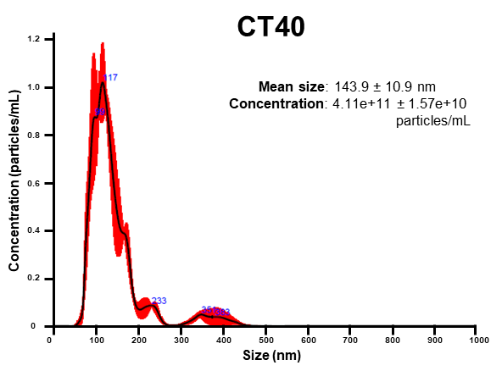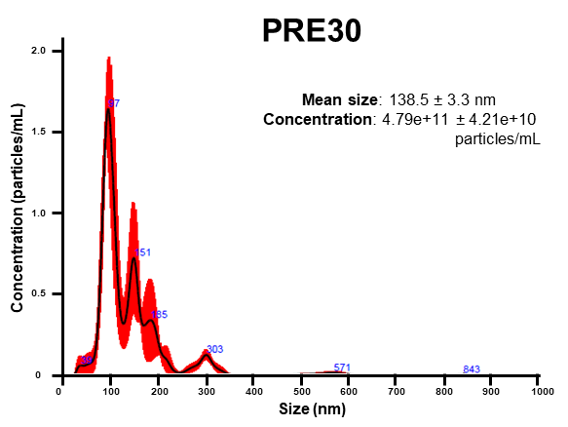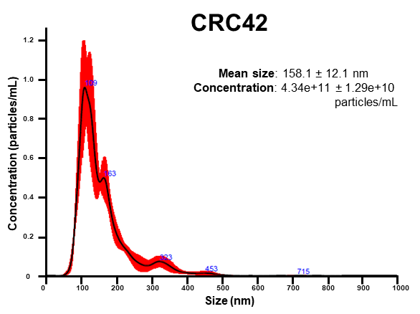

Fig. S1. Characterization of exosomes isolated from the plasma of CRC patients, premalignant individuals, and healthy individuals. Representative nanoparticle tracking analysis (NTA) of exosomes isolated from the controls (CT40), premalignant individuals (PRE30), and colorectal patients (CRC42). (NTA analysis was performed using NanoSight NS3000.)

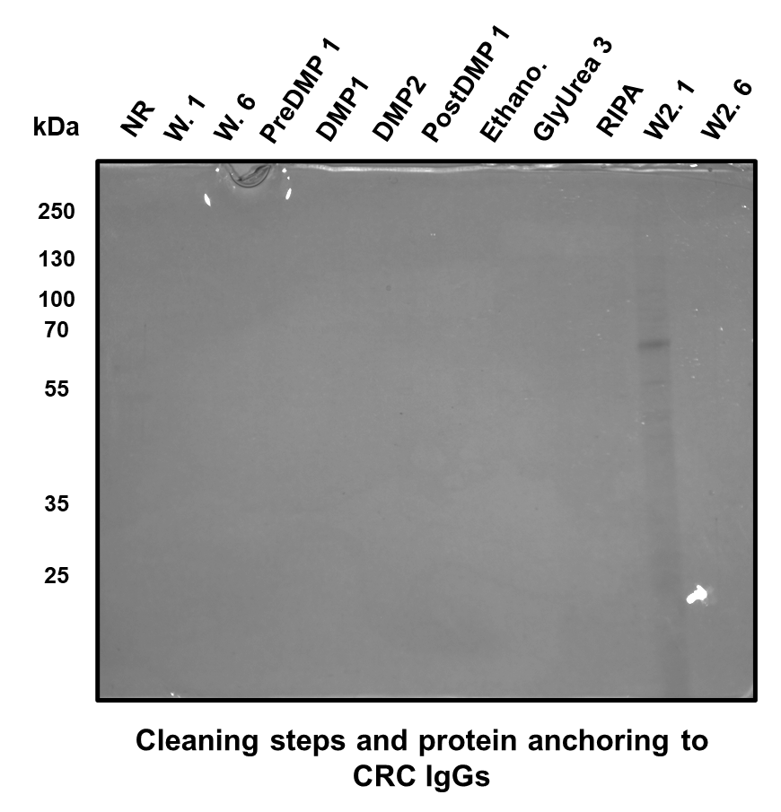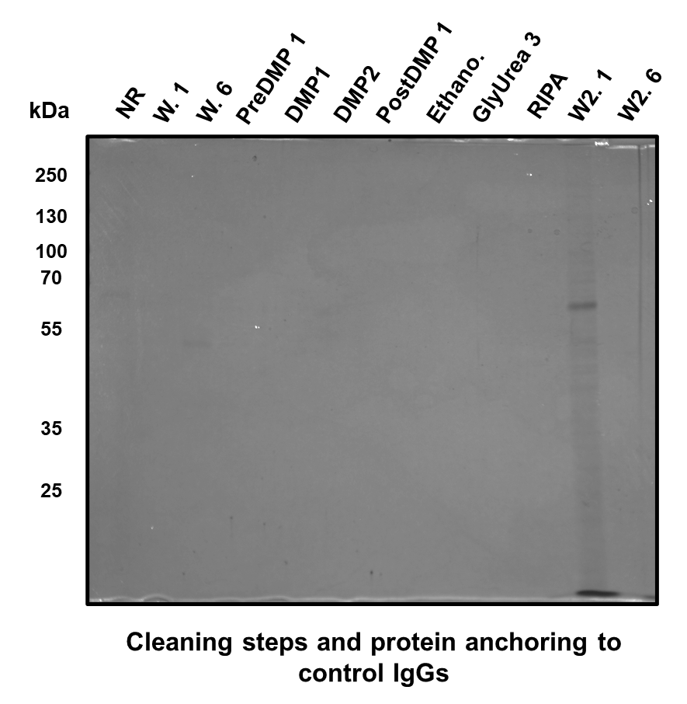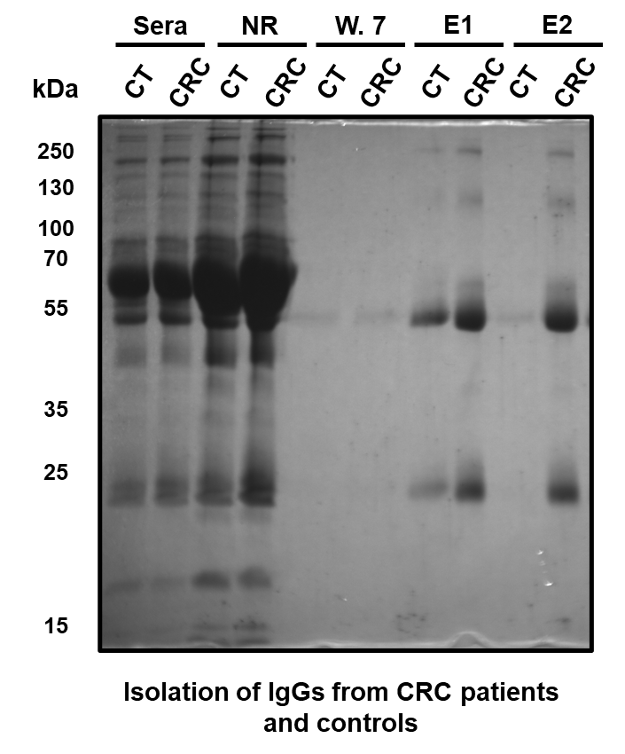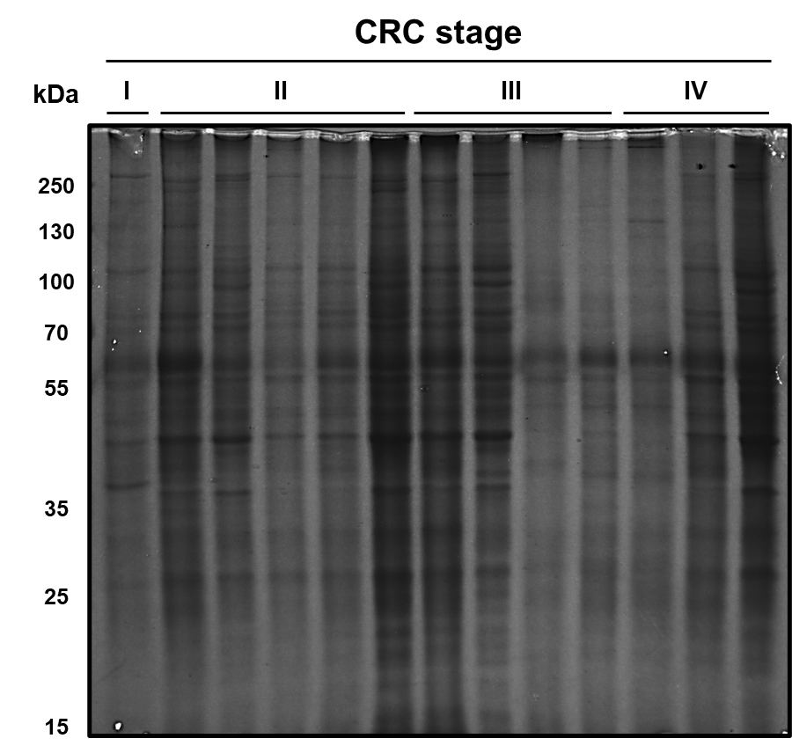
(a)

Fig. S2. Coomassie blue staining gels for the quality control of immunoprecipitation. (a) Tissue extracts from CRC patients at stages I–IV used for immunoprecipitation assays. (b) Samples of IgGs isolation steps from plasma samples from healthy individuals and CRC patients. (c) Samples of steps for cleaning and protein anchoring to IgGs from healthy individuals (left) and from CRC patients (right). (NR: not retained; W: wash; E: elute)

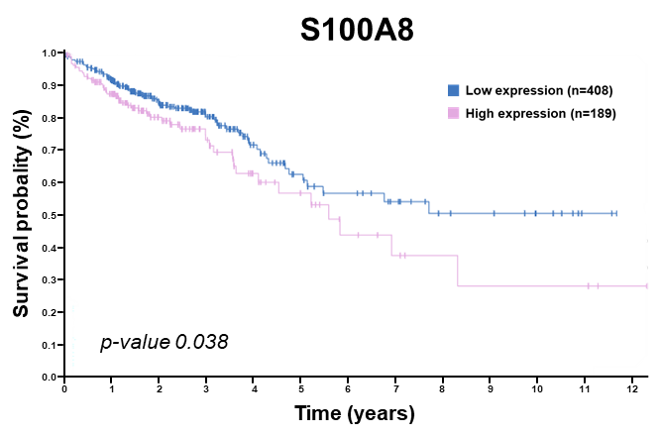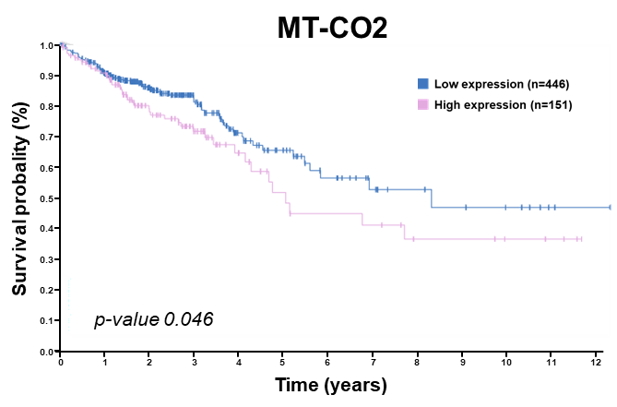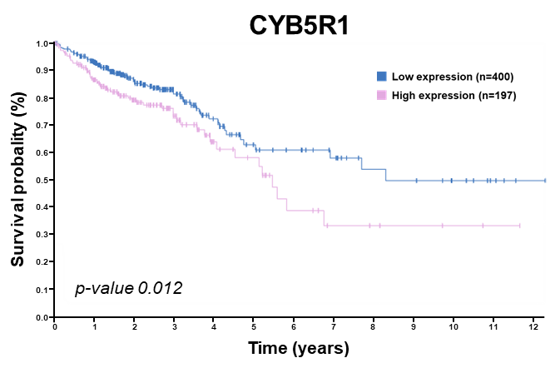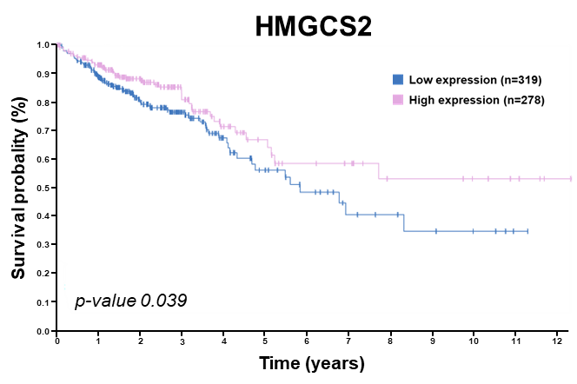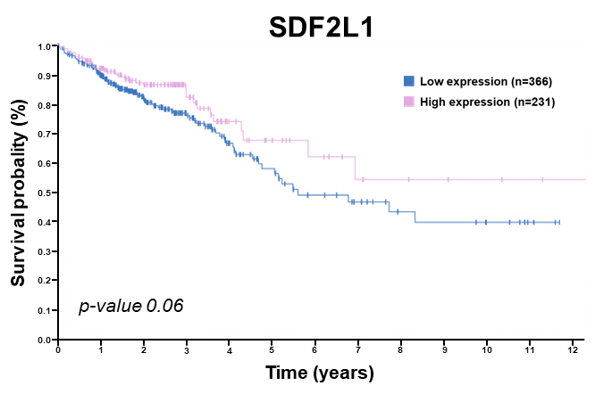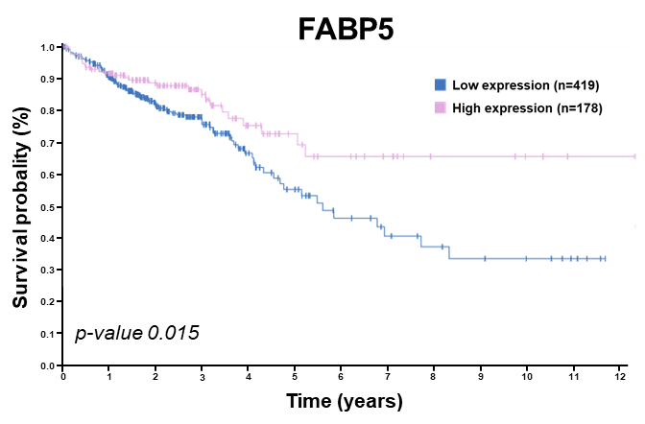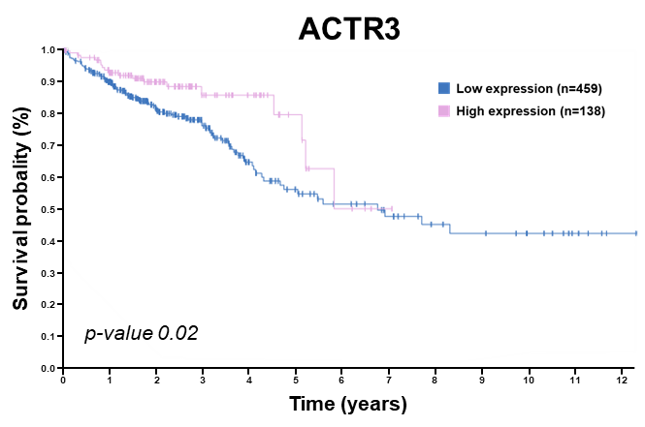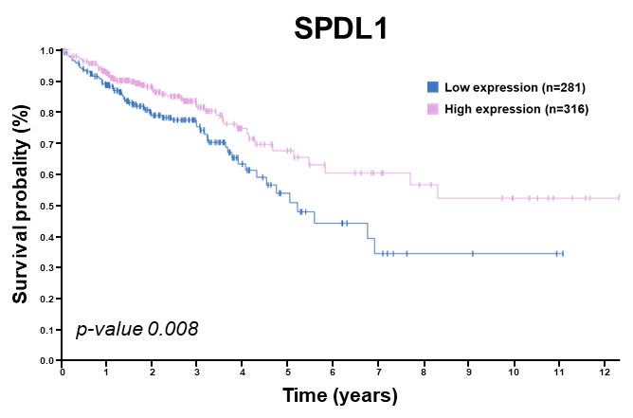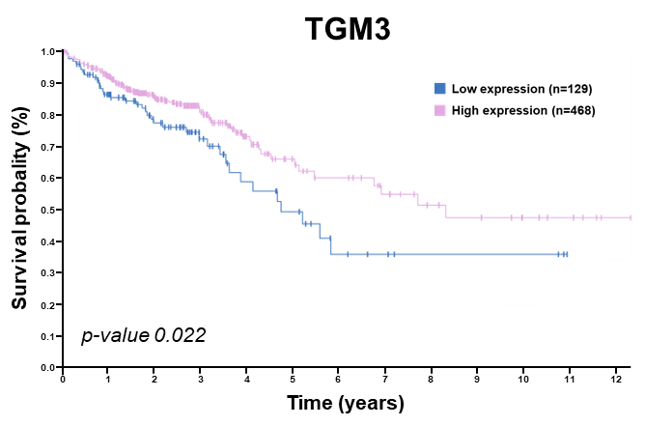
Fig. S3. Evaluation of the individual prognostic association with the identified TAAs targeted by autoantibodies in CRC. The Human Protein Atlas showed that the best cutoff for separating high-expression versus low-expression individuals of the indicated markers are CRC prognostic markers. High mRNA levels of S100A8, MT-CO2, and CYB5R1 were associated with the worst prognosis, whereas high mRNA levels of FABP5, ACTR3, TGM3, SDF2L1, HMGCS2, and SPDL1 was associated with a higher survival probability in CRC patients.

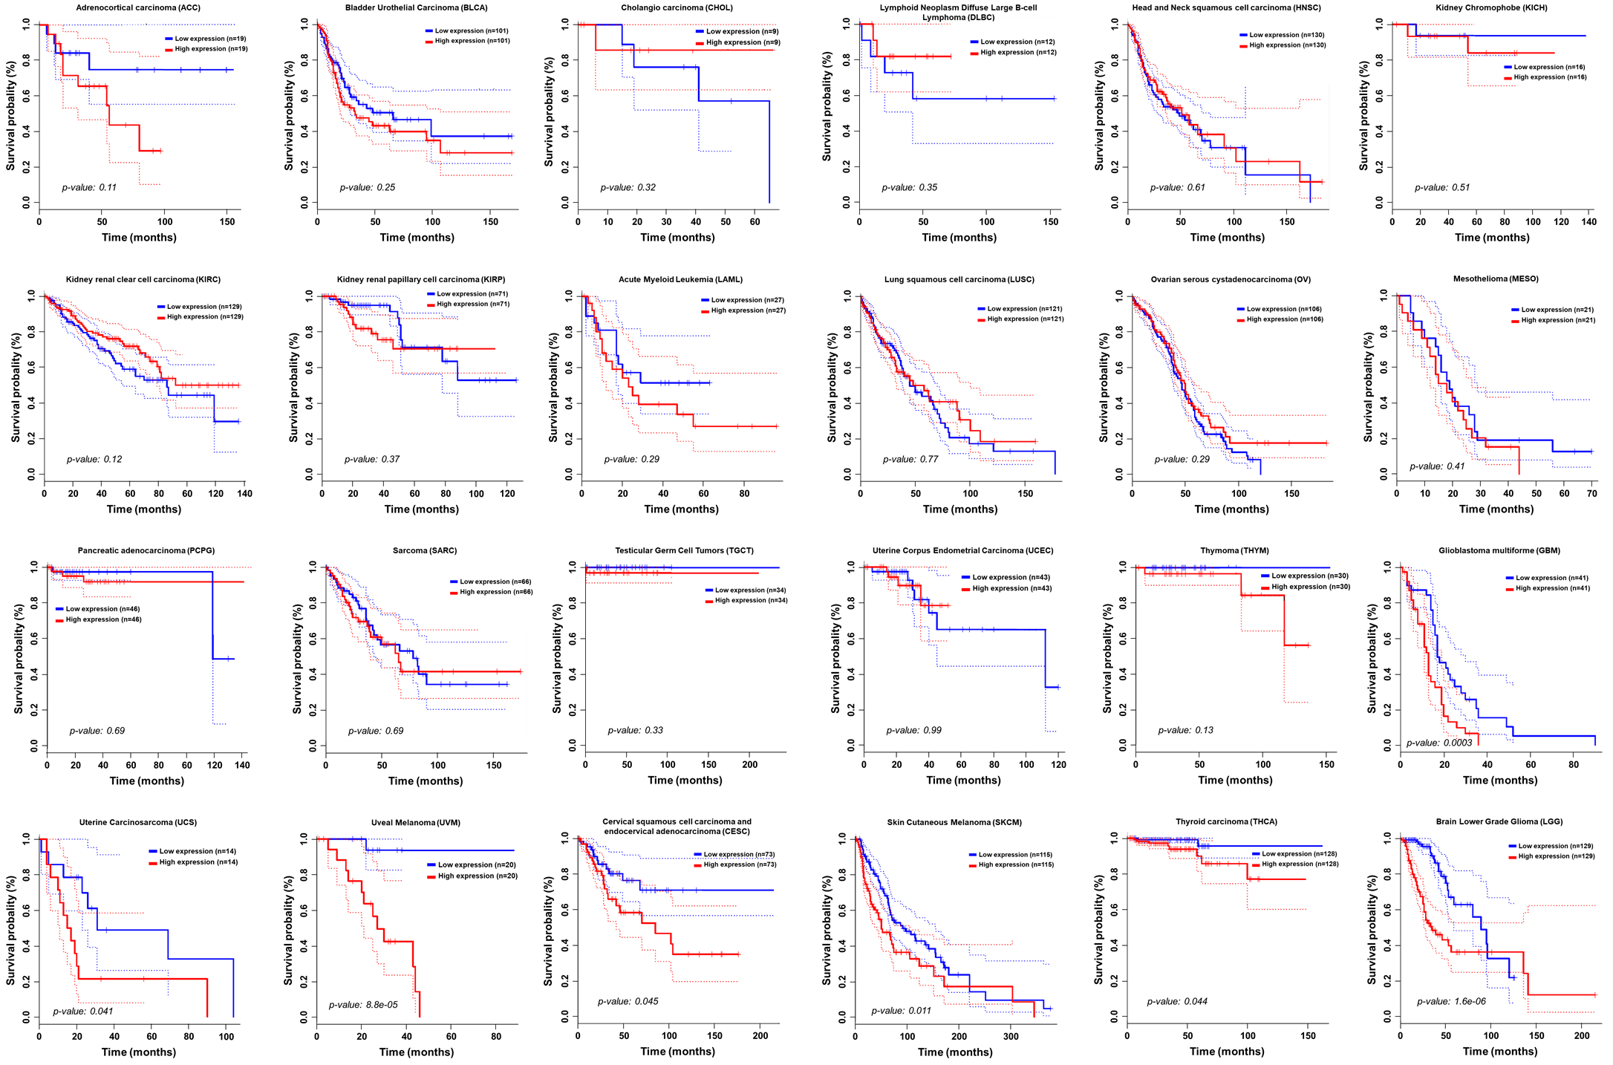

Fig. S4. Association of the combination of the nine-gene signature (S100A8, MT-CO2, CYB5R1, FABP5, ACTR3, TGM3, SDF2L1, HMGCS2, and SPDL1) with the prognosis of cancers non-related to CRC, investigated with GEPIA2. A significant association with lower survival was found for glioblastoma (GBM), brain lower grade glioma (LGG), cervical squamous cell carcinoma (CESC), skin cutaneous melanoma (SKCM), thyroid carcinoma (THCA), uterine carcinosarcoma (UCS), and uveal melanoma (UVM). No association was found for other cancers.

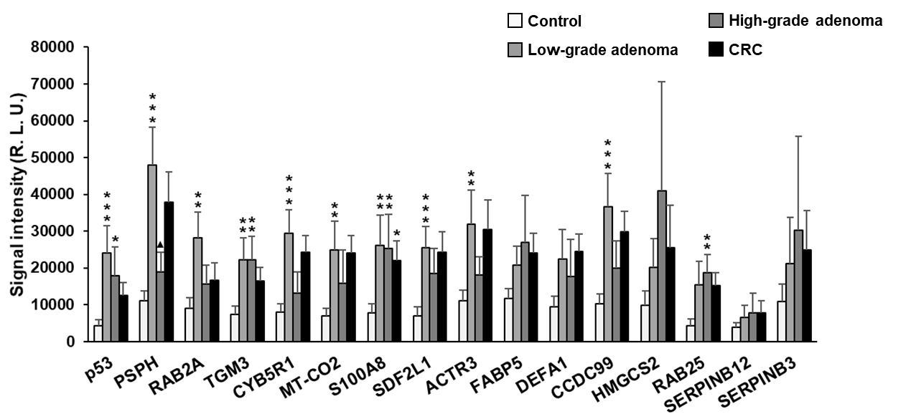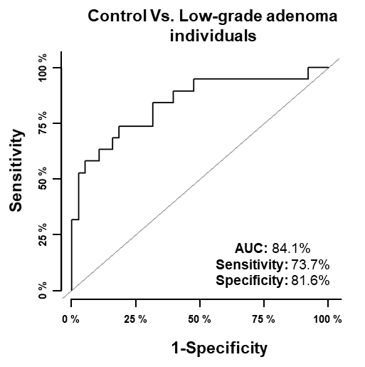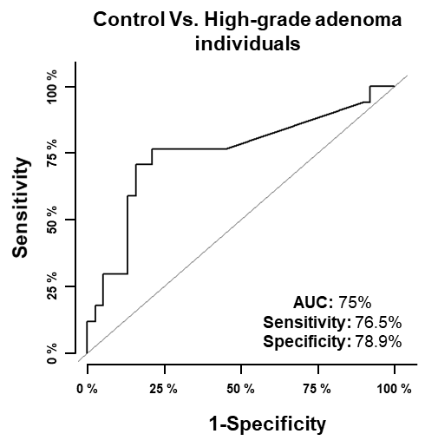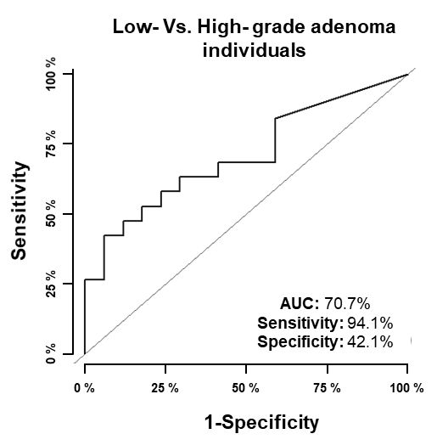
(b)
(a)
Fig. S5. Diagnostic ability of TAAs to distinguish low- and high-grade adenoma individuals from healthy controls and CRC patients. (a) Differences in autoantibody levels among the 112 individual plasma samples from CRC patients, low- and high- grade adenoma individuals, and healthy individuals (Table 1 and Table S1) by luminescence Halotag-based beads assays. Seroreactivity against p53 (p = 9.1E-04), PSPH (p = 3.66E-05), RAB2A (p = 0.003), TGM3 (p = 0.007), CYB5R1 (p = 0.003), MT-CO2 (p = 0.005), S100A8 (p value = 0.008), SDF2L1 (p = 9.77E-04), ACTR3 (p = 0.009), and SPDL1 (p = 7.8E-04) could statistically discriminate low-grade adenoma from healthy individuals. In addition, autoantibody levels against p53 (p = 0.02), TGM3 (p = 0.009), S100A8 (p = 0.02), SDF2L1 (p = 0.05), and RAB25 (p = 0.002) could statistically discriminate high-grade adenoma from healthy individuals. Remarkably, PSPH was able to statistically discriminate low- from high-grade adenoma individuals (▲: p = 0.02). No statistical differences were found between low- or high-grade adenoma individuals and CRC patients. (b) Evaluation of the diagnostic value of TAAs with significant seroreactivity to low- or high-grade adenoma and healthy individuals. The combination of the 10 TAAs, including p53, showed an AUC of 84.1% and a sensitivity and specificity of 73.7% and 81.6%, respectively, in discriminating between low-grade adenoma individuals and healthy controls. Combined detection of autoantibodies against p53, TGM3, S100A8, SDF2L1, and RAB25 showed an AUC, sensitivity, and specificity of 75%, 76.6%, and 78.9%, respectively, in discriminating high-grade adenoma individuals from healthy controls. Finally, PSPH was able to discriminate between low- and high-grade adenoma individuals with an AUC, sensitivity, and specificity of 70.7%, 94.1%, and 42.1%, respectively. *: p < 0.05; **: p < 0.01; ***: p < 0.001; ▲: p < 0.05.

