 | Group 1 (5 doses – 16 weeks) |  |  |  | Group 2 (3 doses – 16 weeks) |  |  |  | Group 3 (3 doses – 6 weeks)
Week | LVEF (%) | T2 (ms) | T1 (ms) | ECV (%) | LVEF (%) | T2 (ms) | T1 (ms) | ECV (%) | LVEF (%) | T2 (ms) | T1 (ms) | ECV (%)
0 | 55.35±3.84 | 45.22±0.47 | 1087±101.1 | 26.03±4.3 | 56.56±3.53 | 45.58±0.6 | 1029±41.2 | 26.08±3.33 | 56.2±2.8 | 45.76±2.52 | 1075±47.5 | 29.09±1.78
1 | 54.05±0.56 | 45.37±0.25 | 1062±21.9 | 30.65±1.3 | 54.9±5.23 | 45.84±1.31 | 1040±37 | 28.91±0.51 | 55.68±2.41 | 46.86±2.3 | 1037±22.4 | 30.48±1.22
2 | 57.65±2.85 | 45.22±1.01 | 1048±30.2 | 26.2±3.44 | 55.41±5.15 | 46.1±0.6 | 1034±33.5 | 27.69±1.94 | 55.73±3.82 | 44.76±2.12 | 1003±23.4 | 30.25±3.91
3 | 58.23±2.5 | 46.97±1.47 | 1020±29.7 | 27.89±2.28 | 56.46±5.65 | 44.7±1.88 | 1040±35.8 | 28.23±1.76 | 55.19±4.87 | 46.14±3.87 | 1015±37 | 28.45±2.19
4 | 56.61±2.94 | 47.22±2.97 | 1032±40.7 | 28.04±1.46 | 57.48±3.3 | 46.04±2.39 | 1043±28.3 | 28.6±0.99 | 54.23±2.35 | 44.96±2.65 | 1017±64.3 | 28.7±2.17
5 | 55.47±3.74 | 47.83±3.33 | 1071±39.6 | 28.72±0.98 | 59.26±3.45 | 45.58±1.7 | 1036±63.3 | 26.31±1.96 | 53.06±2.17 | 48.56±4.35 | 1019±26.7 | 29.4±1.92
6 | 55.2±4.41 | 52.02±1.4 | 1067±25.9 | 28.12±1.34 | 57.94±4.53 | 51.6±0.82 | 1023±68.6 | 26.35±3.39 | 53.27±1.96 | 52.6±2.18 | 1010±27.3 | 26.62±1.46
7 | 57.1±3.33 | 54±1.87 | 1020±61 | 28.56±2.84 | 58.43±3.12 | 45.52±1.26 | 979±55.6 | 27.15±2.08
8 | 52.46±5.98 | 55.58±4.24 | 1085±99.75 | 30.4±4.8 | 57.79±3.61 | 44.38±2.94 | 1045±36.3 | 28.49±1.05
9 | 48.97±2.76 | 58.17±5.36 | 1085±96 | 30.25±1.18 | 59.51±2.86 | 44.1±2.28 | 1016±20.6 | 26.73±1.21
10 | 42.7±6.36 | 58.24±4.13 | 1088±34.2 | 37.05±7.45 | 60.04±3.17 | 45.1±1.79 | 1032±51.6 | 28.26±1.68
11 | 41.14±3.47 | 61.77±4.06 | 1149±84.9 | 37.49±4.43 | 60.08±2.47 | 45.22±0.89 | 1031±25.9 | 26.59±3.2
12 | 32.93±5.83 | 66.94±4.16 | 1220±58.6 | 41±5.35 | 58.86±3.14 | 43.14±2.93 | 1000±52 | 24.86±3.2
13 | 34.79±0.96 | 68.26±3.81 | 1169±6.4 | 41.25±4.84 | 58.3±2.57 | 44.46±1.59 | 992±51.9 | 27.17±2
14 | 30.34±7.55 | 70.78±5.79 | 1315±53.3 | 41.34±1.34 | 57.27±2.17 | 44.66±0.68 | 1112±89.7 | 25.19±3.1
15 | 34.62±2.07 | 73.17±4.5 | 1293±109 | 40.62±1.07 | 59.19±3.23 | 45.34±1.3 | 1082±45.1 | 25.94±0.99
16 | 30.38±7.71 | 72.96±4.6 | 1329±81.3 | 45.22±5.04 | 57.05±4.05 | 44.78±1.43 | 1088±60.7 | 25.95±1.73

Supplemental table 1. Serial multiparametric values (LVEF, T2, T1 and calculated ECV) are represented by group as mean ± standard deviation. Significant p values are marked in determinant timepoints are filled in grey.

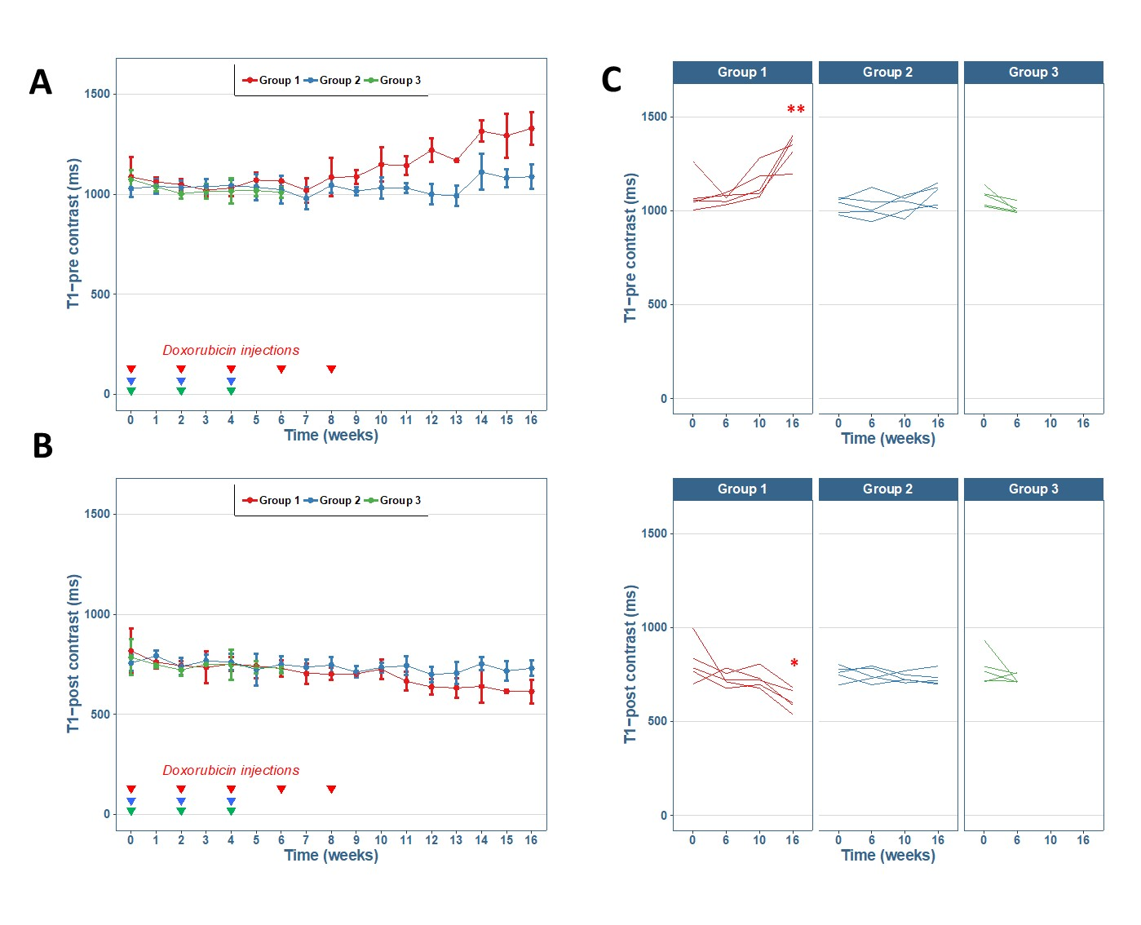
Supplemental figure 1. T1-MOLLI values pre and post contrast are represented. (A) T1-pre contrast (ms) represented over time as mean and standard deviation for each group. (B) T1-post contrast (ms) represented over time as mean and standard deviation for each group. (C) T1 pre and post contrast individual values evolution are represented for each group in the determinant timepoints. Significant statistical differences compared with week 0 for each time point were represented as * (p <0.05), ** (p >0.01) and ns (no significant).

