SUPPORTING INFORMATION
Determining and characterizing circulating nucleosomes in advanced cancer with electrochemical biosensors assisted by magnetic supports and proteomic technologies
Sandra Tejerina-Miranda¹, Elisa Carral-Ibarra¹, Maria Gamella¹, Ana Montero-Calle², María Pedrero¹, José M. Pingarrón¹, Rodrigo Barderas^{2,3*}, Susana Campuzano^{1,3*}
¹Departamento de Química Analítica, Facultad de CC. Químicas, Universidad Complutense de Madrid, Pza. de las Ciencias 2, Madrid 28040, Spain.
²Chronic Disease Programme, UFIEC, Instituto de Salud Carlos III, Majadahonda, Madrid 28220, Spain.
³CIBER of Frailty and Healthy Aging (CIBERFES), Madrid, Spain.

*E-mail addresses: r.barderasm@isciii.es (R. Barderas); susanacr@quim.ucm.es (S. Campuzano)

CONTENTS | PAG.
Materials and methods | S3
Apparatus and electrodes | S3
Reagents and solutions | S3
Bioassay implementation on MBs | S4
Amperometric measurements | S5
Cells and human samples | S5
Figure S1 | S6
Characterization of captured nucleosomes by proteomic technologies | S6
Nucleosome proteome digestion | S6
LC-MS/MS analysis | S7
MS data analysis | S8
Bioinformatic, ROC curves and statistical analysis | S8
Results and discussion | S9
Figure S2 | S9
Table S1 | S10
Figure S3 | S10
Figure S4 | S11
Table S2 | S11
References | S11

Materials and methods
Apparatus and electrodes
Amperometric measurements were undertaken at room temperature using a CHI1140A potentiostat (CH Instruments) provided with the CHI1140A software. Single screen-printed carbon electrodes (SPCEs, DRP110) together with their connecting cable (DRP-CAC) were acquired from Metrohm-DropSens. The SPCEs consisted of three-electrode cell configurations each containing a circular carbon working electrode (WE, ∅ = 4 mm), an Ag pseudo-reference electrode, and a carbon auxiliary electrode. The immunoconjugates were trapped on the surface of the WE of the SPCE by using a homemade polymethylmethacrylate (PMMA) casing with an embedded neodymium magnet (AIMAN GZ, ∅ = 4 mm). A 10 mL glass electrochemical cell was employed.
A magnetic particle concentrator DynaMag-2 (Cat. No: 12321D, Dynabeads®, Invitrogen™ Thermo Fisher Scientific), a magnetic stirrer (Inbea), an MPW-65R centrifuge from MPW (Med. Instruments), a Crison model Basic 20+ pH-meter, a vortex (Velp Scientifica), and a BioSan TS-100 uniform temperature incubator shaker (Thermo), were also employed.

Reagents and solutions
Commercial BlockerTM Casein in phosphate buffer saline (PBS) (BB solution, Cat. No. 37528) and magnetic microbeads functionalized with carboxylic acid groups (HOOC-MBs, DynabeadsTM, Cat. No.: M-270, 2.8 µm ∅, ~2×10⁹ beads mL⁻¹) were purchased from Thermo Fisher Scientific and InvitrogenTM, respectively.
All the reagents involved in the modification of the MBs, preparation of the buffer solutions, and in the preparation of the immunoplatform were of the highest available grade.
For the preparation of buffer solutions, 2-(N-morpholino) ethanesulfonic acid (MES, Ref. 1080.1000), from GERBU Biotechnik, and sodium chloride (Ref. SO02271000), potassium chloride (Ref. PO02001000), tris-hydroxymethyl-aminomethane-HCl (Tris-HCl, Ref.TR0421000), sodium di-hydrogen phosphate (Ref. SO03321000) and di-sodium hydrogen phosphate (Ref. SO03351000), all of them from Scharlab, were used.
Buffered solutions including 0.025 M MES buffer solution pH 5.0, 0.1 M phosphate buffer (PB) solution pH 8.0, 0.1 M Tris-HCl solution pH 7.2, 0.01 M PBS solution pH 7.4, and 0.05 M PB solution pH 6.0 were prepared employing deionized water type I from a Millipore Milli-Q purification system (18.2 MΩ cm).
To activate carboxyl groups of MBs, N-(3-dimethyl-aminopropyl)-N´-ethyl-carbodiimide (EDC, Acros Organics, Ref. 171440100) and N-hydroxysulfosuccinimide (Sulfo-NHS, Apollo Scientific, Ref. OR307159) were used for preparing an EDC/Sulfo-NHS mixture solution (50 mg mL^{–1} each, dissolved in MES buffer pH 5.0). To carry out the blocking step, a 1.0 M ethanolamine (ETA, Sigma-Aldrich, Ref. 398136) solution prepared in 100 mM PB pH 8.0 was employed. Finally, to perform the amperometric measurements, solutions of 100 mM hydroquinone (HQ, Sigma-Aldrich, Ref. H9003) and 100 mM H₂O₂ (30 % v/v, Sigma-Aldrich, Ref. H1009) were freshly prepared in 50 mM PB pH 6.0.
The development of the biotool was carried out by using immunoreagents delivered by two different companies. On the one hand, Nu. Q® Discover H3.1 ELISA Assay-RUO kit (Ref. 1001-01-03) from Volition containing lyophilized solutions of different H3.1 nucleosome concentrations, two control Kits with known concentrations of H3.1 nucleosome, and a solution of HRP-labelled detection antibody (an HRP-conjugated antibody which recognizes intact nucleosome, whose epitope is a combination of histone and DNA, HRP-DAb) was employed. On the other hand, a mouse Histone H3.1/3.2 antibody (H3.1 CAb, Cat. No. 61629, raised against a peptide comprising amino acids 21-39 of human Histone H3.1, a region 100 % identical in human Histone H3.2) and human recombinant mononucleosomes expressed in Escherichia coli (H3.1, Cat. No. 81070) from Active Motif were also used as capture antibody and standard, respectively.
Human hemoglobin (Hb, Cat. No. H7379), human serum albumin (HSA, Cat. No. A1653), and human serum IgG (hIgG, Cat. No. I2511), all purchased from Sigma-Aldrich, were used to assess possible interferences.

Bioassay implementation on MBs
The modification of the HOOC-MBs and the washing steps were performed employing 1.5 mL microcentrifuge tubes. The assay involved several incubation steps employing 25 µL of the modifying solution assisted by a Thermoshaker set at a constant temperature (25 ºC) and stirring (950 rpm). The washing processes were done using 50 µL of the appropriate buffer and a magnetic concentrator for the removal of the supernatant without losing the MBs.
To accomplish the preparation of the nucleosomes sandwich immunoassay, 3 μL-aliquots of the HOOC-MBs suspension were placed in the microcentrifuge tubes and washed twice with MES buffer for 10 min. Thereafter, a 35 min incubation step in a freshly prepared EDC/Sulfo-NHS solution was performed to activate the carboxyl groups in the MBs, followed by two washing steps with MES buffer. The activated microparticles were then incubated with a 100 μg mL⁻¹ H3.1 CAb solution prepared in MES buffer for 30 min. Subsequently, the CAb-MBs were washed twice with MES buffer, and a 60 min incubation in a 1.0 M ETA solution was carried out to block the remaining activated carboxylic groups. Then, the CAb-MBs were washed three times, first with a 0.1 M Tris-HCl buffer (pH 7.2) and then twice with the BB solution. After this step, the H3.1 CAb-MBs can be used to prepare the immunoplatform or stored in filtered PBS at 4 °C for further use.
The biocomplexes were formed in 30 min by performing a single incubation step of the CAb-MBs with a solution containing the standard (or the sample to analyze) supplemented with HRP-DAb, prepared in BB. Lastly, the magnetic bioconjugates were washed twice with BB and resuspended in 50 µL of PB pH 6.0 to perform the amperometric transduction.

Amperometric measurements
The immunoconjugates resuspended in 50 μL of PB buffer pH 6.0 were trapped on the surface of the WE of the SPCEs inserted into PMMA housings containing an embedded neodymium magnet.
To carry out the amperometric measurements, the SPCE/PMMA assembly was connected to the potentiostat through the connector cable (DRP-CAC) and introduced into an electrochemical cell containing 10 mL of 1.0 mM HQ solution prepared in PB buffer pH 6.0. Amperometric detection was performed under constant stirring by applying a constant potential of – 0.20 V (vs. the Ag pseudo-reference electrode). Once the background current was stabilized, 50 µL of a freshly prepared 0.1 M H₂O₂ solution were added to the electrochemical cell generating a change in the cathodic current because of the HQ-mediated enzymatic reduction of H₂O₂. Due to the type of format used, the observed current change was proportional to the analyte concentration. Signals reported in the manuscript were estimated as the difference between the steady-state and background currents.

Cells and human samples
The samples analyzed included nuclear whole protein extracts from CRC cells with different metastatic potential and plasma samples from healthy individuals and patients with advanced stage CRC (III and IV).
Nuclear and cellular extracts were prepared from the non-metastatic cell lines SW480 and KM12C, and the metastatic cell lines SW620, KM12L4a and KM12SM, following the protocol described by ten Have et al. (ten Have et al. 2012). KM12 cells were obtained from I. Fidler’s laboratory (MD Anderson Cancer Center), whereas SW cells were from the from the American Type Culture Collection (ATCC) cell repository. All cells were cultured at 37 °C and 5 % CO₂ in Dulbecco’s Modified Eagle Medium (DMEM, Lonza, Basel) supplemented with 10 % fetal bovine serum (FBS, Sigma Aldrich), 1× L-glutamine (Lonza), and 1× penicillin/streptomycin (Lonza), and grown until 90 % confluence. Cellular fractionation involved mechanical homogenization in isotonic sucrose buffer, followed by sequential centrifugation through increasingly dense gradients, resulting in the isolation of intact nuclei. The successful enrichment of nuclear markers (FUS/TLS and/or FBL) and the nuclear-cytoplasmic marker β-actin in their respective fractions was confirmed by Western Blot (Fig. S1). FUS/TLS (Ref. 11570-1-AP) and FBL (Ref. 16021-1AP) nuclear antibodies from ProteinTech were diluted 1:20,000 and 1:3,000 in 3 % Milk-PBS, respectively. Beta actin antibody from Rockland Immunochemicals (Ref. 600-401-886) was diluted 1:3,000 in 3 % Milk-PBS.
Fig. S1. Western Blot analysis of the prepared nuclear (NU) and nuclear-cytoplasmic (CT) extracts.

Plasma samples were provided, after getting written informed consent from all participants, by the biobank of the San Carlos Clinical Hospital after approval by the Ethical Review Committee (CEI PI 13_2020-v2). All samples were stored at – 80 ºC and used in accordance with all ethical aspects, relevant guidelines, and regulations for both sample handling and experiments conducting. Analysis with the bioplatform required only 0.5 μg of nuclear extracts and a 1/5 dilution of the plasma samples.

Characterization of captured nucleosomes by proteomic technologies
Nucleosome proteome digestion
For the proteomics characterization of the captured nucleosomes, the complexes isolated by the CAb-MBs were resuspended in 200 µL of 1 M glycine buffer (pH 2.7) and incubated for 10 min at 1000 rpm to ensure complete protein elution from beads. After 1-min centrifugation at 6000 rpm, the eluates were transferred to low-binding tubes (Thermo Fisher Scientific) and immediately neutralized with 10 µL of 1 M Tris buffer (pH 8.8) to prevent protein denaturation.
Subsequently, protein eluates were processed by adding 20 µL of 100 mM Tris(2-carboxyethylphosphine (TCEP, Sigma Aldrich) at 37 °C and 600 rpm for 45 min ([TCEP]_{f} = 10 mM) for disulfide-bond reduction. This process was followed by alkylation with 22 µL of 400 mM chloroacetamide (CAA, Sigma Aldrich) at 600 rpm, room temperature, and in darkness for 30 min ([CAA]_{f} = 40 mM). Samples were then incubated with 100 µL of Sera-MagTM Carboxylate-Modified Magnetic Beads (50 % hydrophilic-50 % hydrophobic, Cytiva) and 342 µL of 100 % acetonitrile ([ACN]_{f} = 50 %) at 600 rpm for 35 min, using a previously implemented SP3 protocol (Montero-Calle et al., 2023a). This step facilitated protein binding to the beads, thereby enhancing subsequent protein digestion. Supernatants were discarded, and the beads were washed twice with 200 µL of 70 % ethanol and once with 100 % ACN. The beads were then incubated with 250 ng of trypsin (Thermo Fisher Scientific) and diluted in 50 mM ammonium bicarbonate (ABC) at 600 rpm and 37 °C for 16−18 h. The next day, the samples were centrifuged and sonicated twice to recover the supernatants containing the digested peptides, which were dried under vacuum and stored at − 20 °C until LC-MS/MS was used for analysis (Montero-Calle et al., 2023b).
LC-MS/MS analysis
Data-independent acquisition (DIA) label-free quantification was conducted according to established protocols using an Orbitrap Astral mass spectrometer coupled to a Vanquish Neo UHPLC System (Thermo Fisher Scientific). Briefly, samples were diluted in 10 µl of 0.1 % formic acid (FA) and quantified in the NanoDropTM One Microvolume UV-Vis Spectrophotometer (Thermo Fisher Scientific). 5 µL were loaded onto a PepMap Trap Catridge (5 µm, 300 µm x 5 mm; Thermo Fisher Scientific), followed by elution through an Easy-Spray PepMap RSLC C18 column (3 µm, 75 µm × 15 cm; Thermo Fisher Scientific) heated to 50 °C. The mobile phase flow rate was set at 300 nL min⁻¹, using 0.1 % formic acid in H₂O as elution buffer A and 0.1 % formic acid in 80 % ACN as buffer B. The elution gradient (15 min) was: 4−10 % buffer B for 2 min, 10−40 % buffer B for 11 min, 40−99 % buffer B for 0.5 min, and 99 % buffer B for 1.5 min. For ionization, a liquid junction voltage of 1900 V and a capillary temperature of 280 °C were applied.
The full scan method covered an m/z range of 380−980, with an Orbitrap resolution of 240,000 (at m/z 200), an automatic gain control (AGC) target of 500 %, and a maximum injection time (IT) of 5 ms. MS/MS was performed using the Astral mass analyzer with an AGC target of 500 %, an IT of 3 ms, and a normalized collision energy (NCE) of 25 for precursor fragmentation. The scan range used a 2 m/z isolation window. Window placement optimization was enabled.
MS data analysis
MS raw data were analyzed in Spectronaut (version 19.5. 240724) according to standardized workflows. Raw files were searched against the Uniprot 2024 Homo sapiens database (UP000005640_9606.fasta) containing 20,418 protein entries. Trypsin/P was selected as digestion enzyme, allowing a maximum of two missed cleavages. Carbamidomethylation of cysteines was set as a fixed modification, while methionine oxidation and N-terminal acetylation were defined as variable modifications. The maximum false discovery rate (FDR) for peptide spectral match (PSM), peptide, and protein identifications were set at 0.01. Automatic cross-run normalization was enabled, and all identified peptides were used for protein quantification. Protein inference was carried out using the IDPicker algorithm. Non imputation was applied during peptide and protein identification or quantification.
Data visualization and statistical analysis were conducted using RStudio (version 4.3.3) following an established protocol (https://github.com/pwilmart). The analysis used the “tidyverse”, “psych”, “gridExtra”, “scales”, and “ggplot2” packages. Samples were categorized as Healthy, CRCIII, or CRCIV, considering only proteins identified in at least 60 % of samples per condition for further analysis. Immunoglobulins, blood microparticles and plasma lipoproteins (based on STRING 2025 database) were excluded as potential serum contaminants.
Bioinformatic, ROC curves and statistical analysis
STRING 2025 Homo Sapiens database (version 12.0) was used for functional, pathway and cell component enrichment analyses.
ROC curves (Receiver Operating Characteristic Curve) of individual proteins and in combination were obtained with R (version 4.3.3), using the “pROC” package to determine the diagnostic ability of the tests. For the analysis of plasma samples, values were plotted as mean values ± standard error of the mean (SEM). Plots, mean, and SEM were obtained with Microsoft Excel 2019 and GraphPad Prism 8 programs. Student´s t-test was calculated. p-values < 0.05 were considered statistically significant.

Results and discussion
Fig. S2. Dependence of the amperometric responses obtained with the developed bioplatform for 0 (white bars, B) and 2500 ng mL⁻¹ (grey bars, T) H3.1 nucleosomes standard and the resulting T/B ratio values (red dots and line) with the concentration (a) and incubation time (b) of the H3.1 CAb solution, number of steps involved in the preparation of bioconjugates (c), and the incubation time of the standard and HRP-DAb mixture solution (d).

Table S1. Evaluation of the key experimental variables involved in the preparation of bioconjugates for the determination of H3.1-nucleosomes.
Variable | Tested Range | Selected value
[H3.1 CAb], µg mL⁻¹ | 0.0−100.0 | 100.0
H3.1 CAb incubation time, min | 0−60 | 30
Number of assay steps | 1−2 | 1
H3.1 nucleosome standard+HRP-DAb incubation time, min | 15−60 | 30

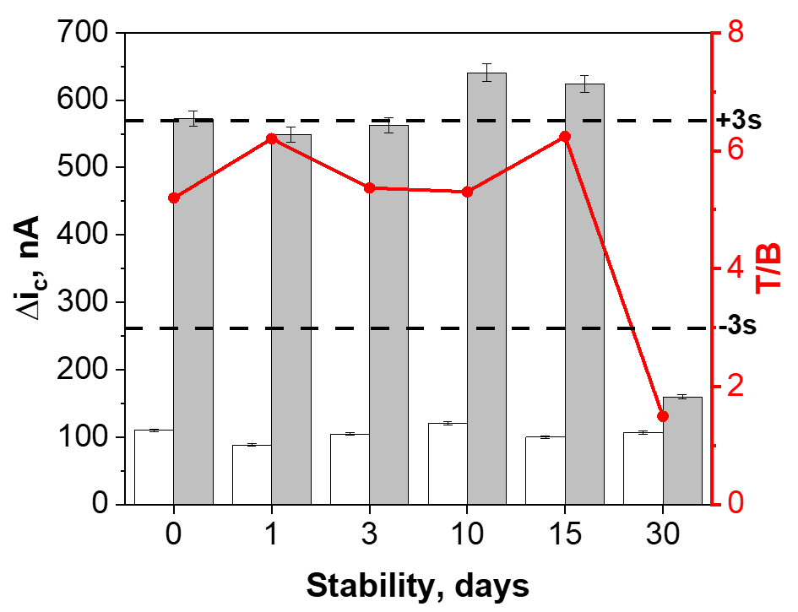
Fig. S3. Amperometric responses provided by the bioplatform prepared from the H3.1 CAb-MBs stored in filtered PBS at 4 ºC after preparation (day 0) and each control day for 0 (white bars, B) and 500 ng mL⁻¹ H3.1 nucleosomes standard (light blue bars, T). Control limits (dashed black lines) were set as ± 3s of the mean value of three bioplatforms prepared on day 0.

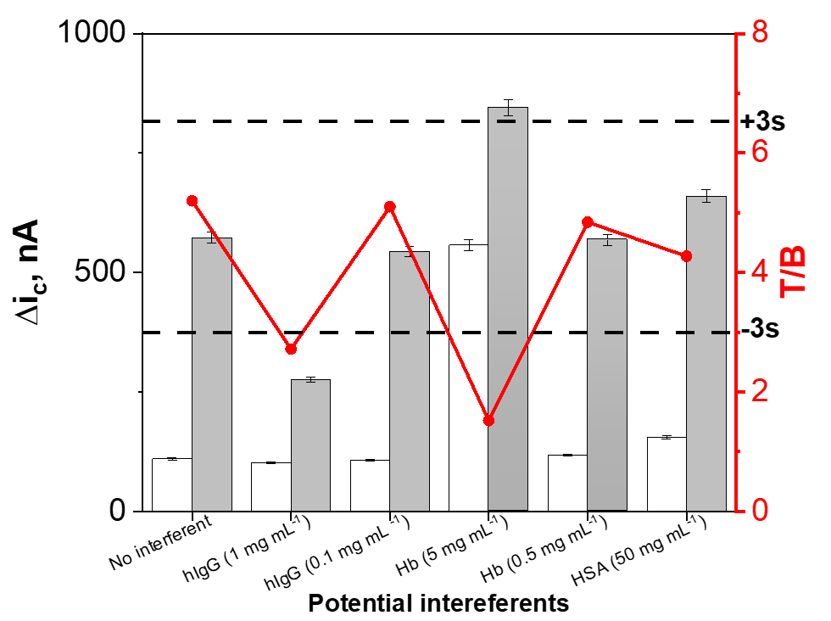
Fig. S4. Amperometric responses obtained with the developed bioplatform for 0 (white bars, B) and 500 ng mL⁻¹ (grey bars, T) H3.1 nucleosomes standard prepared in the absence and in the presence of hIgG (1 or 0.1 mg mL⁻¹), Hb (5 or 0.5 mg mL⁻¹), and HSA (50 mg mL⁻¹). T/B ratio values are shown in red dots and line, and control limits (dashed black lines) were set as ± 3s of the mean value obtained in the absence of interferent with three bioplatforms prepared on the same day.

Table S2. H3.1 nucleosomes concentration (in ng mL⁻¹) determined with the developed bioplatform (n = 3) in the controls provided in the ELISA it.
Kit control | Bioplatform (Mean value ± ts/√n)/RSD (%) | Specified in the kit
1 | (102 ± 8)/3.3 | 83.4
2 | (532 ± 38)/2.9 | 545.6

References
ten Have, S., Hodge, K., Lamond, A. I., 2012. Dynamic proteomics: Methodologies and analysis, in Meroni, G, Petrera, F. (Eds), Functional Genomics. InTech. http://dx.doi.org/10.5772/50786
Montero-Calle, A., Garranzo-Asensio, M., Rejas-Gonzalez, R., Feliu, J., Mendiola, M., Pelaez-Garcia, A., Barderas, R., 2023a. Benefits of FAIMS to improve the proteome coverage of deteriorated and/or cross-linked TMT 10-Plex FFPE tissue and plasma-derived exosomes samples. Proteomes 11(4), 35. https://doi.org/10.3390/proteomes11040035.
Montero-Calle, A., Jimenez de Ocana, S., Benavente-Naranjo, R., Rejas-Gonzalez, R., Bartolome, R.A., Martinez-Useros, J., Sanz, R., Dziakova, J., Fernandez-Acenero, M.J., Mendiola, M., Casal, J.I., Peláez-García, A., Barderas, R., 2023b. Functional proteomics characterization of the role of SPRYD7 in colorectal cancer progression and metastasis. Cells 12(21), 2548. https://doi.org/10.3390/cells12212548.

