Sensitive instrumental method for quantitative determination of high-brominated flame retardants in human serum samples.
Cristina Grande¹, Argelia Castaño¹, Juan José Ramos¹*
¹ Environmental Toxicology, National Center for Environmental Health (CNSA), Instituto de Salud Carlos III, 28220, Madrid, Spain.
* Corresponding author: Dr. Juan José Ramos Tel.: +0034 918223896, ORCID: 0000-0001-9079-6740, E-mail address: jjramos@isciii.es
Cristina Grande, ORCID: 0000-0001-6300-2298
Argelia Castaño, ORCID: 0000-0003-4152-7119

Supplementary Materials. Tables

Supplementary material, Table 1: Ions selected for analytes quantification / confirmation.
Compound | Acronym | CAS number | Quantification/  confirmation ions
Decabromo[¹³C₁₂]diphenyl ether (IS) | ¹³C₁₂-BDE-209 | 562099-68-7 | 492.6 / 494.6
Decabromodiphenyl ether | BDE-209 | 1163-19-5 | 486.6 / 484.6
Decabromodiphenylethane | DBDPE | 84852-53-9 | 79/81
Tetrabromobisphenol A bis(2,3-dibromopropyl ether | TBBPA-DBPE | 21850-44-2 | 79/81

Supplementary material, Table 2: Standard calibration and matrix-matched calibration for BDE-209 quantification in human serum samples from interlaboratory studies.
Quantification method | Sample 1 | Sample 2
Assigned value  (Acceptable range) | 1.18 ng/mL  (0.418 - 1.94 ng/mL) | 0.20 ng/mL  (0.013 – 0.393 ng/mL)
Matrix-matched calibration | 1.33 ng/mL | 0.23 ng/mL
% RSD | 5.6 | 2.5
Recovery | 113 % | 115 %
Standard calibration | 1.31 ng/mL | 0.26 ng/mL
% RSD | 5.2 | 2.2
Recovery | 111 % | 130 %

Supplementary material, Table 3. Demographic details of population included in this study. Random subsample obtained from the Bioambiet.es study

Variable | Levels | Participants
Gender | Males | 22
 | Females | 18
Age groups | 18-29 | 8
 | 30-39 | 15
 | 40-49 | 10
 | 50-65 | 7
Working Sector | Services | 27
 | Others | 13
Seasonality | Jan-Mar | 7
 | Apr-Jun | 16
 | Jul-Sep | 6
 | Oct-Dic | 11
Environment | Urban | 31
 | Residential | 7
 | Countryside | 2

Supplementary Materials. Figures
Supplementary Material, Figure. 1. GC-NCI-MS chromatograms obtained from a standard solution (1 ng/mL) on a 15 m DB-5MS column (0.25 mm id. 0.10 µm film thickness). (A) First injection after column installation, (B) after 200 injections.

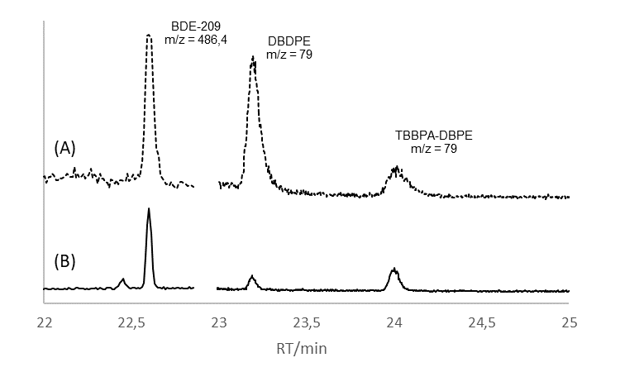
Supplementary Material, Figure. 2. GC-NCI-MS chromatograms obtained after applying the developed method from (A) serum rabbit non spiked and (B) water reagent blank.

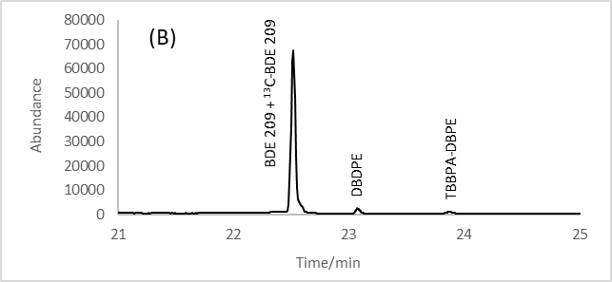
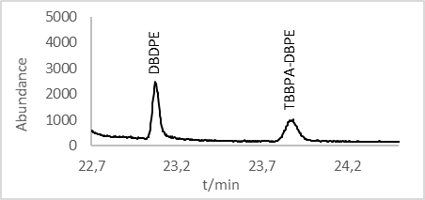
Supplementary Material, Figure 3. Total ion chromatogram (GC-NCI-MS) of 1 mL human serum sample after applying the developed method.

