Title: Multiple evidence strands suggest that there may be as few as 19,000 human protein-coding genes

Authors: Iakes Ezkurdia¹, David Juan², Jose Manuel Rodriguez³, Adam Frankish⁴, Mark Diekhans⁵, Jennifer Harrow⁴, Jesus Vazquez ⁶, Alfonso Valencia^{2,3}, Michael L. Tress^{2,}*.

Affiliations:
- Unidad de Proteómica, Centro Nacional de Investigaciones Cardiovasculares, CNIC, Melchor Fernández Almagro, 3, 28029, Madrid, Spain
- Structural Biology and Bioinformatics Programme, Spanish National Cancer Research Centre (CNIO), Melchor Fernández Almagro, 3, 28029, Madrid, Spain
- National Bioinformatics Institute (INB), Spanish National Cancer Research Centre (CNIO), Melchor Fernández Almagro, 3, 28029, Madrid, Spain
- Wellcome Trust Sanger Institute, Wellcome Trust Campus, Hinxton, Cambridge CB10 1SA, UK
- Center for Biomolecular Science and Engineering, School of Engineering, University of California Santa Cruz (UCSC), 1156 High Street, Santa Cruz, CA 95064, USA
- Laboratorio de Proteómica Cardiovascular, Centro Nacional de Investigaciones Cardiovasculares, CNIC, Melchor Fernández Almagro, 3, 28029, Madrid, Spain

Contents
1. The potential non-coding set, expanded version, page 3.

2. Detecting expression of proteins in the non-coding set from other sources, page 6.

3. Coding genes not in GENCODE 19, page 8.
4. Supplementary figures, page 9.

Supplementary material

The potential non-coding set, expanded version
Class 1. Genes without protein-like features (data from APPRIS, Rodriguez et al, 2013)
This is the largest group of genes and in some ways the most difficult to explain – just because a gene does not have any measurable protein features does not mean that we would expect to find no peptides. These genes do not have similarity to known 3D structures; so many (perhaps most) of these genes are likely to have long disordered regions. However, disorder alone cannot explain why we do not detect proteins for genes without protein features – we detect peptides for 65% of those genes that are predicted to have greater than 50 % disordered residues.

We limited the genes in this set to those with MI scores over 0.4 – we detected peptides for 33% of genes with no protein features but MI scores lower than 0.4 – and we detected peptides for just 16 of the 1212 genes in this set. Three of the genes we detected peptides for were annotated as “small, proline-rich proteins”.

Class 2. Genes with poor protein coding conservation (APPRIS)
Here we included all genes that had an INERTIA MI score above 1, along with those genes where INERTIA did not produce any score because there were too few species with orthologues or because all the exons were shorter than 42 bases. Many of the genes in this set have more than one feature that correlates with lack of peptide detection – over 700 of the genes with poor conservation also had no protein features, the ancestors of half those genes with measurable “family” age appeared during the development of primates. We detected peptides for just 18 of the 987 genes in this group. Three of the genes with most peptides were immunoglobulin genes.

Class 3. Primate genes (Compara, Vilella et al, 2009)
We included those genes that had evolved since primates because we detected peptides for just 5 of the 563 genes annotated as appearing since primates. Again there is much overlap between the features; all but 18 of the genes in this group have at least one other feature that correlates with low peptide detection. We detected peptides for four of these 18 genes and there were UniProt Knowledgebase references for the protein existence of four more, suggesting that some primate genes have evolved to be protein coding. Curiously four of the five proteins in this set for which we did detect peptides are annotated as being secreted by the cell (HTN1, STATH, SEMG1, and SEMG2). HTN1 was also among the ten orphans with peptide evidence found in the Clamp study (1).

Class 4. PUTATIVE genes (GENCODE, Harrow et al, 2012)
These are genes for which all transcripts are annotated as PUTATIVE by the GENCODE annotators. PUTATIVE transcripts are the least reliable level of annotation. We detected peptides for 11 of 434 genes annotated solely with PUTATIVE transcripts. Several genes (such as ZBED5, C12orf75, SPA17 and HOXD13) with all transcripts annotated as PUTATIVE, but no other non-coding features are likely to be real protein coding genes that will in time have transcripts that are annotated as KNOWN. The second lowest level of GENCODE annotation is NOVEL and we only detect peptides for just 18% of genes that have all transcripts annotated as NOVEL or PUTATIVE.

Classes 5, 6 and 7. Genes with weak Protein Evidence (UniProt, The UniProt Consortium, 2013)
Three of the five levels of protein evidence defined by the UniProt curators were related with a lack of peptide detection. We detected peptides for a single gene out of the 100 annotated with the lowest level of reliability, “Uncertain”, peptides for 8 genes of the 507 genes whose existence was “Predicted” and 9 genes of the 131 whose existence was backed by the “Homology” annotation. All genes annotated as Uncertain are also annotated with a UniProt “Caution”, as are most genes annotated as “Predicted”. Most genes annotated as “Predicted” also have no protein features and more than half of the genes annotated as “Predicted” by UniProt also have all their transcripts annotated as “PUTATIVE” by GENCODE. We detect peptides for just under 28% of genes annotated by UniProt with “transcript” protein evidence.

Class 8. Genes with (semi-)circular annotation (UniProt/Ensembl, Flicek, 2013)
There are 336 genes annotated by Ensembl as having descriptions taken from UniProtKB/TrEMBL entries that in turn are annotated with the following caution: “The sequence shown here is derived from an Ensembl automatic analysis pipeline and should be considered as preliminary data”. This is not completely circular logic because Ensembl are taking the protein description from UniProt, not the annotation. However, both databases appear to be pointing to each other as the source of the evidence, suggesting that there is little evidence for the expression of this gene. Most of these genes are annotated as “Predicted” by UniProt and have no protein-like features. Many of these genes are read-through genes. Less than a third have all their introns supported by a single mRNA according to GENCODE. There was peptide evidence for just 4 of these genes, all four genes appeared before the Euteleostomi division.

Classes 9 and 10. Genes with other UniProt Cautions (UniProt)
Other than the Ensembl automatic analysis pipeline warning there were two main reasons for a UniProt caution, either because the gene was a “Product of a dubious CDS prediction” or because the gene “Could be the product of a pseudogene”. There were 126 genes with these cautions, 79 annotated as potential pseudogenes and 47 as dubious CDS. We detect peptides for two potential pseudogenes (including WASH4P, annotated as a pseudogene in the Ensembl description too, for which we detect peptides in five of the seven analyses) and a single gene with a dubious CDS, TSPO, for which we actually also detected evidence of alternative splicing.

Class 11. Obsolete genes (Ensembl/UniProt)
A total of 130 genes annotated by Ensembl with descriptions that lead to “Obsolete” UniProtKB/TrEMBL protein entries. More than half the genes are annotated with putative transcripts only by GENCODE and less than 30% have mRNA evidence that covers all the introns. More than half of the genes first appeared in primates and almost all of them have no protein features. None of the genes had any evidence of protein coding, so it looks as if the protein entries were retired with good reason. Most of these genes had been removed by the GENCODE v18 annotation.

Class 12. Genes supported by suspect ESTs (GENCODE)
GENCODE have classified all transcripts by their supporting evidence. We took the transcript with the best supporting evidence as the representative for the gene. There were 98 genes that were annotated with transcripts supported only by suspect ESTs. We did not detect peptides for any of these genes. Almost half these genes did not have any distinguishing tryptic peptides. For 87% of the genes where we were able to measure gene age, the gene seemed to be the product of a Human or HomoPanGorilla duplication.

Class 13. Nonsense-mediated decay genes (GENCODE)
GENCODE include transcripts annotated as nonsense-mediated decay within their protein coding set. There were 78 genes annotated solely with nonsense-mediated decay (NMD) transcripts. We detect peptide evidence for just one protein. We detect the bare minimum two peptides over the seven analyses for ENSG00000258539, a read-through gene that in any case should probably be annotated as a splice variant of METTL10. All but two of the genes annotated with NMD transcripts are read-through genes. ACTN3, a known protein-coding gene for which we have detected peptides in other experiments is one exception. It is currently tagged in GENCODE as a polymorphic pseudogene.

14. Pseudogenes (Ensembl)
These are genes that are tagged with the word “pseudogene” in the Ensembl description. There are 75 in all and we detect peptides for five, including WASH4P as previously mentioned. We also detect unique peptides for HIST2H3PS2 in four analyses, but just two peptides each for the other two possible pseudogenes. Unlike the majority of the other groups with few detected peptides, the pseudogenes tend not to overlap with any of the other features – they are generally well conserved and have protein-like features. However, 9 are supported by suspect ESTs and another 13 have no transcript support at all. Fifteen of these pseudogenes are olfactory receptors, immunoglubulins or T-cell receptors.

15. Read-through genes (Ensembl/GENCODE)
There are 52 genes annotated as “read-through” in the Ensembl description and a further 177 that we detected within the GENCODE 12 annotation. It is particularly difficult to detect peptides for read-throughs because only those peptides that map to the sequence linking the two fused genes will map uniquely to the read-through protein. Indeed, a number of these read-through genes do not have a single unique distinguishing tryptic peptide. Even if part of the reason that we do not identify read-throughs in proteomics experiments is because there are few distinguishing peptides, read-throughs should probably not be annotated as separate genes at all. They are probably best described as alternative splice variants of one of the two genes. We detect peptides for just one of these genes, PALM2-AKAP2, for which we detect a single peptide in four different analyses. This gene has sufficient supporting evidence to suggest that it may code for a protein, and in fact is quite an unusual read-through gene in that it is annotated with orthologues in stickleback and wild Bactrian camel in the UniProt Knowledgebase. The vast majority of read-through genes are not likely to be protein coding due to their nature and the large (and increasing) numbers of read-through genes and transcripts hampers efforts to detect protein-coding genes – if read-through genes overlap other genes completely (a common occurrence) it is impossible to distinguish which gene peptides belong to.

16. Non-functional genes (Ensembl)
These are 44 genes that are annotated as “non-functional” by Ensembl as part of the description. Many of these are T-cell receptors and immunoglobulins. We do not detect peptides for any of these genes.

17. Non-coding genes (Ensembl)
These are 38 genes that are annotated as “non-coding” by Ensembl in their description. Many of these genes are also annotated as anti-sense or read-through. We do not detect peptides for any of these genes.

18. Antisense/opposite strand genes (Ensembl)
Annotated as anti-sense or opposite strand as part of the Ensembl description. We do not detect peptides for any of these 25 genes.

19. Miscellaneous RNA (Ensembl)
Seven genes are described as by Ensembl as “long intergenic non-protein coding RNA” or “microRNA”.

2. Detecting expression of proteins in the non-coding set from other sources
In order to explore whether further tissue specific proteomics experiments are likely to modify our findings we looked for evidence of the genes in the potential non-coding set in other sources, first in a large-scale proteomics experiment using human placental tissue (Lee et al 2013). The authors detected peptides that mapped to 4,239 genes, including 51 that were not identified in our analysis. However, all 51 genes were in the Not Detected set. Fifteen of these new genes had evidence for expression in placenta, suggesting that large-scale proteomics experiments performed on specific tissues may detect gene products with restricted expression.

Since large-scale MS analyses are not the only form of confirming protein expression, we attempted to detect protein evidence by other means for the 2,001 genes in the potential non-coding set. The Passel initiative (Farrah et al 2012) is a data repository obtained from targeted proteomics experiments performed using selected reaction monitoring (SRM) measurements. The SRM approach is used in many proteomics experiments in order to improve the detection of low-abundance proteins. We interrogated the Passel resource and found evidence for five genes in the potential non-coding set, including two (TSPO and SPRR3) for which we already had detected peptides.

The Human Protein Atlas (Uhlen et al 2010) is a resource that makes use of antibody-based proteomics to catalogue the components of the human proteome. We were only able to identify unique 21 genes (and one pair of genes, DEFA1 and DEFA1B, that were protein sequence identical) with a good or medium reliability scores. Of these, 13 had a high Human Peptide Atlas reliability score, and a further 10 had a medium reliability score. We had detected peptides for three of these 22 genes in the seven studies.

The UniProt Knowledgebase (UniProt Consortium 2013) for each gene provides links to experimental papers for each gene wherever possible. We investigated the links for the genes in this set and found that there is evidence of the function or expression of the protein for 46 separate genes. We had found peptides for 13 of these genes and there was evidence for two other genes in the Human Peptide Atlas resource.

In total using Passel, Human Protein Atlas and UniProt we were only able to turn up evidence of protein expression for a further 54 (2.7%) of the 2,001 genes in the potential non-coding set (see Supplementary Figure 10). We were not able to find any evidence of protein expression for 1,886 genes in the potential non-coding set.

References
Farrah T, Deutsch EW, Kreisberg R, Sun Z, Campbell DS. et al. (2012) PASSEL:the PeptideAtlas SRM experiment library. Proteomics 12: 1170-1175.
Flicek P, Ahmed I, Amode MR, Barrell D, Beal K, et al. (2013) Ensembl 2013. Nucleic Acids Res 41: D48-D55.
Harrow J, Frankish A, Gonzalez JM, Tapanari E, Diekhans M, et al. (2012) GENCODE: the reference human genome annotation for The ENCODE Project. Genome Res 22: 760-774.

Lee HJ, Jeong SK, Na K, Lee MJ, Lee SH et al. (2013) Comprehensive genome-wide proteomic analysis of human placental tissue for the Chromosome-Centric Human Proteome Project. J Proteome Res 12: 2458-2466.

Rodriguez JM, Maietta P, Ezkurdia I, Pietrelli A, Wesselink JJ, et al. (2013) APPRIS: annotation of principal and alternative splice isoforms. Nucleic Acids Res 41: D110-D117.

Uhlen M, Oksvold P, Fagerberg L, Lundberg E, Jonasson K, et al. (2010) Towards a knowledge-based Human Protein Atlas. Nat Biotechnol 28: 1248-1250.

UniProt Consortium. Update on activities at the Universal Protein Resource (UniProt) in 2013. (2013) Nucleic Acids Res 41: D43-D47.

Vilella AJ, Severin J, Ureta-Vidal A, Heng L, Durbin R, et al. (2009) EnsemblCompara GeneTrees: Complete, duplication-aware phylogenetic trees in vertebrates. Genome Res 19: 327–335.

3. Coding genes not in GENCODE 19

We found at least two peptides for the following genes that are not yet in the GENCODE annotation. These genes will be manually curated and added to GENCODE if they have coding potential. Genes that were only supported by two peptides are underlined:

ABO, ACON, ADH1C, BRL, CASP8AP2, FLJ32537, E1CKY7, GTLF3B, HSP90Bf, JRK,
LINC00116, LOC93622, ZAGL1_HUMAN, MB2, MMP12, MORN_HUMAN, NBPF7,
NEFL, NO66, ORF1, PECAM1, PLK1S1, POTEKP, Q6ZRZ8, RAB7B, SEC22B, SL38A3,
SPAG10, SRSF8, TMEM120A, TTC25, UBXN8, VDAC, WASH1, YA61, ZNF316,
ZNF518A, Q14341, FLJ00381, KRTAP7-1, hCG_2043597, HSP90AB2P, HSP90AB4P,
CENPVL1, DKFZp762I1415, Q8TE01, DGKK, DKFZp564P1772, HSP90AA4P

4. Supplementary Figures

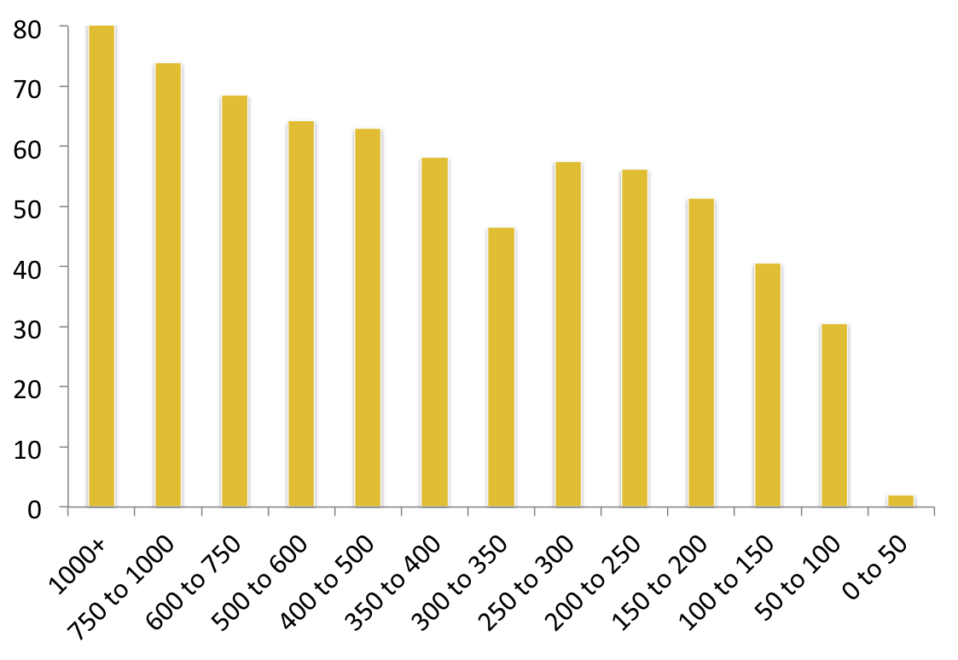
Figure 1. The lengths of genes detected in proteomics analyses
The percentage of genes identified in the proteomics studies against the length of the principal splice isoform from APPRIS for each gene.

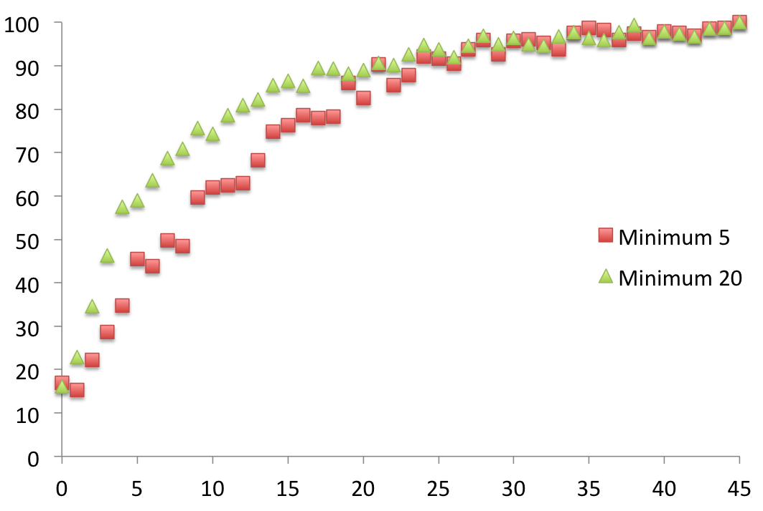
Figure 2. The relationship between tissue expression and proteomics detection.
The percentage of genes identified in the proteomics studies (y-axis) against the number of tissues in which transcript expression was found (x-axis). We used data from UniGene to look at ubiquity of transcript expression over a range of tissues. For each gene we counted the number of tissues in which there was transcript evidence of at least 5 or 20 transcripts per million. Genes were binned according to the number of tissue types in which there was evidence of transcript expression.

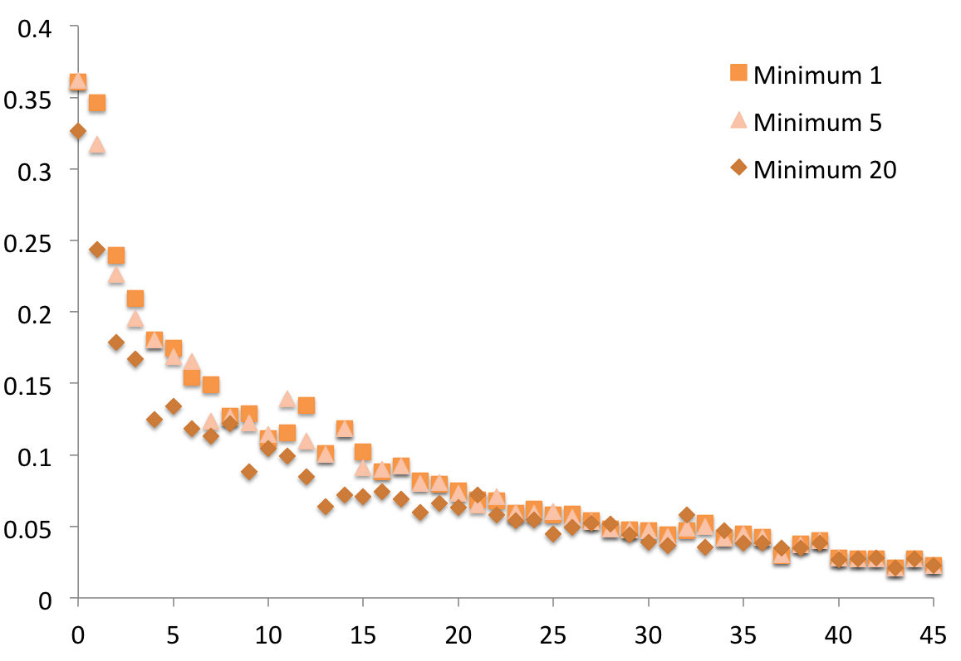

Figure 3. The relationship between tissue expression and gene conservation.
Gene conservation (mean MI score) (y-axis) against the number of tissues in which transcript expression was found (x-axis). We used data from UniGene to look at ubiquity of transcript expression over a range of tissues. For each gene we counted the number of tissues in which there was transcript evidence of at least 1, 5 or 20 transcripts per million. Genes were binned according to the number of tissue types in which there was evidence of transcript expression.

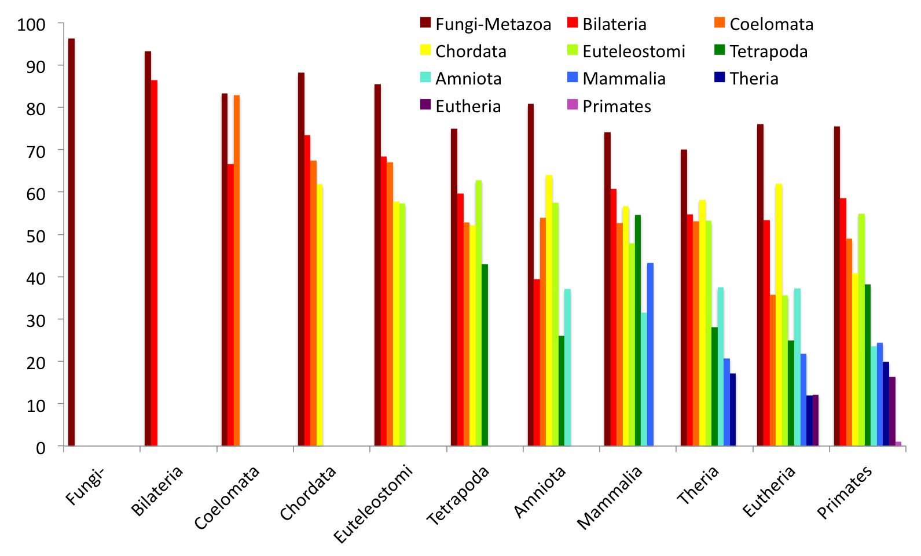

Figure 4. Gene family age and gene age.
Here we show the percentage of genes identified in the proteomics studies against ancestral gene age (gene family age) and the age of most recent duplication event (gene age). The y-axis shows the percentage of genes detected in proteomics experiments. The x-axis shows the age of the last recorded duplication (oldest duplications on the left, most recent on the right), while the legend shows the gene family age (family ages are also coloured by a rainbow colouring scheme, oldest at the red end of the spectrum, most recent at the blue end). Genes with identical family and duplication age are shown in the furthest right-hand bar of each gene duplication cluster, while those that duplicated from genes with Fungi-Metazoa family age are at the left of each cluster (note that Fungi-Metazoa has no separate gene duplicate bar). Curiously we found that there was significantly more evidence for genes with duplication events that arose from genes with Fungi-Metazoa gene family age than for any other, suggesting that genes that duplicate from the most ancient genes tend to find niches in the cellular processes more easily.

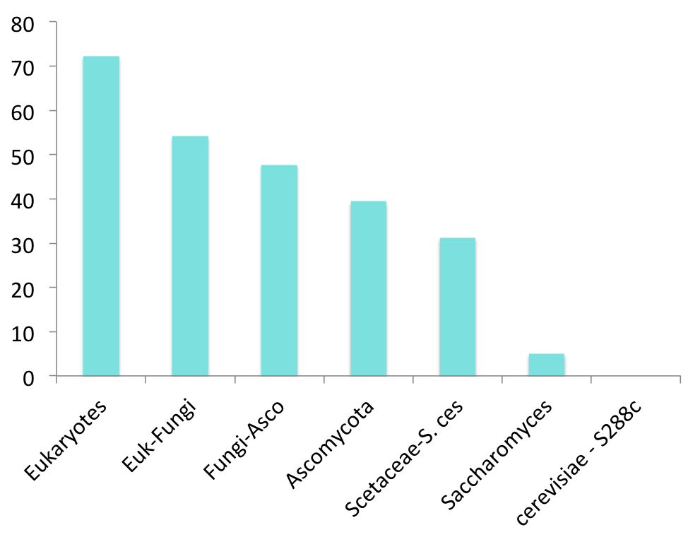
Figure 5. The relationship between gene family age and peptide detection for yeast.
Percentage of Saccharomyces cerevisiae S288c genes for which peptides detected in proteomics experiments against ancestral gene age, oldest ancestral genes (on the left) are detected much more often in proteomics experiments. PeptideAtlas detects peptides for 73% of yeast genes. There is the same clear relation between gene family age and peptide detection rates in yeast. PeptideAtlas detects no peptides for genes that arose since the cerevisiae division. Yeast is a single-celled organism, so here tissue specificity is not the reason why peptides are not detected for certain genes.

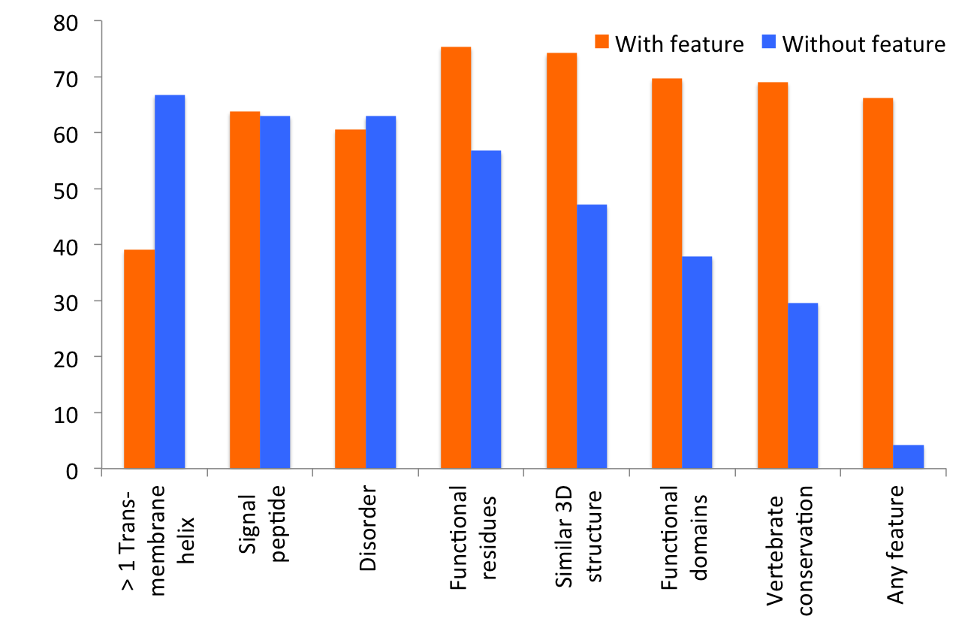
Figure 6. The relationship between protein features and peptide identification
We calculate the percentage of genes identified in the seven datasets (y-axis) for the presence or absence of a range of APPRIS features, for protein disorder and for those genes that were annotated with any single protein-like feature from APPRIS (the “Any feature” columns).

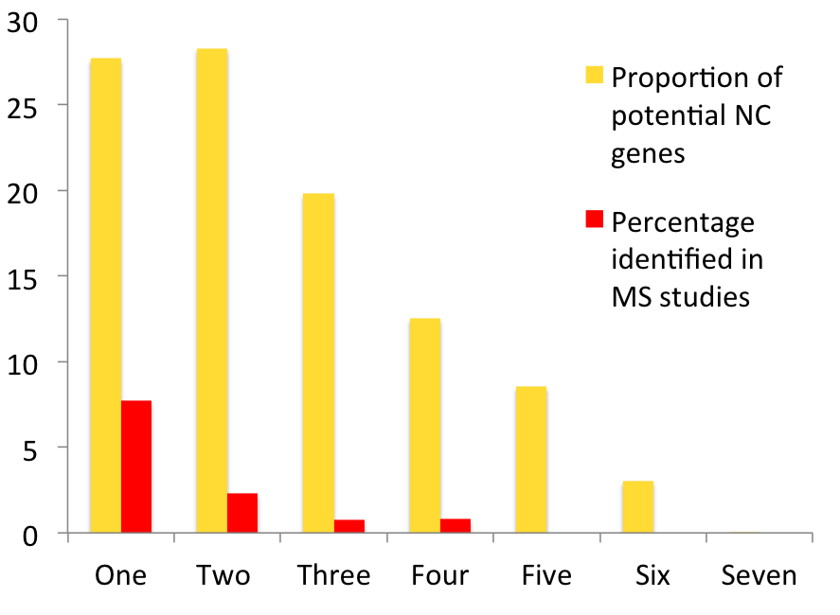
Figure 7. Number of atypical protein features per gene
The x-axis shows the number of protein-atypical features per gene in the potential non-coding set, and the y-axis shows (in yellow) the proportion of the 2,001 potential non-coding genes that have the number of atypical features and (in red) the distribution of the 61 genes that we identified in proteomics studies.

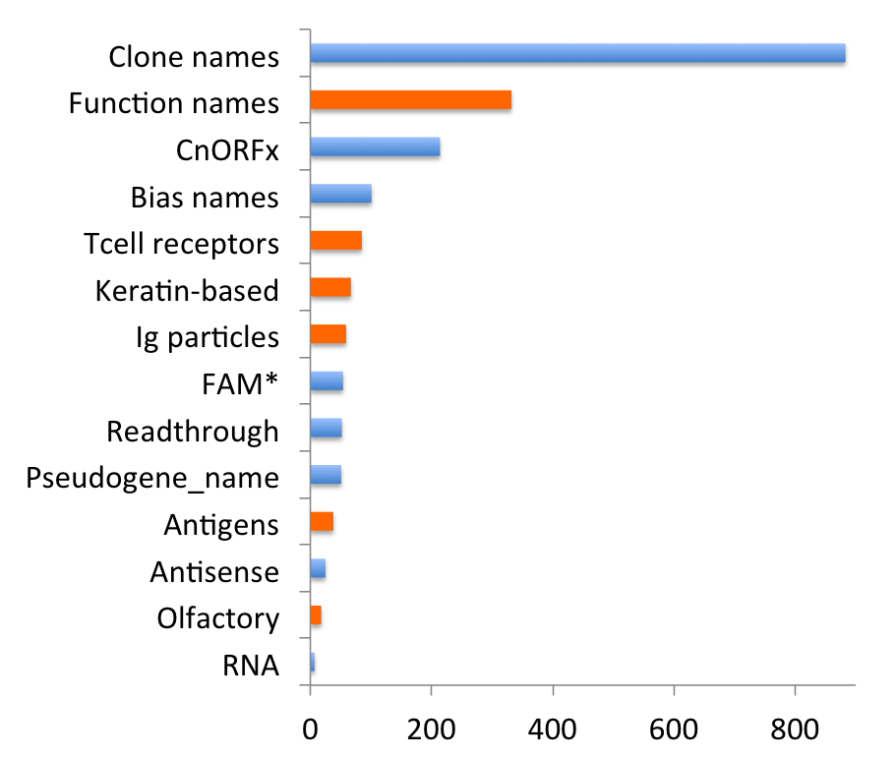

Figure 8. Gene names in the potential non-coding set
HGNC/GENCODE naming information for the 2,001 genes in the potential non-coding set. Names were binned according to type. Bars in blue indicate protein names related to position in the genome or amino acid bias; those in orange show gene names that are at least slightly related to potential gene function.

Figure 9. Genes in the potential non-coding set for which we find evidence of peptides from other sources.

We searched multiple proteomics experiments and four different sources of protein evidence for evidence of the expression of proteins for all 2,001 genes in the potential non-coding set. Here we show the numbers of genes detected by each source and the overlap. The 7 proteomics studies are shown in red, the Passel Database in green, the Human Protein Atlas in yellow and UniProt referenced papers in blue.

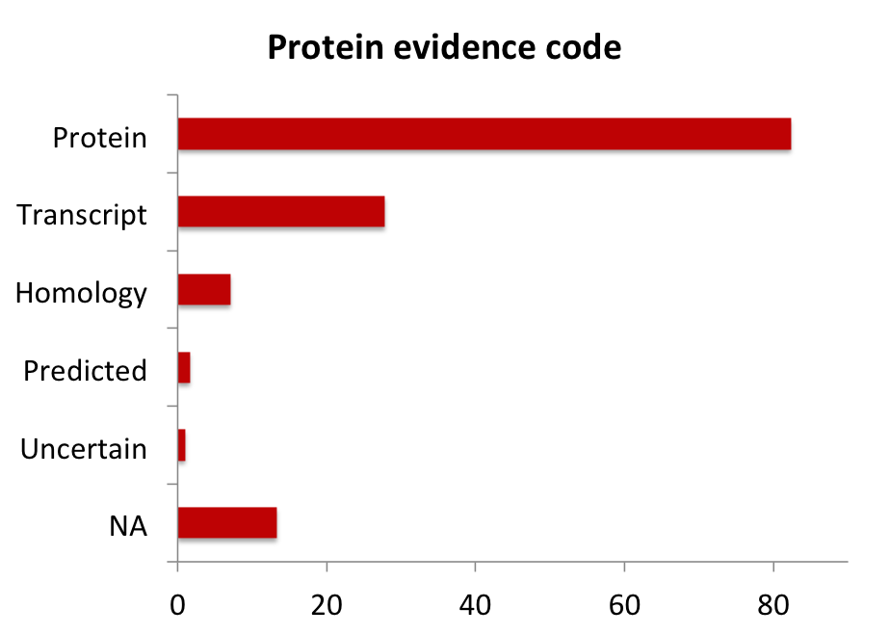

Figure 10. UniProt protein evidence for GENCODE/Ensembl genes.
The percentage of genes identified in the proteomics analysis for different levels of UniProt protein evidence. We took the isoform with the best evidence for each gene. “NA” are those genes for which we could not identify an evidence code in UniProt.

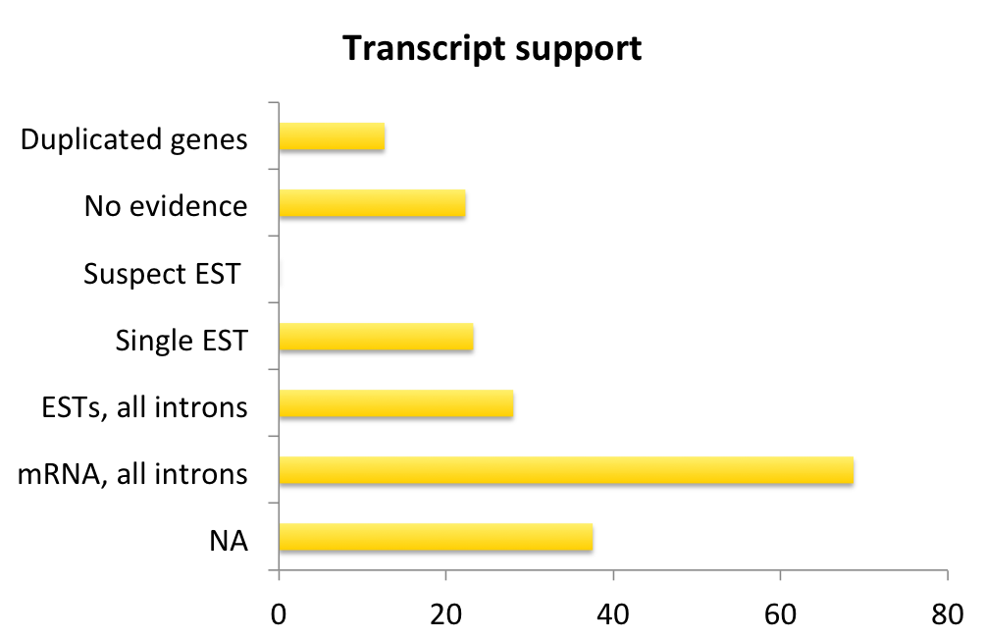

Figure 11. Transcript support for GENCODE/Ensembl genes.
The percentage of genes identified in the proteomics analysis for different levels of transcription support. We took the isoform with the best support to represent each gene. “NA” are those genes for which we were not able to find transcription support.

