Supplementary Table 1. STrengthening the REporting of Genetic Association studies (STREGA) reporting recommendations, extended from STROBE Statement

Item | Item no | STROBE Guideline | Extension for Genetic Association Studies (STREGA) | Page no
Title and Abstract | 1 | (a) Indicate the study’s design with a commonly used term in the title or the abstract. |  | 1
Title and Abstract | 1 | (b) Provide in the abstract an informative and balanced summary of what was done and what was found. |  | 3
Introduction
Background rationale | 2 | Explain the scientific background and rationale for the investigation being reported. |  | 4-5
Objectives | 3 | State specific objectives, including any pre-specified hypotheses | State if the study is the first report of a genetic association, a replication effort, or both. | 5
Methods
Study design | 4 | Present key elements of study design early in the paper. |  | 6
Setting | 5 | Describe the setting, locations and relevant dates, including periods of recruitment, exposure, follow-up and data collection. |  | 6
Participants | 6 | - (a) Cohort study – Give the eligibility criteria, and the sources and methods of selection of participants. Describe methods of follow-up.  Case–control study – Give the eligibility criteria, and the sources and methods of case ascertainment and control selection. Give the rationale for the choice of cases and controls.  Cross-sectional study – Give the eligibility criteria, and the sources and methods of selection of participants. | Give information on the criteria and methods for selection of subsets of participants from a larger study, when relevant. | 6
Participants | 6 | (b) Cohort study – For matched studies, give matching criteria and number of exposed and unexposed.  Case–control study – For matched studies, give matching criteria and the number of controls per case. |  | 6
Variables | 7 | (a) Clearly define all outcomes, exposures, predictors, potential confounders, and effect modifiers. Give diagnostic criteria, if applicable. | (b) Clearly define genetic exposures (genetic variants) using a widely –used nomenclature system. Identify variables likely to be associated with population stratification (confounding by ethnic origin). | 6
Data sources measurement | 8* | (a) For each variable of interest, give sources of data and details of methods of assessment (measurement). Describe comparability of assessment methods if there is more than one group. | (b) Describe laboratory methods, including source and storage of DNA, genotyping methods and platforms (including the allele calling algorithm used, and its version), error rates and call rates. State the laboratory /centre where genotyping was done. Describe comparability of laboratory methods if there is more than one group. Specify whether genotypes were assigned using all of the data from the study simultaneously or in smaller batches. | 6-7
Bias | 9 | (a) Describe any efforts to address potential sources of bias. | (b) For quantitative outcome variables, specify if any investigation of potential bias resulting from pharmacotherapy was undertaken. If relevant, describe the nature and magnitude of the potential bias, and explain what approach was used to deal with this. | 7
Study size | 10 | Explain how the study size was arrived at. |  | 6
Quantitative variables | 11 | Explain how quantitative variables were handled in the analyses. If applicable, describe which groupings were chosen, and why. | If applicable, describe how effects of treatment were dealt with. | 6-7
Statistical methods | 12 | (a) Describe all statistical methods, including those used to control for confounding. | State software version used and options (or settings) chosen. | 7
Statistical methods | 12 | (b) Describe any methods used to examine subgroups and interactions. |  | 7
Statistical methods | 12 | (c) Explain how missing data were addressed. |  | 7
Statistical methods | 12 | (d) Cohort study – If applicable, explain how loss to follow-up was addressed.  Case–control study – If applicable, explain how matching of cases and controls was addressed.  Cross-sectional study – If applicable, describe analytical methods taking account of sampling strategy. |  | 7
Statistical methods | 12 | (e) Describe any sensitivity analyses. |  | 7
 |  |  | (f) State whether Hardy- Weinberg equilibrium was considered and, if so, how. | 7
 |  |  | (g) Describe any methods used for inferring genotypes or haplotypes. | 7
 |  |  | (h) Describe any methods used to assess or address population stratification. | 7
 |  |  | (i) Describe any methods used to address multiple comparisons or to control risk of false positive findings. | 7
 |  |  | (j) Describe any methods used to address and correct for relatedness among subjects. | 7
Results
Participants | 13* | (a) Report the numbers of individuals at each stage of the study – e.g. numbers potentially eligible, examined for eligibility, confirmed eligible, included in the study, completing follow-up and analysed. | Report numbers of individuals in whom genotyping was attempted and numbers of individuals in whom genotyping was successful. | 8
Participants | 13* | (b) Give reasons for non-participation at each stage. |  | 8
Participants | 13* | (c) Consider use of a flow diagram. |  | 8
Descriptive data | 14* | (a) Give characteristics of study participants (e.g. demographic, clinical, social) and information on exposures and potential confounders. | Consider giving information by genotype. | 8
Descriptive data | 14* | (b) Indicate the number of participants with missing data for each variable of interest. |  | 8
Descriptive data | 14* | (c) Cohort study – Summarize follow-up time, e.g. average and total amount. |  | 8
Outcome data | 15* | Cohort study – Report numbers of outcome events or summary measures over time. | Report outcomes  (phenotypes) for each genotype category over time | 8
Outcome data | 15* | Case–control study – Report numbers in each exposure category, or summary measures of exposure. | Report numbers in each genotype category | 8
Outcome data | 15* | Cross-sectional study – Report numbers of outcome events or summary measures. | Report outcomes (phenotypes) for each genotype category | 8
Main results | 16 | (a) Give unadjusted estimates and, if applicable, confounder-adjusted estimates and their precision (e.g. 95% confidence intervals). Make clear which confounders were adjusted for and why they were included. |  | 8
Main results | 16 | (b) Report category boundaries when continuous variables were categorized. |  | 8
Main results | 16 | (c) If relevant, consider translating estimates of relative risk into absolute risk for a meaningful time period. |  | 8
 |  |  | (d) Report results of any adjustments for multiple comparisons.
Other analyses | 17 | (a) Report other analyses done – e.g. analyses of subgroups and interactions, and sensitivity analyses. |  | 8
 |  |  | (b) If numerous genetic exposures (genetic variants) were examined, summarize results from all analyses undertaken.
 |  |  | (c) If detailed results are available elsewhere, state how they can be accessed.
Discussion
Key results | 18 | Summarize key results with reference to study objectives. |  | 9
Limitations | 19 | Discuss limitations of the study, taking into account sources of potential bias or imprecision. Discuss both direction and magnitude of any potential bias. |  | 10
Interpretation | 20 | Give a cautious overall interpretation of results considering objectives, limitations, multiplicity of analyses, results from similar studies, and other relevant evidence. |  | 9-10
Generalizability | 21 | Discuss the generalizability (external validity) of the study results. |  | 9-10
Other information
Funding | 22 | Give the source of funding and the role of the funders for the present study and, if applicable, for the original study on which the present article is based. |  | 12

STROBE: STtrengthening the Reporting of Observational Studies in Epidemiology

*Give information separately for cases and controls in case–control studies and, if applicable, for exposed and unexposed groups in cohort and cross-sectional studies.

Supplementary Table 2. Characteristics of IRF5–TNPO3 polymorphisms in LTNPs and control group.
 | Distribution of genotypes ⁽¹⁾ |  |  |  | HWE ⁽²⁾
SNPs | Genotype | Control group | LTNPs | p-value | Control group | LTNPs
rs4728142 | n=293
 | GG | 33 (30.0%) | 55 (30.1%) | 0.933 | 0.451 | 0.658
 | AG | 51 (46.4%) | 88 (48.1%)
 | AA | 26 (23.6%) | 40 (21.9%)
rs2004640 | n=289
 | TT | 36 (32.7%) | 47 (26.3%) | 0.495 | 0.563 | 1.000
 | GT | 51 (46.4%) | 90 (50.3%)
 | GG | 23 (20.9%) | 42 (23.5%)
rs10954213 | n=293
 | AA | 46 (41.8%) | 67 (36.6%) | 0.482 | 0.529 | 0.755
 | AG | 53 (48.2%) | 90 (49.2%)
 | GG | 11 (10.0%) | 26 (14.2%)
rs2280714 | n=293
 | TT | 52 (47.3%) | 72 (39.3%) | 0.357 | 0.659 | 0.425
 | CT | 49 (44.5%) | 90 (49.2%)
 | CC | 9 (8.2%) | 21 (11.5%)
rs10279821 | n=293
 | CC | 52 (47.3%) | 71 (38.8%) | 0.316 | 0.498 | 0.198
 | CT | 50 (45.5%) | 93 (50.8%)
 | TT | 8 (7.3%) | 19 (10.4%)
rs12537284 | n=292
 | GG | 81 (74.3%) | 136 (74.3%) | 0.951 | 0.447 | 0.758
 | AG | 25 (22.9%) | 43 (23.5%)
 | AA | 3 (2.8%) | 4 (2.2%)

Statistic: (1), Differences in the genotype’s distribution between HIV patients and controls; (2), Hardy-Weinberg equilibrium. P-values were calculated by chi-squared. P-values were calculated by chi-squared.
Abbreviations: HIV: human immunodeficiency virus; HWE: Hardy-Weinberg equilibrium; IRF5: interferon regulatory factor 5; LTNP: long-term nonprogressor; SNP: single nucleotide polymorphism; TNPO3: transportin 3.

Supplementary Figure 1. Pairwise linkage disequilibrium (LD) pattern for IRF5–TNPO3 polymorphisms. The intensity of red or grey decreases with decreasing D´ and r2 values. The genomic location of SNPs is indicated on top. The diagonal represents an SNP, and the square represents a pairwise comparison between two SNPs, indicating the magnitude of LD (D´ and r²). D´ and r² vary from 0 (absence) to 100 (complete). Abbreviations: D´: D-prime or proportion of the possible LD that was present between two SNPs; HIV: human immunodeficiency virus; IRF5: interferon regulatory factor 5; LD: linkage disequilibrium; r²: square of the correlation coefficient; SNP: single nucleotide polymorphism; TNPO3: transportin 3.
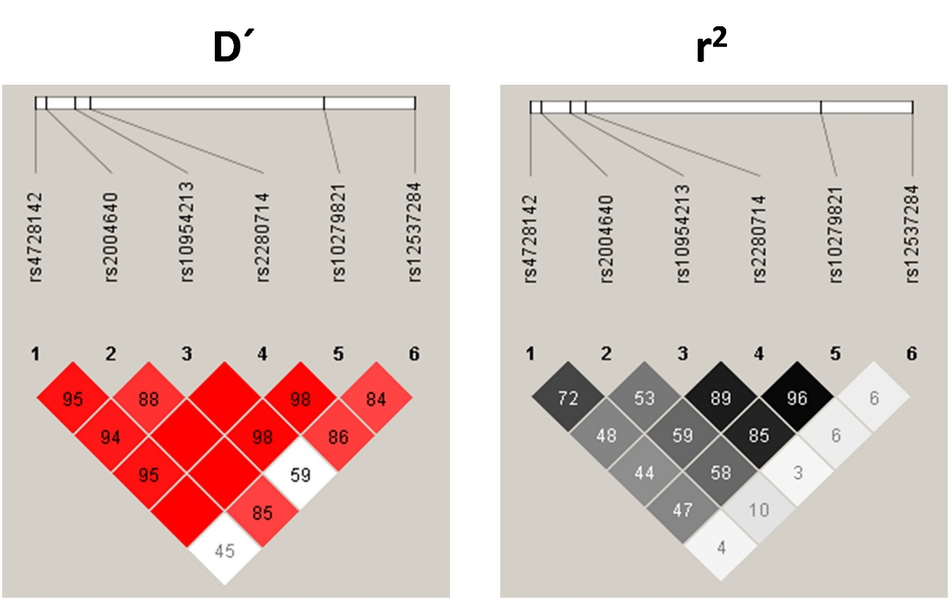

Supplementary Table 3. Genetic association of IRF5–TNPO3 polymorphisms with HIV elite control.

SNPs | Inheritance | Genotypes | OR (95%CI) | p-value | aOR (95%CI) | p-value
rs4728142 | Dominant | GG vs. AG/AA | 0.98 (0.52 - 1.85) | 0.961 | 0.99 (0.52 - 1.88) | 0.963
rs4728142 | Recessive | GG/AG vs. AA | 1.72 (0.85 - 3.49) | 0.134 | 1.80 (0.87 - 3.70) | 0.112
rs4728142 | Additive | nA | 1.19 (0.79 - 1.79) | 0.403 | 1.21 (0.80 - 1.83) | 0.373
rs2004640 | Dominant | TT vs. GT/GG | 0.50 (0.25 - 0.98) | 0.045 | 0.49 (0.25 - 0.97) | 0.041
rs2004640 | Recessive | TT/GT vs. GG | 0.71 (0.35 - 1.43) | 0.339 | 0.76 (0.37 - 1.55) | 0.452
rs2004640 | Additive | nG | 0.67 (0.44 - 1.03) | 0.068 | 0.68 (0.45 - 1.05) | 0.084
rs10954213 | Dominant | AA vs. AG/GG | 0.54 (0.29 - 0.99) | 0.046 | 0.51 (0.28 - 0.95) | 0.035
rs10954213 | Recessive | AA/AG vs. GG | 0.80 (0.35 - 1.86) | 0.606 | 0.74 (0.32 - 1.75) | 0.495
rs10954213 | Additive | nG | 0.69 (0.44 - 1.06) | 0.092 | 0.66 (0.42 - 1.03) | 0.064
rs2280714 | Dominant | TT vs. CT/CC | 0.52 (0.28 - 0.94) | 0.031 | 0.50 (0.27 - 0.91) | 0.024
rs2280714 | Recessive | TT/CT vs. CC | 0.66 (0.26 - 1.69) | 0.388 | 0.65 (0.25 - 1.67) | 0.371
rs2280714 | Additive | nC | 0.63 (0.40 - 0.99) | 0.043 | 0.61 (0.38 - 0.97) | 0.036
rs10279821 | Dominant | CC vs. CT/TT | 0.49 (0.27 - 0.90) | 0.021 | 0.47 (0.26 - 0.87) | 0.017
rs10279821 | Recessive | CC/CT vs. TT | 0.80 (0.31 - 2.10) | 0.652 | 0.79 (0.30 - 2.09) | 0.632
rs10279821 | Additive | nT | 0.63 (0.39 – 0.99) | 0.05 | 0.61 (0.38 - 0.98) | 0.041
rs12537284 | Dominant | GG vs. AG/AA | 0.99 (0.51 - 1.92) | 0.976 | 1.01 (0.51 - 1.97) | 0.988
rs12537284 | Recessive | GG/AG vs. AA | 0.37 (0.04 - 3.61) | 0.391 | 0.35 (0.04 - 3.51) | 0.372
rs12537284 | Additive | nA | 0.92 (0.51 - 1.65) | 0.772 | 0.92 (0.51 - 1.68) | 0.793

Statistics: Data were calculated by binary logistic regression adjusted by gender, age at HIV diagnosis, and injecting drug use (IDU) as the risk factor for HIV acquisition. Significant differences are shown in bold.
Abbreviations: 95%CI: 95% confidence interval; OR: odds ratio; aOR: adjusted odds ratio; HIV: human immunodeficiency virus; IRF5: interferon regulatory factor 5; LTNP: long-term non-progressors; LTNP-EC: long-term non-progressors who are elite controllers; LTNP-non-EC: long-term non-progressors who are not elite controllers; TNPO3: transportin 3.

