Supplementary Methods. Definition of lifestyle-related factors and neighborhood characteristics in the Seniors-Enrica 2 study.
Lifestyle-related factors
Information was collected on smoking (never, former, current smoker), alcohol consumption (never, moderate, heavy, former drinker) and usual time spent watching TV (hours/day), as reported in the Nurses’ Health Study questionnaire validated in Spain [1]. Habitual recreational physical activity (PA) was calculated using the validated questionnaire from the EPIC-Spain cohort [2], which includes walking (commuting, shopping or leisure time), cycling (commuting or leisure time) and playing sports (running, playing soccer, doing aerobics, swimming or playing tennis). Walking was the only recreational PA in approximately 43% of the study participants. Compared with the rate of energy expended at rest, the assigned metabolic equivalents of tasks (METs) were 2.5 for walking and 4.0 for cycling, playing sports, gardening and home repair. In addition to the self-reported information, in a subsample of 2020 participants, the 24-hour activity cycle was also assessed using an ActiGraph GT9X accelerometer (ActiGraphInc) [3]. Participants were asked to wear the accelerometer on the nondominant hand for seven consecutive days and to only remove it during water activities, such as showering. Raw accelerometer data were processed usig the GGIR package (v.1.7-0) [4], and time in moderate-vigorous PA (MVPA) was established based on an ENMO threshold of >100 mg. Individuals who achieved at least 30 min of MVPA were considered to meet MVPA recommendations. Sleep time was derived from accelerometry data using an automatized algorithm [3]. Moreover, a sleep quality scale was built as the sum of the points given to eight symptoms of sleep disturbance (i.e. bad overall sleep, difficulty falling asleep, awakening during nighttime, early awakening with difficulty getting back to sleep, use of sleeping pills, feeling restless in the morning, being asleep at daytime, and having an Epworth Sleepiness Scale>10) [5]. Individuals in the highest quartile of the sleep disturbance scale were deemed to suffer from poor sleep quality [5]. Finally, food consumption was collected with the aforementioned validated diet history and adherence to the Mediterranean diet assessed through the MEDAS score [6].
Other neighborhood characteristics.
Traffic exposure was assessed using Annual Average Daily Traffic (AADT) [7,8], calculated as the total daily volume of traffic on highways, roads, and streets within 500 and 1000 m of the participants´ homes, and expressed in vehicles per day. For this purpose, Navteq mapping combined with traffic density information provided by the Spanish Ministry of Public Works was used. Neighborhood environmental attributes were measured using the Physical Activity Neighborhood Environment Survey [9], which asks participants for the following information (a) primary type of housing, as a proxy measure of residential density; (b) availability of stores and other retail destinations, as a marker of land use mix; (c) presence of public transportation stops; (d) presence and condition of sidewalks; (e) presence of bicycle facilities and free or low-cost recreational facilities; (f) existence of crime in the neighborhood that makes it unsafe to walk at night or during the day; (g) existence of dense traffic that impedes or discourages walking; (h) existence of interesting things to look at while walking; and (i) existence of many places to walk around. The original response options ranged from 1 (strongly agree) to 4 (strongly disagree) and were recoded as "strongly agree/agree" vs. "disagree/strongly disagree," with the exception of housing type that was dichotomized to contrast detached single-family homes (i.e., lower residential density) from the rest (higher residential density).
Finally, a walkability index based on work by Creatore et al. [10], and modified according to European recommendations [11], was created for the subsample of participants living in the city of Madrid. The index considered four items: (a) residential density (obtained from the Housing part of the Spanish Census); (b) population density (obtained from the Padrón); (c) retail destinations (obtained from the Retail Spaces Census, which includes data on economic activities of all occupied commercial spaces); and (d) street connectivity (obtained from CARTOCIUDAD, the National Mapping Agency initiative, which collects and makes available official geo-referenced urban data, including street structure and administrative boundaries in shapefile format) [12]. All data were available for 2014 except for the Spanish Census, available for 2011.
Bibliography:
1. Martínez-González MA, López-Fontana C, Varo JJ, Sánchez-Villegas A, Martinez JA. Validation of the Spanish version of the physical activity questionnaire used in the Nurses’ Health Study and the Health Professionals’ Follow-up Study. Public Health Nutr 2005; 8: 920–927.
2. Pols MA, Peeters PH, Ocké MC, Slimani N, Bueno-de-Mesquita HB, Collette HJ. Estimation of reproducibility and relative validity of the questions included in the EPIC Physical Activity Questionnaire. Int J Epidemiol 1997; 26 Suppl 1: S181-189.
3. Cabanas-Sánchez V, Esteban-Cornejo I, Migueles JH et al. Twenty four-hour activity cycle in older adults using wrist-worn accelerometers: The seniors-ENRICA-2 study. Scand J Med Sci Sports 2020; 30: 700–708.
4. van Hees VT, Gorzelniak L, Dean León EC et al. Separating Movement and Gravity Components in an Acceleration Signal and Implications for the Assessment of Human Daily Physical Activity. PLoS One 2013; 8: e61691.
5. Leon-Gonzalez R, Rodriguez-Artalejo F, Ortola R, Lopez-Garcia E, Garcia-Esquinas E. Social Network and Risk of Poor Sleep Outcomes in Older Adults: Results from a Spanish Prospective Cohort Study. Nat Sci Sleep 2021; 13: 399–409.
6. Ortolá R, García-Esquinas E, Buño-Soto A et al. Healthy dietary patterns are associated with lower concentrations of growth differentiation factor 15 in older adults. The American Journal of Clinical Nutrition 2021; 113: 1619–1626.
7. Canto MV, Guxens M, Ramis R. Exposure to Traffic Density during Pregnancy and Birth Weight in a National Cohort, 2000–2017. IJERPH 2022; 19: 8611.
8. García-Esquinas et al. Exposure to residential traffic and trajectories of unhealthy ageing in older adults. .
9. Sallis JF, Kerr J, Carlson JA et al. Evaluating a brief self-report measure of neighborhood environments for physical activity research and surveillance: Physical Activity Neighborhood Environment Scale (PANES). J Phys Act Health 2010; 7: 533–540.
10. Creatore MI, Glazier RH, Moineddin R et al. Association of Neighborhood Walkability With Change in Overweight, Obesity, and Diabetes. JAMA 2016; 315: 2211–2220.
11. Grasser G, van Dyck D, Titze S, Stronegger WJ. A European perspective on GIS-based walkability and active modes of transport. Eur J Public Health 2016; ckw118.
12. Gullón P, Bilal U, Cebrecos A, Badland HM, Galán I, Franco M. Intersection of neighborhood dynamics and socioeconomic status in small-area walkability: the Heart Healthy Hoods project. International Journal of Health Geographics 2017; 16: 21.

Supplementary Figure 1. Study Participants Recruitment Municipalities within the Autonomous Community of Madrid
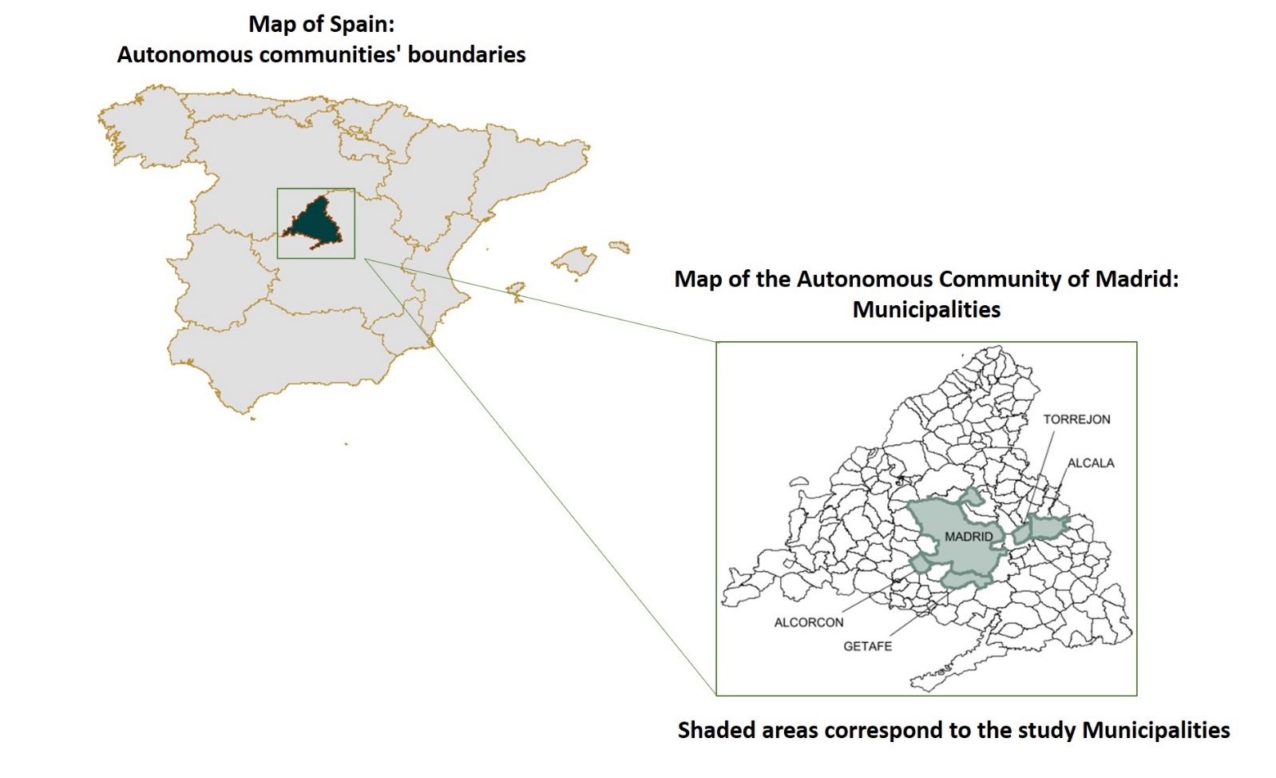

Supplementary Figure 2: DAG representing the associations studied.

CVD: Cardiovascular Disease; MMSE: Mini-Mental Examination Survey; NDVI: Normalized Difference Vegetation Index ; PNE: Perceived Neighborhood Environment; SPPB: Short-Physical Performance Battery.

Mediation analyses was used to 1) decompose the effect of greenness on biomarkers of cardiovascular (CVD) risk (pathways a’, b’ and c’ in blue) and 2) decompose the effect of greenness on CVD incidence (pathways A’, B’ and C’ in pink). Pathway a’ represents the association between NDVI and the studied mediators (i.e. social cohesion, lifestyle-related risk factors, CVD risk factors, mental health, physical function, cognitive function, traffic exposure, perceived neighborhood environment, and residential walkability). Pathway b’ represents the association between the mediators and the studied cardiovascular risk biomarker (NT-ProBNP, hs-TnT or IL6). Pathway c’ represents the direct path of NDVI on the studied biomarkers that is not mediated through the above-mentioned mediators. Multiplying the coefficients of pathways a’ and b’ we estimated the indirect effect (i.e. effect between NDVI index and biomarkers of CVD risk that is mediated by each of the studied mediators). Pathway A’ represents the association between NDVI and the studied cardiovascular risk biomarkers (NT-ProBNP, hs-TnT or IL6); Pathway B’ represents the association between these biomarkers and CVD incidence; while Pathway C’ represents the direct path of NDVI on CVD incidence that is not mediated by the studied biomarkers. By multiplying the coefficients from Pathway A’ and B’ we estimated the indirect effect that is mediated by each CVD biomarker

Supplementary Figure 3: Percentage changes (95% confidence interval) in ProBNP according to residential greenness (Net Normalized Difference Vegetation Index, NVDI) with buffer zones at 250, 500, 750, and 1000 meters, by participant and neighborhood-related characteristics. Models adjusted for sex, age, age-squared, educational level, degree of difficulty in making end meets, and social network score, and included a random-effect for the Deprivation Index at the census tract. Dots represent percentage changes and horizontal lines the CIs. The p-value indicates the significance level for the interaction term. Results are expressed by increasing interquartile range in greenness.
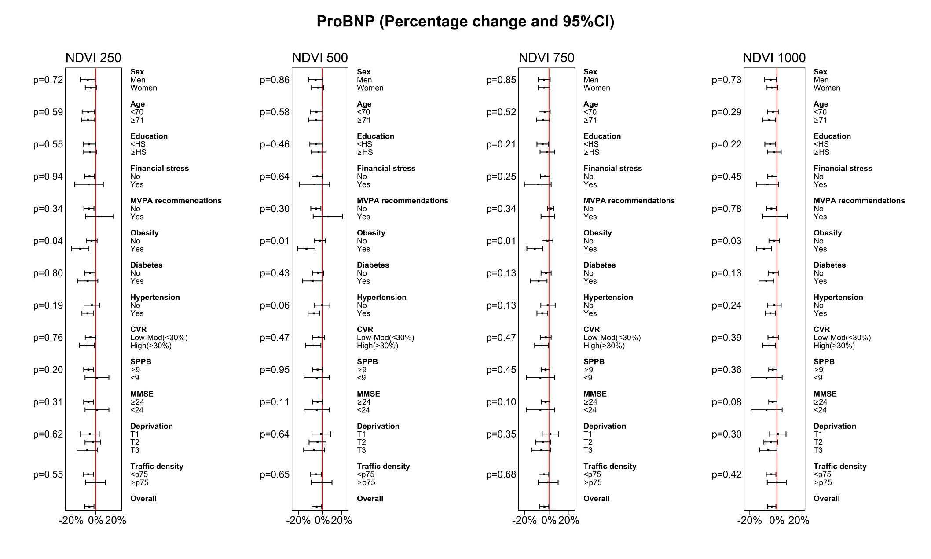
Supplementary Figure 4: Percentage changes (95% confidence interval) in hs-TnT according to residential greenness (Net Normalized Difference Vegetation Index, NVDI) with buffer zones at 250, 500, 750, and 1000 meters by participant and neighborhood-related characteristics. Models adjusted for sex, age, age-squared, educational level, degree of difficulty in making end meets, and social network score, and included a random-effect for the Deprivation Index at the census tract. Dots represent percentage changes and horizontal lines the CIs. P-values indicate the significance level for the interaction term. Results are expressed by increasing interquartile range in greenness.
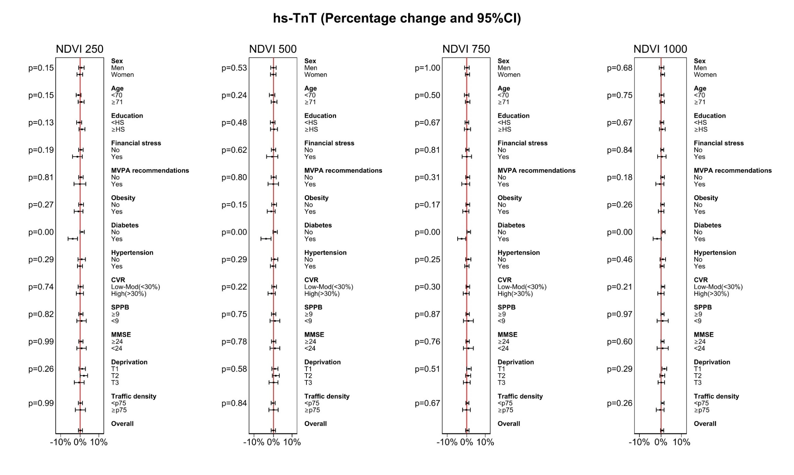
Supplementary Figure 5: Percentage changes (95% confidence interval) in hs-TnT among diabetics according to residential greenness (Net Normalized Difference Vegetation Index, NVDI) with buffer zones at 250, 500, 750, and 1000 meters, by participant and neighborhood-related characteristics. Models adjusted for sex, age, age-squared, educational level, degree of difficulty in making end meets, and social network score, and included a random-effect for the Deprivation Index at the census tract. Dots represent percentage changes and horizontal lines the CIs. P-values indicate the significance level for the interaction term. Results are expressed by increasing interquartile range in greenness.
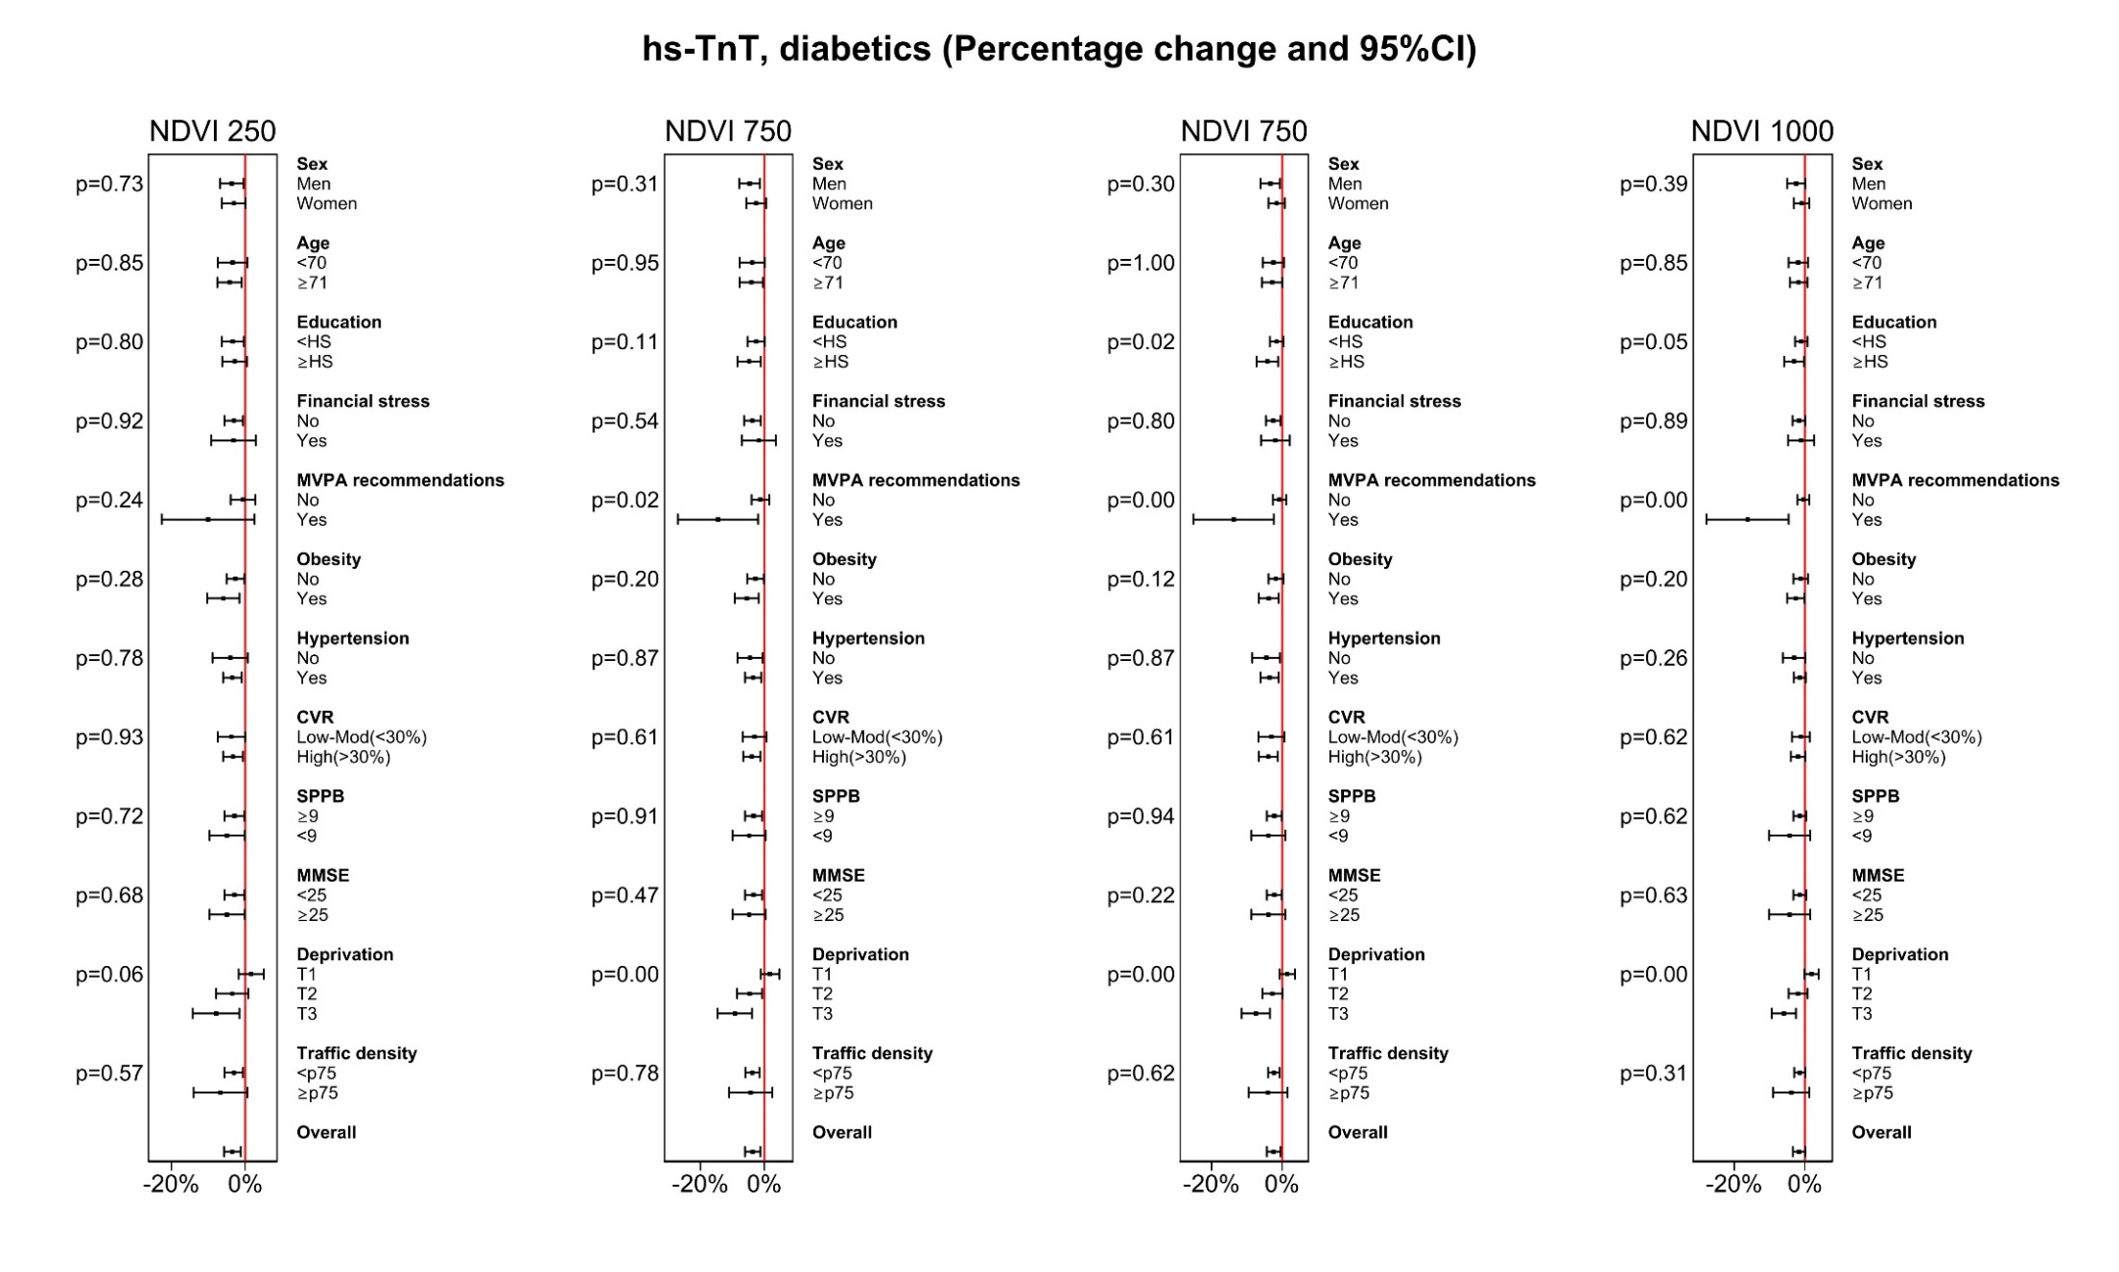

Supplementary Figure 6: Percentage changes (95% confidence interval) in IL-6 according to residential greenness (Net Normalized Difference Vegetation Index, NVDI) with buffer zones at 250, 500, 750, and 1000 meters, by participant and neighborhood-related characteristics. Models adjusted for sex, age, age-squared, educational level, degree of difficulty in making end meets, and social network score, and included a random-effect for the Deprivation Index at the census tract. Dots represent percentage changes and horizontal lines the CIs. P-values indicate the significance level for the interaction term. Results are expressed by increasing interquartile range in greenness.
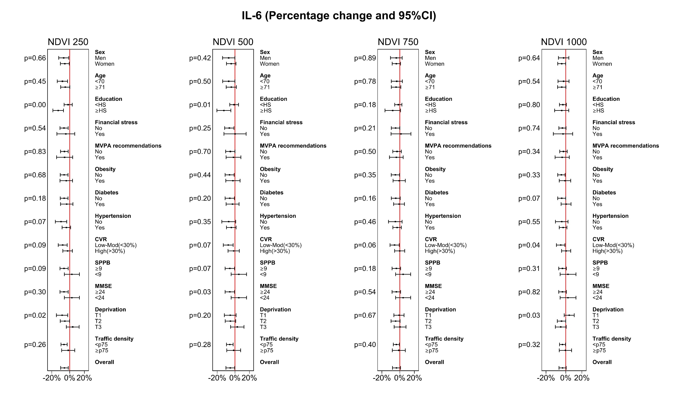

Supplementary Figure 7: Percentage changes (95% confidence interval) in GDF-15 according to residential greenness (Net Normalized Difference Vegetation Index, NVDI) with buffer zones at 250, 500, 750, and 1000 meters, by participant and neighborhood-related characteristics. Models adjusted for sex, age, age-squared, educational level, degree of difficulty in making end meets, and social network score, and included a random-effect for the Deprivation Index at the census tract. Dots represent percentage changes and horizontal lines the CIs. P-values indicate the significance level for the interaction term. Results are expressed by increasing interquartile range in greenness.
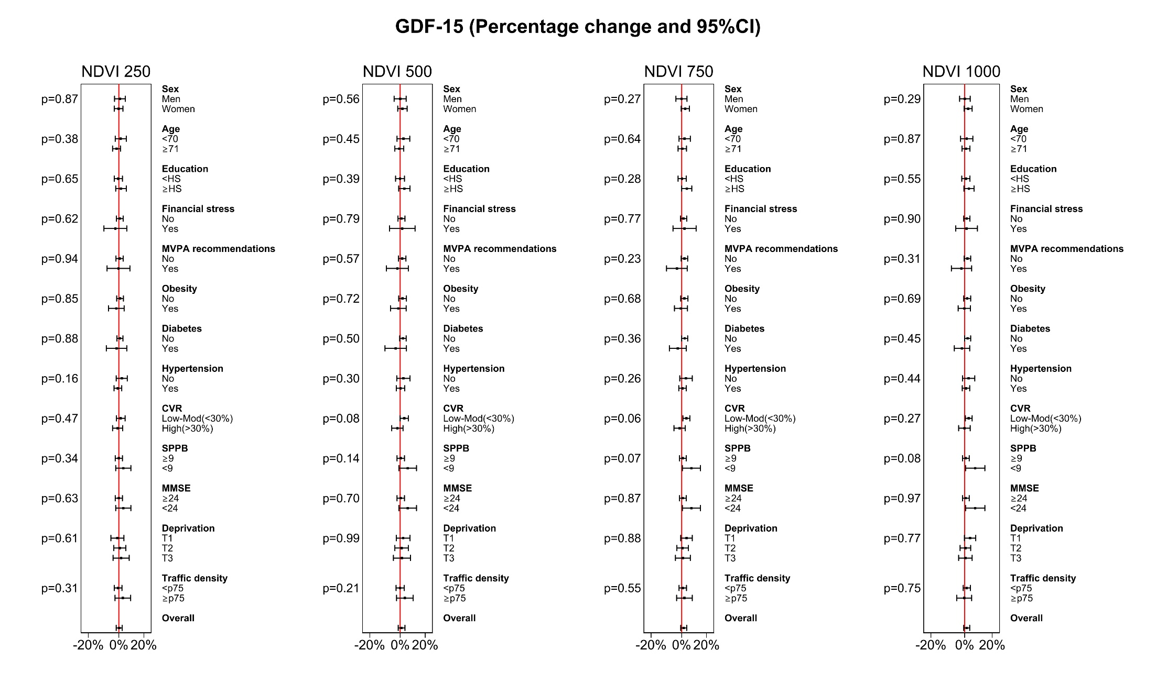
Supplementary Figure 8: Odds ratio (95% confidence interval) for cardiovascular disease incidence according to residential greenness (Net Normalized Difference Vegetation Index, NVDI) with buffer zones at 250, 500, 750, and 1000 meters, by participant and neighborhood-related characteristics. Models adjusted for sex, age, age-squared, educational level, degree of difficulty in making end meets, and social network score, and included a random-effect for the Deprivation Index at the census tract. Dots represent percentage changes and horizontal lines the CIs. P-values indicate the significance level for the interaction term.
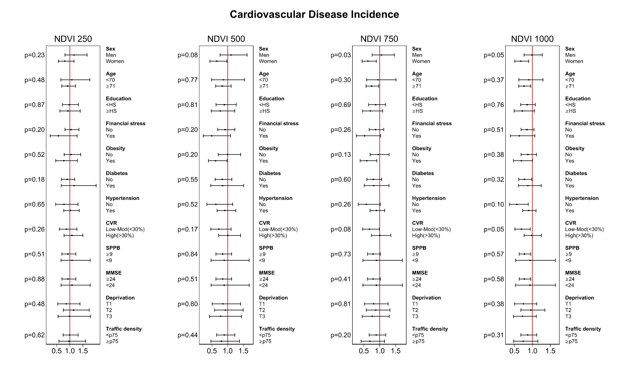
Please note that it was not possible to assess effect modification based on compliance with the MVPA due to the low number of CVD cases among those who did comply (n=3).

Supplementary Table 1: Distribution of socioeconomic variables, lifestyle-related behaviors, cardiovascular risk factors, quality of life, functional impairments and traffic exposure, according to vegetation density at 750 meters from the residence of 2144 community-dwelling older adults with no previous history of cardiovascular disease.
 | Total | Q1 | Q2 | Q3 | Q4 | p-val
N | 2144 | 517 | 528 | 541 | 558
Age, mean (SD) | 71.4 (4.4) | 72.5 (4.7) | 71.1 (4.3) | 71.3 (4.1) | 70.9 (4.1) | <0.01
Male,% | 44.9 | 41.2 | 44.9 | 45.8 | 47.3 | 0.20
Educational level, % |  |  |  |  |  | <0.01
<Secondary | 64.2 | 68.9 | 74.8 | 56.4 | 57.3
>Secondary | 17.4 | 11.6 | 9.8 | 22.0 | 25.3
Deprivation index, mean (SD) | -0.6 (0.7) | -0.4 (0.6) | -0.2 (0.6) | -0.7 (0.7) | -1.0 (0.7) | <0.01
Meeting ends, % |  |  |  |  |  | <0.01
With great difficulty | 1.0 | 1.2 | 0.9 | 0.7 | 1.1
With difficulty | 2.8 | 3.5 | 2.1 | 3.9 | 1.6
With some difficulty | 9.6 | 11.8 | 13.4 | 6.3 | 7.0
With some ease | 22.5 | 25.7 | 25.6 | 18.9 | 20.1
Easily | 56.2 | 49.1 | 53.6 | 61.9 | 59.7
Very easily | 8.0 | 8.7 | 4.4 | 8.3 | 10.6
Social network score, mean (SD) | 5.0 (1.6) | 4.8 (1.6) | 5.1 (1.6) | 5.1 (1.5) | 5.1 (1.5) | <0.01
Smoking, % |  |  |  |  |  | 0.12
Never | 54.0 | 59.2 | 54.4 | 51.9 | 50.7
Ex-smoker | 36.7 | 32.5 | 36.6 | 37.3 | 40.1
Current | 9.3 | 8.3 | 9.1 | 10.7 | 9.1
Drinking, % |  |  |  |  |  | <0.01
Never drinker | 19.3 | 23.6 | 19.1 | 17.6 | 17.0
Moderate drinker | 69.6 | 63.2 | 67.6 | 73.2 | 73.8
Heavy drinker | 5.0 | 4.4 | 5.9 | 3.7 | 5.9
Ex drinker | 6.2 | 8.7 | 7.4 | 5.5 | 3.2
Recreational pa (METs-h/week) , mean (SD) | 28.5 (19.4) | 27.0 (19.0) | 28.9 (19.8) | 29.1 (20.0) | 28.9 (18.9) | 0.25
MPVA (h/day) , mean (SD) |  | 0.87 (0.6) | 0.93 (0.6) | 0.92 (0.6) | 1.0 (0.6) | 0.09
TV viewing (h/d), mean (SD) | 3.2 (1.5) | 3.2 (1.6) | 3.2 (1.6) | 3.2 (1.4) | 3.1 (1.5) | 0.06
BMI, mean (SD) | 27.6 (4.4) | 27.7 (4.3) | 27.9 (4.3) | 27.6 (4.6) | 27.4 (4.2) | 0.23
MEDAS index, mean (SD) | 7.1 (1.7) | 7.3 (1.5) | 7.2 (1.7) | 7.2 (1.9) | 6.9 (1.7) | <0.01
Poor sleep quality, % | 17.1 | 19.4 | 19.6 | 15.4 | 14.3 | 0.04
Night sleep (min), mean (SD) | 601.5 (59.1) | 601 (60) | 602 (59) | 602 (59) | 602 (59) | 0.99
SBP, mean (SD) | 135 (18.0) | 137 (19) | 134 (19) | 133 (16) | 135 (18) | <0.01
HT treatment, % | 48.7 | 50.7 | 47.0 | 50.1 | 47.3 | 0.51
Total cholesterol, mean (SD) | 193.8 (33.2) | 193(33.1) | 193 (32.5) | 194 (33.9) | 196 (33.4) | 0.33
Triglycerides, mean (SD) | 113 (51.7) | 116 (51.9) | 115 (56.8) | 113 (52.7) | 111 (44.8) | 0.40
HDL cholesterol, mean (SD) | 54.8 (14.2) | 54.0 (14.5) | 54.6 (14.2) | 55.5 (14.2) | 55.0 (13.8) | 0.37
Lipid lowering drugs, , % | 23.0 | 39.1 | 22.7 | 17.4 | 13.8 | <0.01
Diabetes, % | 18.9 | 20.3 | 17.9 | 18.5 | 19.0 | 0.89
eGFR, mean (SD) | 81.4 (12.4) | 78.1 (13.2) | 82.7 (12.3) | 82.5 (11.5) | 82.1 (12.1) | <0.01
Framingham score >30, % | 44.4 | 48.2 | 42.8 | 43.4 | 43.2 | 0.01
GDS, mean (SD) | 0.8 (1.6) | 0.9 (1.6) | 1.0 (1.8) | 0.7 (1.6) | 0.7 (1.5) | 0.03
Quality Life PCS, mean (SD) | 46.6 (10.5) | 45.2 (11.6) | 46.4 /10.9) | 47.0 (9.7) | 47.8 (9.5) | <0.01
Quality Life MCS, mean (SD) | 53.9 (9.4) | 54.0 (9.6) | 52.9 (10.4) | 54.3 (9.2) | 54.5 (8.3) | 0.02
SPPB, mean (SD) | 9.9 (1.7) | 9.4 (1.7) | 9.8 (1.7) | 10.1 (1.5) | 10.4 (1.7) | <0.01
MMSE, mean (SD) | 28.0 (2.0) | 27.7 (1.8) | 27.5 (2.2) | 28.1 (1.9) | 28.5 (2.1) | <0.01
Nº chronic diseases, mean (SD) | 1.5 (1.0) | 1.6 (1.0) | 1.5 (1.0) | 1.4 (0.9) | 1.4 (0.9) | 0.002
AADT at 500m, mean (SD) | 551 (644) | 758 (814) | 506 (567) | 525 (612) | 425 (507) | <0.01
AADT at 1000m, mean (SD) | 2680 (2994) | 3528 (3899) | 2765 (3195) | 2328 (2249) | 2154 (2186) | <0.01
PNE, mean (SD) | 10.3 (1.5) | 10.0 (1.71) | 10.4 (1.4) | 10.3 (1.4) | 10.4 (1.4) | <0.01
Walkability, median (IQR)† | 1.5 (4.2) | 1.8 (2.1) | 2.2 (1.7) | 2.0 (6.8) | 0.5 (4.0) | <0.01

AADT: Annual Average Daily Traffic; BMI: Body Mass Index; eGFR: estimated Glomerular Filtration Rate; GDS: Geriatric Depression Scale; HDL: High-Density Lipoprotein; HT: Hypertension; MCS: Mental Component Score of the SF-12; METs: Metabolic Equivalents; MMSE: Mini-Mental State Examination; MVPA: Moderate-vigorous physical activity as estimated with the accelerometer; PA: Physical activity; PCS: Physical Component Score of the SF-12; PNE: Perceived Neighborhood Environment; SBP: Systolic Blood Pressure; SPPB: Short Physical Performance Battery; TV: Television
† Subsample of 2020 participants with an accelerometry-based measures
†† Subsample of 1072 participants with this information available

Supplementary table 2: Mediation analyses of individual lifestyle and health-related variables between residential greenness (buffer zones at 250, 500, 750, and 1000 meters) and levels of cardiovascular disease risk biomarkers. Results are expressed by increasing interquartile range in greenness.
 |  | NDVI at 250 m |  |  |  | NDVI at 500 m |  |  |  | NDVI at 750 m |  |  |  | NDVI at 1000 m
 |  | DE | IE (a’*b’) |  |  | DE | IE (a’*b’) |  |  | DE | IE (a’*b’) |  |  | DE | IE (a’*b’)
 |  | Effect of NDVI on biomarker  c’ | Effect of NDVI on mediator  a’ | Effect of mediator on biomarker b’ | I/T | Effect of NDVI on biomarker  c’ | Effect of NDVI on mediator  a’ | Effect of mediator on biomarker b’ | I/T | Effect of NDVI on biomarker  c’ | Effect of NDVI on mediator  a’ | Effect of mediator on biomarker b’ | I/T | Effect of NDVI on biomarker  c’ | Effect of NDVI on mediator  a’ | Effect of mediator on biomarker b’ | I/T
Pro-BNP
 | M2:M1+Cohesion | -0.057 | -0.002 | -0.002 | -0.005 | -0.053 | 0.001 | -1.886 | 3.821 | -0.043 | -0.002 | -0.049 | -0.229 | -0.420 | -0.043 | -0.072 | -0.420
 | M3 :M1+Lifestyle | -0.051 | -0.007 |  | 11.563 | -0.047 | -0.005 |  | 9.626 | -0.041 | -0.003 |  | 6.942 | -0.040 | -0.003 |  | 7.424
 | M3b:M1sub+accel† | -0.050 | -0.006 |  | 11.026 | -0.046 | -0.006 |  | 10.768 | -0.041 | -0.003 |  | 7.796 | -0.042 | -0.003 |  | 7.730
 | M4: M1+CVR | -0.053 | -0.006 |  | 10.708 | -0.045 | -0.007 |  | 12.889 | -0.039 | -0.006 |  | 13.229 | -0.039 | -0.006 |  | 13.480
 | M5: M1+Mental | -0.056 | -0.001 |  | 1.048 | -0.051 | -0.000 |  | 0.679 | -0.043 | -0.000 |  | 0.271 | -0.042 | -0.000 |  | 0.235
 | M6: M1+SPPB | -0.046 | -0.033 | 0.364 | 20.524 | -0.039 | -0.033 | 0.410 | 25.992 | -0.031 | -0.033 | 0.369 | 28.363 | -0.034 | -0.033 | 0.261 | 20.502
 | M7:M1+MMSE | -0.054 | -0.015 | 0.232 | 6.077 | -0.047 | -0.015 | 0.319 | 9.199 | -0.039 | -0.015 | 0.279 | 9.737 | -0.040 | -0.015 | 0.164 | 5.958
 | M8:M1+Traffic | -0.051 | 0.015 | -0.419 | 11.166 | -0.047 | 0.019 | -0.254 | 9.061 | -0.039 | 0.019 | -0.244 | 10.503 | -0.037 | 0.017 | -0.318 | 12.488
 | M9:M1+PNE | -0.055 | -0.009 | 0.228 | 3.428 | -0.050 | -0.010 | 0.187 | 3.459 | -0.042 | -0.010 | 0.128 | 3.012 | -0.041 | -0.010 | 0.112 | 2.645
 | M10:M1sub+Walk† | -0.053 | 0.001 | -1.886 | 3.821 | -0.050 | 0.003 | -1.653 | 10.301 | -0.039 | 0.006 | -0.732 | 10.105 | -0.036 | 0.007 | -0.258 | 4.715
hs-TnT, T2DM |  |  |  |  |  |  |  |  |  |  |  |  |  | 3.012
 | M1SES
 | M2:M1+Cohesion | -0.082 | 0.015 | -0.131 | 2.356 | -0.098 | 0.015 | -0.113 | 1.702 | -0.082 | 0.015 | -0.125 | 2.170 | -0.056 | 0.015 | -0.138 | 3.468
 | M3 :M1+Lifestyle | -0.075 | -0.007 | * | 8.087 | -0.091 | -0.006 | * | 5.744 | -0.074 | -0.005 | * | 6.887 | -0.049 | -0.005 | * | 9.585
 | M3b:M1sub+accel† | -0.057 | -0.028 | * | 32.705 | -0.081 | -0.021 | * | 20.989 | -0.070 | -0.015 | * | 17.419 | -0.050 | -0.009 | * | 15.087
 | M4: M1+CVR | -0.082 | -0.009 | * | 10.195 | -0.093 | -0.007 | * | 7.191 | -0.077 | -0.008 | * | 9.182 | -0.052 | -0.008 | * | 13.783
 | M5: M1+Mental | -0.080 | -0.125 | 0.025 | 3.786 | -0.098 | -0.128 | 0.017 | 2.189 | -0.082 | -0.131 | 0.010 | 1.579 | -0.057 | -0.132 | 0.012 | 2.618
 | M6: M1+SPPB | -0.082 | -0.011 | 0.208 | 2.643 | -0.097 | -0.008 | 0.338 | 2.872 | -0.081 | -0.008 | 0.336 | 3.228 | -0.056 | -0.010 | 0.249 | 4.196
 | M7:M1+MMSE | -0.082 | -0.007 | 0.188 | 1.642 | -0.098 | -0.006 | 0.279 | 1.673 | -0.082 | -0.006 | 0.229 | 1.718 | -0.057 | -0.007 | 0.162 | 2.050
 | M8:M1+Traffic | -0.096 | -0.026 | -0.401 | 12.44 | -0.106 | -0.024 | -0.232 | -5.498 | -0.088 | -0.023 | -0.182 | -5.050 | -0.063 | -0.024 | -0.223 | -9.156
 | M9:M1+PNE | -0.050 | -0.010 | 0.187 | 3.459 | -0.099 | -0.005 | 0.166 | 0.842 | -0.083 | -0.007 | 0.091 | 0.720 | -0.058 | -0.007 | 0.093 | 1.092
 | M10:M1sub+Walk† | 0.015 | 0.025 | -2.231 | 67.610 | -0.018 | 0.022 | -1.956 | 69.810 | -0.017 | 0.022 | -1.166 | 60.211 | -0.016 | 0.023 | -0.611 | 46.048
IL6
 | M2:M1+Cohesion | -0.066 | 0.020 | -0.002 | 0.056 | -0.058 | 0.020 | -0.006 | 0.221 | -0.040 | 0.020 | -0.049 | 2.363 | -0.034 | 0.020 | -0.072 | 3.950
 | M3 :M1+Lifestyle | -0.070 | 0.004 | * | -6.147 | -0.064 | 0.006 | * | -10.10 | -0.045 | 0.004 | * | -9.925 | -0.038 | 0.003 | * | -8.121
 | M3b:M1sub+accel† | -0.073 | 0.005 | * | -7.372 | -0.061 | 0.005 | * | -8.655 | -0.042 | 0.004 | * | -10.95 | -0.035 | 0.003 | * | -10.63
 | M4: M1+CVR | -0.055 | -0.006 | * | 10.297 | -0.042 | -0.007 | * | 13.684 | -0.028 | -0.006 | * | 17.158 | -0.026 | -0.006 | * | 18.745
 | M5: M1+Mental | -0.066 | 0.000 |  | -0.171 | -0.058 | 0.000 |  | -0.108 | -0.041 | 0.000 |  | -0.048 | -0.036 | 0.000 |  | -0.047
 | M6: M1+SPPB | -0.043 | -0.061 | 0.364 | 34.105 | -0.032 | -0.061 | 0.410 | 43.828 | -0.017 | -0.062 | 0.369 | 56.893 | -0.018 | -0.062 | 0.261 | 46.838
 | M7:M1+MMSE | -0.064 | -0.007 | 0.232 | 2.481 | -0.056 | -0.007 | 0.319 | 3.840 | -0.039 | -0.008 | 0.279 | 5.069 | -0.034 | -0.008 | 0.164 | 3.700
 | M8:M1+Traffic | -0.056 | 0.023 | -0.419 | 14.742 | -0.052 | 0.027 | -0.254 | 11.624 | -0.035 | 0.027 | -0.244 | 16.168 | -0.027 | 0.027 | -0.318 | 23.647
 | M9:M1+PNE | -0.064 | -0.009 | 0.228 | 3.191 | -0.056 | -0.011 | 0.187 | 3.368 | -0.040 | -0.011 | 0.128 | 3.509 | -0.034 | -0.011 | 0.112 | 3.576
 | M10:M1sub+Walk† | -0.054 | 0.026 | -1.886 | 47.701 | -0.057 | 0.028 | -1.653 | 44.299 | -0.052 | 0.030 | -0.732 | 29.979 | -0.038 | 0.032 | -0.258 | 17.925
DE: Direct effect; IE: Indirect effect. NVDI: Normalized Difference Vegetation Index; DE: Direct effect; IE1: Indirect effect from NDVI to mediator; IE2: Indirect effect from mediator to biomarkers of cardiovascular disease risk; I/T: percentage of total effect explained by the mediator; T2DM: Type-2 diabetes.
*When multiple mediators were assessed, the total indirect effect is provided instead of the individual effects of the NDVI in each mediator and the effect of each mediator on the biomarker
All models included a random-effect for the Deprivation Index at the census tract to account for clustering of individuals residing within neighborhoods with similar socioeconomic characteristics. Adjustment variables are indicated below:
Model 1: Adjusted for sex, age, age squared, educational level, degree of difficulty in making end meets, and social network score.
Model 2: As model 1 + further adjusted for social cohesion.
Model 3: As model 1 + further adjusted for lifestyle-related factors including smoking status (never, former, current), alcohol drinking (never, former, moderate drinker, current drinker), diet quality (MEDAS index), self-reported PA (Mets/h-week), time watching TV (h/day), sleep time (h/day) and poor sleep quality.
Model 3b : Model 3 in subsample with information on accelerometry (n=2020) with adjustment for time in moderate-to-vigorous physical activity.†The percentage change in the magnitude of observed effects for model 3b was estimated relative to model 3sub
Model 4: As model 1 + further adjusted for cardiovascular risk factors including BMI (normal weight, overweight, obese), systolic blood pressure (continuous), treatment for hypertension (no/yes), blood total and HDL cholesterol (continuous), triglycerides (continuous), treatment with lipid lowering drugs (no/yes) and glomerular filtration rate (continuous).
Model 5: As model 1 + further adjusted for the presence of depression.
Model 6: As model 1 + further adjusted for physical performance (SPPB score).
Model 7: As model 1 + further adjusted for cognitive impairments (MMSE score).
Model 8: As model 1 + further adjusted for residential traffic exposure.
Model 9: As model 1 + further adjusted for other neighborhood characteristics (PNE scale).
Model 10b: Model 1 in the subsample with information on walkability with adjustment for walkability (n=1072). †The percentage change in the magnitude of observed effects for model 10b was estimated relative to model 10sub
To obtain percentage differences as reported in Table 3, please subtract 1 from the exponentiated effects and multiply the results by 100.

Supplementary Table3:
Baseline concentration (median; interquartile range) of cardiovascular risk biomarkers by incident CVD status at follow-up in 2144 community-dwelling older adults with no previous history of cardiovascular disease. Mean follow-up time of 6.3 years (min-max: 5.54-7.08).

 | Incident CVD |  | p-value
 | No | Yes
Pro-BNP (pg/ml) | 74.83 ( 47.19;122.80) | 95.61 (59.88;167.40) | 0.001
Hs-TnT (ng/ml) | 8.88 ( 6.87; 11.61) | 9.85 ( 7.34; 13.43) | 0.005
IL-6 (pg/ml) | 2.31 ( 1.06; 3.35) | 3.03 ( 1.90; 4.25) | <0.001
GDF-15 (pg/ml) | 1118 (857.7; 1522.5) | 1373 (992.3;2029.0) | <0.001
p-values obtained from ANOVA tests on log-transformed cardiovascular risk biomarkers.

