Liposome induction of CD8⁺ T cell responses depends on CD169⁺ macrophages and Batf3-dependent dendritic cells and is enhanced by GM3 inclusion

J. Grabowska¹, A.J. Affandi¹, D. van Dinther¹, M.K. Nijen Twilhaar¹, K. Olesek¹, L. Hoogterp¹, M. Ambrosini¹, D.A.M. Heijnen¹, L. Klaase¹, A. Hidalgo², K. Asano³, P.R. Crocker⁴, G. Storm^{5,6,7}, Y. van Kooyk¹ and J.M.M. den Haan^{1*}
¹ Department of Molecular Cell Biology and Immunology, Amsterdam University Medical Center, Cancer Center Amsterdam, Amsterdam Infection and Immunity Institute, Vrije Universiteit Amsterdam, Amsterdam, Netherlands
² Area of Cell and Developmental Biology, Centro Nacional de Investigaciones Cardiovasculares Carlos III, Madrid, Spain
³ Laboratory of Immune Regulation, School of Life Science, Tokyo University of Pharmacy and Life Sciences, Tokyo 192-0392, Japan
⁴ Division of Cell Signalling and Immunology, School of Life Sciences, University of Dundee, Dundee, UK
⁵ Department of Pharmaceutics, Faculty of Science, Utrecht University, Universiteitsweg 99, 3584 CG Utrecht, the Netherlands
⁶ Department of Biomaterials, Science and Technology, Faculty of Science and Technology, University of Twente, Enschede, the Netherlands
⁷ Department of Surgery, Yong Loo Lin School of Medicine, National University of Singapore, 117597 Singapore

*Corresponding author/Lead contact: Joke M.M. den Haan, Department of Molecular Cell Biology and Immunology, Amsterdam UMC, P.O. Box 7057, 1007 MB Amsterdam, the Netherlands. Phone: +31-20-4448058, Fax: +31-20-4448081, E-mail: j.denhaan@amsterdamumc.nl

Keywords: liposomes, CD169, Siglec-1, macrophage, dendritic cell, T cell response

Supplementary material

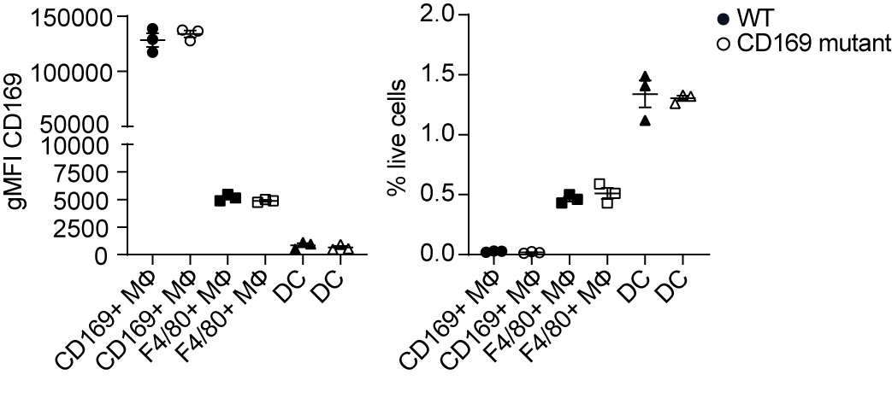
Supplementary Figure 1. CD169 receptor expression of macrophages and DCs in the spleen of WT and CD169 mutant mice, related to Fig. 2B and Fig. 3A. CD169 receptor geometric mean fluorescence intensity (gMFI) (A) and frequency of splenic cell subsets (B) determined by flow cytometry. The data are from one experiment representative of at least two experiments (n = 3). Each symbol represents one mouse. Error bars indicate mean ± SEM. *p < 0.05, **p < 0.01 (one-way ANOVA with Bonferroni’s multiple comparison test).

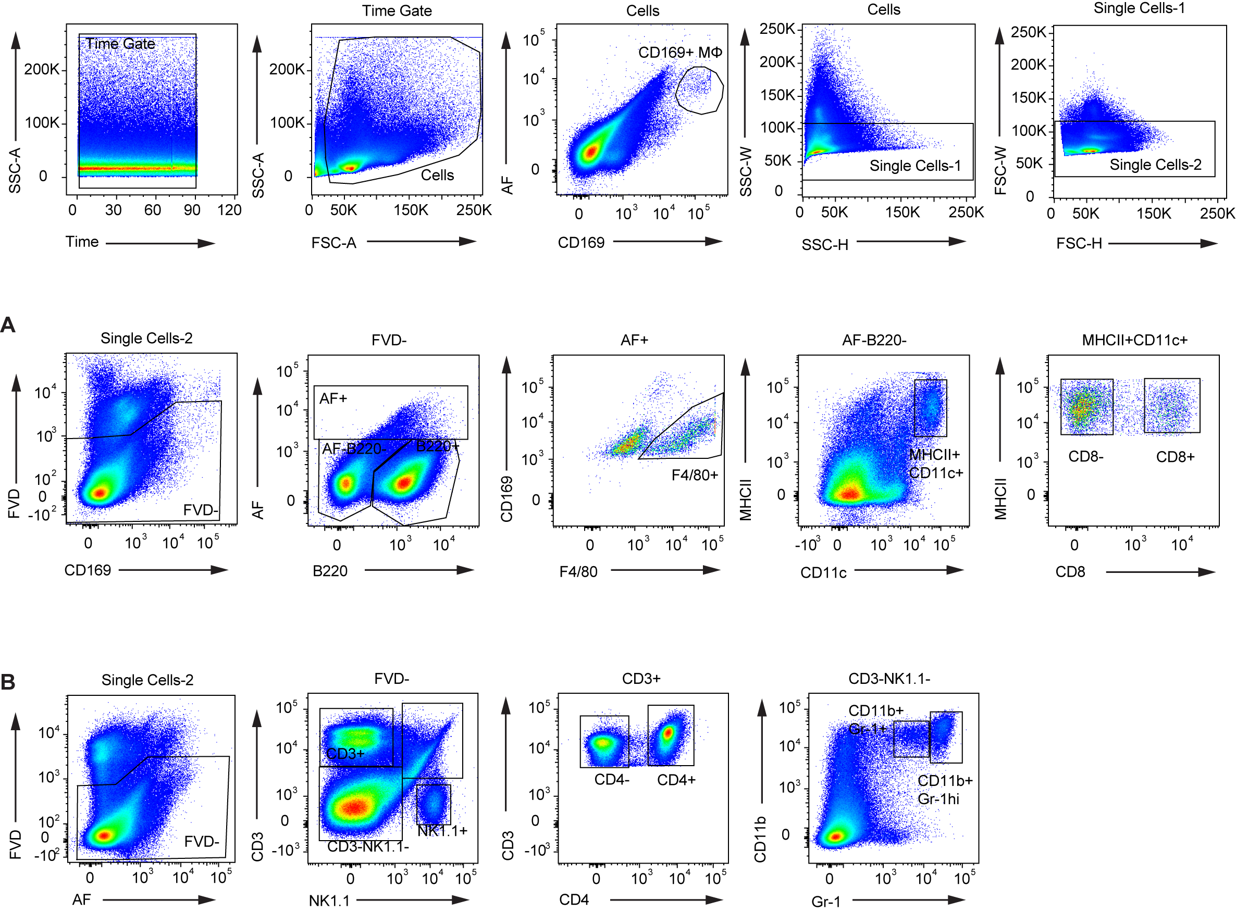
Supplementary Figure 2. Gating strategy of isolated splenocytes used to evaluate liposome binding, related to Fig. 2-3 and Fig. S3. Top panel shows initial gating to obtain single cell fraction. A. Gating strategy for DC/macrophage/B cell staining. B. Gating strategy for NK cell/T cell/monocyte staining.

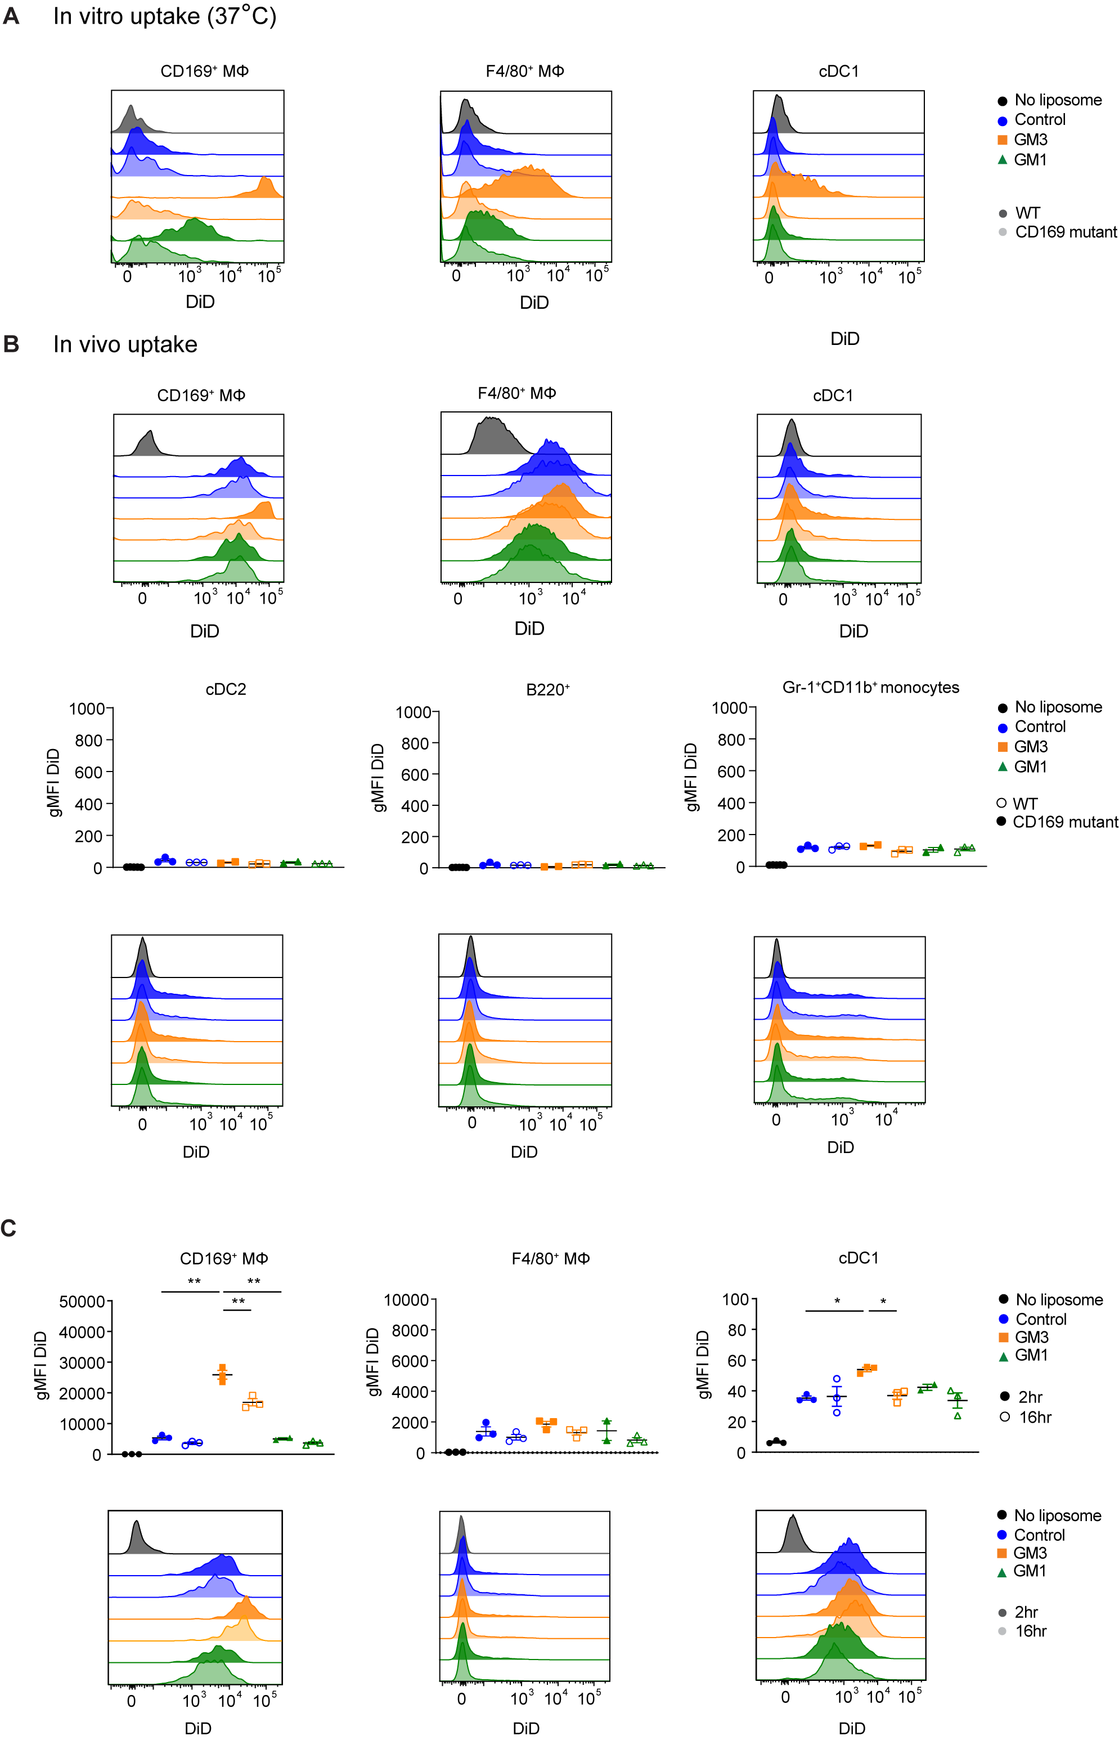
Supplementary Figure 3. GM3 liposomes are predominantly internalized by CD169⁺ macrophages in vitro and vivo, related to Fig. 2-3. A. In vitro uptake (37 °C) of liposomes by WT and CD169 mutant CD169⁺ macrophages, F4/80⁺ macrophages and cDC1 determined by flow cytometry. The graphs are representative histograms. B. In vivo uptake of liposomes by WT and CD169 mutant splenocytes determined at 2 h p.i. by flow cytometry. The graphs are representative histograms for CD169⁺ macrophages, F4/80⁺ macrophages and cDC1 and quantification of DiD gMFI with representative histograms for cDC2, B cells and monocytes. C. Uptake of liposomes by CD169⁺ macrophages, F4/80⁺ macrophages and cDC1 determined at 2 h and 16 h p.i. by flow cytometry. The data are from one experiment representative of three (A, n = 3), from one experiment representative of two experiments (B, n = 3) and from one experiment (B, n = 3). Each symbol represents one mouse. Error bars indicate mean ± SEM. *p < 0.05, **p < 0.01 (one-way ANOVA with Bonferroni’s multiple comparison test).

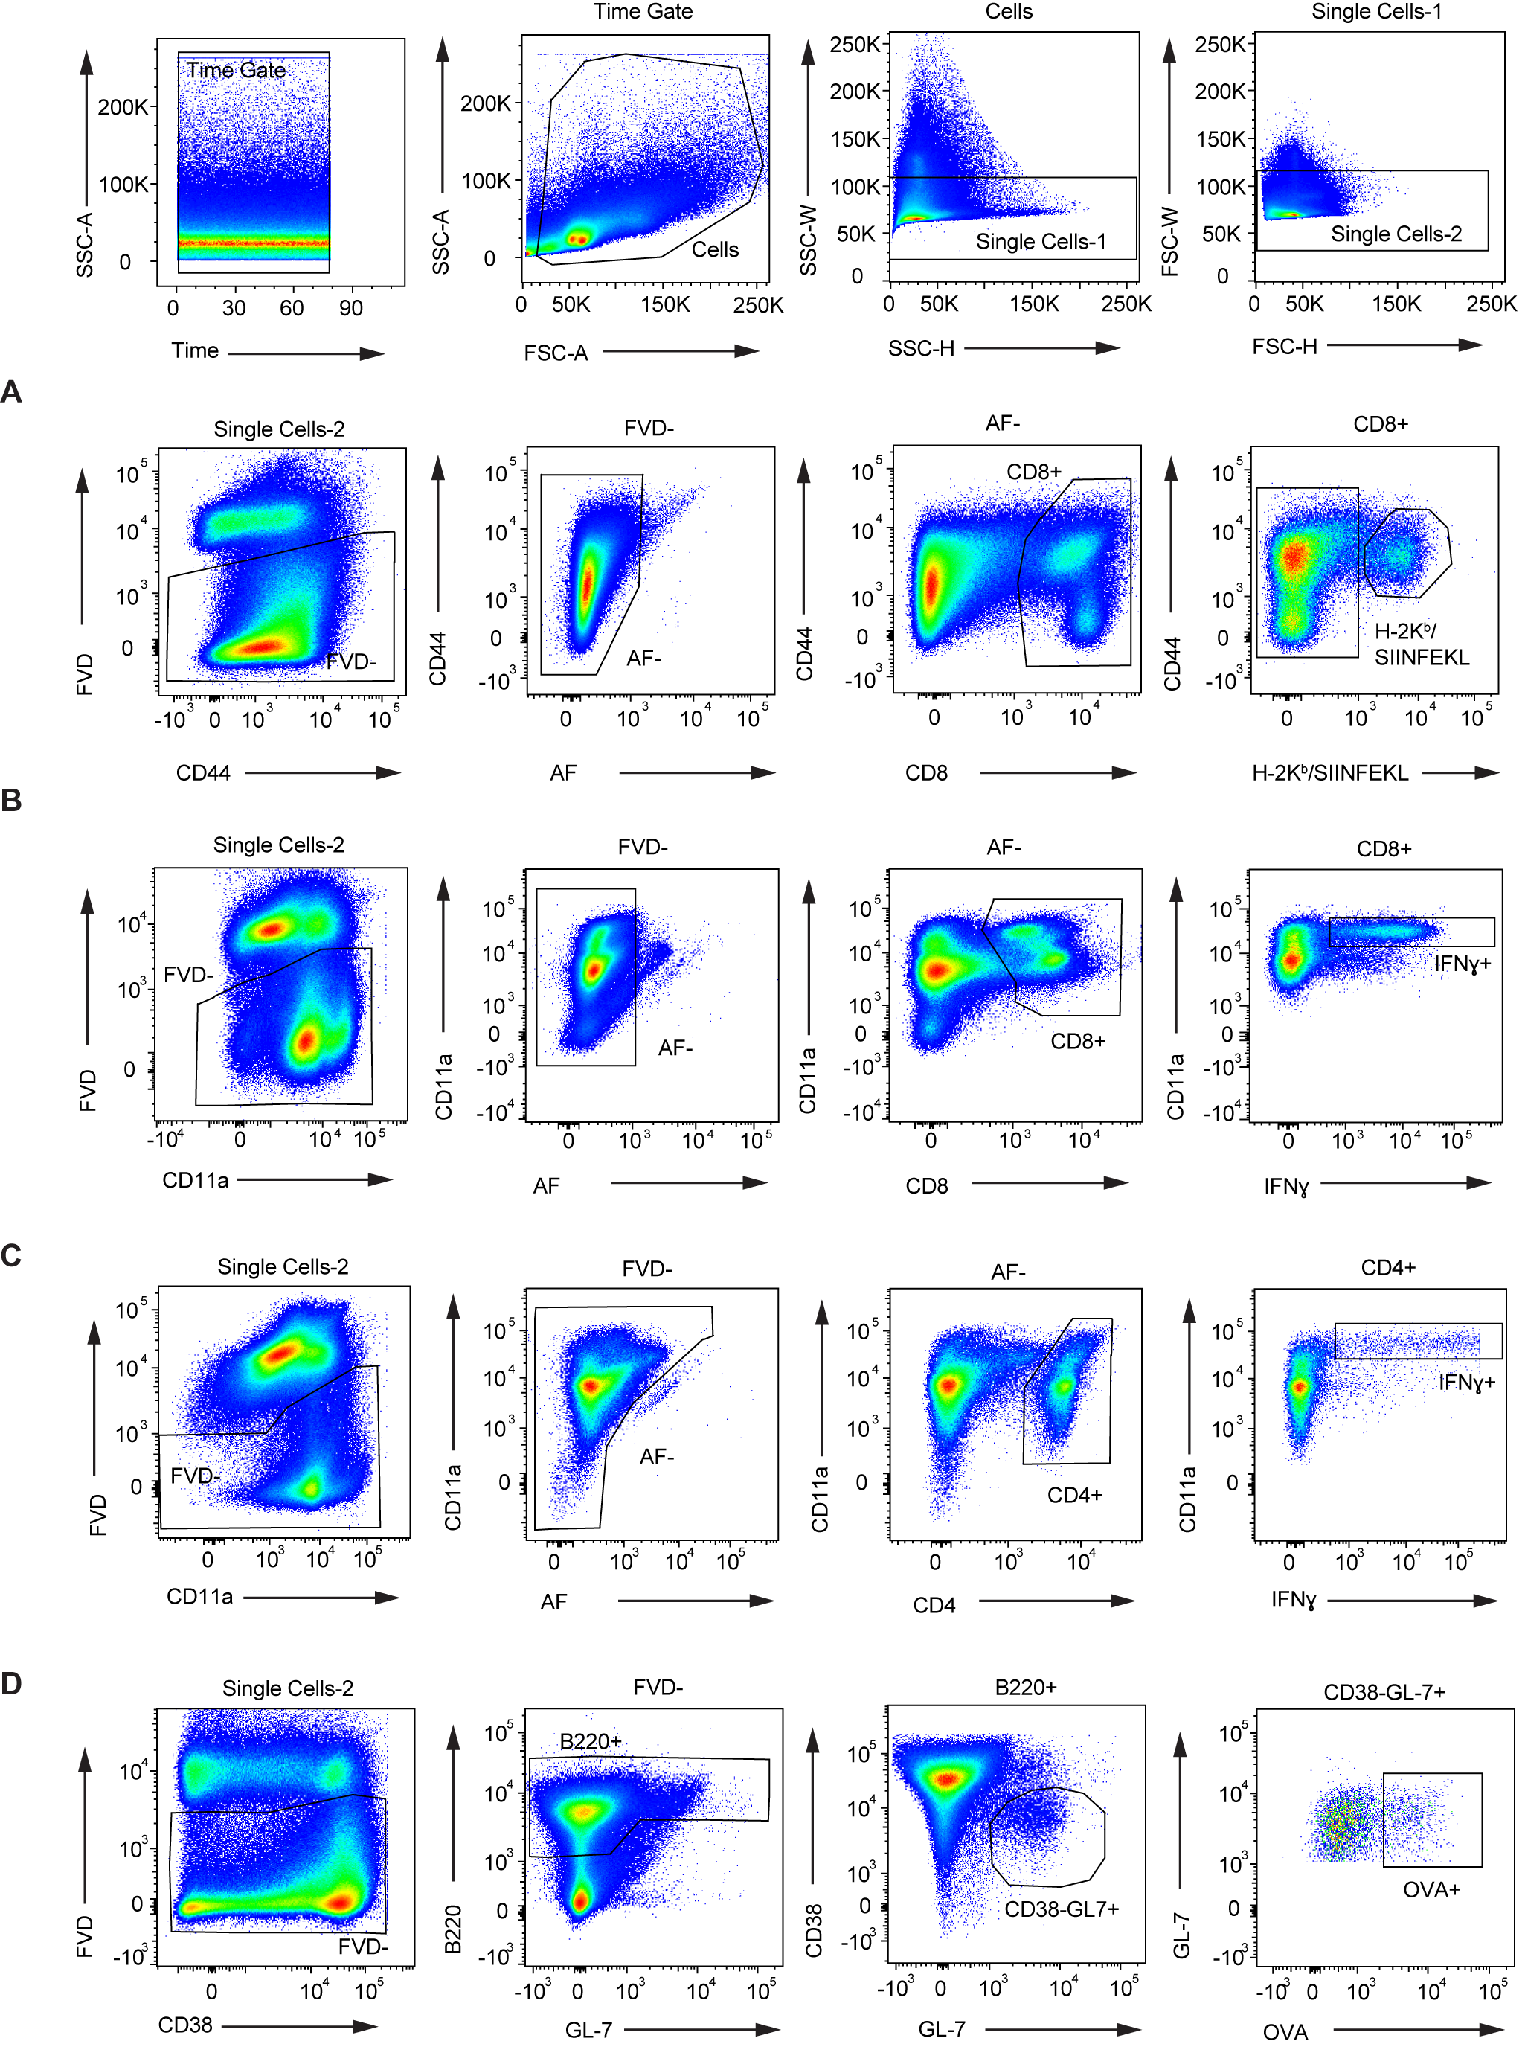
Supplementary Figure 4. Gating strategy of isolated splenocytes used to evaluate adaptive immune responses, related to Fig. 4-7. Top panel shows initial gating to obtain single cell fraction. A. Gating strategy for CD8⁺ T cell Tetramer staining. B Gating strategy for CD8⁺ T cell re-stimulation staining. C. Gating strategy for CD4⁺ T cell re-stimulation staining. D. Gating strategy for germinal center B cell staining.
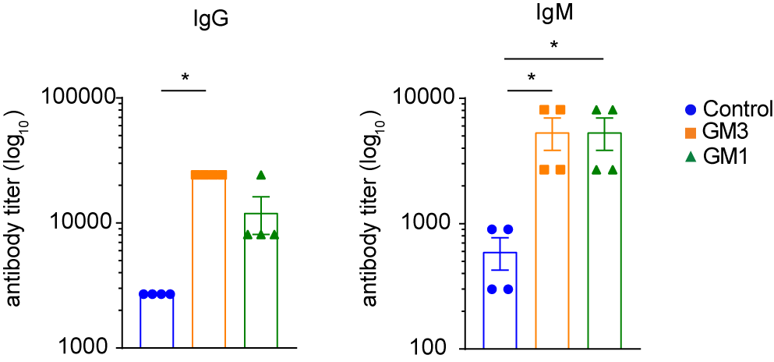

Supplementary Figure 5. GM3 liposomes induce potent B cell responses in presence of adjuvant, related to Fig. 4. Serum titer of OVA-specific IgG and IgM determined on day 7 p.i. by ELISA. The data are from one experiment, n = 4. Each symbol represents one mouse. Error bars indicate mean ± SEM. *p < 0.05, **p < 0.01 (one-way ANOVA with Bonferroni’s multiple comparison test).

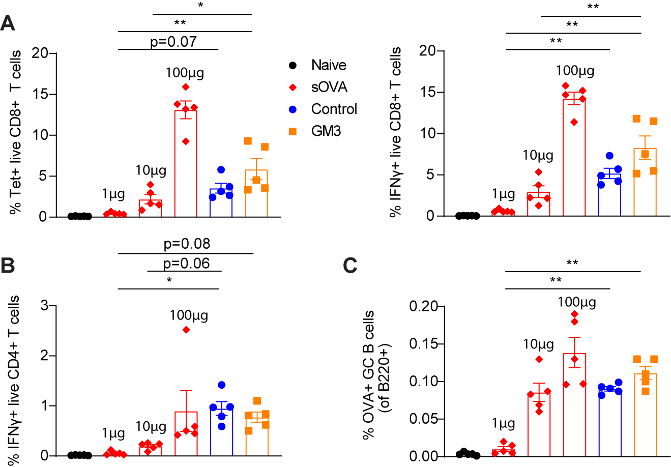
Supplementary Figure 6. Enhanced immune-activating potential of liposome-encapsulated antigen, related to Fig. 4. A. Percentage of H-2K^{b}-SIINFEKL-tetramer⁺ CD8⁺ T cells and percentage of OVA-specific IFNγ-producing CD8⁺ T cells. B. Percentage of OVA-specific IFNγ-producing CD4⁺ T cells after in vitro re-challenge. C. Percentage of OVA-specific germinal center B cells. Immune responses in the spleen determined on day 7 by flow cytometry. The data are from one experiment, n = 5. Each symbol represents one mouse. Error bars indicate mean ± SEM. *p < 0.05, **p < 0.01 (one-way ANOVA with Bonferroni’s multiple comparison test).

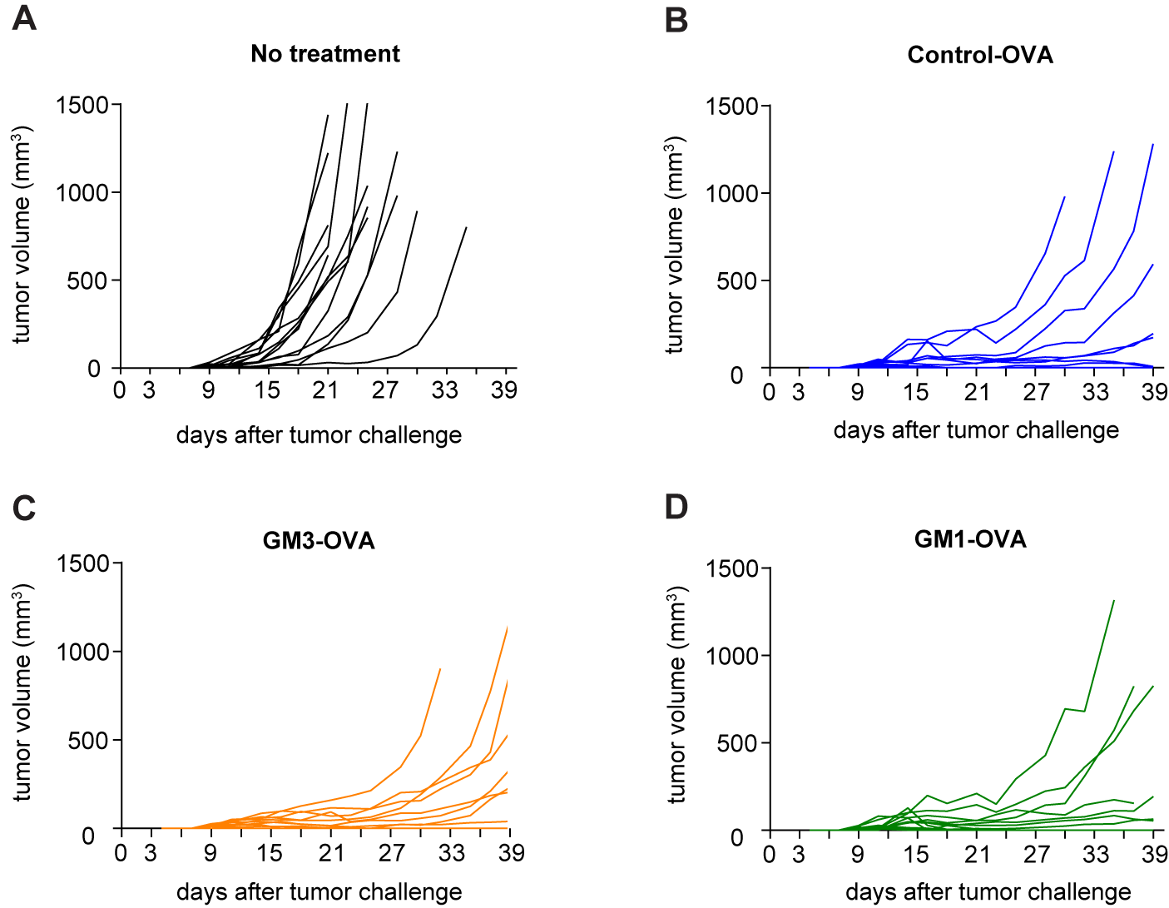
Supplementary Figure 7. Targeting and non-targeting liposomes delay tumor outgrowth in B16-OVA tumor model, related to Fig. 5. A-D Tumor growth curves determined by size measurements performed three times per week until day 39 using a caliper. Each line represents individual mouse.

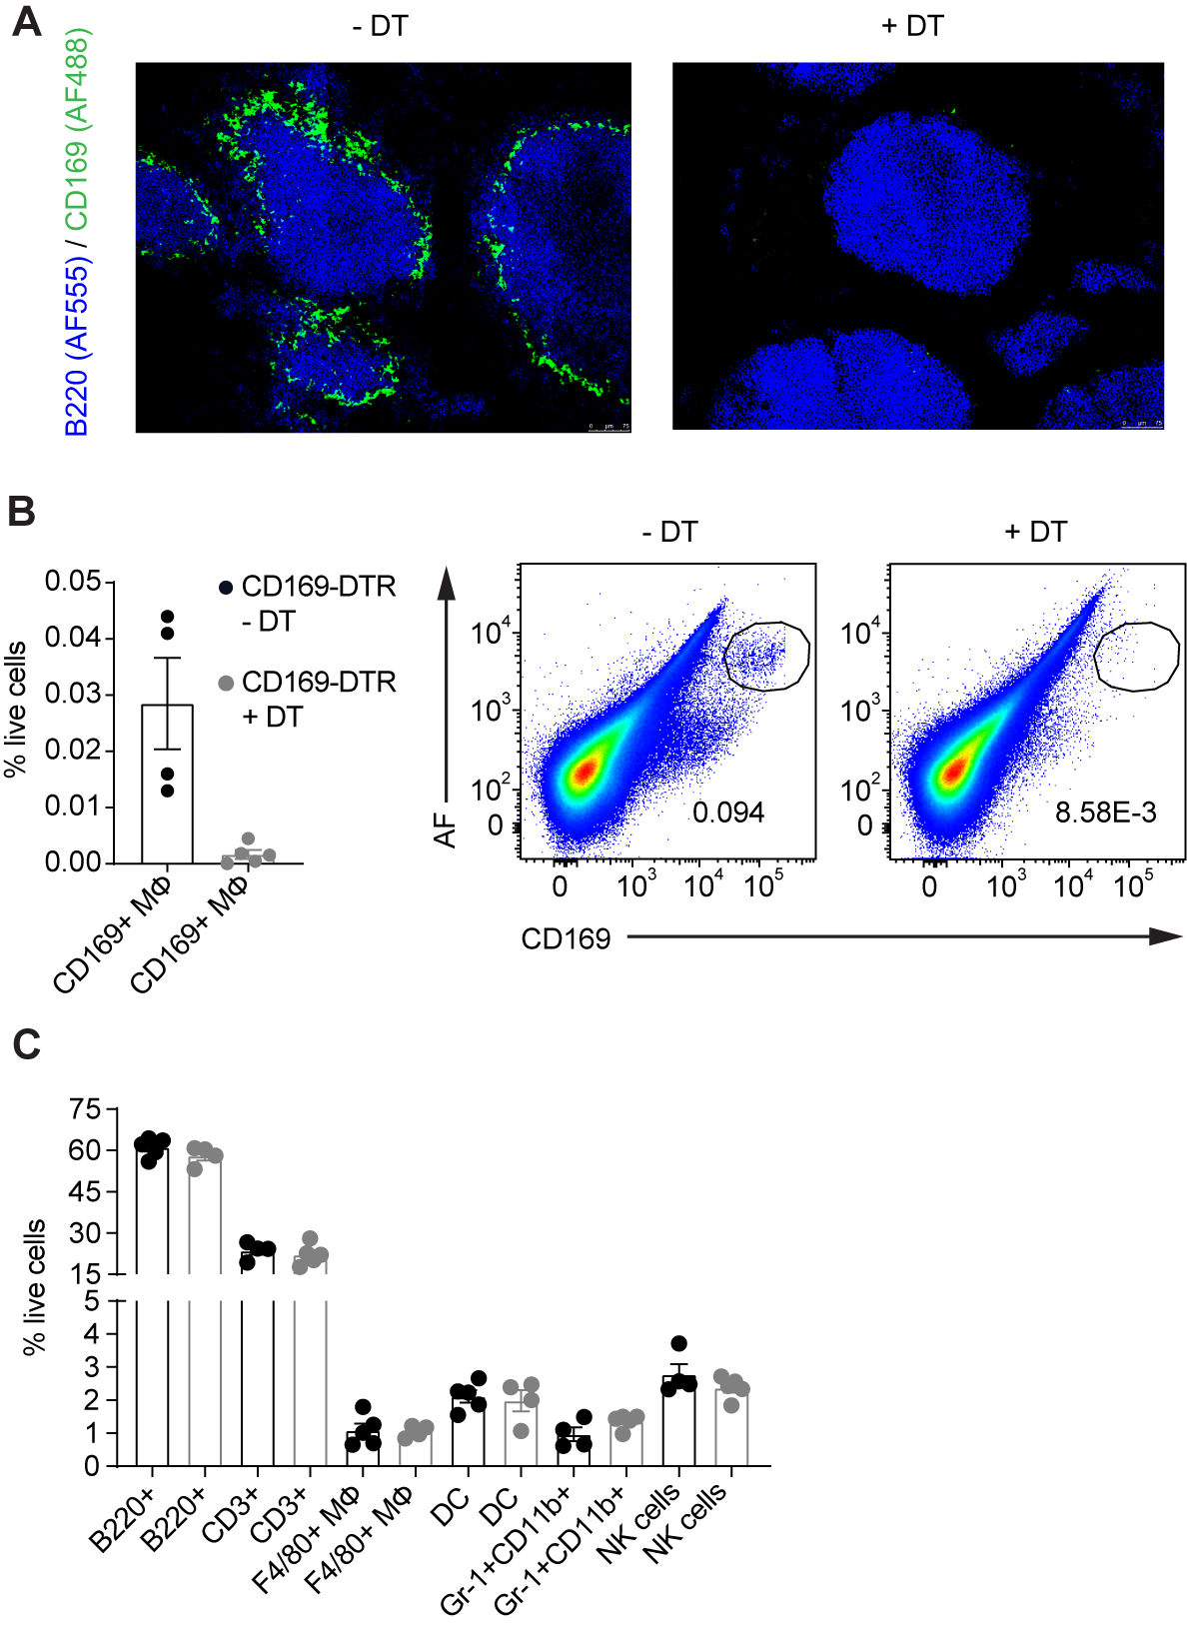
Supplementary Figure 8. Depletion of CD169-expressing cells in the spleen of DT-treated CD169-DTR mice, related to Fig. 6. A. Microscopic analysis. B. Quantification of CD169⁺ macrophages determined by flow cytometry (left). Representative flow cytometry plots used for identification of CD169⁺ macrophages (right). C. Frequency of splenic cell subsets determined by flow cytometry. The data are from one experiment, n = 5. Each symbol represents one mouse. Error bars indicate mean ± SEM. *p < 0.05, **p < 0.01, (one-way ANOVA with Bonferroni’s multiple comparison test).

