Supplementary Information

Basal oxidation of conserved cysteines modulates cardiac titin stiffness and dynamics

Elías Herrero-Galán^{1,¶,*}, Inés Martínez-Martín^{1,¶}, Cristina Sánchez-González¹, Natalia Vicente¹, Elena Bonzón-Kulichenko^{1,2}, Enrique Calvo^{1,2}, Carmen Suay-Corredera¹, Maria Rosaria Pricolo¹, Ángel Fernández-Trasancos¹, Diana Velázquez-Carreras¹, Claudio Badía Careaga¹, Mahmoud Abdellatif³, Simon Sedej^{3,4,5}, Peter P. Rainer^{3,5}, David Giganti⁶, Raúl Pérez-Jiménez^{7,8}, Jesús Vázquez^{1,2}, Jorge Alegre-Cebollada^{1,*}

- Supplementary Files S1-S3 (separate files)
- Supplementary Figures S1-S4 (this document)
- Supplementary Notes S1-S3 (this document)
- Supplementary Tables S1-S6 (this document)
- Supplementary References (this document)

¶ EHG and IMM contributed equally and are joint first authors.
*EHG and JAC are co-corresponding authors: elias.herrero@cnic.es; jalegre@cnic.es (Twitter: @AlegreCebollada)
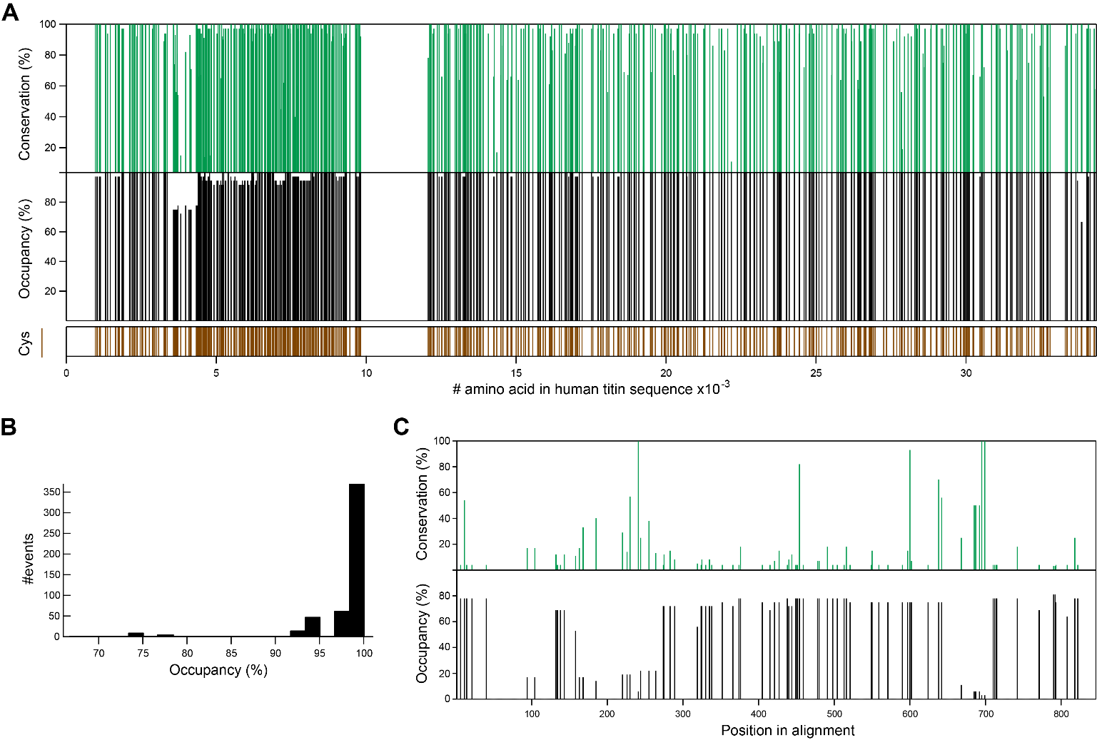
Supplementary Figure S1. Evolutionary conservation of titin cysteines. A: Percentage of conservation (top, green) and occupancy (middle, black) of every cysteine in human titin (bottom, brown, Uniprot Q8WZ42-1) in a sequence alignment including titins from 36 species (Supplementary File S1). B: Distribution of occupancy of all cysteines in human titin. C: Percentage of conservation (top, green) and occupancy (bottom, black) of every N2Bus cysteine in the interspecies alignment.

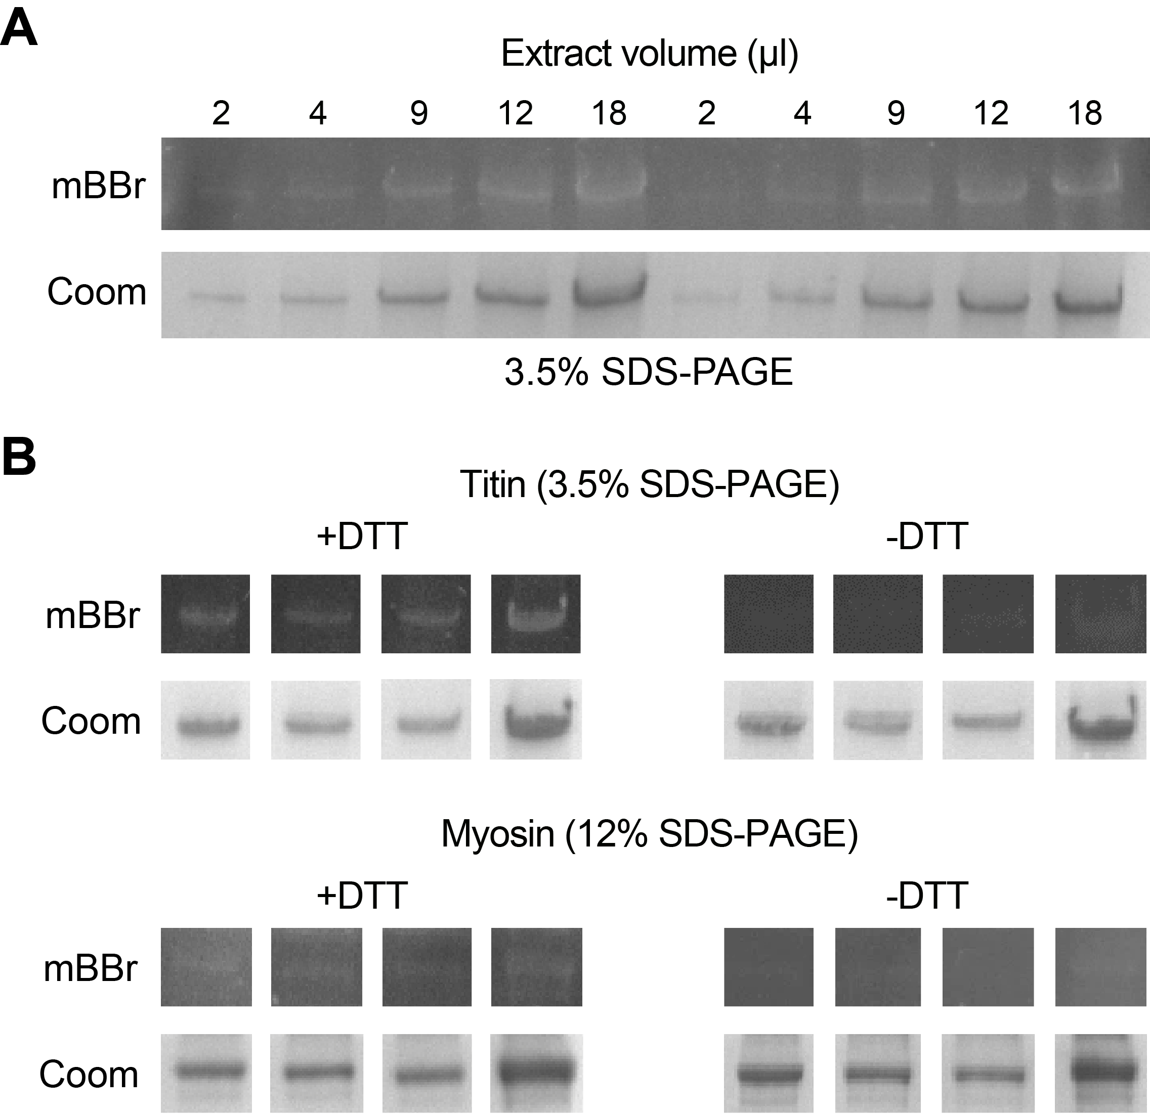
Supplementary Figure S2. mBBr and Coomassie bands used for quantification of reversibly oxidized thiols. A: Linearity of mBBr cysteine oxidation signal. mBBr and Coomassie (Coom) stainings of titin bands resulting from loading different volumes of the same mouse heart extract in a 3.5% SDS-PAGE gel. Quantification is shown in Figure 2B-D. B: mBBr and Coomassie bands used for quantification of reversibly oxidized thiols in titin and myosin. Both gels treated with DTT (+DTT) and controls in which no DTT was added prior to incubation with mBBr to account for non-specific fluorescence (-DTT) are shown to the left and to the right, respectively, together with their corresponding Coomassie stainings (Coom). Brightness and contrast adjustments to improve visualization of mBBr bands in this figure were applied to the entire gel in each case. Quantifications in Figure 2 were performed from unprocessed images, subtracting the -DTT signals from +DTT ones.
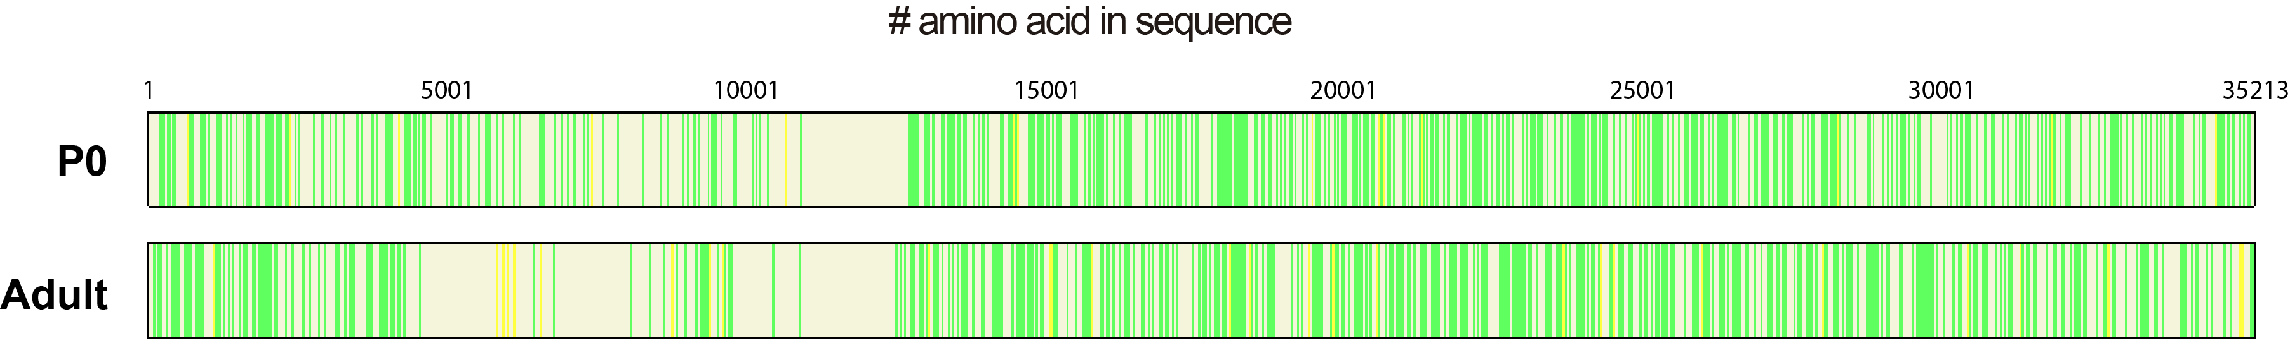
Supplementary Figure S3. Murine P0 samples result in better coverage of titin cysteines than adult samples. Identified peptides belonging to murine titin (reference sequence Uniprot A2ASS6-1, which codes for the long N2BA titin isoform) in P0 (top; also presented in Figure 3B) and adult (bottom) murine samples when the MS/MS spectra are searched against a mouse proteome database containing common contaminants (cRAP). (n=3 mouse hearts per category; yellow and green, peptides detected with FDR<5% and 1%, respectively). Note the higher coverage of the cysteine-rich region 4435-12715 in P0 samples, in agreement with the higher proportion of N2BA isoform in neonatal samples[1, 2].
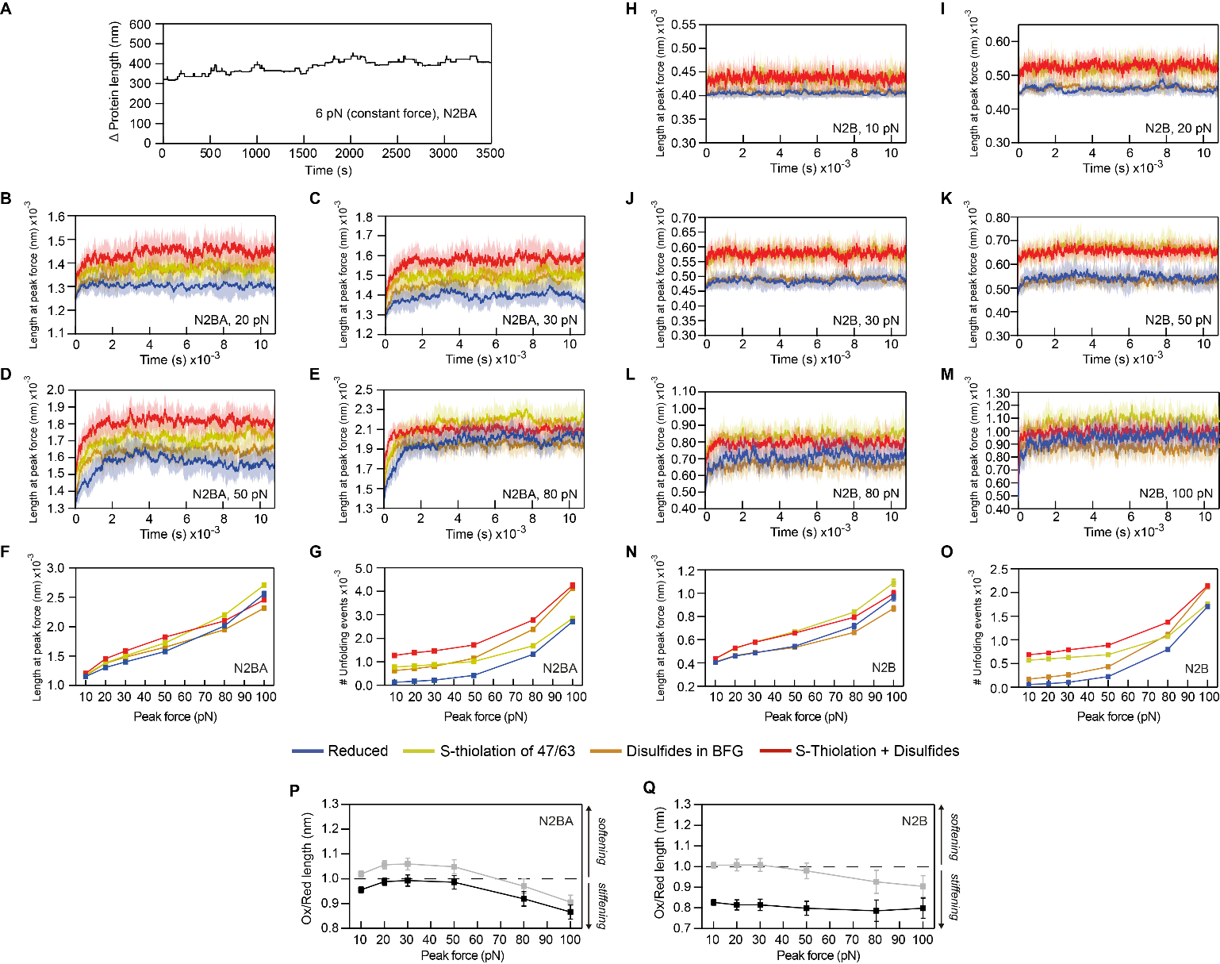Supplementary Figure S4. Monte Carlo simulations. A: Monte Carlo simulations in which a virtual I-band titin is pulled at a constant force of 6 pN. Results are qualitatively similar to experimental observations [3]. B-E: Length of N2BA titin at peak force during simulations in which titin is reduced, or oxidized by disulfides, S-thiolation adducts or both (color code at the bottom of the figure; peak forces are shown in the insets). For subsequent analyses, we considered times longer than 1 hour, when the length of titin fluctuates around steady state values. F: Length of N2BA titin at different peak forces. G: Cumulative number of unfolding events in simulations of N2BA titin at different peak forces. H-M: Length of N2B titin at peak force during simulations in which titin is reduced, or oxidized by disulfides, S-thiolation adducts or both (color code at the bottom of the figure; peak forces are shown in the insets). For subsequent analyses, we considered times longer than 1 hour. N: Length of N2B titin at different peak forces. O: Cumulative number of unfolding events in simulations of N2B titin at different peak forces. P: Ratio of oxidized vs reduced N2BA titin length at different peak forces considering (black) or not (grey, same data as in Figure 4E) that the N2Bus region contains disulfides. Q: Ratio of CysBFG-disulfide-containing vs reduced N2B titin length at different peak forces considering (black) or not (grey, same data as in Figure 4G) that the N2Bus region contains disulfides. In panels B-G, n = 10 simulations, and error bars or shaded areas represent SD.

Supplementary Note S1. Titin model used for Monte Carlo simulations
Titin length as a function of end-to-end force was modeled on the basis of the Freely Jointed Chain (FJC) model of polymer elasticity [4], which was applied independently to Ig domains and the random coil regions of the protein. The total length of titin was then calculated by adding up the contribution of the different protein regions. The Freely Jointed Chain model calculates molecular extension as a result of end-to-end force following
$$Length_{FJC}\left(F\right)=L_{C}\left[coth\left(\frac{F∙L_{k}}{k_{B}∙T}\right)-\frac{k_{B}∙T}{F∙L_{k}}\right]$$
where F is the applied force, L_{c} is the contour length, L_{k} is the Kuhn length, T is the absolute temperature and k_{B} is the Boltzmann constant.
All folding and unfolding events were considered to depend on the applied force according to Bell’s model [5]. Disulfide isomerization reactions were modelled in a similar way, but with the additional restriction that they can only take place in the unfolded state [1]. The probability of unfolding, refolding or isomerization events was calculated according to
$$P_{a→b}=N_{a}*dt*α_{0}*e^{ \frac{F Δx}{k_{B}T}}$$
where a and b are 2 possible states of the domain, N_{a} is the number of domains in the state a, dt is the Monte Carlo simulation step, α₀ is the transition rate at zero force and ∆x is the distance to the transition state. Definition of titin regions and parameters used in the simulations can be found in Supplementary Tables S1-S4. Transition rates are in the range of those previously determined for specific segments of reduced, disulfide-containing and S-glutathionylated titin domains [1, 6, 7], and were further adjusted so that simulations reproduce the folding/unfolding dynamics of native Ig domains stretched at low forces [3]. We also considered that modifications affect the maximum folding capacity of the domains [6] (Supplementary Table S5).

Supplementary Note S2. Sequence identification codes for the analysis of interspecies conservation of titin residues
A5X6X5 | Danio rerio (Zebrafish)
XP_025759277 | Oreochromis niloticus (Tilapia)
XP_031748776 | Xenopus tropicalis (Western clawed frog)
XP_025018685 | Python bivittatus (Burmese python)
XP_016851936 | Anolis carolinensis (American chameleon)
XP_025038559 | Pelodiscus sinensis (Chinese softshell turtle)
XP_019335759 | Alligator mississippiensis (American alligator)
M7AMC7 | Chelonia mydas (Green sea turtle)
XP_032605298 | Taeniopygia guttata (Zebrafinch)
XP_027317399 | Anas platyrhynchos (Wild duck)
XP_031410147 | Meleagris gallopavo (Wild turkey)
XP_027642041 | Falco peregrinus (Peregrine falcon)
XP_016155182 | Ficedula albicollis (Collared flycatcher)
XP_028928092 | Ornithorhynchus anatinus (Platypus)
XP_031816250 | Sarcophilus harrisii (Tasmanian devil)
XP_023398816 | Loxodonta africana (African elephant)
XP_004375522 | Trichechus manatus (West Indian manatee)
L5K2L4 | Pteropus alecto (Black flying fox)
G1P5X9 | Myotis lucifugus (Little brown bat)
XP_023115277 | Felis catus (Cat)
XP_022270508 | Canis lupus (Dog)
XP_019654795 | Ailuropoda melanoleuca (Giant panda)
A0A5F5PSR4 | Equus caballus (Horse)
XP_004267426 | Orcinus orca (Orca)
DAA32835 | Bos taurus (Cattle)
XP_027820594 | Ovis aries (Sheep)
XP_017198704 | Oryctolagus cuniculus (Rabbit)
G3HAC6 | Cricetulus griseus (Chinese hamster)
A2ASS6 | Mus musculus (Mouse)
XP_017456475 | Rattus norvegicus (Brown Rat)
XP_027628916 | Tupaia chinensis (Chinese tree shrew)
A0A5F4VS40 | Callithrix jacchus (Marmoset)
A0A2J8VRG3 | Pongo abelii (Orangutan)
XP_030864472 | Gorilla gorilla (Gorilla)
A0A2J8PRF8 | Pan troglodytes (Chimpanzee)
Q8WZ42 | Homo sapiens (Human)

Supplementary Note S3. Alignment of the 144 murine titin Ig domains in the canonical sequence Uniprot A2ASS6. The position of the first amino acid of each domain is indicated at the beginning of each row and cysteines are highlighted in yellow. The position of the structurally conserved cysteines is indicated on top of the alignment according to the nomenclature in the main text. An equivalent alignment for human titin has been published [1].
CysG
▼

CysF
▼

Cys63
▼

Cys47
▼

CysB
▼

00006 ----------------PMFT---QPLQ-S-VVVLEGS----TATFE-AH--VSGSPV-PEVSWFRDGQ--V-IS-TSTLP----------------------------GVQISF---S--DGRARLMIPAVTKANSGRYSLRATNGSGQA-TSTAELLVT--
00104 ----------------PNFS---QRLQ-S-MTVRQGS----QVRLQ-VR--VTGIPT-PVVKFYRDGA--E-IQ-SS--L----------------------------DFQISQ---E--GDLYSLLIAEAYPEDSGTYSVNATNSVGRA-TSTAELV----
00946 ----------------PTLV---SGLK-N-VTVIEGE----SVTLE-CH--ISGYPS-PKVTWYREDY--Q-IE-SS--I----------------------------DFQITF---Q--GGIARLMIREAFAEDSGRFTCSAVNEAGTV-STSCYLA----
01084 ----------------PFFI---SKPV-V-QKLVEGG----SVVFE-CQ--IGGNPK-PHVYWKKSGV--P-LT-TG-----------------------Y-------RYKVSY-NK-Q-TGECRLVISMTFADDAGEYTIVIRNKHGET-SASASLL----
01293 ----------------SGFD---IRIK-N-YRILEGM----GVTFH-CK--MSGYPL-PKIAWYKDGK--R-IR-HG--E----------------------------RYQMDF---LQ-DGRASLRIPVVLPEDEGIYTAFASNIKGNA-ICSGKLYVE--
01463 ----------------PVFV---LKPA-S-FKCLEGQ----TARFD-LK--VVGRPM-PETFWFHNGQ--Q-IV-ND--Y----------------------------T--HKVVIK-E-DGTQSLIIVPASPSDSGEWTVVAQNRAGKS-TISVTLT----
01562 ----------------PAFVEKL-----KNVNIKEGS----RLEMK-VR--ATGNPN-PDIVWLKNSD--I-IV--P--H--------------------K-----YPR--IRI-E-GT-RGEAALKIDSIISQDSAWYTATAINKAGRD-TTRCKVN----
01709 ----------------PFFK---KKLT-S-LRLKRFG----PAHFE-CRLTPIGDPT-MVVEWLHDGK--P-LE-AA--N----------------------------R--LRM-IN-E-FGYCSLDYGAAYSRDSGVITCRATNKYGTD-HTSATLI----
01847 ----------------PDIV---LFPE-P-VRVLEGE----TARFR-CR--VTGYPQ-PKVNWYLNGQ--L-IR-KS--K----------------------------R--F--RVR-Y-DGIHYLDIVDCKSYDTGEVKVTAENPEGVT-EHKVKLE----
02084 ----------------PKIF---ERIQ-S-QTVGQGS----DAHFR-VR--VVGKPD-PECEWYKNGV--K-IE-RS--D----------------------------R--IYWYWP-E-DNVCELVIRDVTAEDSASIMVKAINIAGET-SSHAFLL----
02177 -------------KQLITFT---QELQ-D-VVAKEKD---TMATFE-CE--TSEPFI--KVKWYKDGI--E-VH-AG--D----------------------------K--YRM-H-SD-RKVHFLSVLTIDTSDAEDYSCVLVEDENIK--TTAKLIV---
02270 -------------GAVVEFV---KELQ-D-IEVPESY----SGELE-CI--ISPENI--EGKWYHNDV--E-LK-SN--G----------------------------K--YSI-T-SR-RGRQNLTVKDVTKEDQGEYSFVVDGKK-----TTCKLK----
02359 -------------PRPIAIL---QGLS-D-QKVCEGD----IVQLE-VK--VSLENV--EGVWMKDGQ--E-VQ-HS--D----------------------------R--VHI-V-ID-KQSHMLLIEDMTKEDAGNYSFTIPALGLST-SGNVSVY----
02436 -PALGLSTSGNVSVYSVDVI---TPLK-D-VNVIEGT----KAVLE-CK--VSVPDV-TSVKWYLNDE--Q-IK-PD--D----------------------------R--VQS-I-VK-GTKQRLVINRTHASDEGPYKLMVGRVE-----TSCNLS----
02626 ----------------GAIS---TPLT-D-QTVAESQ----EAVFE-CE--VANPES--EGEWLKDGK--H-LA-LS--N----------------------------N--FRG-E-SD-GHKRRLVIAAAKLDDAGEYTYKVATSK-----TSAKLK----
02886 --------------ETLHIT---KTMK-S-IEVPETK----AASFE-CE--VSHFNV--PSMWLKNGV--E-IE-MS--E----------------------------K--FKI-V-VQ-GKLHQLIIMNTSTEDSAEYTFVCGNDQ-----VSATLT----
03064 ----------------IEFR---KHIK-D-IKVLEKK----RAMFE-CE--VSEPDI--TVQWMKDGQ--E-LQ-IA--D----------------------------R--IKI-Q-KE-KYVHRLLIPSTRMSDAGKYTVVAGGNMSTA--NLF-------
03245 ----------------PQVL---QELQ-P-VTVQSGK----PARFC-AV--ISGRPQ-PKISWYKEEQ--L-LS-TG--F----------------------------K--CKF-LH-D-GQEYTLLLIEAFPEDAAVYTCEAKNDYGVA-TTSASLS----
03350 ---------------PPAIV---TPLQ-D-TVTSEGR----PARFQ-CQ--VSGTDL--KVSWYCKDK--K-IK-PS--R----------------------------F--FRM-TQ-F-EDTYQLEIAEAYPEDEGTYAFVANNAVGQV-SSTATLR----
03509 ----------------PVFI---REIS-D-VEISVED----VAKLS-VT--VTGCPK-PKIQWFFNGM--L-LT-PS--A----------------------------DYKFVF---D--GDTHSLIILFTRFQDEGEYTCLASNEYGKA-VCSAHLRIS--
03625 ----------------PYFF---KELK-P-VHCGPGI----PAVFE-YS--VHGEPA-PTVLWFKEDM--P-LY-TS--V----------------------------C--YTI-IH-SPDGSGTFIVNDPQRGDSGLYLCKAQNLWGES-TCAAELLVL--
04251 ----------------PAVL---KHLV-D-TISEEGD----TVHLT-SS--ISNAK---EVHWYFKGN--L-VP-SD--G----------------------------K--FKC-LK-E-QNAYTLVIEAVKTEDEGEYVCEASNDSGKA-KTSAKLT----
04344 ----------------PVIK---RRIE-P-LEVALGH----LAKFT-CE--IQGAPN-VRFQWFKAGR--E-IY-ES--D----------------------------KCSIRS---S--NYVSSLEILRTQVVDCGEYTCKASNEYGSV-SCTATLT----
04439 ----------------PTFL---SRPK-A-LTTFVGK----AAKFL-CT--VSGTPV-IEIIWQKDGA--A-LS-PS--P----------------------------DCRVTD---A--DNKHSLELSNLTVQDRGIYSCKASNKFGAD-ICQAELT----
04532 ----------------PHFI---KELE-A-VQSAINK----KIHLE-CQ--VDEDRK-VTITWSKDGQ--K-LP-AG--K----------------------------DYKIYF---E--DKIASLEIPLAKLKDSGTYTCTASNEAGSS-SSSAAVA----
04625 ----------------PSFV---KKVD-PSYLMLPGE----SARLH-CK--LKGSPV-IQVTWFKNNK--E-LS-ES--N----------------------------TVRMSF---V--NSEAILDITDVKVDDSGTYSCEATNDVGSD-SCSTEVVIK--
04719 ----------------PSFI---KTLE-P-ADIVRGA----NALLQ-CE--IAGTGP-FEVNWFKDKK--Q-IR-SS--K----------------------------KYRLFT---Q--KTFVYLEISSFNSADVGDYECVVANEVGKC-GCVATHL----
04812 ----------------PTFV---KKVD-D-FTALAGQ----TVTLQ-AA--VRGSEP-ISVMWMKGQE--V-IK-ED--G----------------------------KIKMSF---S--NGVAVLTIPDVQISLGGKYTCLAENEAGSQ-TSVG-------
04904 ---------------PAKII---ERAE-L-IQVTAGD----PATLE-YT--VSGTPE-LKPKWYKDGR--P-LV-AS--K----------------------------KYRISF---K--NNIAQLKFYSAELHDSGQYTFEISNEVGSS-SCETTFT----
05001 ----------------PLFT---KPLR-N-VDSVVGG----ACRLD-CK--IAGSLP-MRVSWFKDGK--E-LT-AS--D----------------------------RYQIAF---V--EGTASLEISRVDMNDAGNFTCRATNSVGSK-DSSGALI----
05094 ----------------PSFV---TKPG-S-RDVLPGS----AVCLK-SA--FQGSAP-LTIKWFKGDK--E-LV-SG--G----------------------------SCYITK---E--TSESSLELYAVKTSDSGTYTCKVSNVAGSV-ECSADLF----
05186 ---------------PATFI---EKLE-PSQLLKKGD----GTQLA-CK--VTGTPP-IKITWFANDR--E-LR-ES--S----------------------------KHKMSF---A--ESTAVLRLTDVAIEDSGEYMCEAQNEAGSD-HCTGIVI----
05281 ----------------PYFT---KEFK-S-IEVLKEY----DVMLL-AE--VAGTPP-FEITWFKDNT--T-LR-SG--R----------------------------KYKTFL---Q--DQLVSLQVLKFVAADAGEYQCRVTNEVGSS-TCSARVT----
05374 ----------------PSFI---KKIE-A-TSSLRGG----TAAFQ-AT--LKGSLP-ITVTWLKDND--E-IT-ED--D----------------------------NIRMTF---E--NNVASLYLSGIEVKHDGKYVCQAKNDAGIQ-RCSALLS----
05466 ---------------PATIM---EEAV-S-IDVTQGD----PATLQ-VK--FSGTKE-ISAKWFKDGQ--E-LT-LG--P----------------------------KYKISV---T--DTVSILKIISTEKKDSGEYTFEVQNDVGRS-SCKASIN----
05563 ----------------PSFT---KKLR-K-MDSIKGS----FIDLE-CI--VAGSHP-ISIQWFKDDQ--E-IS-AS--D----------------------------KHKFSF---H--DNTAFLEISQLEGTDSGTYTCSATNKAGHS-QCSGHLT----
05656 ----------------PYFV---EKPQ-S-QDVNPGT----RVQLK-AL--VGGTAP-MTIKWFKDNK--E-LH-PG--A----------------------------ARSVWK---D--DTSTILELFSAKAADSGTYICQLSNDVGTT-SSKATIF----
05749 ----------------PQFI---KKPS-PVLVLRNGQ----STTFE-CQ--VTGTPE-IRVSWYLDGN--E-IT-DL--R----------------------------KYGISF---V--DGLATFQISNARVENSGTYVCEARNDAGTA-SCSIELK----
05842 ---------------PPIFI---RELE-P-VEVVKDS----DVELE-CE--VMGTTP-FEVTWLKNNK--E-IR-SG--K----------------------------KYTMSE---K--MSVFYLHITKCDPSDVGEYQCIIANEGGSC-ACSARVA----
05936 ----------------PSFI---KKIE-N-VTTVLKS----SATFQ-ST--VAGSPP-ISITWLKDDQ--I-LE-EN--D----------------------------NVHISF---E--DSVATLQVRSVDNGHSGRYTCQAKNESGIE-RCYAFLL----
06028 ---------------PAQII---EKAK-S-VDVTEKD----PVTLE-CV--VAGTPE-LKVKWLKDGK--Q-IV-PS--R----------------------------YFSMSF---E--NNVASFRIQSVMKQDSGQYTFKVENDFGSS-SCDAYLR----
06125 ----------------PSFT---KKLT-K-MDKVLGS----SIHME-CK--VSGSLP-ISAQWFKDGK--E-IS-TS--A----------------------------KYRLVC---H--ENTVSLEVSNLELEDTANYTCKVSNVAGDN-ACSGILT----
06218 ----------------PSFL---VKPE-R-QQAIPDS----TVEFK-AV--LKGTPP-FKIKWLKDDV--E-LV-SG--P----------------------------KCFIGL---E--GSTSFLNLYSVDSSKTGQYTCQVTNDVGSD-SCTTMLLVT--
06311 ----------------PKFV---KKLE-ASKIIKAGD----SARLE-CK--ITGSPE-IQVVWYRNEH--E-LT-AS--D----------------------------KYQMTF---I--DSVAVIQMNSLGTEDSGDFICEAQNPAGST-SCSTKVIV---
06405 ----------------PVFS---SFPP-I-VETLKNT----EVSLE-CE--LSGTPP-FEVVWYKDKR--Q-LR-SS--K----------------------------KYKVAS---K--NFHASIHILNVESTDIGEYHCKAQNEVGSD-ACVCAVK----
06498 ----------------PKFI---SKLN-S-LTVVAGE----PAELQ-AS--IEGAQP-ISVQWLKEKE--EVIR-ES--E----------------------------NIRISF---V--NNVATLQFAKVEPANAGKYICQVKNDGGVR-ENMATLT----
06591 ---------------PAVII---EKAG-S-MTVTVGE----TCALE-CK--VAGTPE-LSVEWYKDGK--L-LT-SS--Q----------------------------KHKFSF---Y--NKISSLKILSVEKEDAGTYTFQVQNNVGKS-SCTAVVDVS--
06688 ----------------PSFT---RRLK-D-TGGVLGT----SCILE-CK--VAGSSP-ISIAWFHEKT--K-IV-SG--A----------------------------KYQTTF---S--DNVCTLQLNSLDSSDMGSYTCVAANVAGSD-ECRALLT----
06781 ----------------PSFV---KEPE-P-LEVLPGK----NITFT-SV--IRGTPP-FKVGWFRGAR--E-LV-KG--N----------------------------RCNIYF---E--DTVAELELFNIDISQSGEYTCVVSNNAGQA-SCTTRLF----
06873 ---------------PATFV---KKLS-D-HSVEPGK----SIILE-GT--YTGTLP-ISVTWKKDGV--S-IT-PS--E----------------------------RCNIVT---T--EKTCILEILSSTKGDAGHYSCEIENEAGRD-ACDALVS----
06966 ---------------PPYFV---TELE-P-LEASVGD----SVSLQ-CQ--VAGTPE-ITVSWFKGDT--K-LR-ST--P----------------------------EYRTYF---T--NNVATLVFNKVSINDSGEYTCMAENSIGTA-ASKTIF-----
07063 ----------------PSFA---RQLK-D-IEQTVGL----PVTLT-CR--LNGSAP-IQVCWYRDGV--L-LR-DD--E----------------------------NLQMSF---V--DNVATLKILQTDLSHSGQYSCSASNPLGTA-SSTARLT----
07159 ----------------PFFD---IKPV-S-IDVIAGE----SADFE-CH--VTGAQP-MRVTWSKDNK--E-IR-PG--G----------------------------NYTITC---V--GNTPHLRILKVGKGDSGQYTCQATNDVGKD-MCSAQLS----
07252 ----------------PKFI---KKLD-ASKVAKQGE----SIQLE-CK--ISGSPE-IKVVWFRNDS--E-LH-ES--W----------------------------KYNMSF---V--NSVALLTINEASAEDTGDYICEAHNGVGDA-SCSTALKVK--
07346 ----------------PVFT---QKPP-P-VGALKGS----DVILQ-CE--ISGTPP-FEVVWVKDRK--Q-VR-SS--K----------------------------KFKITS---K--NFDTSLHIFNLEAPDIGEYHCKATNEVGSD-TCACTVK----
07439 ----------------PRFV---KKLS-D-ASTLIGD----PVELQ-AV--VEGFQP-ISVVWLKDKG--EVIR-ES--E----------------------------NVRISF---V--DNIATLQLGSPEASQSGKYVCQIKNDAGMR-ECSAVLT----
07532 ---------------PATIV---EKPE-P-MTVTTGN----PFTLE-CV--VAGTPE-LSAKWFKDGR--E-LS-SG--S----------------------------RHHITF---V--RNLASLKIPSAEMNDKGLYTFEVENRVGKS-SCTVSVHVS--
07629 ----------------PSFV---RRLK-D-TSATLGA----SVVLE-CR--VSGSAP-ISVGWFLDGN--E-II-SS--P----------------------------KCQSSF---A--DNVCTLTLSSLEPSDTGAYTCVAANVAGQD-ESSAVLT----
07722 ----------------PSFE---QTPD-S-VEVLPGM----SLTFT-SV--IRGTPP-FKVKWFKGSR--E-LV-SG--E----------------------------ACTISL---E--DFVTELELLEVEPGQSGDYSCLVTNDAGSA-SCTTHLF----
07814 ---------------PATFV---KRLA-D-TSVETGS----PIVLE-AT--YSGTPP-ISVSWMKNEY--P-LS-QS--P----------------------------NCGITT---T--EKSSILEILESTIEDYAQYACLIENEAGQD-ICEALVS----
07907 ---------------PPYFI---EPLE-H-VEAAIGE----PITLQ-CK--VDGTPE-IRISWYKEHT--K-LR-SA--P----------------------------AYKMQF---K--NNVASLVINKVDHSDVGEYTCKAENSVGAV-ASSAVLV----
08004 ----------------PSFA---RKLK-D-VHETLGF----PVAFE-CR--INGSEP-LQVSWYKDGE--L-LK-DD--A----------------------------NLQMSF---V--HHVATLQILQTDQSHVGQYNCSASNPLGTA-SSSAKLILS--
08099 ---------------PPFFD---LKPV-S-VDLALGE----SGSFK-CH--VTGTAP-IKITWAKDNR--E-IR-PG--G----------------------------NYKMTL---V--ENTATLTVLKVAKGDAGQYTCYASNVAGKD-SCSAQLGVQ--
08193 ----------------PRFI---KKLD-QSRIVKQDE----YTRYE-CK--IGGSPE-IKVLWYKDEV--E-IQ-ES--S----------------------------KFRMSF---E--DSVAILEMHSLSVEDSGDYTCEARNAAGSA-SSSTSLK----
08287 ----------------PVFR---KKPF-P-VETLKGA----DVHLE-CE--LQGTPP-FQVSWHKDKR--E-LR-SG--K----------------------------KYKIMS---E--NLLTSIHILNVDTADIGEYQCKATNDVGSD-TCVGSVT----
08380 ----------------PQFV---KKLT-D-ISTIIGK----EVQLQ-TT--IEGAEP-ISVAWFKDKG--EIVR-ES--D----------------------------NIWISY---S--ENIATLQFSRAEPANAGKYTCQIKNDAGMQ-ECYATLS----
08473 ---------------PAAIV---EKPE-S-IKVTTGD----TCTLE-CT--VSGTPE-LSTKWFKDGK--E-LT-SD--N----------------------------KYKISF---F--NKVSGLKIINVVPGDSGVYSFEVQNPVGKD-SCKVSIQVS--
08570 ----------------PSFT---RKLK-E-TNGLSGS----SVVME-CK--VYGSPP-ISVLWFHDGN--E-IS-SG--R----------------------------KYQTTL---T--DNTCALTVNMLEEADAGDYTCIATNVAGSD-ECSAPLT----
08663 ----------------PSFV---QKPD-P-MDVLTGS----NVTFT-SI--VKGSPP-FTVSWFKGST--E-LV-PG--A----------------------------RCNVSL---Q--DSVGELELFDVDTSQSGEYTCIVSNEAGRA-SCTTRLF----
08755 ---------------PAIFV---KRLN-D-YSIEKGK----PLILE-GT--FSGTPP-ISVTWKKNGI--N-VI-AS--Q----------------------------RCNITT---T--EKSAILEILSSTVEDSGQYNCYIENASGKD-SCSAQIL----
08849 ----------------PYFV---KQLE-P-VKVTVGD----SASLQ-CQ--LAGTPE-IGVSWYKGDT--K-LR-PT--A----------------------------TCKMHF---K--NNVATLVFTQVDSSDSGEYICRAENSVGEV-SSSTFLT----
08945 ----------------PSFS---RQLR-D-VQETVGL----PVVFE-CA--VSGSEP-ISVSWYKDGK--P-LK-DS--P----------------------------NIQTSF---L--DNIATLNIFKTDRSLSGQYSCTATNPIGSA-SSGAKLILT--
09040 ---------------PPFFD---IPLA-P-MDAVVGE----SADLE-CH--VTGTQP-IKVTWAKDNR--E-IR-SG--G----------------------------NYQISY---L--ENSAHLTIVKVDKGDSGQYTCYAVNEVGKD-SCTAQLN----
09137 ----------------PSFT---KKLS-ETVEETEGN----SFKLE-GR--VAGSQP-ITVAWYKNNV--E-IH-PT--S----------------------------NCEIMF---K--NNALLLQVKRASMADAGLYTCKATNDAGSA-LCTSSIV----
09233 ---------------PPVFD---QHLA-P-VTASEGD----SVQLS-CH--VQGSEP-IRIQWLKAGR--E-VK-PS--D----------------------------RCSFSF---A--SGTAMLELKETAKADSGDYVCKASNVAGSD-TSKCKVT----
09331 -----PAAKKAAVDGKLFFV---SEPQ-S-IRVVEKT----TATFI-AK--VGGDPI-PNVKWTKGKW--R-QL-NQ--G--------------------G-------R--ILI-HQ-K-GDEAKLEIRDTTKTDSGLYRCVAFNKHGEI-ESNVNLQ----
09621 ----PHIASAKLTVIEPAWE---RHLQ-D-VTLKEGQ----TCTMT-CQ--FSVPNV--KSEWFRNGR--V-LK-PQ--G----------------------------R--VKT-E-VE-HKVHKLTIADVRAEDQGQYTCKHEDLETSA-----ELR----
09721 ---------------PIQFT---KRIQ-N-IVVSEH----QSATFE-CE--VSFDDA--IVTWYKGPT--E-LT-ES--Q----------------------------K--YNF-R-ND-GRCHYMTIHNVTPDDEGVYSVIARLEPRGEARSTAELYLT--
12903 ---------------PLKFV---KEIK-D-IVLTEAESVGSSAIFE-CL--VSPSTA--ITTWMKDGS--N-IR-ES--P----------------------------K--HRF-I-AD-GKDRKLHIIDVQLSDAGEYTCVLRLGNKEK-TSTAKLI----
13000 ---------------PVRFV---KTLEEE-VTVVKGQ----PLYLS-CE--LNKER---DVVWRKDGK--I-VVEKP--G----------------------------R--IVP-G-VI-GLMRALTINDADDTDAGTYTVTVENANNLECS----------
13361 --------------IRLKFI---SPLE-D-QTVKEGQ----TATFV-CE--LSHEKM--HVVWFKNDV--K-LH-TT--R----------------------------T--VLM-S-SE-GKTYKLEIRETTLDDISQIKAQVKNLSSTA-----NLK----
13452 ----------------PYFT---VKLH-D-KTGVEKD----EIILK-CE--VSKDV---PVKWFKDGE--E-IV-PS--P----------------------------K--HSV-K-TD-GLRRILKIKKAELKDKGEYVCDCGTDT-----TKANVT----
13628 ---------------PLIFI---TPLS-D-VKVFEKD----EAKFE-CE--VSREPK--TFRWLKGTQ--E-IT-GD--D----------------------------R--FEL-I-KD-GTRHSLVIKSAAFEDEAKYMFEAEDKR-----TSGKLI----
13807 ----------------PYFT---GKLQ-D-YTGVEKD----EVILQ-CE--ISKADA--PVKWFKDGK--E-IK-PS--K----------------------------N--VVI-K-AD-GKKRMLILKKALKSDIGQYTCDCGTDQ-----TSGKLDIEDR
13982 -------------PRVIGLL---RPLK-D-VTVTAGE----TATFD-CE--LSYEDI--PVEWYLKGK--K-LE-PN--D----------------------------K--VVT-R-SE-GRVHTLTLRDVKLEDAGEVQLTAKDFKTQA-----NLF----
14072 --------------PPVEFT---KPLE-D-QTVEEEA----TAVLE-CE--VSRENA--KVKWFKNGT--E-IL-KS--K----------------------------K--YEI-V-AD-GRVRKLIIHGCTPEDIKTYTCDAKDFK-----TSCNLN----
14161 --------------PHVEFL---RPLT-D-LQVKEKE----TARFE-CE--ISKENE--KVQWFKDGA--E-IK-KG--K----------------------------K--YDI-I-SK-GAVRILVINKCLLNDEAEYSCEVRTAR-----TSGMLT----
14250 --------------EEAVFT---KNLA-N-LEVSEGD----TIKLV-CE--VSKPGA--EVIWYKGDE--E-II-ET--G----------------------------R--FEI-L-TD-GRKRILIIQNAQLEDAGSYNCRLPSSR-----TDSKVK----
14341 ----------------AEFI---SKPQ-N-LEILEGE----KAEFV-CT--ISKESF--EVQWKRDDQ--T-LE-SG--D----------------------------K--YDI-I-AD-GKKRVLVVKDATLQDMGTYVVMVGAAR-----AAAHLT----
14427 --------------EKLRII---VPLK-D-TKVKEQQ----EVVFN-CE--VNTEGA--KAKWFRNEE--A-IF-DS--S----------------------------K--YII-L-QK-DLVYTLRIRDARLDDQANFNVSLTNHRGENVKSAANLI----
14521 --------------EDLRIV---EPLK-D-IETMEKK----SVTFW-CK--VNRLNV--TLKWTKNGE--E-VA-FD--N----------------------------R--ISY-R-ID-KYKHSLIIKDCGFPDEGEYVVTAGQDK-----SVAELLIIEA
14611 ---------------PTEFV---EHLE-D-QTVTEFD----DAVFS-CQ--LSREKA--NVKWYRNGR--E-IK-EG--K----------------------------K--YKF-E-KD-GSIHRLIIKDCRLEDECEYACGVEDRK-----SRARLF----
14789 ----------------PKIK---TADQ-D-LVVDAGQ----PLTMV-VP--YDAYPK-AEAEWFKENE--P-LS-TK--T---------------------------------V-DT-T-AEQTSFRISEAKKDDKGRYKIVLQNKHGKA-EGFINLQ----
15477 ----------------PEIFLDVKLLA-G-ITVKAGT----KIELP-AT--VTGKPE-PKITWTKADT--L-LK-PD--Q----------------------------R--ITI-E-NV-PKKSTVTITDSKRSDTGTYIIEAVNVCGRA-TAVVEVNVL--
16176 ----------------PTID---LETH-D-IVVIEGE----KLNIP-VP--FRAVPV-PTVSWHKDGK--E-VK-AS--D----------------------------R--LTM-KN-D-HISAHLEVPKSVHADAGVYTITLENKLGSA-TASINVK----
16470 --------------------PKVILRT-S-LEVKRGD----EIALD-AT--ISGSPY-PTITWIKDEN--V-IV-PE--EIKKRAAPPVRRKKGEAEEEEPFSLPLTER--LSI-NNSK-QGESQLRIRDSLRPDHGQYMIKVENDHGVA-KAPCSVS----
17184 ----------------PTIKLRLAVRG-DTIKVKAGE----PVNIP-AD--VTGLPM-PKIEWSKNEK--V-ID-KP--T--------------------D--TLNITK--EEV-S-RS-EAKTELSIPKAAREDKGTYTITASNRLGSV-FRNVHVE----
17589 --------PATDIQEVPEVFIDIGAQ--DCLVCKAGS----QVKIP-AV--IKGRPT-PKSSWEFDGK--A-KK-AM--K--------------------DGVHDIPED--AQL-E-TA-ENSSVIIIPECTRAHSGKYSITAKNKAGQK-TANCRVK----
17906 ---------------PPAIELKE-----F-MEVEEGT----DVNIV-AK--IKGVPF-PTLTWFKAPP--K-KP-DS--K---------------------EPVVYDTH--VNK-Q-VV-DDTCTLVIPQSRRSDTGLYSITAVNNLGTA-SKEMRLN----
18311 ----------------PDLQLDASVRD-R-IVVHAGG----VIRII-AY--VSGKPP-PTVTWSMNER--A-L---------------------------------PQE--AAI-E-TT-AISSSMVIKNCQRSHQGVYSLLAKNEGGER-KKTII------
18607 ----------------PTL--DLDFRD-K-LTVRVGE----SFALT-GR--YSGKPK-PKIDWFKDEA--D-VL-ED--D----------------------------R--THI-K-TT-PTTLALEKTKAKRSDSGKYCVVVENSTGSR-KGFCQVN----
19005 ----------------PELILDANMAR-E-QHIRVGD----TLRLS-AI--IKGVPF-PKVTWKKEDR--E-A---------------------------------PTK--AQI-D-VT-PVGSKLEIRNAAHEDGGIYSLTVENPAGTK-TVS--------
19297 ----------------PSVELDVKLI--EGLVVKAGT----TVRFP-AI--IRGVPV-PTAKWTTDGT--E-IK--T--D--------------------D-------H--YTV-E-TD-SFSSVLTIKNCLRKDTGEYQLTVSNAAGTK-TVAVHLT----
19695 ----------------PEVELDVTCRD-V-ITVRVGQ----TIRIL-AR--VKGRPE-PDITWSKEGK--V-LV-KD--K----------------------------R--VDL-I-HD-LPRVELQIKEAVRADHGKYIISAKNSSGHA-QGSAIVN----
19990 ----------------PVL--DLKLSG-V-LTVKAGD----TIRLE-AG--VRGKPF-PEVAWTKDKDATD-LT-RS--P----------------------------R--VKI-D-TS-AESSKFSLTKAKRSDGGKYVITATNPAGSF-VAYATVN----
20393 ----------------PEIDLDASMRK-L-VVVRAGC----PIRLF-AI--VRGRPA-PKVTWRKVGI--D-NV--------------------------------VRK--GQV-D-LV-DTMAFLVIPNSTRDDSGKYSLTLVNPAGEK-AVF--------
20688 ---------------PPKIL----MP--EQITIKAGK----KLRVE-AH--VYGKPN-PICKWKKGDD--E-VV--T--S--------------------S-------H--LAI-H-KA-DGSSVLIIKDVTRKDSGYYSLTAENSSGSD-TQKIKVT----
21082 ----------------PRIELSVEMK--SLLTVKAGT----NVCLD-AT--VFGKPM-PTVSWKKDTT--P-IK--Q--A--------------------E-------G--IKM-A-MK-RNLCTLELFSVNRKDSGDYTITAENSSGSK-SATIKLK----
22165 ----------------PTIVLDPTIKD-G-LTVKAGD----SIVLSAIS--ILGKPL-PKSSWSRAGK--D-IR-PS--D----------------------------I--AQI-T-ST-PTSSMLTVKYATRKDAGEYTITATNPFGTK-EEHVKVS----
23248 ----------------PRIMVDVRFK--DTITLKAGE----AFKLE-AD--VSGRPP-PTMEWTKDGK--E-LE--G--T--------------------G-------K--LEI-K-IA-DFSTHLINKDSSRTDSGAYILTATNPGGFA-KHIFNVK----
23647 ----------------PEIELDADLRK-V-VTIRACC----TLRLF-VP--IKGRPA-PEVKWAREHG--E-S---------------------------------LDK--ASI-E-ST-SSYTLLVVGNVNRFDSGKYILTVENSSGSK-SAFVNVR----
23937 ----------------PAFK---LLFN-T-FTVLAGE----DLKID-VP--FIGRPP-PAVTWHKDDI--P-LK-QT--T----------------------------R--VNA-ES-T-ENNSLLTIKEACREDVGHYTVKLTNSAGEA-TETLNVI----
24330 ----------------PRISMDPKYR--DTVVVQAGE----SFKID-AD--IYGKPI-PTTQWVKGDQ--E-LS--S--T--------------------A-------R--LEI-K-ST-DFATSLSVKDAVRVDSGNYILKAKNVAGEK-SVT--------
24729 ----------------PDIDLDLELRK-V-INIRAGG----SLRLF-VP--IKGRPT-PEVKWGKVDG--D-I---------------------------------RDA--AII-D-VT-SSFTSLVLDNVNRYDSGKYTLTLENSSGTK-SAFVT------
25019 ----------------PDVR---PAFS-S-YSVQVGQ----DLKIE-VP--ISGRPK-PSISWTKDGM--P-LK-QT--T----------------------------R--INV-TD-S-LDLTTLSIKETHKDDGGQYGITVSNVVGQK-TAAIEIIT---
25412 ----------------PRISMDPKFR--DTIVVNAGE----TFRLE-AD--VHGKPL-PTIEWLRGDK--E-IE--E--S--------------------A-------R--CEI-K-NT-DFKALLIVKDAIRIDGGQYILRASNVAGSK-SFPVNVK----
26101 ----------------PSFK---LPFN-T-YSVQAGE----DLKIE-IP--VIGRPR-PKISWVKDGE--P-LK-QT--T----------------------------R--VNV-EE-T-ATSTILHIKESSKDDFGKYSVTATNSAGTA-TENLS------
26494 ----------------PNASLDPKYR--DVIIVHAGE----TFVLE-AD--IRGKPI-PDIIWSKDGN--E-LE-ET--A--------------------A-------R--MEI-K-ST-LQKTTLIVKDCIRTDGGQYTLKLSNVGGTK-TIPIT------
26894 ----------------PEIELDADLRK-V-VTLRASA----TLRLF-VT--IKGRPE-PEVKWEKAEG--I-L---------------------------------TER--AQI-E-VT-SSYTMLVIDNVTRFDSGRYNLTLENNSGSK-TAFVNVR----
27168 PRQLGVPVIAKDIEIKPSVE---LPFN-T-FNVKAND----QLKID-IP--FKGRPQ-ATVAWKKDGQ--V-LR-ET--T----------------------------R--VNV-AS-S-KTVTTLSIKEASREDVGTYELCVSNTAGSI-TVPITVI----
27576 ----------------PRIMMDVKFR--DVIIVKAGE----VLKIN-AD--IAGRPL-PVISWAKDGV--E-IE--E--R--------------------A-------K--TEI-V-ST-DYTTTLTVKDCVRRDTGQYVLTLKNVAGTR-TMA--------
27963 ------PQVAKEREEEPVFDVDSEMRK-T-LIVKAGS----SFTMT-VP--FRGRPI-PNVSWSKPDT--D-L---------------------------------RTR--AYI-D-ST-DSRTLLTIENANRNDSGKYTLTIQNVLSAA-SMT--------
28659 ----------------PVIDLPLEYT--EVVKYRAGT----SVKLR-AG--ISGKPE-PTIEWYKDDK--E-LQ--T--N--------------------A-------L--VCV-E-NS-TDLASILIKDANRLNSGSYELKLRNAMGSA-SATIRVQ----
29058 ----------------PEIDLDVALRT-S-VIAKAGE----DVQLL-IP--FKGRPP-PTVTWRKDEK--N-LG-S------------------------------DTR--YSI-Q-NT-DSSSLLVIPQVTRNDTGKYILTIENGVGQP-KSSTVS-----
29350 ----------------PEVDLSEIPGA-Q-ISVRIGH----NVHLE-LP--YKGKPK-PSISWLKDGL--P-LK-ES--E----------------------------Y--VRF-SK-T-ENKITLSIKNSKKEHGGKYTVILDNAVCRN-SFPIT------
29745 ----------------PTVEFGPEYF--DGLVIKSGD----SLRIK-AL--VQGRPV-PRVTWFKDGV--E-IE--R--R--------------------M-------N--MEI-T-DV-LGSTSLFVRDATRDHRGVYTVEAKNVSGST-KAEVTVK----
30144 ----------------PELDIDANFKQ-T-HIVRAGV----SIRLF-IA--YQGRPT-PTAVWSKPDS--N-L---------------------------------SIR--ADI-H-TT-DSFSTLTVENCNRNDAGKYTLTVENNSGKK-SIT--------
30430 ------------PQIEPTADLTGITN--QLITCKAGS----TFTID-VP--ISGRPA-PKVTWKLEEM--R-LK--E--T--------------------D-------R--MSI-A-TT-KDRTTLTVKDSMRGDSGRYFLTLENTAGVK-TFTIT------
30833 ----------------PKAELDARLQG-DLVTIRAGS----DLVLD-AA--VGGKPE-PKIIWTKGDK--E-LD-L------------------------------CEK--ISL-Q-YT-GKRATAVIKYCDRSDSGKYTLTVKNASGTK-SVS--------
31233 ----------------PDLELADDLKK-T-VIVRAGA----SLRLM-VS--VSGRPS-PVITWSKKGI--D-L---------------------------------ANR--AII-D-NT-ESYSLLIVDKVNRYDAGKYTIEAENQSGKK-SATVLVK----
31525 ----------------PTIDLSTMPQK-T-IHVPAGR----PIELV-IP--ITGRPP-PTASWFFAGS--K-LR-E------------------------------SER--VTV-E-TH-TKVTKLTIRETTIRDTGEYTLELKNVTGTT-SETIKVI----
31923 ----------------PDYELDERYQE-G-VFVRQGG----VIRLT-IP--IKGKPF-PVCKWTKEGQ--D-I---------------------------------SKR--AMI-A-TS-ETHTELVIKEADRNDSGTYDLVLENKCGKK-TVYIKVK----
32322 ----------------PGVR---KEMA-D-VTTKLGE----AAQLS-CQ--IVGRPL-PDIKWYRFGK--E-LI-QS--R----------------------------K--YKM-SS-D-GRTHTLTVMTDEQEDEGVYTCVATNEVGEV-ESSSKLL----
32717 ----------------PHFK---EELR-N-LNVRYQS----NATLV-CK--VTGHPK-PIVKWYRQGK--E-II-AD--G--------------------L-------KYRIQ--EF-K-GGYHQLIIASVTDDDATVYQVRATNQGGSV-SGTASLE----
32817 ----------------PKT----LEGM-GAVHALRGE----VVSIK-IP--FSGKPD-PVITWQKGQD--L-ID-NN--G----------------------------H--YQV-IVTR-SFTSLVFSNGVERKDAGFYVVCAKNRFGID-QKTVELDVA--
33358 -----------------PVS---GQIM-H-AIGEEGG----YVKYV-CK--IENYDQSTQVTWYFGVR--Q-LE-NS--E----------------------------K--YEI-TY-E-DGVATMYVKDITKFDDGTYRCKVVNDYGED-SSYAELF----
33478 ----------------PEFT---LPLY-N-KTAYVGE----NVRFG-VT--ITVHPE-PRVTWYKSGQ--K-IK-PG--D--------------------D-------EKKYTF-ES-D-KGLYQLTINSVTTDDDAEYTVVARNKHGED-SCKAKLTVT--
33583 ----------------PMFK---RLLA-N-AECHEGQ----SVCFE-IR--VSGIPA-PTLKWEKDGQ--P-LS-LG--P----------------------------H--IEI-VH-EGLDYYALHIRDTLPEDTGYYRVTATNTAGST-SCQAHLQ----
34163 ----------------PRIT---LRMR-S-HRVPCGQ----NTRFI-LN--VQSKPT-AEVKWYHNGV--E-LQ-ES--S----------------------------K--IHY-TN-T-SGVLTLEILDCQTEDGGTYRAVCTNYKGEA-SDYATLDVT--
34350 ----------------ARIL---TKPR-S-ITVHEGE----SARFS-CD--TDGEPV-PTVTWLREGQ--V-VS-TS--A----------------------------R--HQV-TT-T-KYKSTFEISSVQASDEGNYSVVVENSDGKQ-EAQFTLT----
34507 ----------------PKIT---QSLK-A-EASKDIA----KLTCA-VE--SSALCA-KEVAWYKDGK--K-LK-EN--G----------------------------H--FQF-HYSA-DGTYELKIHNLSESDCGEYVCEVSGEGGTS-KTSFQFT----
34641 ----------------PVIV---TGLR-D-TTVSSDS----VAKFT-IK--VTGEPQ-PTITWTKDGK--A-IA-QG--S----------------------------KYKLSS---N--KEEFILEILKTETSDGGLYACTVTNSAGSV-SSSCKLT----
34923 ----------------PSFI---TQPR-S-QNINEGQ----NVLFS-CE--VSGEPS-PEIEWFKNNL--P-IS-IS--S----------------------------NISVSR---S--RNVYTLEIRNAAVSDSGKYTIKAKNFHGQC-SATASLT----
35118 ----------------PKIEALP---S-D-ISIDEGK----VLTVA-CA--FTGEPT-PEITWSCGGR--K-IQ-NQ--E-------------------------QQGR--FHI-E-NT-DDLTTLIIMDVQKQDGGLYTLSLGNEFGSD-SATVNIN----

 | Cysteine Conservation Category
 | B | F | G | 47 | 63 | BFG | 47/63 | SC | NSC
Mouse RII | 0.2 (0.1) | 0.7 (0.8) | 0.5 (0.6) | 0.0 (0.2) | 0.1 (0.0) | 0.5 (0.5) | 0.0 (0.1) | 0.4 (0.4) | 0.1 (0.2)
Human RII | 0.0 (0.0) | 0.3 (0.4) | 0.2 (0.0) | 0.6 (0.7) | 0.3 (0.3) | 0.2 (0.2) | 0.4 (0.5) | 0.3 (0.2) | 0.1 (0.0)

Supplementary Table S1. Redox Identification Indexes by cysteine conservation category. RII for each cysteine conservation category calculated by counting all mBBr- and NEM-modified peptides of all cysteines belonging to each conservation category (cysteines B, F, G, 47 and 63; all BFG; all 47 and 63; SC, all structurally conserved cysteines together; NSC, non-structurally conserved cysteines), as (1·(#mBBr) – 1·(#NEM) + 0·(#mBBr&NEM)) / (#mBBr + #NEM + #mBBr&NEM). For comparison, averages of individual RII values of all cysteines belonging to each category are shown in parentheses.
Class | PEVK | N2Bus | Cys Free Ig | C47 C63 Ig | C47 Ig | C63 Ig | BFG Ig | BF Ig | BG Ig | FG Ig
Number of instances in N2BA (uniprot Q8WZ42-1) | 1 | 1 | 48 | 2 | 3 | 4 | 18 | 16 | 6 | 7
Number of instances in N2B (uniprot Q8WZ42-3) | 1 | 1 | 29 | 2 | 3 | 3 | 0 | 7 | 2 | 2
Modification | None | SS | None | ST | ST | ST | SS | SS | SS | SS

Supplementary Table S2. Classification of human titin I-band regions used for Monte Carlo simulations. N2Bus region and domains containing at least 2 out of the 3 cysteines of the triad (BFG, BG, BF and FG) are assumed to be able to form disulfides (SS). Domains with Cys47 and/or Cys63 are classified as substrates for S-thiolation (ST). As a simplification, domains that do not contain any of these structurally conserved cysteines are classified as Cys-free domains and are therefore not considered to be affected by redox modifications. Also, domains that could fall into both the disulfide bond and the S-thiolation categories were also classified as Cys Free. The PEVK region lacks cysteine residues and therefore is not the target of any oxidative modification.

Element | Contour length (nm) | Kuhn length (nm)
PEVK (N2BA isoform) | 721 | 1.82
PEVK (N2B isoform) | 68 | 1.82
Reduced N2Bus | 230 | 1.32
Oxidized N2Bus | 125 | 1.32
Folded Ig | 4 | 20
Unfolded Ig (reduced) | 35.2 | 1.32
Unfolded Ig (BG disulfide) | 10.8 | 1.32
Unfolded Ig (BF disulfide) | 15.2 | 1.32
Unfolded Ig (FG disulfide) | 31.2 | 1.32

Supplementary Table S3. Mechanical parameters of the different elements in the titin model. These parameters were obtained from the literature [1, 7, 8] and used for calculating the length of the protein according to the FJC model. Regarding oxidized N2Bus, we considered the most frequently established disulfides in vitro, Cys100-Cys367 and Cys7-Cys264 [8]. Domains with the BFG triad behave according to the particular disulfide formed at each simulation point. Folded Ig domains have the same contour length and Kuhn length regardless of their oxidative status.

 | Unfolding |  | Folding
Element | ∆x (nm) | α₀ (s⁻¹) | ∆x (nm) | α₀ (s⁻¹)
Reduced Ig domain containing no more than one BFG cysteine | 0.25 | 8e-5 | -2.2 | 1.2
Reduced Ig domain containing at least two BFG cysteines | 0.12 | 1e-4 | -2.2 | 0.05
S-thiol in C47 and C63 | 0.25 | 1e-2 | -2.2 | 1.2
S-thiol in C47 | 0.25 | 8e-5 | -2.2 | 1.2
S-thiol in C63 | 0.25 | 1e-2 | -2.2 | 1.2
BG disulfide | 0.12 | 1e-3 | -2.2 | 1.4
BF disulfide | 0.12 | 1e-3 | -2.2 | 1.4
FG disulfide | 0.12 | 1e-3 | -2.2 | 0.05

Supplementary Table S4. Transition rates for unfolding and refolding reactions. Domains with the BFG triad behave according to the particular disulfide formed at each simulation point.

Transition | ∆x (nm) | α₀ (s⁻¹)
BG BF | 0.023 | 0.012
BG FG | 0.023 | 0.015

Supplementary Table S5. Transition rates for isomerization reactions.

Element | Reduced Ig | Ig containing a disulfide | S-thiol at C47 and C63 | S-thiol at C47 | S-thiol at C63
Folding fraction | 0.6 | 0.6 | 0.054 | 0.33 | 0.37

Supplementary Table S6. Folding fraction of titin domains. Folding probabilities calculated using Bell's model are multiplied by the folding fractions to obtain the final folding probability.

Supplementary references
1. Giganti, D., et al., Disulfide isomerization reactions in titin immunoglobulin domains enable a mode of protein elasticity. Nat Commun, 2018. 9(1): p. 185.
2. Lahmers, S., et al., Developmental control of titin isoform expression and passive stiffness in fetal and neonatal myocardium. Circulation research, 2004. 94(4): p. 505-13.
3. Rivas-Pardo, J.A., et al., A HaloTag-TEV genetic cassette for mechanical phenotyping of proteins from tissues. Nature Communications, 2020. 11(1): p. 2060.
4. Smith, S.B., L. Finzi, and C. Bustamante, Direct mechanical measurements of the elasticity of single DNA molecules by using magnetic beads. Science, 1992. 258(5085): p. 1122-6.
5. Bell, G.I., Models for the specific adhesion of cells to cells. Science, 1978. 200(4342): p. 618-27.
6. Alegre-Cebollada, J., et al., S-glutathionylation of cryptic cysteines enhances titin elasticity by blocking protein folding. Cell, 2014. 156(6): p. 1235-46.
7. Li, H., et al., Reverse engineering of the giant muscle protein titin. Nature, 2002. 418(6901): p. 998-1002.
8. Grutzner, A., et al., Modulation of titin-based stiffness by disulfide bonding in the cardiac titin N2-B unique sequence. Biophys J, 2009. 97(3): p. 825-34.

