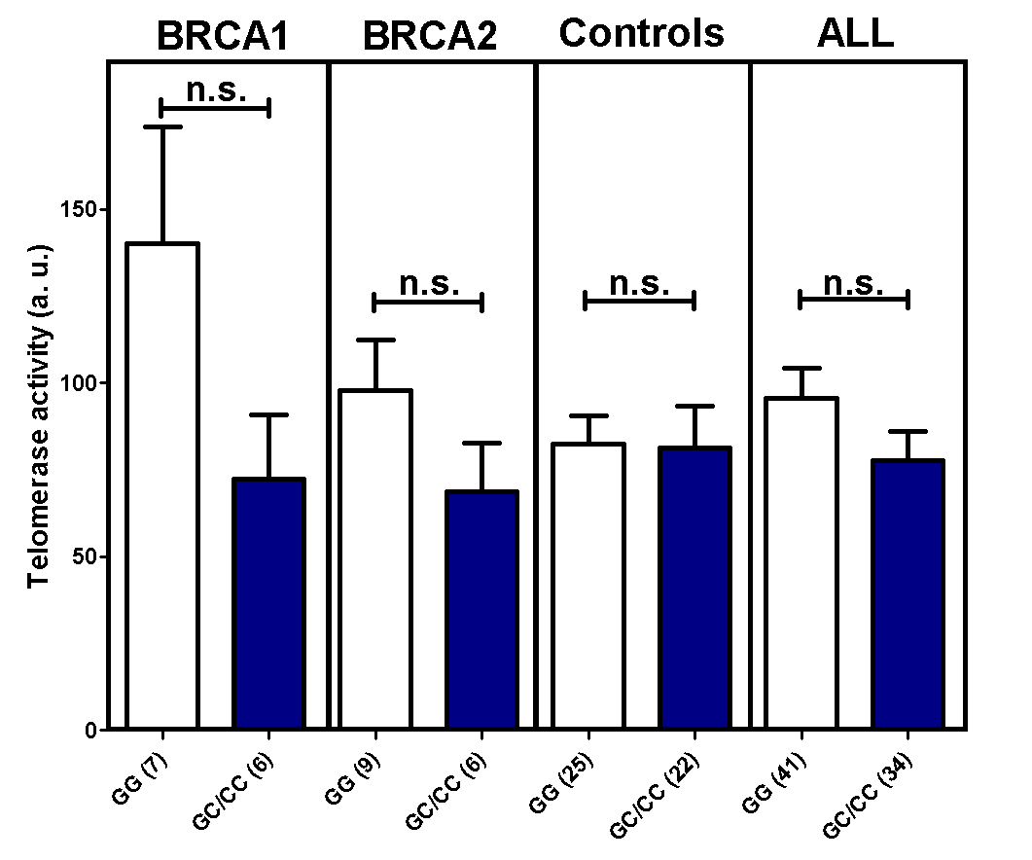
Figure S7. Comparative analysis of telomerase activity in the FBOC series according to the presence or absence of the UNG SNP (non-carriers (GG)/carriers (GC/CC)). Bars show the mean and the SEM. Numbers in brackets denote sample size. Unpaired t‐tests were performed for statistical significance. a. u.: arbitrary units.

