Noninvasive Molecular Imaging of Cell Death in Myocardial Infarction using ¹¹¹In-GSAO
Nobuhiro Tahara, H. Reinier Zandbergen, Hans J. de Haas, Artiom Petrov, Raghu Pandurangi, Takayoshi Yamaki, Jun Zhou, Tsutomu Imaizumi, Riemer H.J.A. Slart, Mary Dyszlewski, Tiziano Scarabelli, Annapoorna Kini, Chris Reutelingsperger, Navneet Narula, Valentin Fuster, Jagat Narula
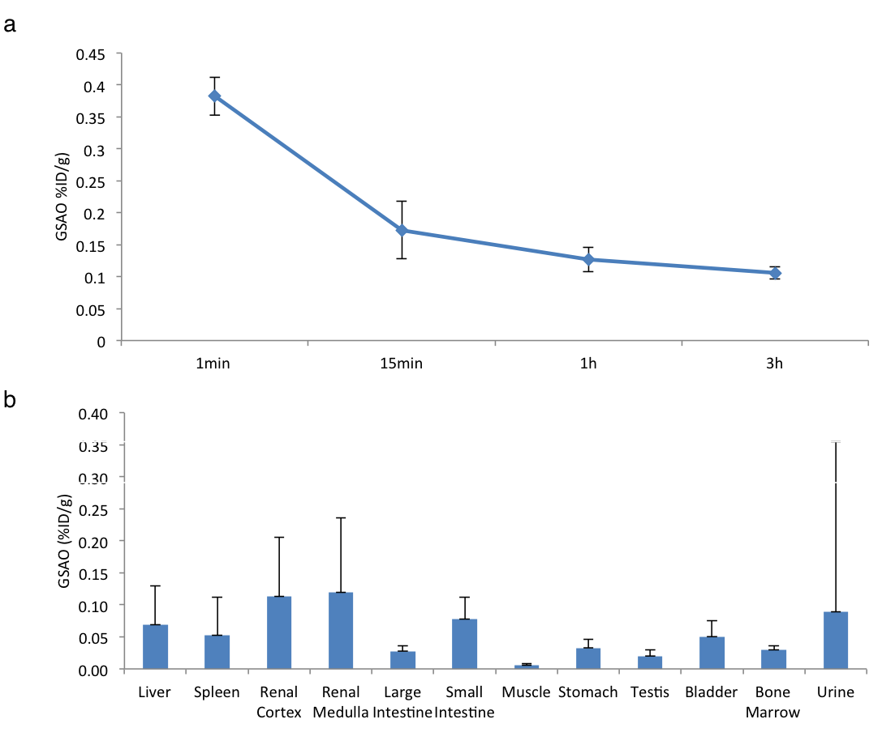

Supplementary Figure 1. Blood clearance and biodistribution studies.
(a) Serial blood sampling revealed rapid clearance of ¹¹¹In-GSAO from the blood. (b) Biodistribution studies revealed mostly renal clearance and low background uptake in the other organs.

