SUPPLEMENTARY DATA

Supplementary Table 1. Differentially expressed miRNAs in AT-AMI vs control subjects.

miRNA ID | FDR corrected p value | AT-AMI/CONTROLS
hsa_mir_107 | 0.000137202950502183 | DOWN
hsa_mir_103a_3p | 0.00073247887227318 | DOWN
hsa_let_7d_5p | 0.000840408616432995 | DOWN
hsa_mir_26b_5p | 0.00104938363046324 | DOWN
hsa_mir_191_5p | 0.00184416334604069 | DOWN
hsa_mir_22_3p | 0.00238496353368204 | UP
hsa_let_7g_5p | 0.0027074437545601 | DOWN
hsa_mir_106a_5p | 0.00271873252253686 | DOWN
hsa_mir_30c_5p | 0.00271873252253686 | DOWN
hsa_mir_454_3p | 0.00271873252253686 | DOWN
hsa_mir_301a_3p | 0.00271873252253686 | DOWN
hsa_mir_374a_5p | 0.00271873252253686 | DOWN
hsa_let_7c_5p | 0.00278843102807841 | DOWN
hsa_mir_29a_3p | 0.00296258025182088 | UP
hsa_mir_125b_5p | 0.00637994864624059 | UP
hsa_mir_18b_5p | 0.0110396122058713 | DOWN
hsa_mir_17_5p | 0.0128259591576138 | DOWN
hsa_mir_29c_3p | 0.0157932881043971 | UP
hsa_mir_365a_3p | 0.0163132842598492 | UP
hsa_mir_22_5p | 0.0264972202122007 | UP
hsa_mir_483_5p | 0.0287061986605215 | UP
hsa_mir_20a_5p | 0.0341543132095997 | DOWN
hsa_mir_497_5p | 0.0498509400549692 | UP

Supplementary Table 2. Confidence intervals (CI, 95%) for DE of miRNAs between control subjects and AT-AMI patients.
miRNA ID | CI (95%)
hsa_let_7d_5p | 0.1974680 - 0.4418131
hsa_mir_103a_3p | 1.207383 - 2.758278
hsa_mir_106a_5p | 1.953191 - 5.197487
hsa_mir_125b_5p | -0.42689799 - -0.08514594
hsa_mir_191_5p | 0.7745062 - 1.9888464
hsa_mir_22_3p | -4.958886 - -1.859620
hsa_mir_26b_5p | 0.5663564 - 1.2859570
hsa_mir_30c_5p | 0.1271989 - 0.3797141
DE Differential expression

Supplementary Table 3. Confidence intervals (CI, 95%) for DE of miRNAs in Discovery and Validation cohorts.
miRNA ID | Discovery cohort CI (95%) | Validation cohort CI (95%)
hsa_let_7f_5p | -0.22174937 -0.07390335 | -0.185443401 - -0.003768791
hsa_mir_146a_5p | -2.3294678 -0.4316445 | -1.11853112 - -0.01522239
hsa_mir_151a_3p | -0.44626052 -0.08303055 | -0.33644209 - 0.00902833
hsa_mir_223_5p | -0.05279846 -0.01585272 | -0.045315483 - 0.003940501
DE Differential expression

Supplementary Table 4. Confidence intervals (CI, 95%) for miRNAS confirmed by individual PCR primer sets.
miRNA ID | CI (95%)
hsa_let_7f_5p | -0.10743882 - -0.03068808
hsa_mir_146a_5p | -2.2816659 - -0.1157393
hsa_mir_151a_3p | -0.58758349 - -0.04650965
hsa_mir_223_5p | -0.056952817 -0.008196918

Supplementary Table 5. Confidence intervals (CI, 95%) for the expression of plasma molecules between AT-AMI and SCAD patients.
Cytokine | CI (95%)
CXCL8 | -93.20006 - -32.69999
TGFB1 | -70031.1 - -26100.1
TGFBR1 | -7304.5 - -1039.7
Endothelin-1 | -231.80008 - -37.80005
MMP2 | -14195.6 - 0.0

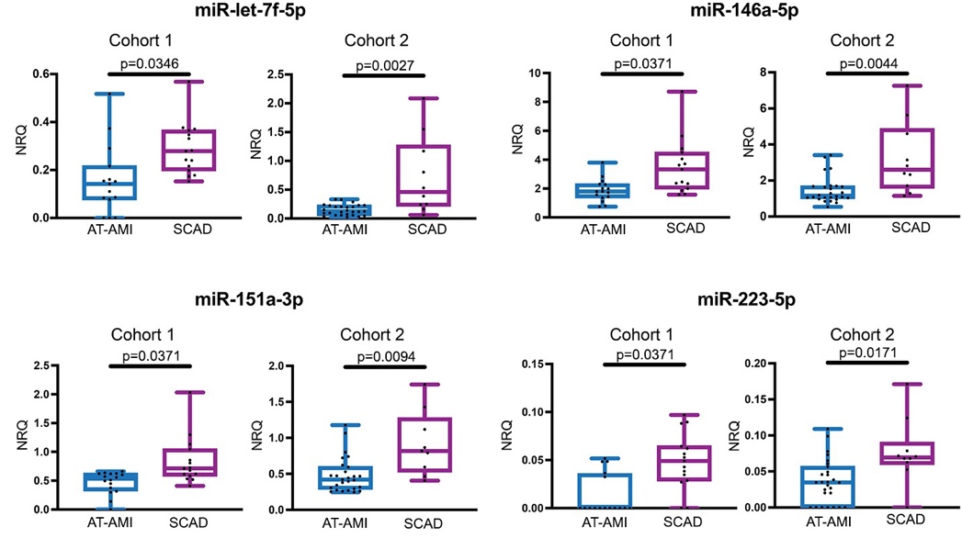

Supplementary Figure 1. Circulating levels of miR-let-7f-5p, miR-146a-5p, mmiR-151a-3p and mir223-5p distinguish SCAD from AT-AMI patients. Box and whiskers Min to Max plots showing plasma levels of miR-let-7f-5p, miR-146a-5p, miR-151a-3p and miR-223-5p from two independent cohorts of SCAD and AT-AMI patients. Expression of miRNAs was analysed by RT-PCR using a serum/plasma focused PCR panel. Data correspond to the expression of miRNAs in cohort 1 (SCAD n=15, AT-AMI n=15) and cohort 2 (SCAD n=10, AT-AMI n=26). Only those differentially expressed miRNAs in cohort 1 and validated in cohort 2 are shown. Data were normalized using the global mean and expression levels are shown as Normalized relative quantity (NRQ), as indicated under Methods. Differences among groups were analysed by a multiple linear regression model adjusted by haemolysis (plasma sample absorbance at 414 nm), sex and/or age when necessary.

