Figure S1
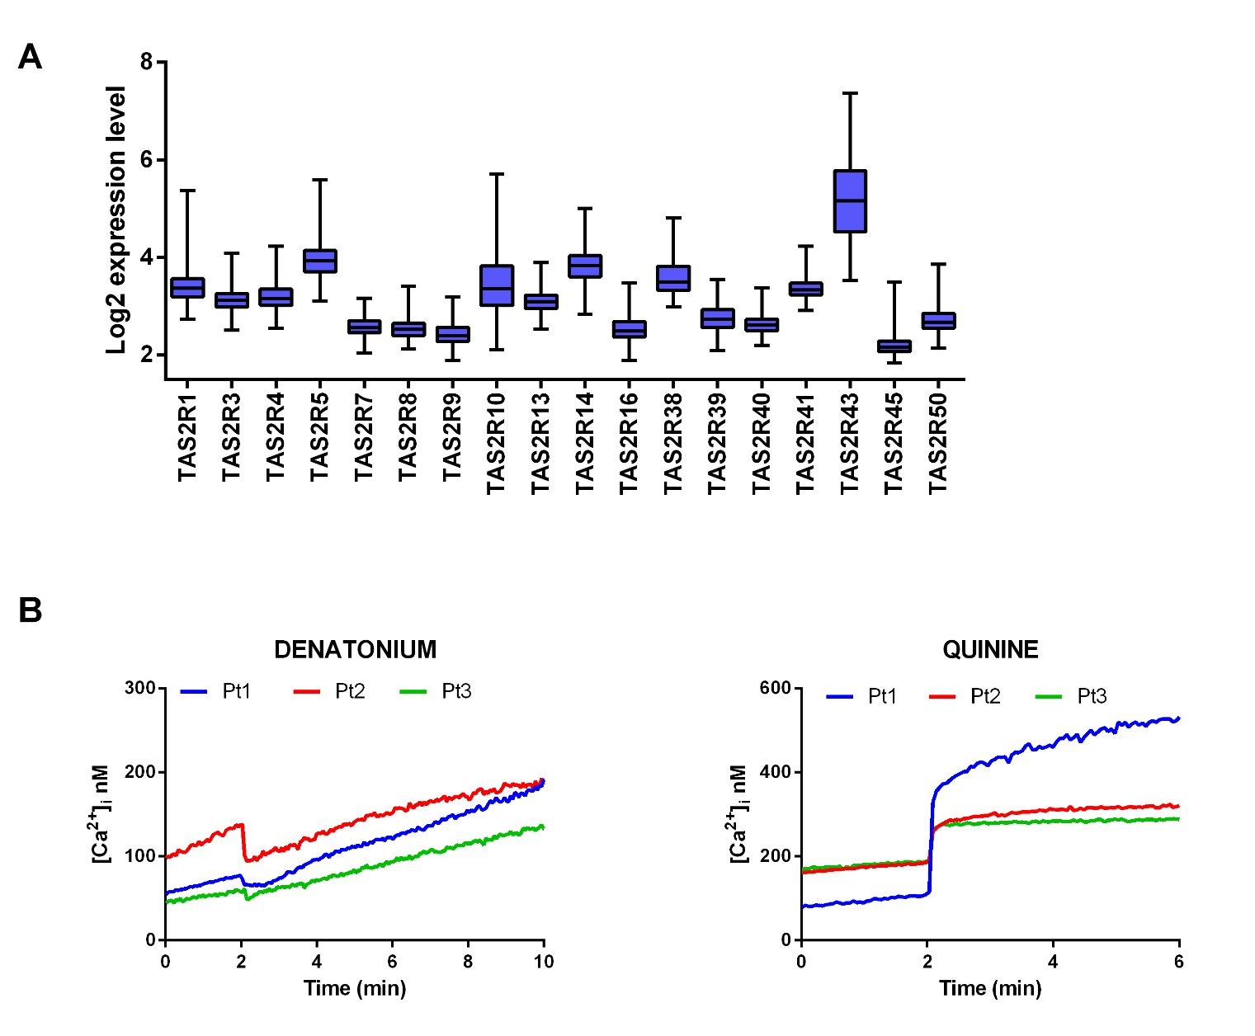
Figure S1. TAS2R expression in AML. (A) Box plots illustrate relative TAS2R mRNA expression obtained by GEP from the TCGA AML cohort consisting of 183 samples. (B) Ca²⁺ release in three AML samples (Pt) loaded with the Ca²⁺ indicator fura-2/AM and treated with 10mM denatonium or 75µM quinine.
Figure S2

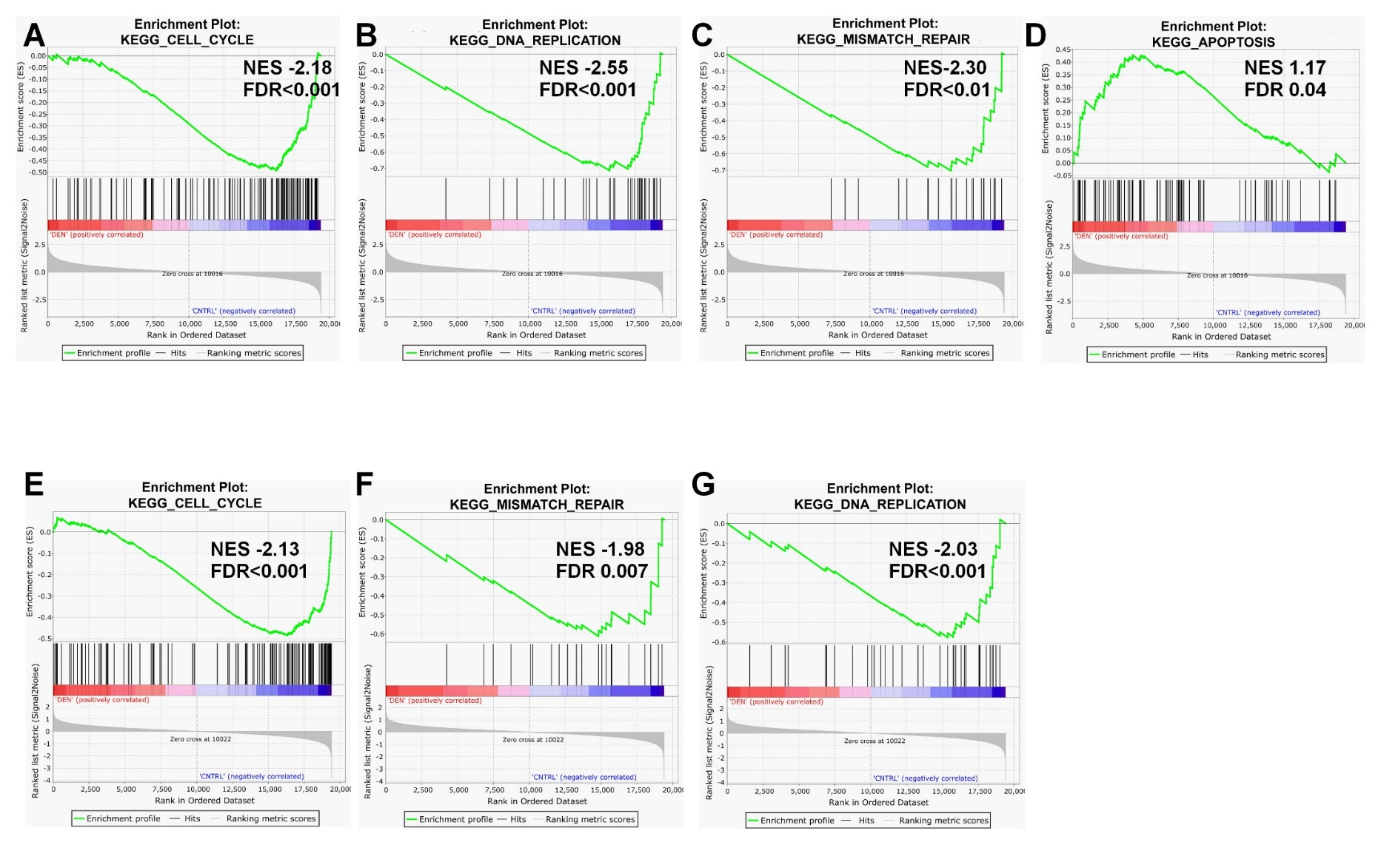
Figure S2. DEN exposure alters cell cycle, DNA replication, DNA repair, and apoptosis gene signatures. GSEA of DEN-treated and untreated THP1 (A-D) and OCI-AML3 cells (E-G) (signatures with significant false discovery rate enrichment are represented; NES: normalized enrichment score; FDR: false discovery rate).

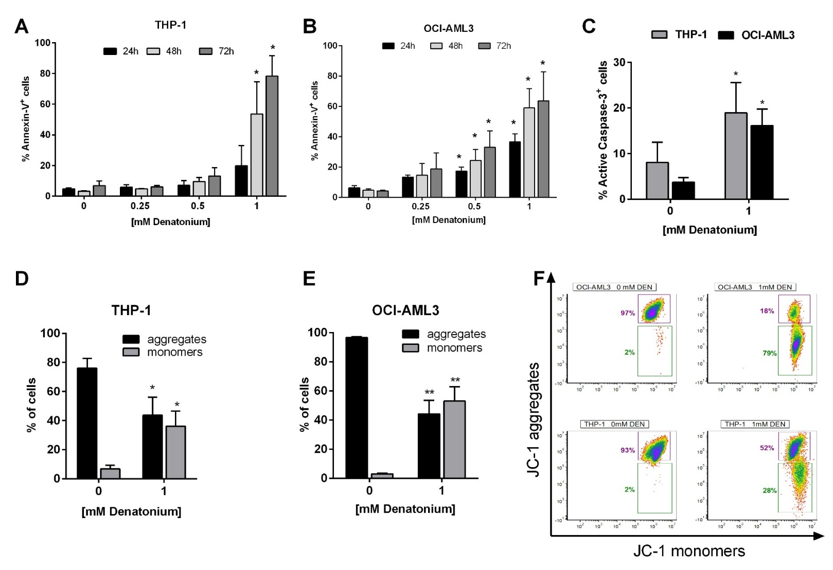
Figure S3
Figure S3. DEN treatment induces AML cell line apoptosis. (A) THP-1 (n=4) and (B) OCI-AML3 (n=4) cell lines were treated for 24, 48 and 72 h with increasing doses of DEN. Annexin V/PI staining was used to detect apoptosis. (C) Active caspase-3 expression analyzed by flow cytometer after treatment with 1mM DEN for 48 h (n=5 for each cell lines). (D-E) Effect of treatment with 1mM DEN on transmembrane potential in mitochondria was detected by FACS analysis, in THP-1 (n=4) and OCI-AML3 (n=5) cell lines. The histograms show the percentage of JC-1 aggregates (cells emitting red fluorescence in the FL-2 channel) and JC-1 monomers (cells emitting green JC-1 detected in the FL-1 channel) from 6 independent experiments. (F) Representative dot plots of JC-1 staining. Data are expressed as mean ± SEM. Statistical analysis was performed by using ANOVA followed by Dunnett’s multiple comparison test with untreated group as control. *p<0.05; ** p<0.01.

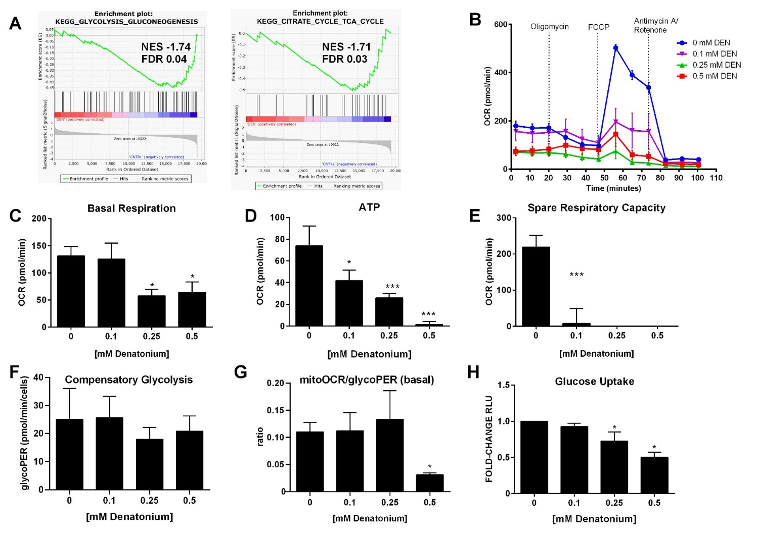
Figure S4
Figure S4. DEN exposure alters mitochondrial bioenergetics. (A) Downregulation of a gene signatures of glycolysis/gluconeogenesis and citrate cycle in OCI-AML3 cells after 24 h exposure to DEN. (B-E) Seahorse Cell Mito Stress Test was performed to asses mitochondrial function in OCI-AML3 cell line (n=5) after 24 h exposure to increasing doses of DEN. (B) Representative oxygen consumption rate (OCR) profile plot. (C) Basal respiration. (D) ATP‐linked respiration. (E) Spare capacity. (F-G) Quantitative data of compensatory glycolysis and ratios of mitochondrial OCR to glycoPER calculated using Seahorse XF Glycolytic Rate assay (n=2). (H) Measurement of glucose uptake in OCI-AML3 cells after 24 h exposure to increasing doses of DEN (n=5). Untreated cells (136,730 ± 78,653 RLU) were used as reference and set as 1. Data are expressed as mean ± SEM. Statistical analysis was performed by using ANOVA followed by Dunnett’s multiple comparison test with untreated group as control. *p<0.05; ** p<0.01; ***p<0.001. NES: normalized enrichment score; FDR: false discovery rate.

Figure S5
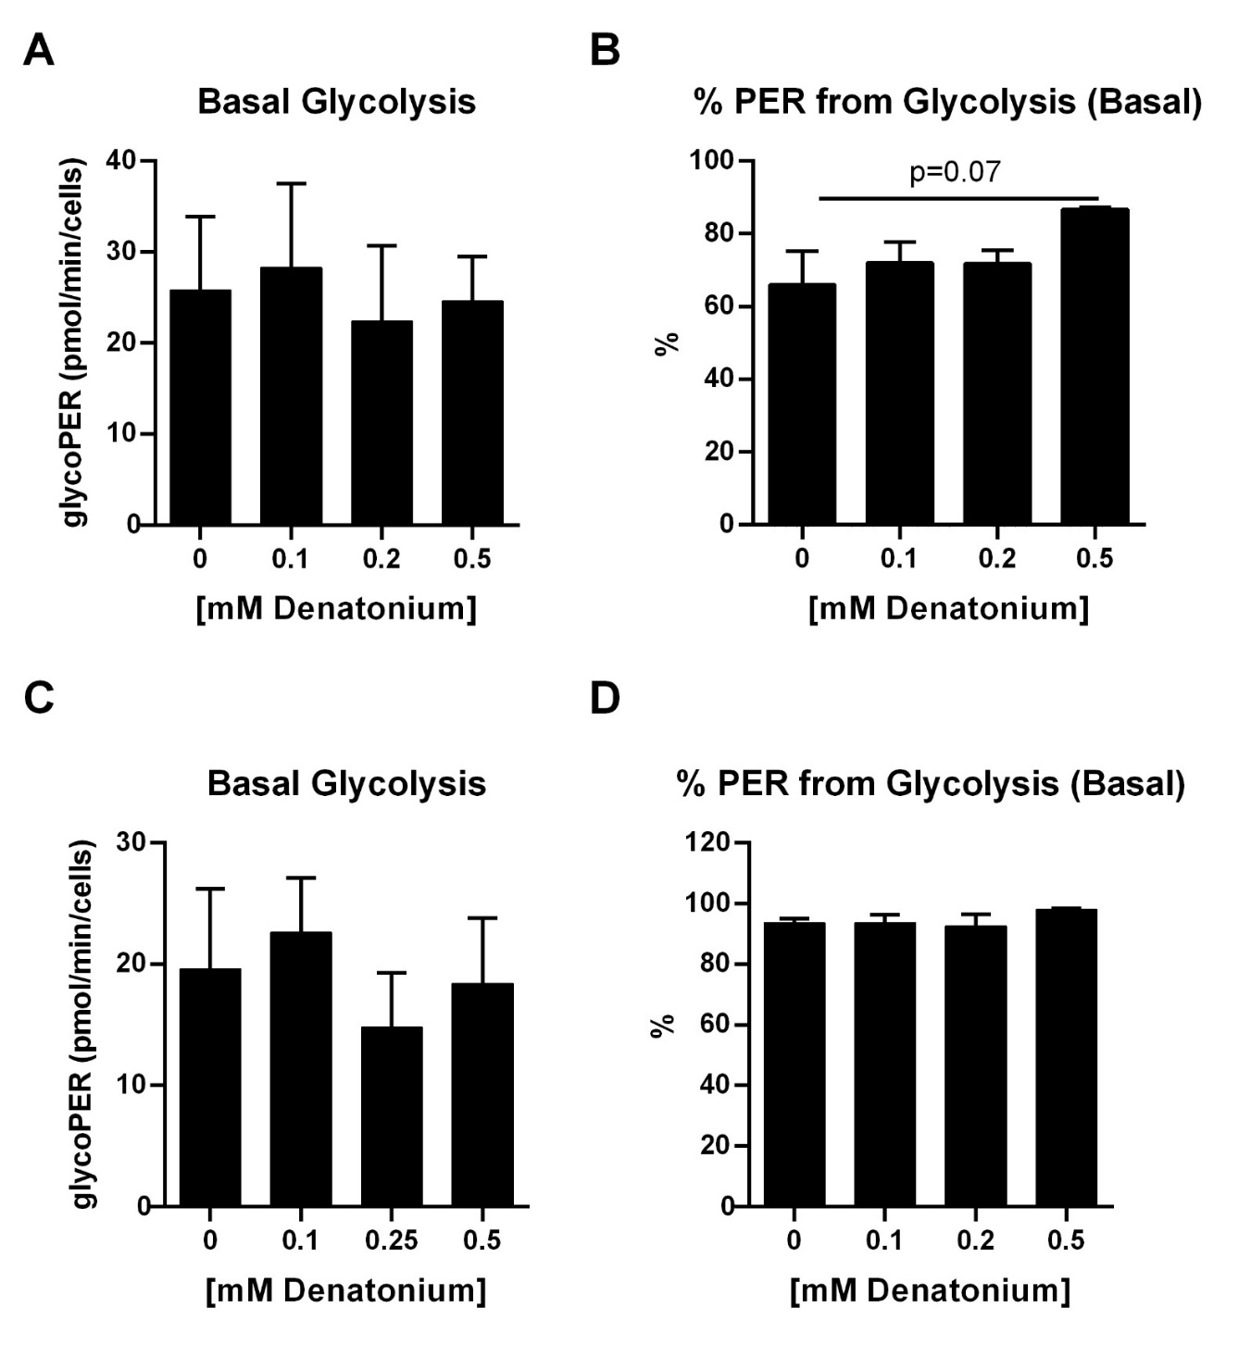
Figure S5 Denatonium effects on glycolytic proton efflux rate (glycoPER) at basal. Individual parameters for basal glycolysis and basal percentage PER from glycolysis in THP1 cells (A-B, respectively; n=3) or in OCI-AML3 cells (C-D, respectively; n=2) treated with DEN at different concentrations. Data are expressed as mean ± SEM. Statistical analysis was performed by using ANOVA followed by Dunnett’s multiple comparison test with untreated group as control.

Figure S6
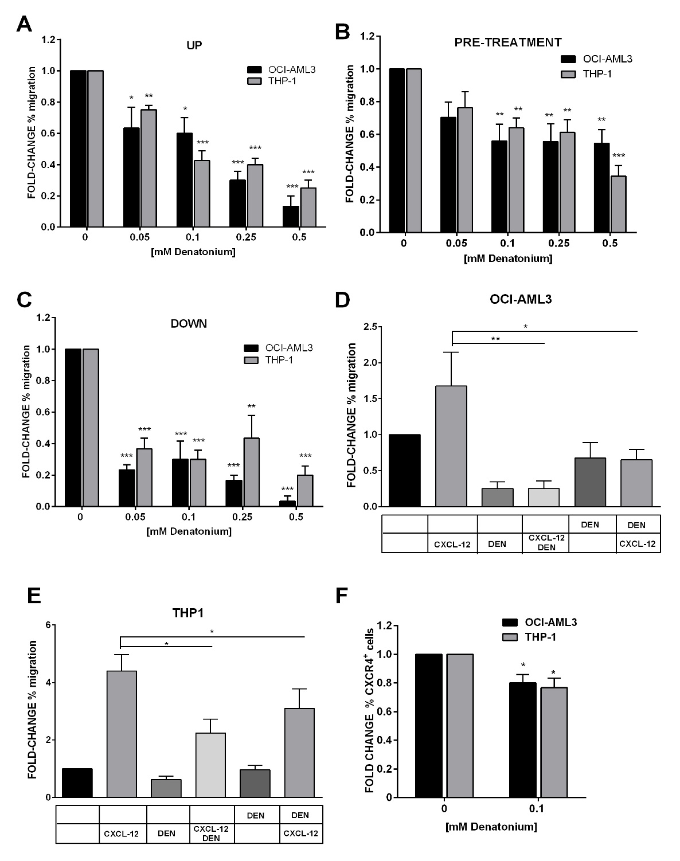
Figure S6. DEN stimulation inhibits OCI-AML3 and THP-1 cell lines migration. Results of cell lines migration in transwell assays were shown as fold-change of the percentage of migration in comparison with the untreated condition set as 1. (A) Spontaneous migration in presence of increasing doses of DEN in the upper chamber of transwell (n=4 for each cell lines). The percentage of migrating cells in control samples was: THP-1 10.6 ± 2.7 SEM and OCI-AML3 31.7 ± 8.7 SEM. (B) Spontaneous migration after a pre-treatment of 4 h with increasing doses of DEN (THP-1 n=3; OCI-AML3 n=4 ). The percentage of migrating cells in control samples was: THP-1 18.4 ± 2.8 and OCI-AML3 35.8 ± 8.6 SEM. (C) Migration towards a gradient of DEN in the lower chamber of transwell (n=3 for each cell lines). The percentage of migrating cells in control samples was: THP-1 10.6 ± 2.7 SEM and OCI-AML3 31.7 ± 8.7 SEM. (D-E) The histograms show the effect of the presence of 0.1mM DEN in the upper or in the lower chamber on the CXCL-12 induced chemotaxis (150ng/mL) (THP-1 n=8; OCI-AML3 n=4). The percentage of migrating cells in control samples was: THP-1 6.7 ± 2.9 SEM and OCI-AML3 32.8 ± 7.8 SEM. (F) CXCR4 expression analysed by flow cytometer after O/N treatment with DEN (THP-1 n=3; OCI-AML3 n=4). The percentage of CXCR4⁺ cells in untreated samples was: THP-1 61.5 ± 18.0 SD and OCI-AML3 77.6 ± 11.2 SD. Data are expressed as mean ± SEM. Statistical analysis was performed by using ANOVA followed by Dunnett’s multiple comparison test with untreated group as control. *p<0.05; ** p<0.01; ***p<0.001.

