Appendix.

  - Scaf1 mediates respiratory supercomplexes and promotes metabolic efficiency in zebrafish

CONTENT:

Appendix figure S1. Generation of Scaf1 loss-of-function zebrafish models. 2
Appendix figure S2. The Scaf1 loss-of-function phenotype is stable in adulthood, recessive and not maternally contributed. 4
Appendix table S1. Nutritional content of Sparos high fat (HFD), control and low proteins/low fats (LP/LF) diets. 5

  - 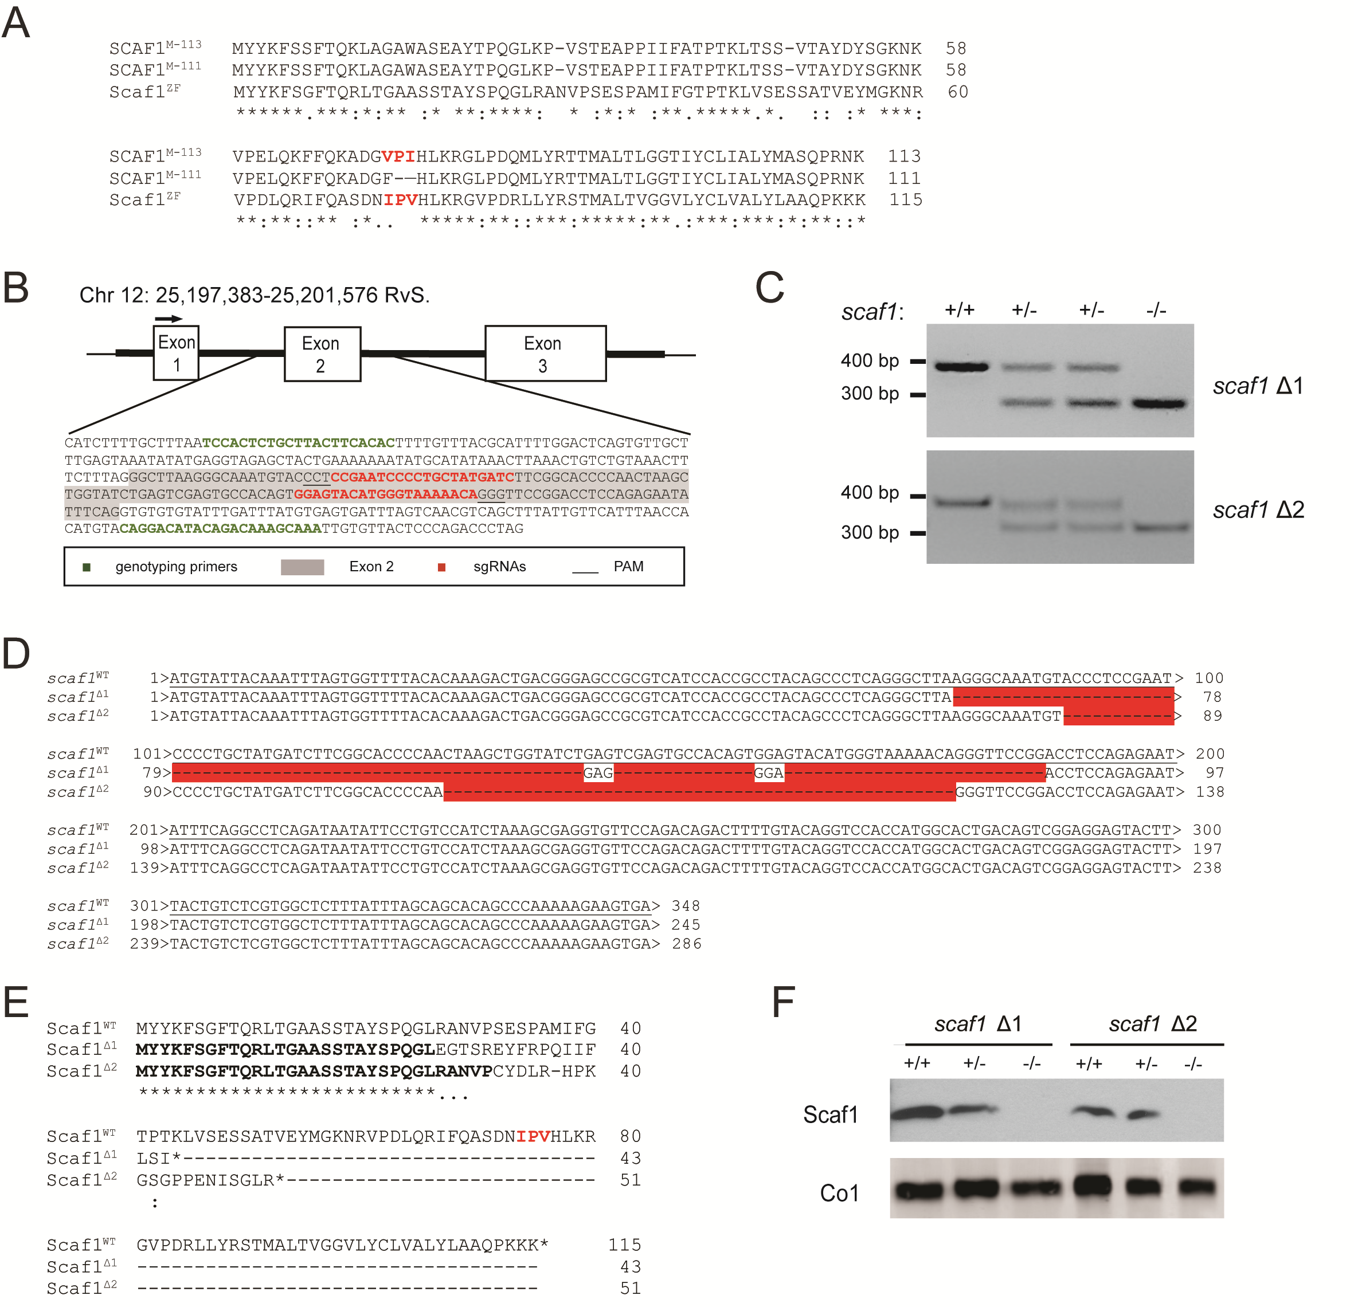
  - Appendix figure S1. Generation of Scaf1 loss-of-function zebrafish models. A, Alignment of the amino acid sequences of mouse SCAF1¹¹³, SCAF1¹¹¹ and zebrafish Scaf1 (also known as Cox7a2l, Cox7a3). B, CRISPR/Cas9 target design for generation of zebrafish Scaf1 loss-of function-models. In green, primer sequences for genotyping, in red sgRNAs with their PAM sequence underlined. Exon sequences are highlighted in grey. C, Representative image of PCR products of the two established Scaf1 loss-of-function lines (scaf1^{Δ1} and scaf1^{Δ2}). D, Sequence of scaf1^{Δ1} and scaf1^{Δ2} mutant alleles. In red, the deleted sequence. E, Predicted amino acid sequence of scaf1^{Δ1} and scaf1^{Δ2}. F, Western blot of isolated mitochondria from scaf1^{Δ1} and scaf1^{Δ2} fish (representative of 4 biological replicates).

  - 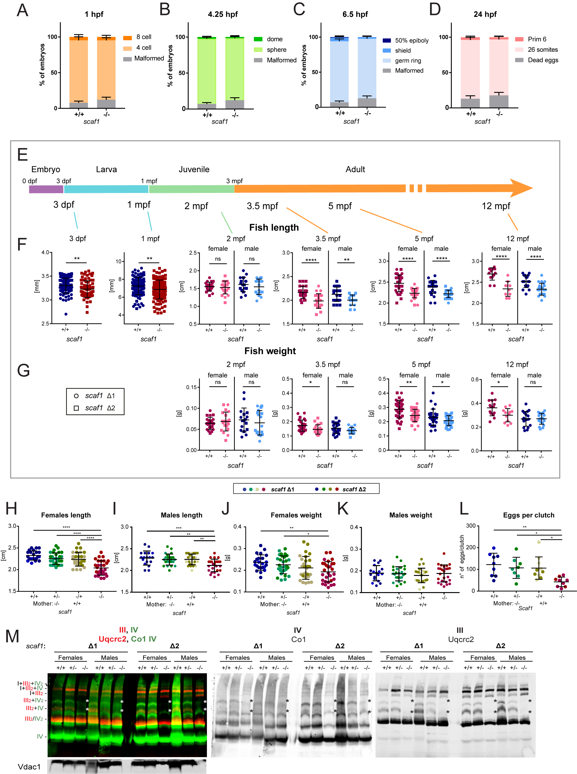

Appendix figure S2. The Scaf1 loss-of-function phenotype is stable in adulthood, recessive and not maternally contributed. A-D, Percentage of scaf1^{+/+} and scaf1^{-/-} fish (Δ1 n=5, Δ2 n=5 clutches of around 60-200 animals each). No significant difference (unpaired t-test p>0.05) was found between scaf1^{+/+} and scaf1^{-/-}. E-G, scaf1^{-/-} fish size at different developmental stages. E, Timeline of zebrafish development. F, Fish length and G, weight at the indicated time point: 3 dpf (Δ1 n=40, Δ2 n= 55), 1 mpf (Δ1 n=60, Δ2 n= 65), 2 mpf (females Δ1 n=11, Δ2 n= 12, males Δ1 n=8, Δ2 n= 8), 3.5 mpf (females Δ1 n=10, Δ2 n= 10, males Δ1 n=8, Δ2 n= 8), 5 mpf (females Δ1 n=15, Δ2 n= 16, males Δ1 n=13, Δ2 n= 23), 12 mpf (females Δ1 n=10-13, males Δ1 n=18-23). H-M, Size at 5 mpf of heterozygous offspring coming from a cross where the mother was scaf1^{+/+} and scaf1^{-/-}. Length of F1 H, females and I, males and weight of J, females(WT1 +/+ n=7, Δ1 +/- n=16, Δ1 -/+ n=17, Δ1 -/- n=16, WT2 +/+ n=15, Δ2 +/- n=12, Δ2 -/+ n=11, Δ2 -/- n=12) and K, males (WT1 +/+ n=7, Δ1 +/- n=12, Δ1 -/+ n=10, Δ1 -/- n=11, WT2 +/+ n=10, Δ2 +/- n=12, Δ2 -/+ n=14, Δ2 -/- n=13). L, number of eggs per clutch (WT1 +/+ n=5, Δ1 +/- n=4, Δ1 -/+ n=6, Δ1 -/-, n=6, WT2 +/+ n=4, Δ2 +/- n=4, Δ2 -/+ n=4, Δ2 -/- n=3). M, BNGE and immunoblot analysis with the indicated antibodies comparing the impact of Scaf1 deletion in Δ1 and Δ2 fish lines. Asterisks indicate absent bands. Split channels are included. E-G, Unpaired t-test. H-L, One-way ANOVA. Data are represented as mean ± SD. * p<0.05, ** p<0.01, *** p<0.001, **** p<0.0001.

Diet composition | HFD | CONTROL | LP/LF
Crude protein, % feed | 55 | 55 | 27.8
Crude fat, % feed | 30.1 | 14.1 | 7
Fiber, % feed | 1.6 | 17.2 | 50.9
Ash, % feed | 6.7 | 6.7 | 5.5
Others % (aminoacids, vit, metals...) | 6.7 | 7 | 8.7
Gross Energy, MJ/kg feed | 22.2 | 18.3 | 16
Gross Energy Kcal/kg feed | 5302.4 | 4370.9 | 3821.5
Gross Energy of protein and fat Kcal/kg feed | 4904.3 (141%) | 3464.3 (100%) | 1748.06 (50%)

Appendix table S1. Nutritional content of Sparos high fat (HFD), control and low proteins/low fats (LP/LF) diets.

